Inclusion London’s Annual Report
April 2022 to March 2023
Summary Report - Easy Read

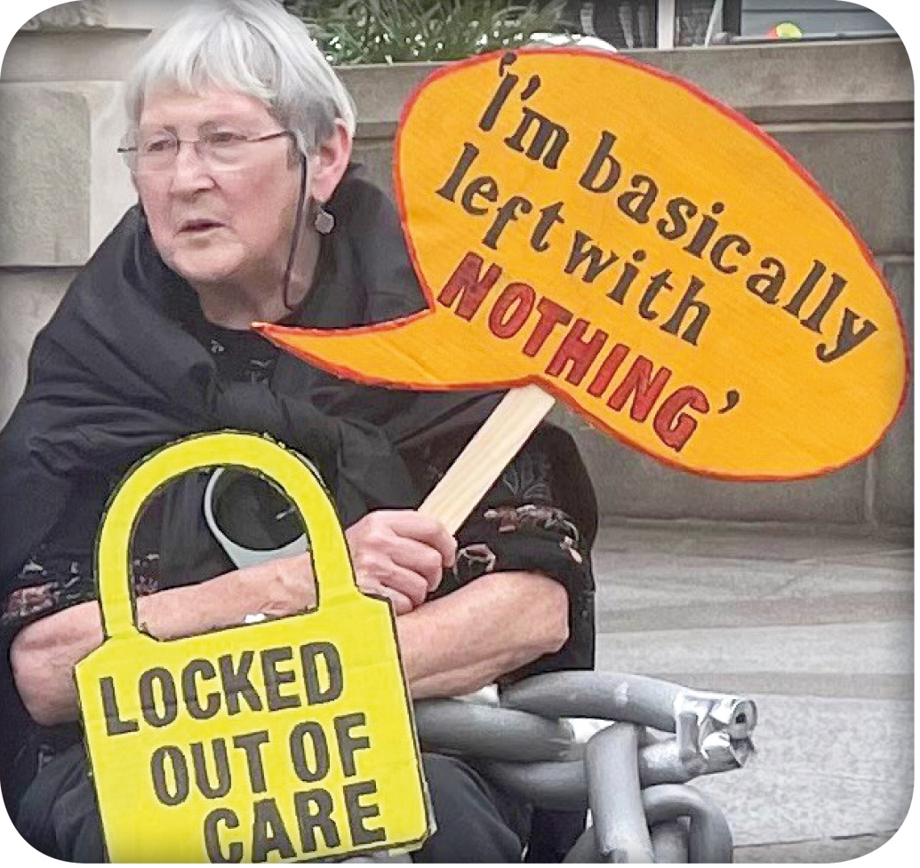

336 Brixton Road, London SW9 7AA
info@inclusionlondon.org.uk
020 7237 3181
07718 394 687
www.inclusionlondon.org.uk

Registered Charity number: 1157376.
Company registration number: 6729420.

Chair’s Report
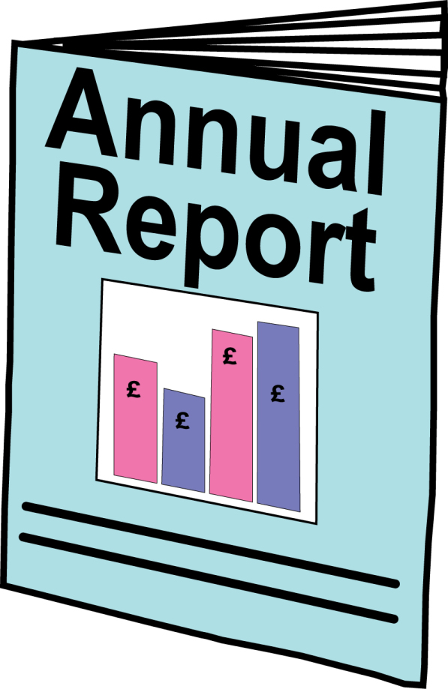
Welcome to Inclusion London’s annual report for April 2022 to March 2023.
This report shows some of the work we did over the year.
We had another busy year!

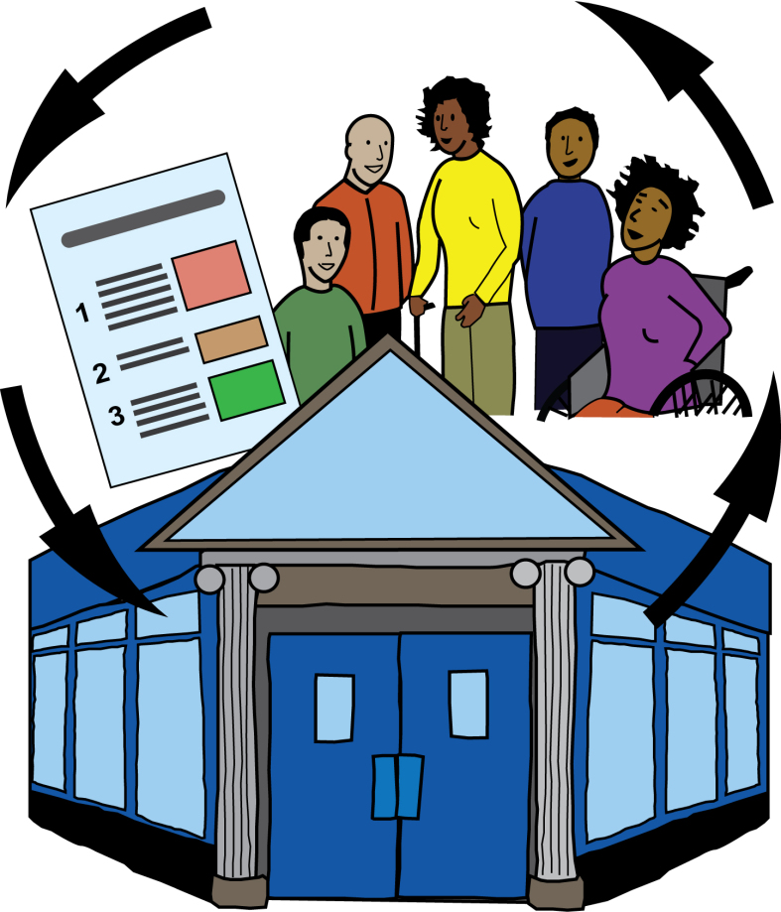
We worked with more than 70 Deaf and Disabled People’s Organisations (DDPOs).
More than 1,000 people came to our training, events, and forums during the year.

Forums are like regular meetings. People come together to talk about important matters and how to solve problems.

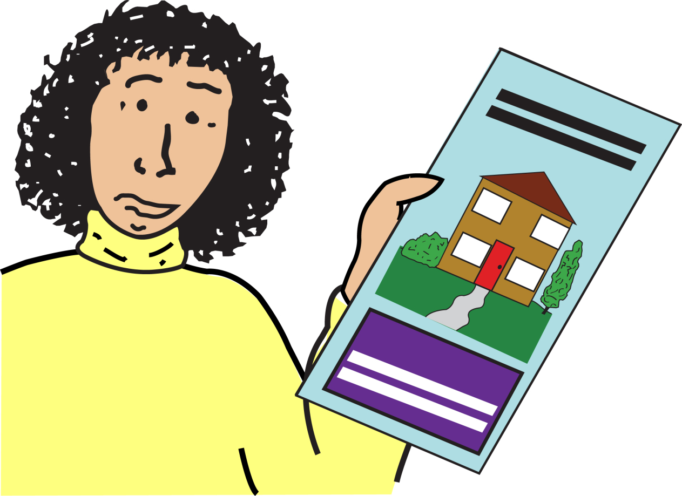
We started work on housing, de-institutionalisation, and how DDPOs can communicate and share information.

De-institutionalisation is about moving Disabled people from large care homes or hospitals to living in the community.

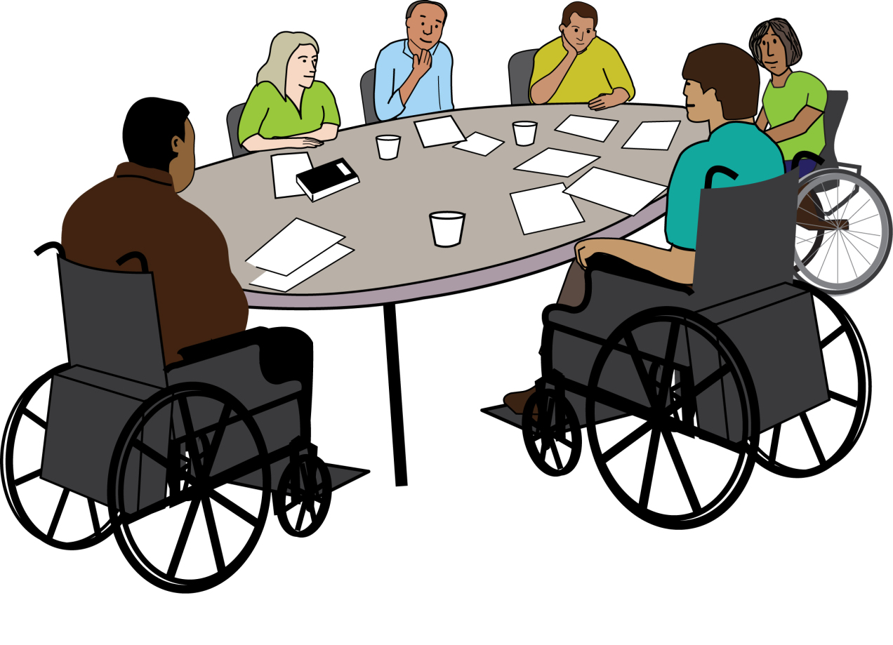
We also welcomed four new Trustees to our board.

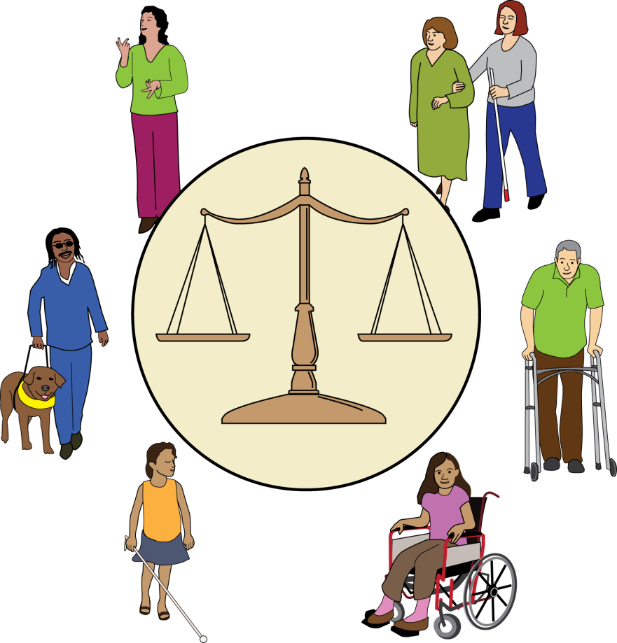
This report talks about some of our work from April 2022 to March 2023.
We worked hard to fix unfairness in our communities and groups.

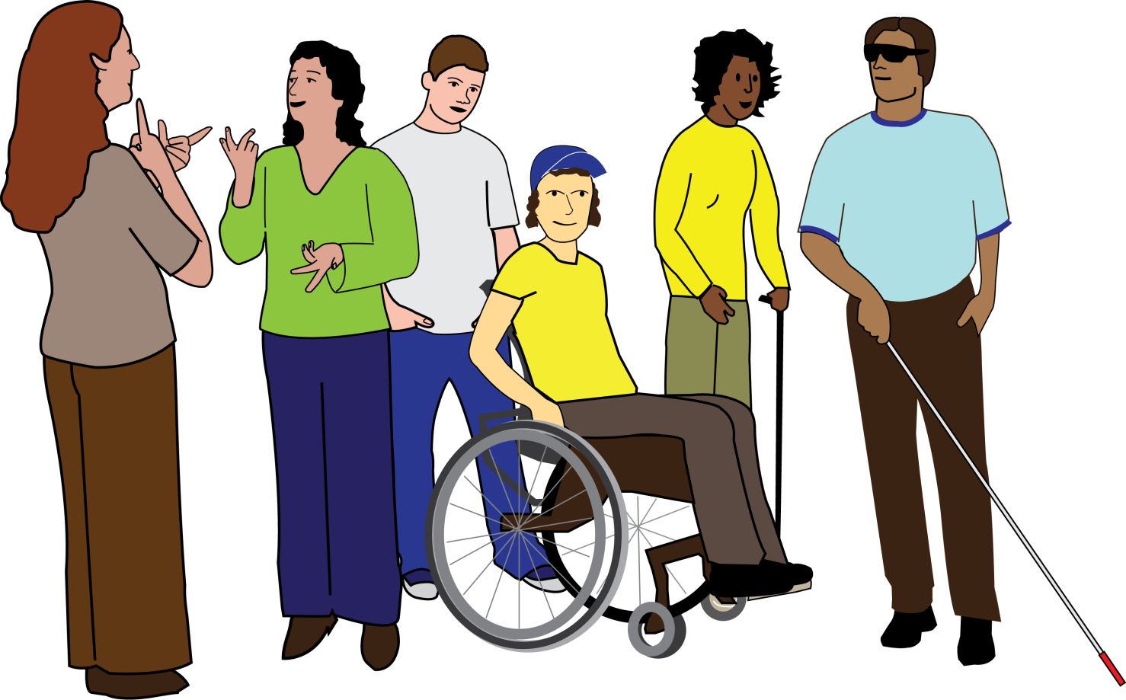
We want all DDPOs to be strong and welcoming for everyone.
We will keep working towards this.

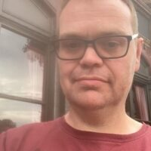
Paul Hawkins.
Chair of Inclusion London.

Disabled people

Inclusion London use the words ‘Disabled people’ to mean all people living with impairment.

This includes:
• People with physical impairments
• People with visual impairments
• Deaf people
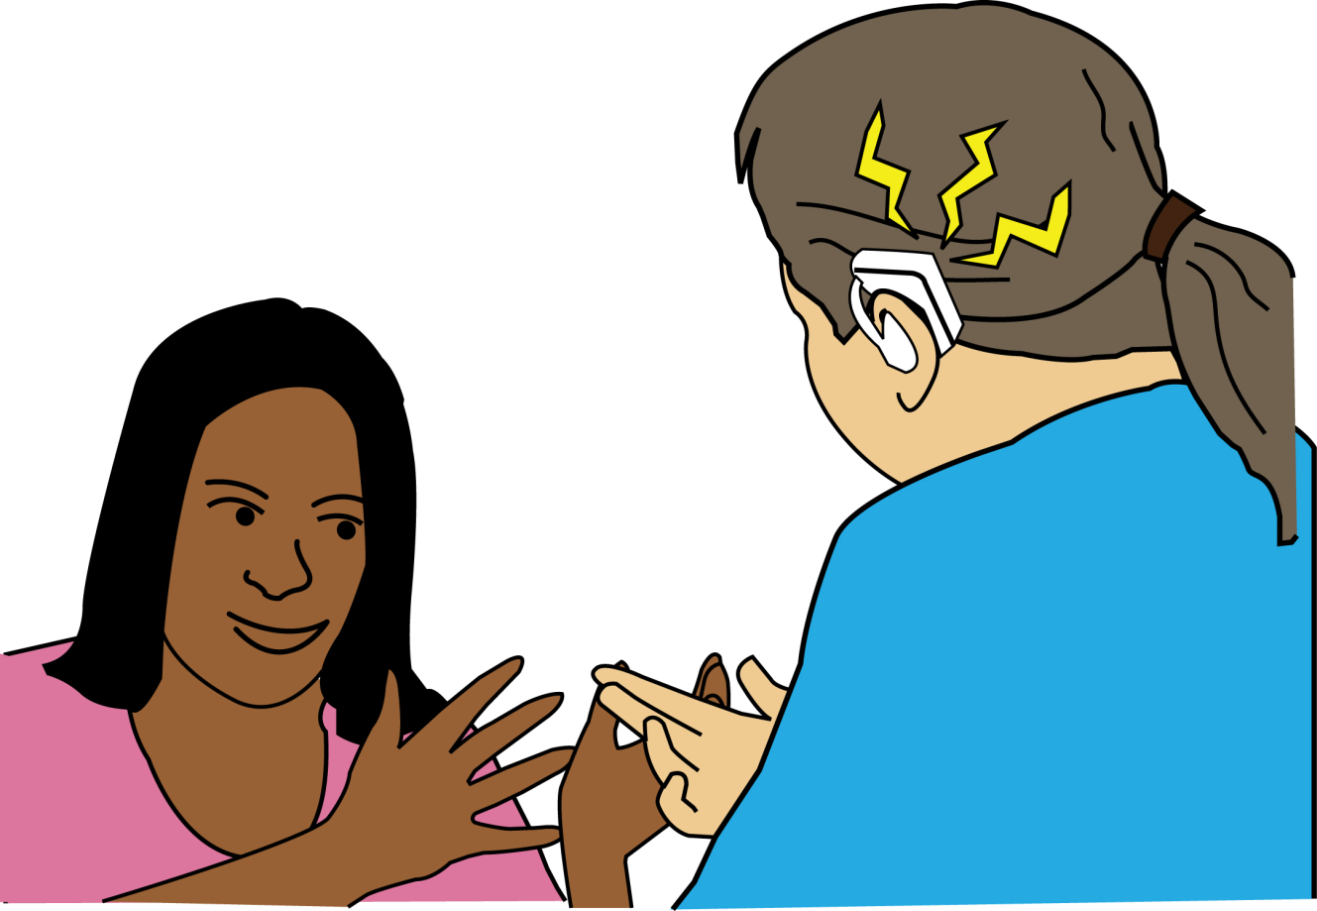
• People with hearing impairments
• People with learning difficulties
• People who experience mental health difficulties
• People with long term health conditions
• People who are neurodivergent
• People with invisible impairments

Important things we did in 2022-2023

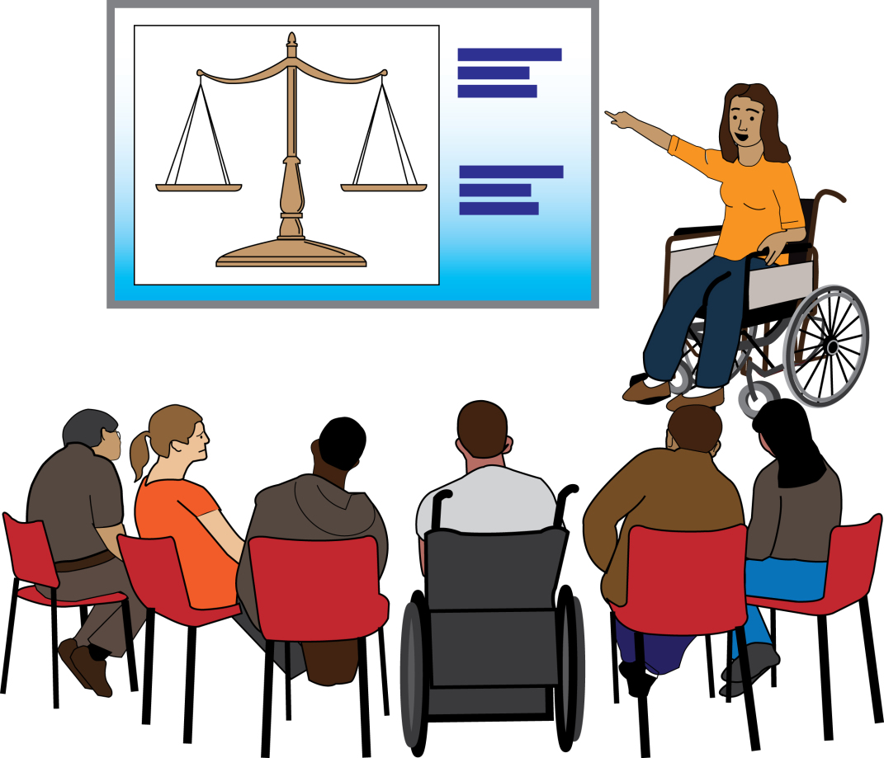
We ran 94 events over the year.
This included training, meetings, peer support, and others.

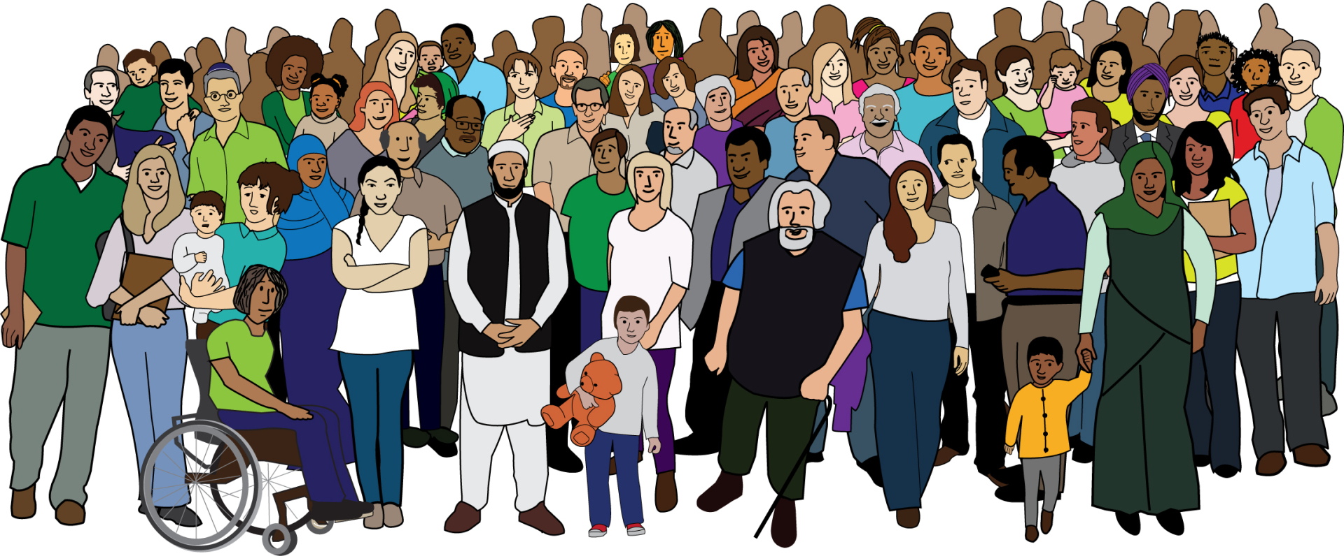
More than 1,000 people came to our events in total.

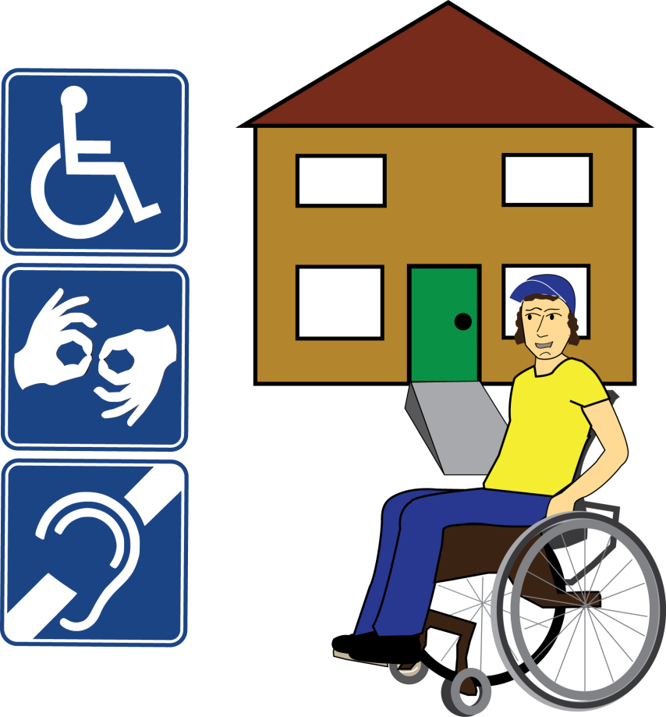

We set up a new DDPO Housing Network.
20 DDPOs have joined so far.

We campaigned to change the Ultra Low Emission Zone (ULEZ) scheme.

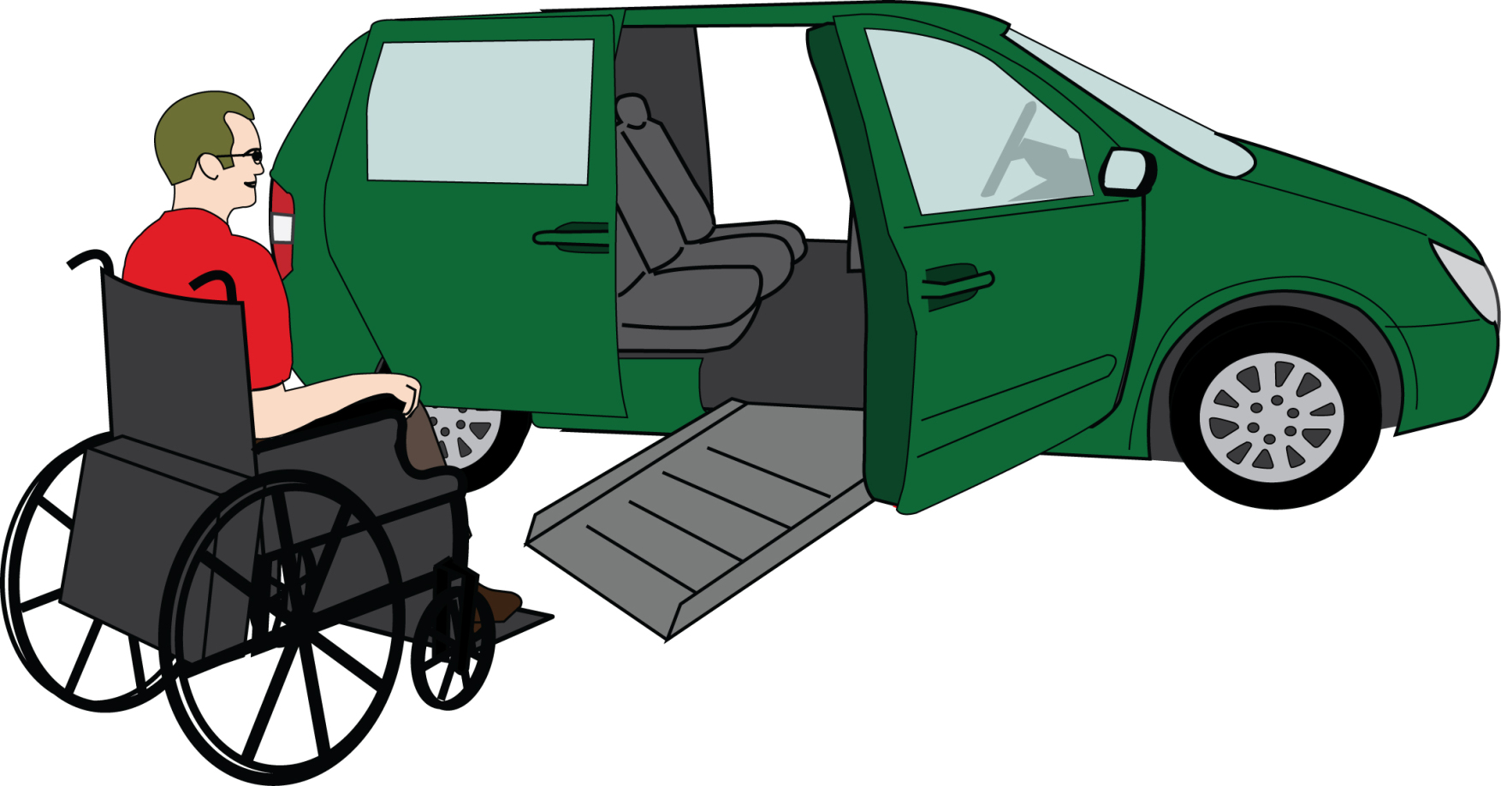
This was about the changes for using vehicles in London.
We made the scheme better for Disabled people.

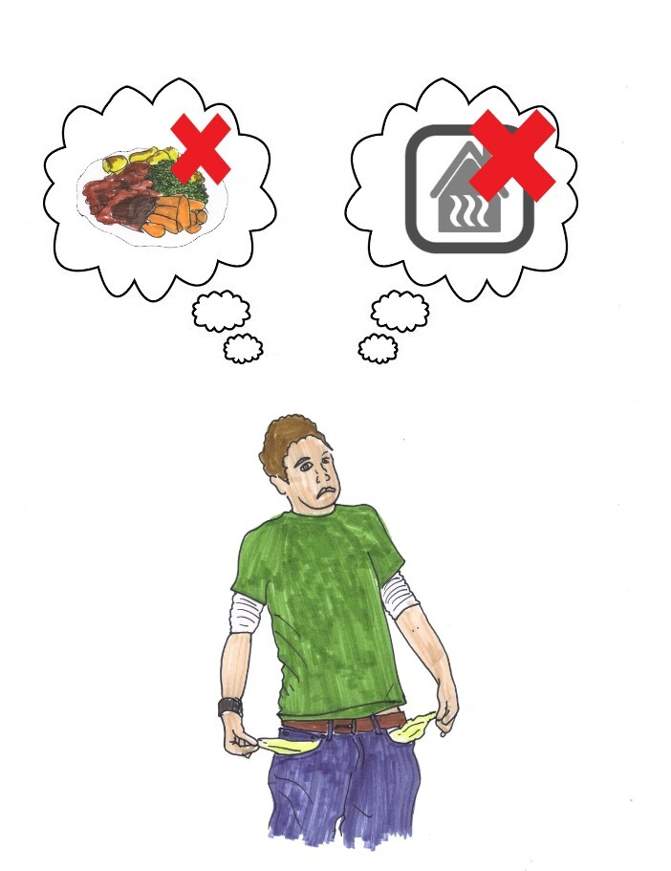
We worked with Disability Rights UK and set up the Disability Poverty Campaign Group.

20 DDPOs and charities joined to work on poverty together.

We worked with people to make a chat bot for helping with Disability Related Expenditure.

Disability Related Expenditure is the extra money you spend because you are a Disabled person.
These costs are for things that help in daily life. For example, it might be special equipment or the cost of a service that helps you.

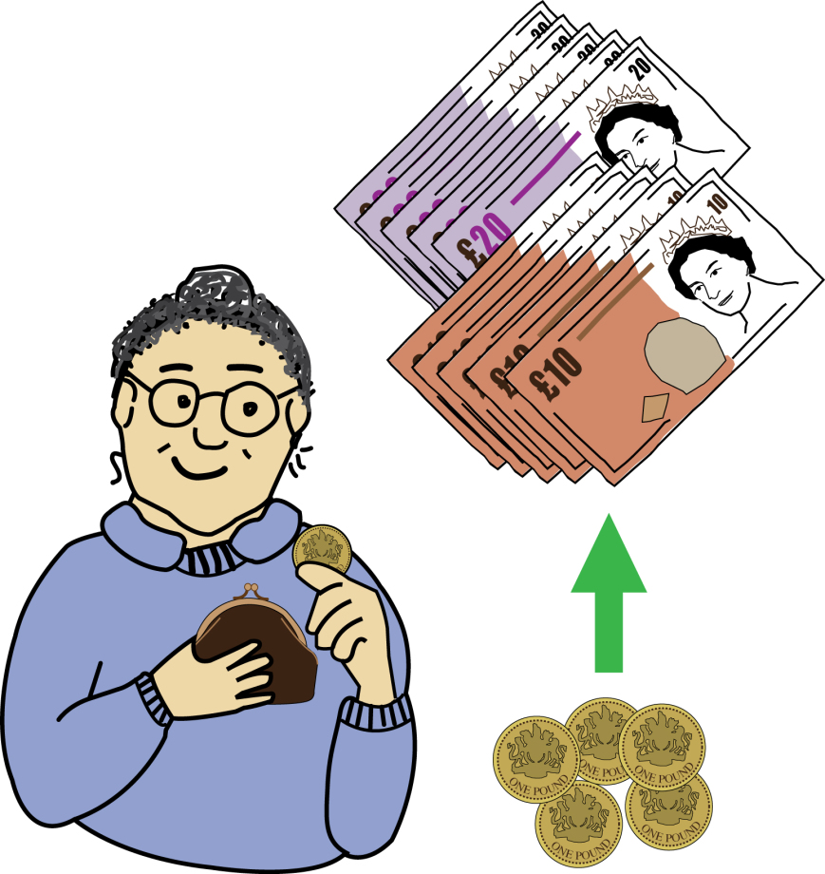

Our chat bot can help people protect more of their money from social care charges.

We are working with DDPOs and carer groups to help people use our chat bot.

We ran a campaign about how big a problem social care charge debt is.
3,668 people wrote to their MPs in this campaign.

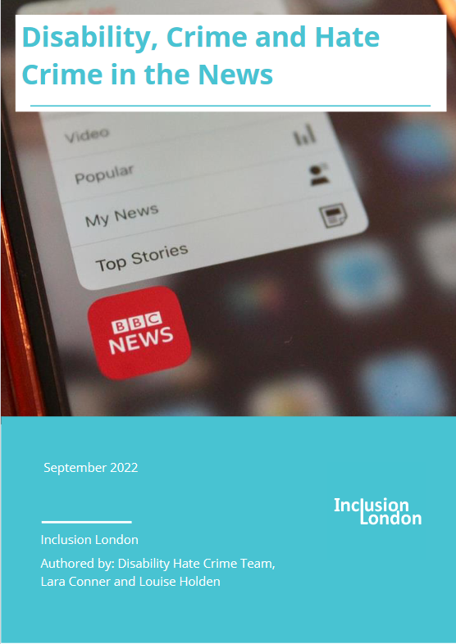

We wrote a report called ‘Disability, Crime, and Hate Crime in the News’.
This looked at how the news reports crimes involving Disabled people.

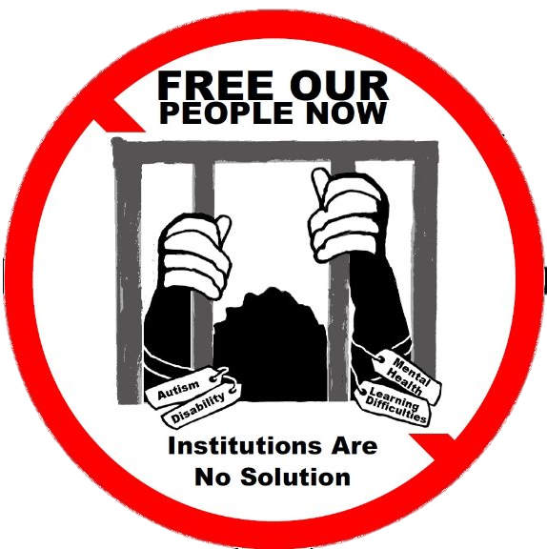
We set up the Free Our People Now project.
The project works to help Disabled people get out of institutions.

Institutions here means a place where people are kept for a long time away from their community.
Often these places are hospitals.
People may have been put in these places for many reasons. Usually, mental health is part of the reason.

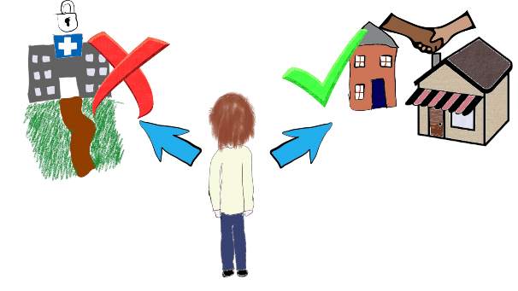
We support DDPOs to help Disabled people get out of institutions.
We also speak up about the rights Disabled people have to live in the community.

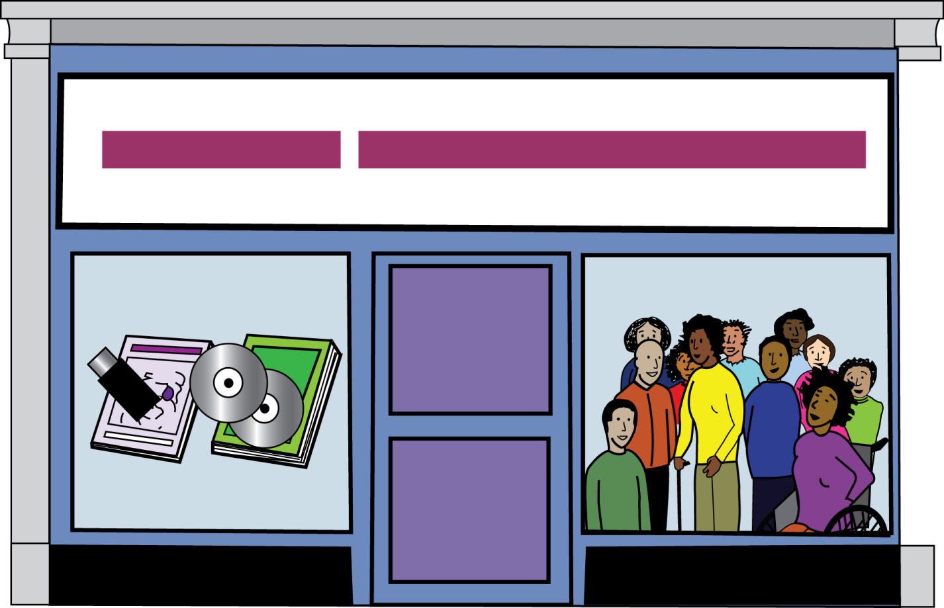
We kept giving DDPOs help to run their organisations.

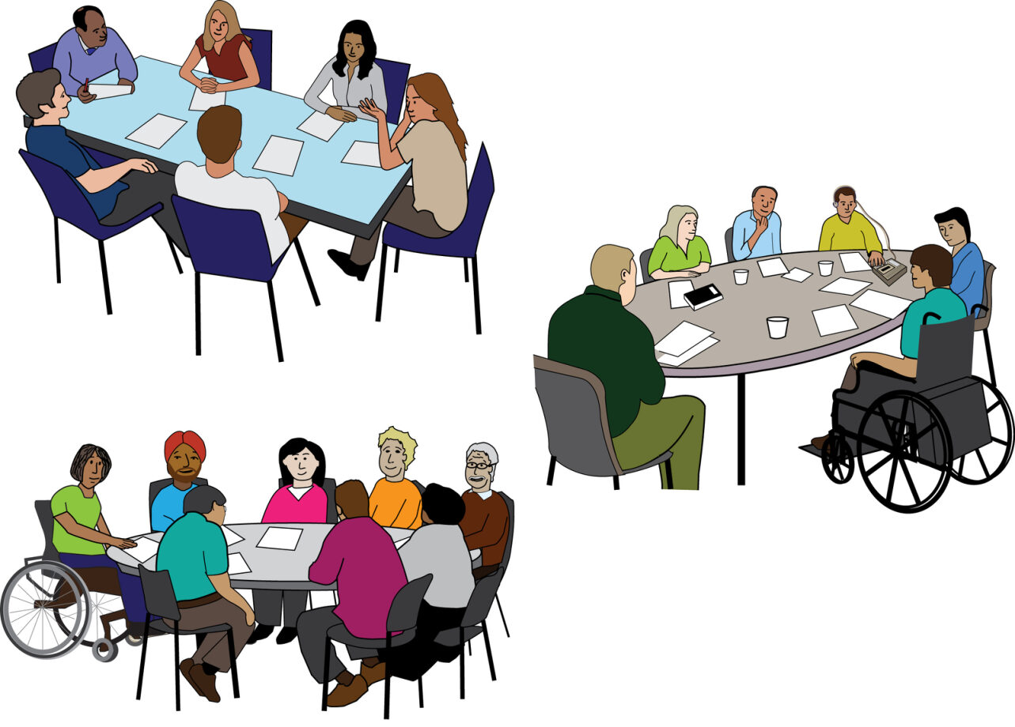
We gave organisation support to 73 people from DDPOs.
We also worked with 21 different DDPOs one-to-one.

We kept working with Charitable Trust funders.
We worked with them to understand disability as a social justice and human rights issue.

This was to help DDPOs be more included in funding decisions.

Some information about our money.

In 2022-2023 we had £1,112,197 come into Inclusion London.
This is more than one million pounds.

We get our money from funding and grants.

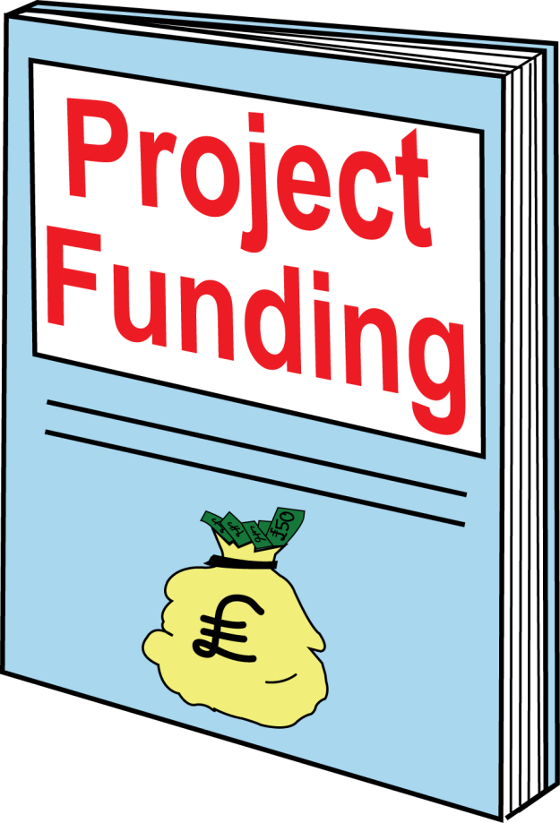
We spent £1,111,926.
That is also more than one million pounds.

We spent our money on running projects, campaigns, and supporting DDPOs.

At the moment, we have £352,113 in our reserves.
This is money we keep in case there is an emergency or something serious happens.

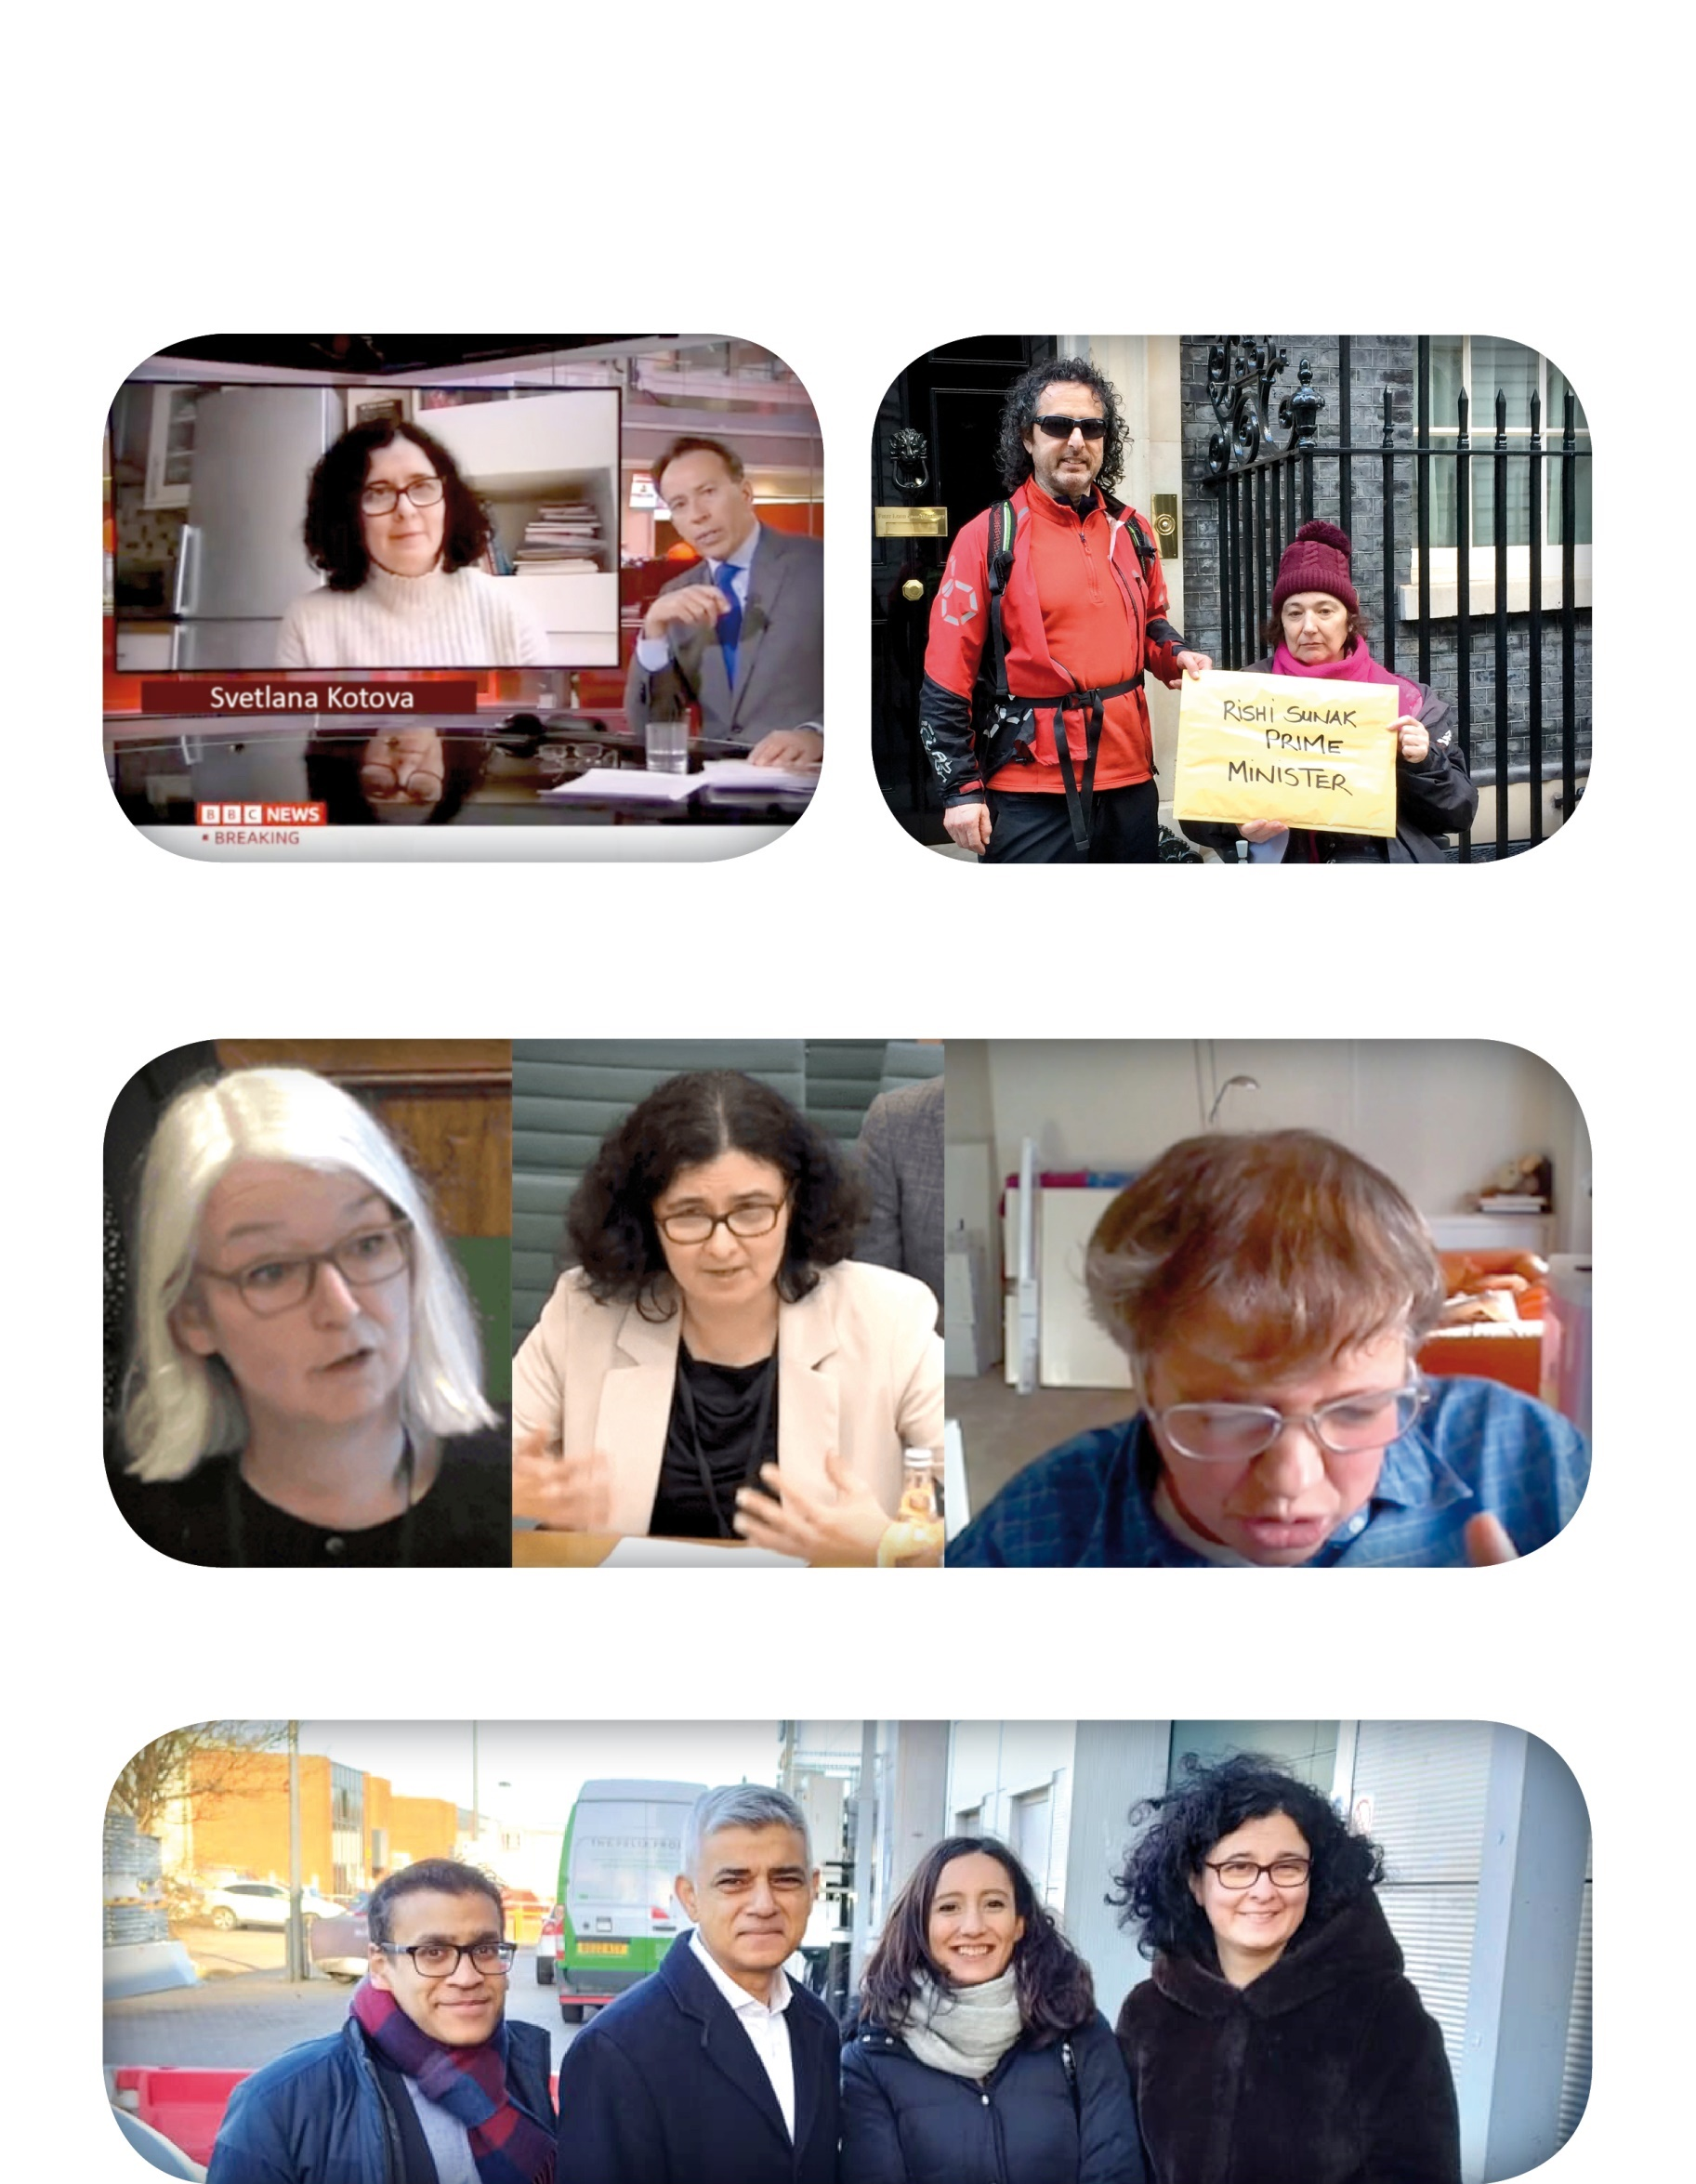
Photographs from 2022-2023

Inclusion London (IL) on the BBC News
Keep guards on trains petition
at No10
ULEZ scrappage launch event
IL staff giving evidence to MPs
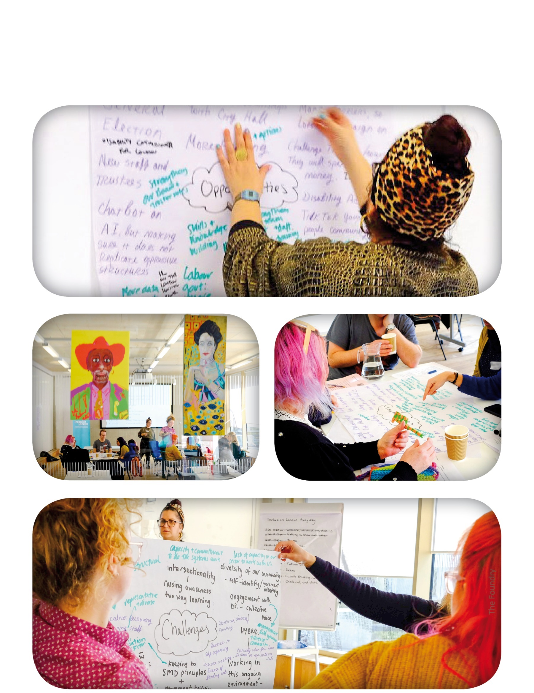
Inclusion London Trustee and Staff Away day:

What people from DDPOs said about our work.

Here are some things people said about our work in 2022 – 2023.

I like all of it—a brilliant place to learn, network and make a meaningful difference to people needing assistance.
DDPO Housing Network

Good to have the space to raise the issues and my understanding and think about the potential to build DDPOs to respond to intersectional barriers.
Intersectionality and anti-racism training

I found the trainer very kind, helpful, patient, mindful. Great knowledge on hate crime
Disability hate crime training

Genuine peer support - people really opened up and talked about fear and difficult stuff.
SVRR Peer network meeting

Fab presentation! Can’t wait to start trialing the DRE (disability related expenditure chatbot) tool! Thanks Inclusion London!
DRE Chatbot training session

Some of the resources and links in this report:

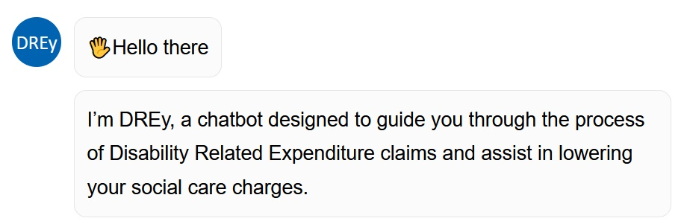
Reduce your social care charges today - Inclusion London

Free Our People Now - Inclusion London

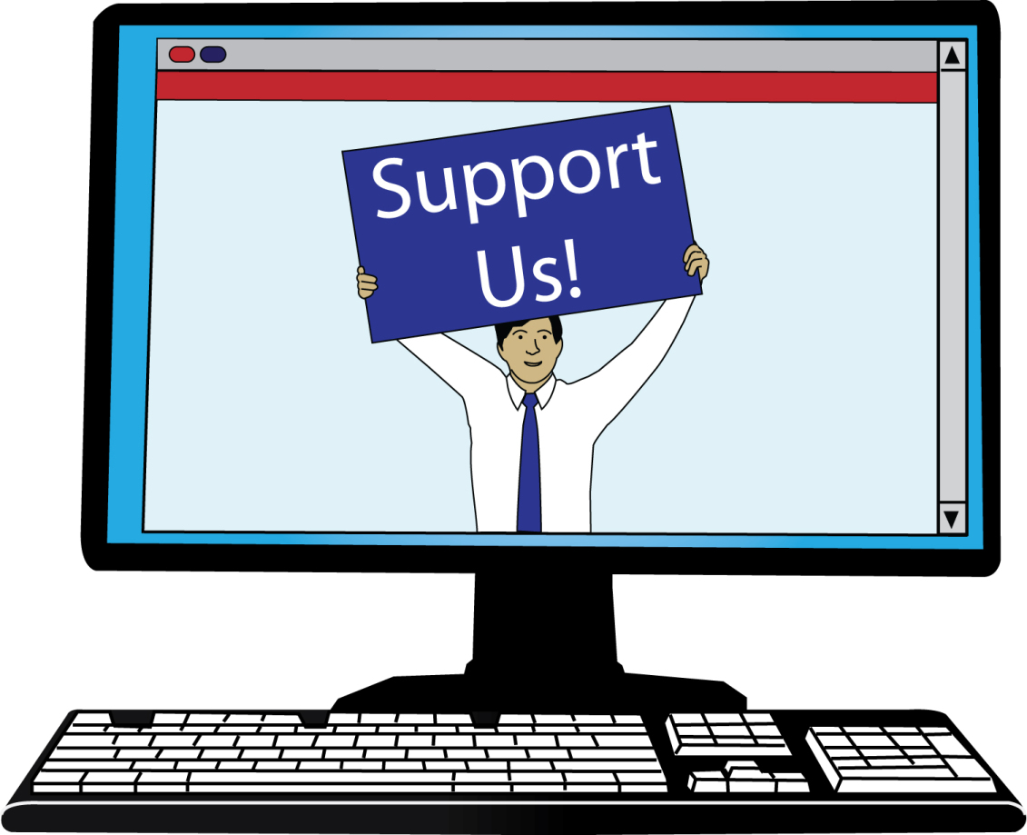

Guide to Campaigning Toolkit - Inclusion London

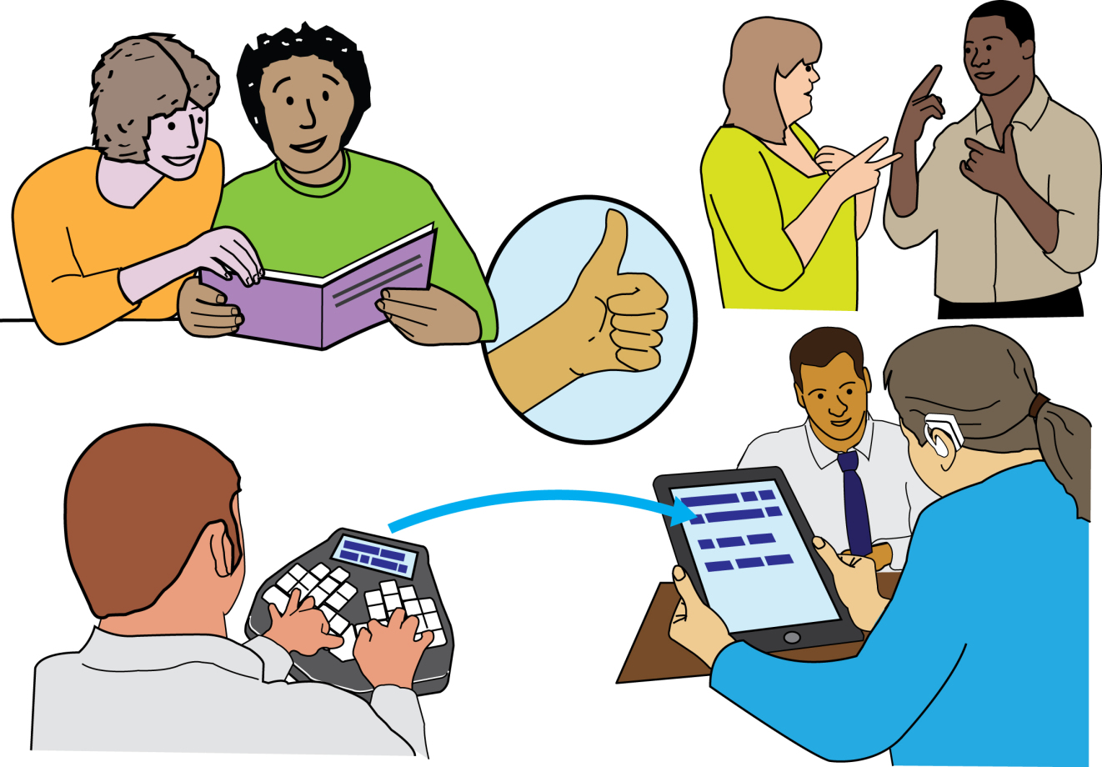

Cornerstone Project: Talking about disability - Inclusion London

Disability, Crime and Hate Crime in the News (Easy Read) - Inclusion London

Inclusion London staff and Trustees in 2022-23

Trustees

Valerie Charbit
Paul Hawkins
Justine Jones (left on 23rd February 2023)
Thomas Adam Lichy
Aisling Gallagher
Adam Gabsi

Our new trustees started on 21st February 2023. They are:
Indigo Rose Fuller Ayling
Natalie Jane South-Law
Kush Kanodia
Stephen Mark Bunbury

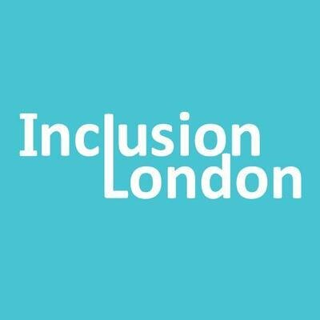
Staff

Staff who have worked at Inclusion London from before 2022 are:
Jon Abrams - Campaigns and Justice Coordinator
Lara Conner - Hate Crime Data and Insight Officer
Christine Hathway - Senior Administrator
Louise Holden - Hate Crime Partnership Project Manager
Svetlana Kotova - Director of Campaigns and Justice
Tracey Lazard - Chief Executive Officer
Ailsa McWilliam - Interim Director of Services and Development
Gelila Tekle-Mariam - Operations Manager
Laura Vicinanza - Policy and Stakeholder Engagement Manager

We had some new staff at Inclusion London in 2022-23. They were:
Simone Aspis - Free our People Now Project Manager
Rensa Gaunt - Media and Communications Officer
Mark Drinkwater - Communications Manager
Mariella Hill – Policy and Campaigns Officer

And we had some staff leave Inclusion London in 2022-23. They were:
Jumoke Abdullahi - Communications and Media Officer
Priscilla Eyles - With Us Project Coordinator
Julia Modern - Senior Policy & Stakeholder Engagement Manager
Sian Williams - Making It Work Project Manager

List of funders

Thank you to our funders for their support.
City Bridge Trust
Trust for London
Oak Foundation
National Lottery Community Fund
Greater London Authority
The Three Guineas Trust
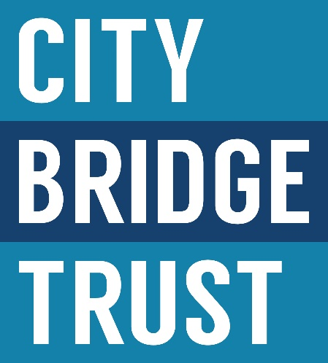
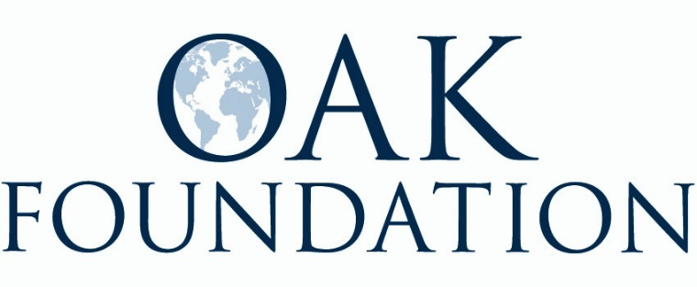
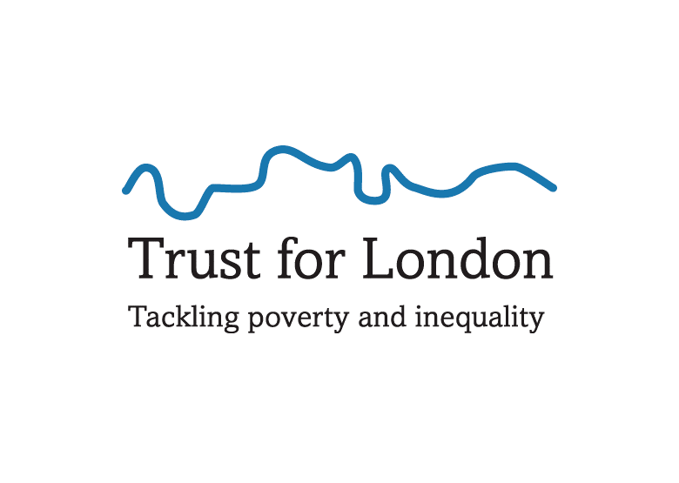
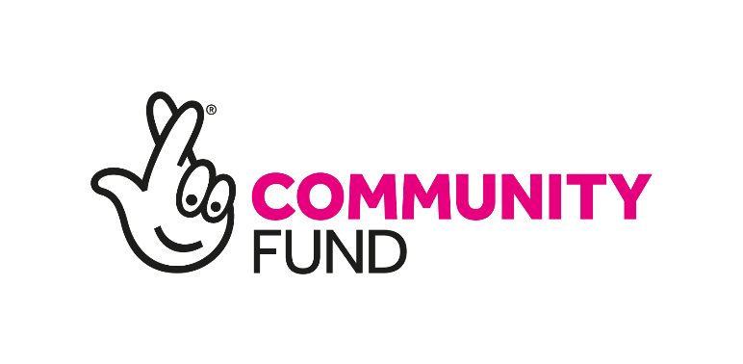

DDPOs - become a member

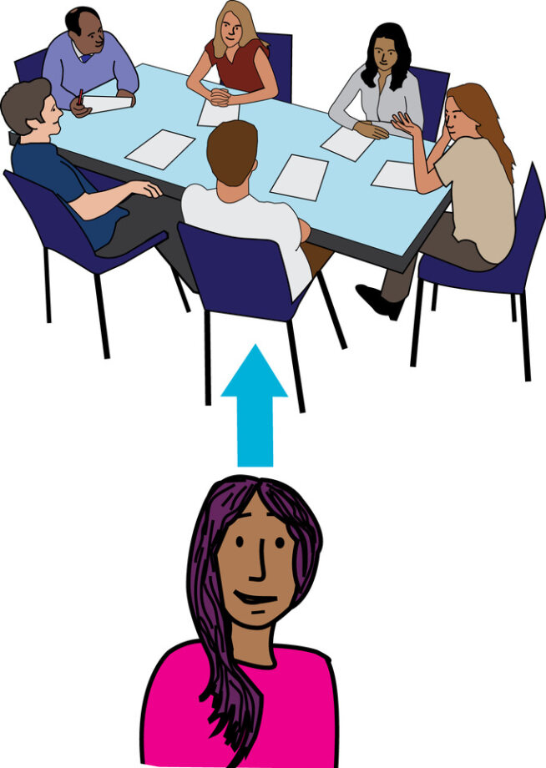
Your DDPO can join our community members if you want.
As a member you will be able to get our resources and help decide on the work that we do.

We also have a Deaf and Disabled People’s Organisations Noticeboard.
On this online noticeboard you can tell people news or information.
You can also post events and advertise jobs or roles at your organisation.

Sign up at:
http://www.inclusionlondon.org.uk/membership

In this report, we use images from:
People First Ltd, Bromley X by X, and Photosymbols.
We paid to use these images.

MissLunaRose12 from Wikimedia Commons.
This image was free to use with credit.

