Inclusion London’s Annual Report
April 2022 to March 2023
Projects Report - Easy Read

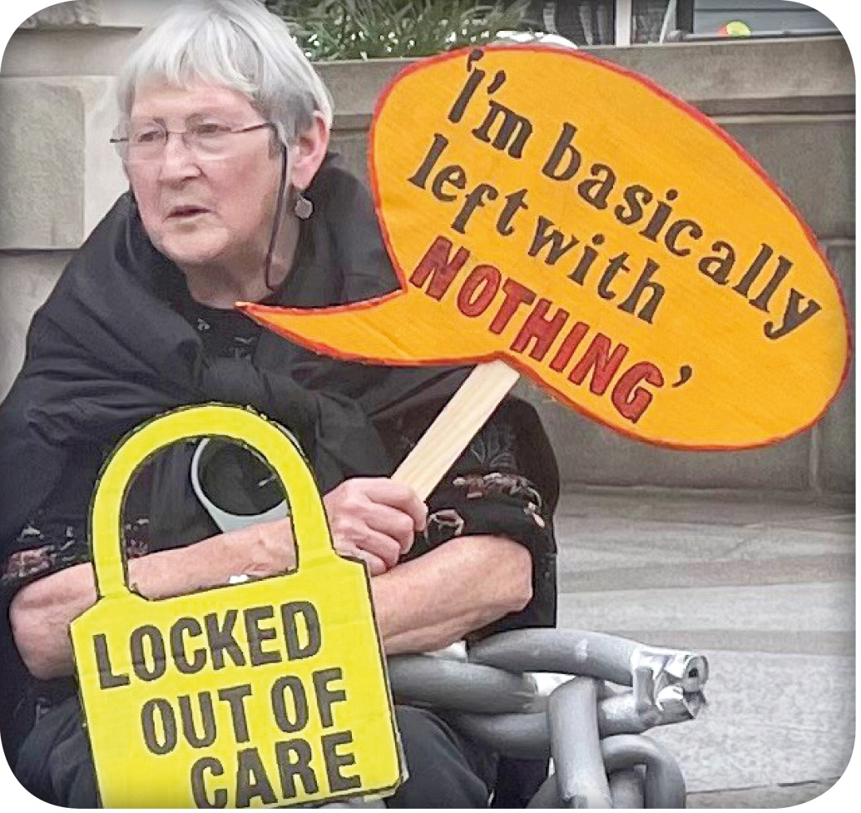

336 Brixton Road, London SW9 7AA
info@inclusionlondon.org.uk
020 7237 3181
07718 394 687
www.inclusionlondon.org.uk

Registered Charity number: 1157376.
Company registration number: 6729420.

Disabled people

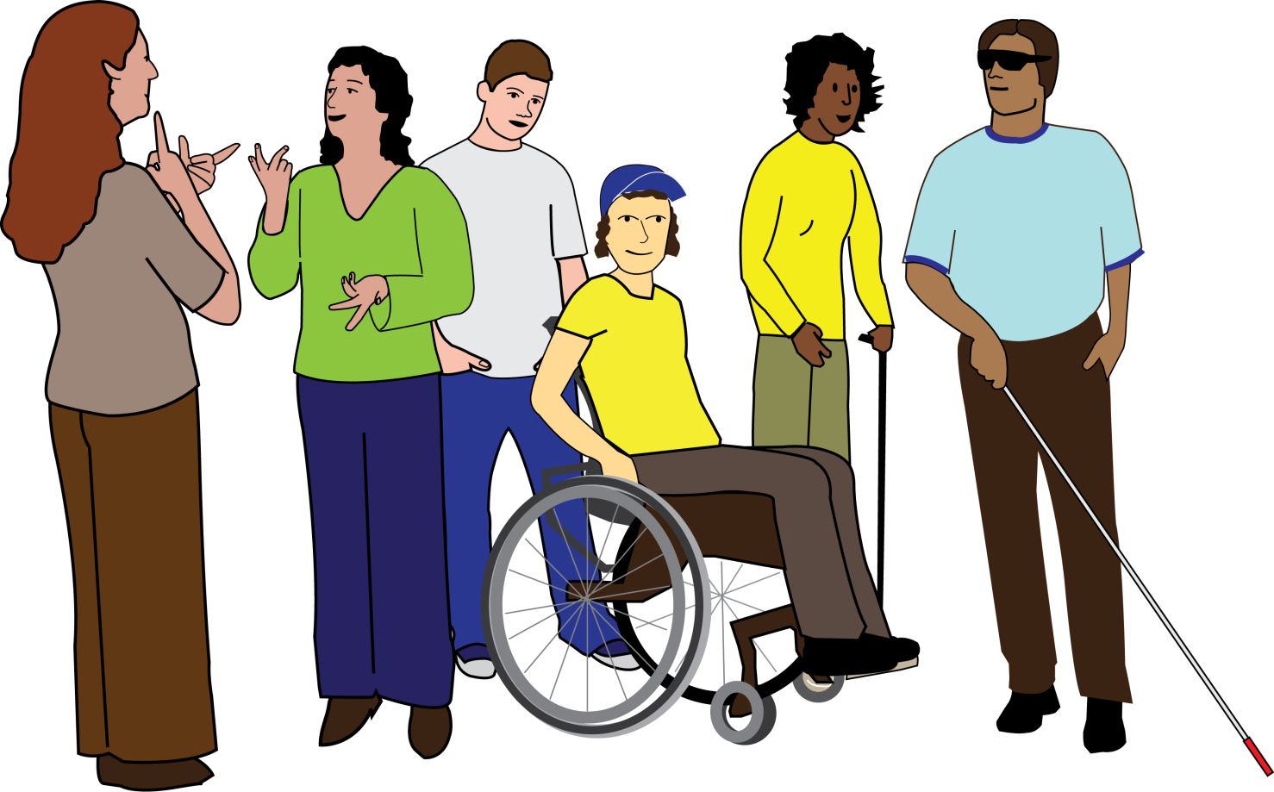
Inclusion London use the words ‘Disabled people’ to mean all people living with impairment.

This includes:
• People with physical impairments
• People with visual impairments
• Deaf people
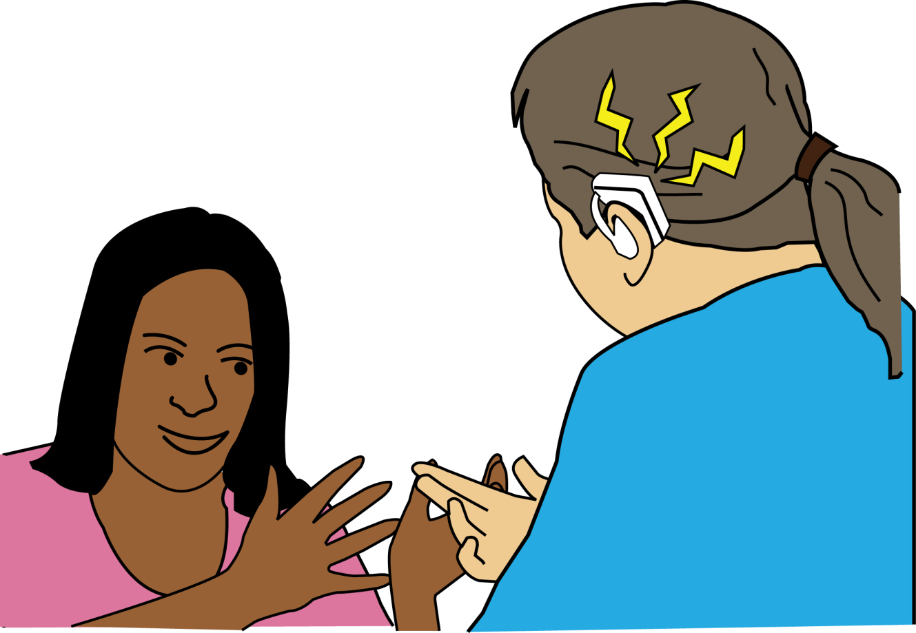
• People with hearing impairments
• People with learning difficulties
• People who experience mental health difficulties
• People with long term health conditions
• People who are neurodivergent
• People with invisible impairments

Our campaigns, justice, and policy work

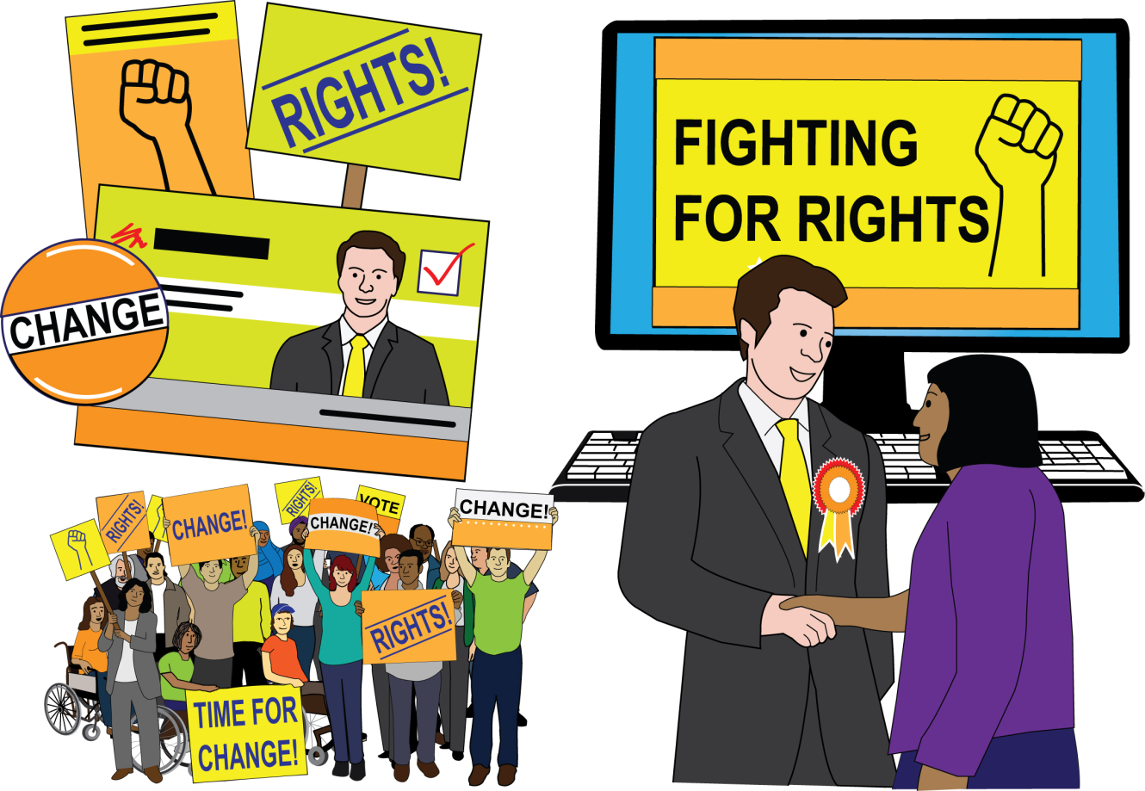
Here are some of the things our campaigns, justice, and policy teams have done between April 2022 and March 2023.

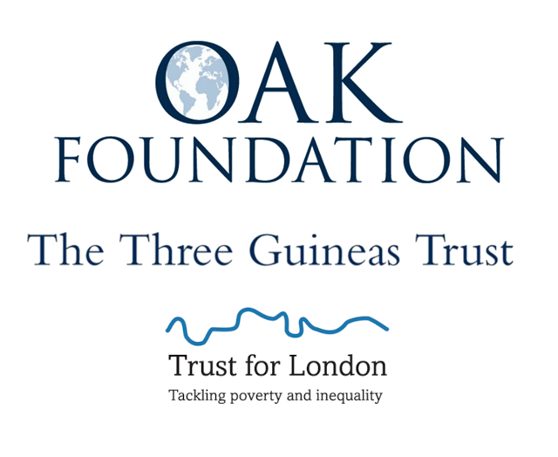
This work was funded by Trust for London, Three Guineas Trust, and the Oak Foundation.

Housing

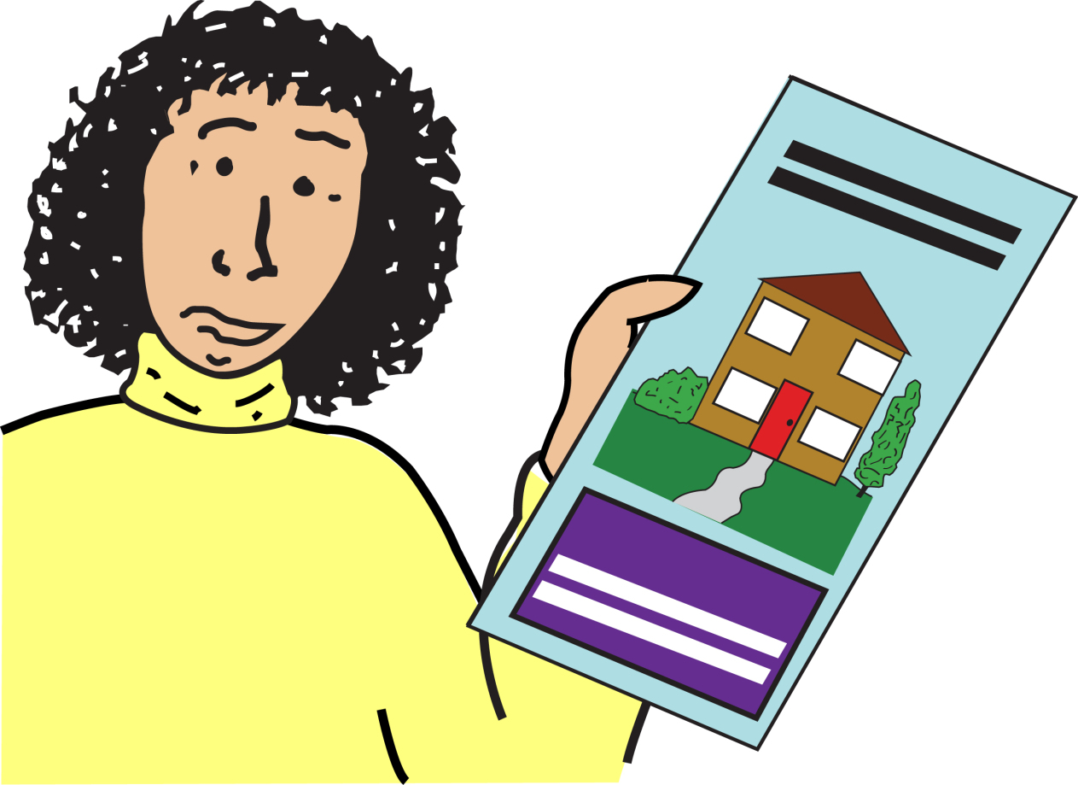
We set up our Housing project.
We gave support and funding to three campaigns led by Deaf and Disabled People’s Organisations (DDPOs).

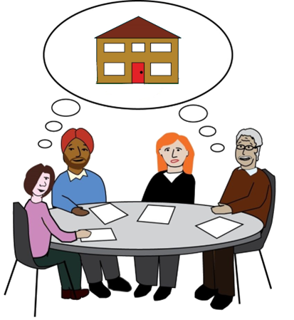
We also set up the DDPO Housing Network and got representation on the Greater London Authority Housing Panel.

Social care/independent living

We led on the ‘scrap care charging’ campaign coalition.

A coalition is when different groups work together for a certain reason.
Our groups are all working together to get rid of care charging.

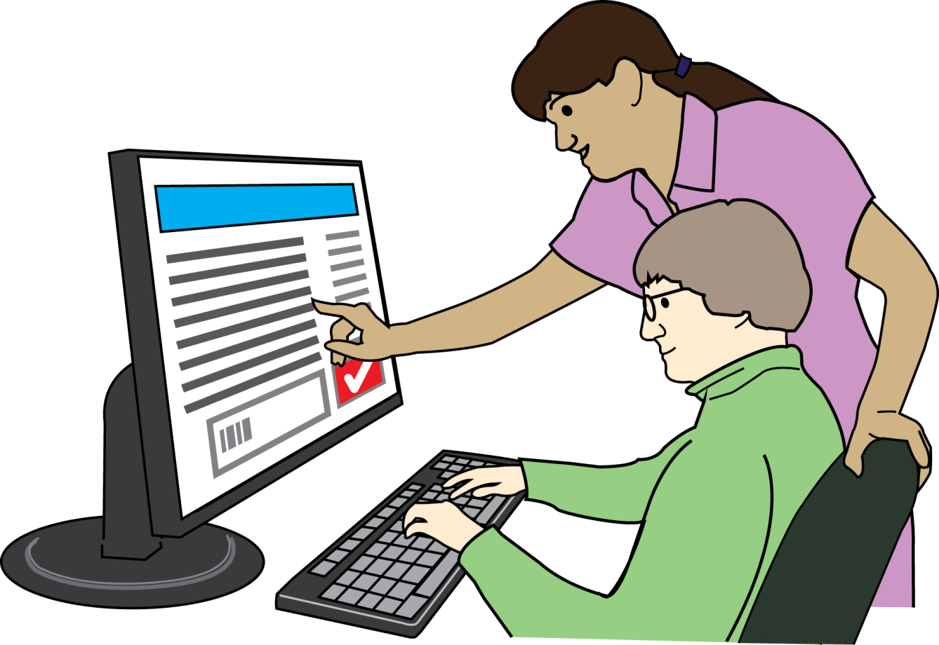
We worked with people to make our Disability Related Expenditure chatbot.

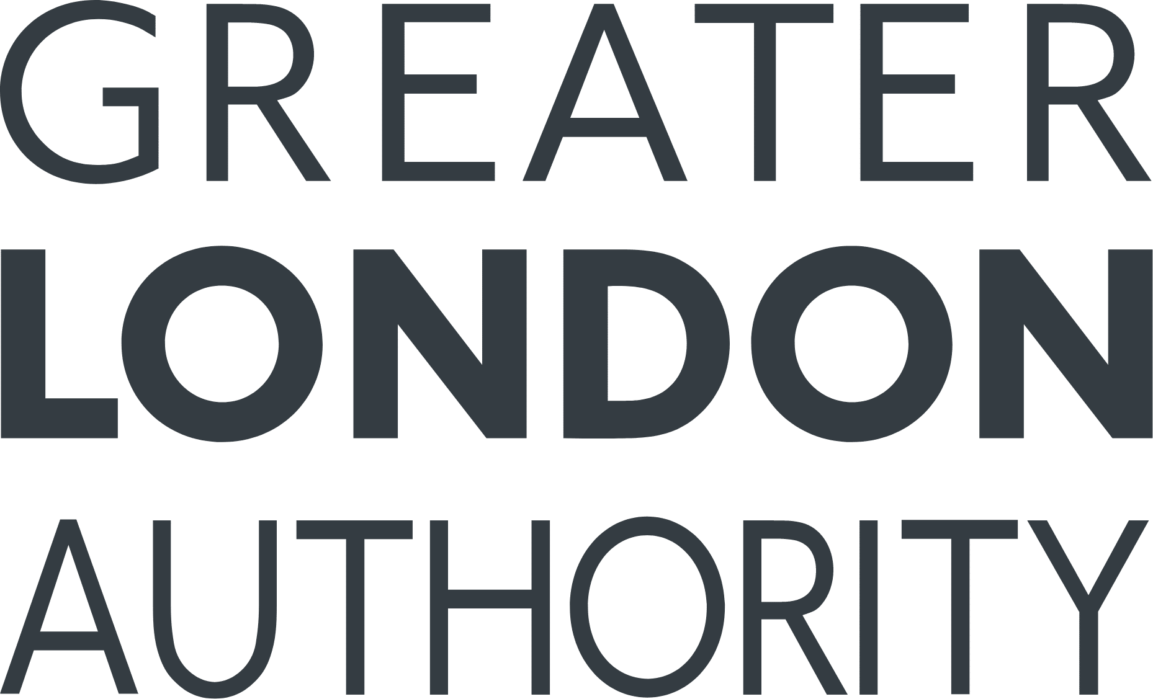
This was funded by the Greater London Authority.

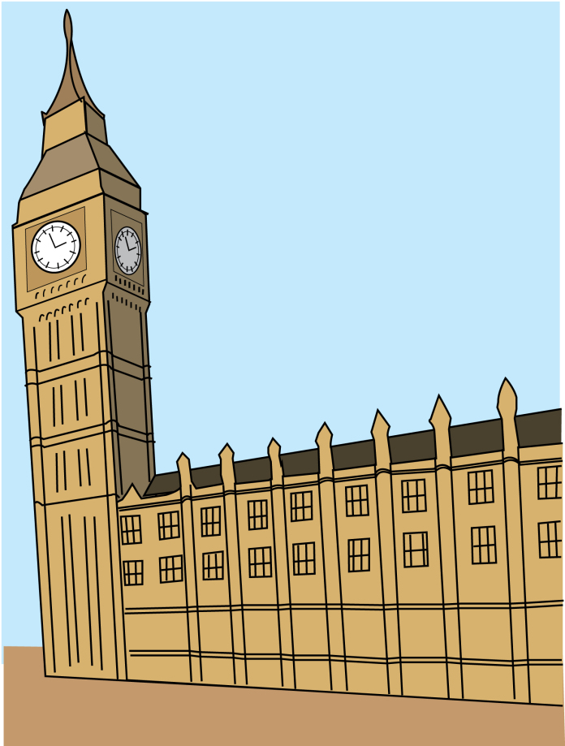
We lobbied the government to increase Minimum Income Guarantee.
The government made some increases. Social care users kept more of their money.

Lobbied means trying to get people in government to do something.
This can be supporting your ideas or plans. People do this to change laws or decisions.

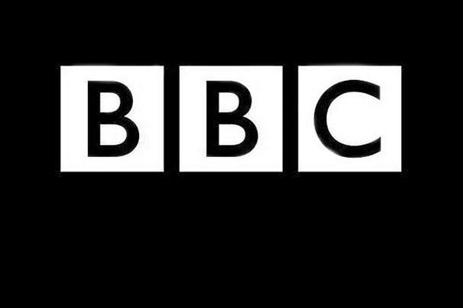
We researched social care charging debt in London.
We used our research to convince the BBC to do an investigation across England.

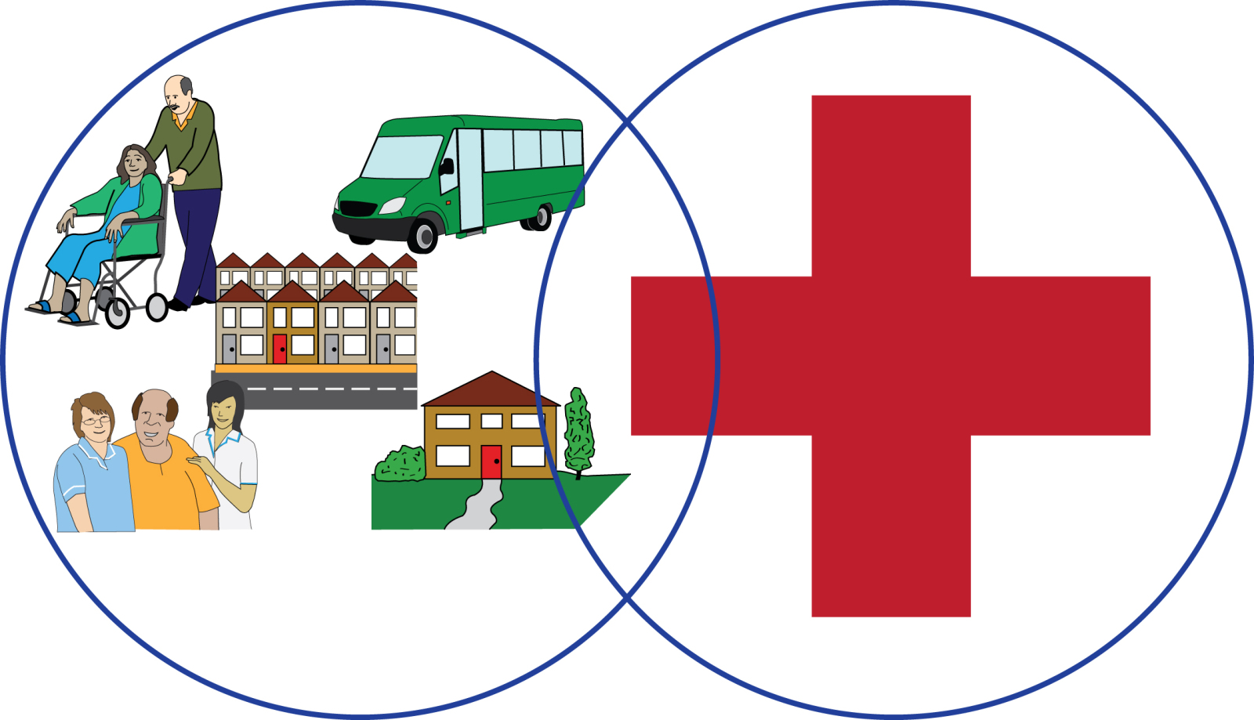
We gave evidence about social care.

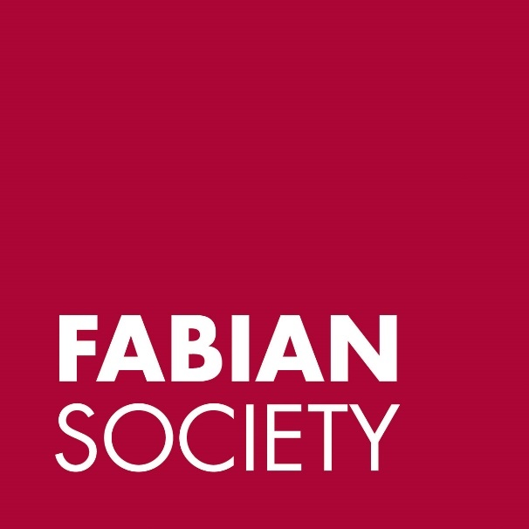
We ran meetings between the Fabian Society and the national DPO forum.
This was so DDPOs could be heard by the Labour party.

Poverty and cost of living crisis
We worked with Disability Rights UK to set up the Disability Poverty Campaign Group.

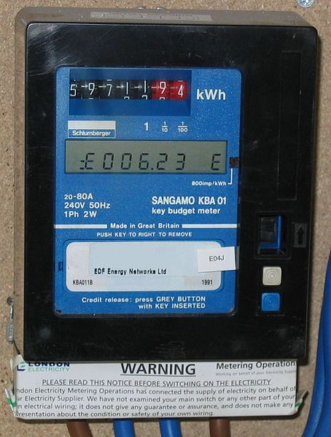
We co-led a campaign to ban making people have pre-payment meters in houses with a Disabled person.

Ofgem made some changes to stop this happening for some Disabled people.

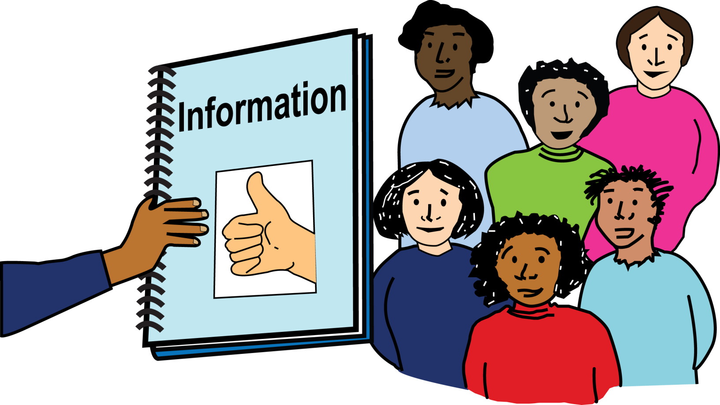
We made and shared information for the cost-of-living crisis.
We used this information to push for change in government policy.

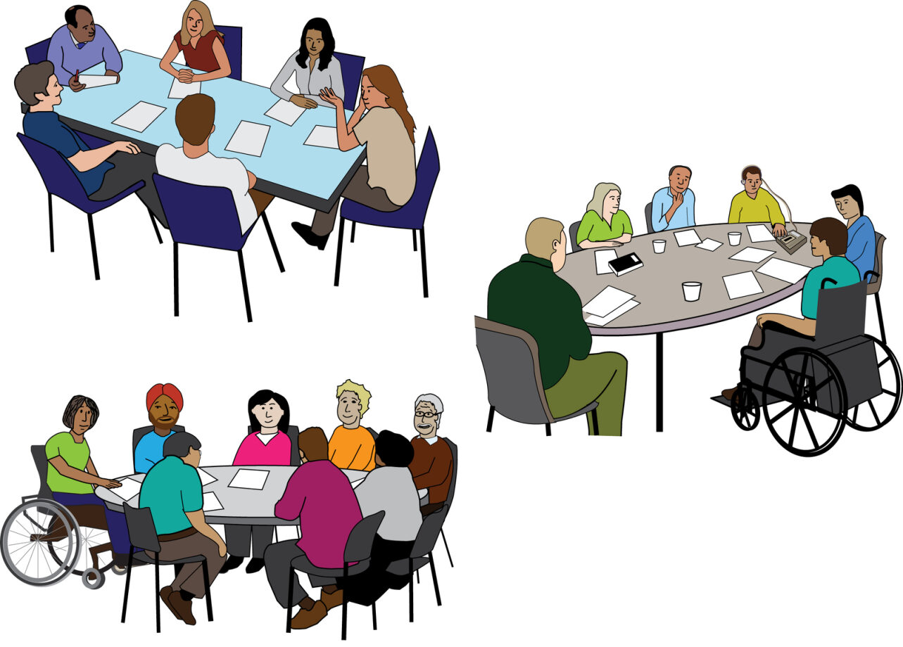
We ran meetings with the government’s Disability Unit about the cost of living and DDPOs.

Working with the Government and Planning with DDPOs

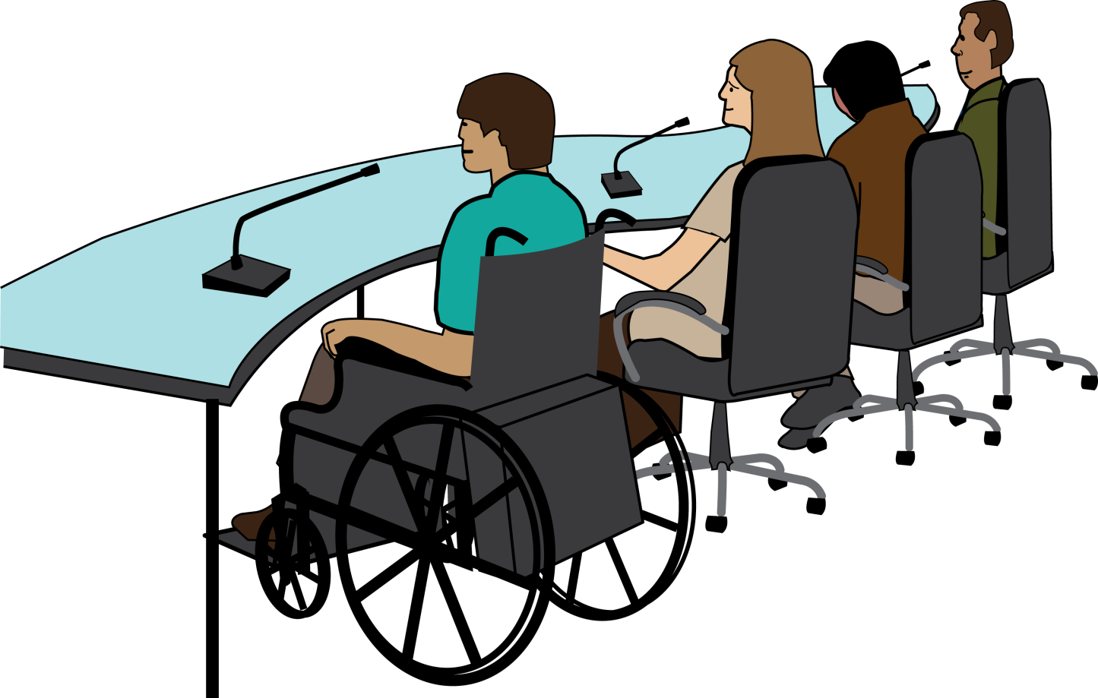
We spoke at different government groups and meetings to give evidence.
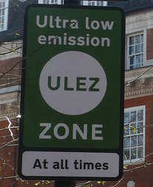
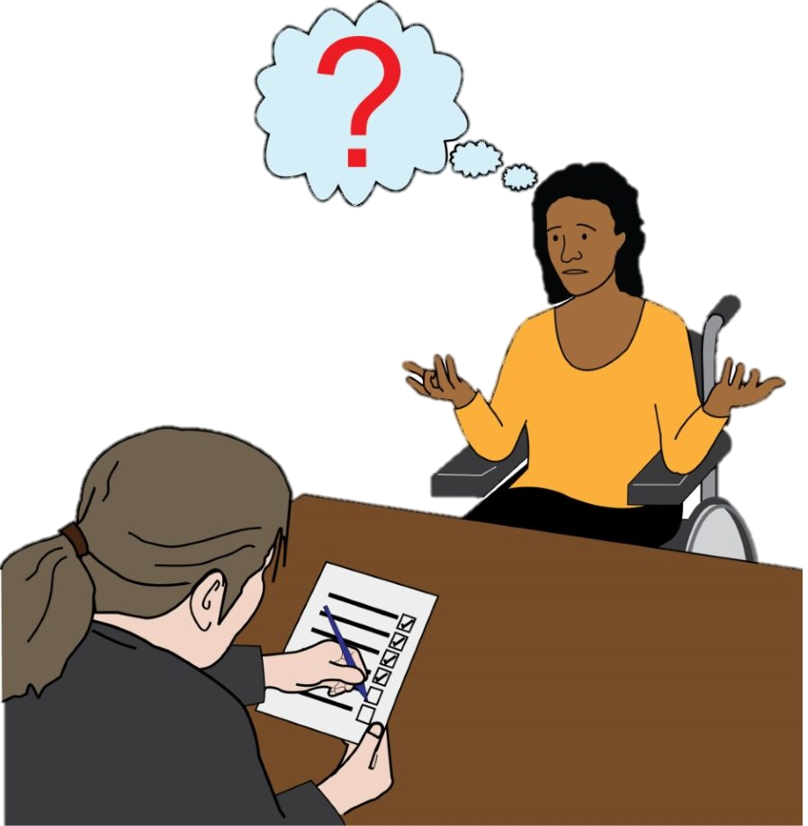

We talked about the Ultra Low Emissions Zone, National Disability Strategy, and disability benefit assessments.

The Ultra Low Emissions Zone covers all of London.
If people have a car or other vehicle that makes a lot of air pollution, they must pay money to drive in the Ultra Low Emissions Zone.

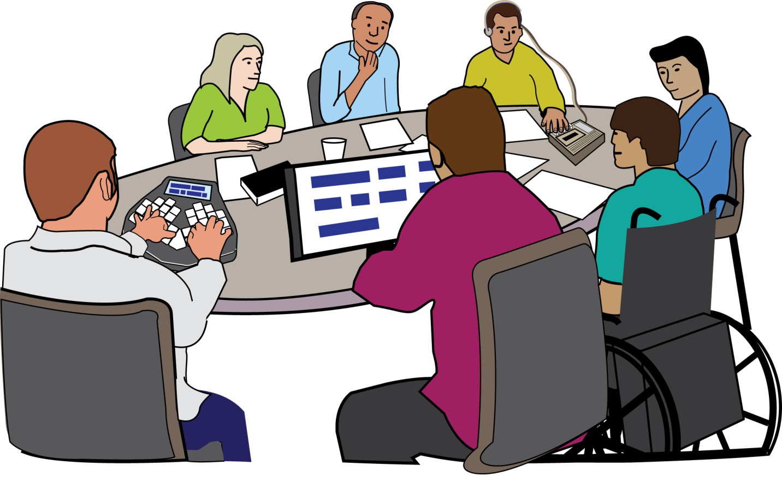
We ran meetings for the national DPO Forum England.

At these meetings, DDPOs can work together on campaigns, issues, and policy responses.

We supported the DPO forum to lobby the Minister for Disabled people and the Disability Unit.
We wanted them to meet with DDPOs more often. Now they do.
We help DDOs prepare for these meetings.

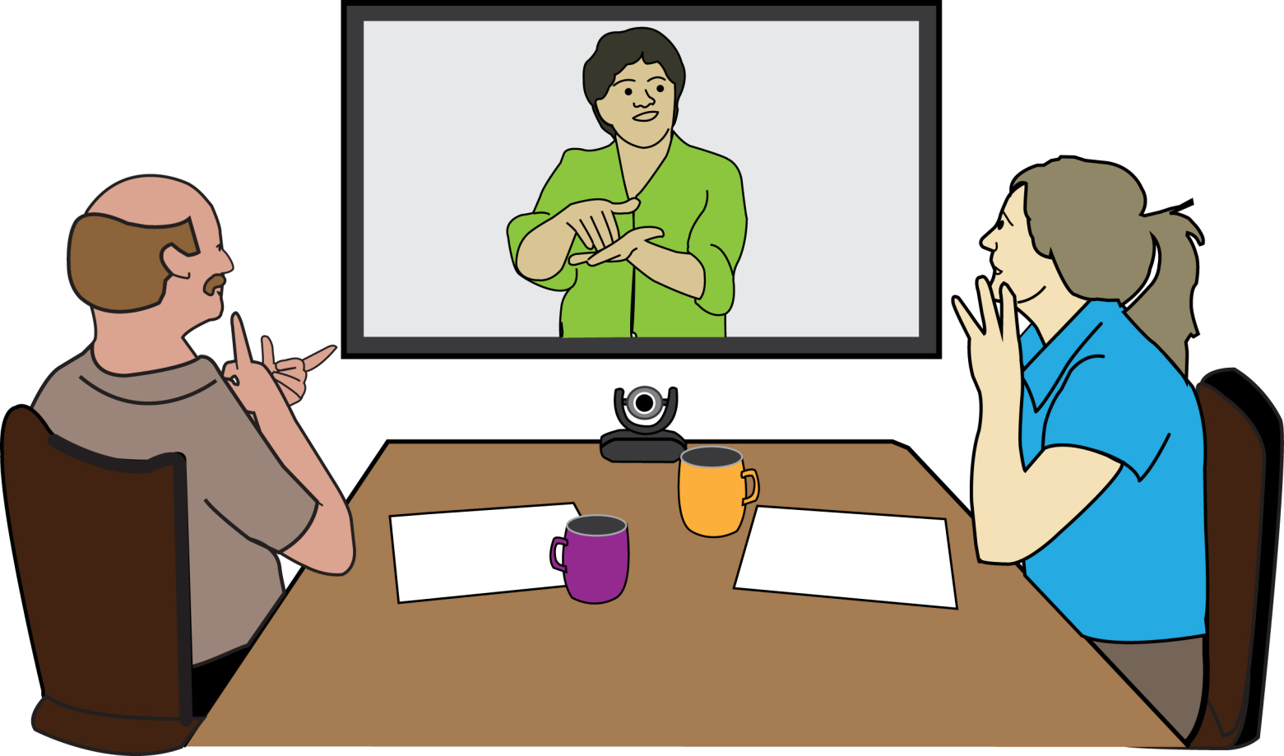
We are still supporting the DDPO forum with the Greater London Authority.

Forums are like regular meetings. People come together to talk about important matters and how to solve problems.

A few other things
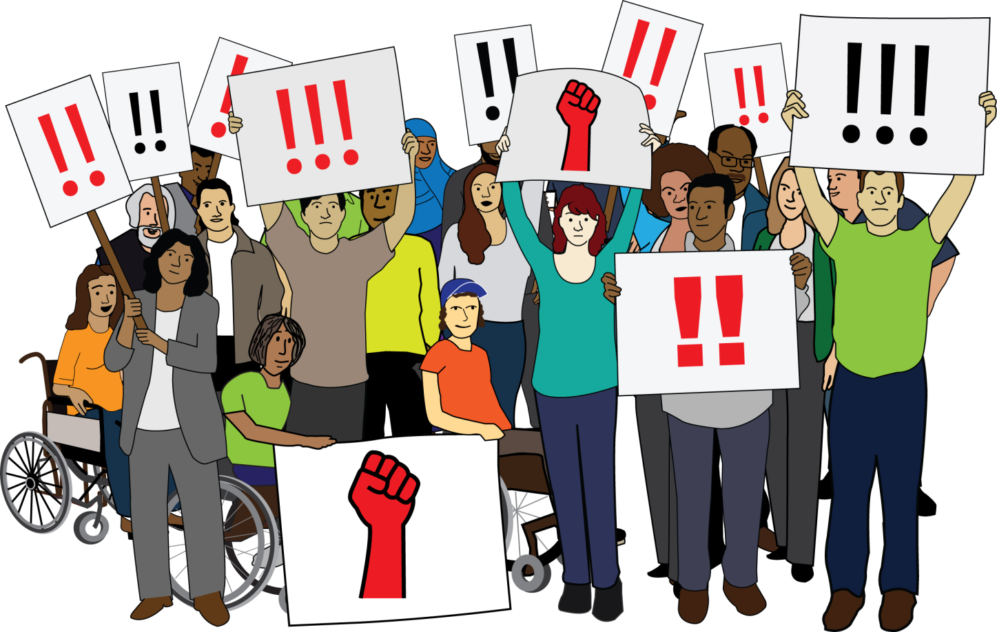
We ran a campaign leadership programme for Disabled activists.
We supported the London campaign forum for activists.

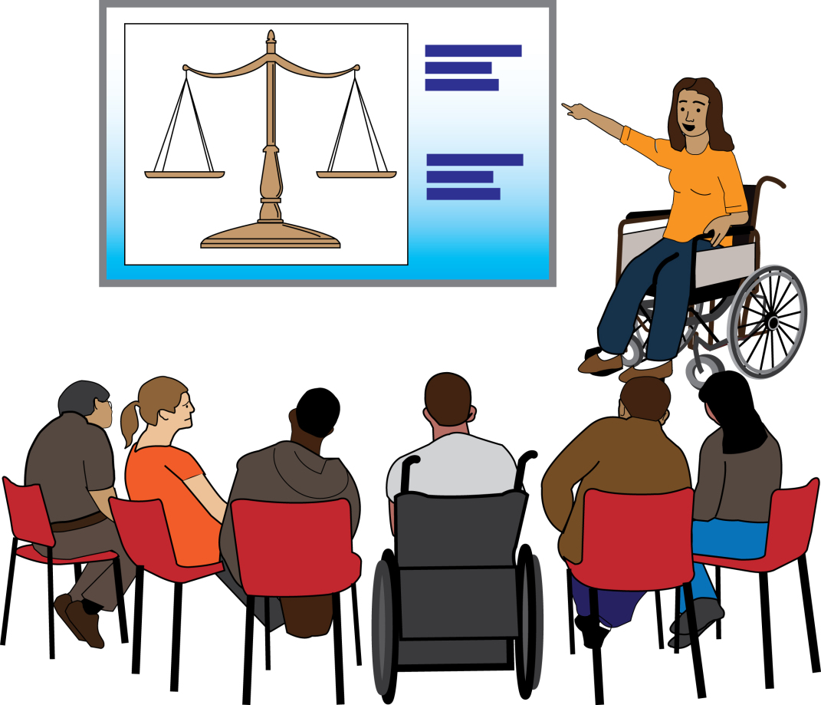
We ran 50 events, including training, briefings, and forums.

Our work to make London DDPOs stronger
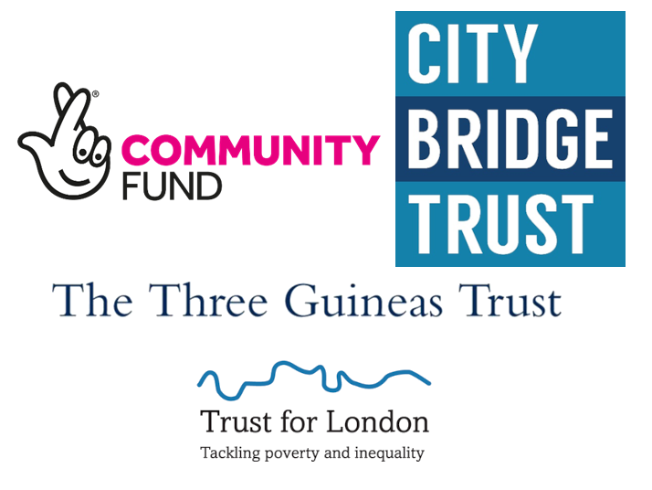
Here are some of the things our teams did to help London DDPOs.
This work was funded by Trust for London, Three Guineas Trust, City Bridge Trust, and the National Lottery Community Fund.

DDPO Organisation Support
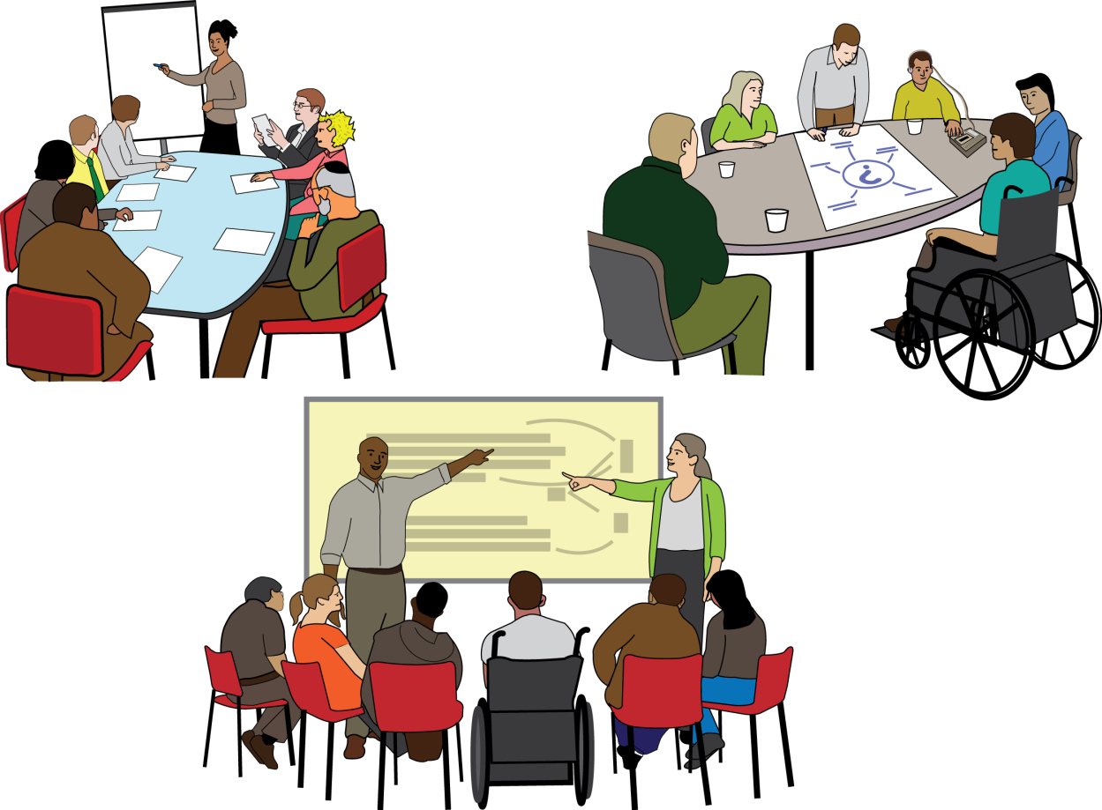
We ran 9 training workshops for DDPOs.
We gave 175 hours of advice, information, and coaching support to DDPOs.

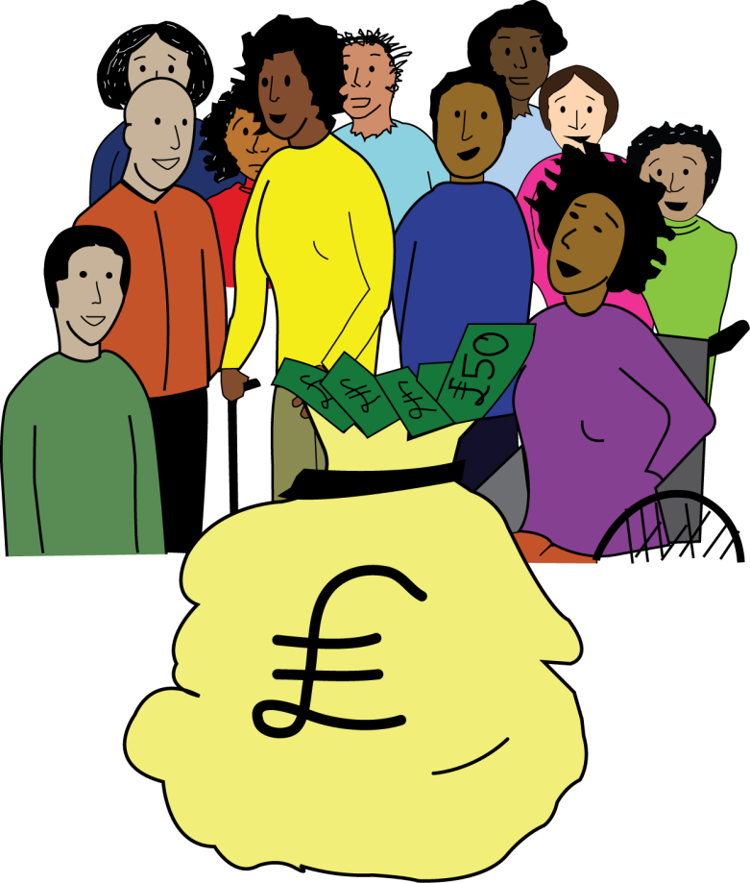
We supported 5 DDPOs to get £700,000 in funding from Propel.
This will mean more Disabled people in advice work in DDPOs.
It will help them stay in our sector.

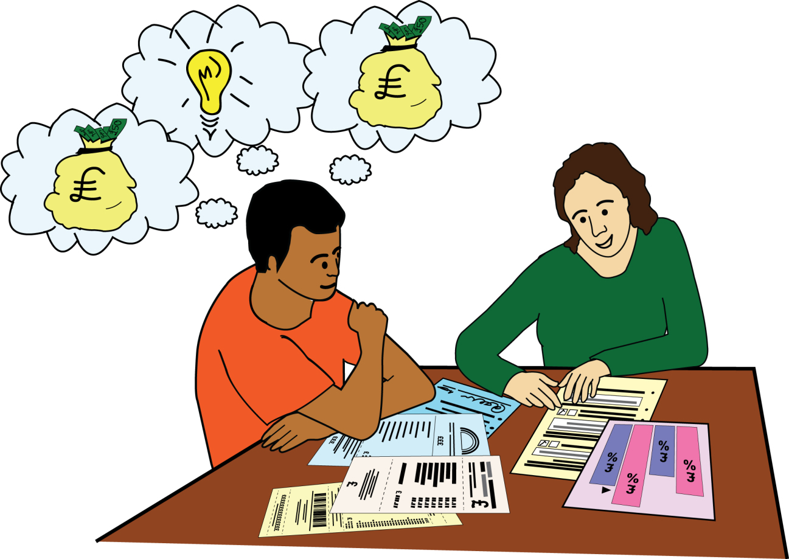
We gave funding advice and support to more than 40 DDPOs.
We ran our new DDPO organisational Health Check for the first time.

‘Strengthening Voices, Realising Rights’ (SVRR) capacity building support

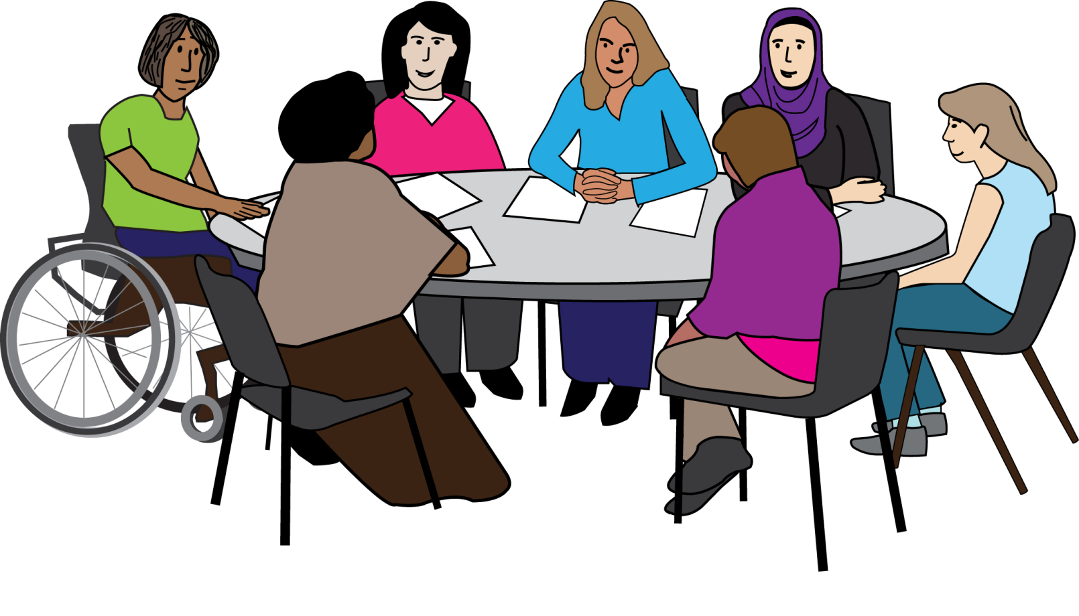
We ran 15 training courses and peer network meetings.
176 people from DDPOs came to them.

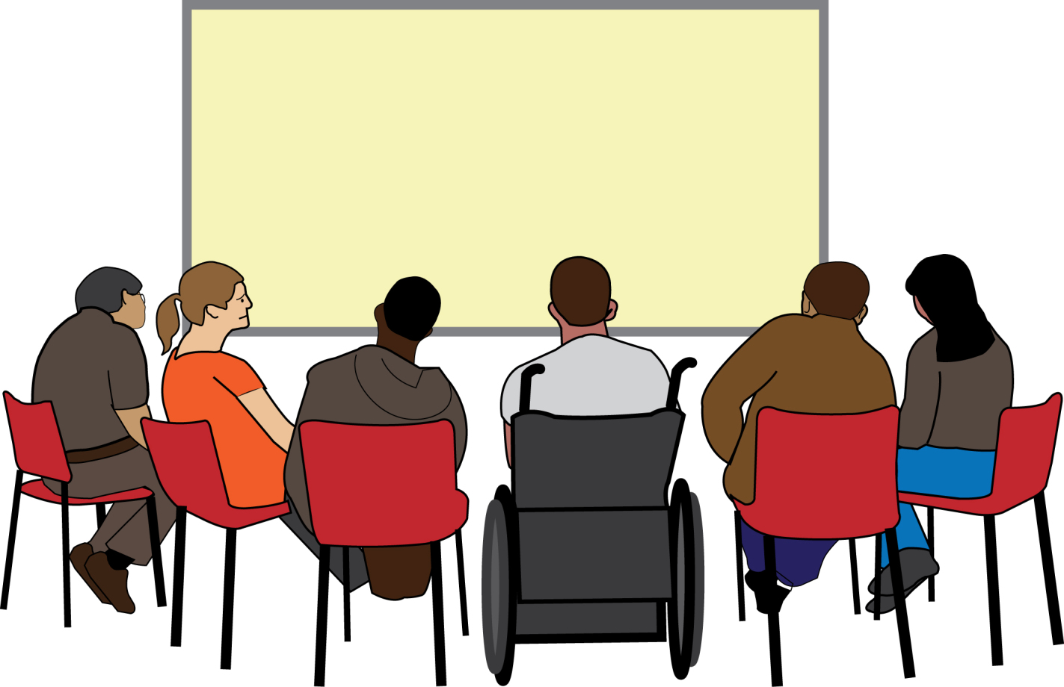
We ran training on advice service skills and advice subjects.

Cornerstone: Talking about disability project
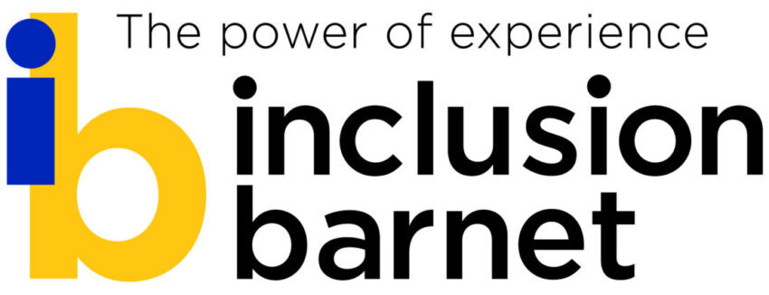
Along with Inclusion Barnet, we set up the ‘Talking about disability’ project.

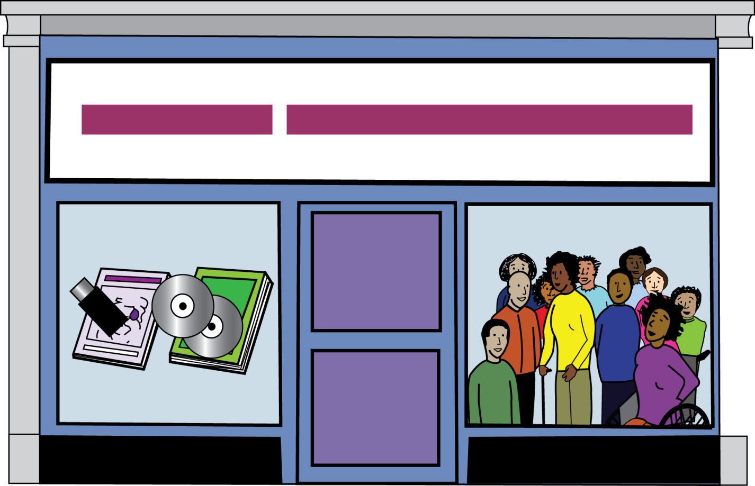
Equally Ours and six DDPOs are working on this, too.
The project is to help change the way people think and talk about disability.

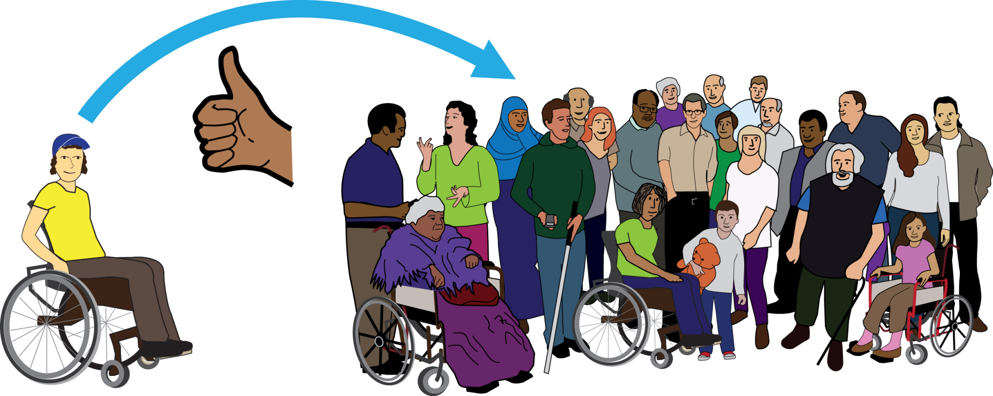
We want more people to help make society more inclusive and accessible.
We also want people to know more about DDPOs and what we do.

We ran four workshops to get our DDPO partners ready for the project.

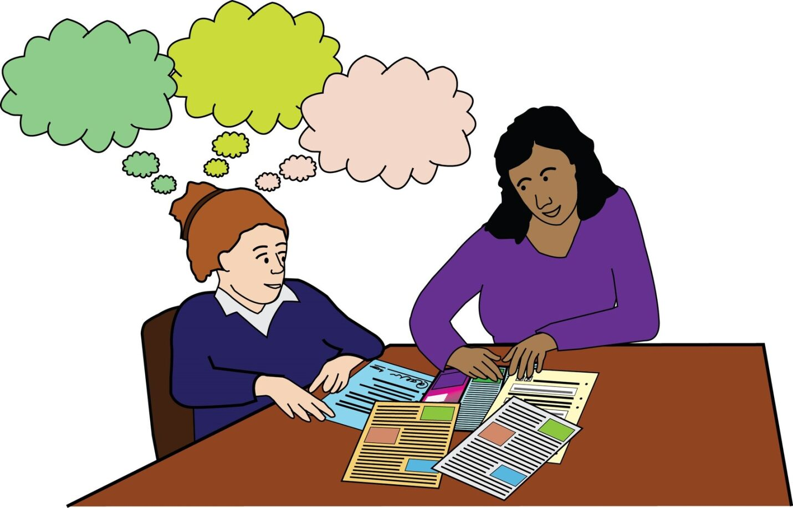
We did research on three things.
The first was about how disability is talked about in newspapers and parliament.
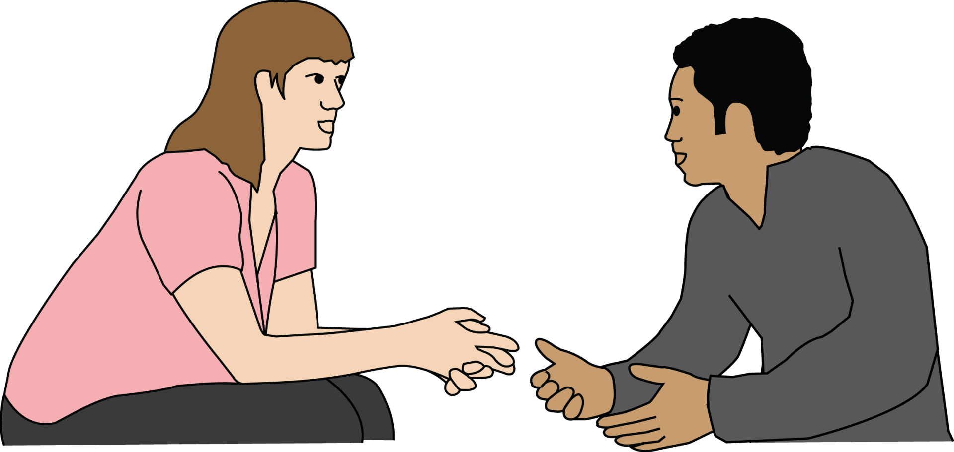
The second was about the main ways people talk about disability in the UK.
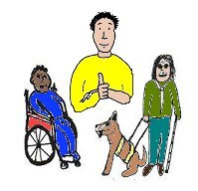
The last one was about different ways we could talk about disability.

We supported Equally Ours with the report on the work the project has done.

London DDPO Hate Crime Partnership
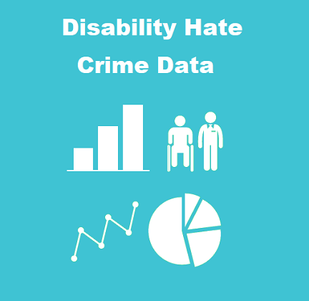
We kept working on our Disability hate crime data project.
We learnt how to make things better from our six-month report.

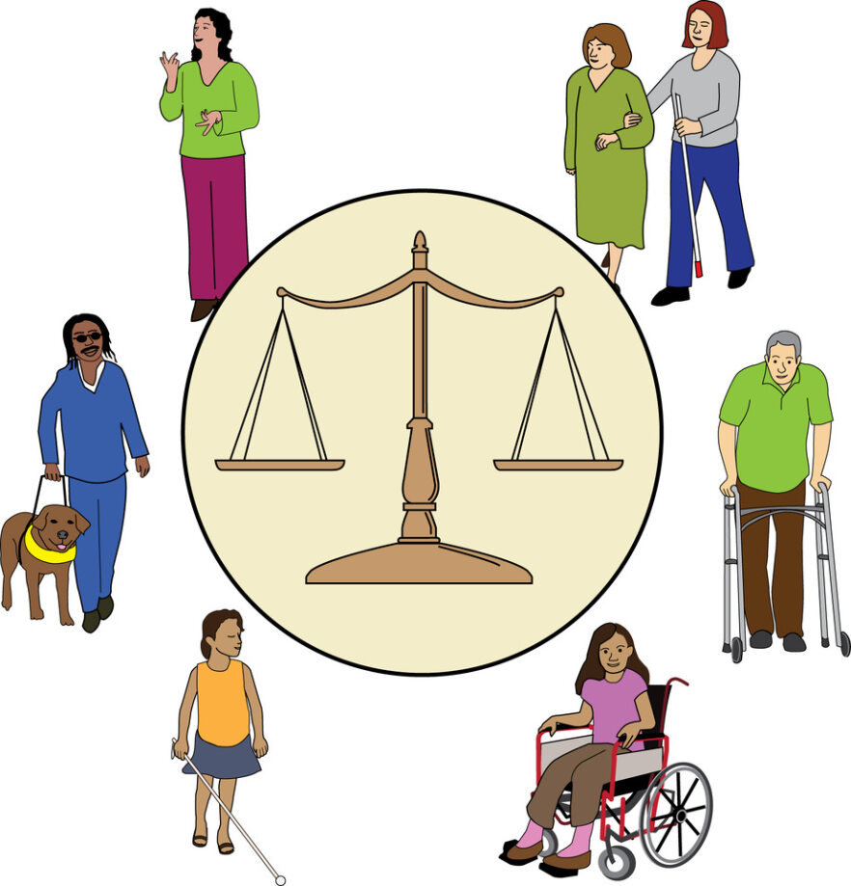
We used this research for campaigning, trying to change policy, and pushing for change in the criminal justice system.

We researched barriers in the criminal justice system for Disabled victims of hate crime.
We gave advice to the Metropolitan Police on how to make access better and easier.

We ran London DDPO Hate Crime Partnership meetings.
At these, DDPOs could talk about their work and get support.
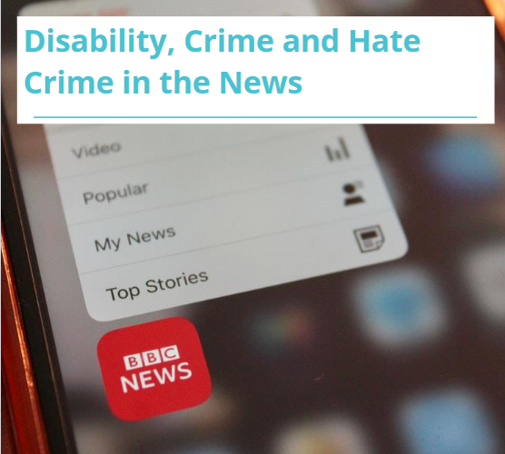
We wrote the ‘Disability, Crime, and Hate Crime in the News’ report.
This looked at how the news talked about crime when a Disabled person was involved.
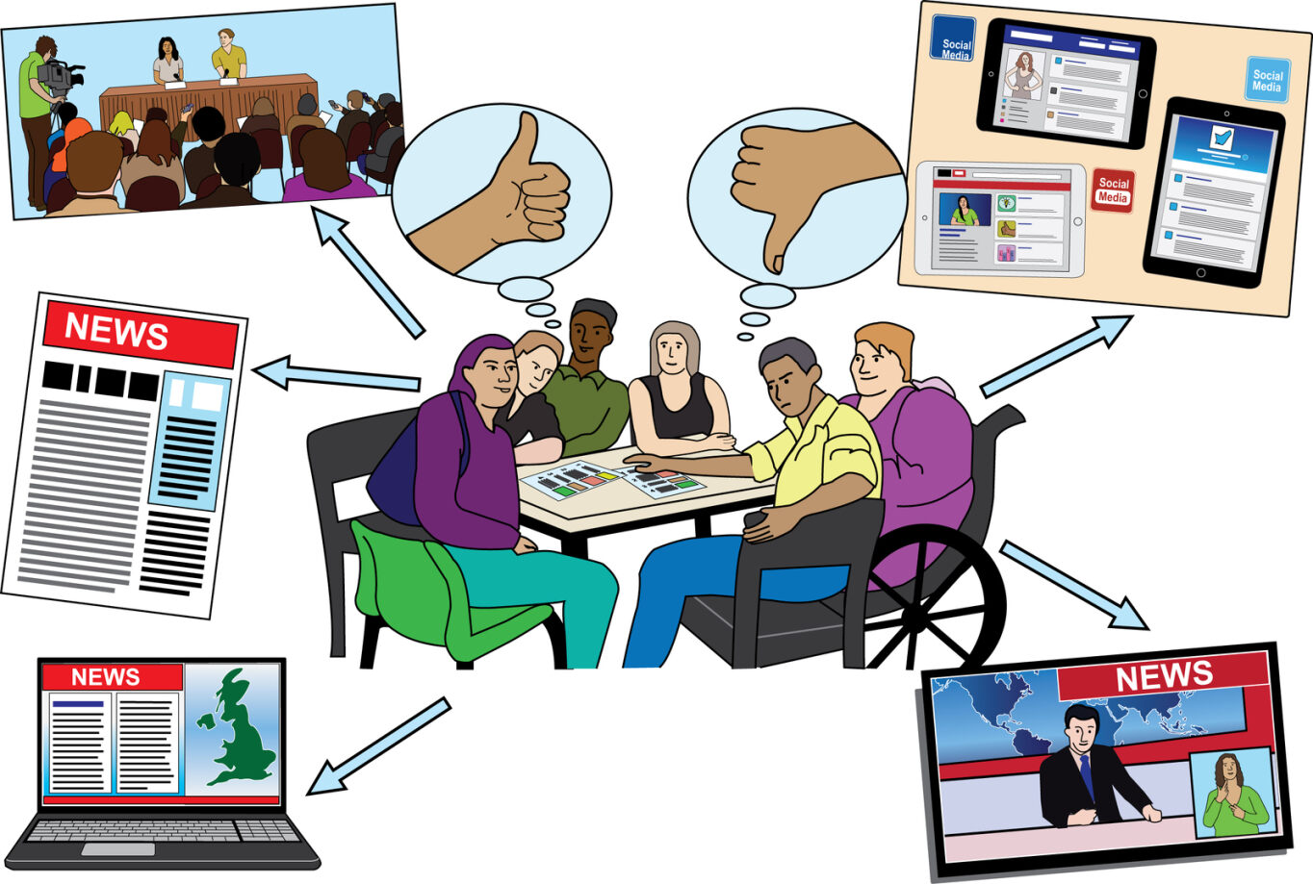
We gave journalists advice about avoiding disablism and being respectful to Disabled victims.

We wrote lots of advice for DDPOs on getting funding for Hate Crime advocates.
We campaigned about how important Hate Crime advocates are.

We went to the Metropolitan police consultation forums.
We ran an event called "Women, Disability, and Hate Crime" as part of Rene Cassin’s Judith Social Justice Series.

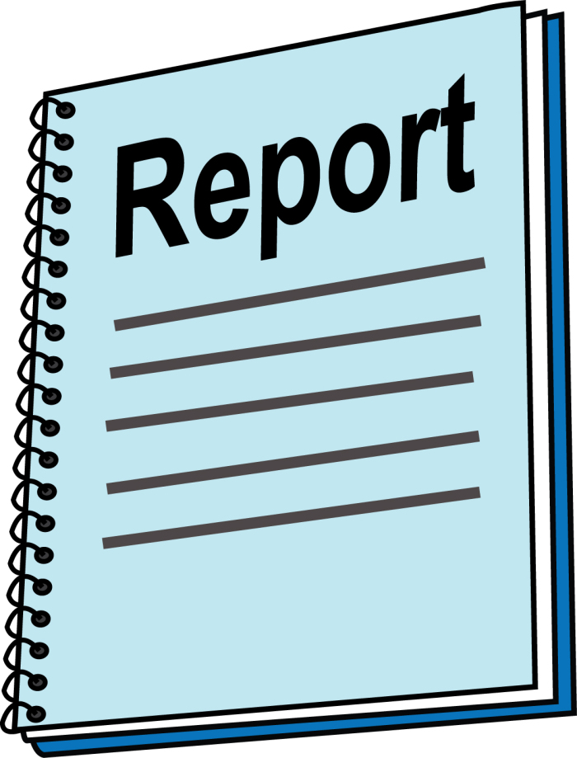
We wrote a Hate Crime Advocacy Qualification and Training Research report.
We also wrote a report for Hate Crime Advocate Posts at DDPOs.
This was based on the partnership’s capacity-building project.

We were part of the Victim’s Law Consultation and gave our expert thoughts.

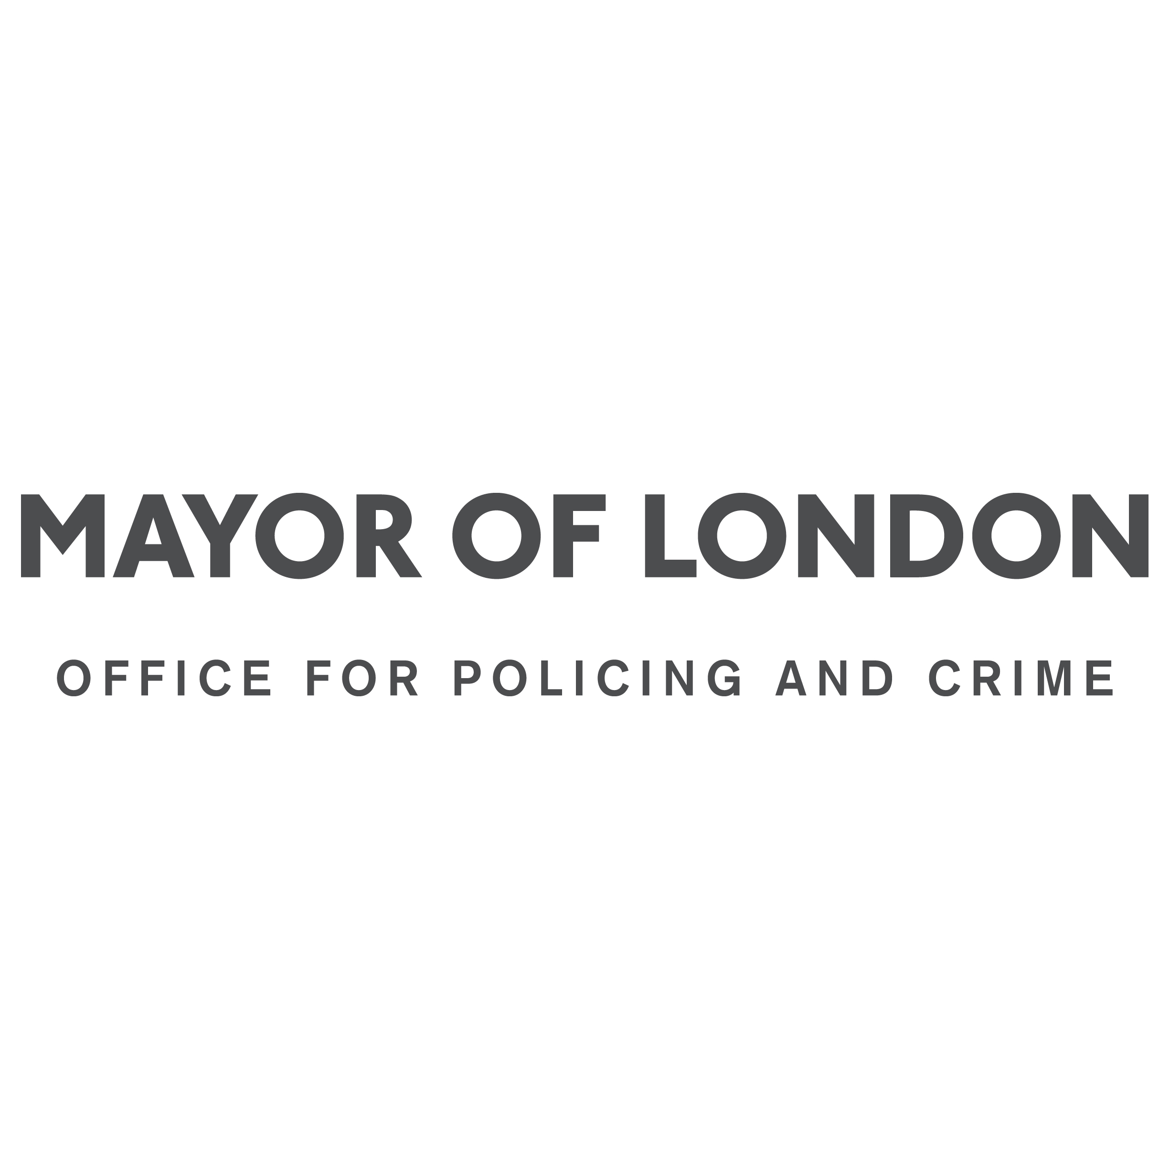
We also responded to London’s Police and Crime Plan.
We advocated for better systems and support for Disabled victims.

We ran training on Disability Hate Crime Matters.
This was for police officers and people working in Hate Crime Outcome and Performance (HCOPs).
We ran this training with Ruth Bashall.

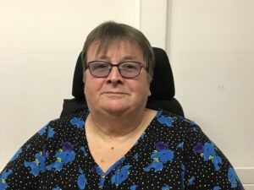
Sadly, Rush Bashall died this year.
She will be very missed by the Disabled community.

We completed a large training programme.
We worked on this with many other Disabled people.

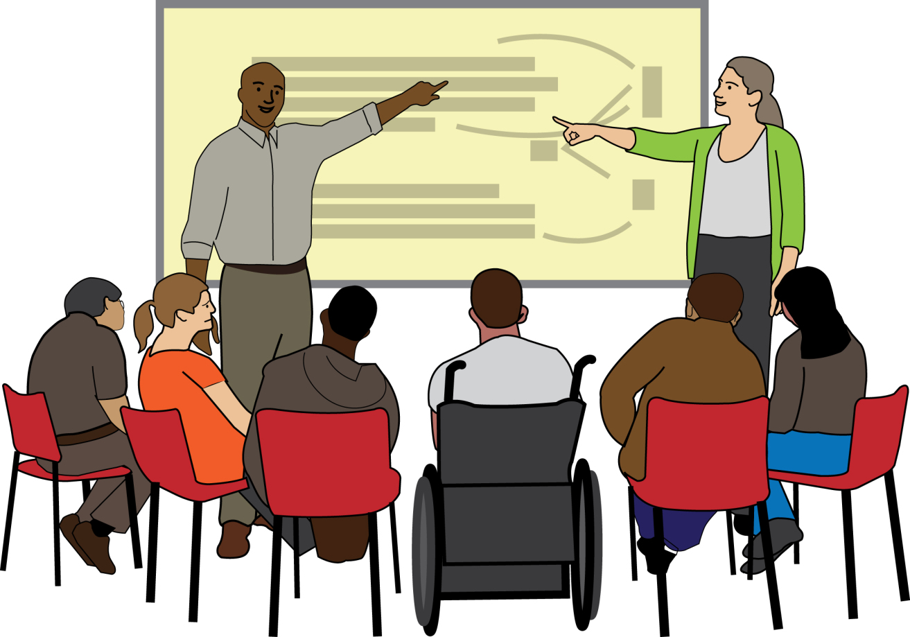
This was to support DDPOs to deliver disability hate crime training to organisations.

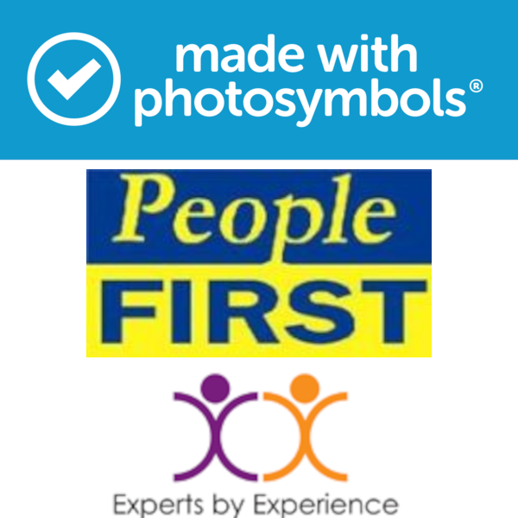
In this report, we use images from:
People First Ltd, Bromley X by X, and Photosymbols.
We paid to use these images.

The image about thinking differently by MissLunaRose12.
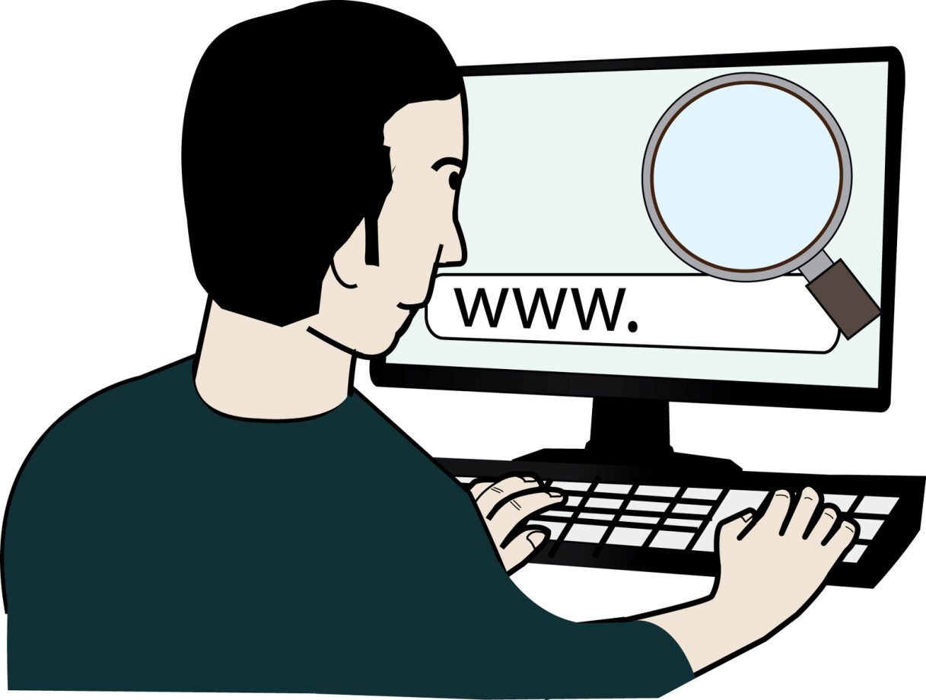
This image was free to use with credit.

The ULEZ sign from citytransportinfo at Flickr.
This was free to use.

The photograph of a prepayment meter was taken by Caroline Ford.
It was free to use with credit.

