Inclusion London Briefing for DDPOs on:
Home Adaptations and Reasonable Adjustments
Part 2: Disabled Facilities Grants and Taking Action

The Disabled Facilities Grant

The Disabled Facilities Grant is money from the local council.
It helps Disabled people change their home, so it is more accessible.
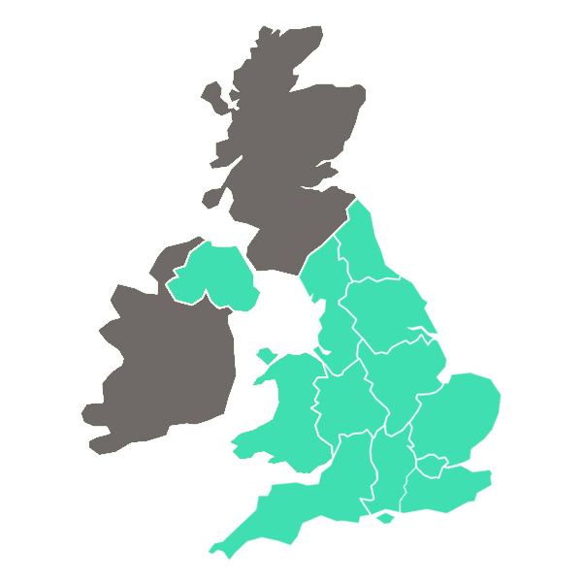

Disabled people in England, Wales, or Northern Ireland can ask for this money.
They must own the home or rent from a landlord, council, or housing association.

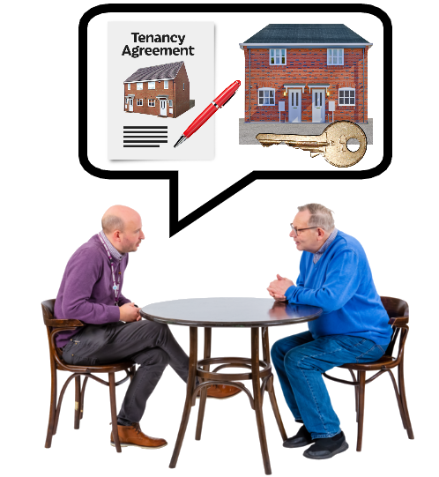
A tenant can apply themselves.
Or their landlord can apply for them, if they want.
In England, they can get up to £30,000.

What can Disabled tenant apply for money for?
To make it easy to get in and out of the home.
To make the home safe for them and others living there.
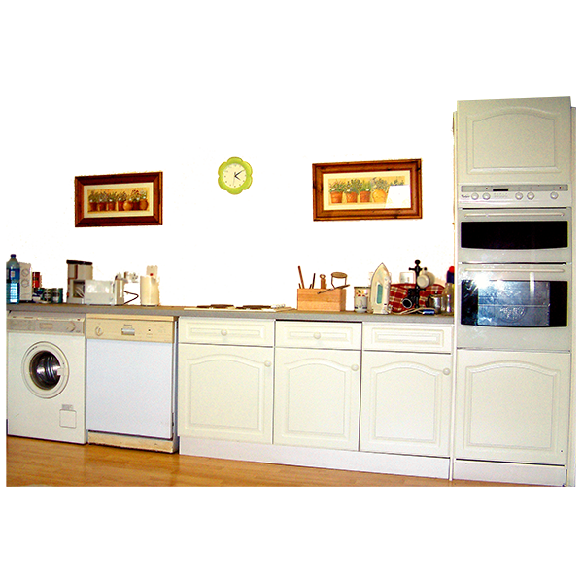
To easily get into the main room, bedroom, or to get accessible rooms.
To easily get into the bathroom or to get an accessible bathroom.
To help make the kitchen accessible for cooking food.
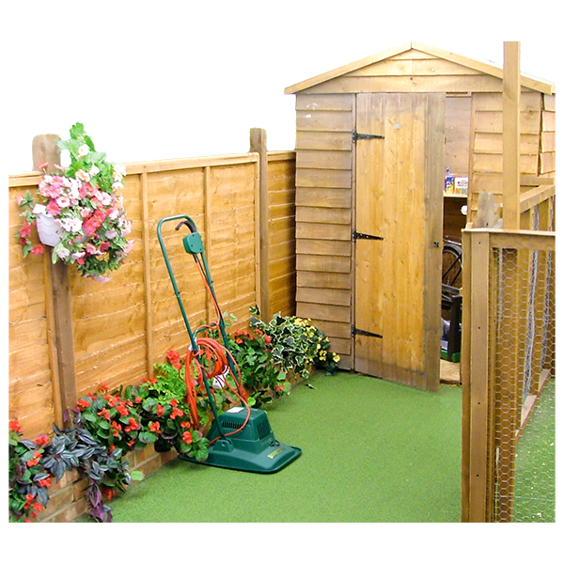
To get or fix a heating system for their needs.
To make the controls for power, light, or heat more accessible,
To make the home more accessible to take care of someone else living there.
To make access to the garden safe.
How can Disabled People apply?
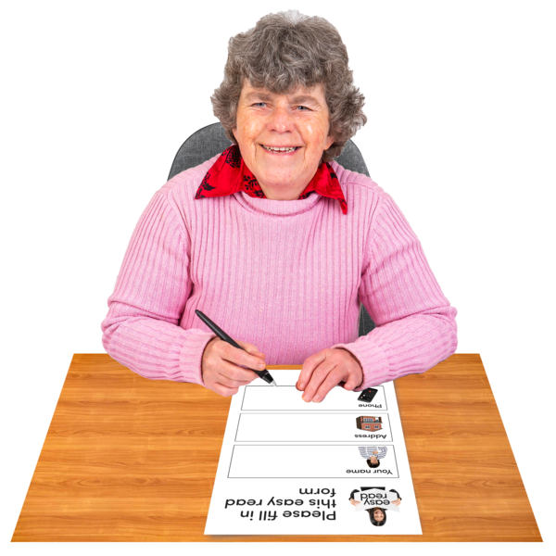
Disabled people or someone supporting them must ask their local council.
The council will give the forms to fill out.

The council should get an expert called an Occupational Therapist.
This occupational therapist will check the home.
They will say what changes are needed to help the Disabled person.

If the form and occupational therapist show the adaptations are needed, money must be given.
How much will depend on the means test.

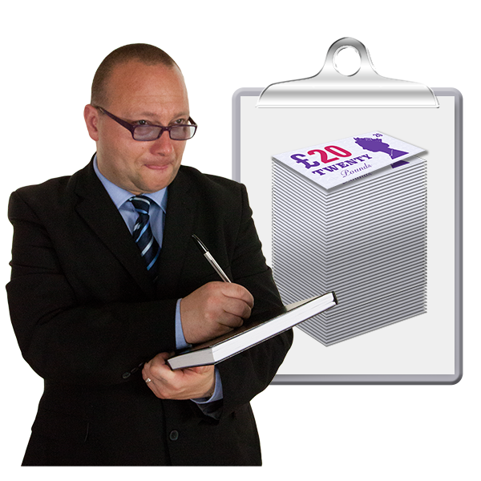
In a means test, the council checks how much money a Disabled person has.
If the Disabled person has a partner living with them, their money is checked too.

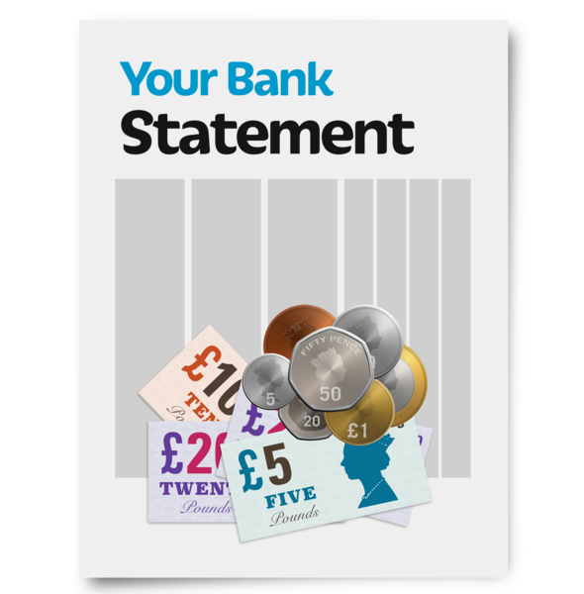
The council look at how much money the people in the house get.
They look at how many savings the people in the house have.

If the people in the house have over a certain amount, they will get less grant.
The Disabled person will have to pay for some or all the adaptations.

People on means tested benefits will probably get all the money they ask for.
Universal Credit and Jobseekers Allowances are means tested benefits.

If the Disabled person is under 19 years old, their money is not checked.

Once the Disabled person applies, the council will reply in 6 months.
The council will say if the Disabled person can get help or not.

If the council says Yes, they will help there will be a letter.
This will say what changes can be made.

It will say how much money the Disabled person will get.
It will say how long until they get the money. This will be less than 12 months.

If the council says No, there will be a different letter.
The council must say why they will not help.

If the Disabled person is unhappy about this, they can appeal.
They can complain, then they can go to the Housing Ombudsman.

Problems with the Disabled Facilities Grant
Private renters have problems with the grant.
They have to prove they will live in the home for 5 or more years.

But most private landlords only give tenancy agreements of 6 or 12 months.
Landlords could write something called a statement of intent.
This would say the Disabled tenant would live in the home for 5 years.

But landlords may refuse to write this.
So, many Disabled people cannot apply for the grant.

19% of Disabled people live in private rented homes. A bit m
This is nearly 1 in every 5 Disabled people.

But only 6% of Disabled Facilities Grants went to private renters.
This is just over 1 in every 20 grants given.
These numbers are very uneven.

The Bureau of Investigative Journalism found other problems.
They write about important things in the UK.

They found Disabled people waited a long time for adaptations.
The exact time they wait is not written down anywhere.

They found that people wait for a long time for an occupational therapist.
Some people waited for more than a year.

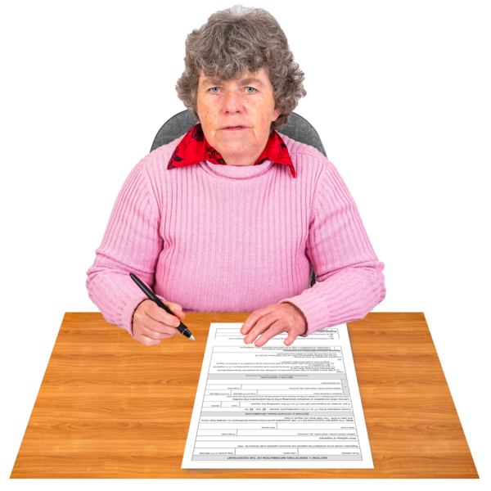
The occupational therapist needs to visit the home before people can apply.
So, Disabled people cannot finish applying for a grant for a long time.

Some councils did not have occupational therapists who knew about all disabilities.
Sometimes they did not know about things like autism.

This meant some people did not get good assessments.
Some people did not get assessments at all.
So, they could not apply for grants.

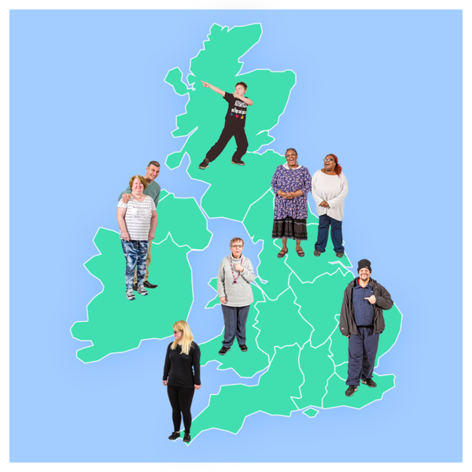
Some places were easier and quicker to apply than others.
People had different experiences depending on where they lived.
It should have been easy for everyone.

The amount of money given was not always enough.
Disabled people can ask for:
£30,000 in England.
£36,000 in Wales.
£25,000 in Northern Ireland.
But this amount hasn't changed since 2008.
Prices have gone up a lot since then.
So, the grant money is not always enough to pay for everything.

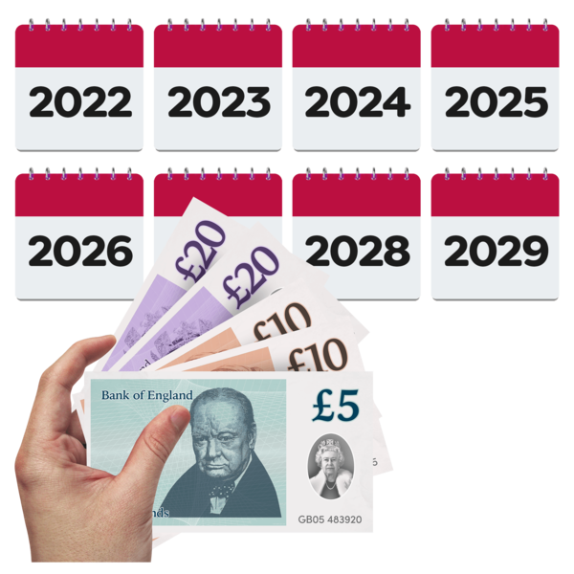
Some councils give top-ups to help.
But these are usually loans.
Disabled people cannot afford to pay them back.

Taking Action

Sometimes, even when people complain, the problems don't get fixed.
So, what can tenants do?

They can ask for help from groups standing up for Disabled rights.
One group is the Social Housing Action Campaign (SHAC).

SHAC want to make life better for people renting social housing.
They are a group of tenants, activists and workers.

They have a group called the Disability Visibility Group.
This group looks at problems that Disabled people who live in social housing face.

They want to make sure that everyone is treated fairly.
This includes people with hidden impairments or who are neurodivergent.

Hidden impairments are things like difficulty breathing, brain fog, cancer, or fatigue. You cannot see these impairments easily.
Neurodivergent means your brain works differently to many people. It is things like autism, ADHD, dyslexia, and dyspraxia.
There are lots of other hidden impairments or ways to be neurodivergent.

SHAC ask landlords to sign up to their Disability Visibility Charter scheme.
If landlords join, they promise to do more for Disabled people.

If landlords do not follow the charter, SHAC can remove them.
Landlords who follow the charter will make homes better for Disabled people.

Talking to local councillors and MPs
Disabled people can contact their local MP or councillor.
They can write a letter, make a phone call, or send an email.
They can tell them what's happening.

If lots of people have the same problem, the MP might talk about the problem in parliament.

People can find their local councillor at: https://www.gov.uk/find-your-local-councillors
People can find their local MP at: https://members.parliament.uk/FindYourMP

In this briefing, we used photographs from photosymbols.
We also used images from Public Domain Vectors
The picture of an autistic mind is by MissLunaRose12

