Inclusion London Briefing for DDPOs on:
Home Adaptations and Reasonable Adjustments
Part 1: The Equality Act and Reasonable Adjustments
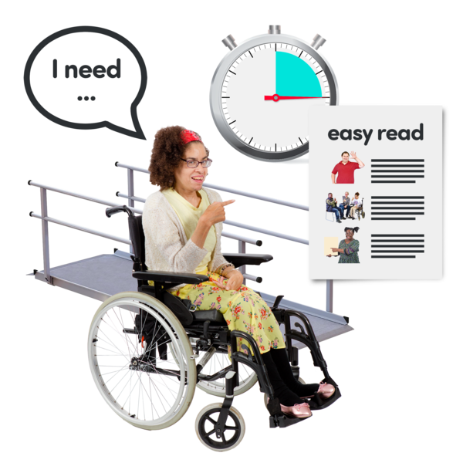
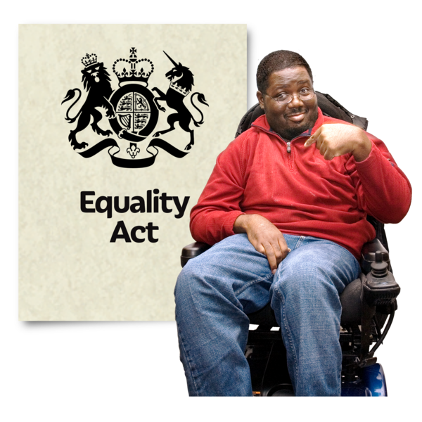

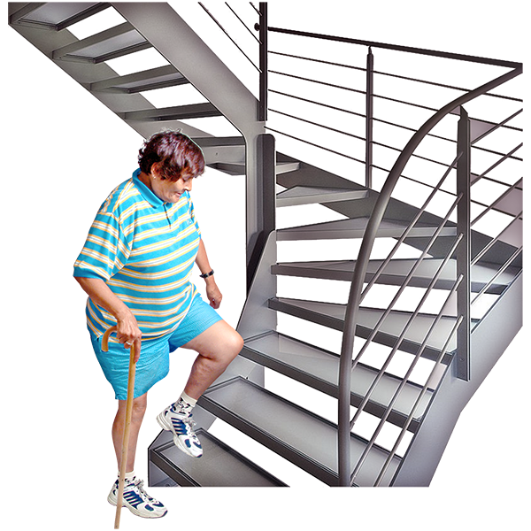
Deaf and Disabled people sometimes face barriers to living in their own homes.
For example, stairs can be a barrier for people with mobility impairments.

Doorbells can be a barrier for Deaf people.
There can be barriers in other ways, too.
In communication, for example.

Impairments are injuries, illnesses, or conditions. They change how someone’s body or mind works.
If someone has arthritis in their knees, this is a mobility impairment. The arthritis changes how their knees work.

We can make changes to homes to help.
These changes make things fair for Deaf and Disabled people.

You can ask the landlord to change things in the home to make it better.

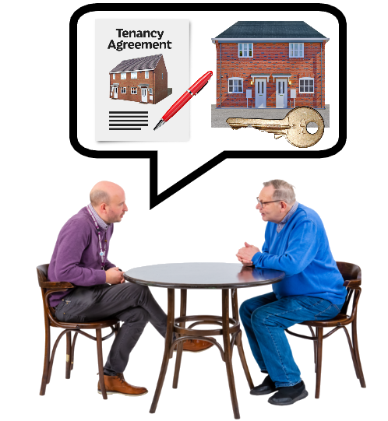
Or you can ask the landlord to do things in a different way.
For example, not making people meet in the morning if it's hard for them.

We will give you information about how to support Deaf and Disabled people.

We will tell you about:
The Equality Act
Reasonable Adjustments
What Deaf and Disabled people’s rights are
Problems Disabled people might have when asking for changes
The Disabled Facilities Grant

The Equality Act 2010
Landlords must make reasonable adjustments for Disabled people.
This rule is from the Equality Act 2010.
The Equality Act says people cannot discriminate against Disabled people.

Discriminate means treated someone unfairly or badly because of who they are.

There are two main parts of the Equality Act important to housing.
The first part is called Public Sector Equality Duty.

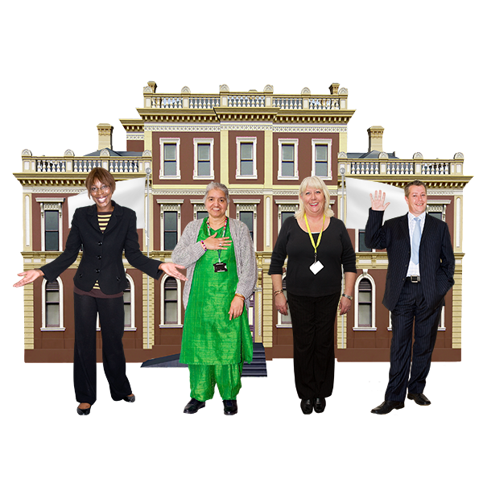
This is something that public organisations must follow.
These are organisations like councils, the NHS, charities, and others.

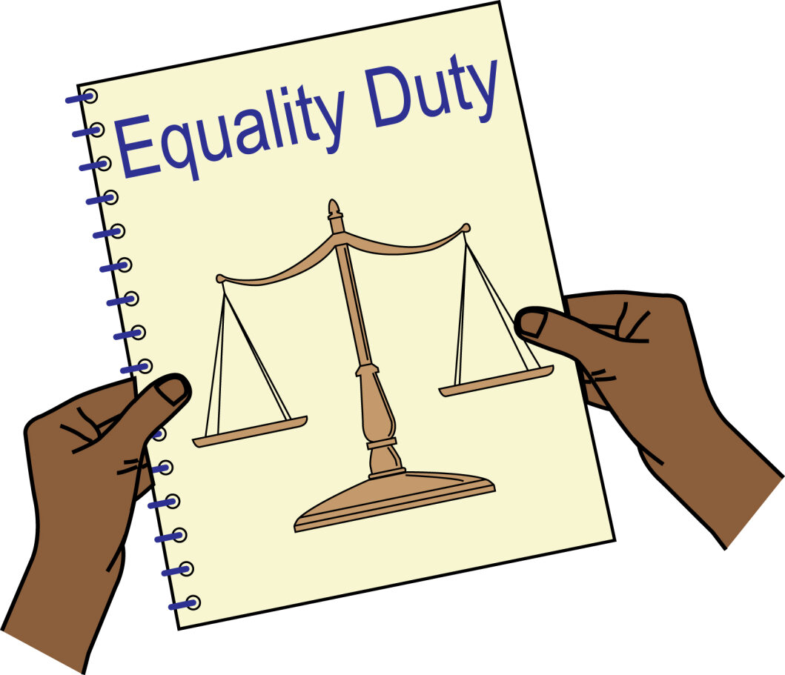
They must be fair to everyone.
They need to think about what might be unfair for Disabled people.
Then they need to try and change those things.

For example, some Disabled people face barriers in filling out forms.
The local council should provide support services to help with this.

The second important part is reasonable adjustments.
Whoever manages or rents the homes must do this.

This can be a company like an estate agent.
Or it can be a person like a landlord.
It includes private landlords, local authorities, and housing associations.

They should make changes so Disabled people are not worse off than non-Disabled people.

What are reasonable adjustments?

Here, reasonable adjustments mean changing something to make it accessible for Deaf or Disabled people.

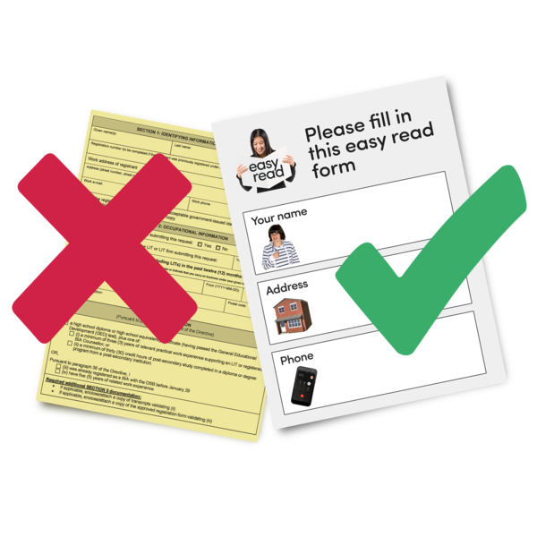
Here are some examples.
Putting rails in the bathroom for people with mobility impairments.
Having doorbells that flash for Deaf people.
Giving papers in Easy Read when people need it.

Who can apply for reasonable adjustments.

Anyone seen as Disabled by the Equality act can ask for reasonable adjustments in housing.

You can find more about the Equality Act here: Click this link

Disabled renters can ask for reasonable adjustments.
They need to apply to whoever manages or rents out their home.
This might be a landlord, housing association, or property management company.

What are reasonable adjustments?
There are not fixed rules about what is reasonable.
It is different for each situation.

Here are some things that will decide what is reasonable.

How long will the Disabled person live in the building?
How much will the adjustment cost?
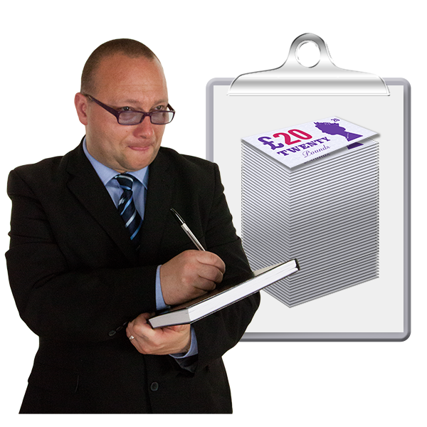
How hard is it to make the adjustment?
Will the adjustment remove the barrier the Disabled person is facing?

There are some changes the owner should make.
Sometimes, the ways landlords or owners work are difficult for Disabled people.
Landlords or owners should try to change how they work.

For example, a tenant might have mental distress.
It is very difficult when the landlord only tells them one day before a home visit.
A reasonable adjustment is the landlord tells them three days before a home visit.

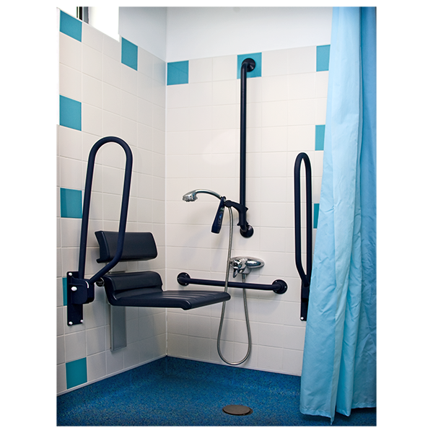

Another change is when a Disabled person needs extra equipment.
They need the extra things or life will be very hard.

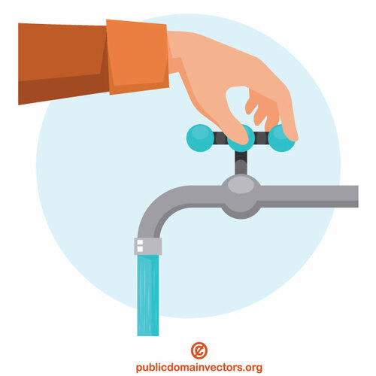
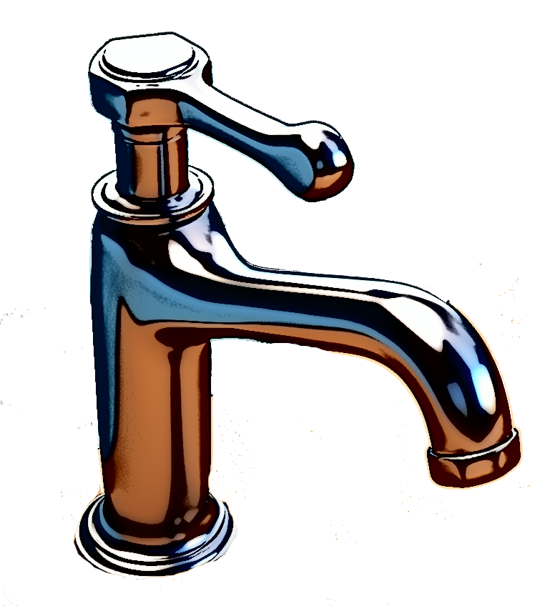
For example, a tenant might have a mobility impairment that affects their hands.
They find it very difficult to turn a tap.
So, they ask for a lever tap.
This is a reasonable adjustment.

There are also some things that landlords and owners do not need to do.

They do not need to make changes to the building structure.
This is things like removing walls or making doors wider.

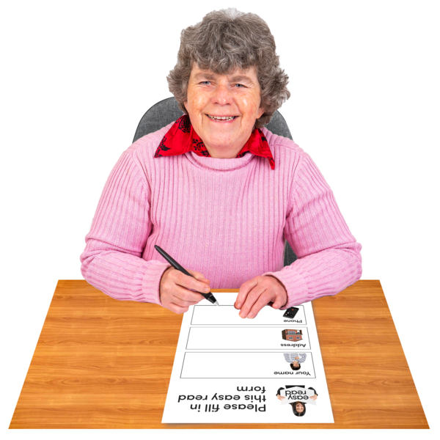
If Disabled people need changes to the building, they can apply for help.
They can apply for the Disabled Facilities Grant.
We will say more about this later.

How to apply for reasonable adjustments
If a Disabled person thinks their adjustment is reasonable, they can ask their landlord.
The landlord should make the adjustment.

People can ask for the adjustment in different ways.
They can ask by phone, in person, or by letter or e-mail.
Sometimes, it is better to ask by letter or e-mail.

Letters are better when:
Someone talked to the landlord, but no change was made.
Someone needs the change soon.
Someone is asking a big group like a housing group or council.
What people should put in the letter.
Their disability or impairment and how it affects them.
Why they need the reasonable adjustment.

Tell the owner or landlord they should make changes because of the Equality Act 2010.

Say if they need a change in how the owner or landlord works.
Say if they need a new tool or equipment.
How this would help.
Here is an example from Mind: Click here for letter
What to do if they say “No” to a reasonable adjustment

Sometimes the owner or landlord will not answer.
Sometimes, they say “No” and will not make the adjustment.

If this happens, there a few things the Disabled person can do.

If a Disabled person lives in council housing or social housing, they can complain.
They can complain to their landlord first.
They should ask for the complaint’s procedure.

They might still be unhappy after complaining to the landlord.
If they are still unhappy, they can contact the Housing Ombudsman.

The Housing Ombudsman helps solve problems between landlords and tenants.
They do not charge money and they are fair.

Someone in social housing can contact the Housing Ombudsman.
They can tell them about their complaint.
They will get a case manager.

The case manager will look at their case.
They will contact the Disabled person about what they can do.

The ombudsman can do a few things.
They can tell the landlord to make a formal apology.
They can tell the landlord to give the Disabled person money in compensation.
They can suggest the landlord trains their team better or keeps better notes.

Another thing a Disabled person with a housing problem can do is take legal action.

If the landlord will not make reasonable adjustments, they might be breaking the Equality Act.

So, the Disabled person can go to a local court because this is discrimination.

They must do this within six months minus one day from the landlord saying no.

They might not remember when the landlord said no.

Then it is safer to go by six months minus one day from when they asked for adjustments.

It is a good idea to talk to a lawyer before making a discrimination claim.

Retaliatory Evictions for Private Tenants

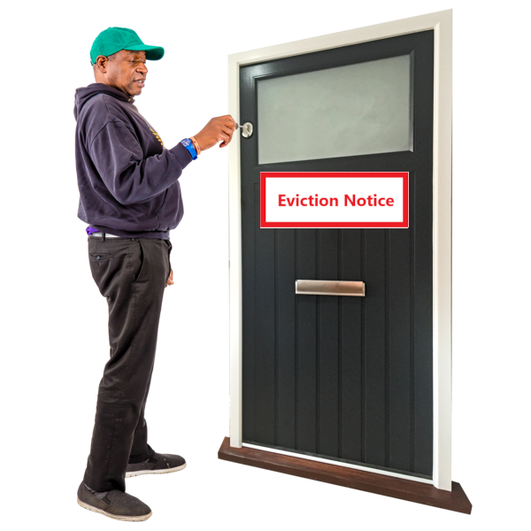
Sometimes, landlords will evict people for asking for reasonable adjustments.
People can use the law to fight these evictions.

The Equality Act says landlords cannot make someone leave just for asking for reasonable adjustments.

Citizen’s Advice have information on what to do if this happens.
You can find it here: Click Here

In this briefing, we used photographs from Photosymbols.
We also used images from Public Domain Vectors

