Inclusion London Briefing for DDPOs on:
Part 2 - What to do if your landlord is harassing you

What to Do if Your Landlord Harasses You

If a landlord is causing problems, tenants can take steps to help themselves.

If the landlord threatens them with violence, they should call the police.

Tenants can also contact their council or take their landlord to court.
If they do, there are some things they all should do.

They should:
Write down what happens each time there's a problem.
Take pictures if they see something wrong.
Ask the landlord to only talk in letters or emails, and keep those saved.

Talking to the Council
The council can help if a landlord is being unfair or doing things illegally.

Each council should have a special team to help with evictions and harassment.

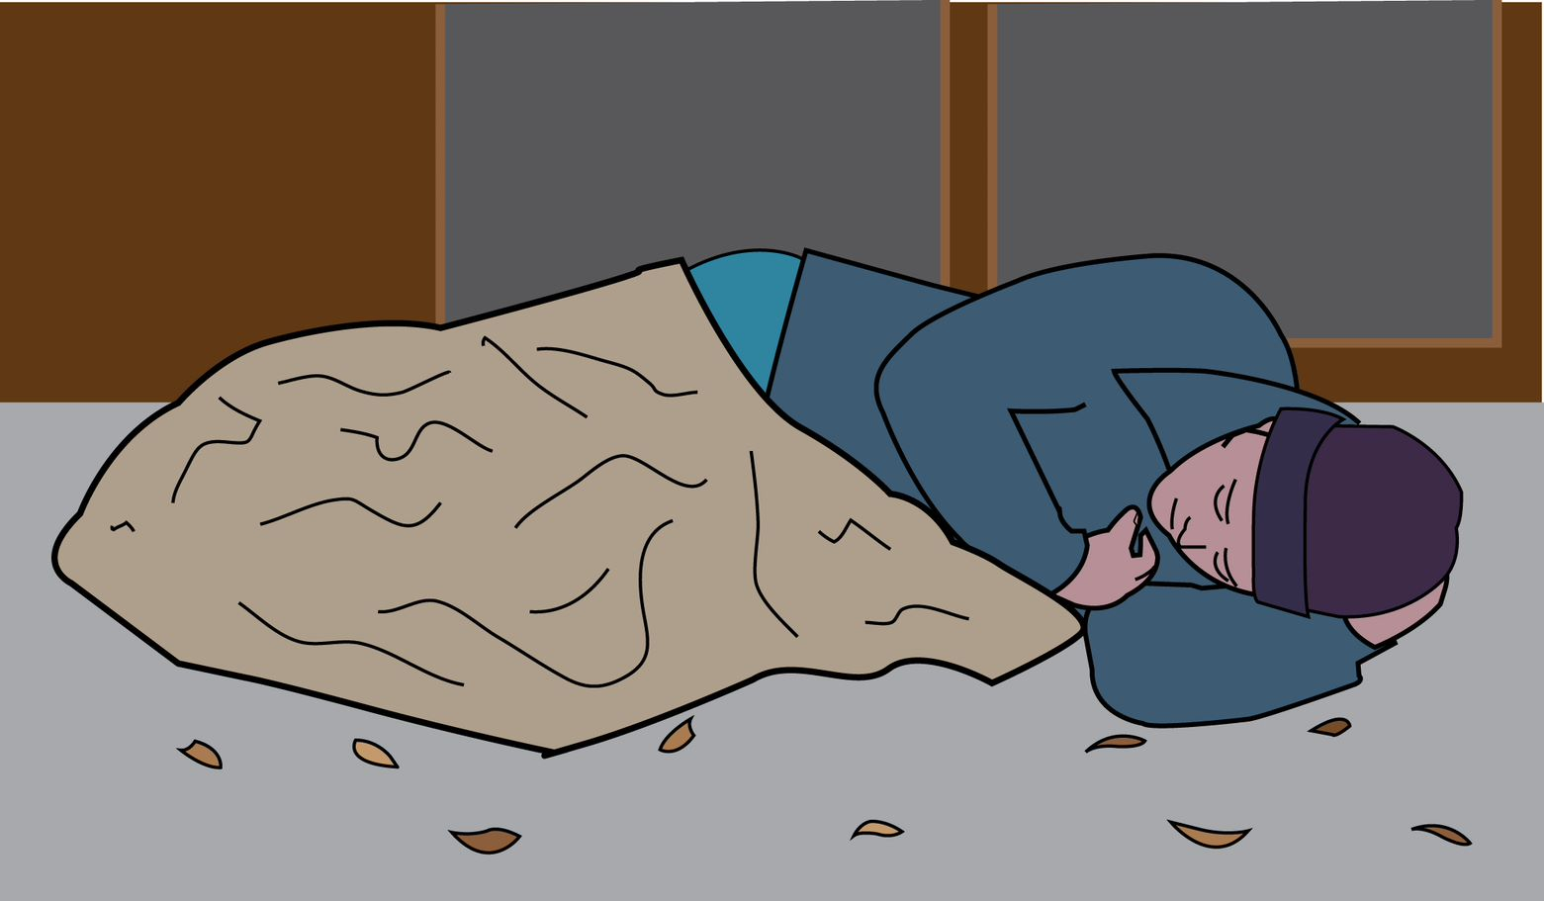
Councils must try to stop illegal evictions if the tenant will be made homeless.
This can be if someone doesn't have a home now, might not have one soon, or if their home is not safe.

Here are some things the council can do.
Talk to the landlord to fix the problem.
Tell the landlord what rights the tenant has.

Let the landlord know if they're doing something illegal.
Take the landlord to court if they're doing things that are very wrong.

In really bad situations, if a house is not safe, the council can take charge of it.
If a landlord is really causing problems, the council can even take the property away from them.

Taking the Landlord to Court
Tenants might think about taking their landlord to court because of problems.

They should talk to a lawyer or get advice first.
They can ask at a local law place, the Disability Law Service, or a place called Citizens Advice.

Some tenants might get help to pay for a lawyer. They can check if they can get this help by clicking here.

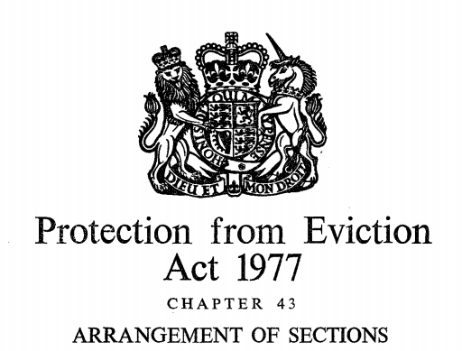
The court could decide on different punishments if the landlord has broken rules from the Protection from Eviction Act 1977.

They could make the landlord pay up to £5,000*.
They could send the landlord to jail for up to six months.

If the case is really serious and goes to Crown Court, the landlord could be in jail for up to two years.

Getting Support from a Union

It can be difficult to access legal aid, prove harassment or get the council to help.
So, sometimes tenants come together to campaign and help each other.

The London Renters Union (LRU)
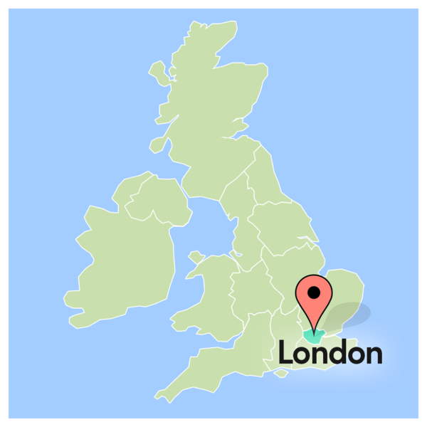
The LRU is a group in London that helps people who rent their homes.
They work all over London.
The LRU was made by housing groups working together.

They want to make sure everyone can have a good, safe, affordable home.
They want to make sure homes are kept in good condition.

Affordable means it does not cost too much. People can pay for it without having money problems.

The LRU teach their members about the rights and issues of tenants.
They come up with a list of changes they want to see.
They let everyone know about these issues, and they take action.

How Can Disabled People Join?
Disabled people can join the London Renters Union.
They can also join the Disability Justice Caucus.

The Disability Justice Caucus meets every month.
They talk about problems that Disabled people might face when renting homes.

You can find information about the LRU here: London Renter’s Union.

ACORN

ACORN is a national group.
It helps communities stand up for their rights.
This includes housing rights.

They have teams in different parts of London.
They support people who rent their homes in many ways.

They take action directly with landlords.
They start local campaigns.
They help to resist evictions.
They offer a support group for tenants (click here).

How Can Disabled People Join?
ACORN has a Disabled Members Network.
They meet to talk about access issues and share advice on campaigning.
They work to make ACORN more accessible for everyone.
You can sign up to become a member of the union here.
You can email: dmn@acorntheunion.org.uk to ask to join the network.

