Inclusion London Briefing for DDPOs on:
Part 1 – Harassment, landlords, and tenant rights

Harassment by landlords makes life hard for Deaf and Disabled people.

It can make us distressed or affect our mental health.
It can stop us from asking for what we need.
Sometimes, it makes us leave our homes.

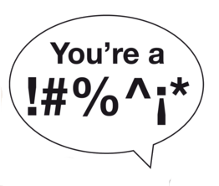
Harassment can be lots of things.
It can be using abusive words. This could be ableist language.

Ableist language is words or phrases that are negative about Disabled people.

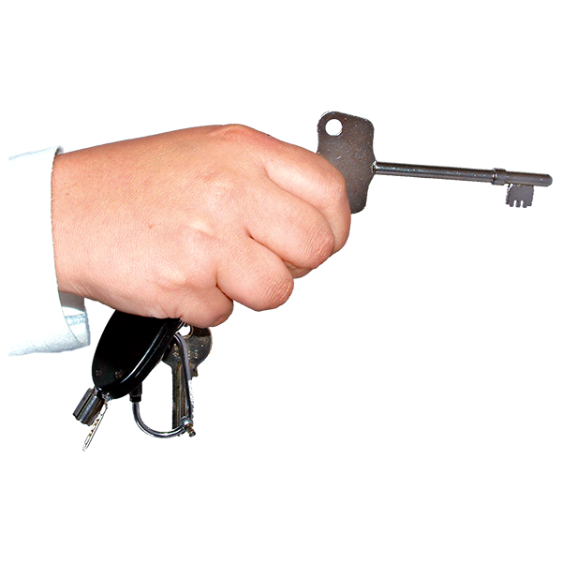

It could be the landlord going into homes without telling the tenants.

It could be threats.
Like saying they will kick tenants out if they ask for repairs.

Tenants are people who rent a property from a landlord.
This property could be a flat, a bungalow, or a house. It could be some other things, too.

This briefing will give you information about these things.

What is harassment?
Laws protecting Deaf and Disabled tenants.
What to do if a landlord harasses a Deaf or Disabled tenant.

What is harassment?
We are going to talk about harassment in housing.
We are using the way harassment is described in law.

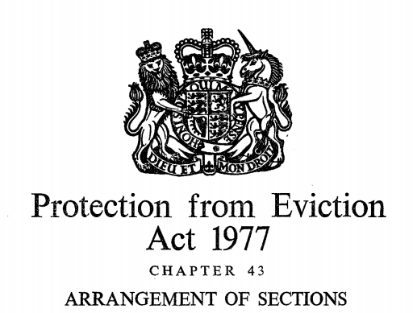
This comes from something called the Protection from Eviction Act 1977.
These are some of the laws that protect tenants.

In this, harassment in housing can be done by the landlord or someone working for them.

Harassment can be when this person does things that make the tenants uncomfortable or bothers them.

This could be making tenants sign papers that take away their housing rights.
Or it could be going into the house without asking.

Harassment can also be stopping people in the house from getting things they need many times.

This could be not letting them have hot water.
It could be not giving them keys to their house.

A landlord may do these things thinking it will make a person:
- Give up their rights
- Not use their rights
- Leave the house before they should

When this happens, it is harassment.

Knowing Your Rights and Landlord Responsibilities
Deaf and Disabled people should know when they are being harassed.

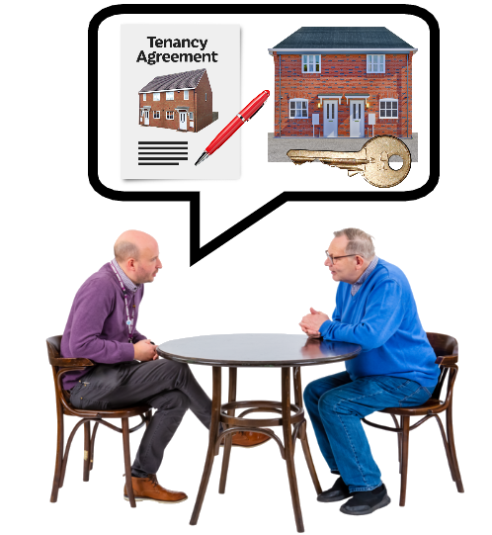
To know this, we must understand what rights tenants have.
We must also know what the landlords are responsible for.

Here are more examples of harassment.
Turning off things like lights, water, heaters, or gas.

Being threatening, rude, or hurtful.
This also means if they use ableist, racist or sexist language.

Touching a tenant's letters.
Letting other people live in the house who are noisy or troublesome.

Asking for money that the tenant doesn't owe.
Taking or messing with the tenant’s things.

Asking the tenant to do a lot of repairs that are not needed.

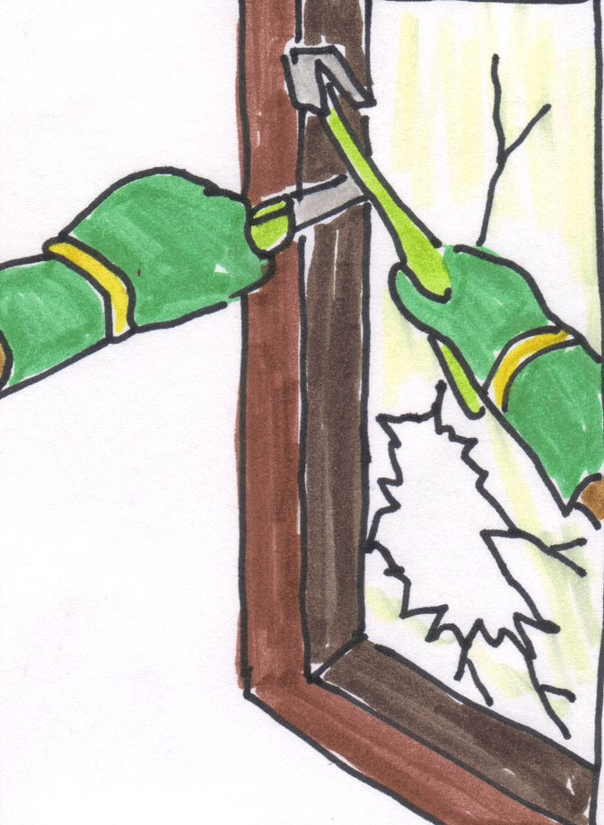
Not fixing things so the house is unsafe to live in.

We did a briefing all about disrepair and how landlords should fix houses.

You can find our other information by clicking here.

Illegal Evictions
Landlords must follow the right steps to ask a tenant to leave.
If they do not follow these steps, it is harassment.

At the moment, many private renters are on Assured Shorthold Tenancies.
This is a kind of tenancy agreement.

Tenancy agreements are written deals between whoever owns the house, flat or bungalow, and the person renting it.

In Assured Shorthold Tenancies, there are certain ways a landlord can ask a tenant to leave.

They can ask them to leave when the 6 or 12-month agreement ends.

They can ask them to leave under "Section 21 – ‘No Fault’ Evictions.
There are only some reasons this can be used.

These reasons are:
If a tenant has a contract with a break clause.
If a tenant has a contract that keeps restarting every week or month.

A break clause is a rule that can be written into a contract.
It means a renter, or a landlord can end the tenancy early.
If one of those is true, the landlord can give 2 months written notice for the tenant to leave.
They do not need to say why.

But, a landlord cannot just make someone leave with this rule.
A judge still needs to agree and give a court order.

Sometimes, this notice might be wrong.
Some reasons are if a landlord didn’t keep the deposit safe or gave the notice too early.

You can use Shelter's tool to see if a "Section 21" notice is right by clicking here.

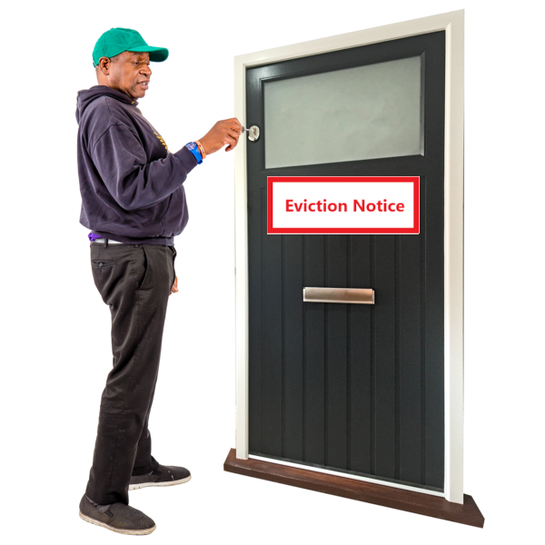
Another way landlords can evict tenants is using "Section 8 – Evictions".
These can be used if the landlord has a legal reason to evict a tenant.
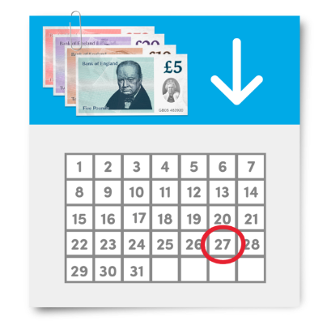
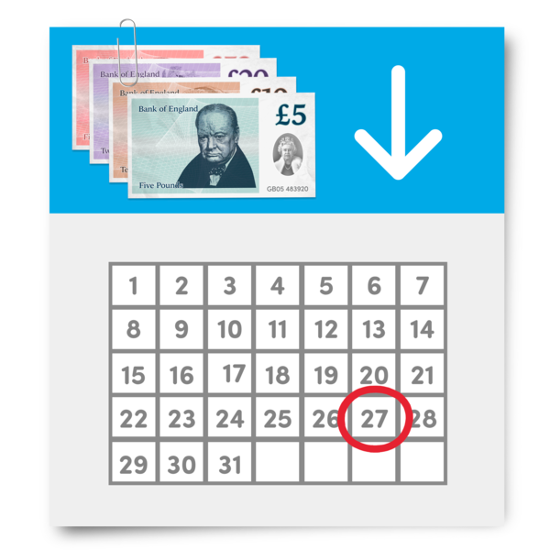

One legal reason is a tenant owes the landlord money for 2 months rent.
They can also use this if a tenant behaves badly or damages the home.

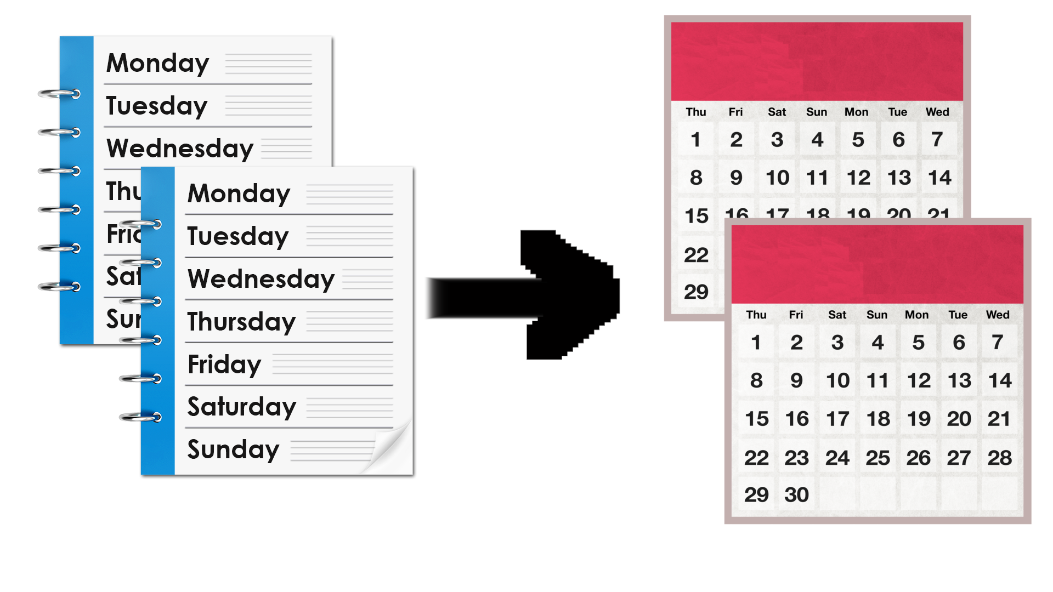
The time given to leave changes from 2 weeks to 2 months based on the reason.

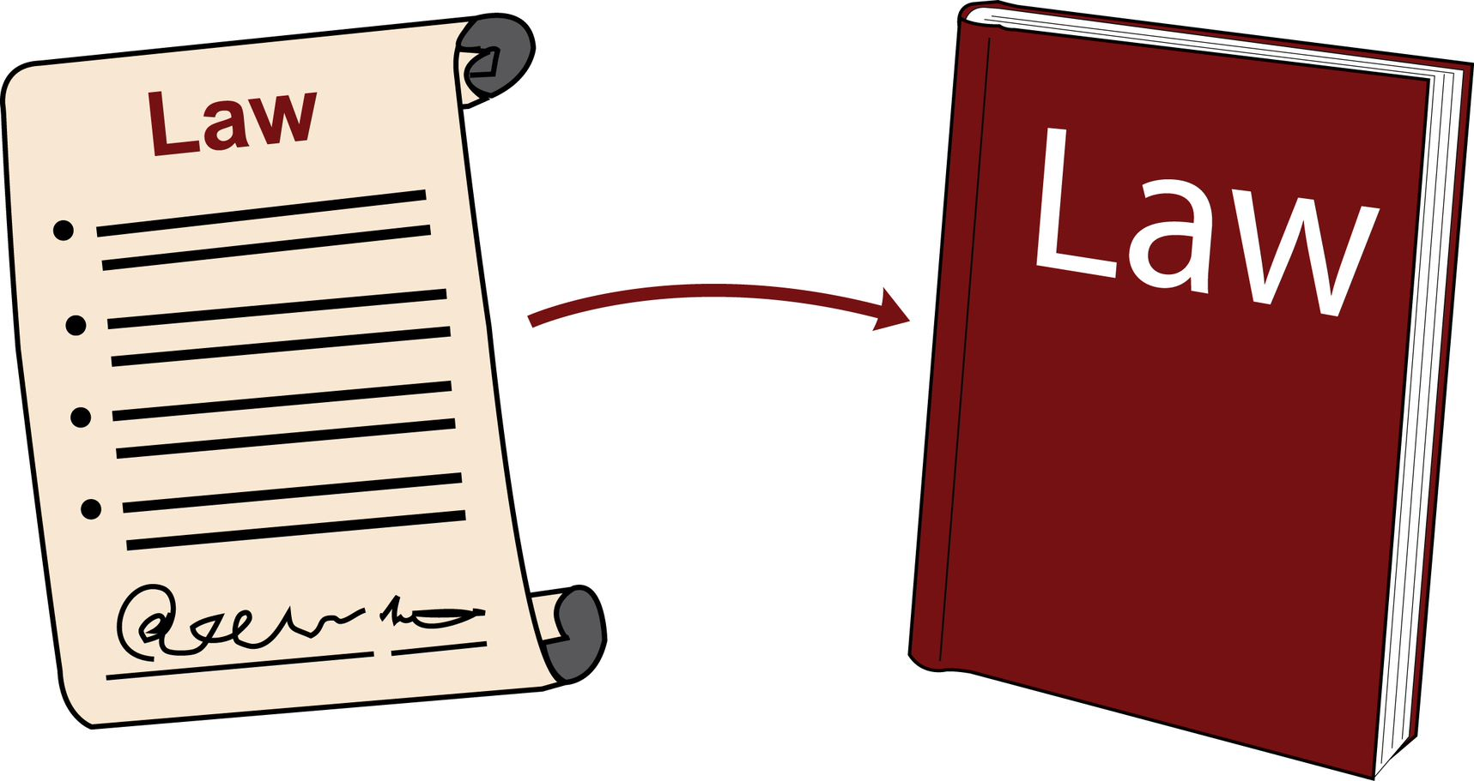
In May 2023, a new rule called the Renters Reform Bill was suggested.
If it becomes a law, it will change how landlords can ask tenants to leave.

We wrote about this, too.
You can read about these changes by clicking here.
Equality Act 2010 and Disabled Tenants
The Equality Act 2010 protects Disabled tenants.

Sometimes, when Disabled tenants stand up for their rights, the landlord makes things hard for them.
This is called "victimisation".

Victimisation is when someone is treated badly because they stood up for their rights using the Equality Act.
It can also be if someone is treated badly for helping someone else stand up for their rights.

The Act says it's wrong to treat people unfairly because of things like disability, gender, race, and more.

It's wrong to treat a Disabled person worse than others because of their disability.

Landlords must make changes to help Disabled tenants if needed.
We wrote about Reasonable Adjustments, too.
You can read about them by clicking here.

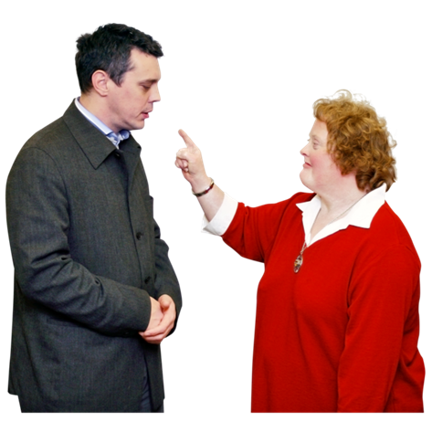

Disabled tenants can complain if they feel treated unfairly because of the Equality Act.

Examples
Here are some ways people can be victimised:
A Deaf person asks for a flashing doorbell.
The landlord says no.

The Deaf person complains.
Then, the landlord tries to make them leave, saying their anti-social behaviour is the reason.

Anti-social behaviour is when someone causing a nuisance or annoyance. It can also be if they are causing harm or distress to people.
A blind person wants letters in digital so they can use their screen reader.
The landlord doesn't help.
The person complains.
After that, the landlord takes a long time to do repairs.
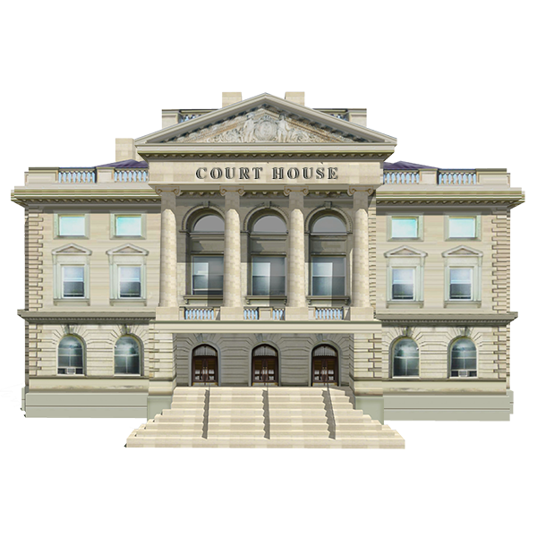
In a house with many tenants, a disabled person complains about the landlord.
Another tenant helps them in court.
Then, the landlord tries to evict the tenant that helped.

