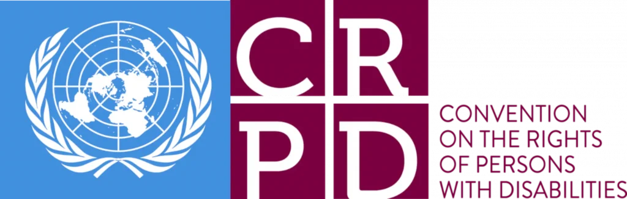

Report Summary – Section 3, 4, 5, 6, 7, 8, 9, 10

- New issues
 |  | Leaving the European Union (EU)
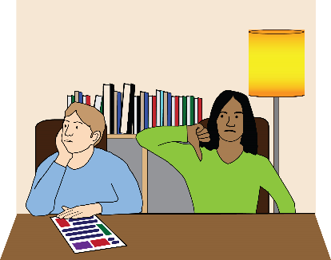  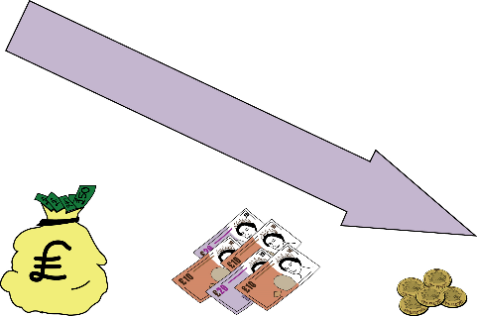 |  | Leaving the European Union and the pandemic has led not being able to recruit enough social care staff.  In 2021/22 the number of vacant posts in adult social care in England had doubled from what it was in 2020/21.  Disabled people living in their own homes are finding it harder to recruit Personal Assistants (PAs).  Disabled people who employ their own Personal Assistants (PA) were not included in pre-Brexit preparations.  The replacement funding that the Government gave to Wales for EU funding was a lot lower.  European Social Fund (ESF) for employment projects in Northern Ireland ended March 2022.
 | COVID-19
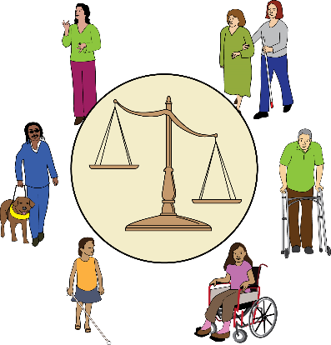 | Disabled people were experiencing a lot of inequality before the pandemic. The pandemic both highlighted and increased these inequalities.
 | The Government was not prepared for the pandemic.

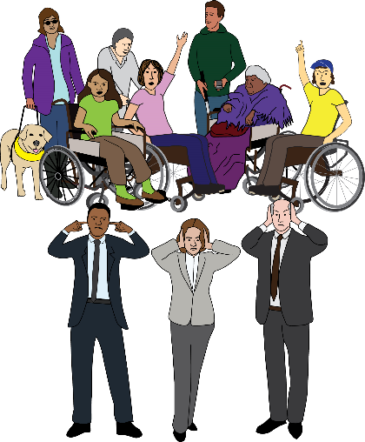 | The Government did not involve Deaf and Disabled people or Deaf and Disabled People’s Organisations in any plans to deal with the pandemic.  This was despite Deaf and Disabled people being most at risk from COVID-19. They were also the hardest hit by the restrictions.
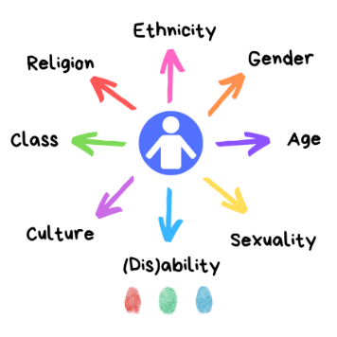 | The intersectional needs of Deaf and Disabled People were not considered. For example, Disabled asylum seekers.
Intersectional: here this means different factors that make up an individual’s identity, such as being a Disabled person who is Black and an asylum seeker. They may face disadvantage and discrimination based on one or all of those factors.
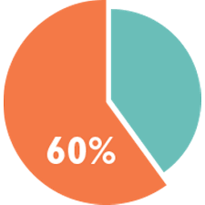  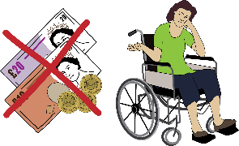 | Official figures said that 60 per cent of COVID-19 related deaths were Disabled people.  Financial and residential living situations were also a reason for this.  It is thought that figures could be higher than those officially recorded.
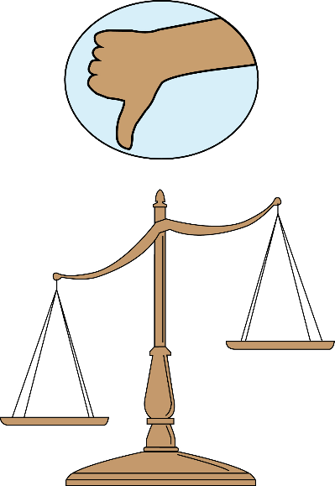 | The Coronavirus Act 2020 allowed local authorities to relax their duties set out in the Care Act 2014 and the Children and Families Act 2014.  This meant they could reduce social care packages for Disabled people.  People detained under the Mental Health Act were not given the right to go outside for exercise once a day.

 | More Disabled people were made redundant than non-disabled people.
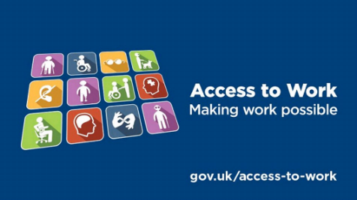  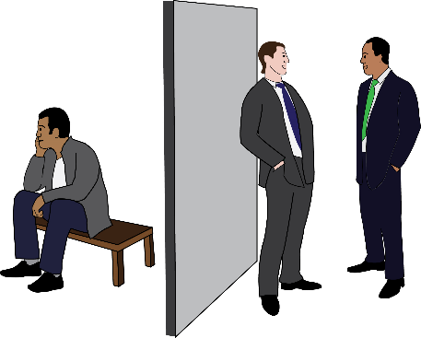 | Disabled people faced long delays when requesting adjustments and other Access to Work issues when working from home during lockdown.  Disabled people with Long Covid have experienced discrimination in the workplace and some lost their job.
 | A temporary increase of £20 to Universal Credit did not include over 2 million legacy benefit claimants. Three quarters of these were Disabled people.
Legacy benefits: These are the six benefits that were replaced with Universal Credit - Child Tax Credit, Housing Benefit, Income Support, Job-Seekers Allowance, Employment and Support Allowance and Working Tax Credit.
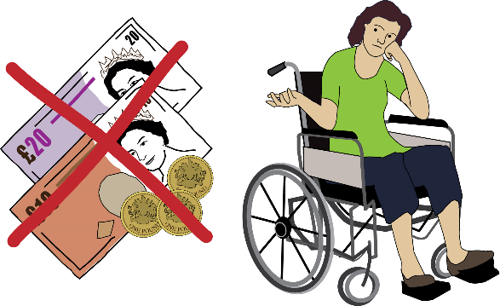 | The Government said the extra £20 was only for people who work. This made Disabled people feel like they were not valued.  Even with the extra £20, Universal Credit didn’t even cover half of what is needed for a decent standard of living.  Despite this and a lot of calls to continue with the extra payment, the Government stopped it on 30 September 2021.
 | Cost of Living Crisis
Disabled people are more affected by the Cost of Living Crisis because:

- They are more likely not to have enough money to live on and have no savings.

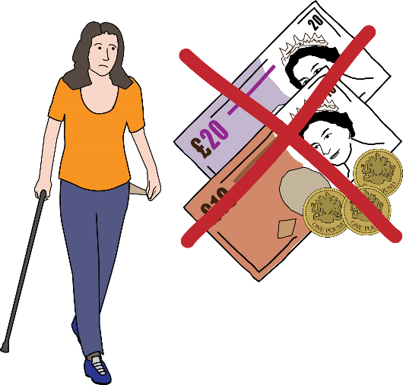
- They have extra costs.

- They are receiving less support.

- Some important policy developments have been stopped.

- Devolved issues
 | Issues that are the responsibility of the governments in each nation (Northern Ireland, Scotland, and Wales).
 | Access to Justice
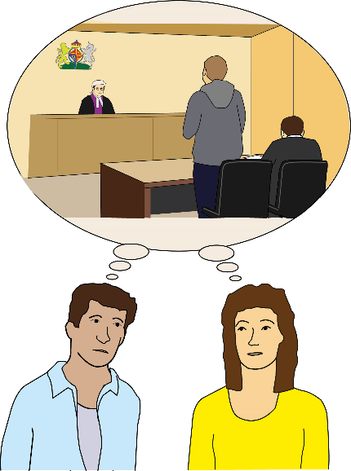 | In Northern Ireland there are barriers to reporting crime and accessing legal services.  In Scotland Disabled people are more likely to experience civil law problems.
Civil law: involves disputes between individuals or individuals and organisations. It relates to offences that harm another person, their rights or property.

 | Cost of Living Crisis
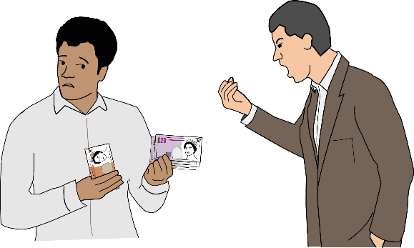  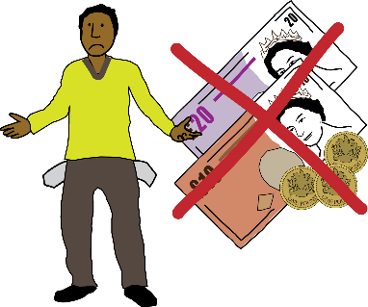 | In England, it was reported that a quarter of Disabled people have had to use food banks.  In Northern Ireland, there has been an increase in abuse and exploitation of Disabled people.  In Scotland, Disabled people are still struggling financially despite benefits being increased.  In Wales, the lack of money and longer-term support is a big barrier to a decent standard of living.
 | COVID-19
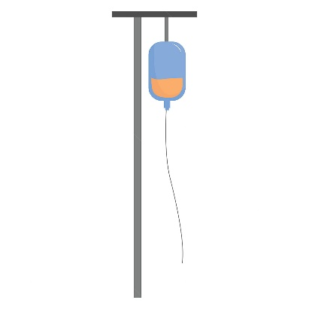  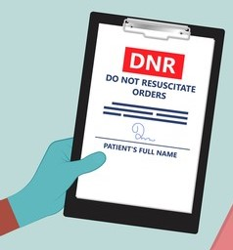  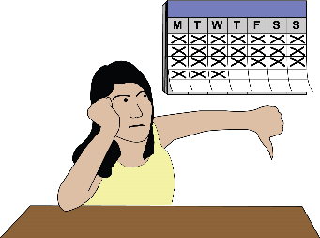  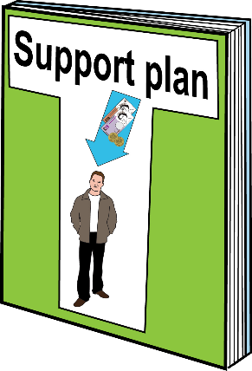  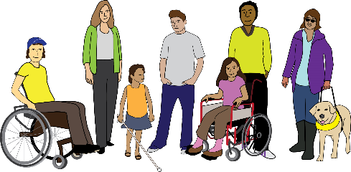  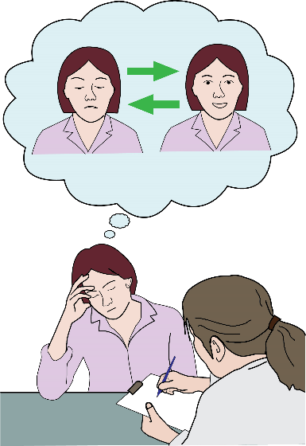 | Because of a medical approach to disability during the pandemic, Disabled people were denied access to life-saving treatment.  The Government did not provide guidance that gave Disabled people the same rights to treatment as non-disabled people.  There was an independent inquiry into Do Not Resuscitation Orders being put on Disabled People’s medical notes.  Information about the pandemic was confusing and was not available in accessible formats.  COVID guidance for Disabled people was published much later.  It took a long time for people using Direct Payments to get the Personal Protective Equipment (PPE) they needed. This meant their Personal Assistants could not work.  Social care support was reduced or stopped. Some people have not had their support returned to the same level it was before the pandemic.  Legal protection for Disabled workers ended when shielding was officially ended.  In Northern Ireland, Disabled people and the Equality Commission questioned the response to the Covid-19 crisis.  In Scotland, Government guidance for doctors making treatment decisions at the beginning of the pandemic discriminated against Disabled people, older people, and people with medical conditions.  The pandemic has a huge impact on Disabled people’s mental health.  Disabled people continue to be isolated with little or no support.
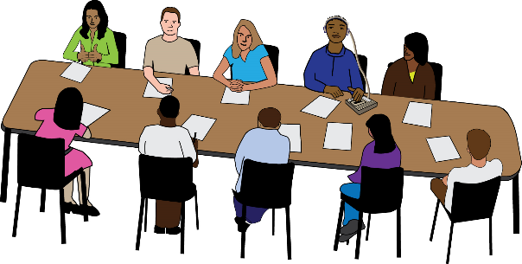  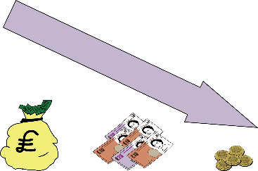 | COVID-19 made many Disabled people financially worse off.  In Wales, a Disability Rights Taskforce has been set up following a report that criticised the Welsh Government’s response to the pandemic.
 | Disability Narratives and Hate Crime
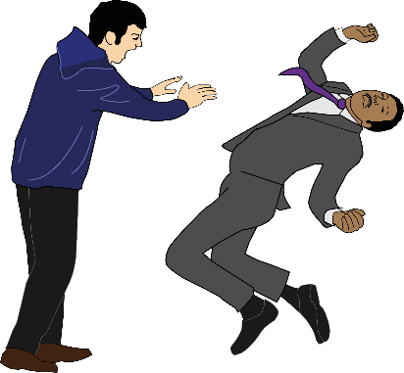  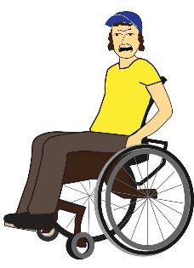 | There is evidence that Disability hate crime increased in London and in Northern Ireland over the last 2 years.  Attitudes towards Disabled people in the workplace got worse with more accounts of bullying.

 | Employment
 | A report published by Inclusion London found that poor work practice and bad attitudes caused lots of problems with the Access to Work scheme.
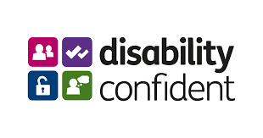 | There will be a large-scale review of the government’s Disability Confident employment scheme.
Disability Confident employment scheme: is a government scheme designed to encourage employers to recruit and keep disabled people and those with health conditions.
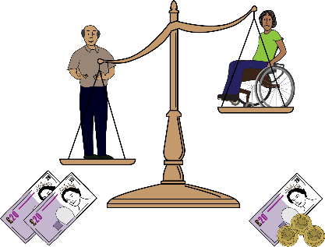 | In Northern Ireland, the disability pay gap in is 18%.  In Scotland, the employment support service has had very low success rates for Disabled people.
Disability pay gap: is the difference between the average hourly pay of disabled and non-disabled people.

 | Engagement, Monitoring and Data
The Westminster government does not keep data on Article 19 of the UN Declaration of Universal Rights (Everyone has the right to freedom of opinion and expression).

To find out about social care and independent living support in England a Freedom Of Information (FOI) request has to be made to all 152 local authorities.

Freedom Of Information (FOI): this gives you the right to ask any public sector organisation for information they hold. Anyone can ask for information.
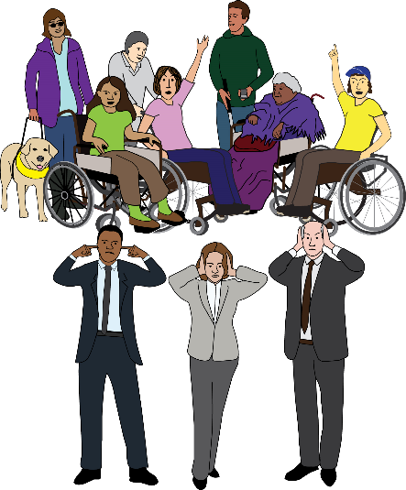 | The Westminster government and Department for Health and Social Care (DHSC) do not engage with Deaf and Disabled People’s Organisations (DDPOs) enough.  They still prefer to talk to the non-user-led charities. The views and concerns of DDPOs are being ignored.
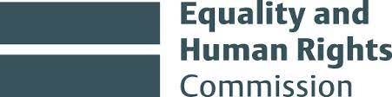 | In England, DDPO’s Organisations are worried that the Equality and Human Rights Commission (EHRC) isn’t doing its job properly.

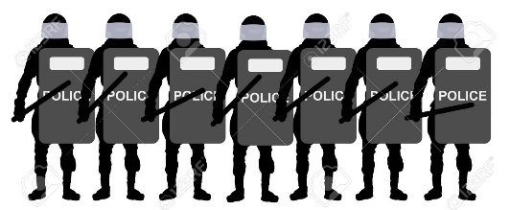  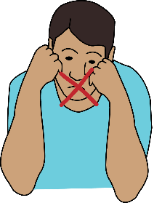  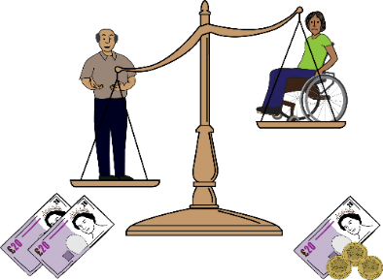  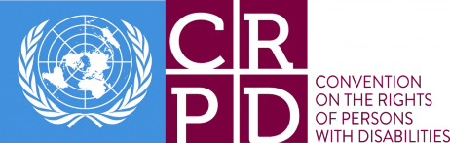 | Anti-protest legislation has made protesting a criminal offence. This will make it harder for Disabled people to get their voices heard and their issues understood by the public.  Disabled people are more likely to experience barriers created by the voter ID requirement.  DDPOs are frightened of speaking out in case they lose funding and can’t run their services.  In Northern Ireland, the disability pay gap in is 18%.  In Northern Ireland there is no monitoring of the Convention on the Rights of Persons with Disabilities (UNCRPD).
United Nations Convention on the Rights of Persons with Disabilities (UNCRPD): is an international human rights treaty of the United Nations intended to protect the rights and dignity of persons with disabilities.

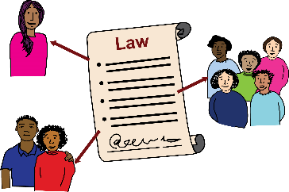 | In Scotland, the Government needs to measure the impact of laws, policies, and practices.  In Wales there is a lack of information about Disabled people.
 | Housing
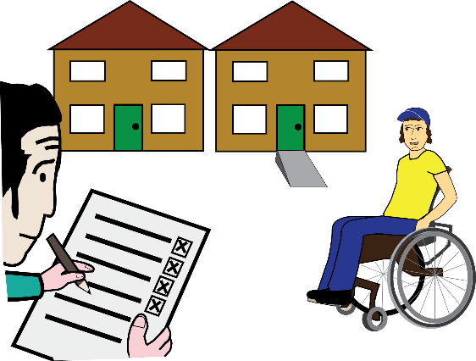  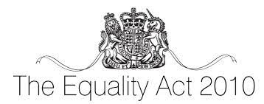  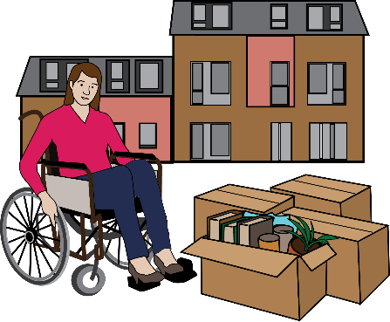  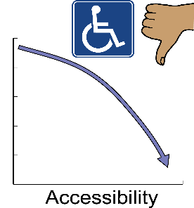 | There is not enough suitable housing for Deaf and Disabled people. This means they are likely to be more isolated.  Westminster government policy does not adequately address the lack of suitable housing.  The Equality Act 2010 does not provide sufficient safeguards against housing discrimination.  Problems with housing are made worse by local authorities and Housing Associations not carrying out repairs.  Disabled residents were among the people killed in the Grenfell Tower fire. They died because they were housed on upper floors because of a lack of suitable housing. They could not escape.  Northern Ireland is experiencing a housing emergency and budgets for housing are going to be reduced even more.  Deaf and Disabled people are trapped in unsuitable housing with no opportunity to move to accessible housing.  In Scotland, a quarter of Disabled people living in local authority housing said it was not fully accessible.  In Wales, some Disabled people said that they are having to move far away from their community or into places that are not good for them.
 | Independent Living
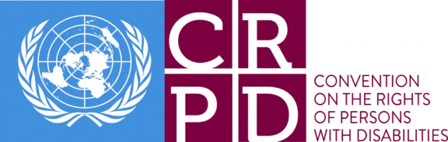  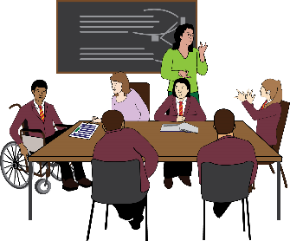  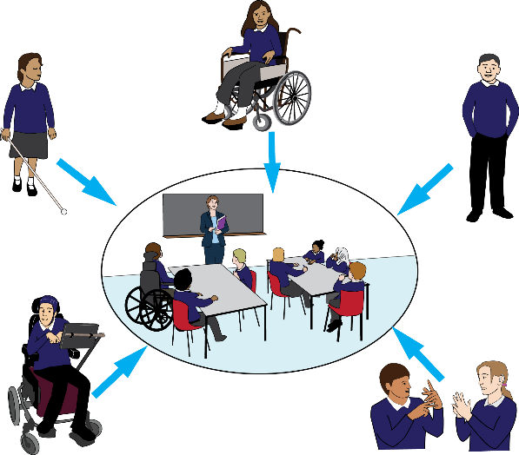  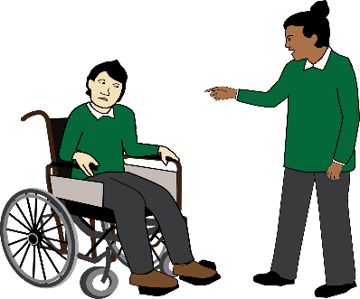  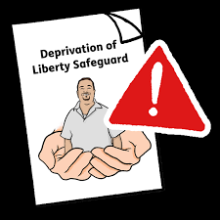  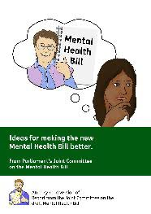  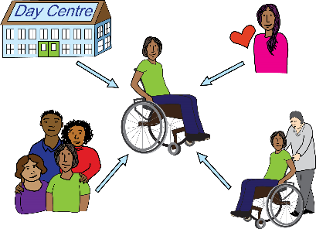  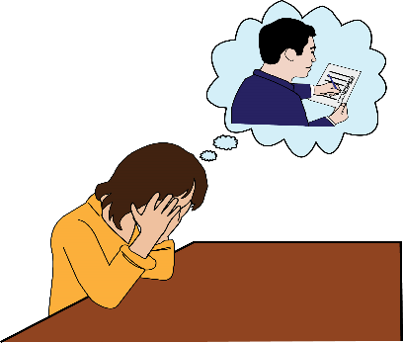  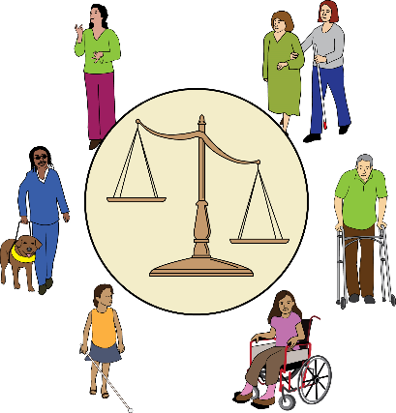  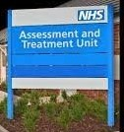  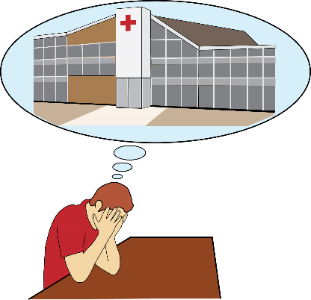  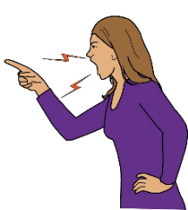  50%  50%  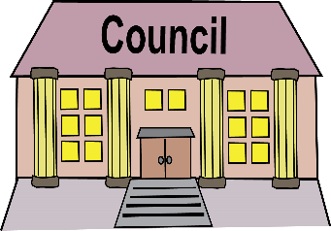  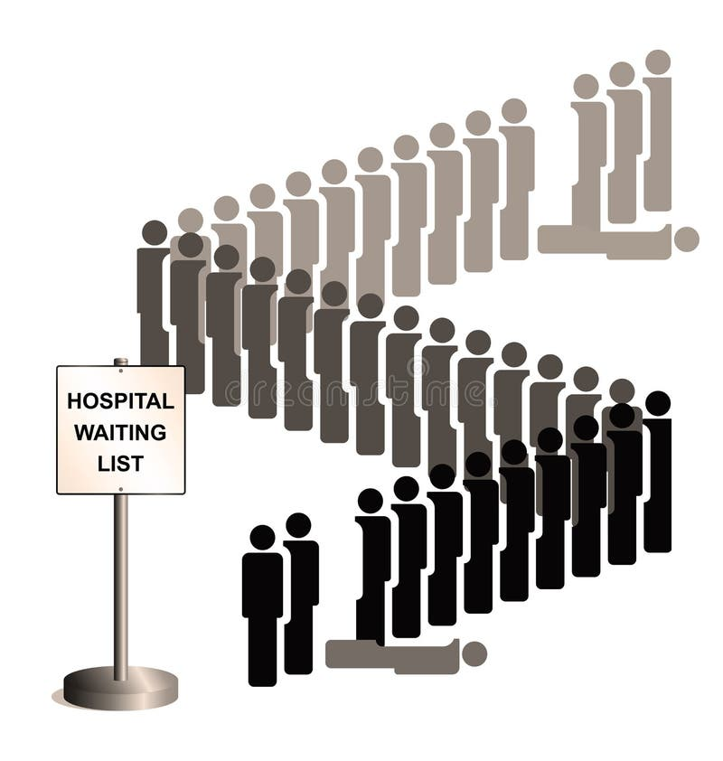  Social Care Services  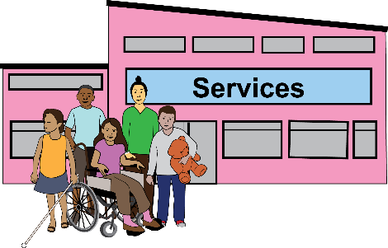  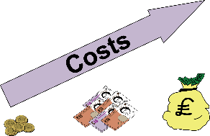  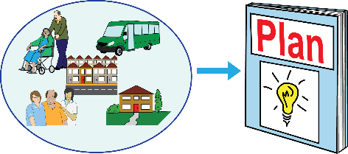  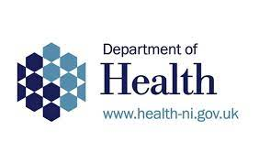  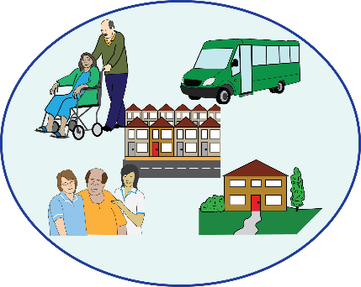  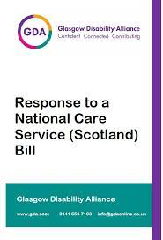  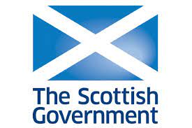  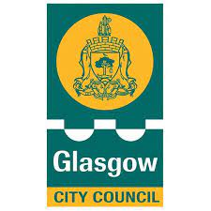  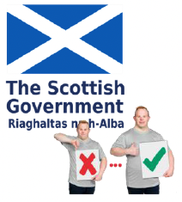  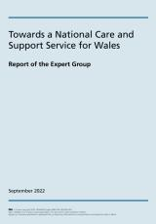 | Disabled people are being denied the right to inclusive education because the Westminster government does not apply this right as set out in Article 24 – Education of the UNCRPD.  The Westminster government have funded 59 new special schools and have plans for another 75. Placements in “special schools” have increased since 1999.  Disabled pupils are more likely to be excluded from school than non-disabled pupils.  The law still limits people’s rights and freedom based on mental health and learning disability diagnoses.  The draft Mental Health Bill 2022 was published after a review of the Mental Health Act. It still isn’t in line with the UNCRDP.  Services were already stretched before the pandemic.  Now there is even less support for Disabled people living in the community.  A lack of staffing and services, and cuts to social care funding has led to thousands of deaths.  Disabled people are being institutionalised in their homes because support is not available or good enough.  Disabled people are having their rights taken away and are not being respected.  Disabled people are at greater risk of crime and abuse.  In some cases, criminals take over someone’s home to use to deal drugs or for sex work.  The number of children being taken away from their parents by the State is higher than ever.  The government has not moved enough people with learning difficulties and autism out of hospitals.  Not having enough support in the community puts Disabled people more at risk of abuse and neglect in institutions.  Over the last 10 years Government funding for local authorities was cut by over 50 per cent.  Last year there were over 500,000 people waiting for social care services.  Many of the cases supported by the Local Government and Social Care Ombudsman (LGSCO) are being put down to the cuts to services.  Fifty per cent of councils have had to deal with care home closures and bankruptcies over the past six month.  Support for Disabled people to manage Direct Payments and employ their Personal Assistants (PAs) has been severely cut.  Social care charges have gone up a lot over recent years. This is forcing people to go without support and to get in debt.  In Northern Ireland there is no legal definition of Independent Living or a plan to promote it.  There is a mental health crisis in Northern Ireland. Levels of mental ill health are high, and budgets are low - lower than England.  The Department of Health in Northern Ireland has stopped funding 62 community organisations.  The demand for social care is increasing, services and programmes are closing, and access to funding is decreasing.  The National Care Service (Scotland) Bill in 2022 received a lot of criticism. There’s concern that it will not lead to any change.  The Scottish Government’s commitment to scrap social care charges has not happened.  £22 million of cuts were made to the social care budget in Glasgow City Council.  The Scottish Mental Health Law Review did not recommend changing the practice of detaining people with learning difficulties in hospital on the grounds of a learning difficulty alone.  The Welsh Government has committed to a National Care Service; but it is not clear what the service would look like.
 | Institutionalisation and abuse
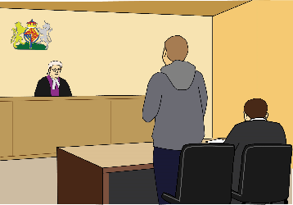  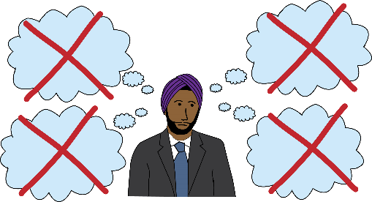 | In 2023, the BBC exposed over 100 reports of appalling abuse and neglect in children’s care homes in Doncaster. A lot more goes on that is not reported in the media.  Abuse scandals at several adult institutions have resulted criminal charges.  In Essex, around 2,000 people died between 2000 and 2020 while on a mental health ward, or within three months of being discharged.  The Scottish Government’s plan to reduce the number of people with learning disabilities living in hospitals is not good enough and will not be reach the targets set for March 2024.  Many people with a learning disability do not have choice and control over where they live and who they live with.
5. Disability Narratives
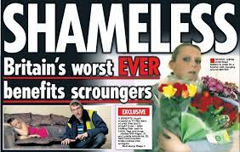  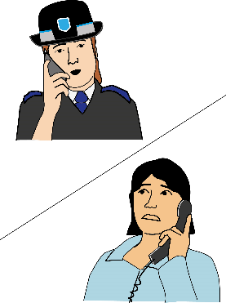  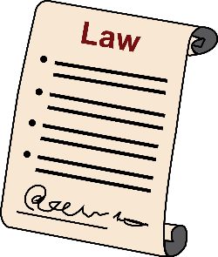 | The government has  done nothing to challenge negative press and public opinion about high levels of benefit fraud.  Reports of disability hate crime have increased but the amount of people prosecuted have remained low. During the pandemic policy did not value Disabled people’s lives.  There is also a lack of legislation for dealing with intersectional discrimination.
6. Barriers to justice
Individuals affected by bad government policy must make legal challenges within three months from when grounds to make a claim first arose. This means a lot of things do not get challenged.

Because it is harder to get Legal Aid there are less Judicial Reviews. A review of the law has not helped to make any improvements.

Legal Aid: is payment from public funds to help pay for legal advice or access to the court system. It is for people who are unable to afford legal representation and access to the court system. It is regarded as central in providing equal access to justice for all.

Judicial review: is when a judge reviews if a decision or action made by a public body is legal. In other words, judicial reviews are a challenge to the way in which a decision has been made, rather than the outcome.
Millions of people in England and Wales cannot get the help and advice they are entitled to. It is getting harder to get access to justice.

It is not easy to make complaints to the Local Authority. It is not possible to make appeals under the Care Act.

Because of cuts to Legal Aid there is a shortage of community care lawyers to challenge Local Authority decisions about cuts to social care support.
7. Engagement
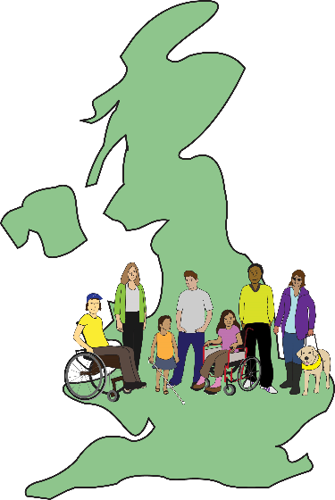  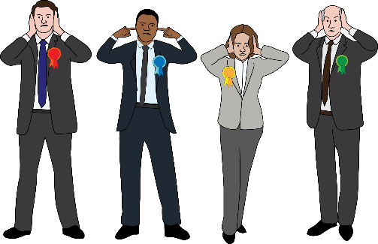 | The Westminster government sets UK-wide legislation and policies. Its engagement with Deaf and Disabled People’s Organisations on these issues should also be UK-wide but this does not happen.  The Westminster government does not like to hear any criticism of its policies.
8. Non-social/human rights model
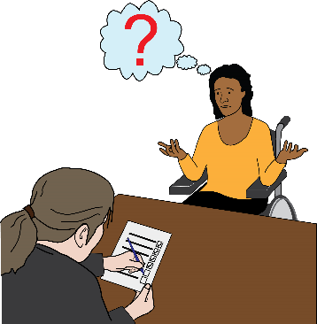 | The Westminster government uses the language of health rather than rights.  The Department of Work and Pensions looks at disability through assessing a person’s capability for work.
9. Monitoring, statistics and data gaps
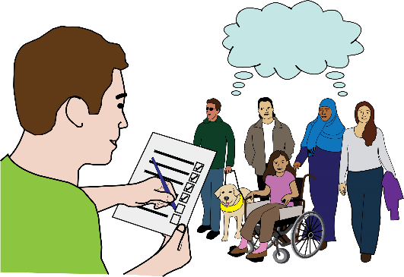  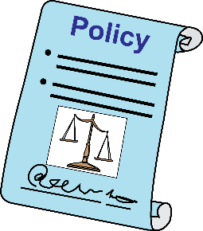 | The Westminster government does not collect as much information about disability as it used to. There’s a lot of missing information.  DWP has tried to block publication of reports about the impact of its policies on Disabled people.  Social security policies and approaches are not based on reliable information.  There are lots of different reasons why disability is increasing but there seems to be no plans to understand the rise.
10. CRDP Importance
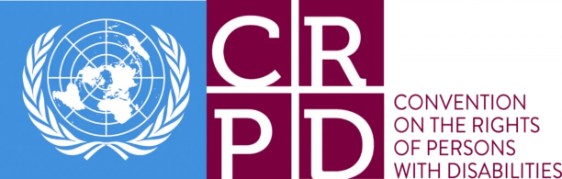  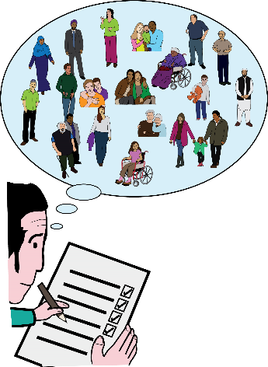  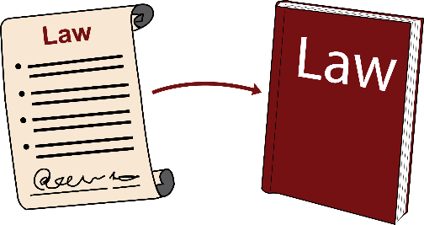 | The Convention on the Rights of Persons with Disabilities (CRPD) is very important to Deaf and Disabled people in the UK.  It is a benchmark against which to defend our rights and a vision of hope for the future.  We know that governments share information. Policy that affects Disabled people in the UK influences policies in other areas of the world and the other way round.  Disabled people across the UK are lobbying for the CRDP to be written into our legislation.

This Easy Read document has been produced by People First (Self Advocacy) 2023
www.peoplefirstltd.com

