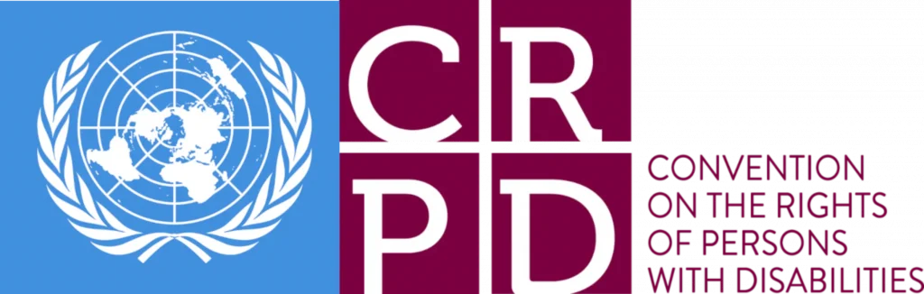

Report Summary – Section 1 and 2

- Introduction
 | This report gives information about United Nations Convention on the Rights of Persons with Disabilities (UNCRPD), particularly the Articles 19, 27 and 28.
The United Nations Convention on the Rights of Persons with Disabilities (UNCRPD) is a document about disabled peoples’ rights that the countries in the United Nations have signed up to - it is often referred to as the Convention. It says that Disabled People should be treated fairly and have the same rights as everybody else.

Articles: these are the different sections of the Convention (UNCRPD), starting with the purpose and principles of the Convention, through to the different rights disabled people should expect. The Convention has 50 articles.
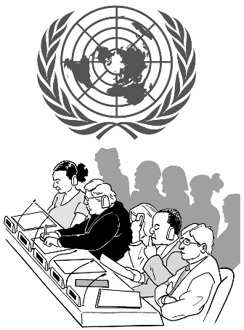  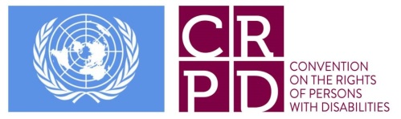 | In November 2016, the UN Committee on the Rights of Persons with Disabilities (the Committee) had an inquiry into Articles 19, 27 and 28.  The Committee published what they found out and made some recommendations.  This report gives information about how these Articles are being put into place by the UK Government since November 2016.
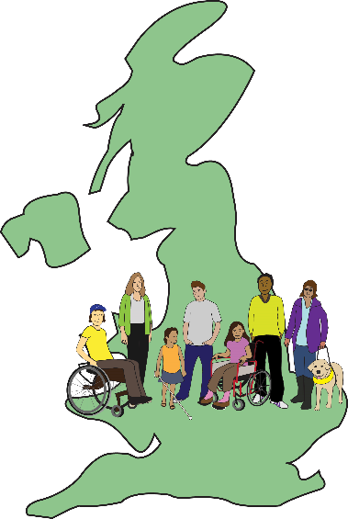 | This report has been put together by Deaf and Disabled People’s Organisations (DDPOs).  These organisations are in England, Wales, Scotland and Northern Ireland.
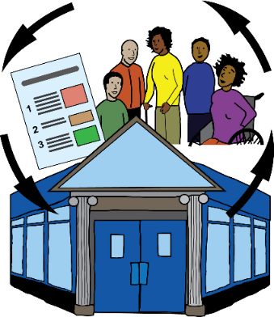  User-led | Deaf and Disabled People’s Organisations are run and controlled by Deaf and Disabled people. In this document we will call them DDPO organisations.
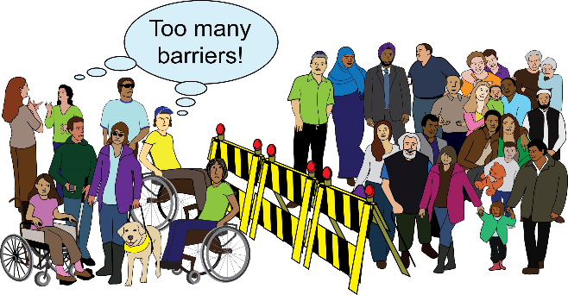 | These DDPO organisations follow the social model of disability. They also follow the cultural model of Deafness. These are based on a human rights model.
Social model of disability: states that people have impairments but that the exclusion and discrimination people face is not because of an impairment, but by the way society is run and organised. People are ‘disabled’ by barriers in society that exclude and discriminate against them.

Cultural model of deafness: focuses on the shared experiences, histories and the important role that sign language has within the Deaf community. It aims to have the culture and language of the Deaf community recognised as a minority.

Human rights model: says that all forms of Disability must be respected. Disabled people have the same rights as everyone else in society. Impairment must not be used as an excuse to deny or restrict people’s rights.
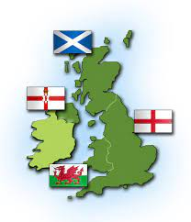 | When making laws and policies in the UK, some issues are reserved, and some issues are devolved.
Reserved issue: This means when laws and policies are made by Westminster Government. They must be followed by all 4 nations in the UK. Or by some of the nations in the UK.

Devolved issue: this means an issue that is the responsibility of the governments in each nation (Northern Ireland, Scotland, and Wales).
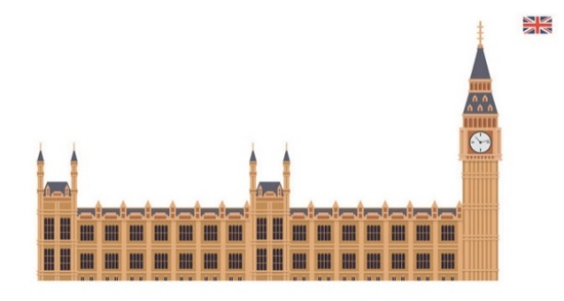 | The Westminster government also functions as the national government of England.
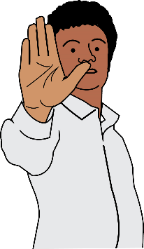  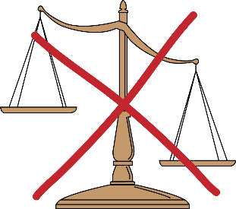 | Some measures have been taken by devolved governments to stop the harmful effects of laws and policies set by the Westminster Government.
Some measures have been taken by devolved governments to take action.

This is when the Westminster government have not taken action.

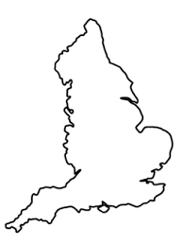  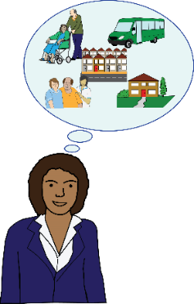 | Deaf and Disabled people’s organisations in England do not have these protections.  Responsibility for social care support in England is devolved by Westminster Governments.  It is devolved to local authorities and the devolved nations.
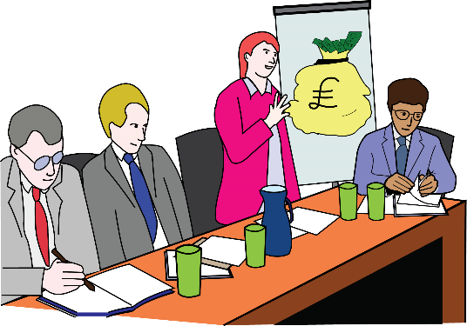 | Northern Ireland is facing a crisis when it comes to politics and economics.  There have been some really big cuts to budgets.
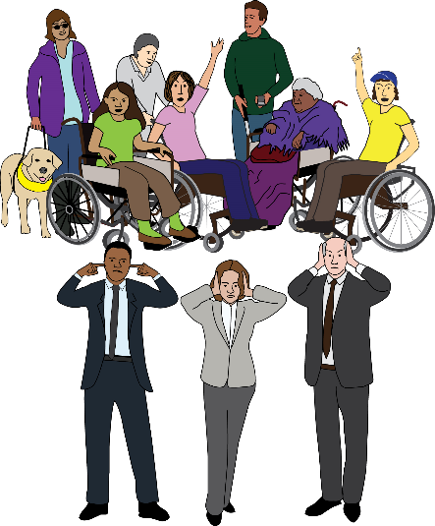 | Decisions to get rid of services and make cuts to other services are being taken by senior civil servants. They are not taking any responsibility for their actions.
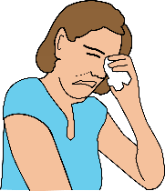 | These cuts are having a really negative impact on Deaf and Disabled People. They are affecting them more than anybody else.
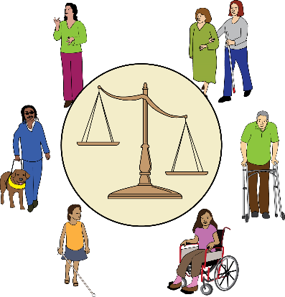 | Our rights as Deaf and Disabled people are being violated. This is because of welfare reform and  austerity.
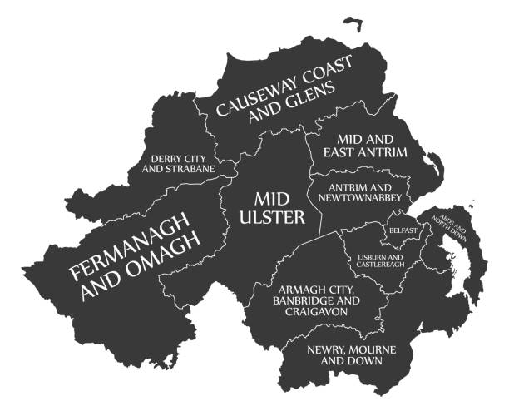 | Rights are also being violated because of the political crisis in Northern Ireland.  There are around 410 thousand Deaf and Disabled People in Northern Ireland.
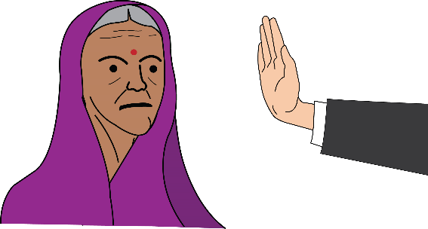 | Deaf and Disabled People face extra barriers if we have other protected characteristics. This means we face more than one kind of oppression.
Protected characteristics: are personal characteristics or situations set out in the Equality Act 2010, that cannot be used as a reason to treat anyone unfairly. The 9 protected characteristics are age, disability, gender reassignment, marriage and civil partnership, pregnancy and maternity, race, religion and belief, sex, and sexual orientation.
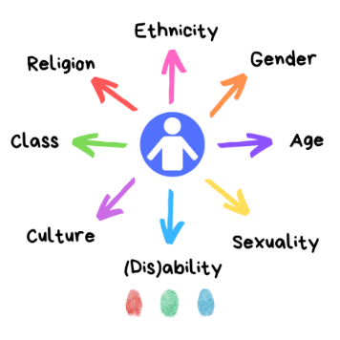 | Intersectionality is often ignored in policy planning. This means that Deaf and Disabled People face even more risks in their lives.
Intersectionality: this is when individuals or groups experience more than one form of discrimination such as racism, sexism, or ageism
- Overview - What has been happening since 2016?

 | Lots of organisations in the UK think that the Committee’s recommendations have not been put into place.
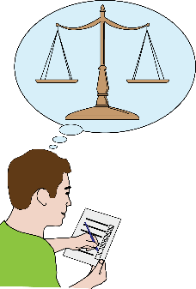  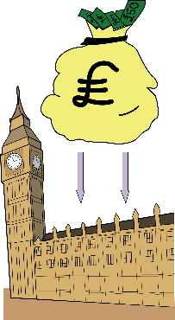 | Westminster Government is still not monitoring rights under Article 19. It gives away its responsibility for meeting these rights.
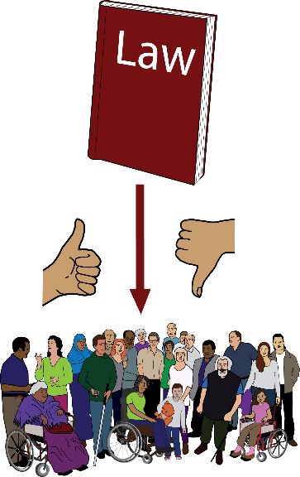 | There is no system to make sure people are responsible for the decisions they make.  In England, the situation has got much worse since 2016.
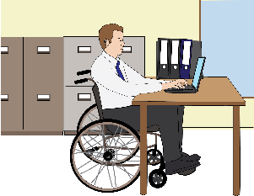  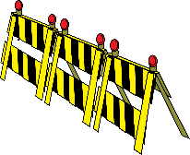  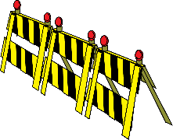 | Deaf and Disabled People face many more barriers to work since 2016. This affects Deaf and disabled workers in an unequal way.
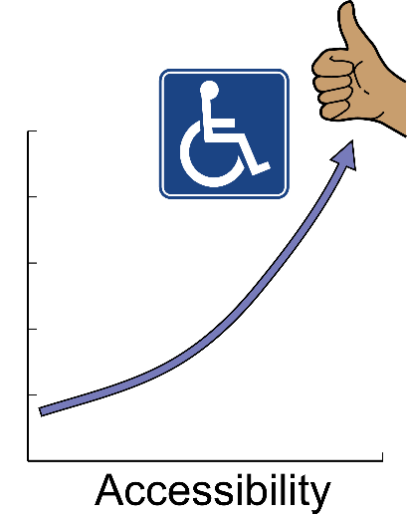  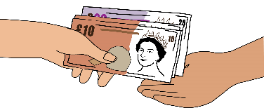 | The most important thing for the Westminster Government is to get Deaf and Disabled people out of the social security system.  They don’t care whether they have enough money for basic living costs like food and bills.
 | Independent Living
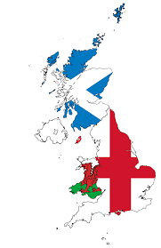  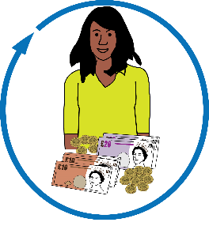  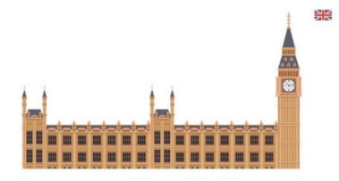  2010 | Support to live in the community is devolved.  However, the devolved governments have been affected by the Westminster austerity and welfare reform policies since 2010.
There are huge barriers to rights when it comes to independent living.

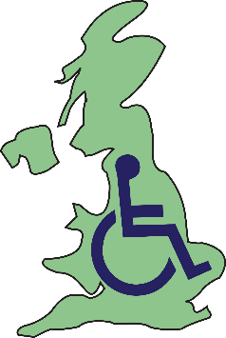
This is affecting Deaf and Disabled People across the UK. 1.2 million use social care support services.

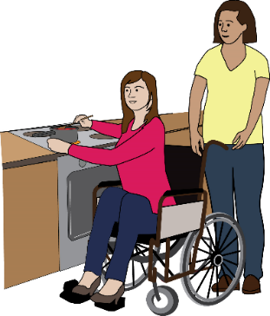 | Some people have support to live in the community.  Some people don’t have this support. It depends on the nation.
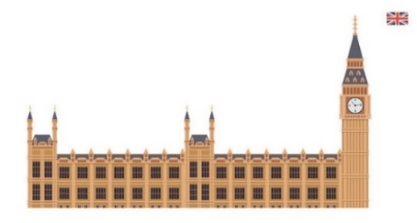  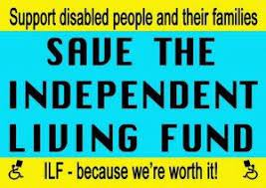  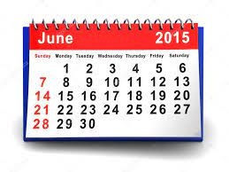 | Westminster closed the Independent Living Fund.  They closed it from the end of June 2015. At the time, 18 thousand people were using this across the UK.
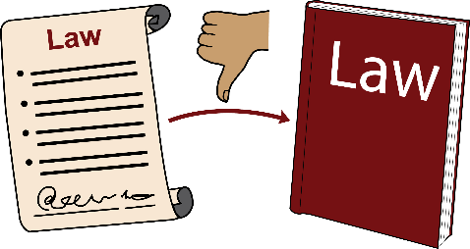  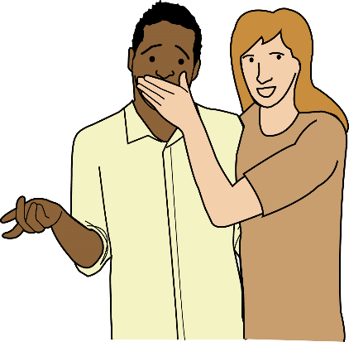  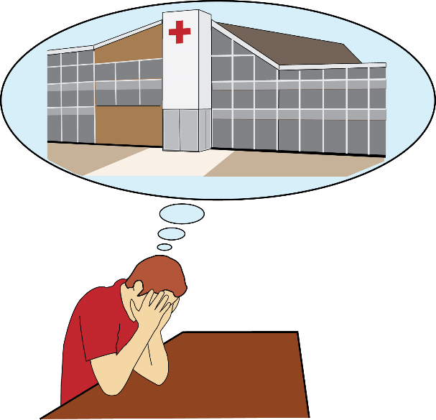 | Mental health laws keep allowing these things to happen:  - Substitute decision-making, this means when a person makes decision about treatment or services on behalf of somebody else.  - Detention in psychiatric institutions, this means being forced to stay in hospitals.  - Involuntary treatment, this means being given medical treatment that you don’t want.  - The use of community treatment orders (CTOs).
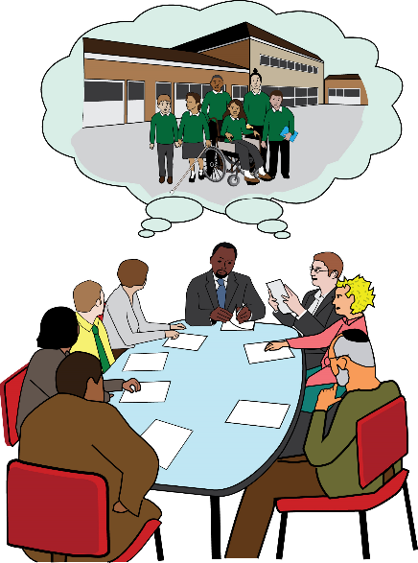 | Westminster still has its reservation and interpretative declaration in place.  They are putting money into building new special schools.
 | Employment
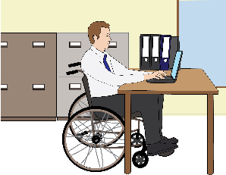 | The number of Deaf and Disabled People in employment has gone up since 2016.  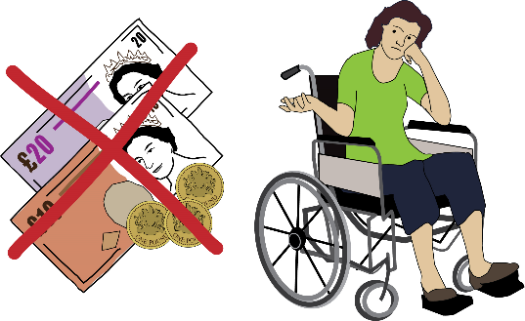  The number of economically inactive Deaf and Disabled people went up by 273,000. This was between 2022 and 2023.  The numbers of unemployed Deaf and Disabled people stayed the same.
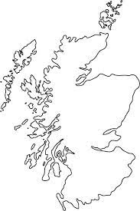  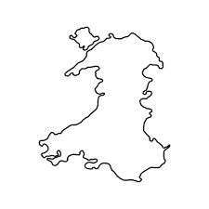  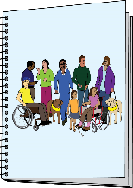  31.6%  32.3%  32.4%  42.9% | These places have the highest disability employment gaps:  - Northern Ireland  - The North East of England  - Scotland  - Wales
Disability employment gap: this is the difference between how many disabled people are in work compared to how many non-disabled people are in work.

Over the past 10 years the gap between the number of Disabled people and non-disabled people in employment has been around 30%.
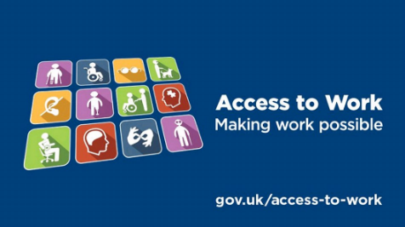 | It is still very hard to assess the Access to Work disability employment support programme.  In 2022, there were still nearly 21 thousand cases waiting for their decisions.
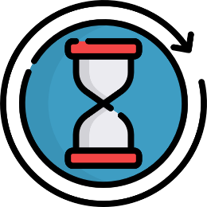  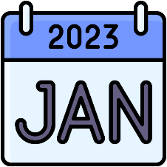 | In January 2023, it was reported that there were long delays for applications and claims.  Sometimes people were waiting for as long as half a year. This is putting thousands of jobs at risk.
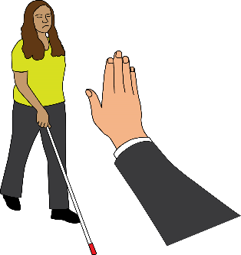  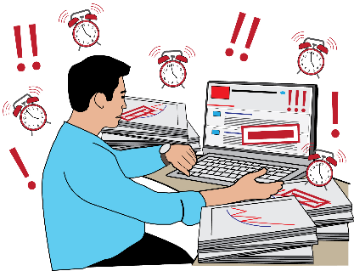 | Here are some other examples of more barriers to employment:  - There is more and more disability discrimination in the workplace.  - People are being given more tasks to do at work. They don’t have enough time to do all these tasks.  - There are more bad work opportunities. For example, there is more job insecurity. There are more jobs without protections such as sick pay.
Job insecurity: this is when you feel like your job isn’t safe and worry that you could lose it at any time.

Sick pay: is the money you get from your employer instead of your normal wages when you are ill and unable to work.
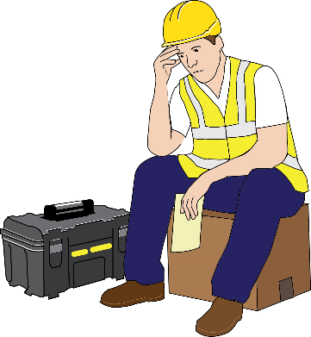 | There are more and more deaf and disabled people in work where:  There is no guarantee they are in work that suits their needs.  There is no guarantee that the work will give them a living income.
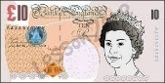  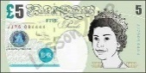  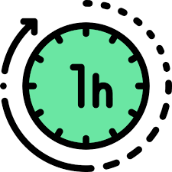  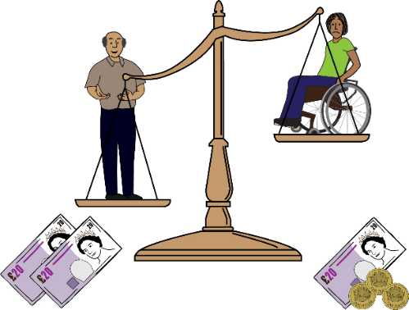 | There are lots of Deaf and Disabled people on low pay, compared to other groups in society. The disability pay gap has widened.  7 in 10 disabled workers earn less than £15 per hour. This is compared to 5 in 10 non-disabled workers.
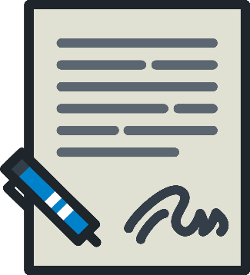  ZERO HOURS | There are lots of Deaf and Disabled people on zero hours contracts, compared to other groups in society.
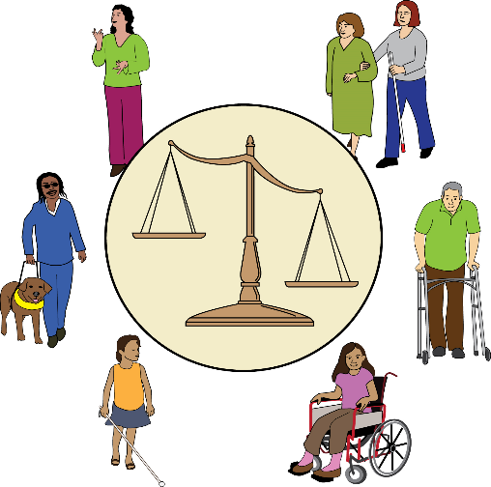  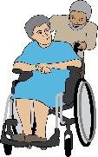  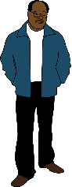 | Intersectional discrimination affects workers with protected characteristics. For example, they are more likely to face barriers to employment and pay gaps.
Intersectional discrimination: is being treated differently or in an unfair or worse way on a combination of characteristics, such as your disability, gender and race. When this happens, it is hard to separate them.
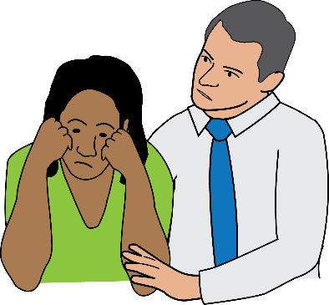 | Disabled women workers are more likely to face sexual harassment in the workplace than non-disabled women workers.
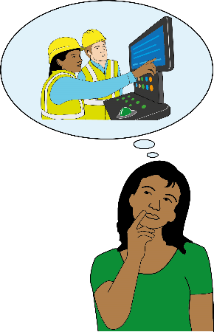  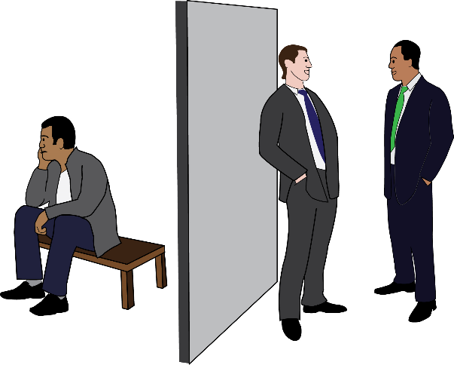 | We have heard about more and more disability discrimination in the workplace.  Reasonable adjustments have not been put in place by employers.  Poverty has pushed Deaf and Disabled people further and further away from employment.
 | Social and security and poverty
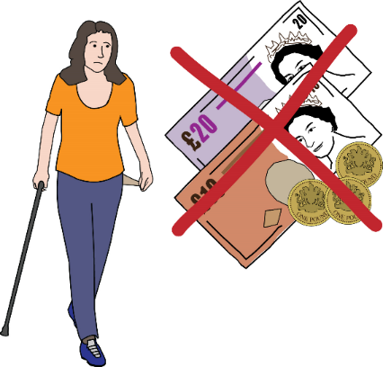 | 7.2 million people in households with a disabled member are living in poverty. This adds up to half of all poverty in the UK.
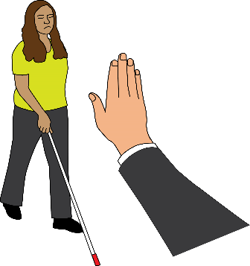 | Deaf and Disabled People are almost three times as likely to not have access to essential items such as food, clothes and heating. This is compared to the rest of the population.
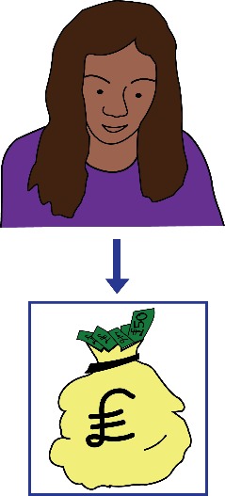  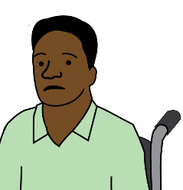 | 1 in 3 adults who get the lowest household income are disabled.  Just 1 in 10 adults in on the highest household income are disabled.
Household income: is the total income received by all members of a household (over 15 years old) within a 12-month period.
2010  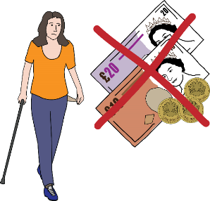  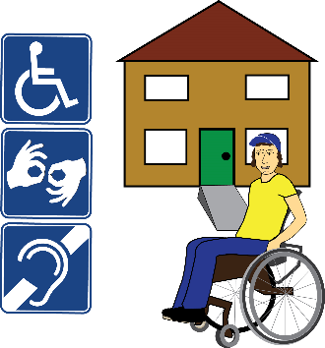 | Deaf and Disabled people have lost out the most because of the tax and welfare reform. This has been happening since 2010.  If there are more disabled people in a household, there is more cash lost per year.  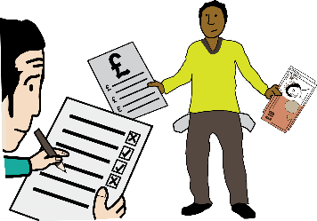  Benefits in the UK are low compared to other countries. People don’t get a lot of benefits compared to the amount that people get paid to work.
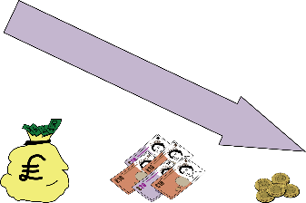  2010  2023 | When working out the value of benefits, the amount has gone down a lot. People are getting £40 less per month than in 2010.
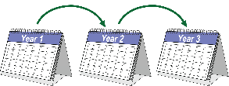  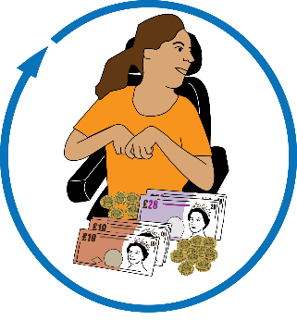  Year 4 | Use of foodbanks and homelessness have gone up.  The four-year benefit freeze affected 27 million people. It pushed another 400,000 people into poverty.
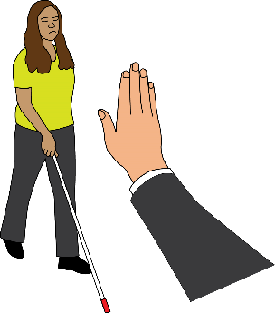 | Westminster expected around half of the households who would lose from the benefit cap to have someone who is disabled living in it.
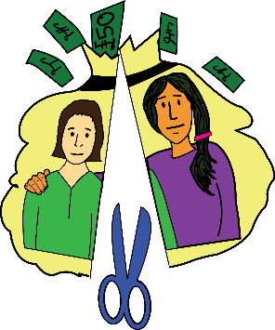 | After the benefit cap was lowered more than 10,000 with a disabled adult had their benefits cut.
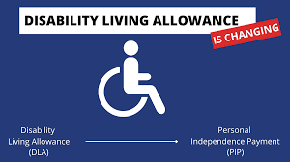 | The Disability Living Allowance (DLA) was replaced with Personal Independence Payment (PIP). Lots of Deaf and Disabled people lost income because of this.
2018 | In June 2018 it was reported that over 3,000 Disabled people receiving Disability Living Allowance (DLA) were turned down for Personal Independence Payment (PIP) when they were reassessed.
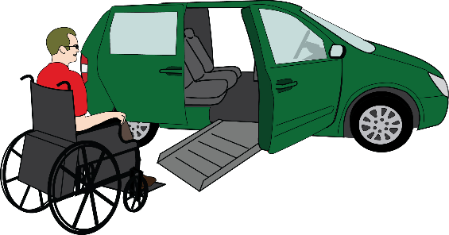  2020 | By January 2020, 102,000 Motability customers had lost Personal Independence Payment (PIP) awards that paid for vehicles for travel and mobility.

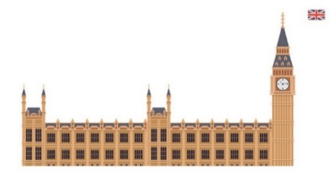  2017  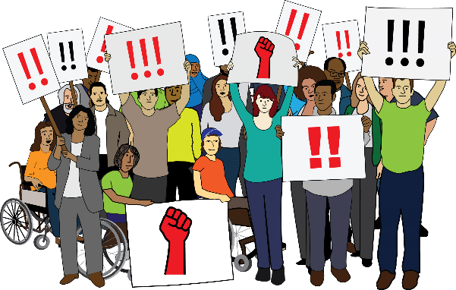  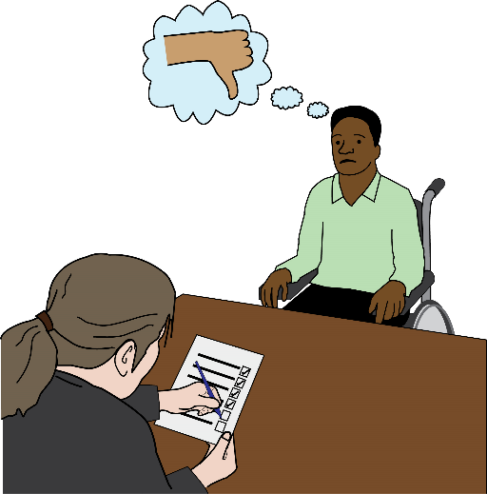  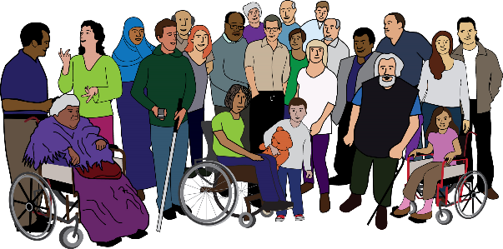  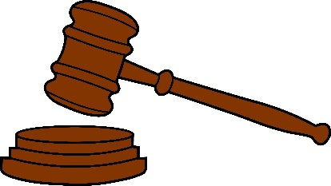  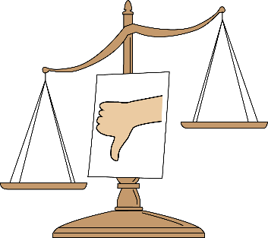 | In April 2017 the Westminster government reduced benefit payments by £30 per week for all new claims for Employment Support Allowance (ESA) and Universal Credit (UC).  There was a lot of opposition from Deaf and Disabled People’s organisations, MPs and members of the House of Lords and United Nations.  Despite this, benefits were reduced for people who received Employment Support Allowance (ESA) and were placed in the “Work Related Activity Group” (WRAG) following a Work Capability Assessment (WCA).  As of May 2016, there were 429,000 in the Work Related Activity Group (WRAG).  In December 2017, the High Court ruled that changes that the UK government made to Personal Independence Payment (PIP) were an attempt to stop people getting the benefit. The court said this was discriminatory.
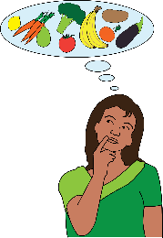  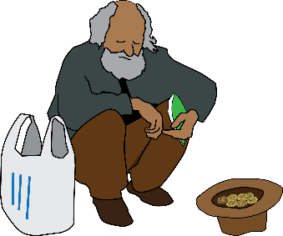  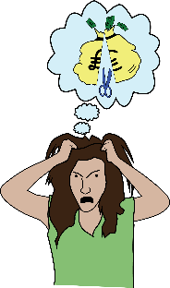  \\\\\\\\\\\\\\\\\\  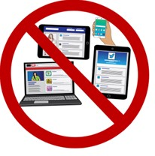  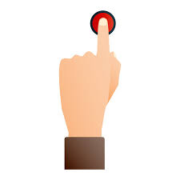 | The Westminster government continued to roll out Universal Credit even though there was lots of evidence that it was making things worse.  There didn’t seem to be any thought about how the digital system for Universal Credit (UC) would exclude a lot of Deaf and Disabled people.  Calls for existing claimants to be automatically enrolled onto Universal Credit (UC) were also ignored.
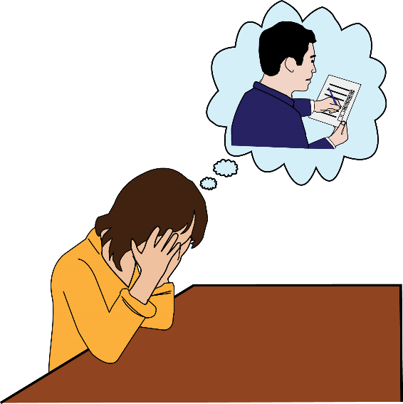  2010  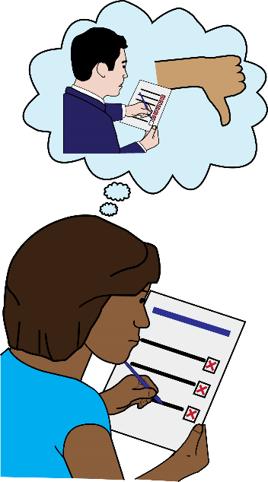  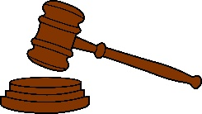 | The benefits assessments that were introduced in 2010 still cause a lot of distress. The assessment process is complicated.  Reassessments cause a lot of anxiety because of the threat of having benefits stopped or losing some of the money.  In 2013 the high court ruled that the Work Capacity Assessment discriminates against people with mental distress. This is because people must collect and send off their own evidence.
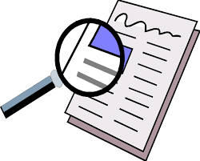  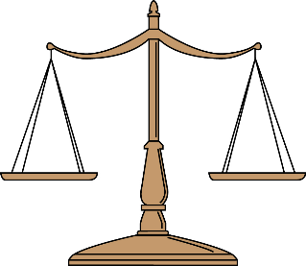  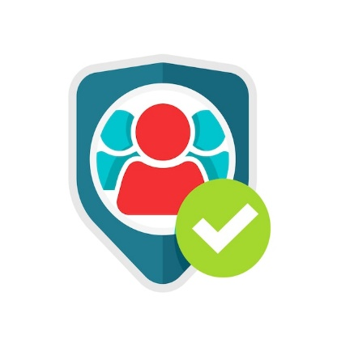  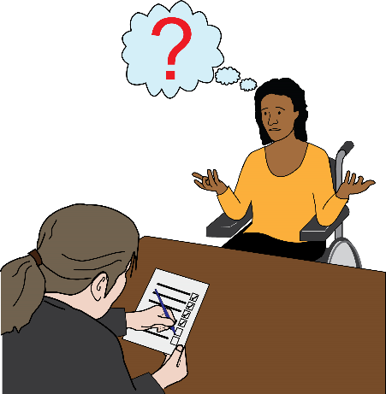  2013 | The quality of reports is poor with important information missing. This makes it difficult to really understand the current situation.  The amount of assessment decisions overturned at appeal is very high.  The Westminster government is ignoring its safeguarding duty to benefit claimants. It is also avoiding doing an inquiry into benefit related deaths.  In 2013 the Westminster government brought in another stage to the assessment process. This was called ‘Mandatory Reconsideration’.
Mandatory Reconsideration: if you disagree with a benefits decision, you can ask the Department of Work and Pensions to look at it again to see if the decision was right.
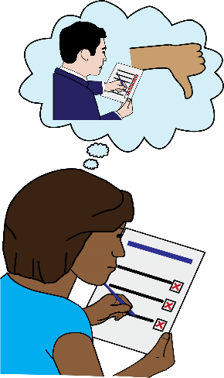  2020 | In 2020 the High Court ruled that forcing claimants to go through a Mandatory Reconsideration for Employment Support Allowance (ESA) was unlawful. It remains in place for PIP.
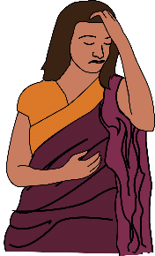 | Benefit changes and sanctions continue to be linked with deaths, suicides and harm.
Sanctions: this is when some of the money from your benefit is taken away or stopped for a period of time. This is because you haven’t done the things the Jobcentre expects you to do in order to get your benefit payments. These things are set out in an Agreement or Claimant Commitment.
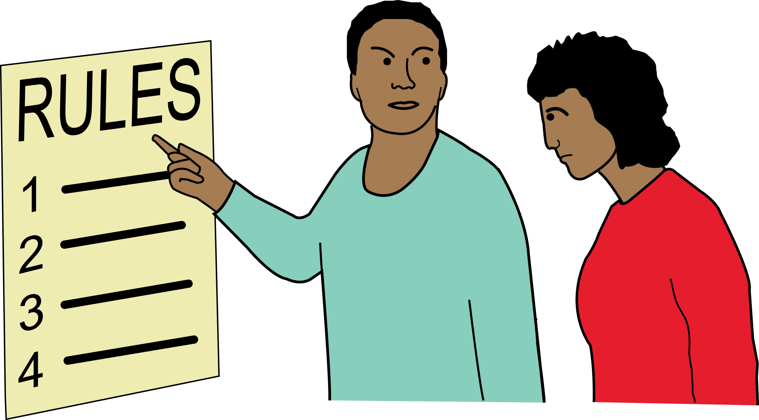 | There is evidence of a ‘culture of hostility’ towards benefit claimants within the Department of Work and Pensions. Staff have reported getting pressured to apply sanctions.
Culture of hostility: in this document it refers to the negative attitudes and discouraging actions of DWP staff towards benefit claimants. This creates long lasting distrust, discrimination, and destitution.
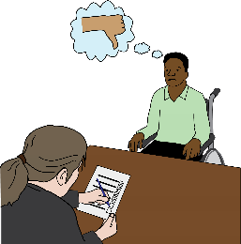 | In March 2023 the Westminster government announced the end of Work Capability Assessments.
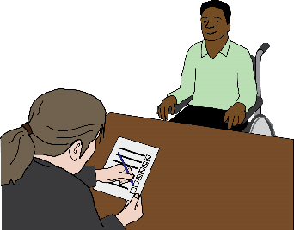  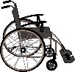 | There will now be just one Personal Independence Payments (PIP) assessment for out-of-work and extra costs disability benefits.
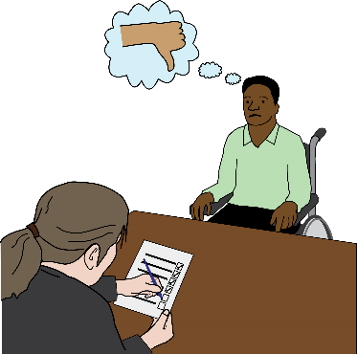  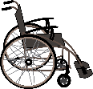 | The worry is that if you are assessed as not being eligible then you risk losing both benefits at once.  People who get PIP will get a new “health element”.
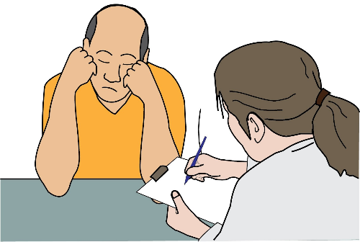  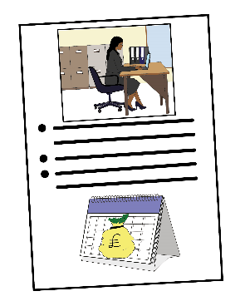  ! | Work Coaches will decide the level of work-related activity for each claimant. The worry is that they are not experienced enough to make these decisions.
 | In September 2023 the In-Work Progression scheme will be brought in, affecting around 600,000 claimants.
In-Work Progression: this is a scheme to encourage claimants in low-paid work to increase their earnings by working extra hours or taking another job.
 | It will be difficult to see if Deaf and Disabled people are being discriminated against by this policy. This is because separate information about sanctions is not kept under Universal Credit.
 | Mitigating measures
 | These are things that can be done to reduce the risk of harm or restrictions.
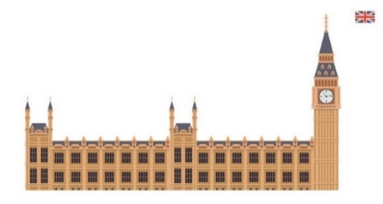 | Some action has been taken to reduce the impact of policies brought in by the Westminster government.
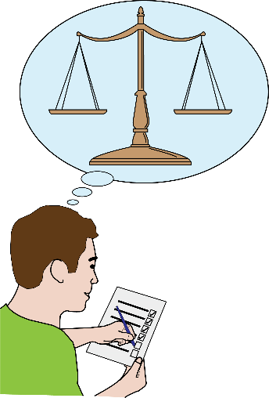 | In Scotland, there are concerns that the principles of human rights are not put into practice. Time taken to process payments has increased from weeks to months.  In Wales, Action on Disability: Framework for Independent Living is an action plan aimed at reducing or removing social barriers to equality experienced by Disabled people.  Since 2020, all public bodies in Wales must consider the impact their activities have on people with lower levels of education and lower rates of income.
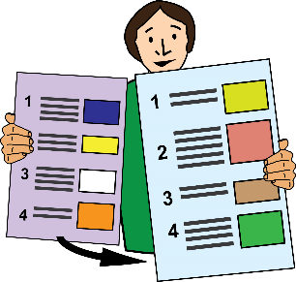

This is the end of Part 1 of the document.

Please go to Part 2 to read:
Section 3: New issues
Section 4: Devolved issues
Section 5: Disability narratves
Section 6: Access to justice
Section 7: Engagement
Section 8: Non-social/human rights model
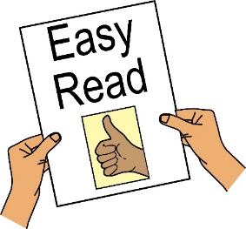

This Easy Read document has been produced by People First (Self Advocacy) 2023
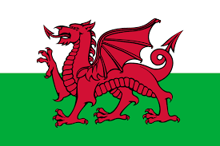
www.peoplefirstltd.com

