DDPO Disability Hate Crime
Data Project – Final Report
How to Make Things Better?
August 2023
We have some ideas that could make support for disabled victims better.

More Support for DDPOs in the Community

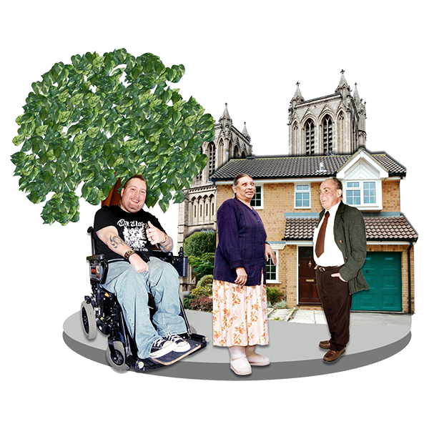
We think support in the community is important.
The DDPOs gave support in many ways to victims.

DDPOs had staff who knew a lot about helping hate crime victims.
This meant victims were listened to and got the right help.
DDPOs get money to do their work.
But this is not always enough for them to do all their work.
DDPOs should get more money to build their relationship with the community.
Funding is often short term.
This means DDPOs must apply to get money often.
Sometimes this is every year.

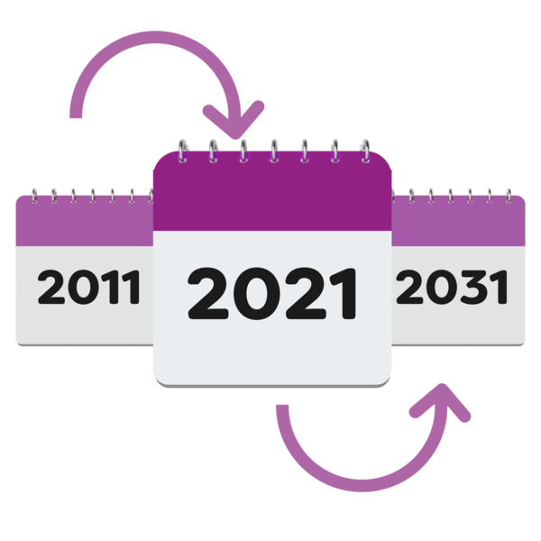
Applying for this money takes a long time.
It would be better if they only had to apply every 5 years.
Or even every 10 years.

They could do a lot of work in 5 or 10 years.
They would know their project would be around for a long time.
This is better for victims.

All Support Should Be Accessible
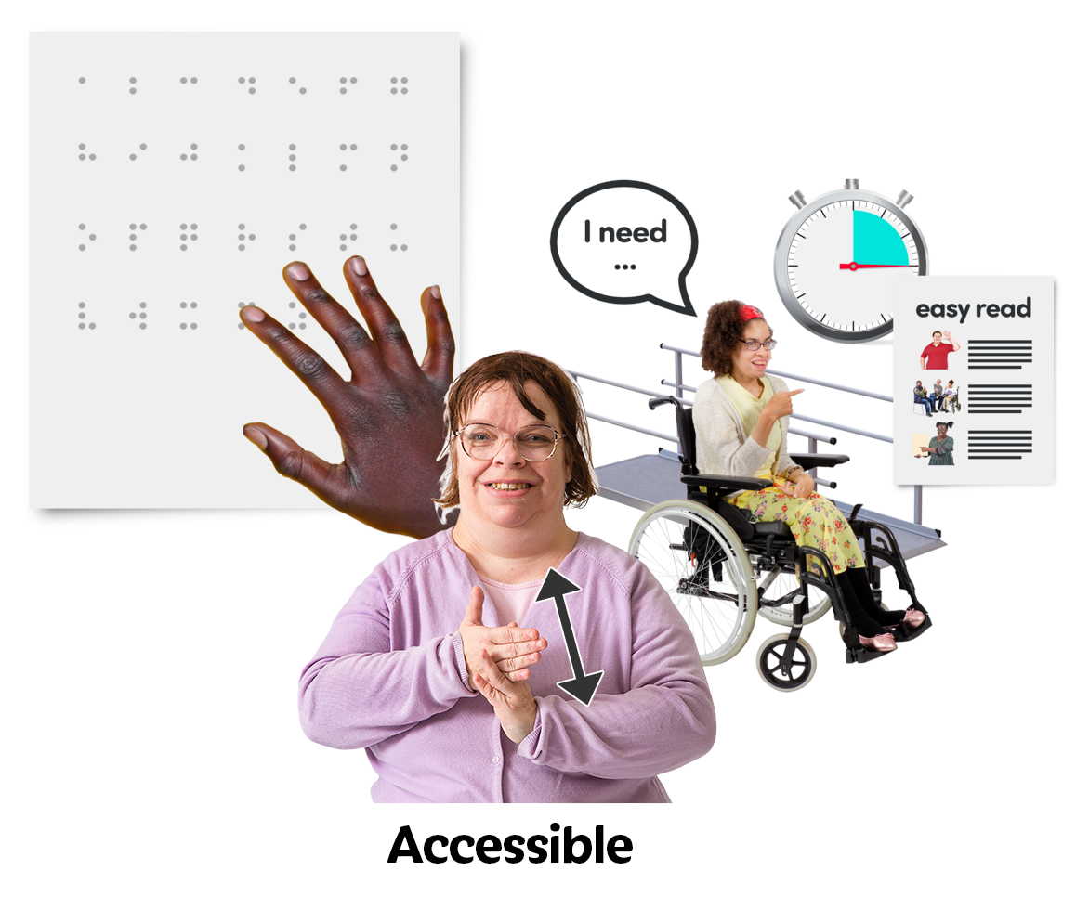
Next, we think all support should be accessible.
This means Disabled people can access that support.

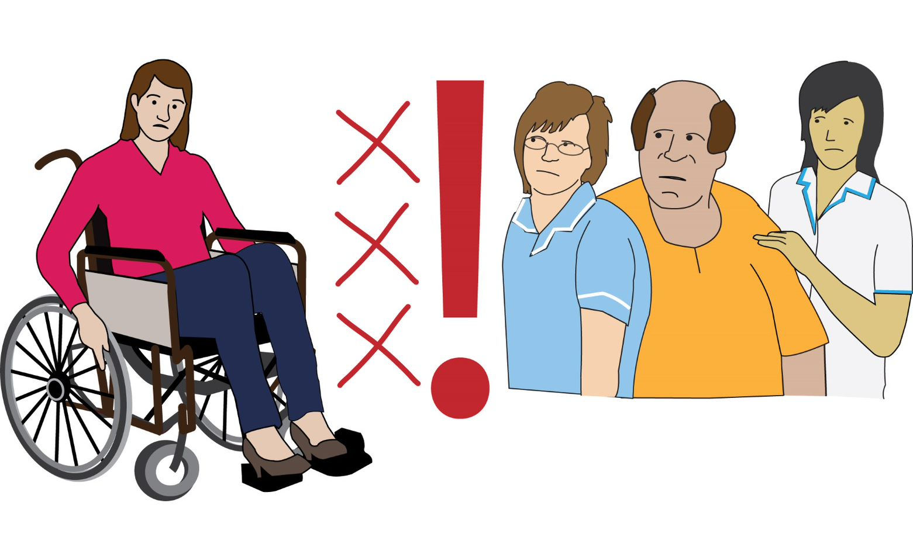
There are too many barriers to getting support.
Disabled people cannot get the help they need.
These barriers need to be removed.

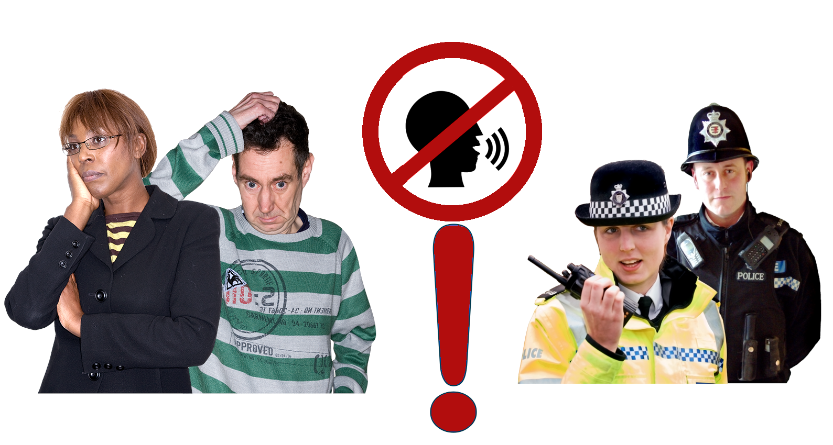
Also, not everyone wants to talk to the police.
They might not want to treat what happened to them like a crime.

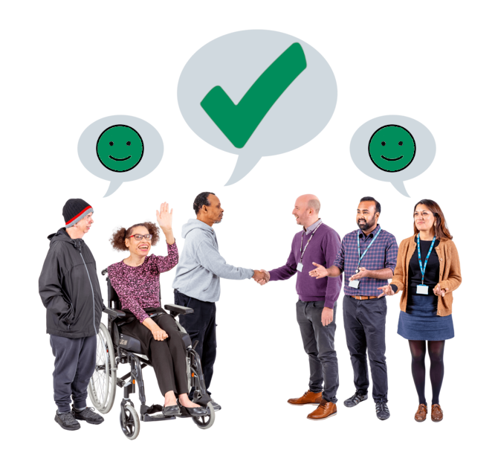
There can still be good results without going to the police or to court.
It would be good to have more ways to help people like this.

Sometimes, hate crime work is only called a success if more police reports happen.
But there is good work that would never make more hate crimes be reported.
This work is still important.

Ideas from the ‘Poor Police Response’ report

We talked about other things to change in our Poor Police Response Report.
For police, we said these things.

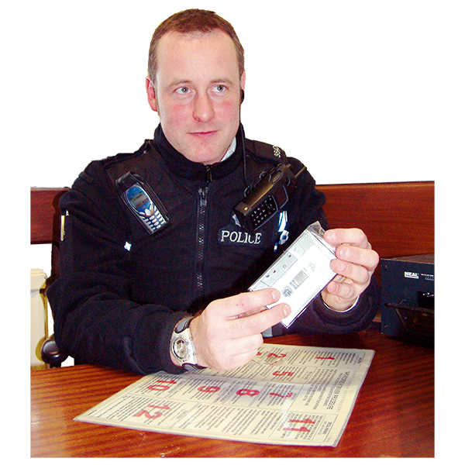

Bring back Disability Hate Crime Matters Initiative.
This was something that helped police take reports of hate crime.

Use the Metropolitan Police Disability Independent Advisory Group.
These are Disabled people who can give the police advice.

Work closer with the Crown Prosecution Service to look at hate crime cases.
This would help understand hate crime against Disabled people better.

The Crown Prosecution Service decides if and how someone will be prosecuted for a crime.
This means they decide what happens to someone when enough evidence has been found for a case.
Work with other organisations for high-risk anti-social behaviour and hate crime cases.
This would help find Disabled victims of different types of harm.

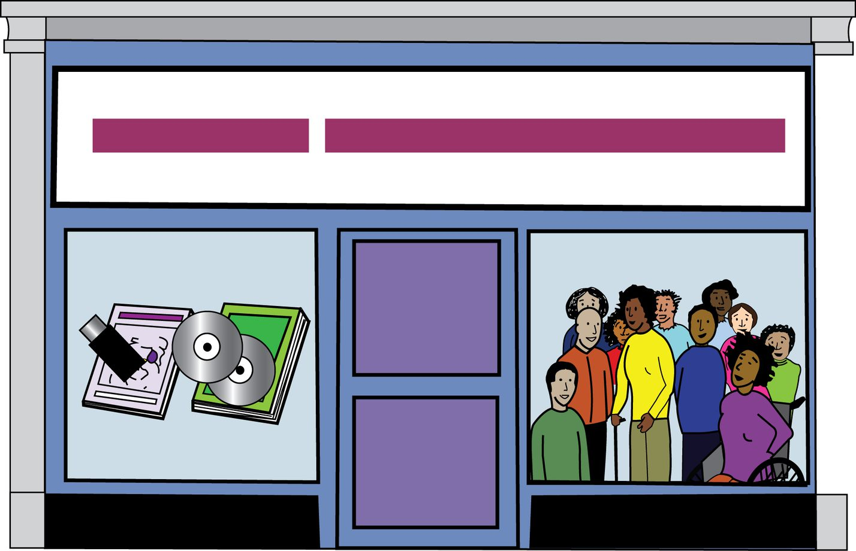
Work closely with DDPOs.
Especially the DDPOs in their CATCH partnership.
This is a group set up specially for hate crime work.

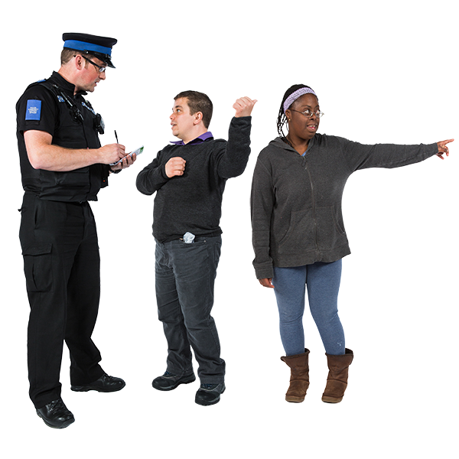
Stop Disablism in police work.
Make sure people who become police have good values and attitudes towards different groups of people.

Getting training from Disabled people and supporting Disabled police officers.

Use different tools, information, and software to spot hate crimes before they happen again and again.

For the Crown Prosecution Service, we had these ideas.

Disabled victim cannot trust police who harm Disabled people.
In our work, we found too many times this happened.

Police need to be made to leave when they harm Disabled people.
But, if bad police are got rid of quietly, no-one knows they were punished.
So, the CPS should give out information when they get rid of bad police.

The CPS and police can work together to rebuild trust in the community.
They need to understand how and why Disabled people do not trust the system.

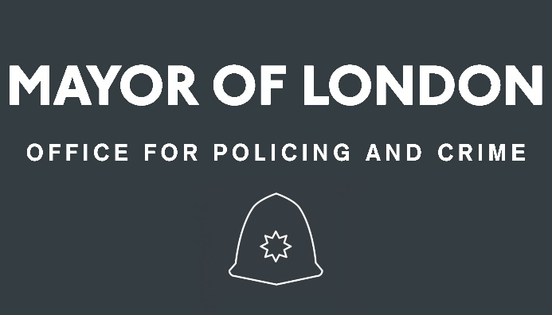
For the Mayor’s Office of Police and Crime, we have these thoughts.

There needs to be better funding through the small grants scheme.
Disabled people need local support to get the help they need.

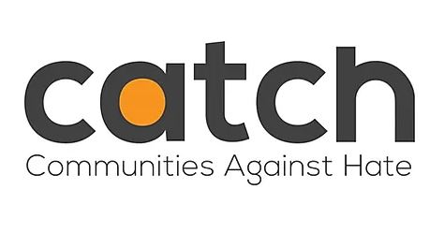
There needs to be more information about the CATCH partnership.
There must be more information about disability hate crimes and how to report them.
The Mayor’s Office also need to work with the Deputy Commissioner’s Delivery Group.
This is another group that give advice on how to improve their work.

