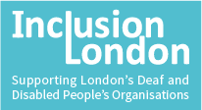

DDPO Disability Hate Crime
Data Project – Final Report
Quick Information
August 2023

Quick Information

This report is about the data from our Disability Hate Crime data project.
It is about the data Deaf and Disabled People’s Organisations (DDPOs) gave us.

Here data is facts or numbers about something. On its own, it does not tell us much.
When we put it together with lots of data, it gives us information. This is useful.

All the data and information is about disability hate crimes.
It is about work done between July 2021 and March 2023.

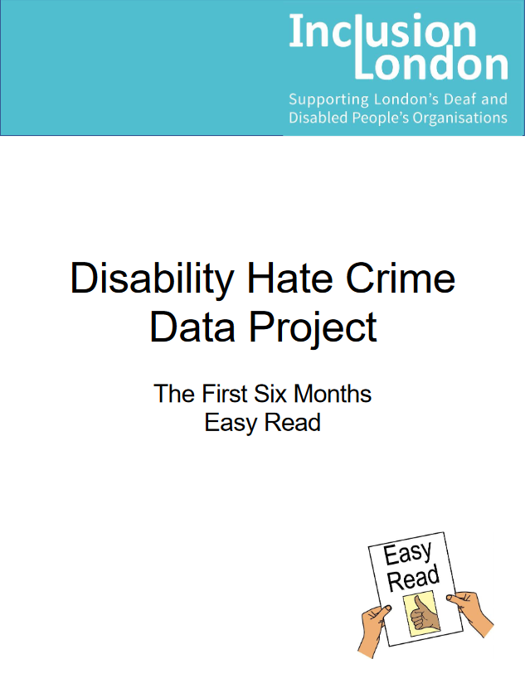
We wrote a report after 6 months.
You can find it here: Link to our website

We talked about what the data told us in that report.
We found many of the same things in this report.

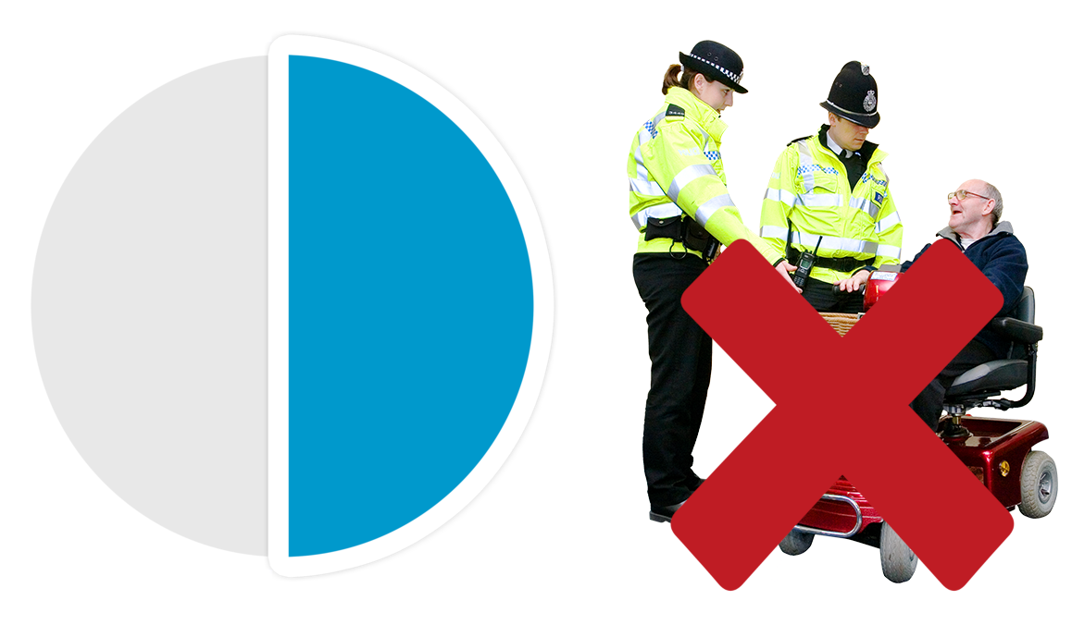
Here are some important things we learnt.
Half of the victims of disability hate crime did not want to talk to police.
They had many reasons for this.

The main reason was they did not think they had enough evidence.

Evidence is used to show that a crime happened.
It could be a weapon, someone who saw what happened, or video of the crime.
It can be other things, too.
Another main reason was that the victim just wanted to talk to someone.
They wanted someone to listen.

Most disability hate crimes happened at the victim’s home.

Most of the disability hate crimes had verbal abuse happening to the victim.

Verbal abuse is when someone uses words to cause harm.
It is usually a lot of harmful words, said more than once.
The things said can be very cruel, including telling people they should be harmed or killed.

The people most often doing the hate crime were neighbours.

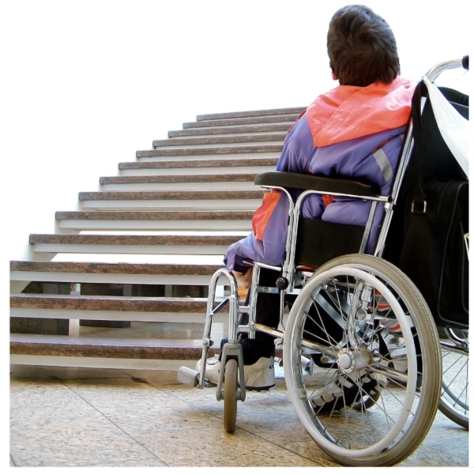
Some things were different from our first report.
There were even more access problems for victims this time.

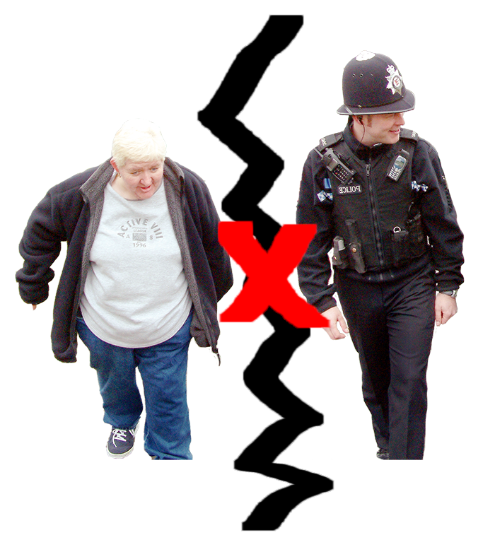

More victims found it difficult to report crimes.
There were more barriers.

Hate crime cases still took a long time.
Staff at DDPOs spent many months working with victims.

DDPO staff worked with lots of different people.
People of different ages, races, genders, sexualities, and disabilities.

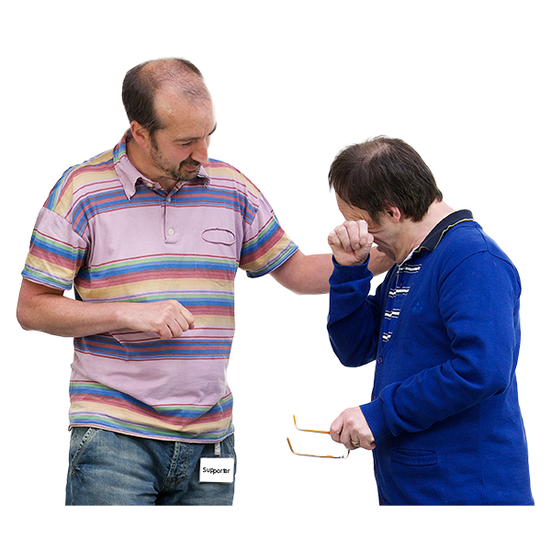
Staff helped people in many ways.
Not all the ways they helped were with the criminal justice system.
This is okay. Not everyone wants to be helped the same way.

The Criminal Justice System is the whole system that deals with crime.
It includes the police, lawyers, the courts, prisons, and other people who work on crimes.
It also includes the way things are done.
There was still not enough money for DDPOs to do all the work they wanted.
2 DDPOs lost their funding.

The money they got to do hate crime work stopped.
So, they could not help hate crime victims anymore.

They had to stop working on our data project, too.

Thank you

All the DDPOs and staff in the hate crime partnership helped with this project.
Without them, this project would not have started.
So, we want to say thank you to all of them for their support.

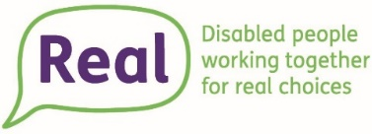
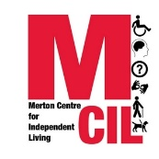
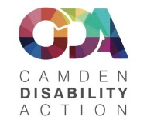
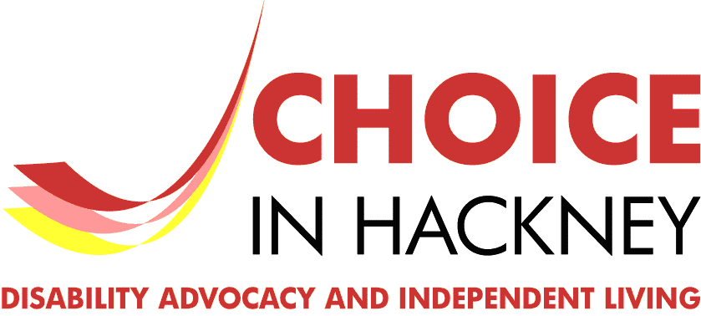
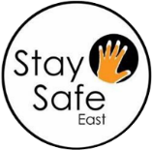
Another thank you to the DDPOs who gave us data.

Real Tower Hamlets, Breaking out of the Bubble, Merton Centre for Independent Living, Camden Disability Action, Choice in Hackney, Stay Safe East, and Deaf Plus.

