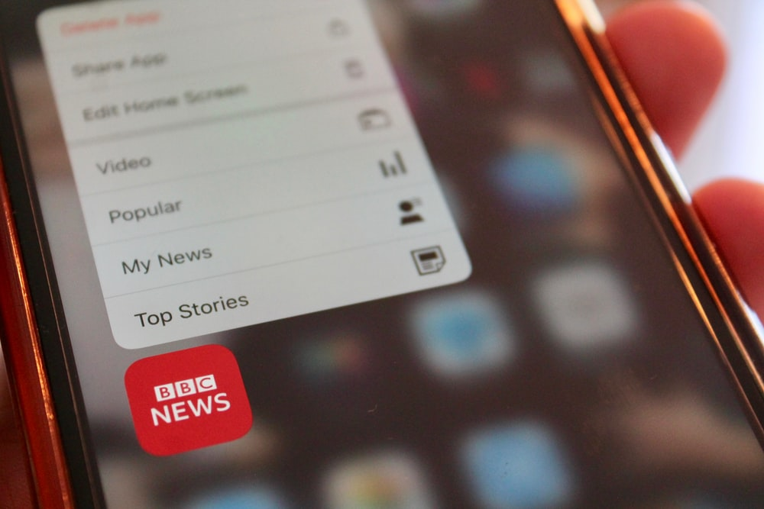

Disability, Crime and Hate Crime in the News

Part 1 – Introduction to our Report
December 2022

Inclusion London
Authored by: Disability Hate Crime Team – Lara Conner and Louise Holden

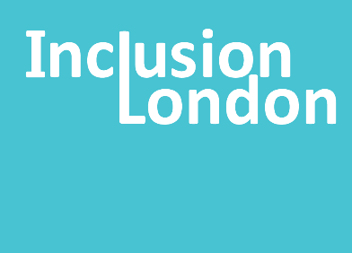

Content Warning

In this report, we write about many crimes and violent acts.
The victims are all Disabled people. Some of them are babies and children.

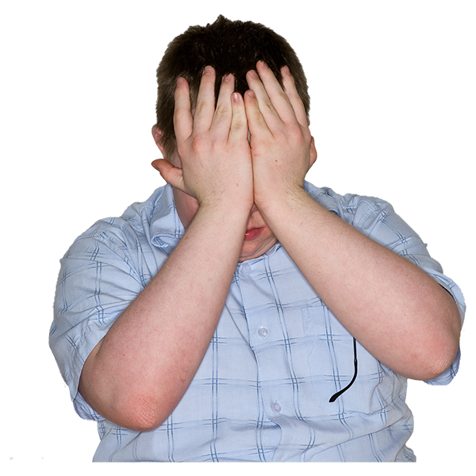
Some people might get upset reading about this.
Some people might be reminded of things that have happened to them.

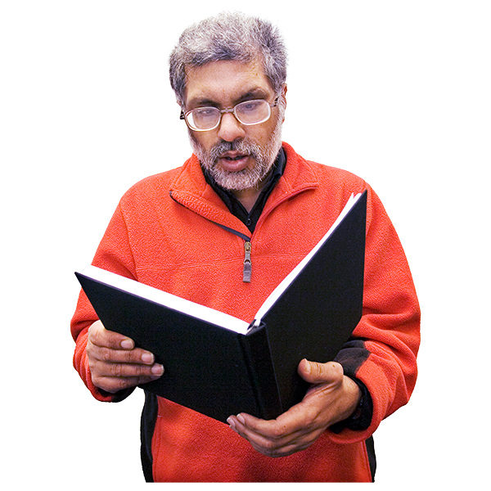
You might start reading and be okay.
The news stories might make you feel a bit upset or angry, but you are okay to keep reading.

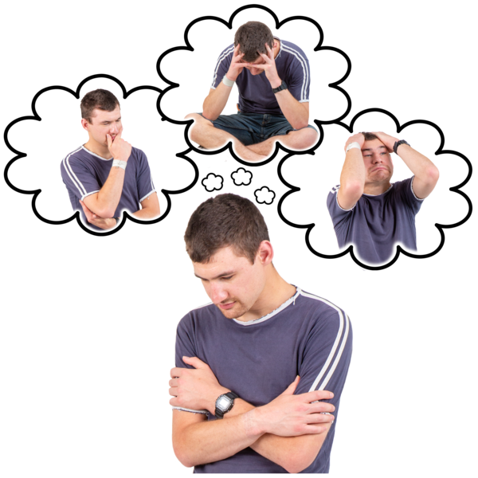
You might start reading and not be okay.
The news stories might make you very upset. You might choose to stop reading.

Both are okay.

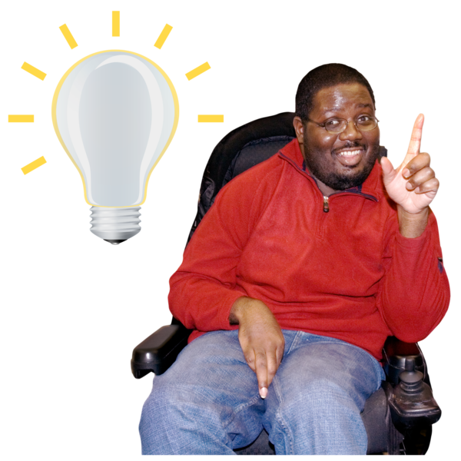
It is good to look after yourself and your emotions.
Sometimes this means not reading things that might upset or hurt you.

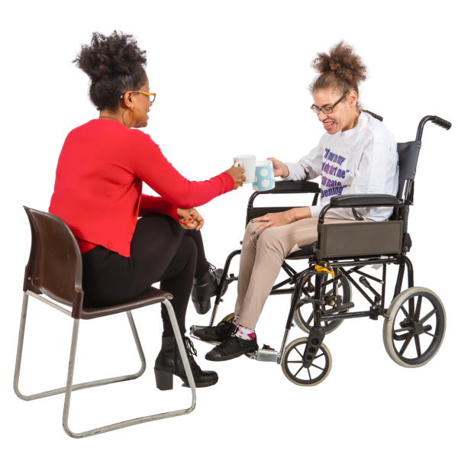
If you cannot stop thinking or worrying about what you have read, ask for help.
You can talk to someone about what you are thinking.
You can do something you enjoy.
Keep yourself safe.

Crimes again disabled people in the news

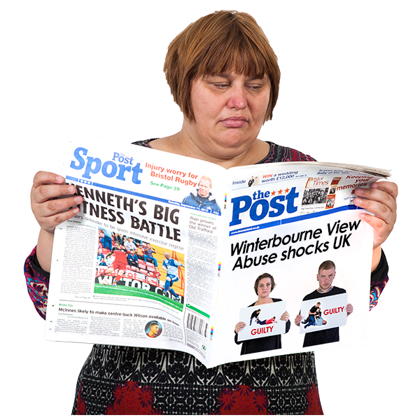
Some people think that no-one would ever carry out a crime against a Disabled person.
But there are many news stories about crimes against Disabled people.
Disabled people are targeted more often by criminals than non-Disabled people.

Inclusion London looked at news reports about 300 crimes against Disabled people.

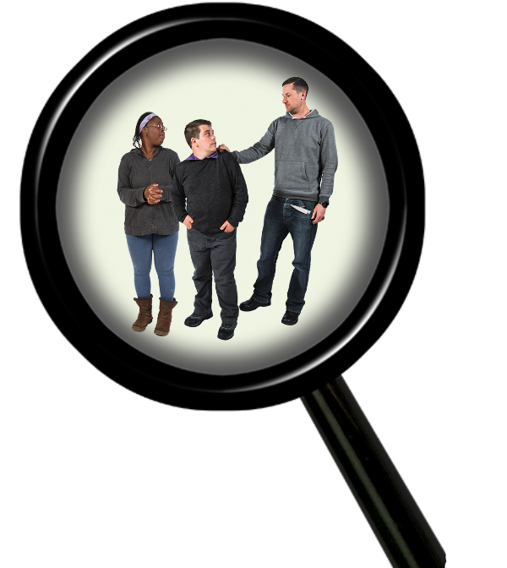
We looked for information about the crime and what happened after.
We looked if it was called a hate crime.
We look at how Disabled people were written about.

A hate crime is when someone carries out a crime against someone because they have negative ideas about the person’s identity.
In hate crimes, the identities we mean are things like disability, race, gender, sexuality, and other things like that.

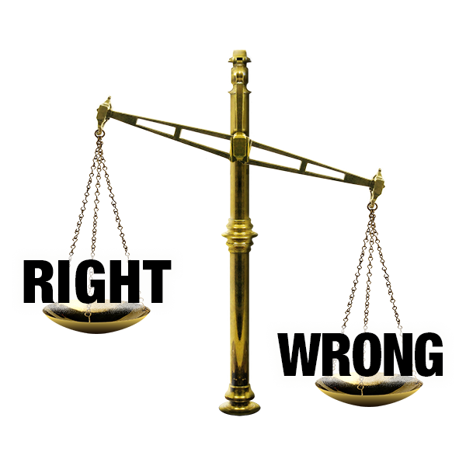
Some news stories have the wrong information.
Some do not have all the information about what happened.
Sometimes the news only looks at very shocking crimes.
The news can change how people think about crime.
The words they use can change what people think about victims.
So, it was important to look at these news stories.
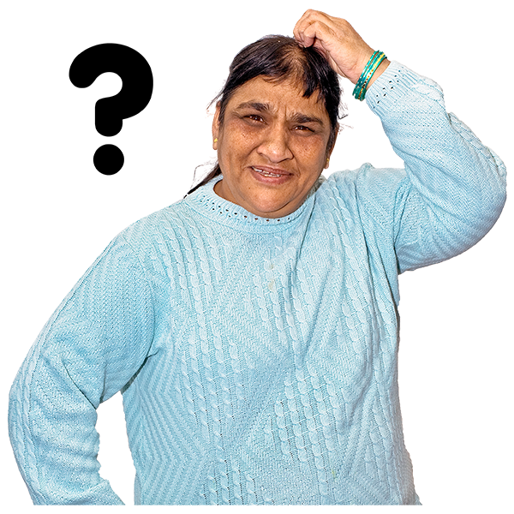
Many people do not know what a hate crime is.
Some people think hate crimes are mostly about people writing hateful things online.
Some people even think hate crimes are not real crimes. This is not true.

A crime must happen for something to be a hate crime.
If there is no crime, it is a hate incident.
Hate crimes can be any crime.
They can be online harassment, but they can be crimes like assault or murder.
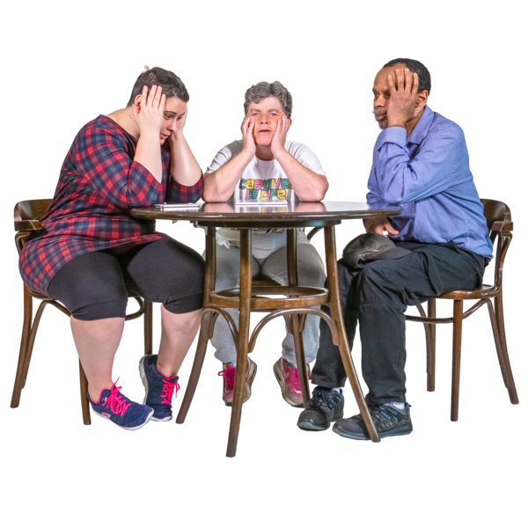
Hate crimes are an attack on who someone is.
A hate crime can affect a whole community.
People find out how people like them are being hurt. This makes them worried and angry.

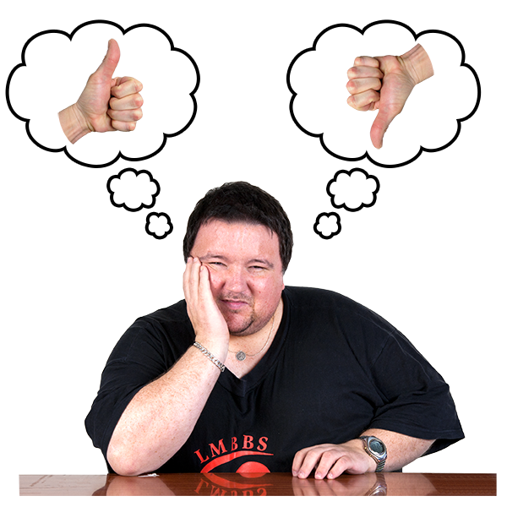
How people write about Disabled victims is important.
It can change what people think of Disabled people.
Sometimes when people are writing about Disabled people, they use disablist language.

Disablist language is using words which say or suggest negative things about Disabled people.
Some news stories were respectful writing about Disabled victims.
This was good to see
New stories had less disablist language than older stories.
But some news written in 2022 still had disablist language.

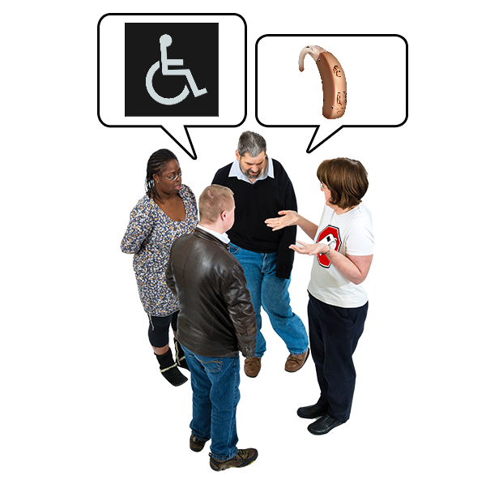
Sometimes, people do not realise they are being disablist.
This is because disablism is everywhere in society.
People learn disablist things and do not know they have.

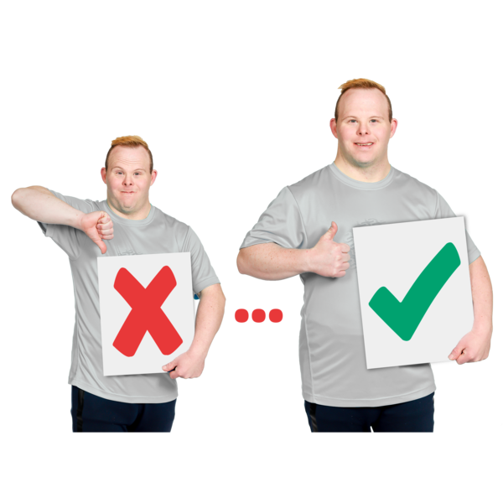
This does not mean disablism is okay. It is not.
It is an explanation. People can do better if they unlearn this disablism.

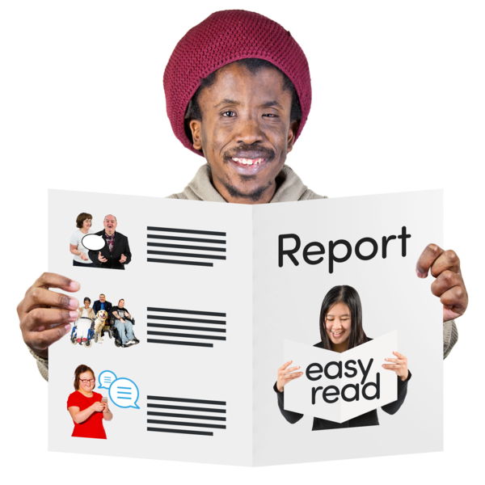
We hope this report helps people.
It might help people who want to know about how the news reports crimes against Disabled people.
It might help people think carefully about how to write about Disabled people.

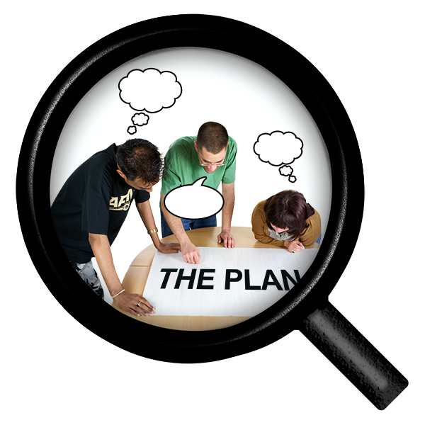
The information might also make people want to do more research.
They might want to look at more things about crime and Disabled people.
Maybe this report can give them some ideas.

The standard read of this report is 86 pages long.
The Easy Read is longer because half the page has images.
This is a lot to read at once.

We have split the report into many smaller parts.
We think this makes it easier to read.

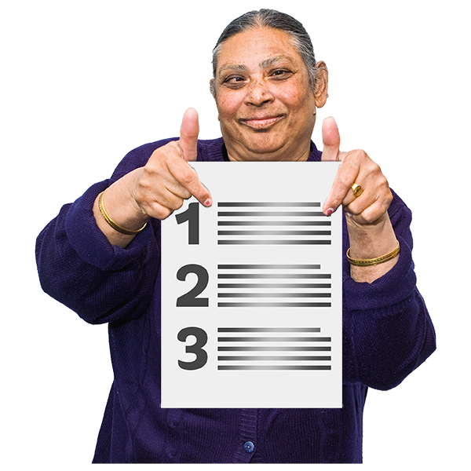
In a few pages, you will see a list of all the smaller parts.
You can find the parts you want to read using this.

Why we use some cases where Disabled people died by suicide.
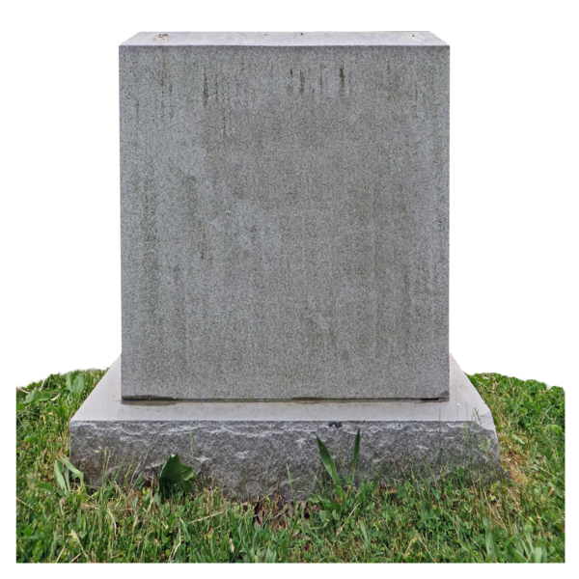
Suicide is when someone dies because of injuries they did to themselves.
They wanted these injuries to kill them.
There are many reasons why people die by suicide.

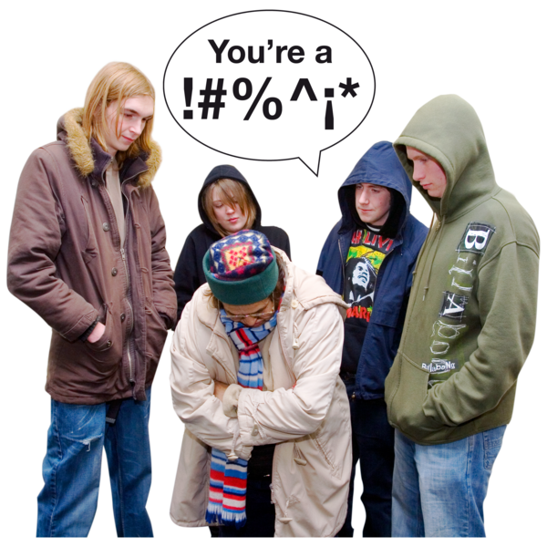
The cases we wrote about were when a Disabled person was harassed or abused, then died by suicide.
The harassment and abuse were usually enough to be a hate crime.
But the news and the police did not call them hate crimes.

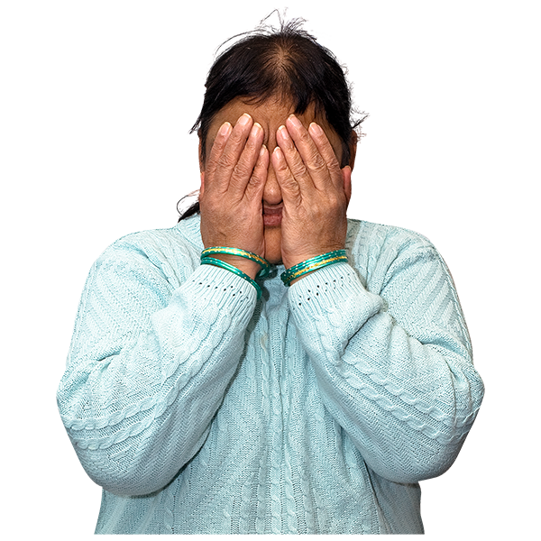
We think this is important to write about.
Hate crimes can cause serious harm. This is true even if the hate crime was not violent.
This is why we included these cases.

What is in the report?

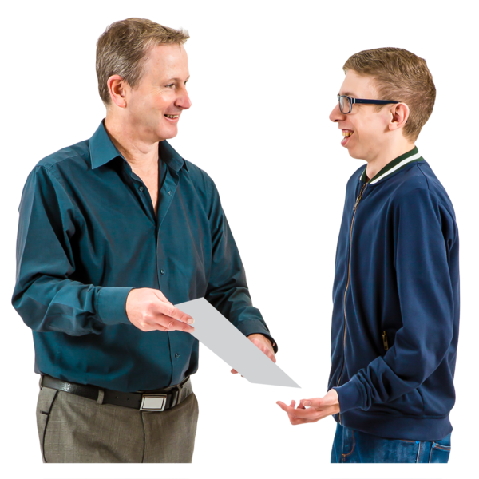
Introduction (we are reading this now)
This tells you why we did this report.
It gives you information you need in the rest of the report.

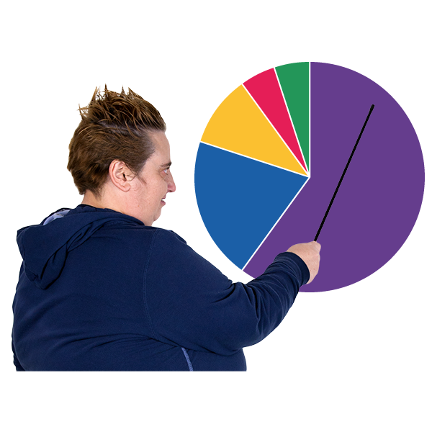
About the Crimes: Some Numbers
This will tell you information about the crimes.
Like where they happened, how many there were, when they happened, and other things.

About the victims
This will give you some information about the victims.
It will tell you about how they knew the people who harmed them, too.

How much news there was and what happened
This will talk about the news reports.
It will also say what happened after the crimes.

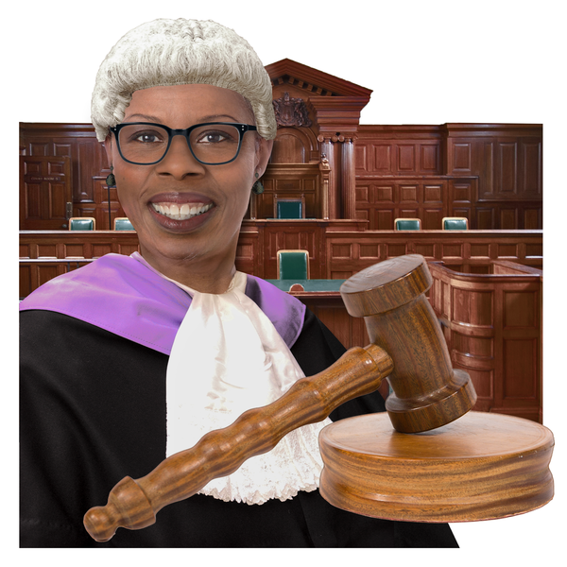
Disability hate crime information
This will talk about Disability hate crimes.
It will talk about why so many hate crimes do not get charged.

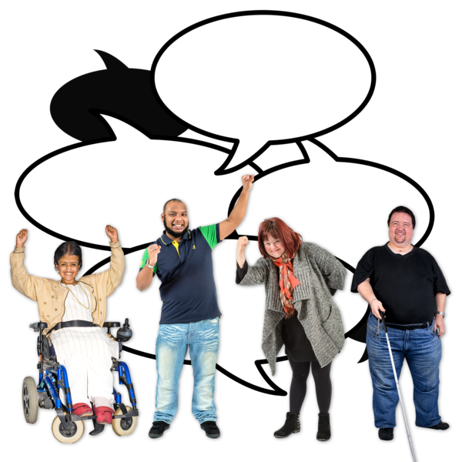
Language in the News Part 1
This section is the biggest part. It has a Part 1 and a Part 2.
It will look at disablist language in the news, why it matters, and how to do better.

Language in the News Part 2
We will keep looking at disablist language.
We will keep looking at examples and how to do better.

Disabled victims dying by suicide
We will talk about suicide and how hate crimes push Disabled people to suicide.

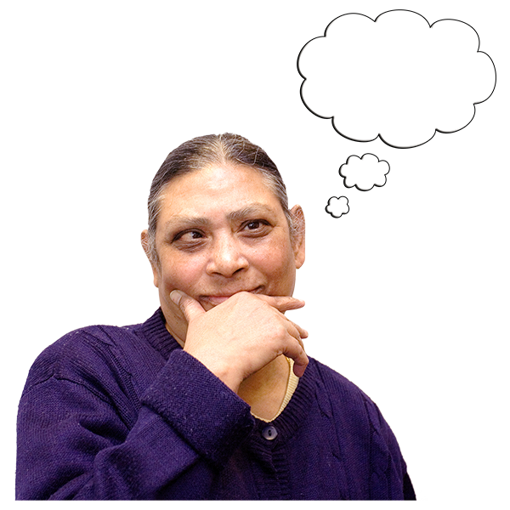
Conclusion
We will finish our report with some final thoughts.

Thank you to…
We used some websites to help us find all the information we needed.
This information was very helpful.
The websites had lots of information about crimes against Disabled people.
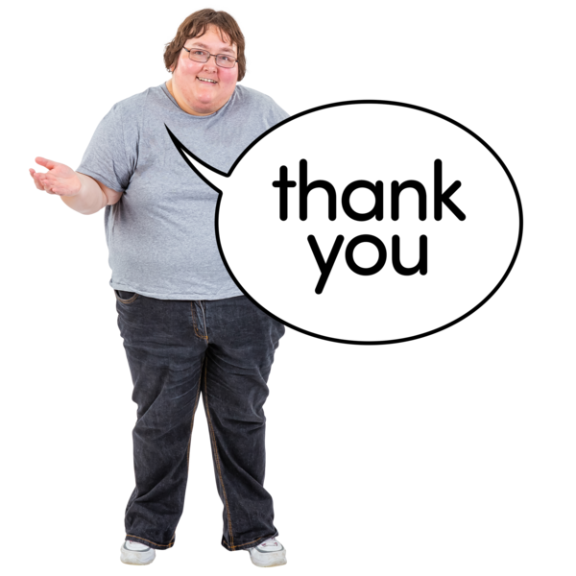
We are grateful to the people who made these websites.
Which is why we are saying thank you to them here.

The Disability Day of Mourning Memorial
https://disability-memorial.org/
This is about Disabled people who were killed by their family. It has information from the 1980s onwards.
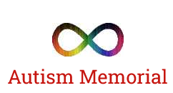
Autism Memorial
https://autismmemorial.wordpress.com
This website remembers autistic people who died from murder, lack of support, or malpractice.

Malpractice is when a professional or organisation behaves in a way that is illegal or falls very far below the standard expected.

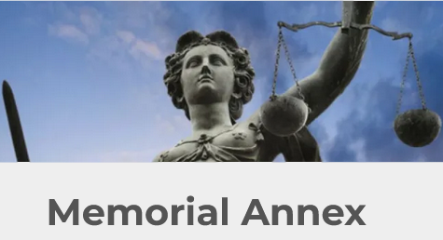
Memorial Annex
https://memorialannex.wordpress.com
This remembers Disabled people who were victims of murder, malpractice, or lack of support.

Ableism and Disablism

We use these words a lot in this report.
Some people use ableism and disablism to mean the same thing.
They use them both to mean ‘being negative about Disabled people’.
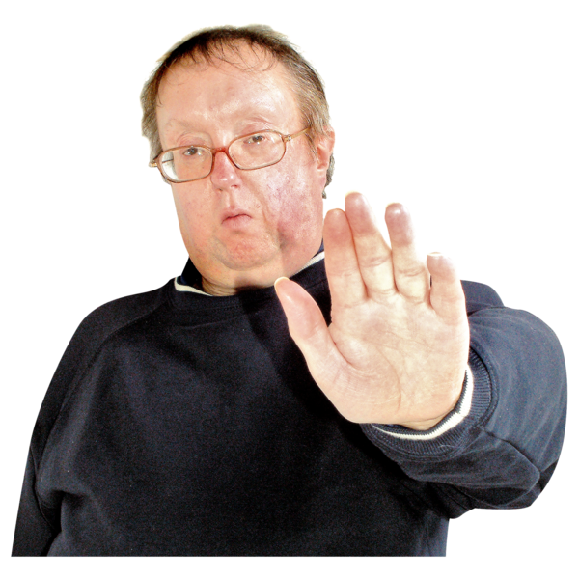
Other people use disablism and not ableism.
They feel like ableism is saying oppression is caused by ability. So, they do not like that word.
Oppression here is when someone is not valued, they are not allowed rights or things they should have or are treated cruelly.
This can happen to a person or a group of people.

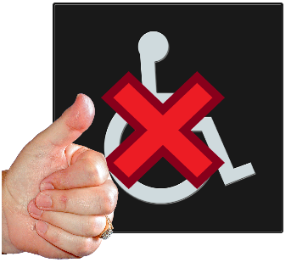
Other people say they mean slightly different things.

Ableism is when people treat non-Disabled people better than Disabled people. They might think better of non-Disabled people.

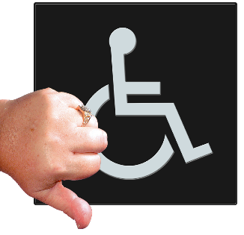
Disablism is when people have prejudice against Disabled people. They might think poorly of Disabled people.

This sounds a bit like the same thing, so we have an example to help.

Example of ableism and disablism
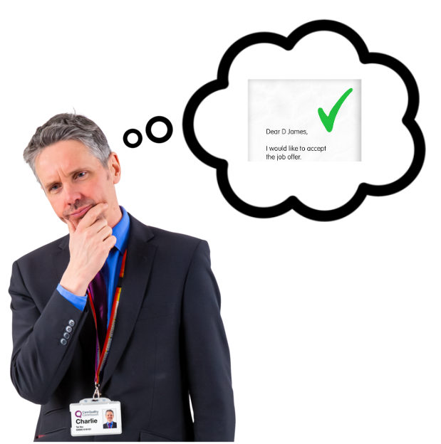
Richard has two people he could hire.
One of them has a learning disability.
One of them has no disabilities.

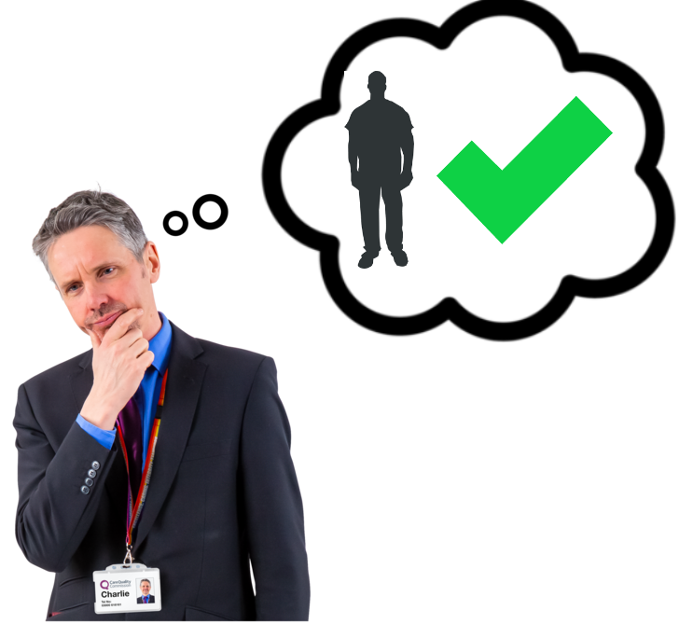
Richard thinks the person with no disabilities will be better.
He thinks this because he thinks non-Disabled people can learn the job quicker.
This is ableism.
It is saying non-Disabled people are better because they have no disabilities.
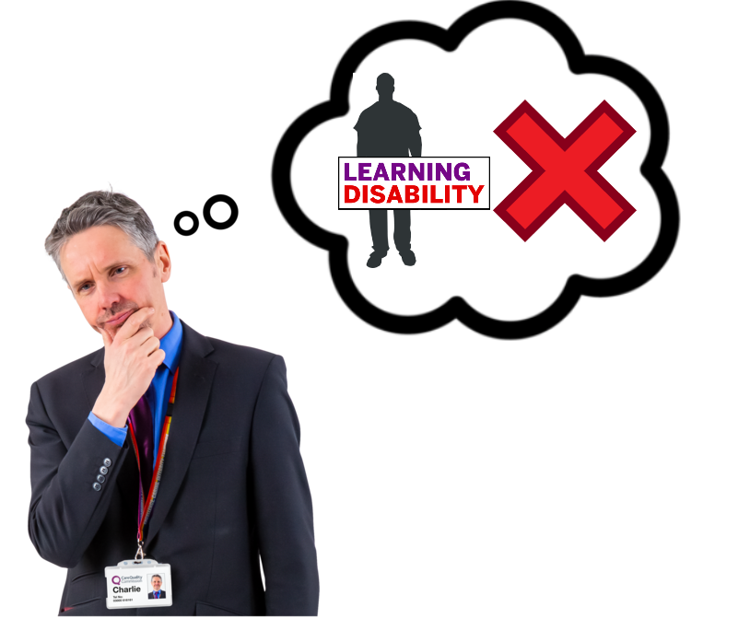
Richard could think something else.
Richard could think the Disabled person will be slow to learn the job.
He could say that is why they should not get the job.
This is disablism.
It is saying Disabled people are worse because of their disability or impairment.
In this report, we use disablism more.
This is because we are mostly talking about Disabled people being treated worse.

