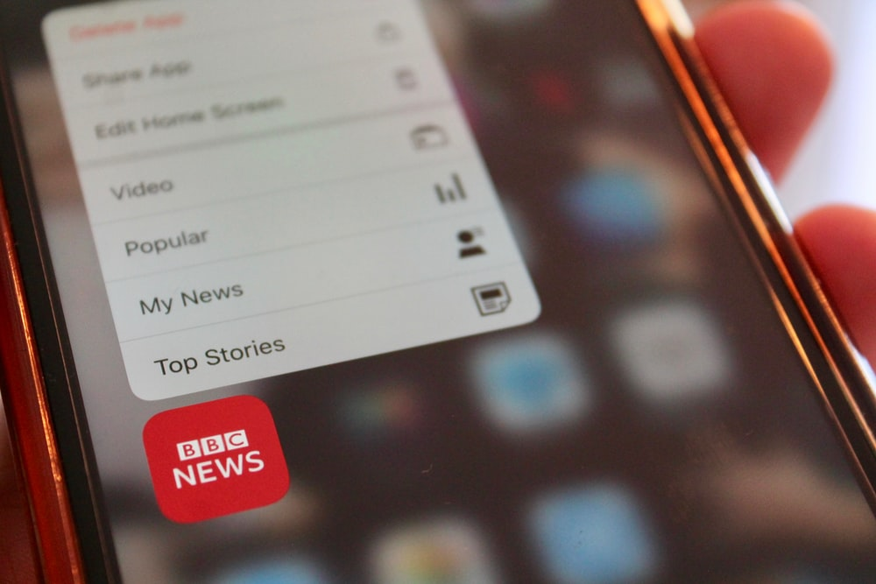

Disability, Crime and Hate Crime in the News

Part 5 – Disability hate crime information.
December 2022

Inclusion London
Authored by: Disability Hate Crime Team – Lara Conner and Louise Holden

How many crimes were called disability hate crimes?
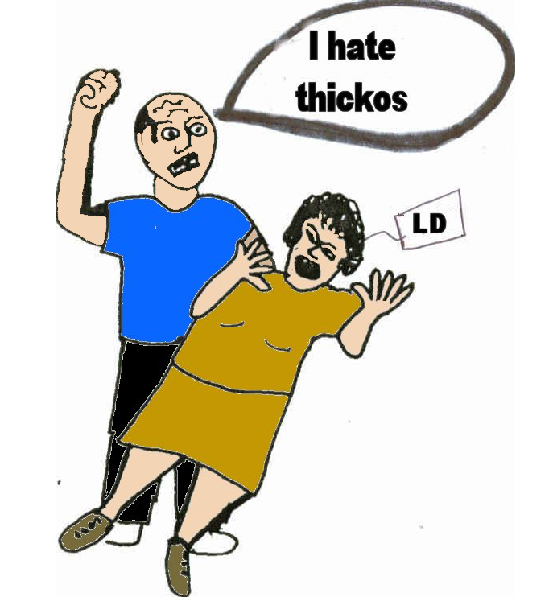
We looked at all 300 cases to see if anyone called them a disability hate crime.
We found just 5 cases where a judge agreed they were a disability hate crime.

A disability hate crime is when the crime is carried out because the person doing it has negative beliefs about disability.
If the courts agree a crime is a a disability hate crime, it gets an uplift.
This means the person who did the crime might have extra consequences. They might get a longer sentence or pay more money or have to complete community work.
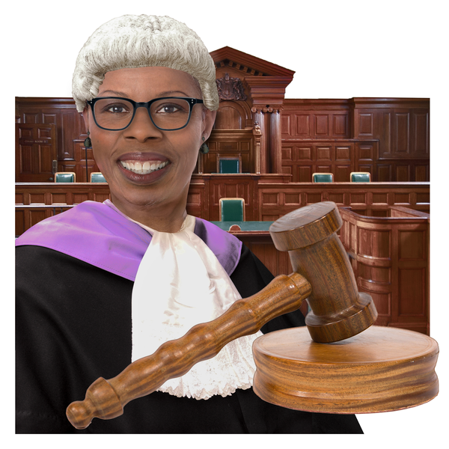
We found 30 cases where a lawyer or judge said the victim was “vulnerable”.
Or they said the victim was targeted because they were Disabled.
These might have been uplifted. We are not sure.

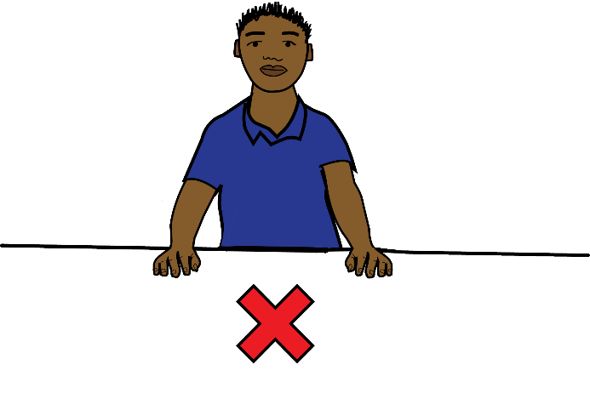
None of the other cases said anything about disability hate crime at all.
There might have been more cases.
But journalists did not write about it.

What Inclusion London thought about the cases.
When we looked at the cases, we thought more than 5 were disability hate crimes.
We thought more than 35 were disability hate crimes.

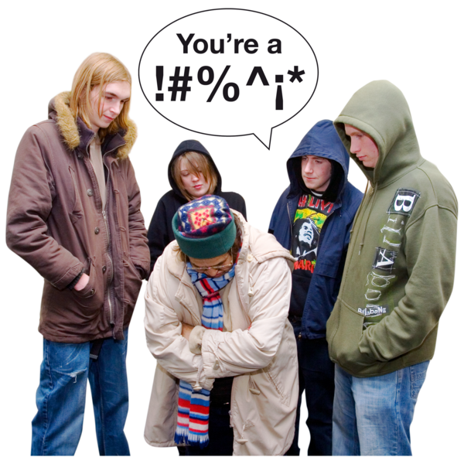
We found 63 cases where we thought there was a disability hate crime.
In these cases, disablist language was used, or someone said they thought it was a hate crime.

Here is one example.
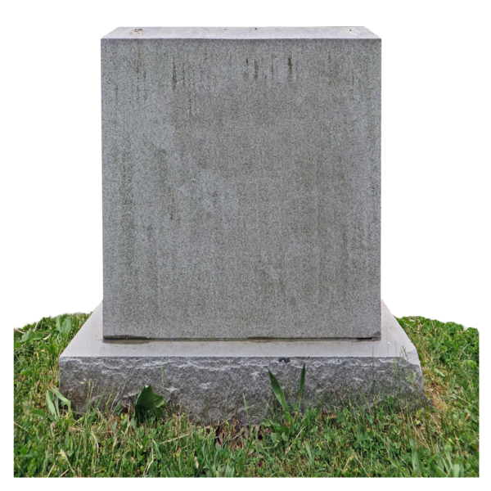
Darren Henson was a 9-year-old autistic boy.
His mother, Bethany Vincent, was in a relationship with Daniel Boulton.
In 2019, Daniel Boulton killed Darren and Bethany.

Part of why Daniel did this was he hated that Darren was Disabled.
The judge said Daniel was hostile towards Darren’s disability.
But nothing says if Daniel was charged with a hate crime.
Hostile means being unfriendly and behaving in an angry way.
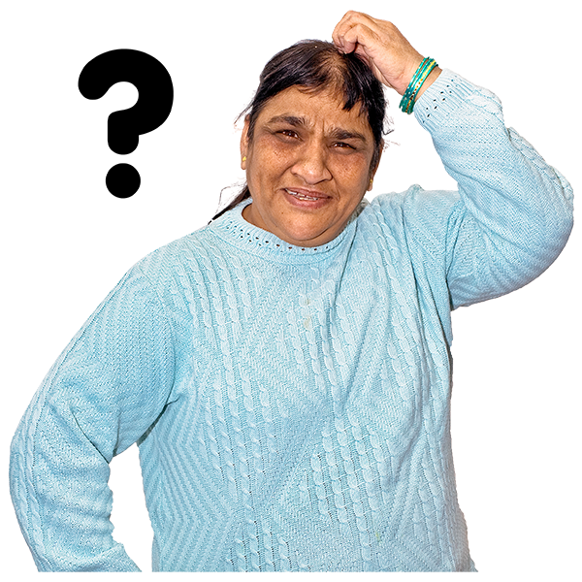
There were 111 cases where they might have been a disability hate crime.
These cases did not have as much information.
So, we were not sure.

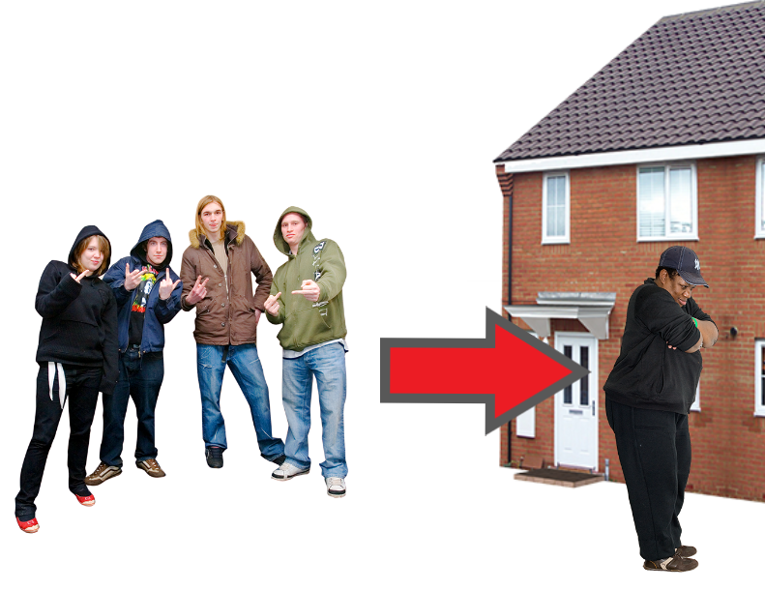
Some of these were crimes that had ‘cuckooing’.
This is when people take over a Disabled person’s home.
Then they carry out crimes. They use the Disabled person and their home.

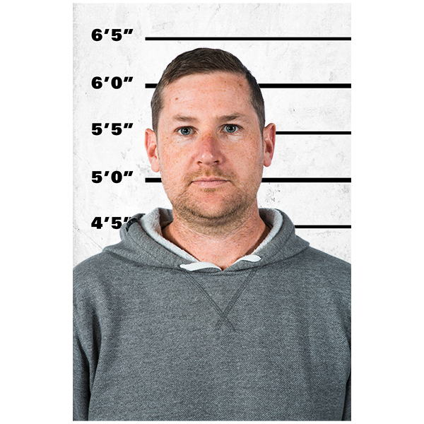
Many cases of cuckooing have Disabled victims.
Some criminals choose Disabled victims. They think they are easier targets.
We think this is an example of disablism, so it could be a hate crime.

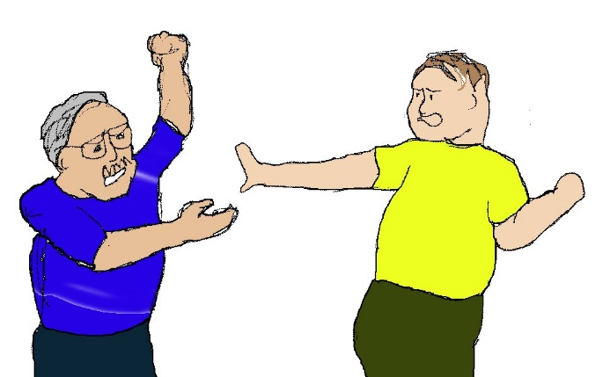
Other cases were ones where family members thought Disabled people were burdens.
They hurt or killed them.
This is also an example of disablism. We think this could be a hate crime too.

Here, burden means someone who is difficult to accept or deal with. It usually means they make other people’s lives harder.
In 126 cases we found no information that the crimes were hate crimes.
Some were definitely not hate crimes.
Others, we saw no information that they were or were not.
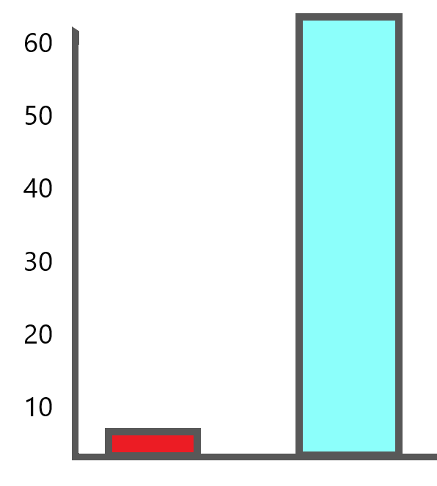
In the news, we found 5 cases had been called disability hate crimes.
But we think 63 cases were disability hate crimes.
This is a big difference.

Why proving something is a disability hate crime is difficult.
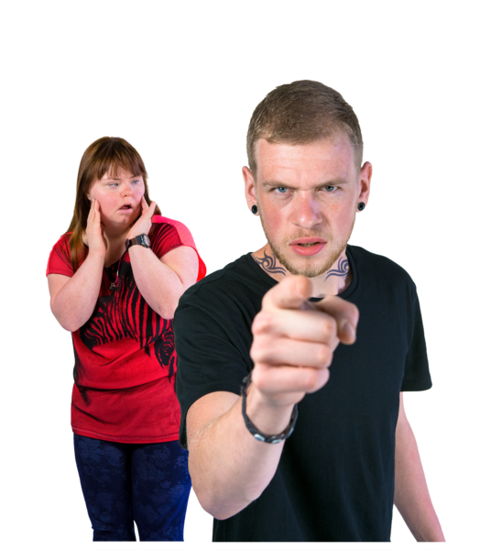
All hate crimes can be difficult to prove.
To prove a hate crime, you have to prove someone was hostile towards a person’s identity.

Identity means a part of who someone is. These are the things that make up who we are. In hate crime this is things like race, gender, disability, sexuality, and other things.

You also have to give a lot of proof.
You cannot just say someone did a crime because they are disablist.
You must show things to prove it.

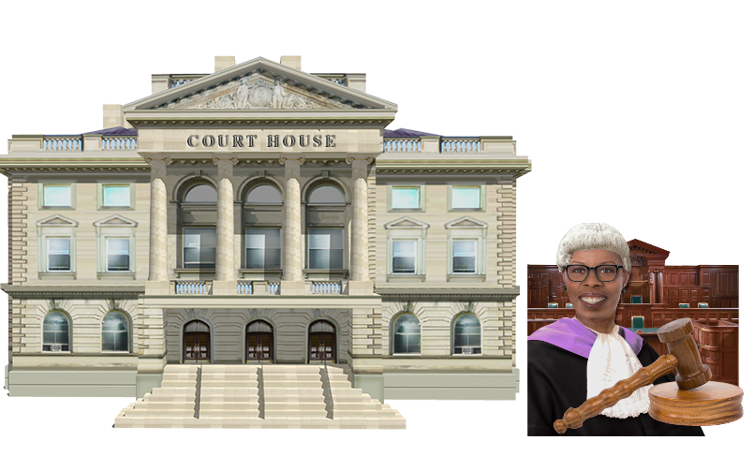
The courts decide if there was enough proof of hostility.
So, you do not know if you have enough proof until you finish in court.

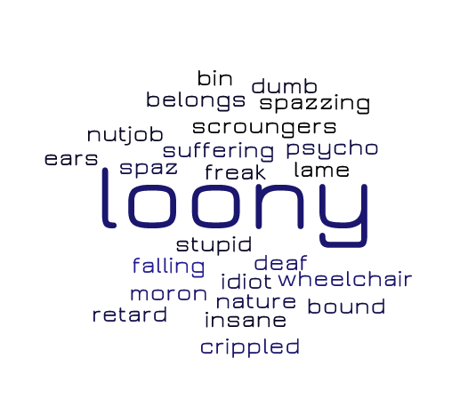
Disability hate crime is hard to prove.
So many people use disablist language and have disablist ideas every day.
They do not always know they are disablist.
Even when someone uses a disablist word, like ‘retard’ during a crime, the judge might say it is not a hate crime.
They say these words are used so often, it does not always mean people hate Disabled people.

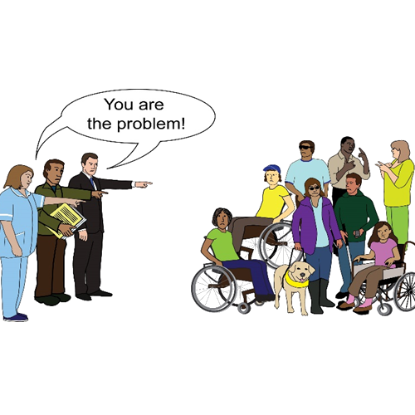
Because there is a lot of disablism in society, it is hard to prove hate.
It is why getting a hate crime uplift is so difficult.

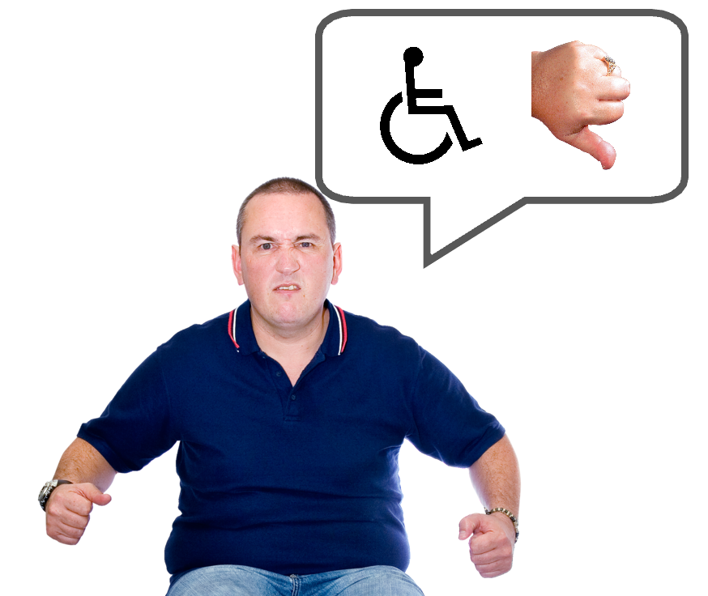
There are many crimes in this report caused by how the person doing the crime felt about disability.
Like they thought disability made someone a burden.
We think they are disability hate crimes.

Being made “vulnerable”.

Sometimes, instead of talking about hate crimes, lawyers and judges talk about “vulnerability”.

Vulnerability here means able to be easily hurt, made to do things, or attacked.
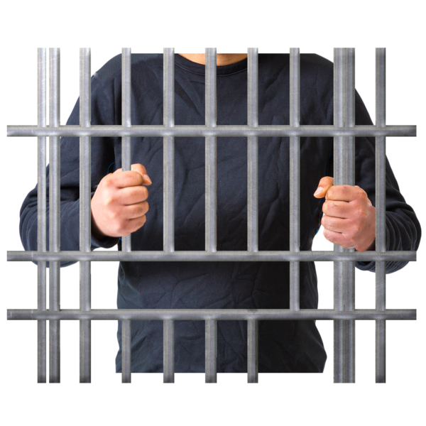
When a judge agrees a victim is “vulnerable”, this can have more consequences for the person who did the crime.
They might get a longer sentence.
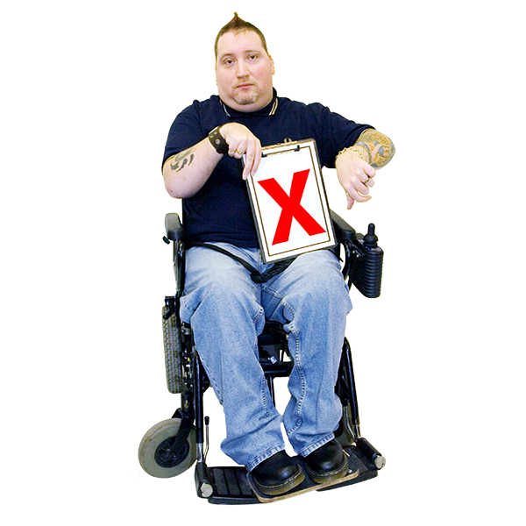
Some people think Disabled people are always more vulnerable than non-Disabled people.
Many Disabled people do not like this idea.
Saying Disabled people are more vulnerable all the time can lead to people stereotyping.

Stereotyping here means something lots of people think about a type of person that is unfair or too simple. It is usually wrong in many ways.
An example of a disability stereotype is that all Disabled people are helpless and need people to do everything for them.

Some lawyers do not like arguing that a victim is vulnerable.
They know it is a stereotype.
But sometimes they will use this argument in court.

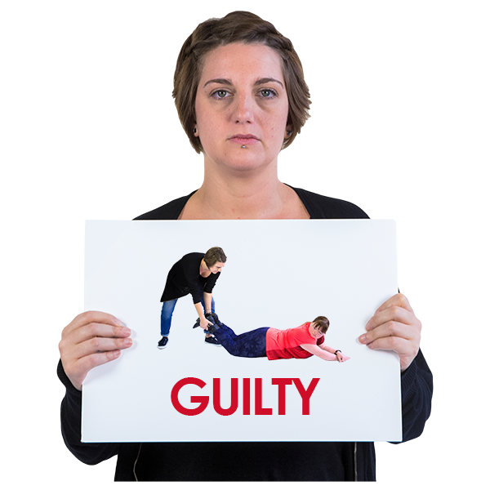
They do this when they do not think they will prove a hate crime.
This means they get a conviction for a more serious crime.
They do this because proving vulnerability is more likely than proving disability hate crime.

Conviction is when someone is found guilty of a crime.
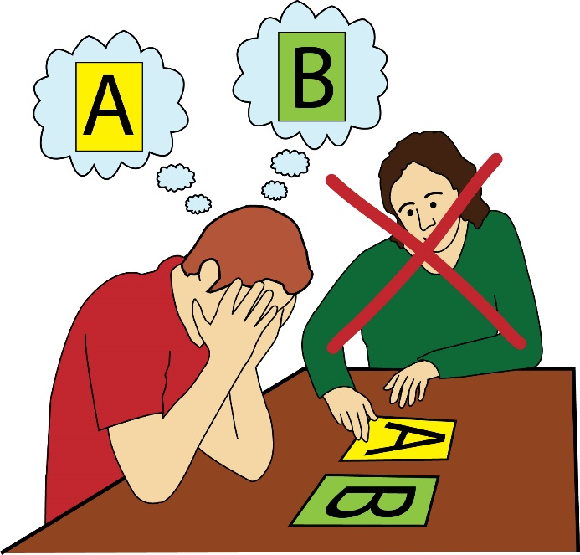
Disabled people can be made vulnerable.
They are made vulnerable when they cannot get support they need.

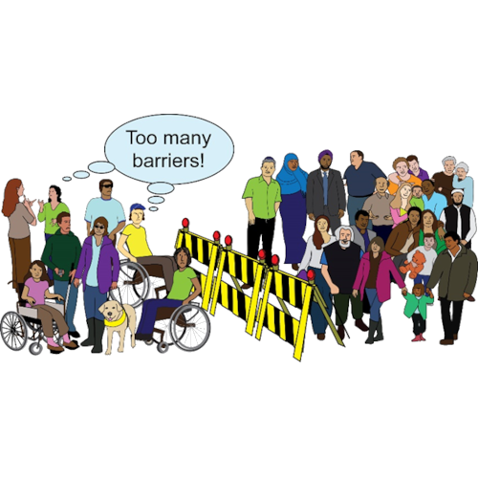
They are made vulnerable when services are cut.
They are made vulnerable by inaccessibility.

This does not mean that they would always be vulnerable.

If services were accessible or there was more support, many Disabled people would not be vulnerable.
They would get better support to be safe.

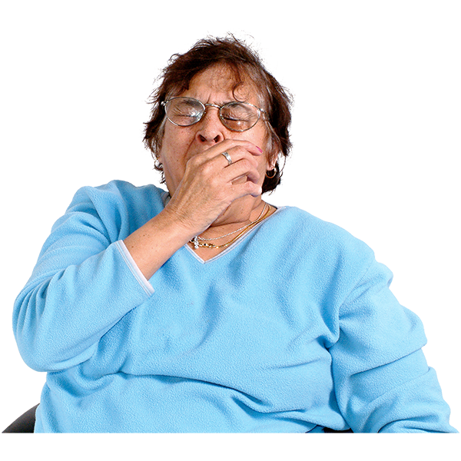
Anyone can be vulnerable sometimes.
Non-disabled people can be vulnerable if they are lost in a new city.
Non-disabled people can be vulnerable if they are tired on public transport.
But we do not say that makes them always vulnerable.

Some other things that make people vulnerable are:
Being alone
Not having money
Not having people to support you
Having poor health
Having unsafe housing

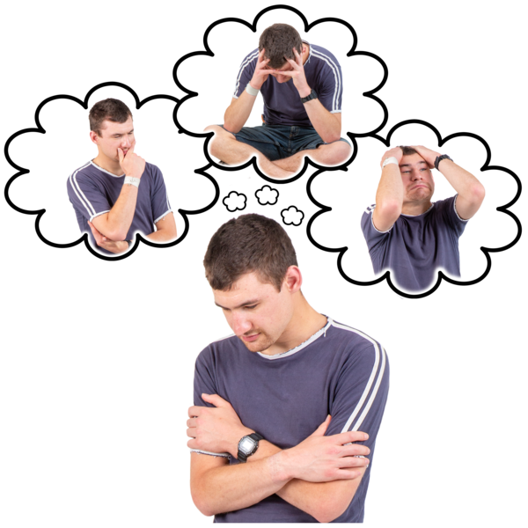
Not all Disabled people have these difficulties.
But more Disabled people have these problems than non-Disabled people.
This makes it easier for criminals to target people.

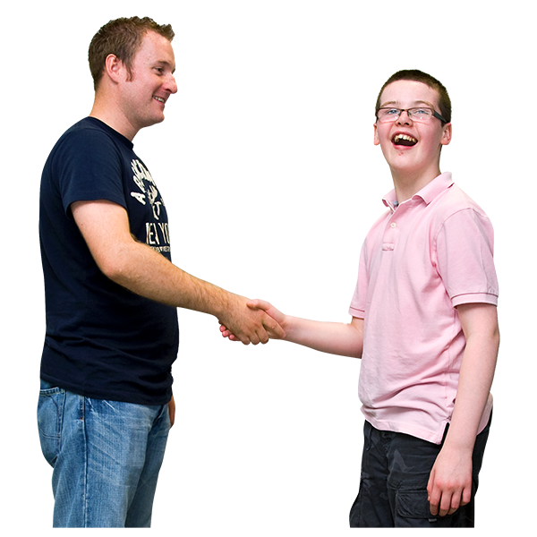
If people had better support, they would not be seen as “easy targets”.
For example, it would be harder for criminals to “cuckoo” them.

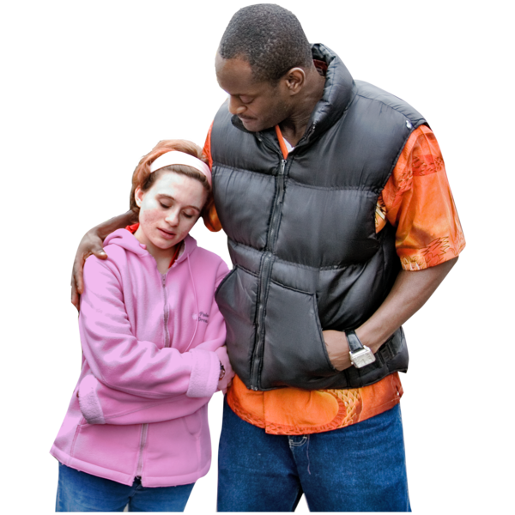
This is because the Disabled person would be able to get support easily.
Better support would mean less victims of disability hate crime.

