Disability, Crime and Hate Crime in the News

Part 4 – What happened after the crime.
December 2022

Inclusion London
Authored by: Disability Hate Crime Team – Lara Conner and Louise Holden

How much did the news talk about the crime?

We looked for each case on the internet.
We looked at how many news stories had been written.
We only used news websites like the BBC or local news like Lancashire Post.
Other places talked about the crimes and the victims.
But these were small websites.
They were not written by journalists.
So, we did not include them.

Here a case is a criminal case. This is the word used when a crime or many crimes have happened to a person.

A journalist is someone who finds information writes stories for the news.

Journalists have guides and rules they should follow when writing about people.
They have guides and rules for writing about crime.
Also, websites like the BBC have lots of readers.
Someone writing on their own personal website does not. So, we just looked at news websites.

How many news stories did we find?
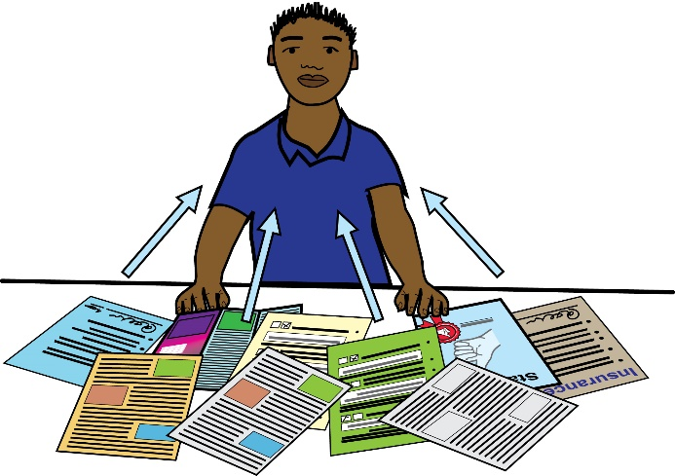
126 of the cases had a lot of news stories written about them.
They had 10 or more different news stories.

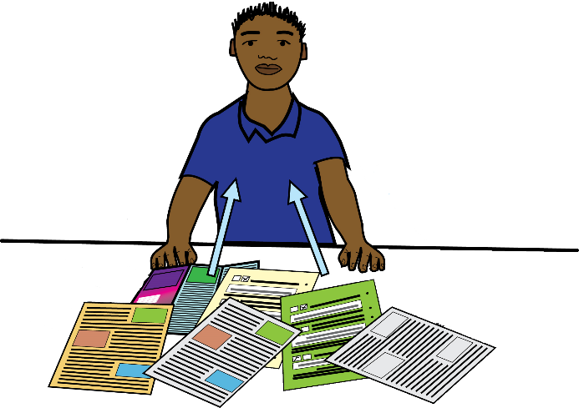
79 cases had some stories written about them.
They had between 5 and 9 different news stories.

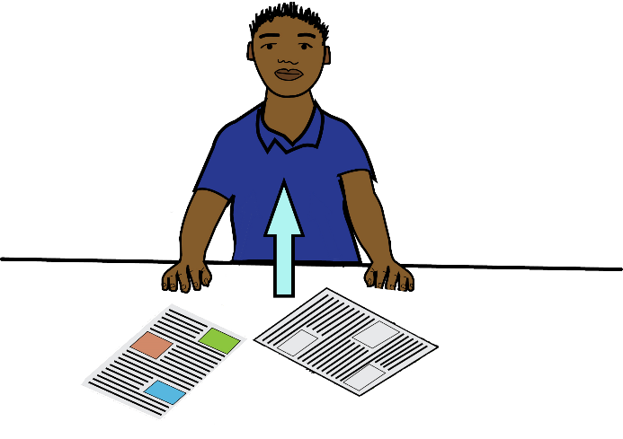
93 only had a few stories written about them.
They had less than 5 news stories.

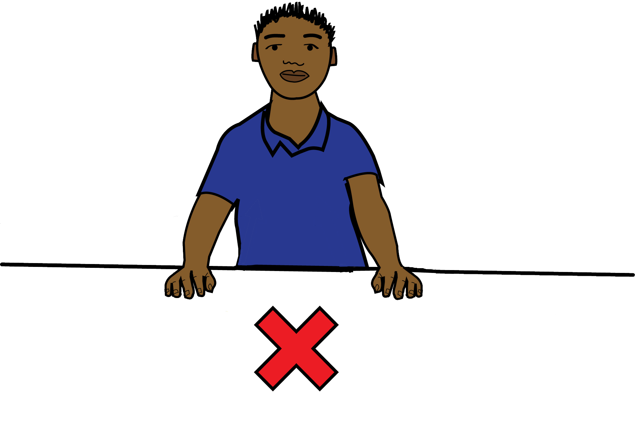
2 cases did not have their own news stories.
They were added into stories about other crimes.

We tried to look at which crimes got more news stories written about them.
But it was too difficult with the information we had.
It would not have given us good information.

We can only say that more serious crimes usually got more news stories.
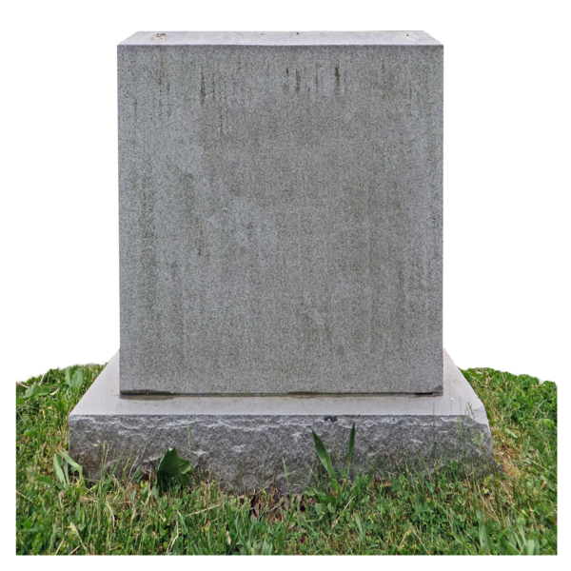
Murders usually had lots of news stories written about them. Usually, 10 or more.
But not always.
There were some murders with less than 5 news stories.

Sometimes crimes get more attention because of who the victim was.
Some people have done research on this.
They found out when victims are Black, there are less news stories.
This is a type of societal racism.

Societal racism here is about how negative and unfair ideas about people from different races is in all parts of society.

What happened after the crime?

Some crimes were still being investigated when we searched for them.
So, things may have changed by the time you are reading this.

Investigated here means the police looked at what happened. They looked for information and proof to know who did what.

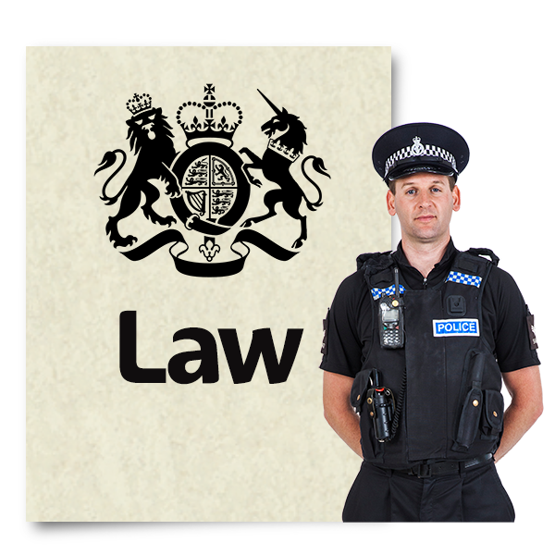
In 218 out of 300 cases, someone was charged for the crime.
This means, the police thought they had enough evidence to prove someone did the crime.

There were 9 cases where the police were still investigating.

In 73 cases no-one was charged for the crime.
In some cases, they did not find the person who did the crime.
In other cases, they found the person. Then they investigated and said they would not charge them.

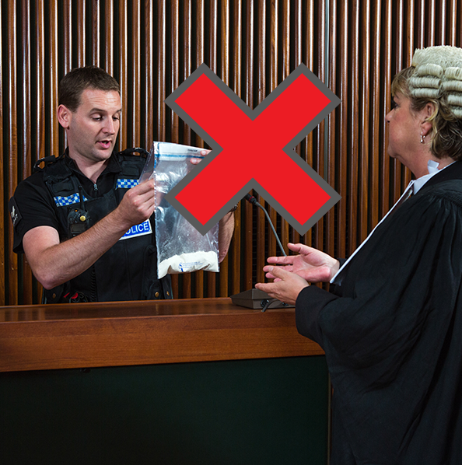
Sometimes, when someone has carried out a crime, they do not get charged.
One reason for this is because lawyers and police do not think they have enough evidence.

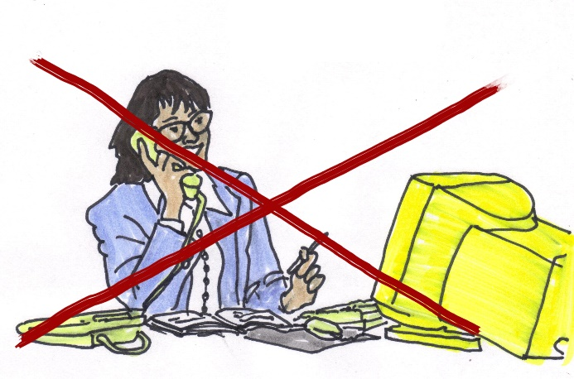
Another reason is something else happened to the person.
People can have consequences even if they do not get charged with a crime.
Like losing their job.

The consequences here are what happens to people because they did a crime.
Some consequences of crime are going to jail, paying money, and having to do work in the community for free. There are others too.
There was a case where a teacher kicked a Disabled student.
He did not get charged with a crime by the police.
He was fired by the school.

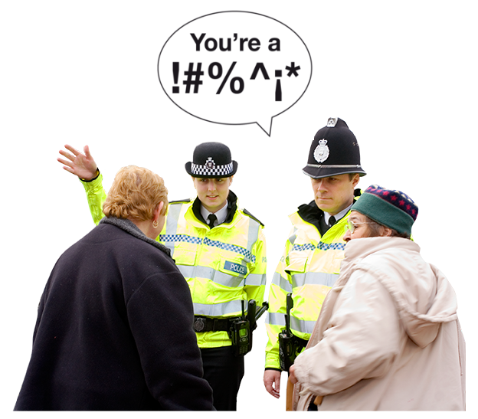
In another case, two police officers threatened a Disabled man and called him disablist names.
They did not get charged with a crime.
They were fired and not allowed to work as police officers again.

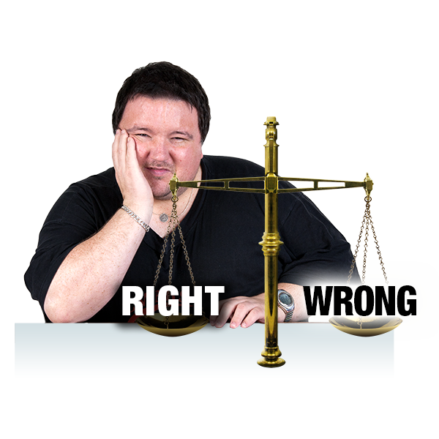
Some people think things like this are a fair consequence.
Other people say it is not fair, that there should be more consequences.
Especially when the person who did the crime was a police officer.

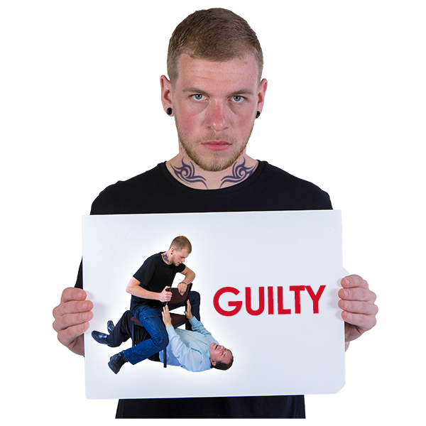
When people were charged with a crime, a lot of them were found guilty.
Out of 218 cases, in 202 of them someone was found guilty of a crime.

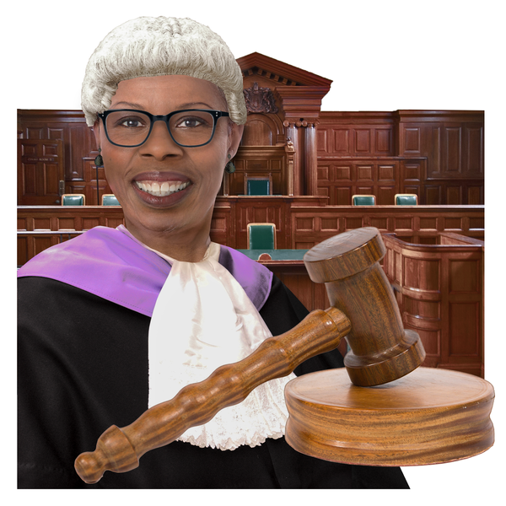
In the other 16 cases, 9 were still waiting to go to court.
This means we did not know if the person would be found guilty or not.

There were 3 cases where the person who did the crime died before the court decided if they were guilty.

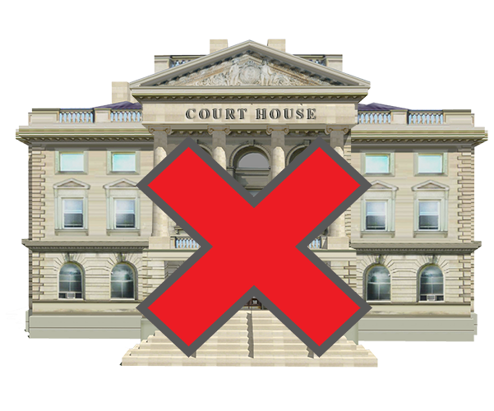
There were 2 cases that were dropped. This means the Crown Prosecution Service decided not to go to court anymore.

The Crown Prosecution Service are in charge of all criminal prosecutions in England and Wales.
This means they decide if a criminal case will be charged and with what crime. They do this after the police investigate.
There were 2 cases where the people were found ‘Not Guilty’.

