What Inclusion London have to say about the draft Mental Health Bill

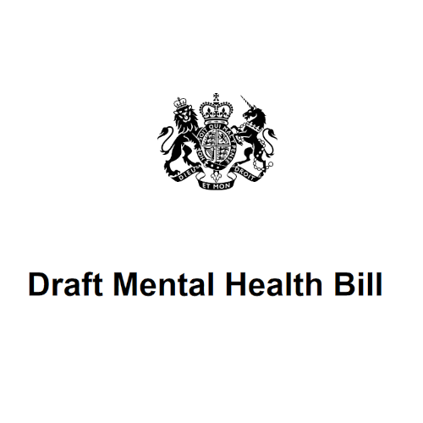
In June, the draft Mental Health Bill came out.
In it are the Government’s plans for changing the Mental Health Act.

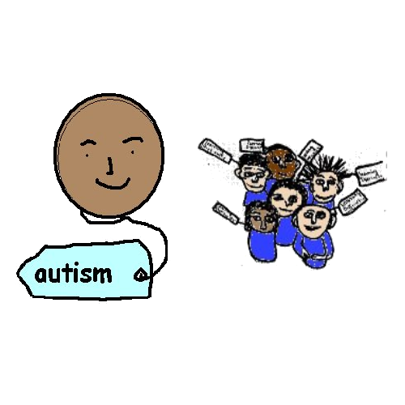
The Government said this bill will change laws for people with mental health conditions, autistic people, and people with learning difficulties in mental distress.
It will change how people in mental crisis are treated.
It will change what will happen while people are in crisis.

A mental health condition can affect someone’s mood, thinking, and behaviour. Depression, anxiety, and schizophrenia are examples of mental health conditions.
Some people prefer to use mental distress instead of mental health condition.
Some people use mental distress to mean when their emotions and thoughts stop them from coping with everyday life.

At Inclusion London, we think there are problems with this bill.
We also think it could do a lot more.
This would help more people.

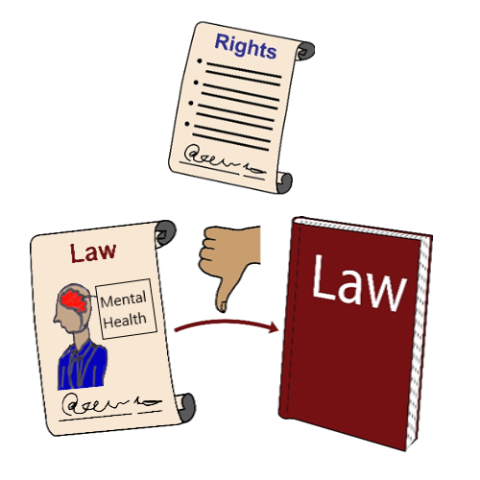
The Draft Mental Health Bill is not based on human rights.
The Draft Mental Health Bill is still to do with locking up people with mental health conditions or who have mental distress in hospital.

Human rights are a set of rules to protect people and say how they should be treated.
Everyone has them just for being a human.
But sometimes these rights are not respected.

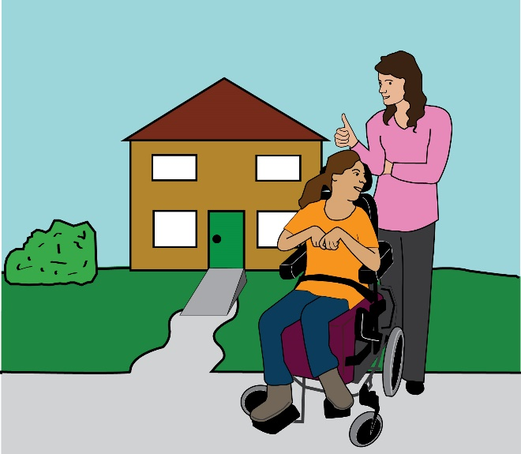
We want the Draft Mental Health Bill to give Disabled people the right to independent living.
We want it to give better access to good mental health support.

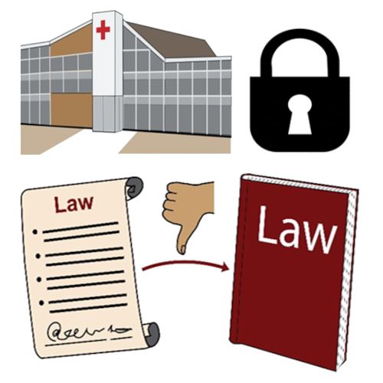
Too many autistic people and people with learning difficulties are being put in psychiatric hospitals.
These are hospitals for mental distress and trauma.
The Draft Mental Health Bill does not look enough at ending this.

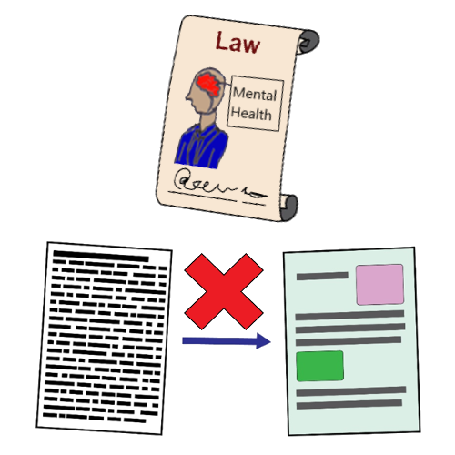
The day the draft Mental Health Bill came out, there was no Easy Read information.
This was a bad start.
It meant the information was not accessible.

People First groups asked for the draft Mental Health Bill in Easy Read.
It was written too late.
It came out after the closing date for speaking up groups to tell MPs and Peers what they thought.
People who use Easy Read were left out.
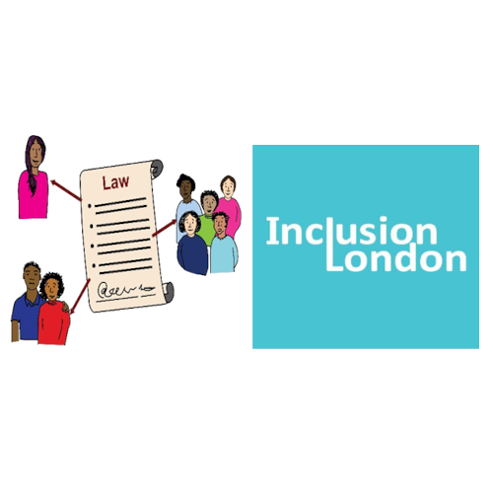

Inclusion London and Liberation wrote about what we thought of the draft Mental Health Bill.

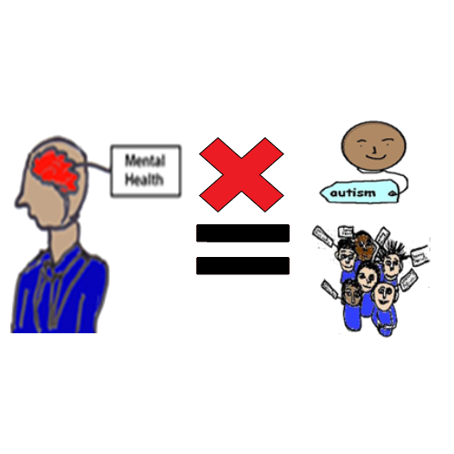
We are glad there are changes in how people with learning difficulties and autism will be treated.
The changes mean they will not be given treatment for being autistic or having learning difficulties.
This is a good change.

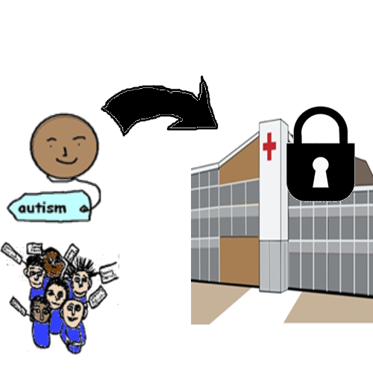
Some things have not changed.
The law will still say autistic people and people with learning difficulties can be locked up in psychiatric hospitals.
It will just be for other reasons.

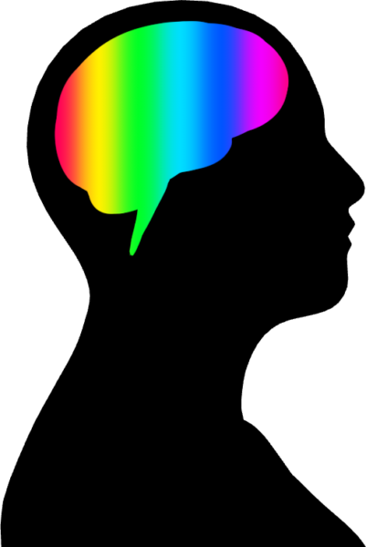
It is wrong to lock people up in hospital because they are Disabled.

People with learning difficulties, autistic people, and other Disabled people think differently to many other people.
Their brains can work differently.
They should not be locked up for this.

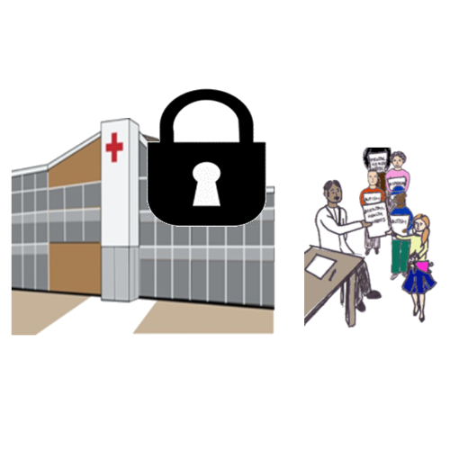

Autistic people and people with learning difficulties will also be locked up in hospitals for mental health assessments.

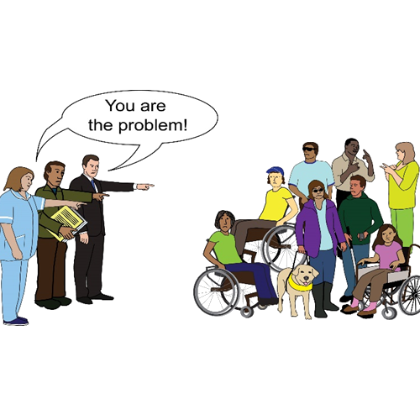
The law still uses the medical model of disability.
It is still about changing people with learning difficulties and autistic people’s brains and minds so they are ‘normal’.

The medical model of disability says that being disabled is an individual health problem.
It looks at what a person can’t do because of their impairment or health condition.
It says that Disabled people should be changed or cured.

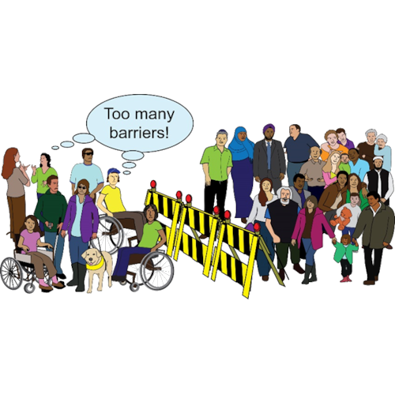
The law does not use the social model of disability.
The social model is about:
Changing people’s attitudes about disability
Changing the environment
Changing law and service rules

These changes are made to make things inclusive for Disabled people.
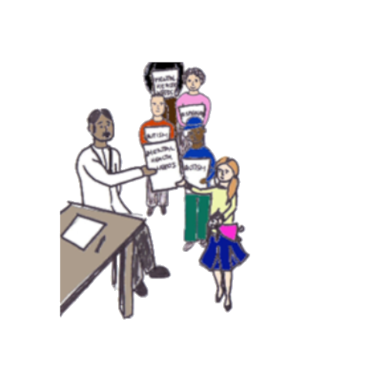
We are worried that doctors will say that autistic people and people with learning difficulties have mental health conditions.
They might say they have depression, psychosis, or personality disorders.
People can still be put in psychiatric hospitals for these.

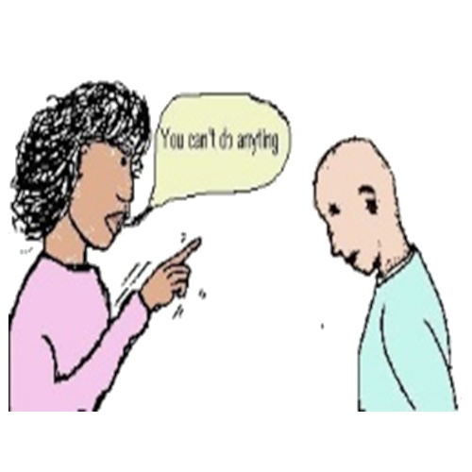
Sometimes, people think Disabled people cannot understand things.
They think they are not able to make decisions.
We are worried doctors will decide Disabled people cannot make decisions about their mental health care.
The Mental Capacity law could be used by doctors to make choices for Disabled people and force them to go into hospital.

Mental Capacity Law is meant to protect people over 16 years old when it comes to making decisions.
It has guidelines about when people can make decisions and when they might not be able to make decisions.
Sometimes, it is used badly to take people’s decision-making away when they can make decisions with help.

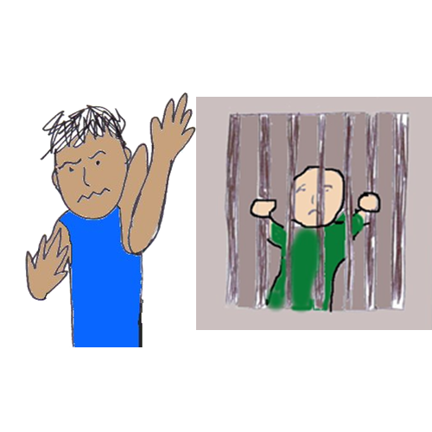
Autistic people and people with learning difficulties might behave differently.
They might have ways of coping people do not understand.
They might understand things differently to other people.
We are worried their behaviour and their ways of coping will be treated like a crime.

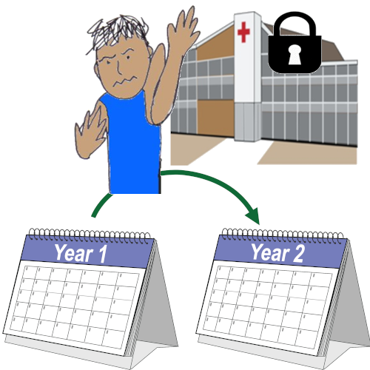

We are worried autistic people and people with learning difficulties will be locked up in hospitals for longer.

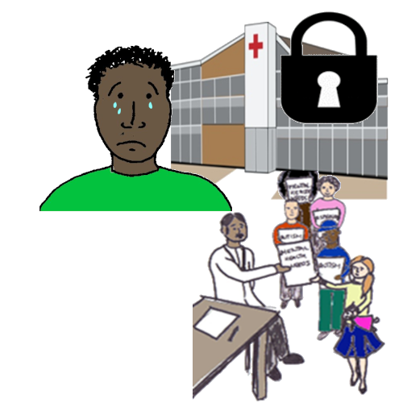
Being in a hospital can be upsetting and traumatic.
Especially for autistic people and people with learning difficulties.
We are worried people will get unhappy and distressed in hospitals.
Then they might be diagnosed with mental health conditions.

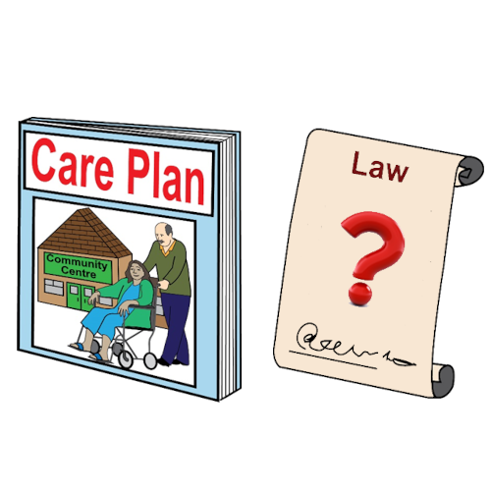
The bill also says that Care, Education and Treatment Reviews will be required by law.
It says that doctors and local authorities have to look at and use what these say.
But Care, Education and Treatment Reviews are not always very good.
Many of them do not focus on the person.

Care (Education) and Treatment Reviews are done for autistic people or people with learning difficulties who are in psychiatric hospitals. They are also done for people who might go into psychiatric hospitals.
The review is meant to help keep the person safe and make sure they are getting good care.
It is meant to plan for them to have care and treatment in the community.

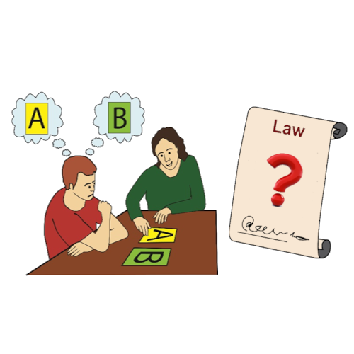
It would be good if there were more independent Mental Health Advocates.
It would be even better if people could choose who supports them.
But advocacy support is only as good as the law.
When the law lets people be locked up or stops them leaving hospital, advocates cannot always make it better.

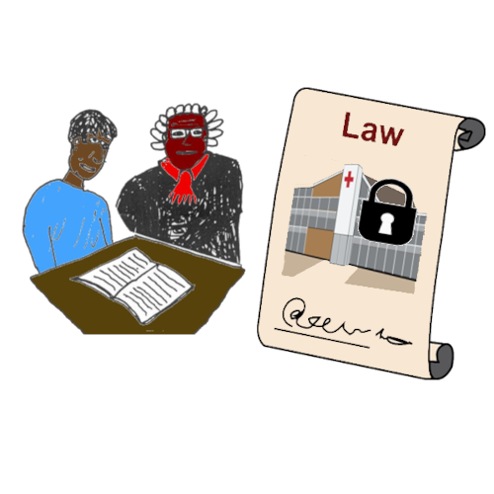
There are other good changes.
Patients will be able to ask for a Mental Health Review more easily.
They will be able to ask the court to review them being locked up in hospital.
We hope this means more patients can ask the court to be freed from hospital.

These are good changes.
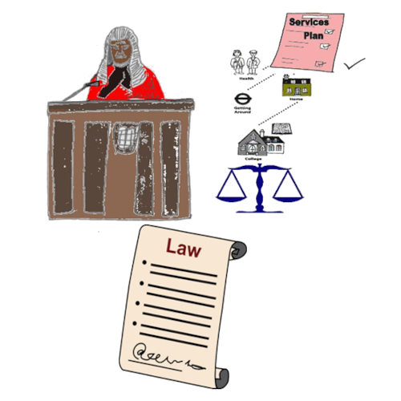
But only court judges will be allowed to recommend future treatment or community care.
There will be no law to make the local authority provide community care.
The law does not tell hospital doctors to stop drug and other treatments.
Sometimes, the type of treatment is not right and needs to stop.

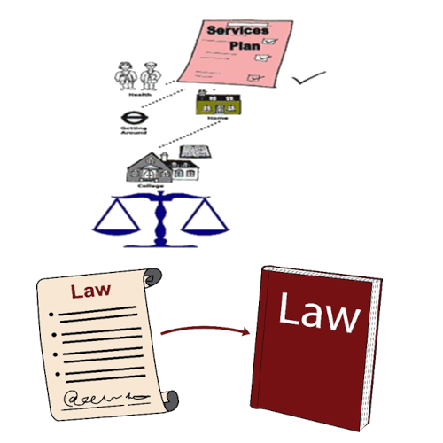
There are no changes in the law for people to get good housing and support.
Without this support, community care will not be as good.
It will not help autistic people or people with learning difficulties as well as it could.

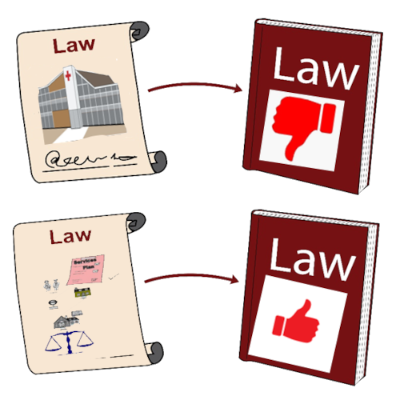
We do not want a law that puts more autistic people and more people with learning difficulties in hospital.

We want a law that supports autistic people and people with learning difficulties to be supported in the community.
We want laws for the right support to help Disabled people.

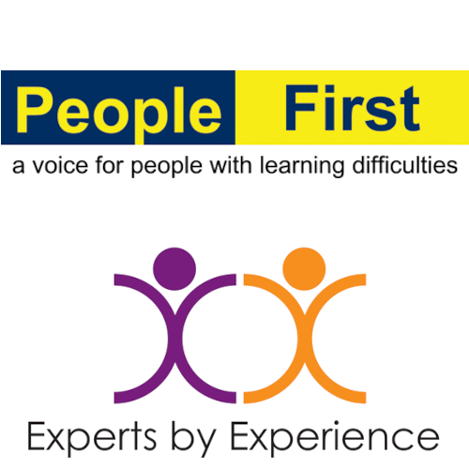
We used pictures on this page by:
People First Ltd
Bromley X By X
They gave us permission to use their pictures.

The picture of the Neurodivergent Brain (Thinking Differently) is by MissLunaRose12.

