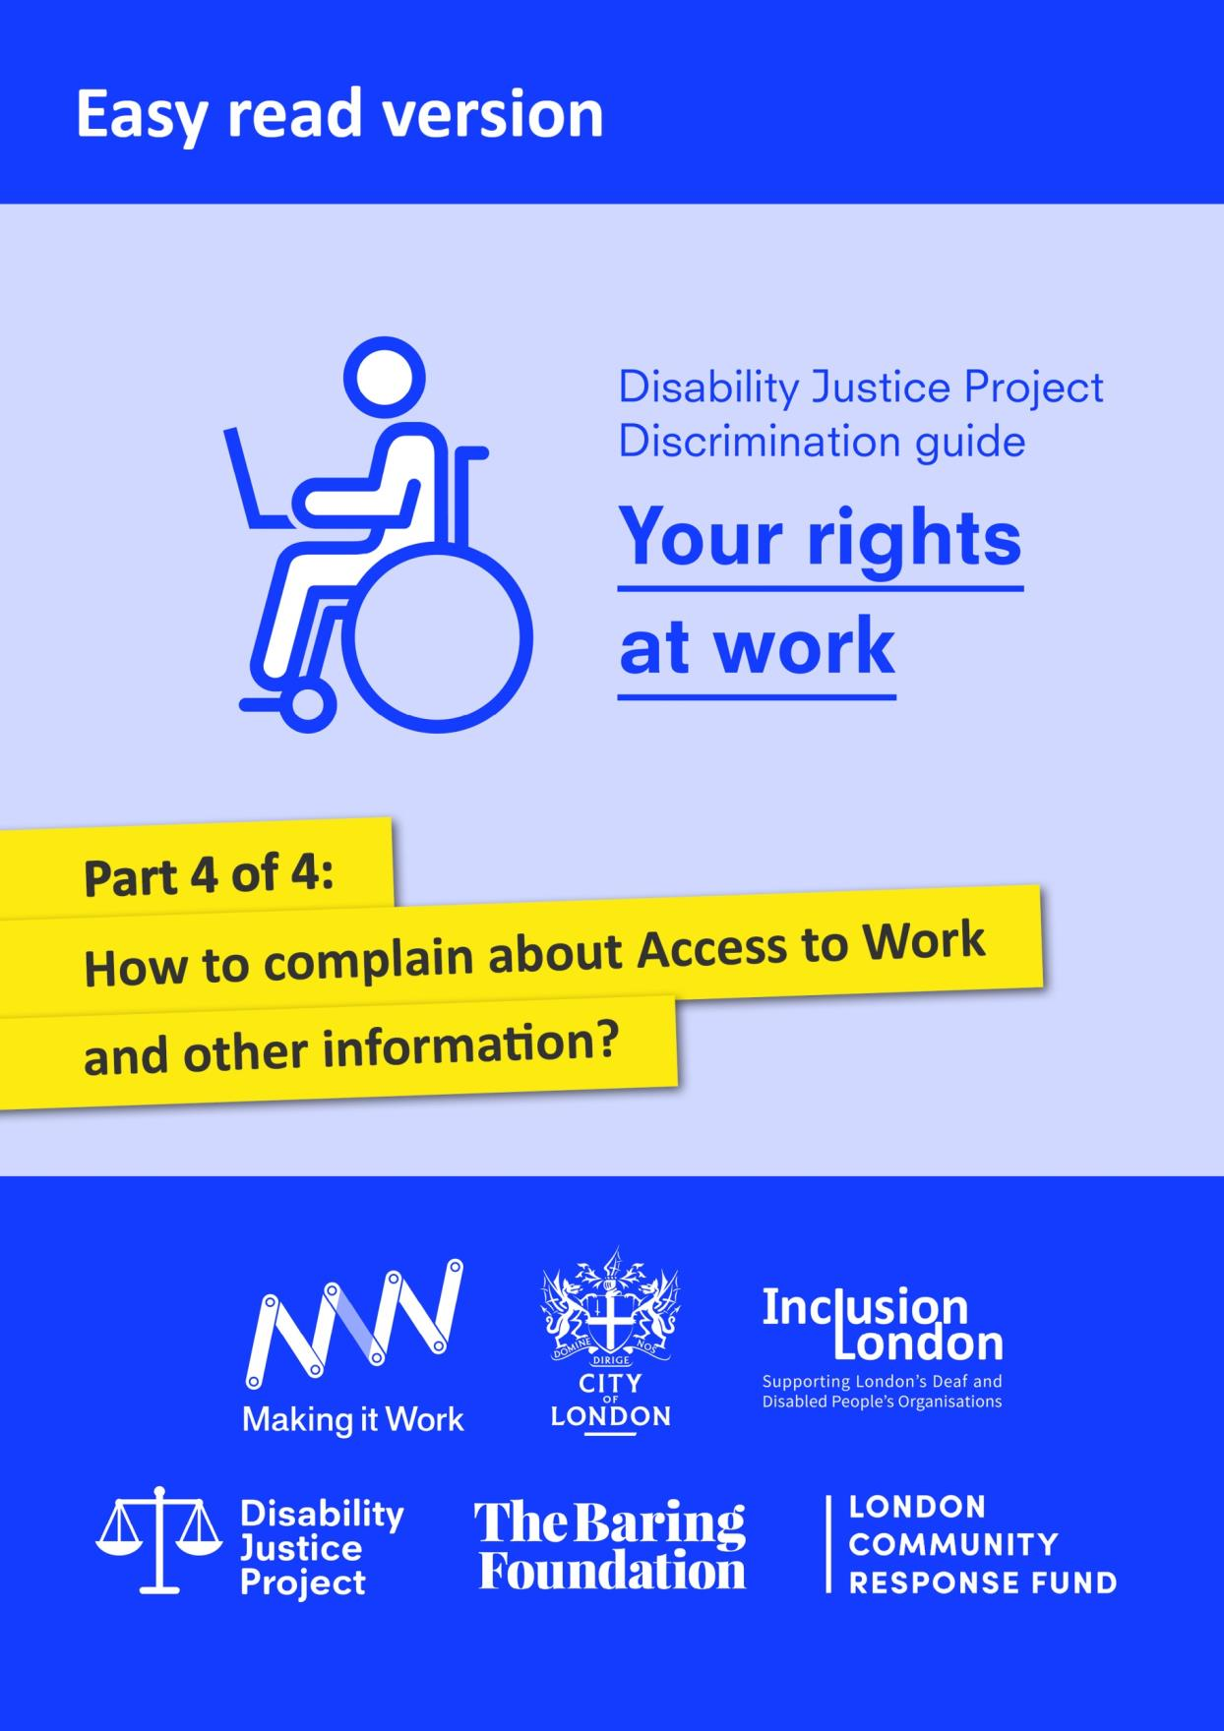

With thanks to City Bridge Trust and the London Community Response Fund for funding this easy read guide, as part of Inclusion London’s Making it Work project. Making it Work was a project which aimed to increase opportunities for young Disabled people to find employment and remove barriers in the workplace.
We would also like to thank the Equality and Human Rights Commission who funded the production of the original version of this guide through its grants programme.
The guide was originally produced as part of Inclusion London’s Disability Justice Project (https://www.disabilityjustice.org.uk/.) It is full of complex information. We have tried to make this easy read version as accessible as possible. However, if you use the easy read version, we recommend that you get further support from a trusted person.
This document was produced in collaboration between Inclusion London and People First. Images used and edited for use were from People First (https://peoplefirstltd.com/) and Photosymbols (https://www.photosymbols.com/) under licensing.
Produced by Inclusion London, July 2022
Copyright: We welcome reproduction of any part of this resource but we request that Inclusion London is acknowledged. Inclusion London has endeavoured to ensure that information included in this resource is up to date and correct. However, this cannot be guaranteed and it is, therefore, the responsibility of readers to seek their own legal advice where necessary.
Disability Justice Project
Guide to Discrimination
What are your rights at work?
Part Four – How to complain about Access to Work and Other Information

Access to work: this is a programme run by the government to help Disabled people find jobs or stay in work.
Disability Justice Project: this is a project by Inclusion London. The project supports Deaf and Disabled people. We want to make our rights to independent living and access to services a reality.
Discrimination: this means being treated unfairly. This could be because of a person’s race, age, sex or because of another part of who a person is. In this document we are talking about discrimination against Disabled people.
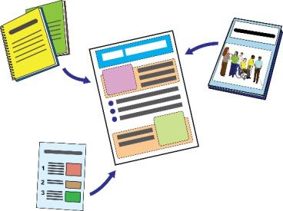  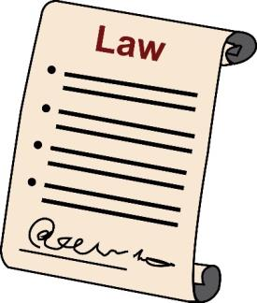 | This is Part Four of our guide.  In this part, we will look at how to complain about Access to Work.  We will look at examples of letters that you can use to deal with discrimination at work.  Please read all parts of this guide.  Here are the different sections:  Part One – How can the law keep you safe from discrimination at work?  Part Two – How can the law keep you safe from discrimination when your job ends?  Part Three - What steps can you take if you think you have faced discrimination at work?  Part Four – How to complain about Access to Work and other information
Complaining about Access to Work
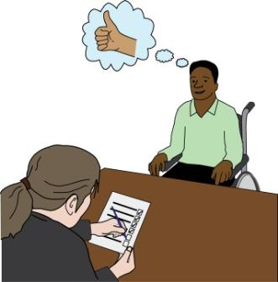 | You should try to deal with problems you have with your Access to Work adviser as early as possible.  You should:  - Tell them about any problems  - Ask questions  - Give them your opinions  - Ask to see copies of any policies or guidance they talk about
Policies: these are decisions or rules made by your employer.
The way that you stand up to decisions made by Access to Work will depend on what kind of decision it is.
You might not agree with a decision about the level of your Access to Work award.
For example, you might not agree with:
- How much money they agreed to pay for this support.
- What kind of support Access to Work agreed to.

In this situation, you should ask for reconsideration.

Reconsideration: here, this means when you ask Access to Work to think again about the decisions they have made.
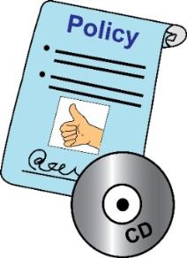 | If you are not happy with Access to Work’s customer service or ways of working, you should make a complaint.  You should follow the Department for Work and Pension ’s complaints policy.
Department for Work and Pension or DWP: this is the department in the government that is responsible for dealing with complaints about Access to Work.
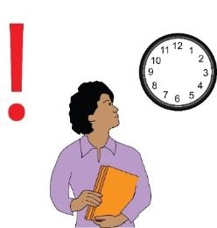 | Asking for Reconsideration:  You might disagree with Access to Work’s decision about the support they will give and how much they will pay for it.  If you don’t agree with their decision, you can ask them to look at it again.  You should do this after your application and review.  While your decision is being looked at again, a different person at Access to Work will look at your case and the decisions.  You have 4 weeks from the date of the first decision to ask them to rethink their decision.  You can send more evidence to support your argument.  You should ask the person who dealt with your case in the first place for reconsideration.
In your letter or email you should make it clear that you are asking for reconsideration.

Explain why you disagree with the first decision.
Add in any extra evidence you have.

When writing your letter think about these things:

- Why won’t the support meet your needs?
- What challenges will you face at work with the support they have offered?
- Did anything go wrong during the assessment?
- What level of support do you need and why?
- Did Access to Work work out your payment in a realistic way?

For example, maybe it won’t be possible to hire the support you need for the price they decided.

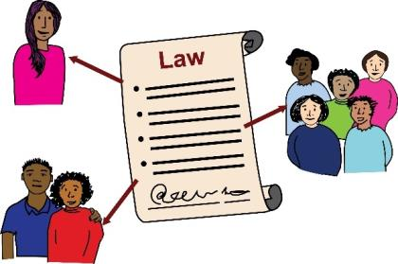 | The person you send the letter or email to should let you know when they get it.  They should let you know what to expect next.  This should take no more than 10 working days.  If you are not happy with the result, you can complain.  Keep reading to find out how to do this.  You might think that the decision was another example of discrimination.  If you think this, you should think about getting advice about the law.  You can stand up to some decisions by doing a judicial review.
Judicial review: this means when a court looks at decisions that were made by government organisations. They decide whether or not the decisions were made in a way that followed the law.
You can find lawyers who are experts on Discrimination against Disabled people at the Disability Justice Project’s website:

Find a solicitor - Disability Justice

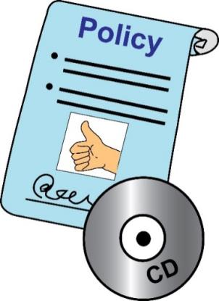 | Complaining about Access to Work service  If you want to complain about Access to Work, you must follow the Department for Work and Pension’s policies about complaints.  You should send your letter to the contact details in your decision letters.  You could also send your letter to the staff member you were in touch with.  You must tell them you want to make a complaint about how they dealt with your Access to Work application.  If you don’t get a good result, you could think about complaining to the Parliamentary and Health Service Ombudsman: www.ombudsman.org.uk
Parliamentary and Health Service Ombudsman: this is a group that makes final decisions about complaints that have been made against government organisations. They do this is a fair way without taking sides.
 | You can get more help and advice about Access to Work at these websites.
Here are some facts about Access to Work:
www.gov.uk/government/publications/access-to-work-factsheet/access-towork-factsheet-for-customers

Here is the staff guide for Access to Work:
https://www.gov.uk/government/publications/access-to-work-staff-guide

Deaf Access to Work has useful information about Access to Work.
It has information about how to complain about its services and decisions.

Here is the webpage:
www.deafatw.com/frequently-asked-questions-faqs.html

Example letters
In this part of the document, we will look at some example letters.
You can use these letters to help you reach out to the right people to deal with discrimination at work.

On this website, there are example letters and important information:
https://righttoparticipate.org/take-action/employment/

The Equality Advisory and Support Service can give you information and letters you can use here:
www.equalityadvisoryservice.com/

Equality Advisory and Support Service: this is an organisation which gives people advice about issues to do with equality and human rights.
For example, this letter can be used to remind your employer of their responsibilities to make reasonable adjustments:
www.equalityadvisoryservice.com/app/answers/list

Here is a letter you can use to help you with a Data Subject Access Request:

https://ico.org.uk/your-data-matters/

Data Subject Access Request: this means when you ask your employer to share all the personal information they have about you.

Getting in touch with us
Here are our details in case you need to get in touch with us:

This guidance was written by the Disability Justice Project and Inclusion London

Inclusion London’s address is:
336 Brixton Road London SW9 7AA

Here is our website:
www.disabilityjustice.org.uk
Our email address is: info@inclusionlondon.org.uk

Our phone number is:
020 7237 3 181

We would like to say thanks to the Equality and Human Rights Commission. They paid for this guide to be made.

Equality and Human Rights commission: this is a group that makes sure employers are meeting their responsibilities under the Equality Act.
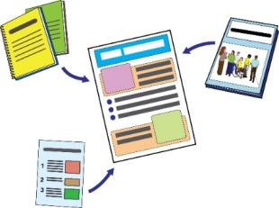 | This is the end of the guide. Please make sure that you have read all four parts of this guide.
In these guides, we use images from Photosymbols and People First.
We used these with their permission and under license.
This means they said it was okay for us to use them because we paid for them.

