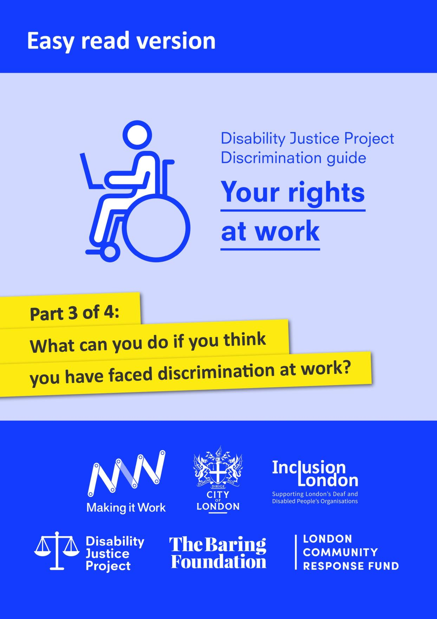

With thanks to City Bridge Trust and the London Community Response Fund for funding this easy read guide, as part of Inclusion London’s Making it Work project. Making it Work was a project which aimed to increase opportunities for young Disabled people to find employment and remove barriers in the workplace.
We would also like to thank the Equality and Human Rights Commission who funded the production of the original version of this guide through its grants programme.
The guide was originally produced as part of Inclusion London’s Disability Justice Project (https://www.disabilityjustice.org.uk/.) It is full of complex information. We have tried to make this easy read version as accessible as possible. However, if you use the easy read version, we recommend that you get further support from a trusted person.
This document was produced in collaboration between Inclusion London and People First. Images used and edited for use were from People First (https://peoplefirstltd.com/) and Photosymbols (https://www.photosymbols.com/) under licensing.
Produced by Inclusion London, July 2022
Copyright: We welcome reproduction of any part of this resource but we request that Inclusion London is acknowledged. Inclusion London has endeavoured to ensure that information included in this resource is up to date and correct. However, this cannot be guaranteed and it is, therefore, the responsibility of readers to seek their own legal advice where necessary.

Disability Justice Project
Guide to Discrimination
What are your rights at work?

Part Three – What steps can you take if you think you have faced discrimination at work?

Disability Justice Project: this is a project by Inclusion London. The project supports Deaf and Disabled people. We want to make our rights to independent living and access to services a reality.

Discrimination: this means being treated unfairly. This could be because of a person’s race, age, sex or because of another part of who a person is. In this document, we are talking about discrimination against Disabled people.
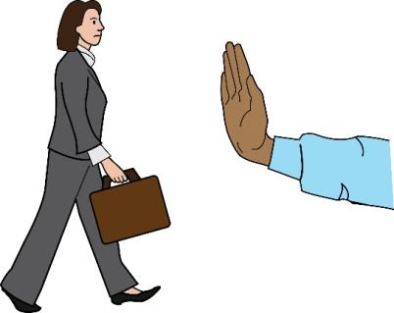  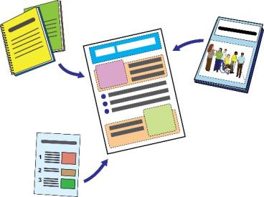  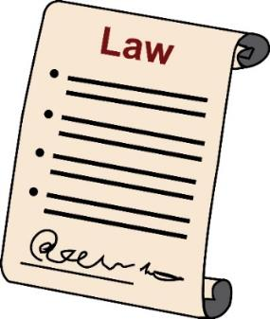 | This is Part Three of our guide.  In this part, we will look at what you can do if you are discriminated against.  We will look at how the law can keep you safe from discrimination in these different situations.  Please read all parts of this guide.  Here are the different sections:  Part One – How can the law keep you safe from discrimination at work?  Part Two – How can the law keep you safe from discrimination when your job ends?  Part Three - What can you do if you think you have faced discrimination at work?  Part Four – How to complain about Access to Work and other information
Time limits – How much time to I have to deal with discrimination at work?

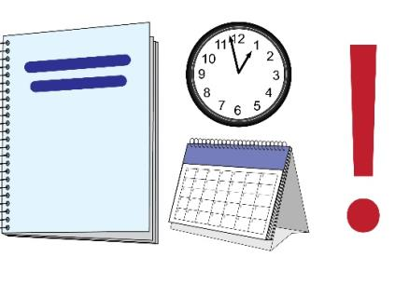 | There are strict time limits when you are making a claim about discrimination at work.  If you want to make a claim at an employment tribunal, you only have a certain amount of time to do this.
Claim: in this document, this means when you say in court that you have faced discrimination at work.

Tribunal: this is a special type of court that only looks at one area of the law.

Employment Tribunal: this is a special court that makes decisions about problems at work. They look at the law to make decisions about things like unfair treatment or discrimination at work.
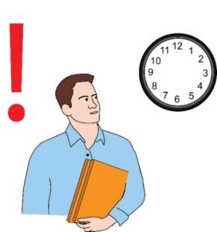 | Usually, you have just less than three months to take your employer to a tribunal.  You usually have one day less than three months.
Employer: this means the person or people who have hired you to work for them.
The three months start from the day that the discrimination happened. For example, when:
- The day your employer didn’t give you a chance for a promotion.
Promotion: this means when your employer gives you a new role or job at work. You usually get paid more and have more responsibilities.
- The day someone at work made a comment about you as a Disabled person.

- The last day at work. This is if you were fired or made redundant and it was discrimination.
- The day your employer wouldn’t make any reasonable adjustments

Reasonable Adjustments: here, this means making changes to get rid of barriers faced by Deaf and Disabled people at work.
Before the tribunal, you must apply for Early Conciliation.
You can apply f or this on ACAS.

Early Conciliation: this means when ACAS talks to you and your employer about your problem. They give you a chance to solve the problem together so that you don’t have to go to an employment tribunal.
ACAS or Advisory, Conciliation and Arbitration Service: this is a group that works with employers and workers to make their relationships better. They get funding from the government.
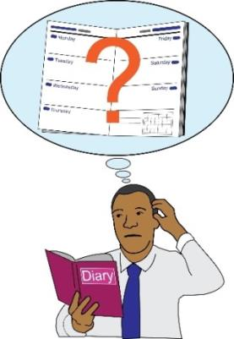  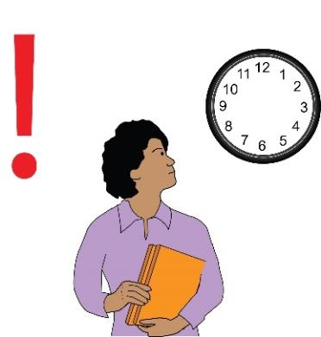 | Applying for early conciliation can affect your time limit.  If you have faced discrimination at work, you must always think about the time limit when deciding what to do next.  Time limits are complicated.  If you are not sure about them, you should get some advice as quickly as possible.

What actions can you take if you have faced discrimination at work?
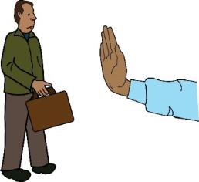
 | Now we will look at the different steps you could take to deal with discrimination at work:
Step 1 - Talk to your employer about the problem
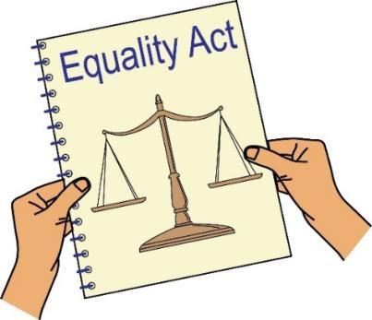 | Sometimes employers don’t know what they must do under the Equality Act.  Lots of employers don’t even know that their policies are leading to discrimination.
Equality Act 2010: this is a law that aims to look after people’s rights and make sure that people don’t face discrimination.

Policies: these are decisions or rules made by your employer.
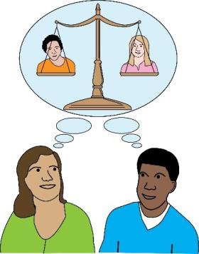 | If you think you are being untreated unfairly, you could write to your employer or ask to meet with them.  You could talk about the problem and tell them about their responsibilities under the Equality Act.  You can ask them to make things better for you at work.  Sometimes meeting with your manager or Human Resources can be helpful.  You could also meet with someone you trust at work.
Human Resources or HR: this is the department at work that deals with your relationship with your employer. They deal with things like training, hiring and firing and making your work environment safe.
The best way to tell your employer about the problem will depend on your situation.
It will depend on what you feel comfortable with.

For example, you might have asked for reasonable adjustments and your employer didn’t do anything.

In this situation, you could talk to the Human Resources department or your manager.
You could tell them about your employer’s responsibility to make reasonable adjustments.

If they don’t reply, you could write to them and think about your next steps.
Here is an example of a letter you could use.
This letter will help you tell your employer about their responsibility to make reasonable adjustments under the Equality Act:
www.equalityadvisoryservice.com/app/answers/list

Step 2 - Raise a grievance
Grievance: this means a problem or complaint that you want to tell you employer about.
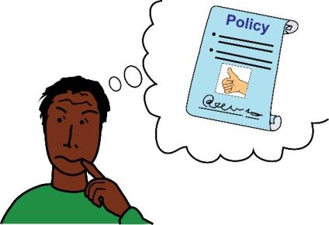 | If you think you have been treated unfairly at work, you could raise a grievance with your employer.  You could also do this if you think you might be treated unfairly in the future.  Different employers have their own policies about grievances.  You should read your employer’s policy to see what it says about how to raise a grievance at work.
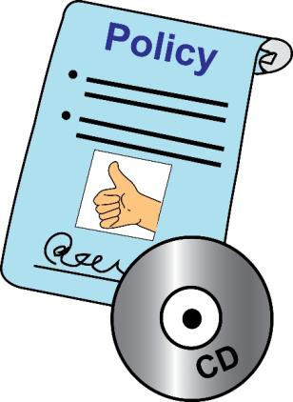 | If your employer does not have a policy about grievances, then you should follow this advice from ACAS:  www.acas.org.uk/media/1047/Acas-Code-of-Practice-on-Disciplineand-Grievance/pdf/11287_coP1_Disciplinary_Procedures_v1_Accessible.pd  You should try to make sure that your grievance is clear.  You should give some facts as examples.  These facts will help your employer to see what the problem is.
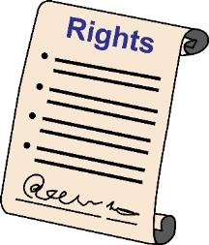 | You have a right to complain about problems at work.  It is against the law for your employer to treat you differently because you have complained.  Employers must not cause problems for you at work or make your workspace uncomfortable.  You should ask for advice if you are not sure how to raise a grievance.
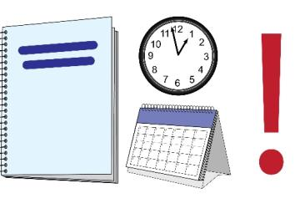 | Please also remember the time limit that we talked about above.  You still have just less than three months to go to tribunal, even if you complain to your employer first.
Step 3 - Finding Evidence
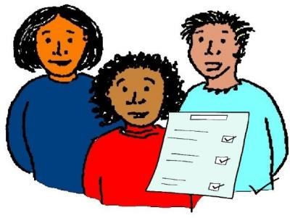  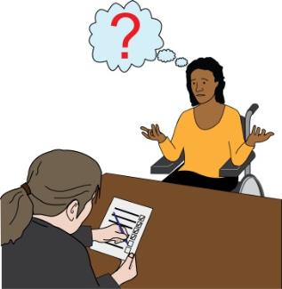 | If you decide to take your employer to a tribunal, you must be able to show you faced discrimination at work because you are Disabled.  You will have to give facts which show that it is likely that the discrimination really did happen.  You will also have to prove that you meet the definition of a Disabled person under the Equality Act.  You will only have to do this if your employer doesn’t agree that you meet this definition.  You can prove that you are a Disabled person by showing your medical records.  You might need to ask for information from your GP or other doctors.  The tribunal will then look at the discrimination that happened.  It is very important to try to find as much evidence as possible about the discrimination.  This evidence will help you to stand up to your employer.  It will help you if your employer says the discrimination wasn’t that bad or didn’t really happen.
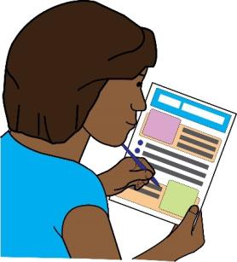  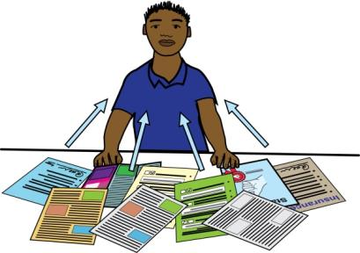 | You should write down or keep a copy of everything that happens with your employer.  Keep any documents or information that will help you to talk about the events at work.  Try to make sure your information is right.  Write down names, dates, times and addresses.  Try to keep these documents in the right order, from the least recent to the most recent.  If your file is in a good order, it can really help your case.
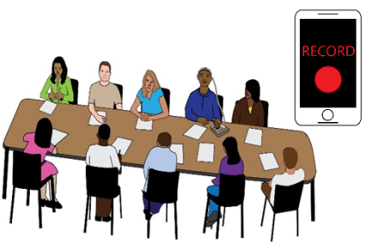 | You might think it’s a good idea to record a meeting or phone call.  However, the tribunal might not see this as a good thing.  If your employer finds out you recorded them and did not tell them, they could fire you.  It would be better to ask your employer if you can record the meeting or phone call.  You could also ask if you can take notes during or straight after the meeting.  If you can, type the notes and save them so that there is a date stamp.  It might also help if you email the employer with a copy of what you say happened.  This would be good evidence that you have told your employer about what is happening.
You could also speak to other people at work about the problems you are facing.
It’s good to have somebody else who knows what is happening.

They could be the person who agrees with you and says that what you are saying is true.
They could do this at the tribunal.

You should be careful, though.
Only talk to people at work that you really trust.
You might not want lots of people to know about your situation.
Your employer might not want you to talk about the situation to lots of people.

You might be given evidence which shows that you didn’t actually face discrimination.
Or, you might be given evidence that shows you did.
Here are some ways that you could get evidence from your employer:

Data Subject Access Request
You have a right to be given a copy of personal information your employer has about you.

Data Subject Access Request: this means when you ask for your employer to share all the personal information they have about you.
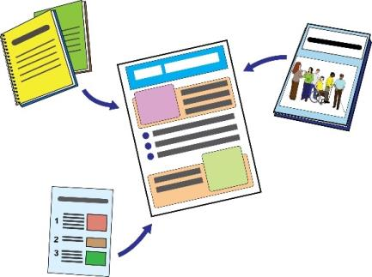 | Examples of things they might have talking about you are:  - Documents  - Phone recordings  - CCTV recordings  - Minutes and notes from any meetings.  You can find more information about this on the Information Commissioner’s Office website.  Here is an example letter you could use to ask for your personal information:  https://ico.org.uk/your-data-matters/

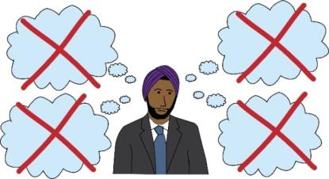 | ACAS Questions and Answers  Another way you can find out more information is by asking your employer questions.  You can do this by using the ACAS Questions and Answers.  You can find out more information here: https://www.acas.org.uk/advice  Asking and responding to questions of discrimination in the workplace.  Your employer doesn’t have to answer this.  If they don’t answer, the tribunal can look at this and think about why they might not have answered.

Step 4 - Making a claim at an employment tribunal
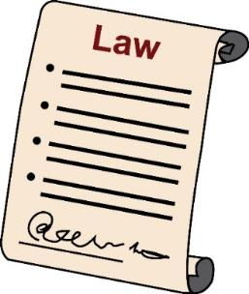  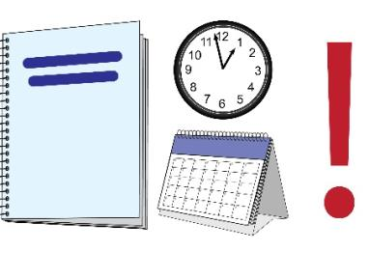 | If you think that your employer has gone against the law you could make a claim at the employment tribunal.  It doesn’t matter whether or not you have had time to collect evidence.  You must make your claim with the employment tribunal within the time limit.  You must apply for ACAS Early Conciliation before you make your claim.  This is because you must have the Early Conciliation Certificate number when you make your claim.
Early Conciliation Certificate number: this is a number that is given to you at the end of the Early Conciliation process.
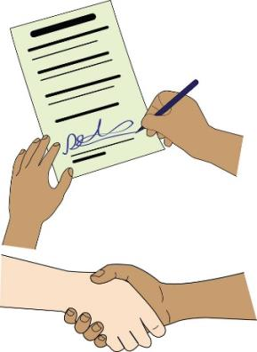 |  | You must make sure that you get your employer’s name right when you apply for Early Conciliation.  Your employer’s name is usually shown on your payslip or contract.
Contract: this means an agreement between you and your employer about your roles, responsibilities, and rights at work.
If you want to make sure you have the right name, you could email your employer to ask.
If they say no or don’t answer don’t worry.
You will be able to show this as evidence if you use the wrong name by mistake.

You must also make sure that you apply for Early Conciliation.
You must get a certificate, for everybody who replies to the claim.

For example, you might claim that you faced harassment because of your disability.
It would be best to apply for Early Conciliation against all the people who harassed you, as well as your employer.

Harassment: this means treating a Disabled person in a way that does not show them respect.
This can be things like calling them names, making them feel scared, or damaging things that belong to them.
This is because an employer can stand up to your claim if they can show that they took all reasonable steps to stop people harassing you.

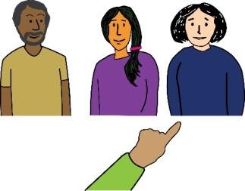
In a situation like this, you could carry on with your claim against the people who actually harassed you.

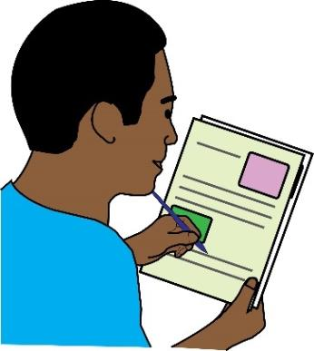
Then, you would fill in each person separately on the claim form.
Each person would have their own Early Conciliation Certificate numbers.
To start your claim, go to this website:

https://employmenttribunals.service.gov.uk/apply

Here is some more information about Employment Tribunals:

You can read more about the employment tribunal here: www.gov.uk/employment-tribunals

You can read more about getting ready for your tribunal case here:
www.citizensadvice.org.uk/work/problemsat-work/employment-tribunals/preparing-anemployment-tribunal-case/
You can read more about dealing with discrimination at work here:

www.equalityhumanrights.com/en/multipageguide/dealing-discrimination-employment

What will happen if you win your case?

Here are the things an employment tribunal could do if you win your case:
- Say yes, your employer did discriminate against you at work.
- Give compensation for money you lost because of the discrimination. This usually means if you have lost earnings but can mean expenses, too.

Compensation: here, this means when you get given money to make up for the money you lost because of discrimination at work.
Earnings: this means the money you get paid to do your job.
Expenses: this means extra money you have spent because of your job. For example, money you have spent on travel or food.
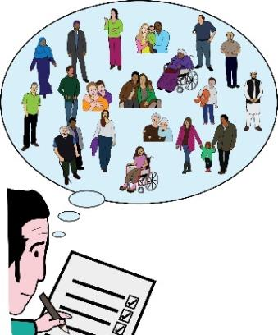 | - Give damages for hurting your feelings.  There are guidelines about how this works.  The court will look at how serious the discrimination was.  They will look at how many times you faced discrimination at work.  They will look at how the discrimination has affected you.  Then, they will decide if you get damages for hurt feelings.  This is also called emotional damages.
Damages: here, this means when you are given money to make up for the emotional pain you had to deal with because of discrimination at work.
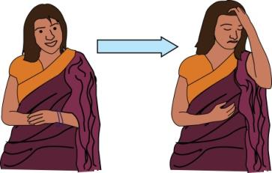 | - Give you damages for injury to health.  This will happen if the discrimination has affected your mental health badly.  - Give you aggravated damages
Aggravated damages: this means money that is given to you in the most serious cases of discrimination.
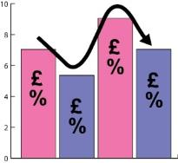 | - Give you interest on any compensation you get.
Interest: here, this means extra money that must be paid while you are waiting for your compensation.
The longer you are waiting to be paid, the more interest you will get.
 | - Give you an ACAS uplift on any compensation you get
ACAS uplift: this is when ACAS can get you more compensation from a tribunal.
They can get you up to 25% more than the original amount. They can do this if your employer has gone against their policies.
 | - Make suggestions so the employer must take steps to get rid of discrimination or make sure that less discrimination happens.

What are the risks of making a claim?
How much money will it cost to make a claim?
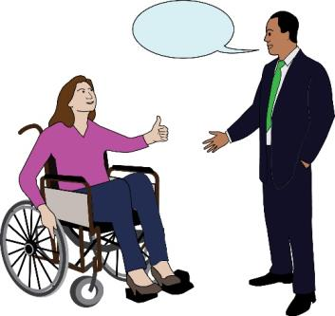 | You don’t have to pay to make a claim at an employment tribunal.  However, you do have to pay for a lawyer to speak for you in court.  The only reasons you wouldn’t have to pay for this is if you get legal expenses cover or are a member of a Trade Union.
Legal expenses cover: this is a type of insurance that can pay for things to do with the law such as advice about the law and lawyers. It is usually found in your home or motor insurance policy.

Insurance: this is an agreement where a person pays money to a company and the company promises to pay money back if something happens. For example, they might pay for costs to do with the law.

Trade union: this is a group of workers who have come together to push for their rights.
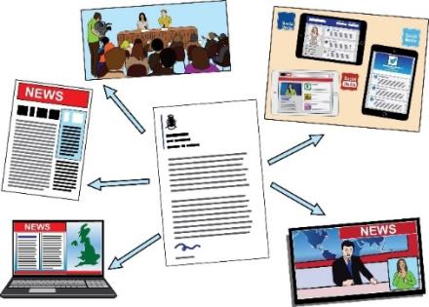  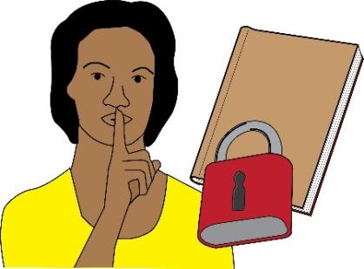 | Employers must also pay for someone to speak for them in court.  Some employers might have insurance that will pay for this.  They might already have somebody who works for them to speak for them and their business.  If you pay for a lawyer and win your case, you are not very likely to get your money back.  Most of the time, if you lose your case, you won’t have to pay for your employer’s costs.  But you might have to pay your employer’s costs if:  - Your claim was based on false or wrong evidence.  - If your claim had no chance of winning from the start.  Sometimes, your employer might have to pay costs too. This will happen if they act in a way that is not fair and not honest.  It is important to know that any judgement that is made by the tribunal will be on public record.  This means that anybody will be able to know about the case if they search for your name online.  They will know that you made a claim. They might be able to read more details about the claim.  This depends on when the claim was made.  It also depends on the results of the tribunal.  You can ask to stay anonymous during the tribunal. But this is not usually allowed.
Anonymous: here, this means the information about the tribunal won’t have your name on it.
You can find out more information and tips about costs on the Citizens Advice website:
Paying costs after an employment tribunal claim - Citizens Advice
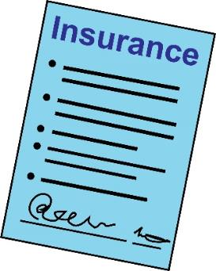 | Where can you get more help and advice?  If you are a Trade Union member, you could get free advice about the law from your Union.  Talk to the person who represents your workplace or regional office.  You should check your home or motor insurance.  This insurance might pay for advice about the law at employment tribunals.
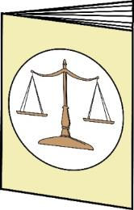 | Equality Advisory and Support Service can give you information and example letters you can use: https://www.equalityadvisoryservice.com/
Equality Advisory and Support Service: this is an organisations which gives people advice about issues to do with equality and human rights.
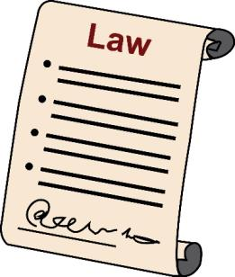 | ACAS can also give you advice about the law and your rights:  https://www.acas.org.uk/  You can find lawyers who are experts at dealing with discrimination at work here:  https://www.lawsociety.org.uk/for-the-public/common-legal-issues/problemsat-work/  Some lawyers can work with individual people. This might be a cheaper way to pay for someone to represent you at a tribunal.  You can find out more information here:  https://www.directaccessportal.co.uk/search/1/barrister  Advocates can help some people access free advice or get represented in court for free.  You can find out more information here: https://weareadvocate.org.uk/
Advocate: in this document, this means a person who stands up for Disabled people. They talk about Disabled people’s rights and the barriers that they face.
The Free Representation Unit might be able to represent you at a tribunal.
This works as a referral system.
This means someone would have to invite you to get in touch with them.
You can’t get in touch with them yourself. Here is their website: http://www.thefru.org.uk

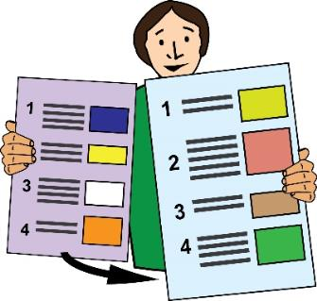 | This is the end of Part Three of our guide.  Please go to Part Four to read about complaining about Access to Work and other information.
In these guides, we use images from Photosymbols and People First.
We used these with their permission and under license.
This means they said it was okay for us to use them because we paid for them.

