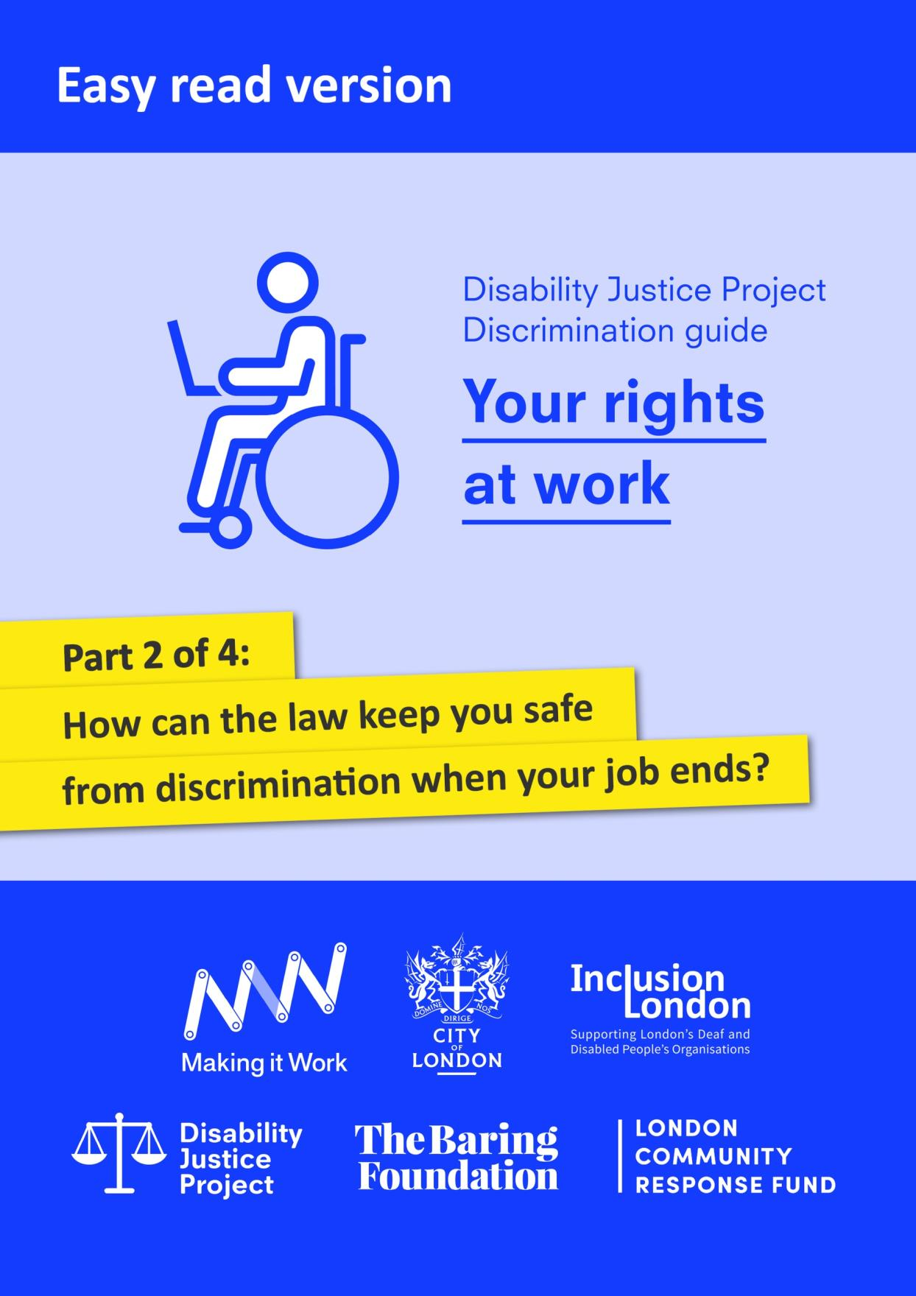

With thanks to City Bridge Trust and the London Community Response Fund for funding this easy read guide, as part of Inclusion London’s Making it Work project. Making it Work was a project which aimed to increase opportunities for young Disabled people to find employment and remove barriers in the workplace.
We would also like to thank the Equality and Human Rights Commission who funded the production of the original version of this guide through its grants programme.
The guide was originally produced as part of Inclusion London’s Disability Justice Project (https://www.disabilityjustice.org.uk/.) It is full of complex information. We have tried to make this easy read version as accessible as possible. However, if you use the easy read version, we recommend that you get further support from a trusted person.
This document was produced in collaboration between Inclusion London and People First. Images used and edited for use were from People First (https://peoplefirstltd.com/) and Photosymbols (https://www.photosymbols.com/) under licensing.
Produced by Inclusion London, July 2022
Copyright: We welcome reproduction of any part of this resource but we request that Inclusion London is acknowledged. Inclusion London has endeavoured to ensure that information included in this resource is up to date and correct. However, this cannot be guaranteed and it is, therefore, the responsibility of readers to seek their own legal advice where necessary.
Disability Justice Project
Guide to Discrimination
What are your rights at work?

Part Two– How can the law keep you safe from discrimination when your job ends?

Disability Justice Project: this is a project by Inclusion London. The project supports Deaf and Disabled people. We want to make our rights to independent living and access to services a reality.

Discrimination: this means being treated unfairly. This could be because of a person’s race, age, sex, or because of another part of who a person is. In this document, we are talking about discrimination against Disabled people.
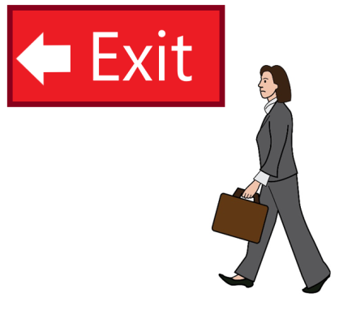  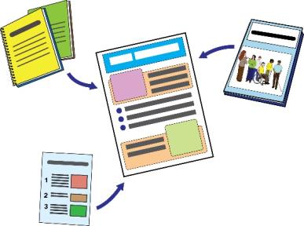  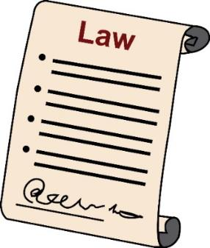 | This is Part Two of our guide. In this part, we will look at the different ways that your job might end.  We will look at how the law can keep you safe from discrimination in these different situations.  Please read all parts of this guide.  Here are the different sections:  Part One – How can the law keep you safe from discrimination at work?  Part Two – How can the law keep you safe from discrimination when your job ends?  Part Three - What can you do if you think you have faced discrimination at work?  Part Four – How to complain about Access to Work and other information
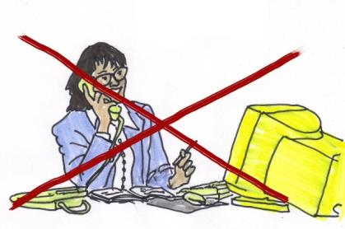 | There are lots of different reasons why your employer might end your job. Sometimes they have a fair reason for doing this.  However, sometimes the situation might be seen as discrimination.
Employer: this means the person or people who have hired you to work for them.
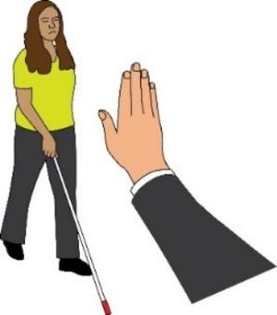 | Ending your job because of your Disability is discrimination.  If the way your employer ends your job is unfair to you as a Disabled person, this is also discrimination.
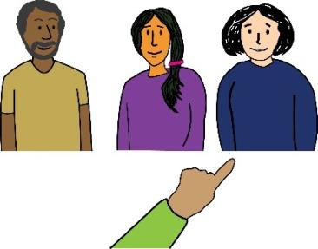 | In this part of the document, we will look at the reasons that employers might end your job.  Sometimes the law says these reasons are fair.  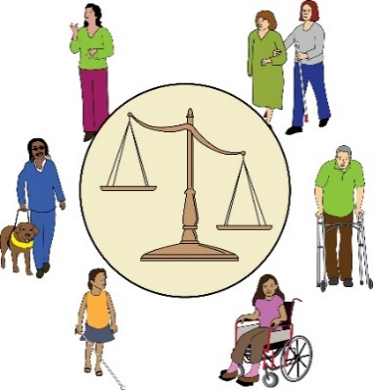  However, we will also look at whether your disability was a reason for their decision.  If this is the case, their decision might be an example of discrimination.

What are the different ways that your job could end?

- Redundancy
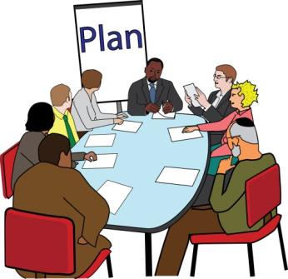  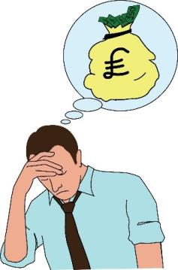  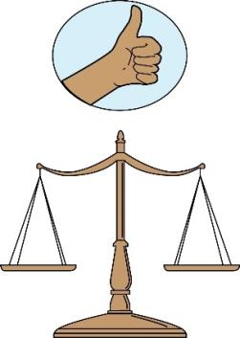 | Employers need to make the best decisions for their business.  They must think about decisions like:  - What is the best way to run the business?  - How can they meet the changing needs of customers?  - What is the best way to set-up the business?  - How many workers they can pay?  Sometimes, these decisions mean that some employers might face redundancy.  In these situations, employers must deal with redundancies in a fair way.
Redundancy: Here, redundancy means when jobs end because an employer needs to make their workforce smaller. So they need less staff.
This can be because projects have ended. It can be because they do not have enough money. It can be because they are closing part or all the company. There are other reasons, too.
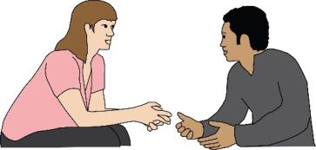 | Employers must consult with workers.  They must think about other roles workers could take on instead of being made redundant.
Consult or Consultation: here, this means when employers talk to their workers about redundancy. They explain why they need to make redundancies. It’s also a chance to try and work out different actions that could be taken so redundancy doesn’t have to happen.
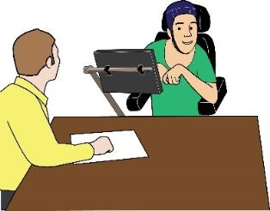 | Sometimes employers might pretend that they are making redundancies to support their business.  But they might actually be doing this to get rid of a Disabled worker.  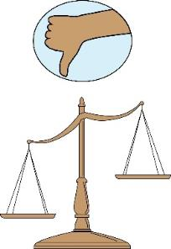  Sometimes employers might deal with redundancies in a way that is unfair to Disabled workers.
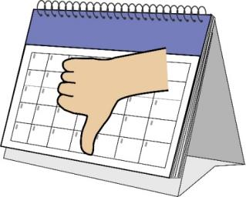  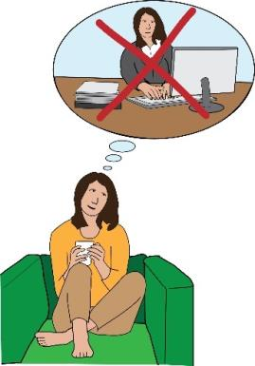 | Here are examples of discrimination that can happen in a redundancy situation:  Employers might look at absences to decide who should be made redundant.  Disabled workers are more likely to take time off work because of their disability.  If workers who have more absences are more likely to be made redundant, this would be unfair to Disabled workers.
Absence: this means taking time off work.

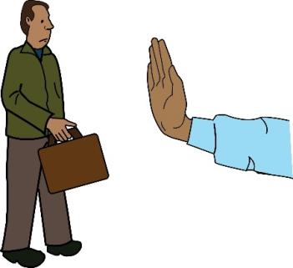  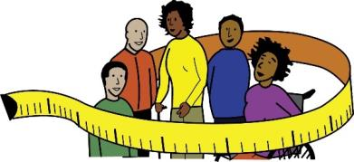 | Employers not offering Disabled workers a different role because they are Disabled.  They might think it will be too hard for the person to do this role because of their impairment.  Employers must think about how the role can be changed to make it more accessible for Disabled workers.  They must think about making any other reasonable adjustments.
Reasonable Adjustments: here, this means making changes to get rid of barriers faced by Deaf and Disabled people at work.
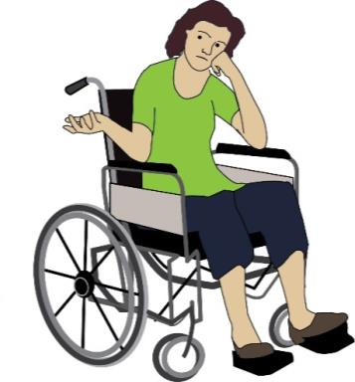 | Employers changing the set-up of their business, but the only worker who is affected is a Disabled person.  The employer doesn’t have a good enough reason for changing the set-up of their business.  So, really they are just doing it to get rid of the Disabled worker.
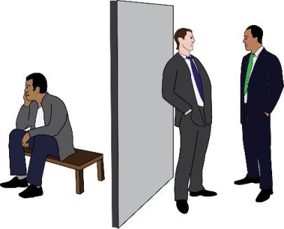 | Judging a Disabled person as a worse worker than a non-disabled person.  This happens even though the Disabled person is doing just as well or better than the non-disabled person at work.
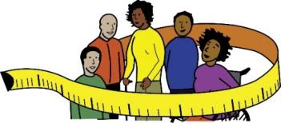  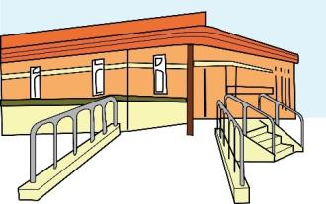 | Employers not making reasonable adjustments when they deal with redundancies.  For example, they might not think about:  - Which times are good for you  - Where the consultation meetings are held  - How the information about the redundancy is given  An example of a reasonable adjustment would be to give you a British Sign Language Interpreter at your consultation.
- Performance – Ending your job because you are not doing a good enough job

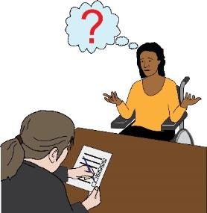 | Often employers look at how their workers are doing at work.  If they think they are not doing as well as they should be, they might do a performance review.
Performance Review: this means when your employer looks at how well you are doing at work. They might look at what is going well and give you feedback about what you could be doing better.
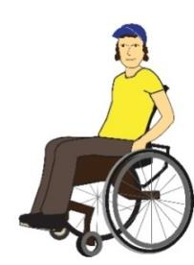  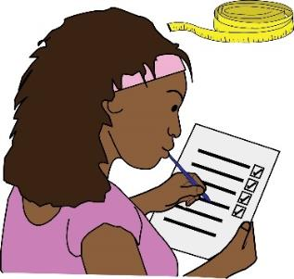 | However, if the reason for the review is because of a worker’s disability then this might be discrimination.  An employer might do a performance review because of the way a person thinks or acts at work.  However, if the person thinks or acts this way because of their impairment, this could be discrimination too.
Impairment: this means an injury, illness or condition that affects the way a person moves, acts or thinks.
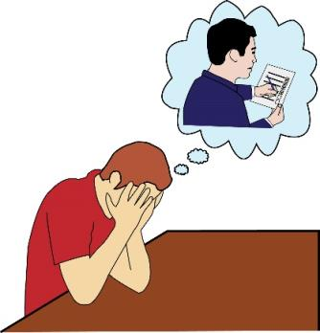 | Here are examples of discrimination that could happen in a performance situation:  A disabled worker is doing well at work, but they are still made to do a performance review.  They are doing just as well or better than non-disabled workers in the same situation.
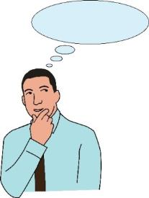  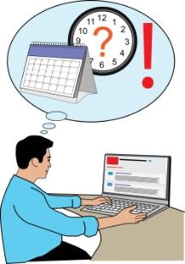 | An employer doesn’t think about changing the way they review their workers’ performance.  They don’t try to meet the Disabled worker’s needs.  For example, they don’t think about the best time and place to carry out a performance review with a disabled person.
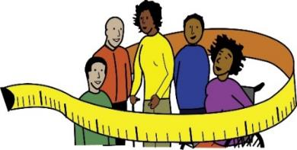  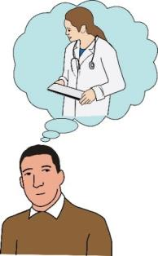 | Your performance is not as good as it should be, but the reason for this is because you have to manage your impairment.  You have to take time off to go to medical appointments.  Your performance might not be good enough because your employer has not made reasonable adjustments for you at work.  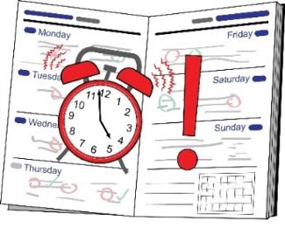  One way to make reasonable adjustments would be to set different targets for you as a Disabled worker.  For example, an employer might need their workers to make a certain number of sales every day.  If a worker has a visual impairment, they might not be able to reply to customers as fast as non-Disabled workers.  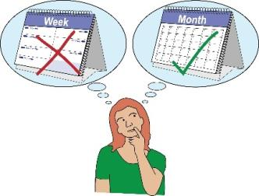  A reasonable adjustment would be to change the Disabled worker’s sales target.  This means they have to make less sales than non-Disabled workers.

- Capability – This means looking at whether or not you are able to do your job.
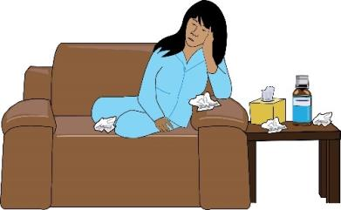  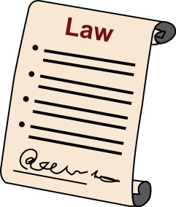  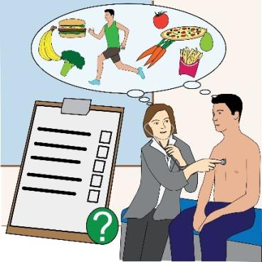 | Often, an employer looks at whether or not someone is able to do their job after they have been off sick for a while.  If you took time off because of your disability, the employer must not treat you unfairly.  They might have responsibility by law to make reasonable adjustments.  Before they make any decisions about a Disabled employee’s capability, an employer should ask for medical evidence.  For example, they should do an Occupational Health assessment if they can.
Occupational Health assessment: this is when a medical exam is done on a worker by a doctor.
The doctor can suggest adjustments that could be made at work. These adjustments would lead to a safer and healthier workplace for that person.
Then, the employer should meet with the worker.
This can be either in person or by telephone.
They should talk about the worker’s absence and find out if they might be able to come back to work in the future.
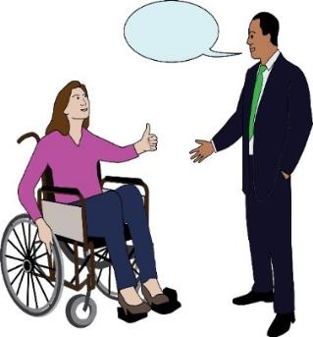  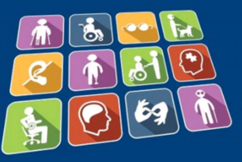 | The employer should also think about any reasonable adjustments which might help you come back to work.  They should think about changing the way they look at absences.  For example, they could look at how and when they get in touch with you about your absence.  Please remember that Access to Work can help pay for extra support you need to do your job.  Even after reasonable adjustments are made by your employer, you might still need some more changes.
Access to work: this is a programme run by the government to help Disabled people find jobs or stay in work.
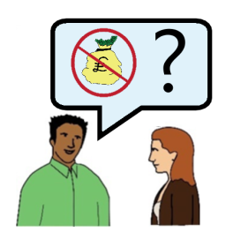 | You should talk to your employer if they are worried about how much the adjustments will cost.
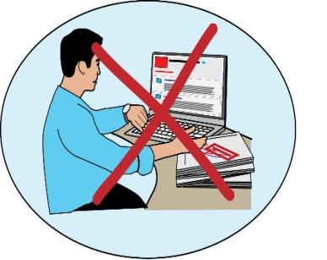  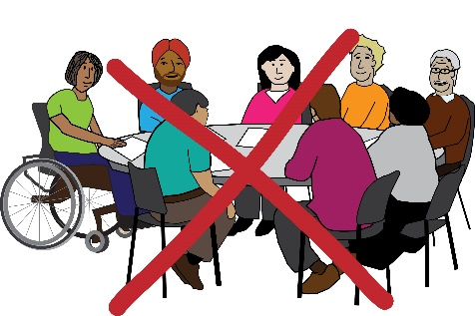 | Here are some examples of discrimination that could happen in a capability situation:  An employer decides to get rid of a worker because they have been absent for a long time.  The person had to take time off work because of their disability.  Sometimes, it might seem like the disabled worker is not going to be able to come back to work even with adjustments.  If this happens, the employer might be able to ask them to leave the job.
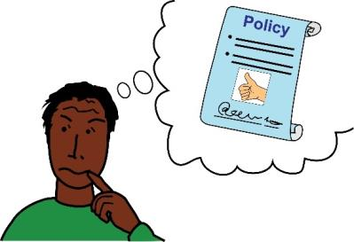 | An employer might have a policy which means they look at capability after somebody has taken a certain amount of time off work.  This might be unfair to Disabled workers who take more time off work because of their impairment.
Policies: these are decisions or rules made by your employer.
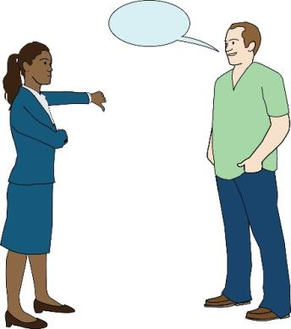 | Sometimes the law says it is okay to ask someone to leave a job.  An employer might be able to say the way they deal with absences is fair.  They might talk about how a worker’s absence is affecting the business and other workers.  They might argue that it is not very likely that the worker will come back to work.
- Conduct – How a worker acts at work
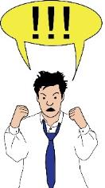 | An employer will review a worker’s behaviour when they think that the person has done something that is seen as an act of misconduct.
Act of misconduct: this means when the way you act at work goes against your employer’s policies.
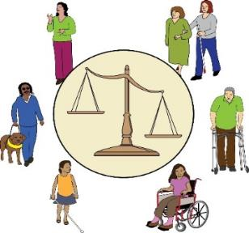  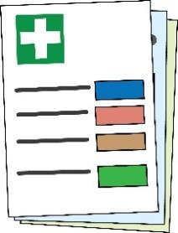  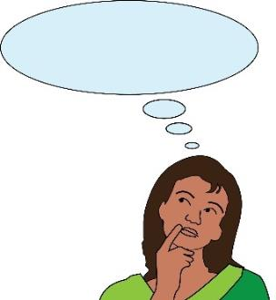 | Sometimes acts of misconduct are something to do with the person’s impairment or disability.  When this happens, the decision to review or punish them could be an example of discrimination.  An employer should think about these things before taking action:  - The person’s medical information.  - Listening to the worker and hearing why they carried out the act of misconduct.  - Whether any adjustments could have been made to stop the misconduct from happening.  - What adjustments could be made to stop the misconduct from happening again.
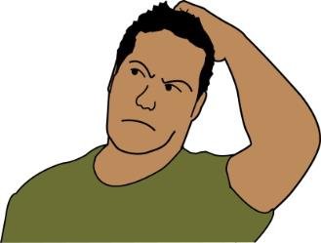  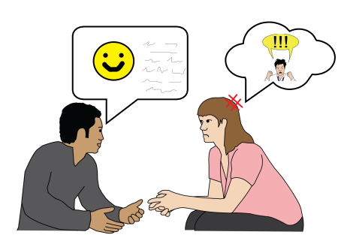 | Here is an example of discrimination that could happen in a conduct situation:  A worker’s misconduct is something to do with how they act towards other people at work or how they deal with instructions at work.  The person has autism.  Autism affects how the person acts around other people and deals with instructions.

- Resigning – Deciding to leave work
If your employer goes against your contract at any time, you could decide to leave work.
This is also called resigning.

If they discriminate against you, you could resign.
You could say that discriminatory or constructive dismissal has happened.
Contract: this means an agreement between you and your employer about your roles, responsibilities, and rights at work.

Discriminatory or constructive dismissal: this means when your employer changes the conditions of your job because they want to force you to resign.
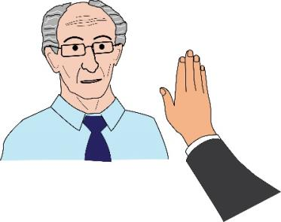  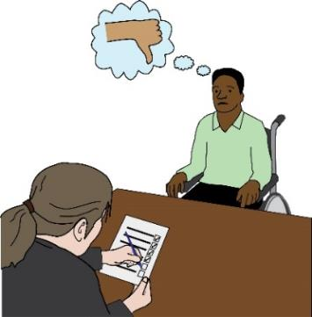 | If you want to say that your employer broke the law, you would have to prove that they discriminated against you.  You would have to prove that resigning was the only way to solve the problem.  You would have to say that you resigned because of discrimination and not for any other reason.
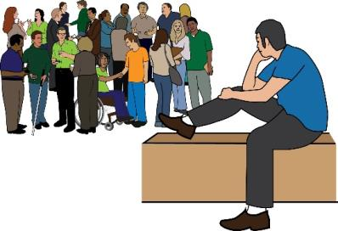  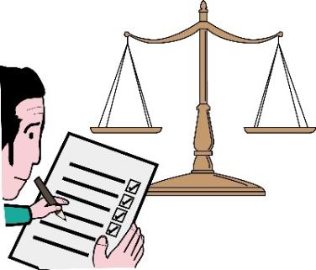 | Sometimes, the discrimination might happen when your job is already ending.  For example, you might be going through one of the situations we have already talked about such as redundancy.  Your employer might be able to prove they were going to end your job in a fair way before you resigned.  If this is true, you might not be able to get as much compensation.
Compensation: here, this means when you get given money to make up for the money you lost because of discrimination at work.
Here is some more information about keeping you safe from discrimination when your job ends:
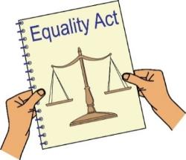
You can read about the Equality Act here:
www.legislation.gov/uk/ukpha/2010/15/contents

You can read more about what the Equality Act means on the Equality and Human Rights Commission’s website:
www.equalityhumanrights.com/en/publication-download/employment-statutory-code-practice

Equality and Human Rights commission: this is a group that makes sure employers are meeting their responsibilities under the Equality Act.
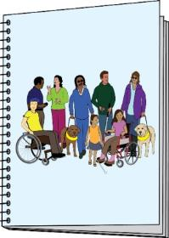 | Here is the Disability Rights UK’s Right to Participate guide. It has some examples of letters and information dealing with discrimination.  https://righttoparticipate.org/take-action/employment/
You can read more about ACAS here:
https://www.acas.org.uk/index.aspx?articleid=1461

ACAS or Advisory, Conciliation and Arbitration Service: this is a group that works with employers and workers to make their relationships better. They get funding from the government.
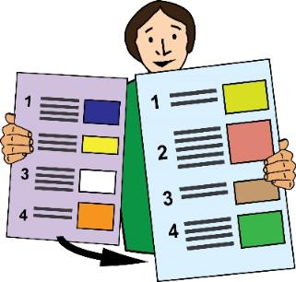 | This is the end of Part Two of our guide.  Please go to Part Three to read about what steps you can take if you think you have faced discrimination at work.
In these guides, we use images from Photosymbols and People First.
We used these with their permission and under license.
This means they said it was okay for us to use them because we paid for them.

