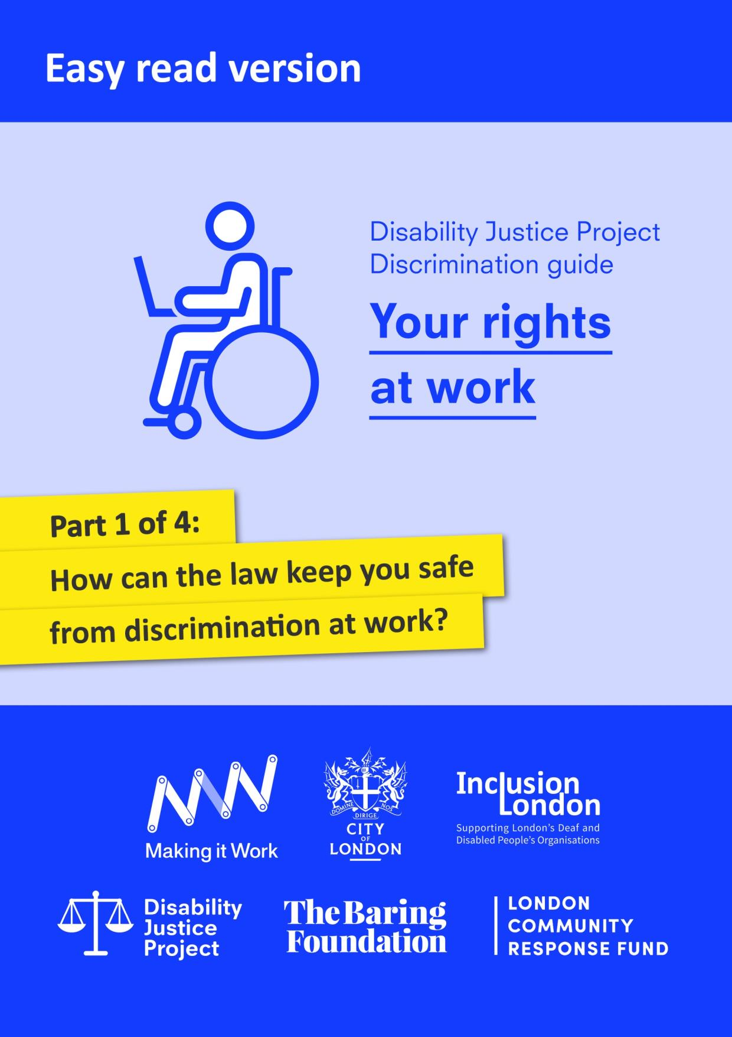

With thanks to City Bridge Trust and the London Community Response Fund for funding this easy read guide, as part of Inclusion London’s Making it Work project. Making it Work was a project which aimed to increase opportunities for young Disabled people to find employment and remove barriers in the workplace.
We would also like to thank the Equality and Human Rights Commission who funded the production of the original version of this guide through its grants programme.
The guide was originally produced as part of Inclusion London’s Disability Justice Project (https://www.disabilityjustice.org.uk/.) It is full of complex information. We have tried to make this easy read version as accessible as possible. However, if you use the easy read version, we recommend that you get further support from a trusted person.
This document was produced in collaboration between Inclusion London and People First. Images used and edited for use were from People First (https://peoplefirstltd.com/) and Photosymbols (https://www.photosymbols.com/) under licensing.
Produced by Inclusion London, July 2022
Copyright: We welcome reproduction of any part of this resource but we request that Inclusion London is acknowledged. Inclusion London has endeavoured to ensure that information included in this resource is up to date and correct. However, this cannot be guaranteed and it is, therefore, the responsibility of readers to seek their own legal advice where necessary.

Disability Justice Project
Guide to Discrimination
What are your rights at work?

Part One – How can the law keep you safe from discrimination at work?

Disability Justice Project: this is a project by Inclusion London. The project supports Deaf and Disabled people. We want to make our rights to independent living and access to services a reality.
Discrimination: this means being treated unfairly. This could be because of a person’s race, age, sex or because of another part of who a person is. In this document we are talking about discrimination against Disabled people.
What is this guide about?
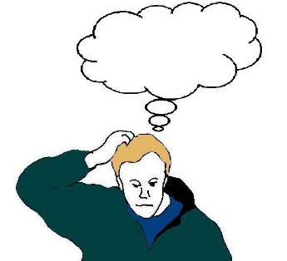 | As Disabled people, we face discrimination every day.  Sometimes we might not know that what is happening is against the law.  Some of us feel like we can’t do anything about it.
That’s why we wrote this guide.
It will tell you how the law keeps you safe from discrimination at work.
It will tell you what you can do if you think you have faced discrimination at work.
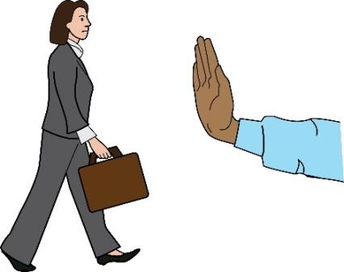  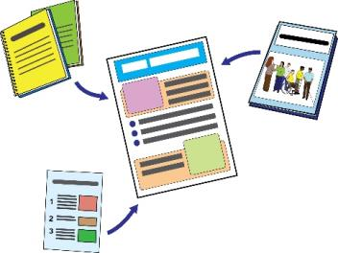  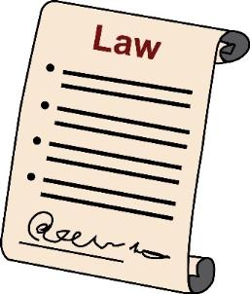  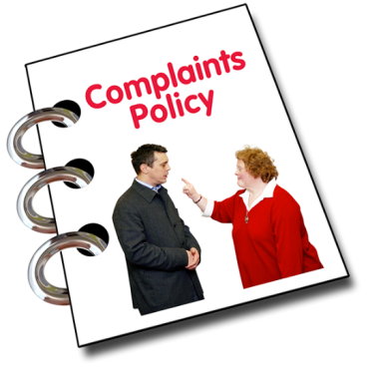 | This is Part One of our guide.  In this part, we will look at the different types of discrimination you might face at work.  We will look at what the law says about these different types of discrimination.  There are four parts to this guide.  Please read all parts of this guide.  Here are the different sections:  Part One – How can the law keep you safe from discrimination at work?  Part Two – How can the law keep you safe from discrimination when your job ends?  Part Three - What can you do if you think you have faced discrimination at work?  Part Four – How to complain about Access to Work and other information

Part One - How can the law keep you safe from discrimination at work?
What does the law say?
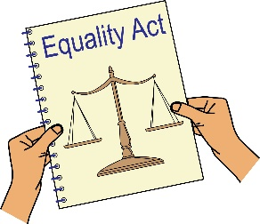 | The Equality Act 2010 says it is against the law for employers to discriminate against Disabled people at work.
Equality Act 2010: this is a law that aims to look after people’s rights and make sure that people don’t face discrimination.

Employer: this means the person or people who have hired you to work for them.
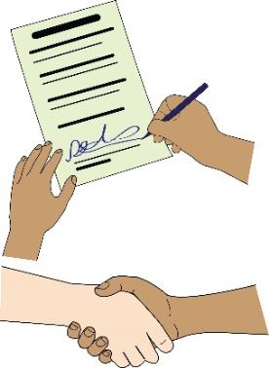  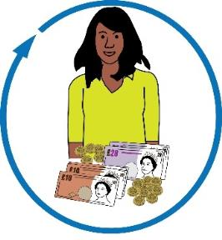  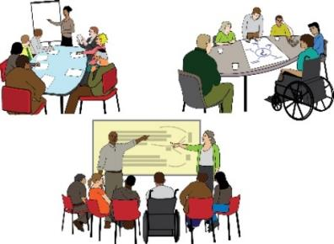 | Discrimination can be to do with lots of different things at work such as:  - Terms and conditions. These are agreements between you and your employer. They are about your roles, rights and responsibilities at work.  - Benefits  - Getting paid  - Training  - Leaving work or getting fired  - Promotions  - Performance reviews  - Absences
Promotion: this means when your employer gives you a new role or job at work. You usually get paid more and have more responsibilities.

Performance Review: this means when your employer looks at how well you are doing at work. They might look at what is going well and give you feedback about what you could do better.

Absence: this means taking time off work.
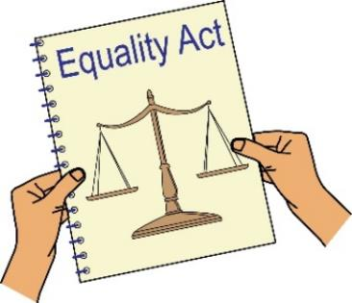  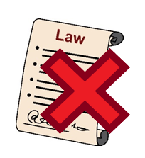 | The Equality Act talks about what disability means.  When we talk about Disabled people in this guide, we mean people who meet the definition of disability in the Equality Act.  If you don’t meet this definition, the law can’t keep you safe from discrimination.
Who is disabled under the Equality Act?
 | The Equality Act says that a person is disabled if they have a physical or mental impairment.
Impairment: this means an injury, illness or condition that affects the way a person moves, acts or thinks.
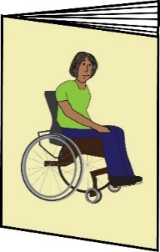  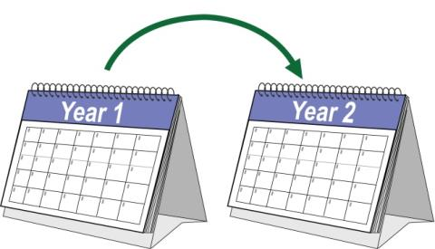 | The impairment must:  - Affect the person a lot and for a long time.  - It must make it really hard for the person to do normal activities every day.  - Affect the person for over a year. Some people have a condition that comes and goes away.  - The Equality Act says that you are a Disabled person if the condition affects you for 12 months or more.
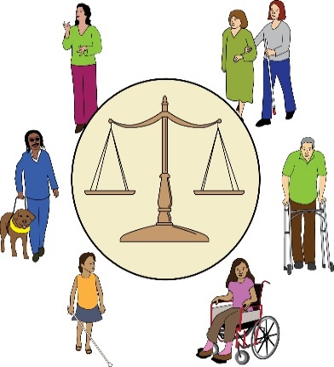  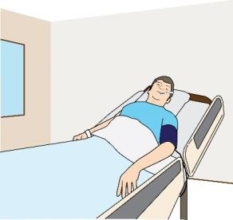  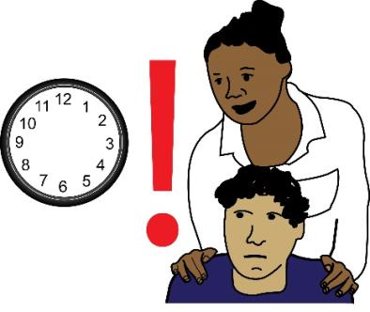 | Some people with impairments will definitely meet the definition of disability in the Equality Act.  For example:  - Blind and visually impaired people  - People with HIV. HIV is an illness that affects the way your body deals with infections and diseases  - People with cancer  - People with MS or Multiple sclerosis, this is a condition that affects a person’s brain and nerves  Some people might have a condition that will get worse over time.  The law can cover them even in the early stages of their condition.  This means they are covered even when their impairment doesn’t affect their everyday lives yet.
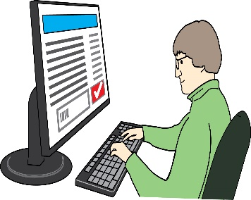 | The Equality and Human Rights commission has more information about what disability means under the Equality Act 2010.  You can read more about this on this webpage:  www.citizensadvice.org.uk/law-and-courts/discrimination/protected-characteristics/what-counts-as-
Equality and Human Rights commission: this is a group that makes sure employers are meeting their responsibilities under the Equality Act.
What are the different types of discrimination that you could face at work?

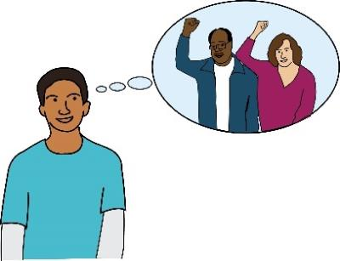  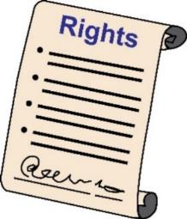  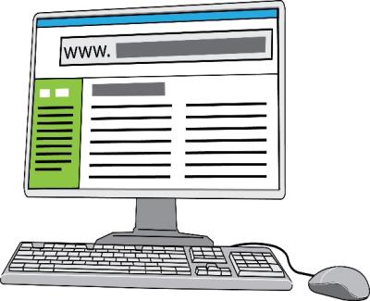 | Now we will look at the different types of discrimination that Disabled people might face at work.  Everybody has rights at work.  This document looks at your rights as a Disabled person.  Here are some websites that can tell you more about other rights at work that everybody has.  www.gov.uk/browse/working  www.citizensadvice.org.uk/work/rights-at-work/  www.acas.org.uk/article/4663/Rights-andresponsibilities-at-work
- Direct Disability Discrimination. This is when you are treated differently or worse than other people at work because you are a Disabled person.

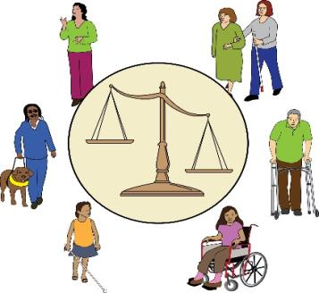 | It’s against the law for employers to treat you worse compared to other non-Disabled workers.  Employers must not treat you worse just because you are a Disabled person.
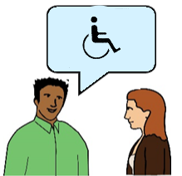 | It’s important your employer knows you are Disabled.  The law can only see your employer’s actions as discrimination if your employer knows you are Disabled.
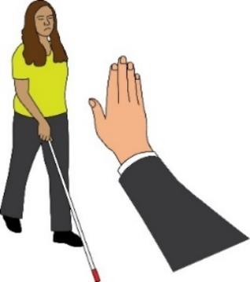  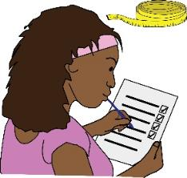 | Here are examples of what could be direct discrimination:  - Not giving you the chance to get a promotion or training because you are Disabled.  - Not inviting you to a team event because you are Disabled.  - Making you go through a performance review because you are Disabled.  - Making you go through a capability review because you are Disabled.  - Paying you differently or not giving a bonus because you are Disabled
Capability review: this means when your employer looks at whether or not you are still able to do the job.

Bonus: this means when you get paid extra money, usually because you are working hard or doing well at work.

- Discrimination arising from Disability. This means when you are treated unfairly because of something to do with your disability, not because of the disability itself.
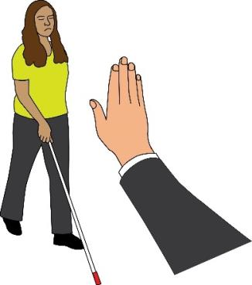 | It’s against the law for your employer to treat you badly because of something to do with your disability.  They must be able to prove that there is a good reason for the way they are treating you.  The way they treat you must be proportionate.
Proportionate: this means the way your employer treats you at work is the only reasonable way they can get the results they want.
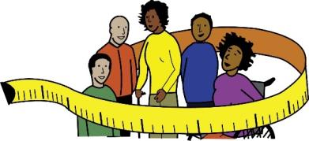 | When deciding the best way to treat you, employers must think about what reasonable adjustments they could make.
Reasonable Adjustments: here, this means making changes to get rid of barriers faced by Deaf and Disabled people at work.
You must tell your employer that you are Disabled.
But you do not need to tell them all the details about your impairment or disability.
You do not need to tell them all the ways your disability affects the way you think or act.
Discrimination arising from disability is against the law even if your employer does not know all the details.

For example, your employer knows that you have autism.
But they might not know this causes you to find some things difficult to do.
Because they know you are autistic, discrimination arising from disability may still apply.

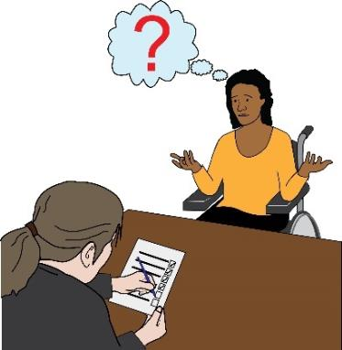  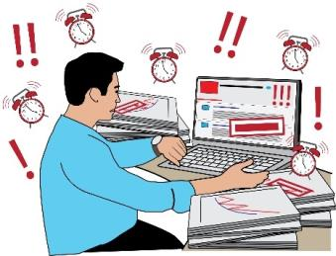  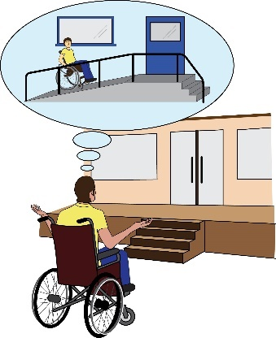 | Here are examples of what could be discrimination arising from disability:  - Deciding to do a performance review because you have been too sick to go to work.  - Putting hard targets in place, even though they know it takes you longer to do some things.  - Punishing you because you got very angry or cried at work. Your employer does this even though they know you have a mental health condition.  - Running training sessions or important meetings in a space that is not accessible. This means you have to join online. It means you don’t get to talk to people face to face.  - Not giving you a chance to get a promotion because your employer thought it was too much for you. They thought it would be too hard for you to manage because you have MS.  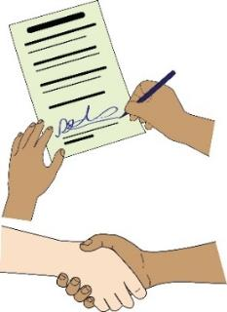  - After being too sick to come to work, you are told that you must come back on a different contract. You are told you must come back on a fixed-term contract.
Contract: this means an agreement between you and your employer about your roles, responsibilities and rights at work.

Fixed-term contract: this means when your contract has a specific ending. For example, a date or a time when you have finished a project.
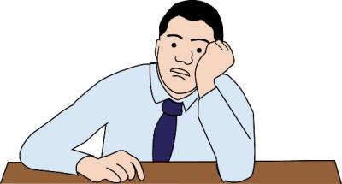 | - Not being offered a role because you didn’t seem to have much energy in an interview. Your employer knows that you have ME. This is a condition that makes you very tired.
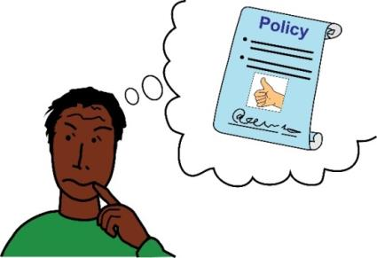 | After reading these examples, you might think your employer has unfair policies or they do things in a way that is unfair to you, as a Disabled person.
Policies: these are decisions or rules made by your employer.
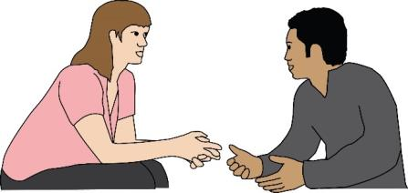  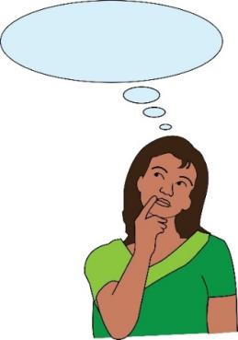 | If this is the case, you can talk to your employer and tell them about your impairment.  It might help if you could think of some ideas or actions to solve the problem.  But this is really your employer’s responsibility. Not yours.  The way you deal with discrimination depends on your situation.
- Indirect disability discrimination. This is when rules or policies at work are the same for everyone, but they affect Disabled people in a worse way.

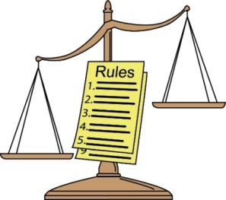  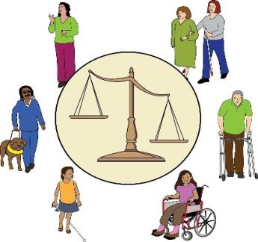 | It’s against the law for employers to put a policy or rule into place that affects Disabled people worse than non-Disabled people.  They must not do things in a way that is unfair to you as a Disabled person.  However, your employer can show there is a good reason for their way of doing things if it is proportionate.
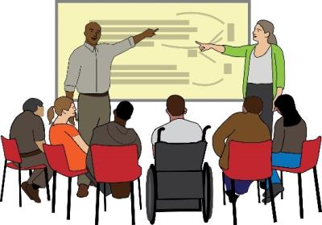  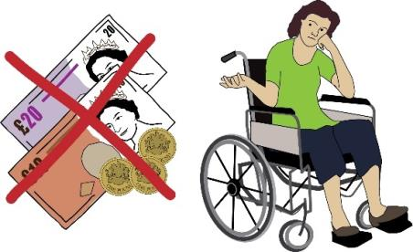  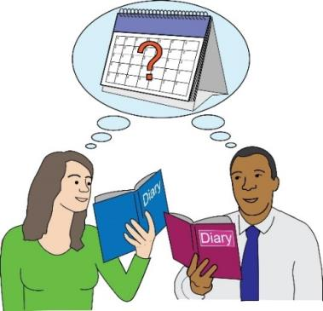 | Here are examples of situations that could be indirect disability discrimination:  - Giving full-time staff more promotions and training.  - Disabled people sometimes need to work part time to manage their impairment, so this would be unfair.  - Giving a bonus to somebody who has been to work nearly every day.  - Sometimes, Disabled people have to take time off work because of their impairment. This would mean they are less likely to get a bonus and would be unfair.  - Judging how good someone is at work by looking at how many hours they work.  - This is unfair to Disabled people who sometimes work less hours because of their impairments.

Dealing with indirect discrimination - Making reasonable adjustments
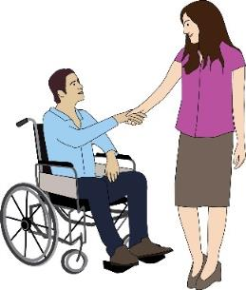 | By law, employers must take steps to get rid of barriers for Disabled people at work.  This is called their duty to make reasonable adjustments.  This means your employer must get take steps to rid of barriers for Disabled people at work.  These barriers can be rules, policies, physical barriers, or ways of doing things.
Barrier: in this document, this means the things that stop persons with disabilities living equal lives.
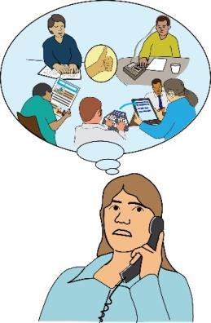 | This also means your employer might have a responsibility to give you equipment or support which can help to get rid of barriers.  For example, a screen reader, an ergonomic chair, or an interpreter.
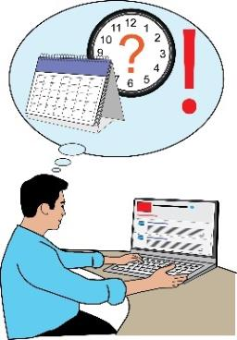  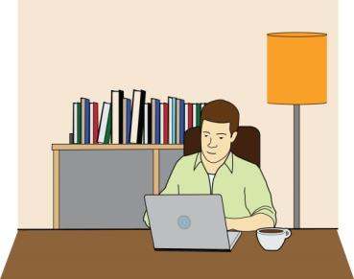  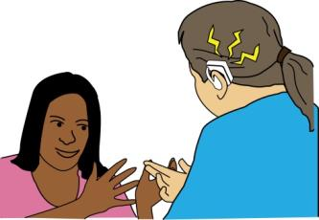  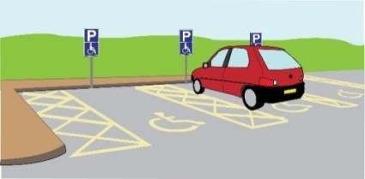  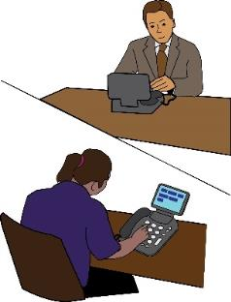  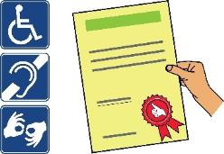 | Here are some examples of reasonable adjustments:  Changing your work pattern, working hours or your responsibilities at work.  Letting you come in late or take breaks at work.  Letting you work from home.  Counting absences to do with disability separately to absences when people are just sick.  Making the office more accessible. For example, moving your desk somewhere else, putting in a ramp, a lift or a hearing loop.  Paying for a British Sign Language interpreter so you can go on a training course.  Offering you a support worker.  Giving you a desk in a quieter part of the office.  Giving you your own parking space.  Buying software or giving you other equipment such as a screen reader.  Changing the way they hire people, do performance reviews, or ask people to leave work  Paying for a taxi to take you to meetings  Giving you information in a different format.
Your employer only needs to make adjustments that are reasonable for them to put into place. This depends on things like:

- How these adjustments will affect others and their business.
- Whether or not the adjustments seem like they will work.
- How much the adjustments will cost.
- What resources your employer has.
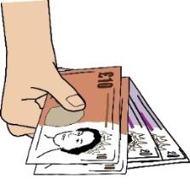  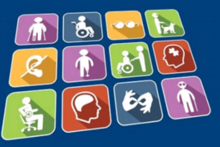 | Your employer is responsible for paying for the adjustments.  The Government’s Access to Work scheme might help pay for adjustments you need at work.  Find out more information here:  www.gov.uk/access-to-work
Access to Work: this is a programme run by the government to help Disabled people find jobs or stay in work.
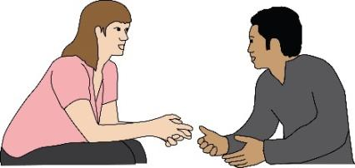 | You might feel like there are barriers that make it hard for you to do your job.  You might feel like you don’t have the same opportunities as other staff have.  You could think about talking to your employer about this.  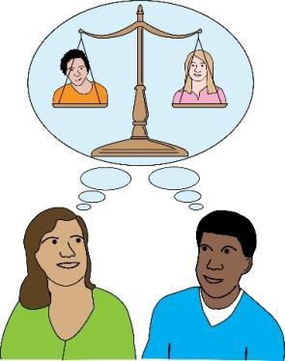  It would help if you could think about what reasonable adjustments might be needed to get rid of barriers.  However, it is really your employer’s job to look at reasonable adjustments. It’s their job to make these adjustments.
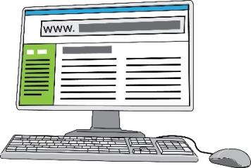  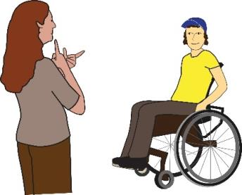  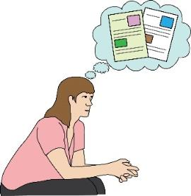 | To be able to make reasonable adjustments, your employer must know you are a Disabled person.  You can get in touch with Access to Work.  They can help to look at the support you need. They might pay for some of it as well.  For more information go to these webpages:  www.gov.uk/access-to-work/apply  Deaf Access to Work has lots of information about how to apply for support:  www.deafatw.com
- Harassment to do with Disability

Harassment: in this document, this means treating a Disabled person in a way that does not show them respect.
This can be things like calling them names, making them feel scared, or damaging things that belong to them.
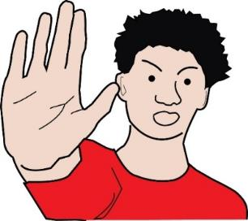  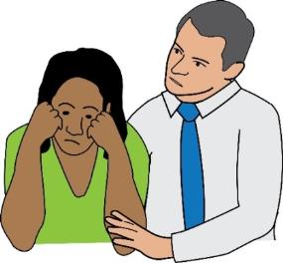 | It’s against the law for your employer to harass you.  Your employer also has a responsibility by law to try to make sure people at work don’t harass you.  In most cases, the law will look at the way people at work treat you as evidence for how your employer treats you.
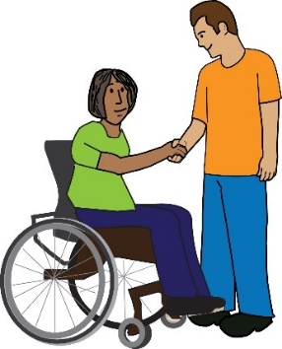 | Your employer might also be responsible for the way other people treat you in the work place. For example, customers.  This is more complicated, though.  Employers must make sure that you don’t feel scared or uncomfortable at work.  They must make sure you are treated with respect at work.
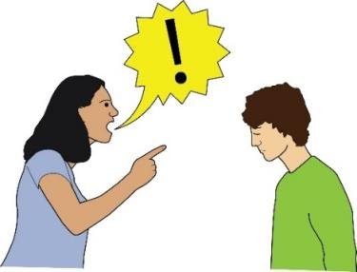  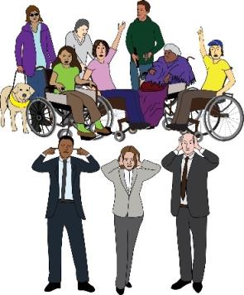  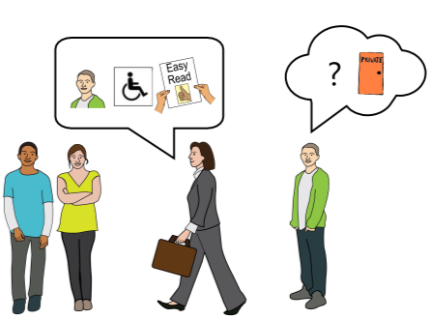 | Here are examples of what could be harassment of Disabled people at work:  - Making bad comments or jokes about Disabled people at work.  - Telling people at work about your disability.  - Forcing you to do things when they know you can’t do them.  - Getting in your way on purpose or not respecting your personal space at work.  - Not taking action when customers or other people attack you or make comments about you.
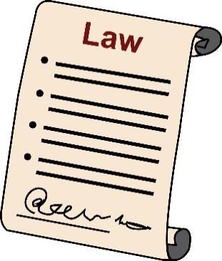  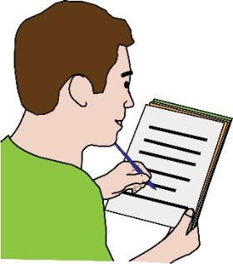 | An employer might try to say that you have been too sensitive and what happened wasn’t really discrimination.  This is a hard argument for an employer to make in court.  However, in terms of the law, it is possible for them to argue this.  In the other parts of this document, we look at how you could keep a record of what is happening.  This would make it harder for an employer to say that discrimination isn’t happening.

5. Victimisation. This means making you a victim at work.
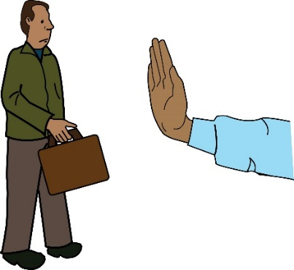 | It is against the law for your employer to treat you differently because you complained about discrimination or helped someone else to.  It is also against the law for your employer to treat you differently because they think you might complain about discrimination or help someone else to.
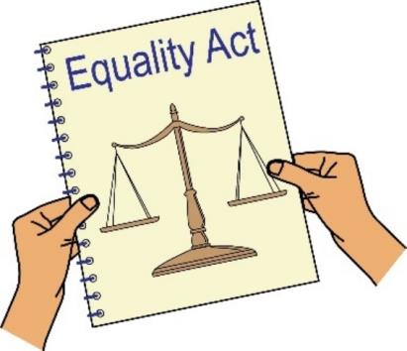 | Your employer must not treat you differently because you:  a. Brought your employer to an employment tribunal  b. Took any actions under the Equality Act
Employment Tribunal: this is a special court that makes decisions about problems at work. They look at the law to make decisions about things like unfair treatment or discrimination at work.
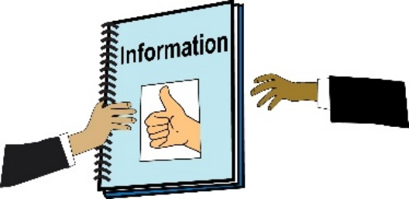 | c. Gave evidence or information under the Equality Act.  d. Spoke out about someone who has gone against the Equality Act.
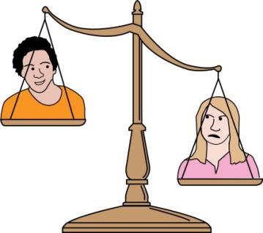 | Doing any of these things is called a protected act.  This means your employer can’t treat you differently because you have done it.  It is also a protected act if your employer thinks that you might have taken one of these steps in the past or might take one of these steps in the future.
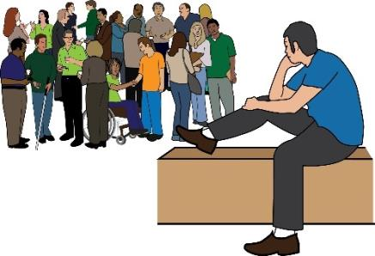 | Here are examples of what could be victimisation:  - Your employer leaves you out at work because you have asked for reasonable adjustments.  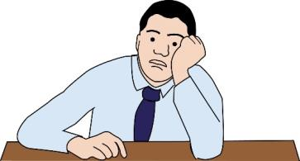  - You are not given the chance for a promotion because you complained about harassment at work.  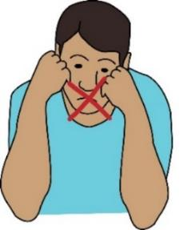  - You are controlled or managed more closely at work because you complained about harassment.  - Your employer treats you badly because you spoke out about the way they treat Disabled people.  - Your employer treats you badly because you supported somebody else to speak out about this.

Did you know: Employers are allowed to treat you better than other people at work!
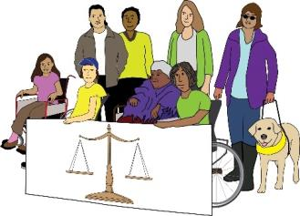 | It’s ok for employers to treat you better than others because you are Disabled.  For example, they can run trainings for Disabled workers only.  They can also support Disabled workers to take part in peer support and mentoring.
Peer support: this means when people use their own experiences to help each other.

Mentoring: this means getting advice and support from other workers.
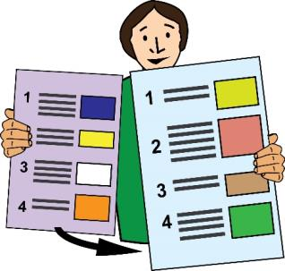 | This is the end of Part One of our guide.  Please go to Part Two of our document to find out about discrimination when your job ends.
In these guides, we use images from Photosymbols and People First.
We used these with their permission and under license.
This means they said it was okay for us to use them because we paid for them.

