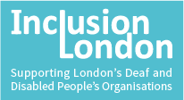
Information about funding for DDPO campaigns on Housing
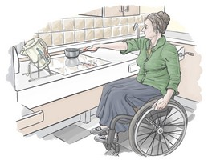

Inclusion London is a Deaf and Disabled People's Organisation based in London.

We have a new project called ‘Disability and Housing in London.’ We are campaigning for Disabled people in London to get housing that is accessible for them.

We have some money to give to other Deaf and Disabled People’s Organisations (DDPOs) so that they can run their own campaigns about housing.
This information sheet will tell you how to apply for the money.

- How much money is there and when is it for?

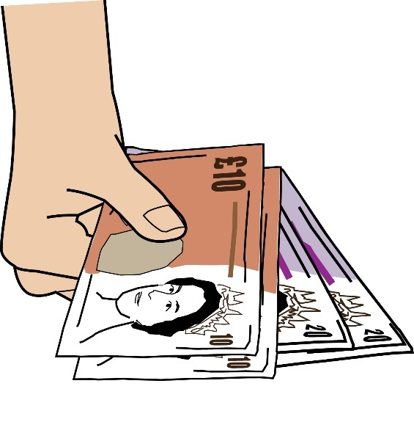
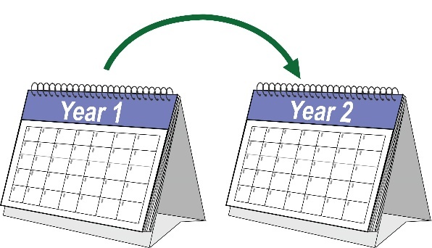
In total, we have £60,000 to give out. We want to give money to three organisations. We will give up to £20,000 to each organisation.

The organisations we give money to must start their campaigns by December 2022 and finish them by April 2024.

- Who can apply for the funding?

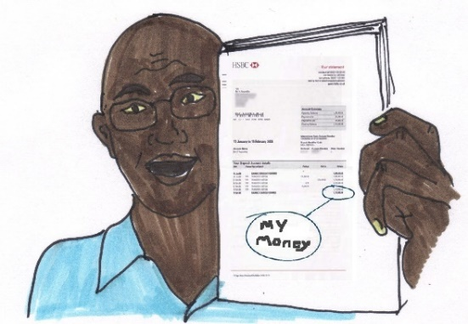

You must have a bank account in the name of your organisation.

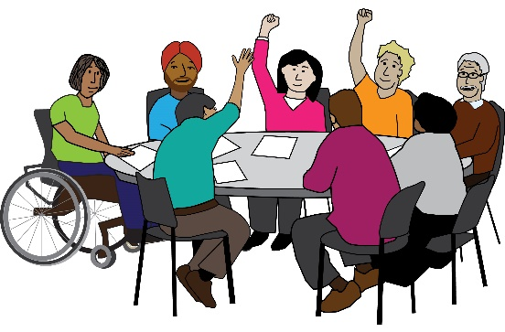

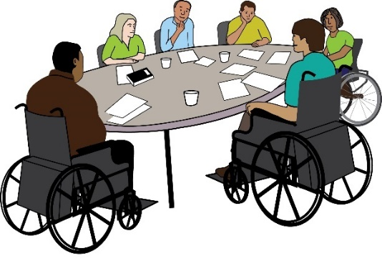

You must be an organisation that is led by Deaf and/or Disabled people

You must work in London.

A ‘Deaf and/or Disabled People’s Organisation’ means an organisation where at least 75% of the Board Members are Deaf or Disabled people and at least 50% of the staff are Deaf or Disabled people. We are more likely to give your organisation money if you match this description.

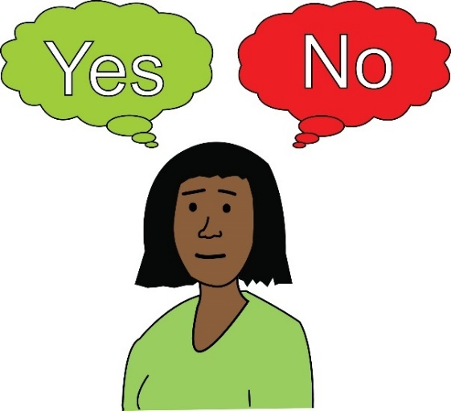

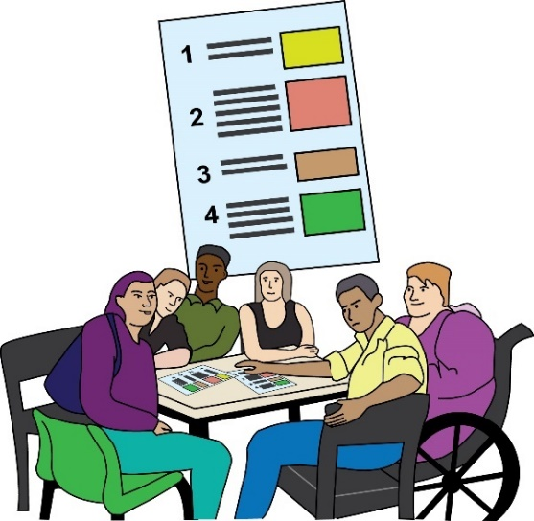

If your organisation is not a Deaf and/or Disabled People’s Organisation but you can show us that it is run by Deaf and/or Disabled people, we might still give you money.

You must send us a formal document that tells us about your organisation, including who makes important decisions and who works there. This document could be a constitution, a set of rules agreed by members of your organisation, or another type of ‘governing document.’

If you are not sure if you have the right kind of document, you can email Julia Modern at julia.modern@inclusionlondon.org.uk to ask her.

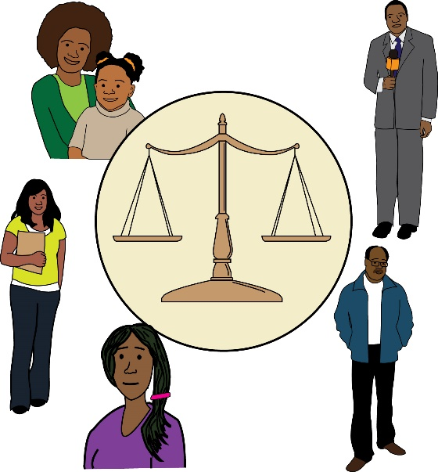

We will make sure that we give money to at least one organisation run by Deaf and/or Disabled people who are Black or from other communities of colour.

We are doing this because we know that Deaf and/or Disabled people who are Black or from other communities of colour have more problems getting good housing than other people.

If your organisation is run by Deaf and/or Disabled people who are Black or from other communities of colour, please contact Julia at julia.modern@ inclusionlondon.org.uk, because we give you extra support to apply. There are more details about this support in section 4 of this information sheet.

- What kind of work will we fund?
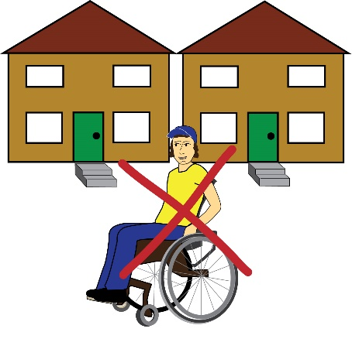

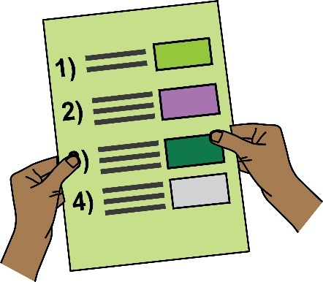

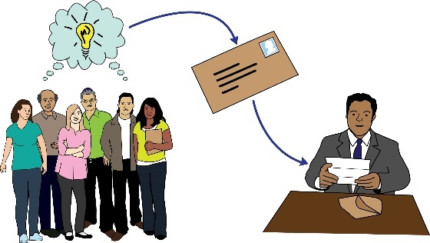
We want to fund campaigns that will tackle a problem Deaf and/or Disabled people face when they are trying to get housing in London.

You have to tell us clearly what you will do in your campaign.

Campaigning is about influencing other people. It is any work that aims to make things better for Deaf and/or Disabled people by changing a law, policy, or budget that is decided by someone else.

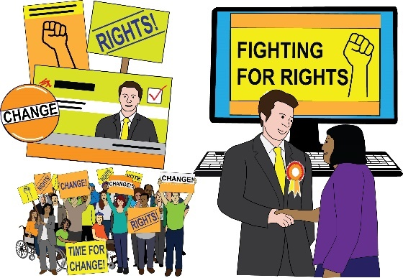

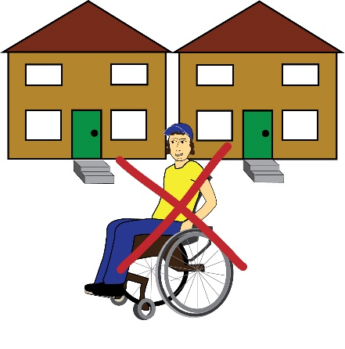

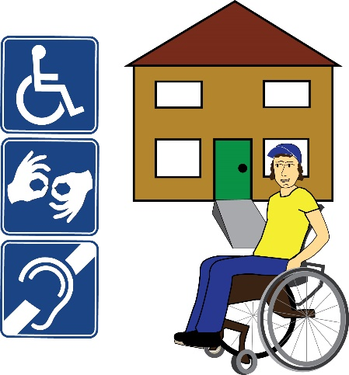

Campaigning aims to change the way things work, not just to improve things for individual people.

When you do campaigning, you work in a particular way. Campaigning includes first spotting a problem, then finding out who can fix the problem and how they can fix it. Then you put pressure on that person or organisation so that they fix the problem.

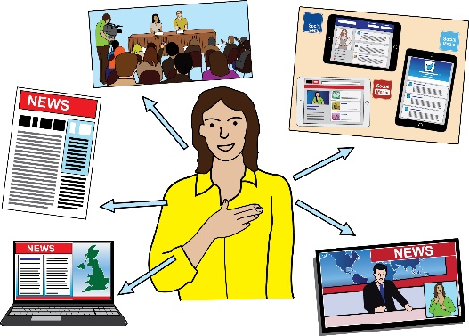
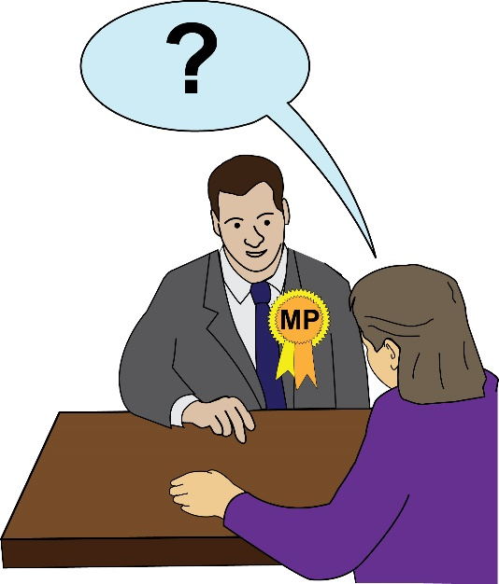
Some examples of things you can do in campaigns are:

- Getting journalists to write stories about the problem
- Writing about the problem on social media

- Holding protests or direct action

- Running petitions

- Meeting councillors or MPs and asking them to change what they are doing
- Messaging councillors or MPs on social media.

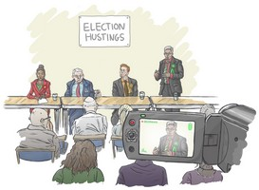

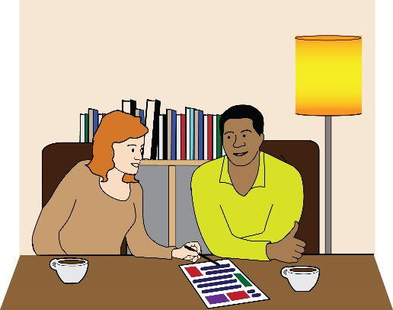
There are many other things you can do in campaigns. If the thing you want to do is not on this list, you can still apply, as long as you think it will work as a campaign.

You cannot use this money to work on cases for individual people. But you can use the money to campaign for changes to policies, laws, systems, or overall budgets using examples from work your organisation has done for individual people.

This funding is for new work. This work can build on things you have done before, but the money cannot be used for work that you already have funding to do

- What items will we fund?
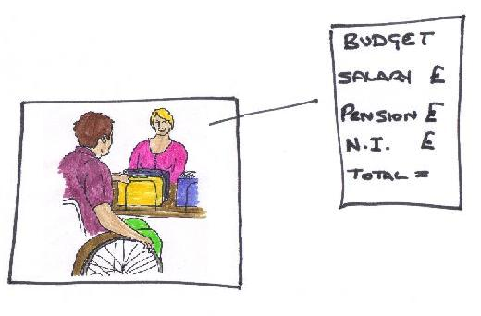
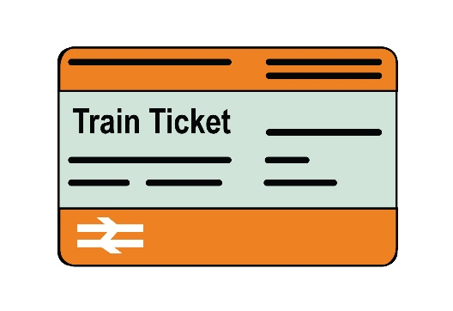
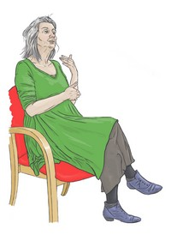
We will fund the costs for you to run your campaign.
Examples of things we can fund are:

- Staff time
- Consultant time

- Travel costs

- Costs to make the campaign accessible

- Meeting costs

- Making or buying props and materials for actions

- Stationery

You can apply for up to 10% of your budget to be a contribution to your ‘core costs.’ ‘Core costs’ are the costs of running your organisation.

We will not fund any ‘capital costs’, equipment, or rent. ‘Capital costs’ are costs for buying you things that you can keep after the end of the project, for example laptops

- Will you help me with my application?

We will run a question and answer session about applying for the money at 2pm on Thursday 4th August 2022. Anyone can join this session. We will explain the type of projects we want to fund and give you time to ask questions.

If you want to come to this session, please email julia.modern@inclusionlondon.org.uk to book.

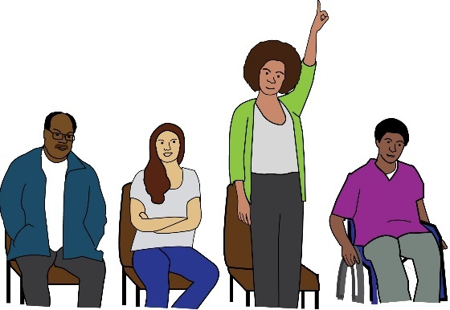

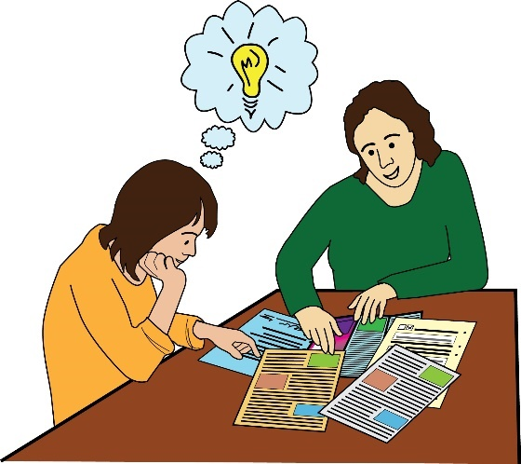
If your organisation is run by Disabled people who are Black or from other communities of colour, we can give you extra support.

If your organisation is run by Deaf people, we can give you extra support.

Please contact Julia on julia.modern@inclusionlondon.org.uk to set up a meeting. We will go through the application form with you and answer your questions. We will not write your application for you.

- How do I apply?

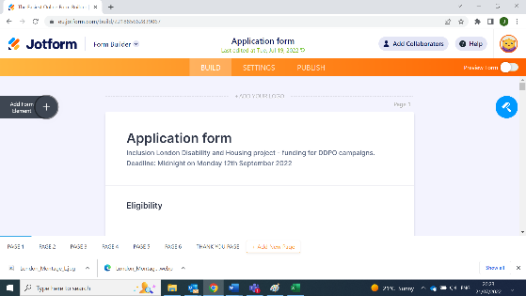

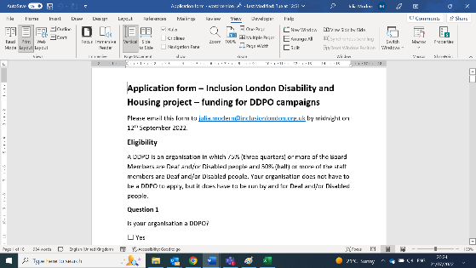

You must send us your application before midnight on Monday 12th September 2022.

There are two ways to get the application:

- There is an online application form here https://form.jotform.com/221885662839067, or

- You can get a Microsoft Word version of the application form from our website, complete it, and email it to julia.modern@inclusionlondon.org.uk. Click here for the form.

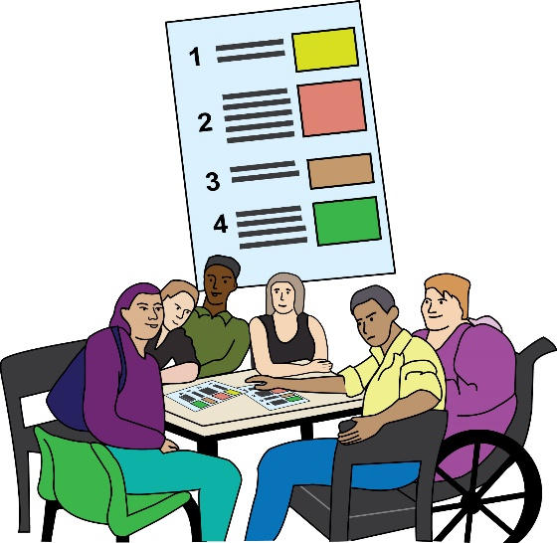

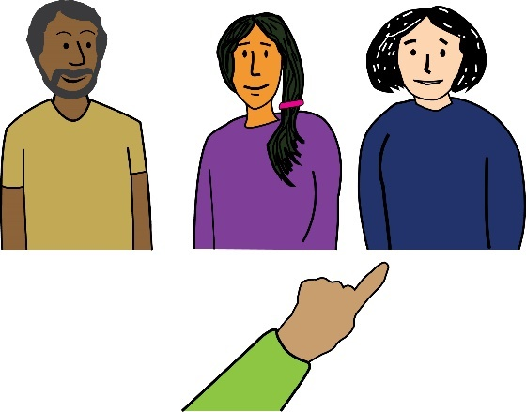
After the 12th September, a group of people who work for Inclusion London will look at all the applications. We will decide how well the applications match the list of things we are looking for (the list is in the next section, section 7) and then choose the five best applications.

We will ask the five organisations who sent us the best applications to come to an online interview on Wednesday 14th or Thursday 15th September 2022. In the interview, we will ask you to discuss the application with us and answer some questions.

We will decide which three organisations we will give the funding to by Tuesday 20th September 2022. We will send you an email to tell you if we will fund your project.
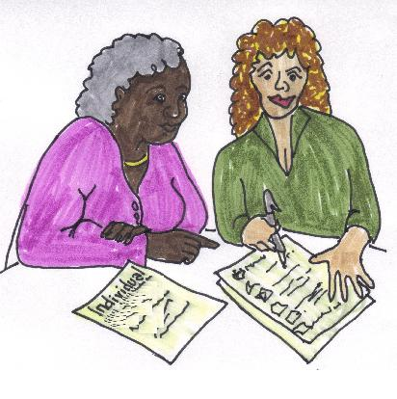

In September and October 2022, we will work with the organisations who we have decided to give funding to write a more detailed project plan.

This will include writing a ‘theory of change,’ which is a plan that shows how your project will lead to the changes you are trying to make. We will help you to write it.

The projects will begin between October and December 2022.

- How will Inclusion London choose which organisations to give money to?

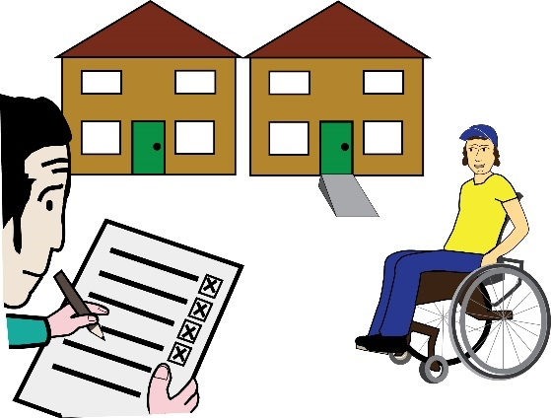
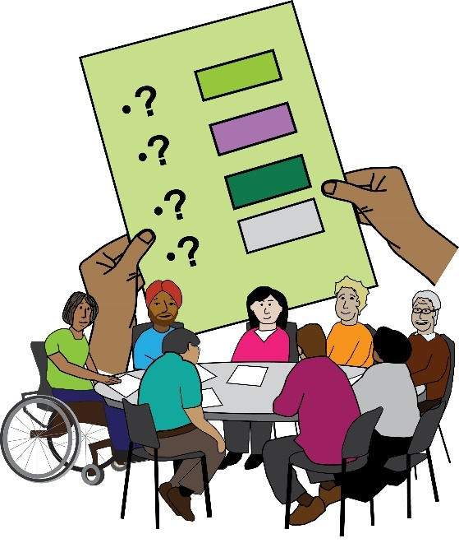

We will judge the applications by checking that they meet all the things we are looking for. The list of things we are looking for is below. The numbers show how many points you will get for each thing on the list:

- The project is about a housing-related need – 10 points

- The aims and activities match the priorities that have been set by the London DDPO Housing Network. (These priorities are written on pages 21 and 22, after this list.) – 10 points

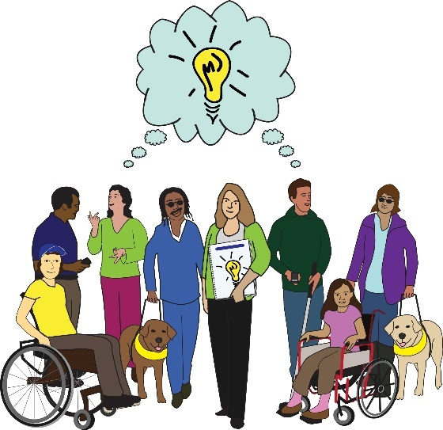

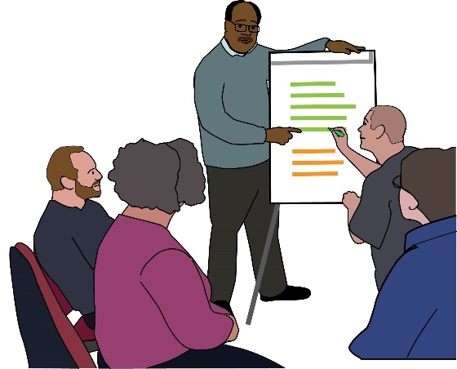

- The application shows that the organisation has experience of campaigning with Deaf and/or Disabled people – 10 points

- The application shows that the aims and activities have been planned carefully and are likely to make the problem the project is about better – 30 points
  - This does not mean we are only looking for low-risk projects. We are also interested in funding trials of new ideas. What we want to check is whether you have carefully though about how your activities will cause the change you are aiming for.

- The project is designed to meet the needs of Deaf and/or Disabled people who experience intersectional exclusion. For example, Deaf and/or Disabled women, Black Deaf and/or Disabled people, Deaf and/or Disabled people from other communities of colour, and LGBT+ (Lesbian, Gay, Bi, and Trans) Deaf and/or Disabled people – 10 points

- 'Intersectional exclusion' is when somebody is treated badly because of more than one part of their identity. This makes things much more difficult for them. For example, Black Disabled people are often treated badly because they are Disabled AND because they are Black. Another example is that Deaf women are often treated badly because they are Deaf AND because they are women.

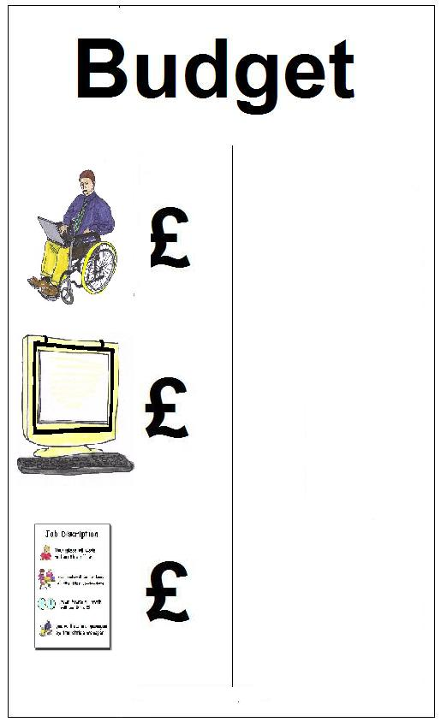

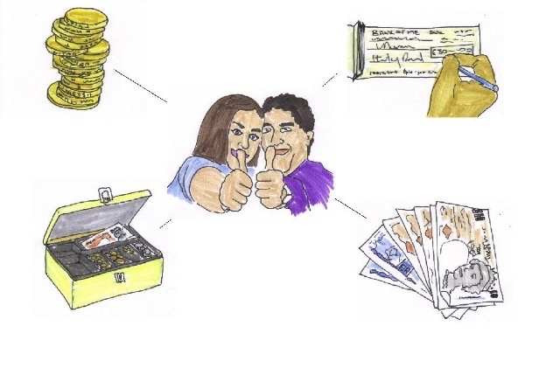

- The application provides a realistic budget, which shows costs for each activity and other expense. This should include staff time and making the campaign accessible – 15 points

- The application shows that the organisation has enough resources to complete the project with the funding applied for – 15 points

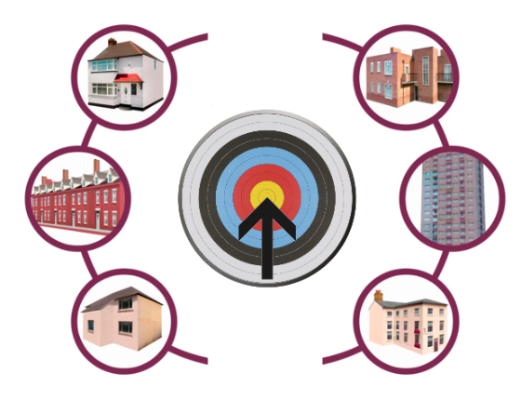

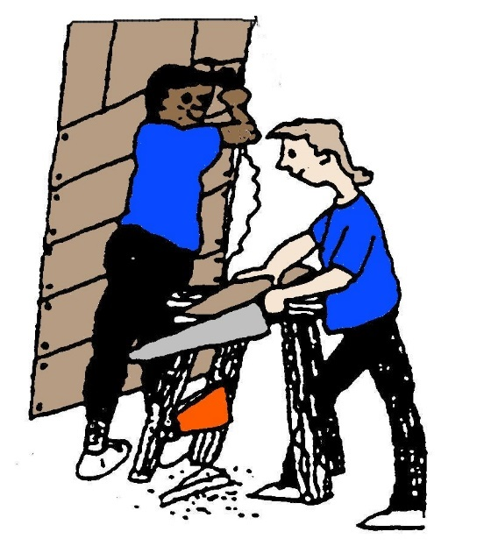

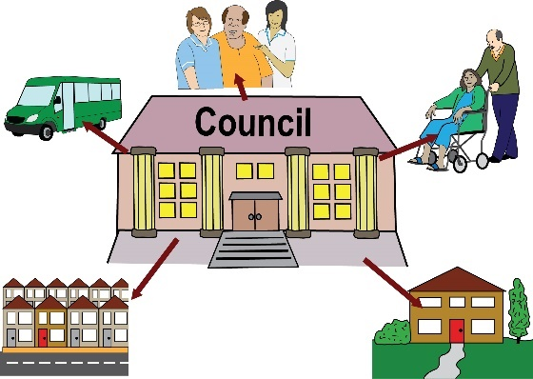

The London DDPO Housing Network priorities are:

- Increasing the supply of accessible housing

- Improving how repairs are prioritised and carried out

- Improving the accessibility of councils and housing associations

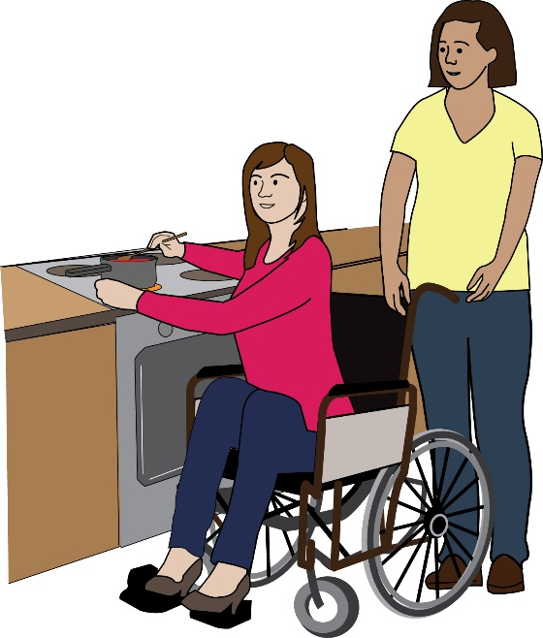

- Tackling problems joining up care and housing

- Fighting discrimination by landlords and neighbours.

This information sheet was created with images from:
People First’s Easy Read Picture Bank https://peoplefirstltd.com/easy-read-one-stop-shop/
Bromley X by X’s Image Bank https://www.xbyxbromley.com/
And Inclusion London’s Easy Read Image Bank.
These organisations have given Inclusion London permission to use the images.
Some of Inclusion London’s images were created using Photosymbols.
The image of London on page 3 is by Mewiki and is used under a Creative Commons Attribution-Share Alike 3.0 Unported license, see https://commons.wikimedia.org/wiki/File:London_Skyline.jpg.

