Inclusion London Briefing: The Ultra Low Emissions Zone Expansion

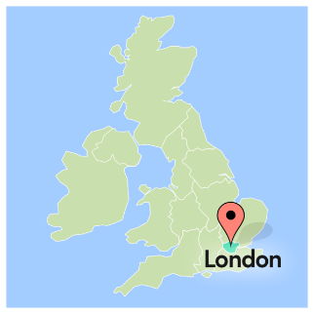
Ultra Low Emissions Zone, Pollution and Vehicles
The Ultra Low Emissions Zone is called the ULEZ for short.
It is an area in London where vehicles which make lots of pollution must pay to go.

Pollution is when harmful things get into the air, water, or land. These are usually gases, smoke, or chemicals.
The ULEZ is a plan to cut air population. It is trying to cut harmful gases and smoke coming from cars and other vehicles.
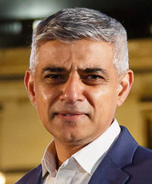
It is part of work the Mayor of London is doing.
The Mayor of London in 2022 is Sadiq Khan.
Sadiq Khan is trying to cut pollution in London.

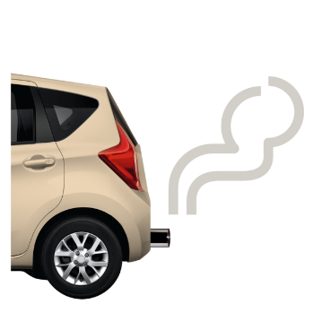
Cars and other vehicles make pollution.
When we drive, the vehicle makes smoke and gases which are harmful.
These go into the air. People breathe them in.
If we breathe in a little bit, this will usually not hurt us.
But when we breathe in more, it can hurt us.
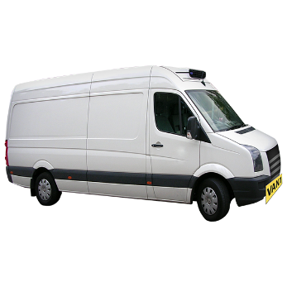
Some vehicles make more dangerous smoke and gas than others.
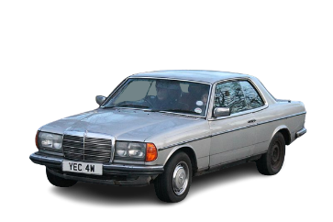
Diesel vehicles usually make more than petrol vehicles.
Older vehicles make more than newer vehicles.

Diesel and petrol are types of fuel we put in vehicles to make them run. They are both made from oil.
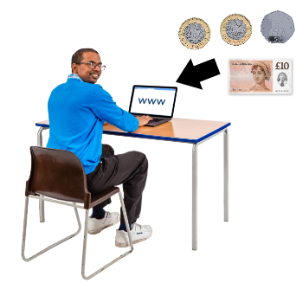
Usually, if you drive a vehicle that makes more pollution into the ULEZ, you must pay £12.50 a day.
Some people do not need to pay, even if their vehicle makes more pollution.
We will talk about this later.

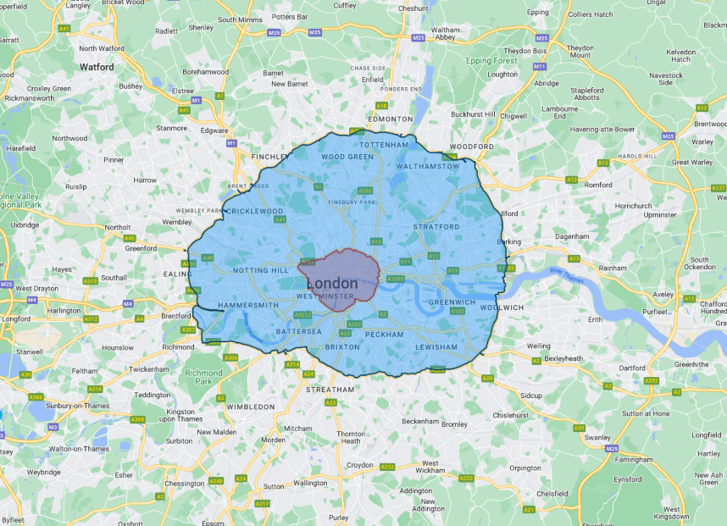
The ULEZ was set up in 2019. In 2021, it got bigger. On the map, the red part in the middle is how big it was in 2019. The bigger part in blue is how big it became in 2021.
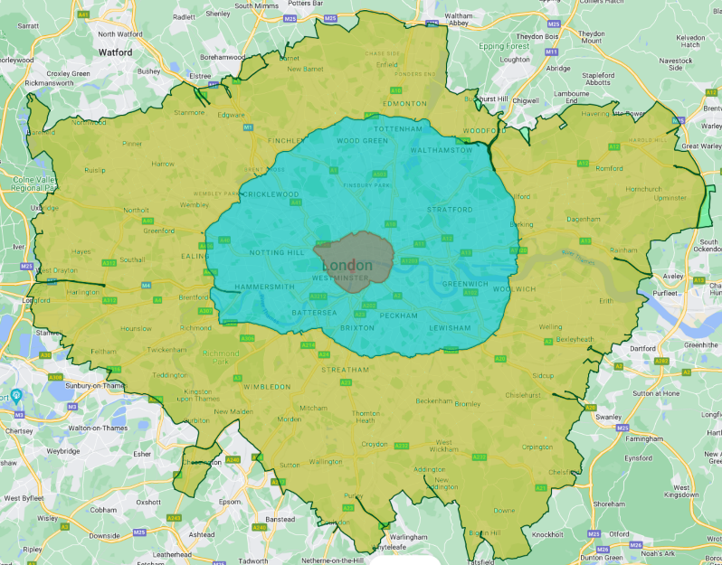
In 2023, the Mayor wants to make the ULEZ bigger again. He wants to make the new part in yellow on the map ULEZ too. This covers all of London.

Why this matters.
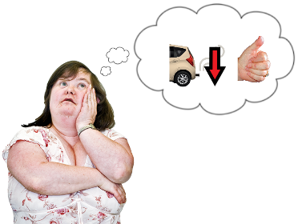
Less pollution is good.
Pollution makes people sick. It can make people die young.
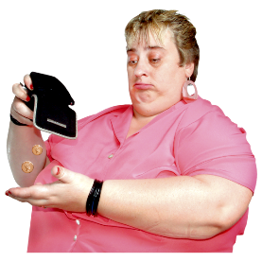
Inclusion London thinks less pollution in London is great.
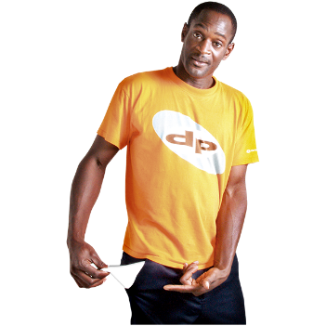
But, we are worried that the ULEZ plan will make life hard for many people.
We think it will make life much harder for many Disabled people.
We think the plan needs to be made better.
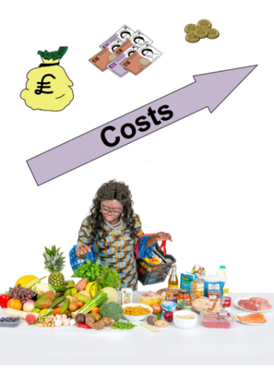
Right now, the price of food is going up.
The price of electricity and gas are going up.
The price of lots of other things are going up too.
Some people are calling this a ‘cost-of-living crisis’.

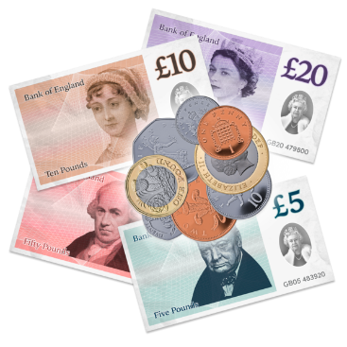
The ULEZ getting bigger will be another cost.
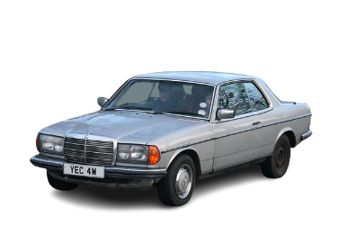
Some people have old cars that make more pollution.
They will either need to buy a newer vehicle or pay £12.50 a day to drive their car.

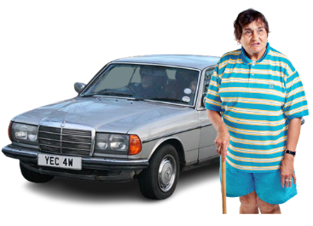
Some Disabled people have older cars adapted for them.

Adapted cars are cars that are changed so a Disabled person can drive them or get in them.

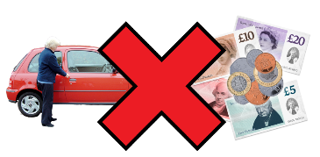
Some people already cannot pay for food, electricity, or gas.
They will not have money for a different car.
They will not have money to pay £12.50 a day.
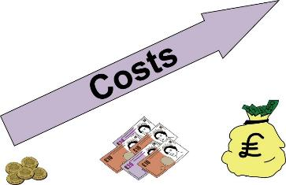
Disabled people have to spend more money to get the things they need.
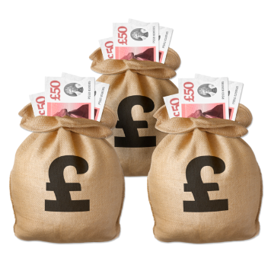
Usually, they have to spend around £583 a month more.
Some Disabled people have to spend as much as £1000 more a month.
This means more Disabled people live in poverty than non-Disabled people.

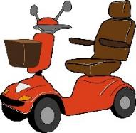
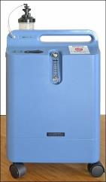
Disabled people often spend more money on energy.
Medical equipment and mobility devices need electricity to work.
Disabled people often need more heating in their homes, so they are not in pain or very ill.
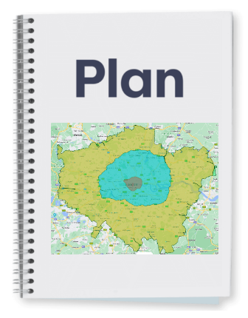
Some Disabled people will struggle even more when the new ULEZ starts.
We think there needs to be more support for Disabled people in the ULEZ plan.

Blue Badge holders should be exempt from ULEZ cost
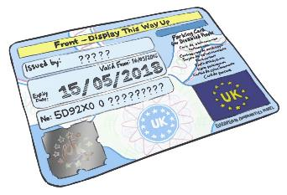
Some Disabled people or their family have blue badges.
They have to apply for them.
Blue badges let people park in places other drivers cannot.
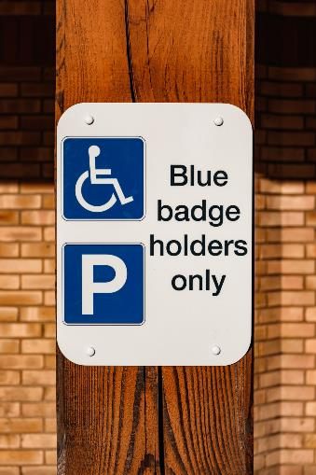
Not all Disabled people can get them.

There are 247,000 people in London who have blue badges.
We think they should not have to pay the ULEZ £12.50 a day cost. Even if their car is older and makes more pollution.

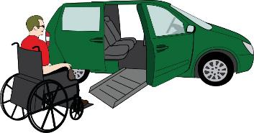
The Mayor of London does not think all people with Blue Badges should not have to pay.
He says some Disabled people already do not have to pay.
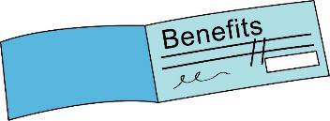
This is because their vehicle has a disabled or disabled passenger vehicle tax class.
This is something people can get for their vehicle.
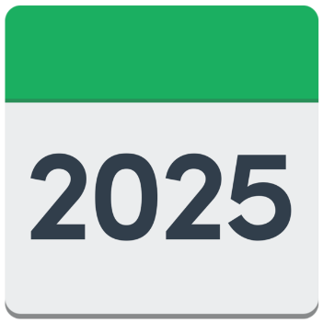
Only some Disabled people can get it. They must get certain benefits to get it.
They do not have to pay until October 2025.

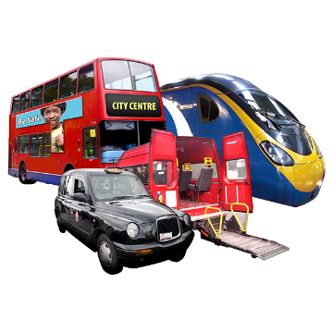
The Mayor says Disabled people can use newer vehicles which do not make as much pollution.
He says Disabled people could use public transport, Dial a Ride, or Taxicard.
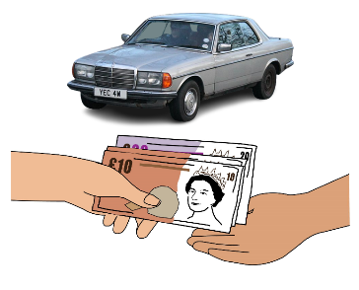
If Disabled people need to buy a newer car, the Mayor says there is a scrappage scheme they can use.
They would get money for getting rid of their old car. Then they could buy a newer car.

We think these suggestions are unfair.
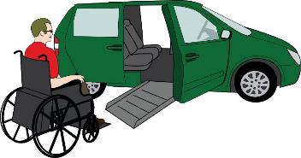
They do not think about how much support Disabled people need. Or how expensive travelling when Disabled is.

Some vehicles get disabled or disabled passenger vehicle tax class. Even these people will have to pay after October 2025.
We worry about what will happen to those Disabled people after October 2025.

There are 247,000 people with blue badges.
There are 34,000 cars with disabled or disabled passenger vehicle tax class.
There are a lot more people with blue badges.
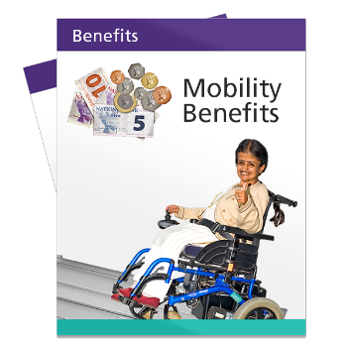
Only Disabled people who get higher or enhanced mobility benefits can get disabled or disabled passenger vehicle tax class.
But we know benefit decisions can be unfair. We see this in the news.
We know some people need their car even if they do not get these benefits.
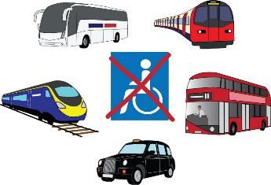
Public transport is not accessible.
There are lots of places Disabled people cannot get to on public transport.
Disabled people cannot rely on public transport.
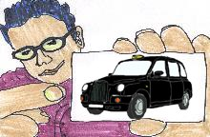
Disabled people can use Dial a Ride and Taxicard to travel.
But they are for social trips. Like going shopping. Or visiting your friends.
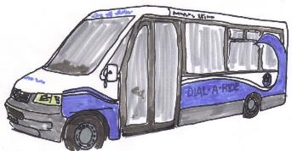
They are not for daily trips. Like going to work, day centres, or school.
Disabled people cannot rely on Dial a Ride or Taxi card.
This is why many Disabled people have cars.
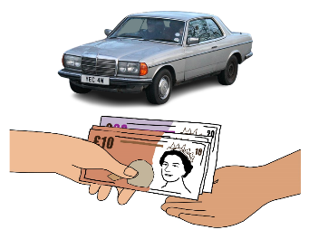
The car scrappage scheme was a good idea.
It gave people money to get rid of their old car.
But it was not enough for Disabled people.

Many Disabled people need their vehicles adapted so they can use them.
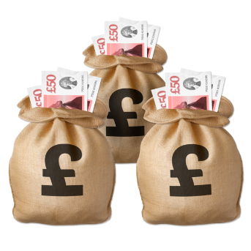
This makes their vehicles much more expensive.
The £2,000 from scrapping their old vehicle is not enough to buy a newer adapted vehicle.

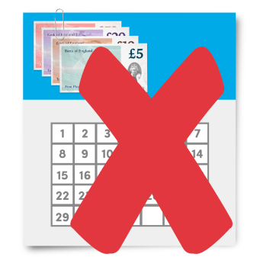
For example, cars that wheelchair users can drive from their wheelchairs can cost £30,000.
Other vehicles are less expensive, but still much more than £2,000.
The money from the scrappage scheme could also be seen as savings.
Some Disabled people could then have their benefits stopped. Because they have too many savings.

These are the reasons we think people with blue badges should not pay ULEZ cost.

Talk to us about ULEZ
If you want to know more, you can e-mail Laura Vicinanza.
Laura is Inclusion London’s Policy and Stakeholder Engagement Manager.
laura.vicinanza@inclusionlondon.org.uk

Where we found our information
We talked about some facts and numbers. These are the places we found those facts and numbers.

We found out how many Disabled people live in poverty. This was from Trust for London.
https://trustforlondon.fra1.cdn.digitaloceanspaces.com/media/documents/Londons_Poverty_Profile_2020.pdf

We found out how much money Disabled people had to spend to live. This was from Scope.
https://www.scope.org.uk/scope/media/files/campaigns/disability-price-tag-report-2019.pdf

We found out how many people in London had Blue Badges. This was from GOV.UK
https://www.gov.uk/government/statistics/blue-badge-scheme-statistics-2021/blue-badge-scheme-statistics-england-2021

Pictures we used
We used many pictures from:

Photosymbols (https://app.photosymbols.com)
People First (https://peoplefirstltd.com/ )
Bromley Experts by Experience (https://www.xbyxbromley.com/)

We used them under license. This means we had permission to use the images because we bought them, or they were given to us.
We used some pictures under a Creative Commons copyright license.
Creative Commons copyright license means the people who took the photographs or made the pictures said anyone could use their work if they said where they got them from.
This is where we got them and who made them.
1980 Mercedes 280 CEW Auto taken by Charles Cars (https://commons.wikimedia.org/wiki/File:1980_Mercedes_280_CEW_Auto_(11781008596).jpg) Remixed under the Creative Commons Attribution 2.0 Generic (Background Removed)
Blue Badge Holders Only taken by Jakub Pabis (https://unsplash.com/photos/aX0j8SikPU0) Used under Unsplash Free Usage License

