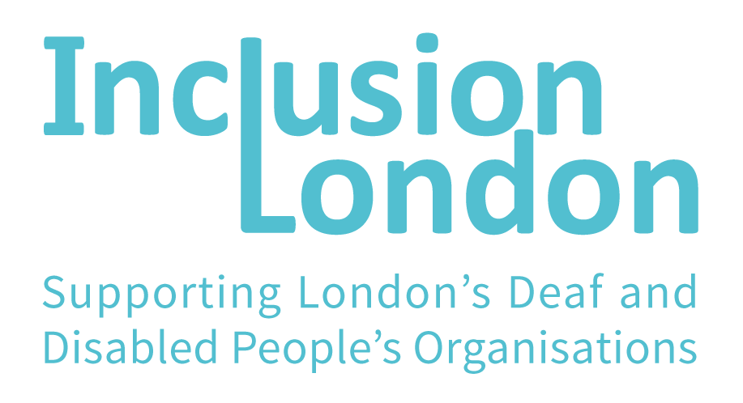

Cost of living crisis.
How to get help with energy and care costs.

Remember: The information here is not legal advice.

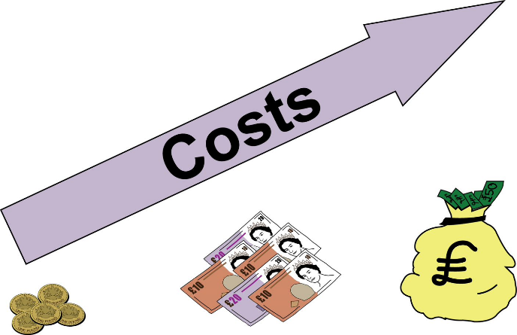
The cost of living has been going up for months. Food and fuel have gone up in price a lot.

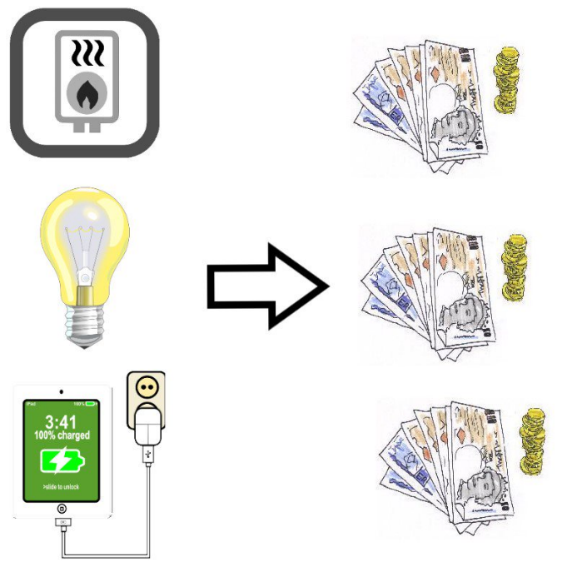
This got worse in April, because the Energy Price Cap went up.
The Energy Price Cap is the most companies can charge for their energy. Now it has gone up, they can charge more money than before.

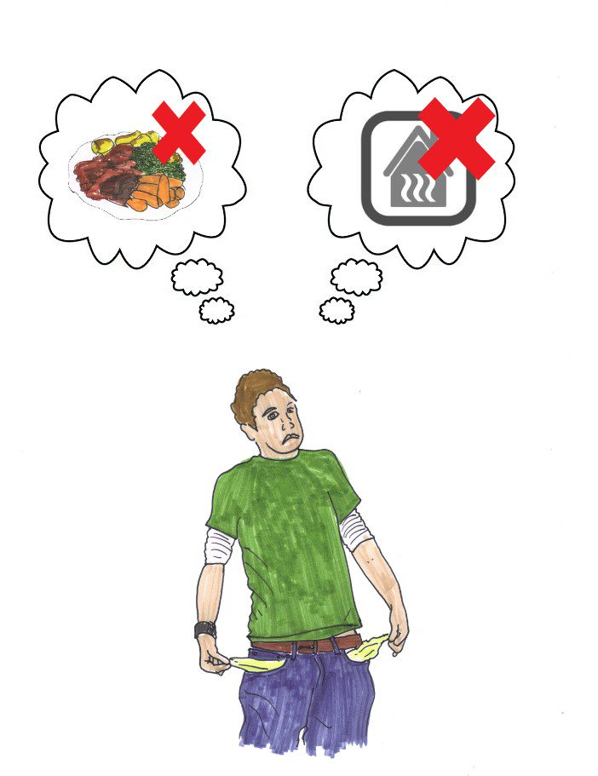
Disabled people are more likely to live in food and fuel poverty than non-Disabled people.
Food and fuel poverty is when eating and keeping warm costs more than people can afford.
Not being able to eat properly or stay warm can make people ill.
Food and fuel poverty is a serious problem.

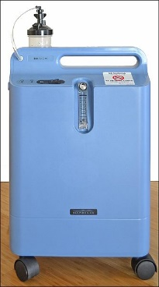
Disabled people often have to spend more money on energy. Medical equipment and mobility devices need electricity to work.
Disabled people often need more heating in their homes, so they are not in pain or very ill.

This is a list of ideas and ways that you might get help with the cost of living going up.
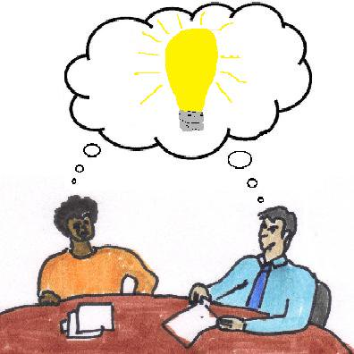
There needs to be more help for food and fuel poverty. At the moment, there is not enough.

Some places which are meant to help people are not accessible to everyone. Some websites can be difficult to use.

If you need more support, please check the places below.

Your local DDPO: https://www.inclusionlondon.org.uk/directory/listing/

Charities in your area.
Your local council.
Citizen’s Advice.

You might need to contact your local council or your energy supplier. To find out who they are, you can use a postcode finder: https://www.gov.uk/find-local-council
Or look at letters from them for
their name and information.

Make sure you are getting all the benefits you should be getting.

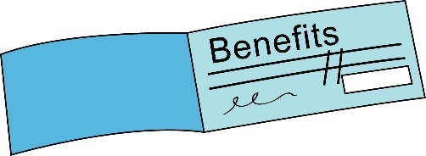
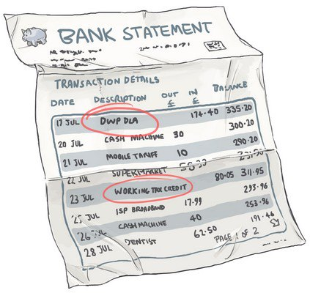
You might not be getting all the money that you have a right to get.

Turn2Us have a website with a calculator that will tell you if you are getting all the benefits you should be getting.
https://benefits-calculator.turn2us.org.uk/

Citizens Advice have a webpage about grants and benefits.
https://www.citizensadvice.org.uk/ consumer/energy/ energy-supply/get-help-paying-your-bills/grants-and-benefits-to-help-you-pay-your-energy-bills/

Check your local food bank.

Food banks like The Trussell Trust give food to people who cannot afford to buy food.
They are called food banks, but some can help with other things, too.
Some food banks have fuel vouchers.

Fuel vouchers are vouchers you can use to pay for energy.
Not all food banks have these. You can ask a food bank close to you if they have fuel vouchers.
You can find a food bank here: https://www.trusselltrust.org/get-help/find-a-foodbank/

Ask your council for energy cost help.

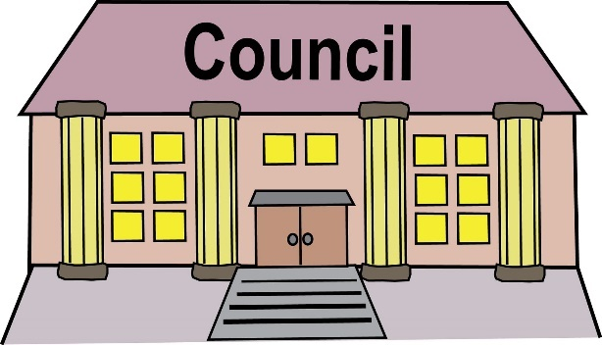
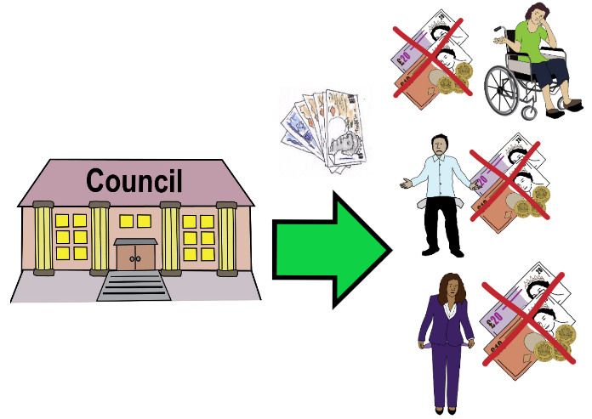
Some councils have money to help people with the increased cost of living.
They might have sent you a letter, so check any letters from your council.
Ask your council if they have fuel vouchers or emergency needs schemes.

Emergency needs schemes are funds for people who need money right away for an emergency.
The Household Support Fund got £500 million in April to help people.
Ask your council if there is money from this you can get.
Not all councils have these. You will need to ask your local council if they can help.
https://www.gov.uk/find-local-council

Ask for help from your energy company.

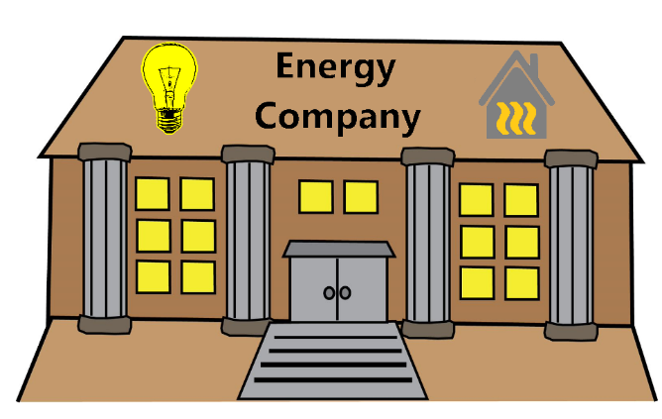
Some energy companies give emergency credit. Some give discounts or have other funds to help.
Emergency credit is money you get now but have to pay back in the future.

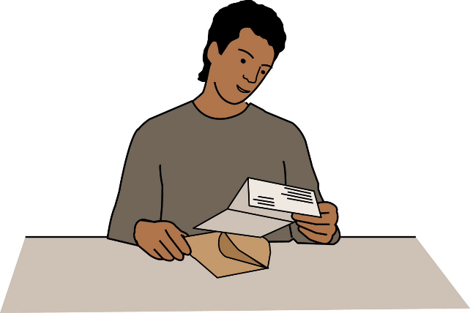
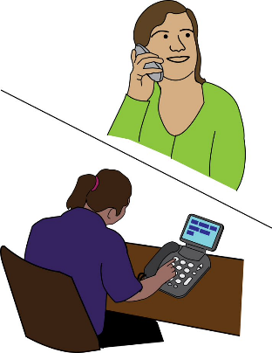
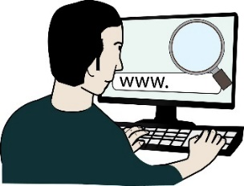
Tell your energy company about yourself. If they know you are Disabled, they might give you extra help.

You should tell them:
- Your disability.
- If you have medical equipment which needs to be on all the time or a lot of the time.
- If you have a condition that is made worse by the cold.

Your energy company might be British Gas, EDF Energy, EON, Npower, Scottish Power, SSE, or a different company.
You will need to find the name of your energy company, then call them or go on their website to ask for help.
Change the type of energy meter you have in your house.
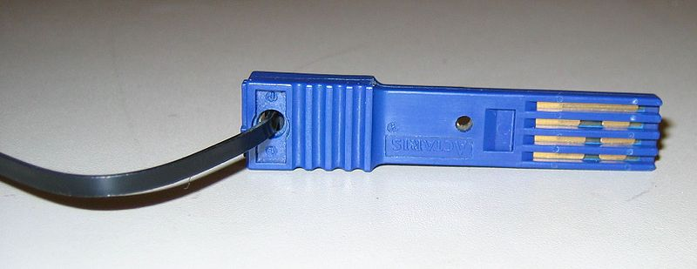
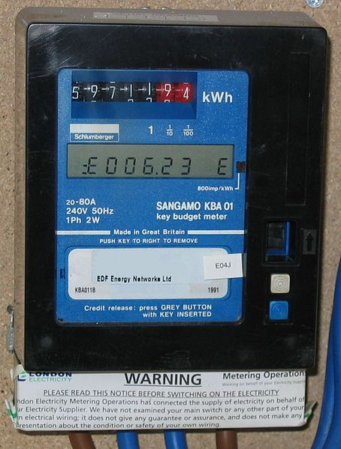
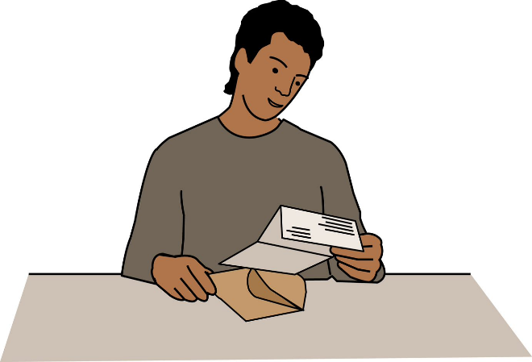
Pre-payment meters are meters which need money before you get power. You might use a key, token, or smartcard to add money.
Regular meters do not need to be topped-up with money first. You pay the money through bills or direct debit instead. You pay after using the energy.

Pre-payment meters make it easier to know how much money you are spending, but they have problems.
Pre-payment meters are usually more expensive than regular meters.
In the winter, energy companies cannot cut off energy for ‘vulnerable people’ who have a regular meter.
This is different if you have a pre-payment meter. If you cannot put money on your pre-payment meter, then your energy is disconnected. This means you cannot get any electricity or gas. This can happen even in the winter.

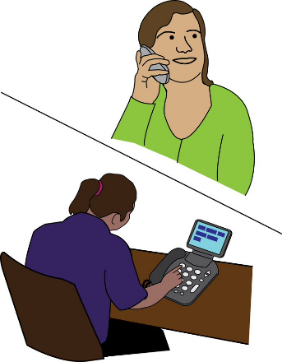
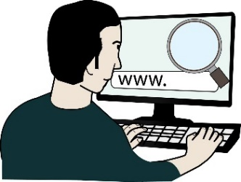
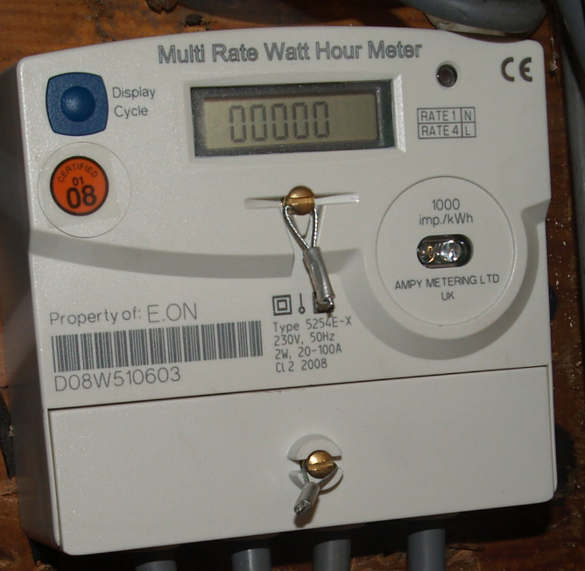
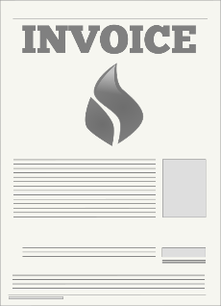
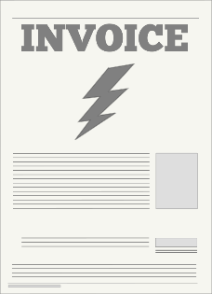
If your disability means your health gets worse if your power goes off, tell your energy company. If you want a regular meter because of problems with your health, they must give it to you.

Find out who your energy company are and contact them. Tell them you have a disability that means you need a regular meter, so you are not left without power.

When people are in debt, energy companies try to make them change from a regular meter to a pre-payment meter.

If you have medical equipment that needs power all the time or you are in a ‘very vulnerable situation’, the energy company cannot make you change meters.
https://www.ofgem.gov.uk/information-consumers/energy-advice-households/check-prepayment-meter-rules

If your energy company do not help, you can complain here:
https://www.citizensadvice.org.uk/consumer/energy/energy-supply/complain-about-an-energy-company/complain-to-your-energy-supplier/

If you use an oxygen concentrator at home, claim your refund.

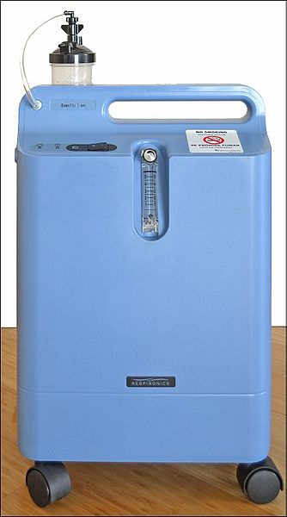
If you use an oxygen concentrator at home, you can get money for the electricity it uses.

You have to apply for this.

You can call BOC Home Oxygen Service on 0800 136 603
You can call Air Liquide Healthcare on 0800 781 9939

If your oxygen concentrator is from a different company, you will need to look them up and call them.

If you pay for your care, make sure your disability-related expenses were included.
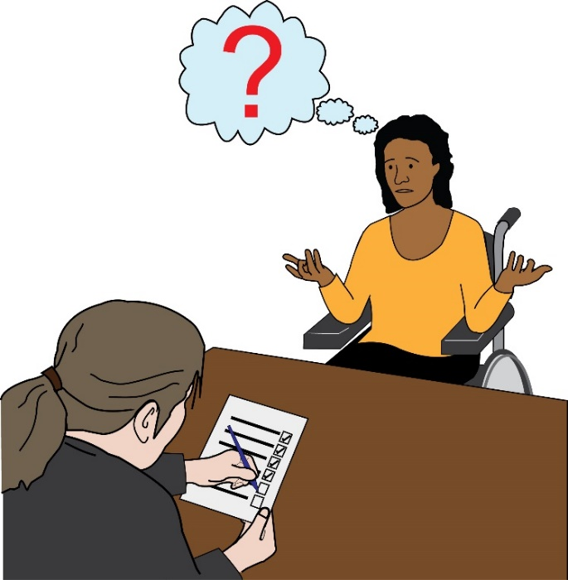
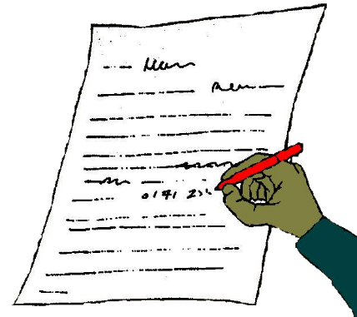
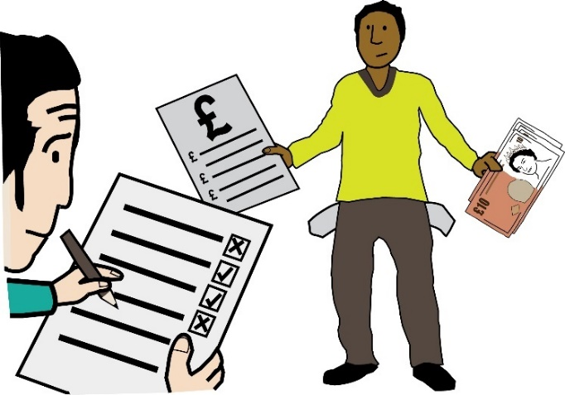
If you pay for care in your home, you will have had a means test.
A means test is when your council checks what money you have and how much you can pay. The test is meant to make sure you have enough money to live.
This means test should look at how much you spend on extra things because of your disability, but sometimes it does not. The council calls these extra things ‘disability-related expenses’.

Disability-related expenses are costs you have to pay or things you need because of your disability or impairment. This includes energy.
If you do not think the council included your disability-related expenses in your means test, ask for a reassessment.
A reassessment is when the council checks again if you can afford to pay for your care.
We have a letter template you can use to ask for this.
Link to Letter Template (Click or Ctrl Click)

Join our campaign

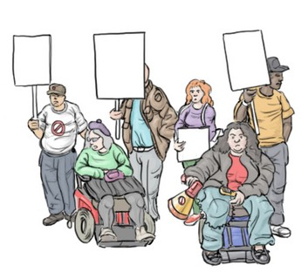
The minimum income the government says is enough to live is too low.

People do not have enough money to live.

We are campaigning to change this. This means we are trying to make the government and councils change the way they do things.

We are campaigning to increase the minimum income level.
We are also campaigning for care to be free.
You can find out more here:
https://www.scrapcarecharges.com/

Disability Poverty Campaign Group

The government has not given any specific help for Disabled people for the cost-of-living crisis.

We do not think this is okay.

We have started a new group called the Disability Poverty Campaign Group.

This group is led by Disabled People’s Organisations and works with other groups, too.

We want the government to change policies which make us poor. We want to end poverty for Disabled people in the UK.

If you would like to talk about this group, please e-mail:
Julia.modern@inclusionlondon.org.uk

Some pictures we used were used under the Creative Commons copyright license when we used them (03/05/2022).
Creative Commons copyright license means the people who took the photographs or made the pictures said anyone could use their work if they said where they got them from.
This is where we got them and who made them.
Images of lightbulb, electricity, and invoices for energy bills are from OpenClipart.org (https://openclipart.org)
‘Cestas mini e cestas super famílias.’ (Box of food) created by Eduardo Batista do Nascimento Conceição Soares (https://upload.wikimedia.org/wikipedia/commons/2/24/Trabalhamos_com_cestas_b%C3%A1sicas_mini_cestas_e_super_cesta_fam%C3%ADlia..png)
Pre-payment key taken by Caroline Ford (https://commons.wikimedia.org/wiki/File:London_electricity_keymeter_key.jpg)
Pre-payment meter taken by Caroline Ford (https://commons.wikimedia.org/wiki/File:London_electricity_key_meter.jpg)
New (regular) meter taken by Alex Foster (https://www.flickr.com/photos/niles/2199834273)
Philips Respironics Oxygen Concentrator taken by i_am_jim (https://commons.wikimedia.org/wiki/File:Philips_Respironics_Oxygen_Concentrator._Photo_taken_by_me_on_April_24th,_2012.jpg)

We also used pictures under license from:
Bromley Experts by Experience
People First

Under license means Bromly Experts by Experience and People First gave Inclusion London permission to use their pictures.

