On behalf of the National Union of British Sign Language Users (NUBSLI)

Why a VRS monopoly is a bad thing for the deaf community

What’s wrong with a monopoly?

You may think that companies only monopolise because they offer a good service? This is rarely the case. You just have to look at companies like Amazon or Sports Direct to see why.

Workers are a commodity who aren't valued and whose conditions as the company grows, rather than improve with the companies wealth, worsen. For the consumer, the cost of using the service, is seeing smaller independent companies disappear. These are the small businesses who support our communities and provide a value that isn’t monetised and is too often taken for granted. How many small businesses have come to their communities rescue during Covid compared to the larger companies who have simply profiteered. Is this what we want to see in the UK?

Any monopoly should always be a concern. Without exception.

VRS services in the UK

VRS services offer an important means of access and the Deaf community have the right to access in their first language. However, when this starts to be offered in large government frameworks and is seen as an alternative to face to face appointments in areas such as healthcare, we need to worry. Remember - those who influence what goes in these contracts are the suppliers - not the deaf community or interpreters.

What is concerning is that a large company such a Sorenson is positioning themselves to take over the entire market (see monopolies above).

They have used the pandemic to their advantage, establishing at a time when everything has had to happen online. This has strengthened the position the hold and they have been able to go on a large recruitment drive.

Why is this bad for the deaf community?

We are already seeing how much the recruitment of interpreters is impacting face to face appointments - and things are no where near back to normal yet. Many interpreters like working at home and don’t want to travel so are happy to take VRS work. Many others are doing so out of fear (we will consider that next).

With a reduction in the ability to provide face to face interpreters, this is feeding into the narrative that VRS is needed. This is removing choice and control from the deaf community.

A deaf person should be able to say whether they want to have an interpreter present at an appointment or prefer a remote interpreter. For many deaf people this isn’t a choice - they may have additional needs and need an interpreter to attend or they may have no access to technology. There is huge digital deprivation in the UK deaf community. This is an area that hasn’t been considered or researched and we face large numbers of people being excluded.

But BSL interpreters are happy working there!

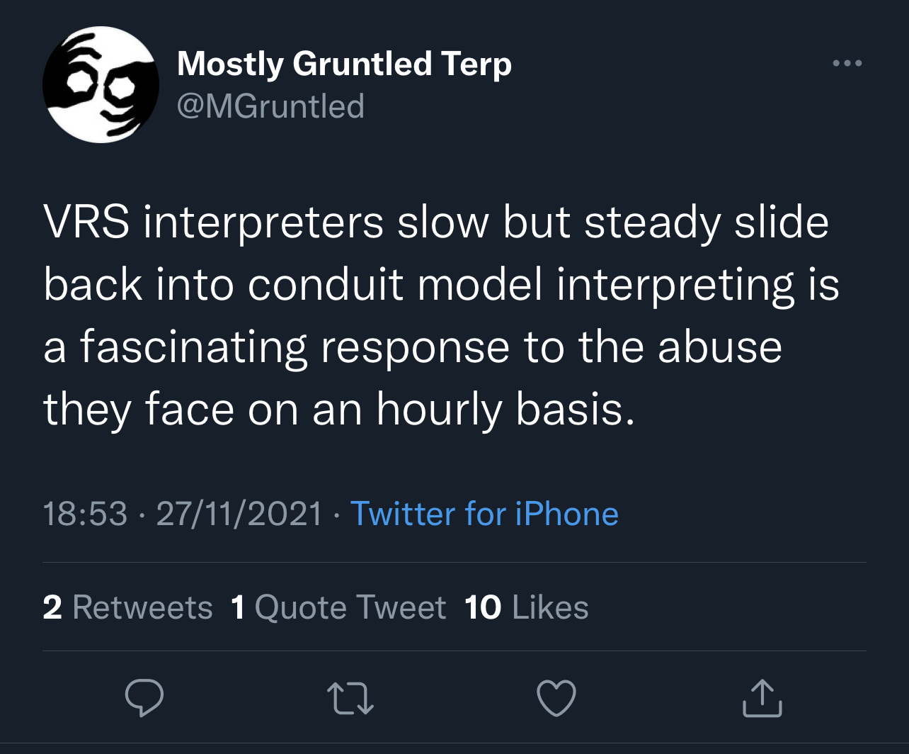
We need to recognise that the same interpreters who are actively promoting the service are also telling us that “I’d rather work 3 hours than 4 as it’s too much really, but I need to make the money up”, “you wouldn’t get a break if you didn’t take one”, “it is non-stop”. This is concerning given the service has only just arrived - it’s worth looking at these tweets from the other side of the pond…
Caption
A workplace union branch was requested was refused by Sorenson. This is not allowed and the group are now pursuing statutory enforcement of the right to a union.

A good company shouldn’t be preventing a union branch being established. Unions lead to improved conditions and a happier workforce - it does however mean that workers rights are taking into consideration and that the workforce has more say - something that we’ve seen doesn’t fit with monopolies.

What drives people?

Caption

But Deaf people are promoting the service?

We know that some deaf people are being paid on a commission basis to bring in new business. This is a way of making it look like the service is being requested by the deaf community - in actual fact they are being paid! This is highly questionable from an ethical standpoint.

We also know that these companies are going to be sponsoring lots of events - this isn’t for the good of the community - it’s to gain trust so they then get to take over much business as possible.
Remember their aim is to monopolise. Remember why this is not a good thing.

So what should we do?

The aim of this piece is to raise awareness of the issues. Be aware that what is being presented may not be as it seems.

Look to the smaller UK based initiatives whose aims are to support the community, rather than make a profit.

