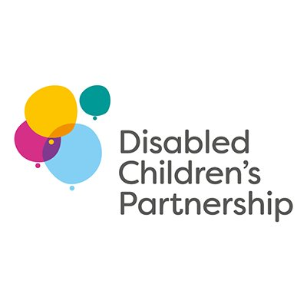
United Nations Convention on the Rights of Disabled People (CRDP) – Call for Evidence
Submission from the Disabled Children’s Partnership

The Disabled Children's Partnership is a coalition of nearly 100 charities who have come together to campaign for better health and social care services for disabled children and their families.
We believe that disabled children, young people and their families should have access to the services they are entitled to, when they need them.
We are not asking for disabled children to be singled out or treated differently. We are asking for fairness.
Disabled children face four big challenges.
- There are not enough services
- Many of those that exist are not good enough
- Families cannot access them easily
- Services do not always work together and communicate well with each other
This has led to an unacceptable contrast between the quality of life and the opportunities available to disabled children and their families, compared to those without disabilities. Simple tasks such as visiting a park, going to school or doing the weekly shop are often extremely challenging and in some cases impossible. This particularly impinges on disabled children’s rights under articles 23, 24, 25 and 30.
The situation set out above pre-dates the Covid-19 pandemic, but the pandemic has had a disproportionate impact on disabled children and their families and further exacerbated this existing inequalities. The Disabled Children’s Partnership has researched the impact on disabled children and their families throughout the pandemic. Our report Then There Was Silence (Cath Lunt, September 2021) brings this research together. It draws on the experiences of countless families, through surveys and interviews, as well as information obtained through Freedom of Information requests and other research.
Key findings in the report are that –
- Children and families have been isolated and abandoned; and not been listened to.
- Covid restrictions meant services were stopped or reduced; and many are still slow to return.
- Mental health and wellbeing of all the family has deteriorated.
- Children’s conditions have worsened and needs become more complex; delays in assessments mean needs haven’t been identified.
As a result of our findings, we have identified five vital steps for central government, local government and the NHS.
- Prioritise the needs of disabled children and their families within covid recovery plans and programmes.
- Tackle the backlog in assessments and ensure that children’s needs are re-assessed in light of missed support during the pandemic.
- Ensure the right support is in place for all children and families, including education, health (including mental health), therapies and equipment.
- Take a whole family approach to assessments and support, including siblings. This should include the provision of respite/short breaks and opportunities for families to take part in activities to overcome the isolation felt by so many.
- Invest in disabled children’s health and care services through the Comprehensive Spending Review.

Disabled Children’s Partnership
November 2021

https://disabledchildrenspartnership.org.uk/wp-content/uploads/2021/10/Then-There-Was-Silence-Full-Policy-Report-10-September-2021.pdf

