In view of the fact that no representatives for disabled people were invited to the recent Integrated Care Summit:

https://www.convenzis.co.uk/events/the-integrated-care-summit-2021/?fbclid=IwAR2l77h893isfaSd98PHDPyU4PKAgUYz6sNXVKX6aVVC_5YzGg9uUkkMMz4
The Integrated Care Summit 2021, We are living through the greatest - Convenzis
The Integrated Care Summit 2021. We are living through the greatest challenge our health and care system has ever faced, yet, even in crisis conditions, everyone working in our health and care system has continued to deliver excellence.
www.convenzis.co.uk

I would like to know why the UK Govt has such scant regard for our opinion and how it intends to remedy this.
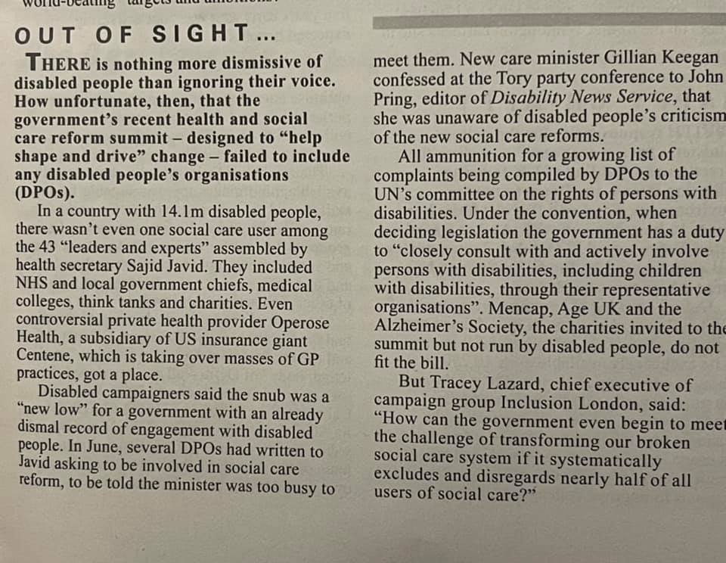

The recent debacle around the NICE pause to publication of guidelines for the treatment of ME/CFS runs against the following:
Freedom from torture or cruel, inhuman or degrading treatment or punishment.
Freedom from exploitation, violence and abuse.
While the delay was caused by certain medical protagonists, these people were also involved in the PACE trials which again caused treatment which ran against the 2 above points.
There is lots of literature available and it may be that you would choose not to include the care and treatment of patients with ME/CFS in your scope but I feel it is an opportunity for the UK to set things right, particularly when other countries medical establishments have progressed beyond the outdated thinking of the cabal responsible in the UK.
I hope the following links are useful.
Mayo Clinic
Invest in ME Research
US ME/CFS Clinician Coalition
David Tuller 23 October 2021
MDPI
The Science Bit - Same old Denialism
Kings College - 3 advocates for GET now say it was due to 'misunderstandings'
Journal of Health & Psychology (1st published 2017)
ME Advocates Ireland 2020
NIHR

I hope the above demonstrates the breadth of opposition to the stance taken by those medical practitioners in the UK who delayed and presumably opposed the NICE revised guidelines.
Best regards
Linda Coy

