Haley Jones
@haleyjones0333
Nov 24
My Spinal operation remove to cyst in the spinal cord on the expect me to go home and survive without a care package
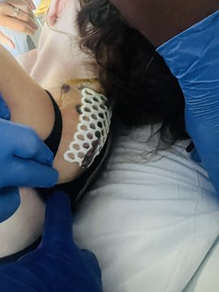
What is the point in spending thousands on an operation and send someone home with literally no care package.
I have a case manager but only put there the shifts out on Wednesday only till this Sunday anymore out there were only put one person on shift when it’s 2 to all times.

