People with learning disabilities – COVID-19 Support and Action Group

Wednesday 10th November 2021

UN CRDP Capacity-building and Consultation Workshop

1. Present [redacted]
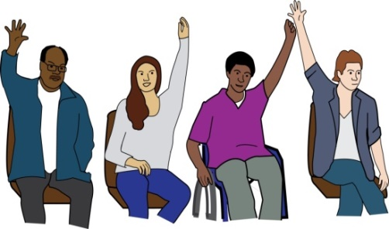

We welcomed our international guest Christopher Mitchel from the USA.

Apologies: [redacted]

2. Introductions

Joanne and Jenny welcomed everyone to the meeting and asked everyone how they were feeling.

Andrew introduced the subject of the workshop.
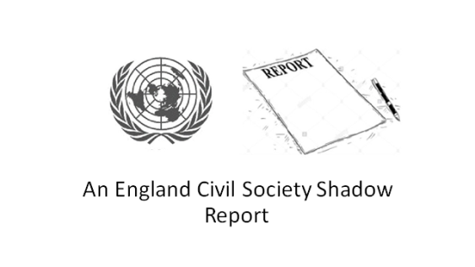
We went through the slides to explain what the UNCRPD Shadow Reporting Process was.
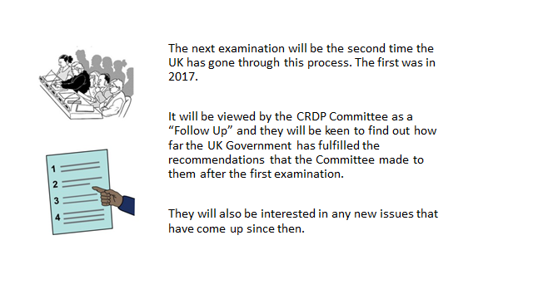
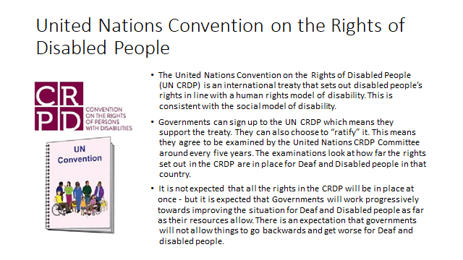
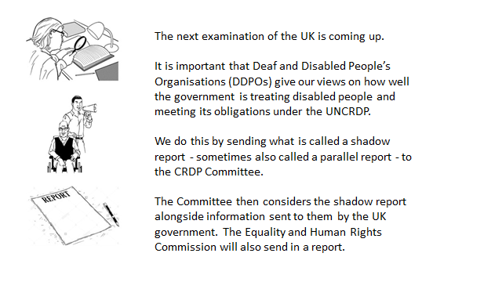
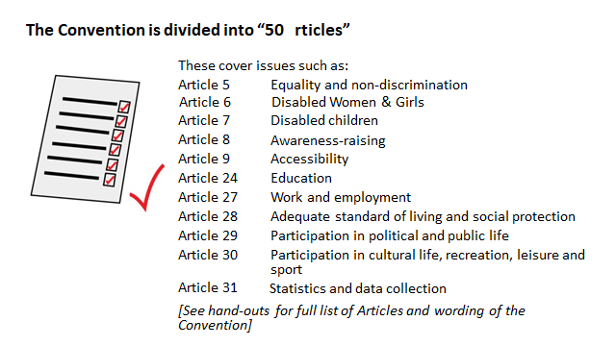
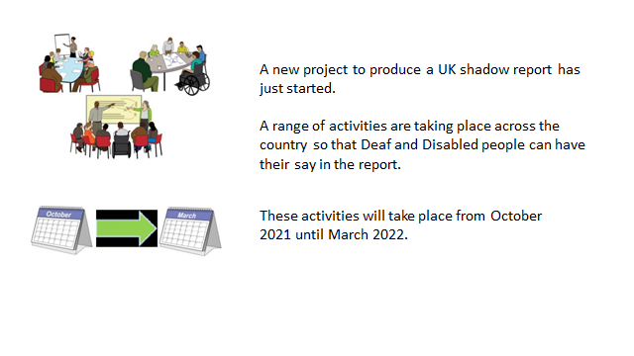
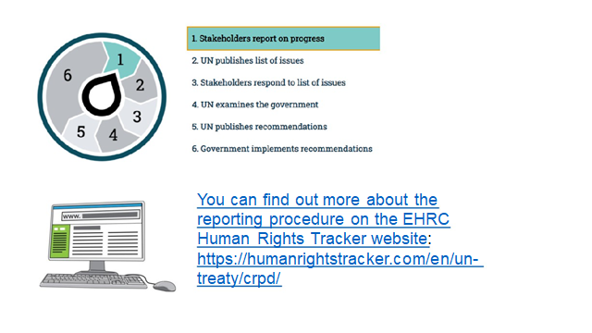
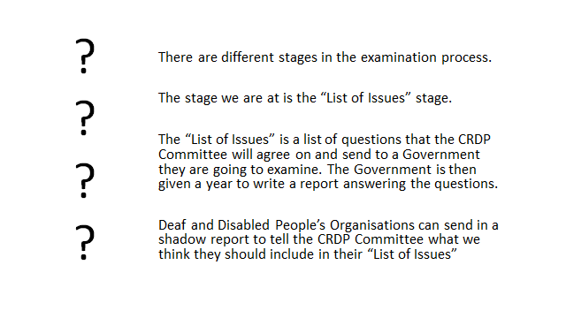
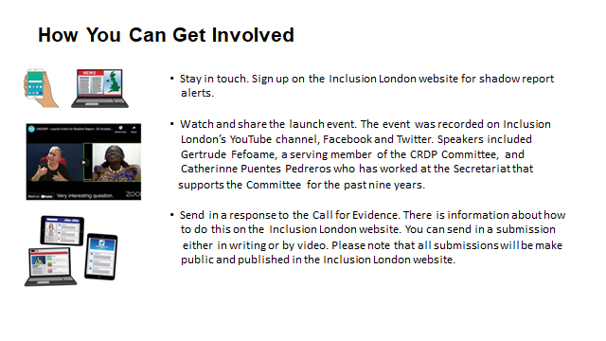
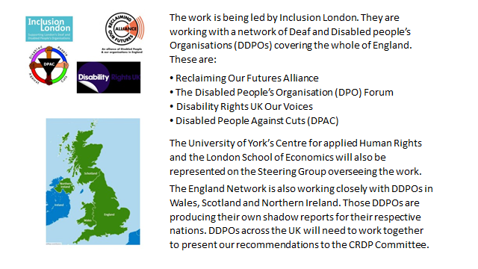
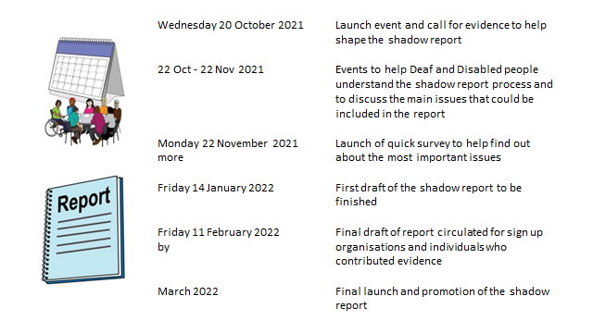
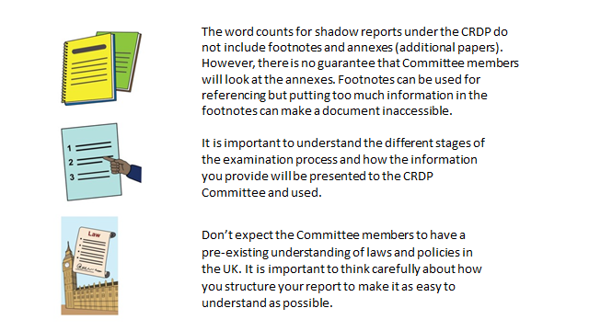
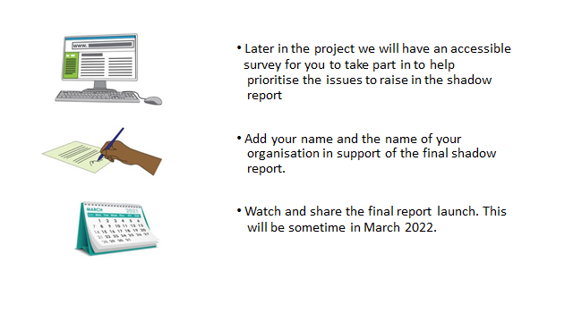

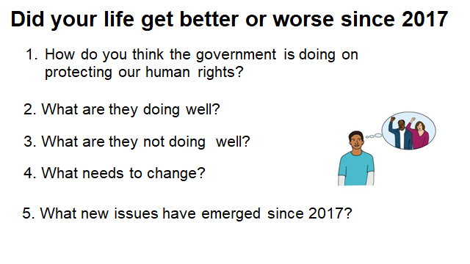
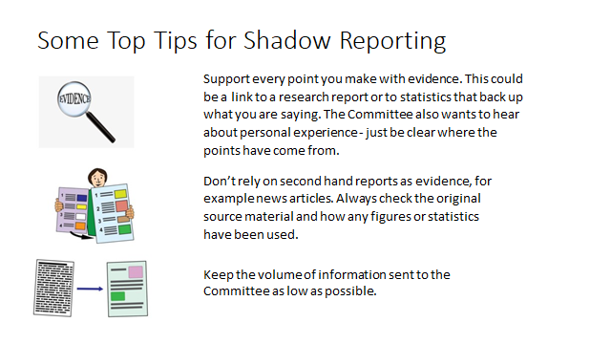
The Questions
We discussed all the issues and then will do follow up work to gather more information and evidence and examples to support our points.

Generally people felt things have stayed the same since 2017, with not much improvement. Then Covid-19 highlighted (all at once) just how little the Government and some sections of society regarded the needs and rights of disabled people. People with learning disabilities felt scared, isolated, cut off and forgotten about.

They also felt scared and not valued as we heard more and more cases of people being given Do Not Resuscitation Orders without knowing and based on them having a disability (this is not always a health issue)..

See the Covid-19 Support & Action Group Covid-19 Statement https://peoplefirstltd.com/wp-content/uploads/2020/04/Coronavirus-Statement-from-People-with-Learning-Disabilities-21.04.2020-1.pdf

Here is a summary of the points made.

- How do you think the government is doing on protecting our human rights?

- It’s worrying that there are plans to review/update the Human Rights Act and change parts of the Act and obligations that the UK ‘opts out’ of.

- The Government set up the Joint Committee on Human Rights (JCHR).

- EU Charter of Fundamental Rights

- People generally talk about rights more and the UK has a better human rights record compared to some other countries.

- Staff in our public services need to be better trained and aware of their responsibilities in promoting and protecting people’s rights.

- Things like Hate Crime must be stopped, it shouldn’t be tolerated.

- The Government are not doing as much as they could – people who cannot talk are not treated well.

- Criteria for learning difficulties/disabilities is still based on intelligence and historical systems and hierarchies - but we can all face barriers.

- What are they doing well?

- We now have Peer in the House of Lords who have disabilities and understand and promote the rights of disabled people and the social model of disability. E.g. Baroness Jane Campbell’s work on a bill for Independent Living. It gives us ambitions for positions like this.

- Our right to vote – local politicians and UK Parliament are working well to engage with and include disabled people in politics.

- Accessible public transport – new stations and vehicles are more accessible. Brought about by pressure from outside the central Government though.

- Not enough social care for people to live in the community independently.

- Emergency Covid-19 funds were made available and accessible quickly through a number of channels.

- What are they not doing well?

- The Covid-19 pandemic showed us that the Government did not see disabled people as important at first. It felt like we were at the bottom of the list and had to fight for ‘our right to life’. We also had to campaign to be a priority for vaccinations.

- People with learning disabilities are still being locked away in institutions (Assessment and Treatment Units) and continuing to be treated badly and isolated from families (Winterbourne View and many others). The recommendations and targets in the Transforming care: A national response to Winterbourne View Hospital not being followed up.

See our Statement on Assessment & Treatment Units https://peoplefirstltd.com/wp-content/uploads/2020/09/Assessment-and-Treatment-Units-Position-Statement-1.pdf

- Producing accessible information and making reasonable adjustments in a timely manner. Not included in the mainstream – always marginalised, the easy read information being produced late during Covid-19 is an example of this.

- Digital exclusion – a lot of health, social care and housing information and systems going online.

- People with disabilities having to move out of area for support.

- Limited and inaccessible consultations for potential changes in law – E.g. Mental Capacity Act

- Care Act, Accessible Standards all good but need proper implementation.

- Providing good guidance on benefits.

- Reporting the deaths of people with learning disabilities from Covid-19 Every life matters campaign https://peoplefirstltd.com/wp-content/uploads/2020/05/Easy-Read-Every-Death-Counts-campaign.pdf

- What needs to change?

- Attitudes and approaches to housing needs to change to help people live independently and get adaptions – not institutions! More understanding and support for people with learning and physical disabilities.

- Need more creative solutions to supporting people to live in the community – not on the margins.

- Digital exclusion – digital developments are moving fast and not in-line with

- Understanding what we are saying about independent living National Independent Living Support Service (NILSS). More choice and community presence.

- Employment levels for people with learning disabilities (6%). Government messages need to promote positive policies and attitudes, not perpetuate negative ones.

- Make it harder to weaken current legislation that protects our rights – any changes must strengthen them.

- Government need to talk directly to people with disabilities and lived experience – this still doesn’t happen with people with learning disabilities. Others (usually non-disabled people) are spoken to on our behalf (de facto). We need more access to Government.

- Social Care for all ages of people that need it.

- What new issues have emerged since 2017?

- Government proposals to reform Human Rights law. The Independent Human Rights Act Review (IHRAR) was set up December 2020.This was set up following the Conservative party’s pledge to “update the Human Rights Act and administrative law…” The report of the review is still to be published. Here’s the BIHR response to the review https://www.bihr.org.uk/Handlers/Download.ashx?IDMF=6efd6aef-3bc3-4c75-867c-d744ede5d0c9

- Brexit and the loss of protections in EU law and access to European Social Funds for Disabled People and Deaf and Disabled Peoples Organisations.

Additional written information

  - Whether things have got better or worse or stayed the same since the last examination in 2017

Things have got worse…

Article 5 – Equality and non-discrimination
Heidi court case highlights the continued disability discrimination – before birth disabled and non-disabled unborn babies do not enjoy the same legal status in law.
Equality Act needs to be made stronger – cannot enforce the law because it cost too much money to go to court, medical model and is not always clear what is meant by reasonable adjustments – should it be reasonable adjustments?
Public Sector Equality Duty – means that all the state has to do is reconsider the decision after consulting disabled people properly – do not need to make changes to the decision,

Article 6 – Women with disabilities
Girls and women find it much harder to have their learning difficulties recognised by professionals. This is because professionals do not always understand how women and girls can be very good of hiding their difficulties from families, schools, social services and alike.
Women with learning difficulties are still being sterilised or being encouraged to have abortion or give their children up for adoption. Social Services still do not do enough to help parents (usually mums with learning difficulties) keep hold of their children. Questions need to be asked if children with learning difficulties are not taught about relationships, sex etc. whilst in education.
Lots of girls and women with learning difficulties are locked up in psychiatric hospitals is because they are often diagnosed with a mental health condition rather than a learning disabilities, learning difficulties and autism.

Article 7 – Children with disabilities
Increasingly children with learning difficulties and autism are ending up in psychiatric hospitals. Double the number of children are locked up in hospitals because of the lack of recognition of learning disabilities/difficulties and autism. This leads to children and young people do not get the support they need to be educated in mainstream schools and live at home. There is a lack of education, health and care support for children with LDs to help children live at home. Many children with high needs end up having to go to residential special schools or end up in hospitals. Families are less likely to get the support they need to help their children flourish.

Article 9 – Accessibility
There is a lack of accessibility and reasonable adjustments – such as provision of easy read information, face to face meetings etc.
Article 10 – Right to life
Article 25 – Health
Article 26 – Habilitation and rehabilitation

Heidi court case - right to life before birth – less rights than non-disabled unborn babies.
The covid-19 paramedic was used to ration health care for people with learning difficulties – GPs were found acting unlawfully by putting DNR notices into people with learning difficulties medical records – telling doctors and health care professionals not to give us healthcare treatment.

6 times more likely to die from covid 19 if one had a LD. And for young people it was 24 times greater than the general population. We had to fight to get covid-19 vaccinations as a priority group.

Before covid-19 paramedic – many people with LDs die at least 10 years earlier than their non-disabled peers. Too often doctors and medical professionals do not listen to us, do not take us seriously and do not want to give us treatment that non-disabled people would have received.

Children and young people with LDS have had their therapy services taken away or reduced and have not returned to prior paramedic levels.

Article 12 – Equal recognition before the law

People with learning difficulties do not have the same legal status in law with their non-disabled peers. People with learning difficulties can be forced into institutions, denied the right to make decisions and treated against their wishes. Many people with learning difficulties can be medicated and treated that makes them more unwell rather than better. (I.e. antipsychotic medication) People with learning difficulties can be labelled as losing capacity and therefore lose a lot of rights to make decisions that non-disabled people can make.

Article 13 – Access to justice
Majority of people with LDs cannot afford lawyers. They have to rely on legal aid which is harder to get for fewer types of court cases. For example, one cannot get legal aid for taking on disability discrimination cases. It’s very hard to get money for legal cases because one must get benefits and not have much money in the bank. Many people with LDs do not think crime is taken seriously – hate crime in particular. Do not get enough support in the criminal justice system as someone who is a victim or is accused of crime.

Article 16 – Freedom from exploitation, violence and abuse
There is growing evidence that LD people are not being protected against violence and abuse. The on-going scandals of LD people in institutions and segregated education settings continue to allow violence and abuse of LD people. There have been plenty of TV programmes, social media exposure and reports published highlighting the abuse of LD people in institutions. CQC and other public bodies have been pretty useless in preventing such abuse.

Article 17 – Protecting the integrity of the person
Many LD people are being denied to make decisions and have control over their lives. LD people do not have the same opportunities as their non-disabled peers to develop themselves, to choose how they want to live their lives and support to have control over their lives. Many LD people do not have any choice about their education, work, and leisure, housing and alike.

Article 19 – Living independently and being included in the community
Article 28 – Adequate standard of living and social protection
Article 22 – Respect for privacy
Article 23 – Respect for home and the family
Article 29 – Participation in political and public life
Article 30 – Participation in cultural life, recreation, leisure and sport

Majority of LD people still live with parents and family right through older age
Lack of resources to support LD people in the community
Viewed as community care placements rather than homes
Lack of choice of homes and support arrangements – minimum care support
Focus is on independent living – medical rather than social mode of disability
Not supporting LD people to have full lives – to do what they want whenever they want etc.
Cannot take full time work because it can mean that LD persons have to pay for their own support.
Need to stop institutionalised care settings – hospitals, group homes etc.
Lack of control over support
Insufficient support and importance of LD people being supported to engage in various activities.
Many activities are still not inclusive of LD people, particularly those who are labelled as having severe and profound LDs – design of activities are not inclusive. Lack of community facilities such as changing places toilets for example
LD people’s rights to have family (children) and live with family (LD children with their families)
Covid-19 had a big impact.
Social security benefits do not cover the real cost of living.

Article 21 – Freedom of expression and opinion, and access to information
Increasingly parents and professionals are speaking about us without us. They are talking about us a lot - Government funds national parents and carer’s forums whilst speaking up groups get no or little money. Parents and professionals are appointed onto Government, parliamentary and other influential public body task forces. There may be at best one token person with learning difficulties. For example various task forces dealing with people with LDs and Autism stuck in ATUs. This includes state funded research and projects where its parent and professional lead organisations and people win the contracts and control if and how people with LDs are involved. Examples include covid-19 research, projects and alike. There has been fewer people with LDs, experts by experience hired for independent care and treatment reviews. People with LDs do not have a real voice or influence – this is because the state funds and supports the voice of others with LD.

People with LDs can be fearful of speaking up and out when they are using services or are in institutions – the fear of being punished or having services taken away from oneself etc.

People with LDs are not supported to have a collective voice and therefore individuals can just been seen as those and nothing more.

Article 24 – Inclusive education
Increased segregation and exclusion of people with learning difficulties from mainstream education. More children and young people with learning difficulties are now placed in special schools, being educated at home, excluded from school. Children and young people with learning difficulties are less likely to be in mainstream education.

Chris’s Art Work
