Survey Findings, 2021-2022

We had two surveys running in September 2021, one for individuals to complete, and one for organisations. We run the surveys so that we can prioritise our limited capacity on what matters to our members. The organisational survey allows us to hear from members of other groups who may not be able to complete our survey, e.g. because of time restrictions. It also means their members don’t have to share their concerns over and over again for different groups.

Individuals
To consider the results, we’ve analysed allies and disabled/chronically ill respondents separately. For ease of reading, we have combined disabled and chronically ill people under the label disabled. We know that there will be some chronically ill people who don’t identify as disabled, it is purely for ease of understanding the results.

How do you identify?
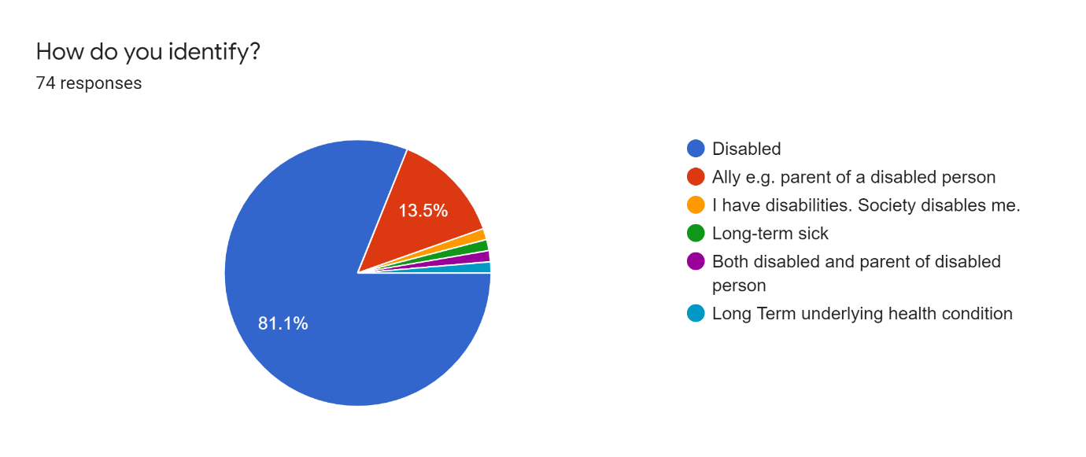

Tell us about your local priorities for York's disability community

Aside from any issues arising from the pandemic, what are your local priorities for the disability community in York? Please choose your top three:
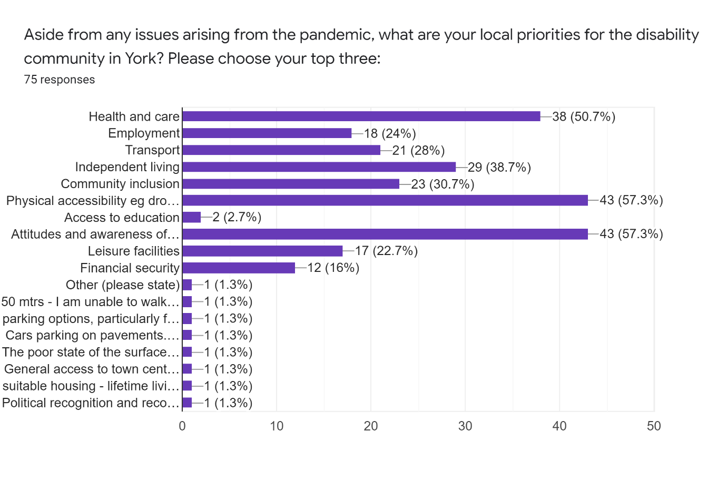
Before separating disabled respondents and allies out, we can see three key areas highlighted:
- Physical accessibility
- Attitudes and awareness of disability
- Health and care
Both physical accessibility and attitudes and awareness of disability were in the top three priorities from 2020-2021. We also know nationally that health and social care is becoming a much bigger concern amongst disabled people.

Disabled repondants:

Health and care | Transport | Physical accessibility | Attitudes and Awareness of disability | Independent living | Financial security | Employment | Community inclusion | Access to education | Leisure facilities
30 | 17 | 43 | 40 | 22 | 11 | 15 | 19 | 1 | 16
Note, where comments fit within an existing category, we have included that as a 'vote' for that category

The top three priorities for disabled people are:
- Physical accessibility
- Attitudes and awareness of disability
- Health and care
Comments from respondents:
- Concern about those disabled people who aren't 'disabled enough' to get a blue badge yet need the support it offers
- Pavement obstacles including cars parking on pavements, bins being left in the way and untrimmed, overhanging plants
- Poor quality of surfaces of pavements and car parks, including potholes and the impact of speed bumps
- Housing inaccessibility and unsuitability e.g. inadequate insulation

There were also various comments regarding the changes in city centre access for Blue Badge holders and the impact that this has had. Respondents report not feeling treated with dignity or respect, having little to look forward to and raised concerns about the lack of political recognition of our human rights. The city centre access changes were asked about in more detail later in the survey.

Allies:

Health and care | Transport | Physical accessibility | Attitudes and Awareness of disability | Independent living | Financial security | Employment | Community inclusion | Access to education | Leisure facilities
8 | 3 | 3 | 5 | 6 | 1 | 2 | 3 | 1 | 1

The top three priorities for allies are:
- Health and care
- Independent living
- Attitudes and awareness of disability

Comments:
There was concern about being a parent of a young adult disabled person, specifically around support for parents as well as the need for support and activities for young adult disabled people once they leave education.

Experiences of the pandemic

What concerns do you have, if any, about disability and coronavirus? Please select as many as apply:

In addition to concerns around relaxed restrictions and reduced support, disabled respondents noted feeling unsupported throughout the pandemic; the way attitudes towards disabled people have worsened (e.g. DNRs, prejudice if you can’t wear a face mask); and mental health impacts.
The impact on services such as GPs was mentioned, as well as inaccessible covid measures such as pavement cafes and one way systems. The reduction of virtual services and home working were also of concern.
Allies noted the overwhelming number of visitors and tourists to York and the impact that’s having on the city’s residents.

Disabled People
Relaxed restrictions such as people not being required to wear masks | Reduced support because shielding is no longer official | No concerns
47 | 27 | 9

Allies
Relaxed restrictions such as people not being required to wear masks | Reduced support because shielding is no longer official | No concerns
10 | 2 | 0

