Helen Rowlands <helenrowlands.mail@gmail.com> | Dec 8, 2021, 12:41 PM
to Mike, Louise

Dear Mike and Louise

Last night, I attended the Cheshire West and Chester Council Hate Crime Strategy focus group.

I shared with officers DPAC and the Cheshire Disabled People's Panel's deep concern at the cutting by the local authority of the Safe in Town programme.

CDPP panel member People's Choice Group provided me with this statement, which I shared with officers in a breakout group:

In Northwich we used to have a scheme called Safe in Town where local businesses signed up and displayed cards in their windows showing they were a safe place to go to if someone needed help. Individuals got a Safe in Town card that they could put their emergency contact numbers on and be supported to call someone from a safe place. It was arranged via the Learning Disabilities Partnership and originated in Halton before being extended. Funding for this stopped but it was a really good scheme that helped people feel more secure whilst in town.

Group members at PettyPool College pre-Covid told me about the Safe Places App which is a phone app that shows Safe Places from different schemes nationally. They only charge £7.60 a week for an area's Safe Places to be listed on the app. The Pettypool students were really disappointed that there was nothing in Cheshire West anymore and asked for it to be raised at the Partnership Board. Then Covid-19 happened so it was on hold.

We would really like something like this to be put back in place across Cheshire West and Chester to help people feel safer.
Can you please let me know if this can be included in the revised Hate Crime Strategy

As the local MP Mike, I assume you have received the attached data from the Northwich LPU, flagging a wholly unacceptable spike in disability hate crime in Northwich.

The axing of the Safe in Town programme by the local authority may have contributed to the rise in hate crime against disabled people in my town.

It is imperative that the scheme is relaunched, and extended, with an accompanying app.

DPAC will be monitoring rates of disability hate crime in Northwich and across Cheshire, and analysing any causal or contributory links to cuts to disabled people's services.

with best wishes,

Helen
--
Helen Rowlands
Co-founder: Cheshire Disabled People Against Cuts and Cheshire Disabled People's Panel
Member: West Cheshire Access Group / Cheshire West and Chester Corporate Disability Access Forum / Greater Manchester Coalition of Disabled People / Inclusion London Disability Justice Project

DPAC are campaigning for an end to social care charging in England. Our Campaign Twitter: @OCharging

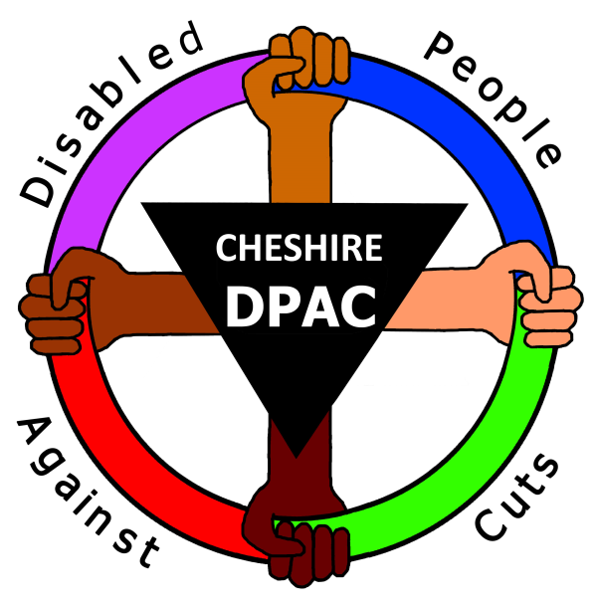''Rights, not charity''

GITTINS, Louise (Leader of Cheshire West and Chester Council) | Dec 21, 2021, 8:46 AM (6 days ago)
to Mike, me

Hi Helen a quick follow up: the Hate crime strategy is being refreshed and Michelle Nicolson is leading, the refresh will include the Safe in Town scheme. I understand Michelle is meeting with Alistair Jeffs from Vivo and PettyPool College to find out more, we’ll also need to look for funding to support. Ill keep you updated and with details of consultation with wider stakeholders.
Have a peaceful Christmas and a happy and healthy 2022
Best wishes
Louise

