Call for Evidence Now Open

Have your say in what goes in the next UNCRPD civil society shadow report.

The United Nations Convention on the Rights of Persons with Disabilities (UNCRPD) is a document about disabled peoples’ rights that the countries in the United Nations have signed up to - it is often referred to as the Convention. It says that Disabled People should be treated fairly and have the same rights as everybody else.

A shadow report is an opportunity for Deaf and Disabled People’s Organisations to write about the issues and provide evidence about what has happened in the UK since the last report. that have not been properly addressed in government reports, under the Convention of the Rights of Disabled People (CRPD). It brings together other evidence about what has happened in the UK since the last report.
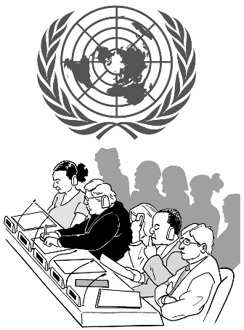
Every four years, the United Kingdom has to report to the United Nations (UN) and be reviewed on what it has achieved. This is usually called an examination. It is done by a committee of independent experts, the UN Committee on the Rights of Persons with Disabilities (the Committee).

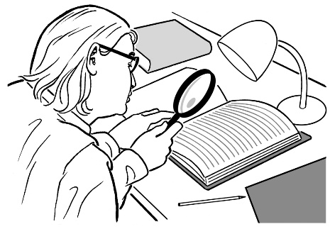
The next public examination of the UK under the United Nations Convention on the Rights of Disabled People (CRDP) is coming up.

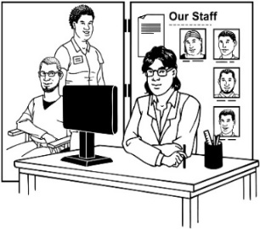
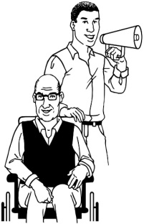
It is important that Deaf and Disabled People’s Organisations (DDPOs) give our views on how well the government is treating disabled people and meeting its obligations under the UNCRDP.

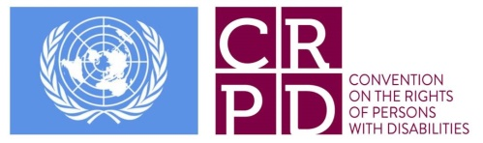
The shadow report is sent to the UN Committee responsible for the CRDP. They will then consider the shadow report alongside information sent to them by the UK government.

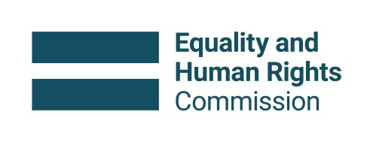
The Equality and Human Rights Commission and its equivalents in Scotland and Northern Ireland will also send information.

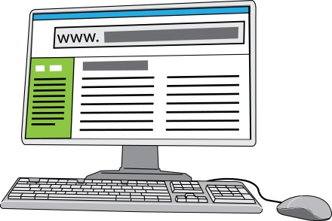
You can find out more about the reporting procedure on the EHRC Human Rights Tracker website: https://humanrightstracker.com/en/un-treaty/crpd/
The next examination will be the second time the UK has gone through this process.
2nd

The CRDP Committee are particularly interested in looking at how far their previous recommendations have been met.

We want Deaf and Disabled People, DDPOs and allies such as disability charities and human rights organisations to send us evidence that you think should be included in the England shadow report.

What information to send

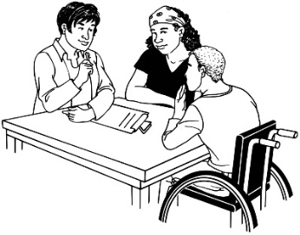
Please send information about how well the Articles of the Convention or previous recommendations are being met within England.

Articles of the Convention are the different sections, starting with the purpose and principles of the Convention, through to the different rights disabled people should expect. The Convention has 50 articles.

Evidence can focus on as many or as few of the recommendations and/or Articles as you choose to.

        - There are links on the Inclusion London website where you can find the full list of Articles and also the full list of Committee recommendations from the last examination.

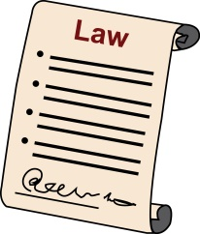
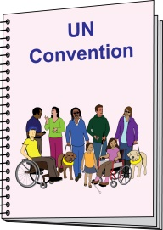
        - Inclusion London has also created a list of key legislation and policies introduced since 2017 that are relevant to each recommendation.

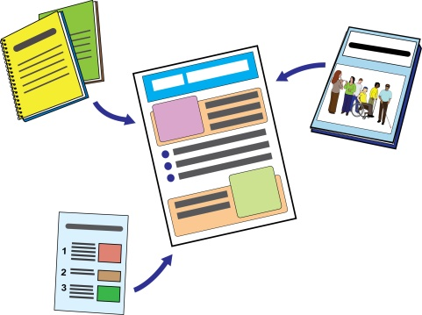
        - Information that you send could be links to reports, statistics, or other data. Everything we write in the report needs to be backed up by evidence that we can prove comes from a reliable source.

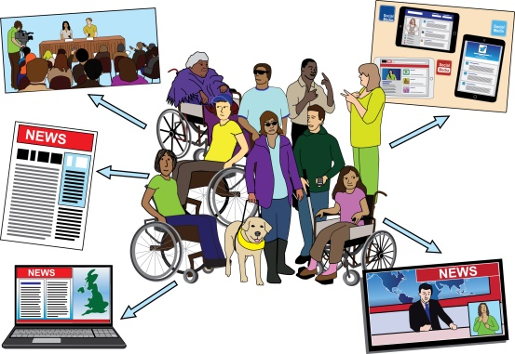
        - The Committee are also interested in the personal experiences of Deaf and Disabled people. If you or members send us examples from your own lives, please be aware that everything we are sent will be published online and will be publicly available.
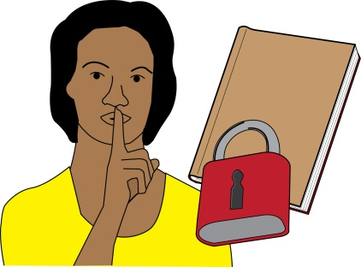
Please do not include any identifying information such as people’s names unless you have explicit permission.

How to send your information to us

You can send evidence in written English or BSL.

Email information to CRPD@inclusionlondon.org.uk with “Evidence” in the subject line.

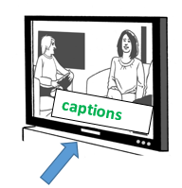
BSL videos can be sent by email or via WhatsApp to
07561 064 227

What We Will Do With Your Evidence
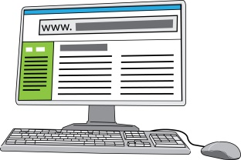
All evidence must be published online.

The England shadow report cannot be very long. It can only contain 5,350 words. This means we cannot include every piece of information we are sent. We will however look at everything.
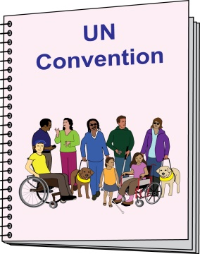
The final shadow report will be published in February 2022.
Shadow Report
We will also work with DDPOs in the devolved nations to produce combine all our separate reports into one longer UK wide report.

Download a permission form:
https://www.inclusionlondon.org.uk/wp-content/uploads/2021/10/Consent-Form.docx

Complete and email this form:
https://www.inclusionlondon.org.uk/wp-content/uploads/2021/10/Video-evidence-consent-form.docx

