Top Tips for Shadow Reporting under the United Nations Convention on the Rights of Disabled People (UN CRDP)

- Support every point you make with evidence. This could be a link to a research report or to statistics that back up what you are saying. The Committee also wants to hear about personal experience – just be clear where the points have come from.
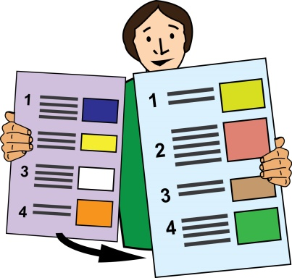
- Don’t rely on second hand reports as evidence, for example news articles. Always check the original source material and how any figures or statistics have been used.

- The word counts for shadow reports under the CRDP do not include footnotes and annexes (additional papers). However, there is no guarantee that Committee members will look at the annexes. Footnotes can be used for referencing but putting too much information in the footnotes can make a document inaccessible.
- It is important to understand the different stages of the examination process and how the information you provide will be presented to the Disability Committee and used.

During the first stage of the examination process the Committee wants to hear what areas Deaf and Disabled People’s Organisations think are most important to question to the Government about.

During the second stage the Committee wants to hear what recommendations DDPOs have for the Government after they have finished the examination. This means thinking about solutions as well as listing problems.

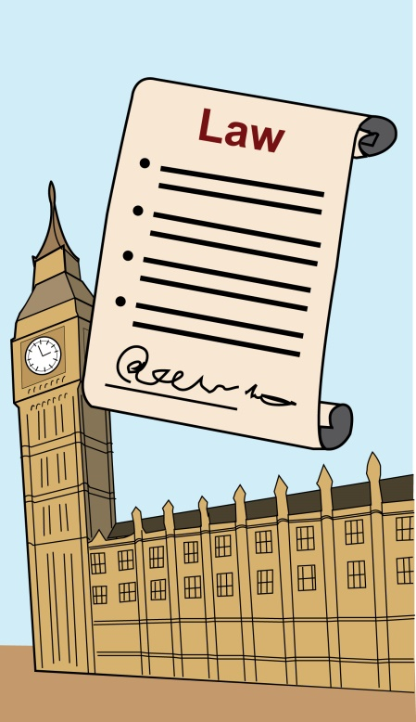
- The Committee wants to hear about new concerns affecting Deaf and Disabled people. They also want to hear about the progress that has or has not been made towards the last set of recommendations.

- Don’t expect the Committee members to have a pre-existing understanding of laws and policies in the UK.
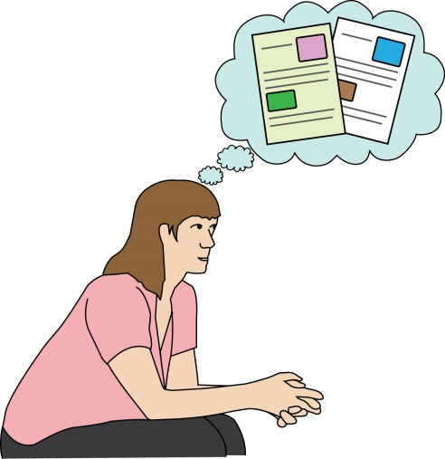
It is important to think carefully about how you structure your report to make it as easy to understand as possible.

- Keep the volume of information sent to the Committee as low as possible.

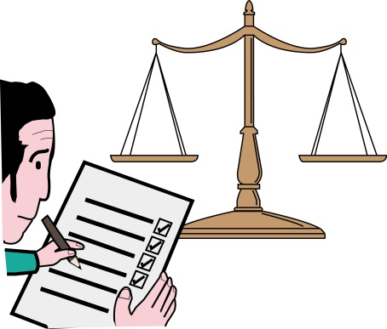
- The CRPD does not have any legal force in the UK but the examination process and reports can help build support for changes that Deaf and Disabled people want to see. It is important to think about how you will use your reports in between the examinations.
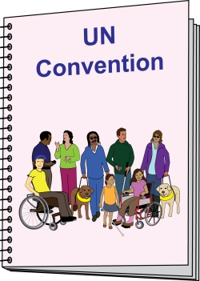
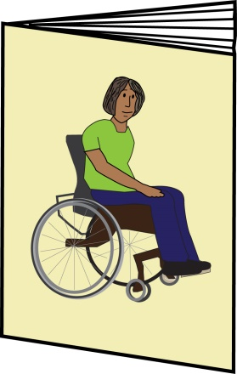
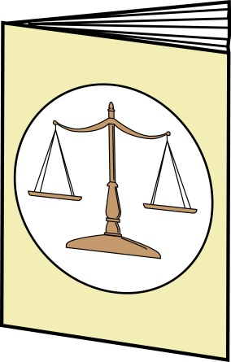
- Take a cross-treaty approach and look at the latest reports and recommendations from other international treaties, for example the International Covenant on Economic, Social and Cultural Rights (ICESCR), the Convention on the Rights of the Child (CRC), the Convention on the Elimination of All Forms of Discrimination Against Women (CEDAW).
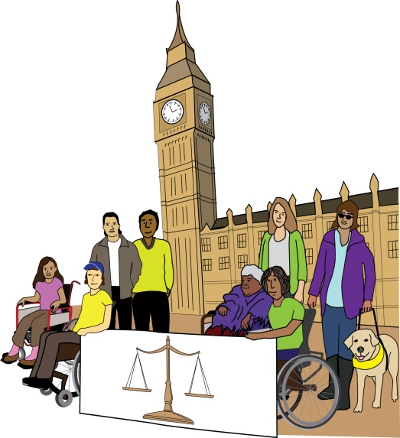
- Take a Human Rights Based Approach to your shadow report. The PANEL principles behind a human rights based approach are:
- Participation
- Accountability
- Non-Discrimination
- Empowerment
- Legality

Links

Guidelines on the Participation of Disabled Persons Organizations (DPOs) and Civil Society Organizations in the work of the Committee: https://www.globaldisabilityrightsnow.org/tools/crpd-shadow-report-guidance

List of General Comments: https://www.ohchr.org/EN/HRBodies/CRPD/Pages/GC.aspx

Simplified reporting procedure: https://www.ohchr.org/EN/HRBodies/CRPD/Pages/Simplifiedreportingprocedure.aspx

Human Rights Tracker: https://humanrightstracker.com/en/

Human Rights Based Approach including self-assessment toolkit: https://www.scottishhumanrights.com/projects-and-programmes/human-rights-based-approach/

Briefing on the special inquiry: https://www.inclusionlondon.org.uk/campaigns-and-policy/act-now/briefing-paper-inquiry-concerning-united-kingdom-great-britain-northern-ireland-carried-committee-article-6-optional-protocol-convention-rights-per/

