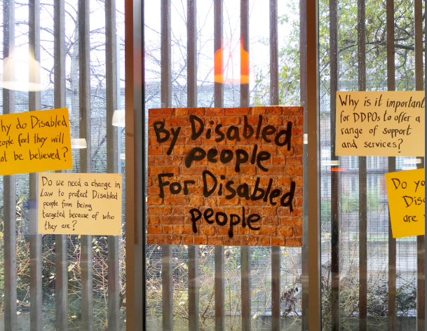

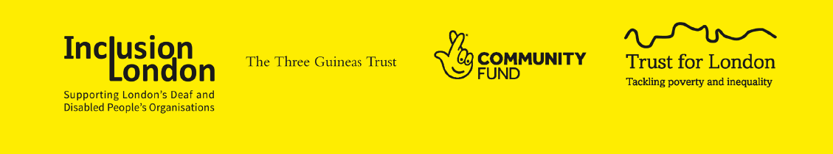

London Deaf & Disabled People’s
Hate Crime Partnership

Our work from April 2020 to March 2021
Part 2

Contents
Contents list for Part 2

6. Projects | 3
7. Services | 12
8. Strategic Campaigns, Comms & Policy | 17
9. Representation | 23
10. Meetings and Events | 25
11. What’s next? | 26

6. Projects

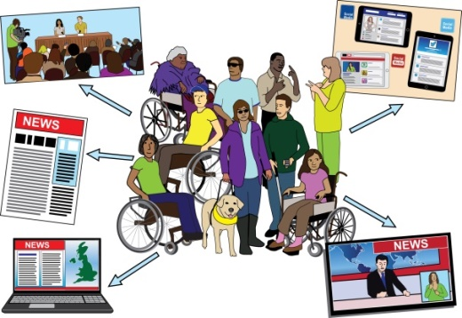  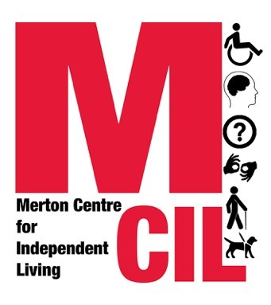 | 6.1. Secondment Project  This project aims to raise awareness and knowledge of hate crime against Disabled people with Deaf & Disabled People Organisations that do not have any hate crime support services.  Support is given to write funding applications to set up hate crime support services and run hate crime training programmes  An experienced Hate Crime Advocate from Stay Safe East is placed with an organisation for 2 days a week for 8 months.  Merton CIL have developed the Deaf & Disabled People Organisation Disability Hate Crime Evaluation & Monitoring Handbook  What we did during 2019 to 2021  Merton CIL and Stay Safe East worked with four Deaf & Disabled People Organisations in London.
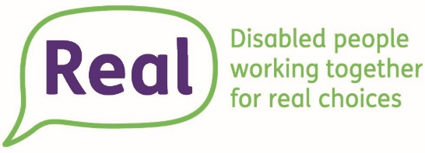
April 2019 – September 2019
Real
Tower Hamlets

October 2019 – March 2020
RUILS
Richmond

April 2020 – September 2020
Action Disability
Kensington & Chelsea

October 2020 – March 2021
Transport for All
London-wide

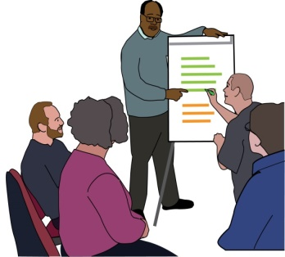 | Staff, trustees, and volunteers in each organisation received training to suit their needs.
 | Stay Safe’s Hate Crime Advocate worked with staff to find out if anyone they were working with was experiencing hate crime.
 | The team then used what they had learnt in the training to deal with hate crime cases and update their policies and ways of working.
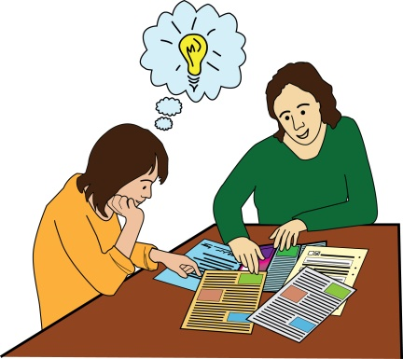 | The follow-up support after the end of the secondment gave teams the opportunities to have extra support for cases they were working on.
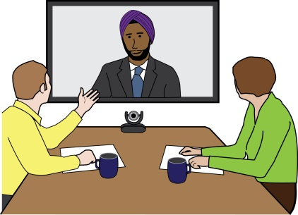 | Challenges:  - None of the organisations we worked with were able to get any extra funding to set up an anti-hate crime service after the secondment ended.  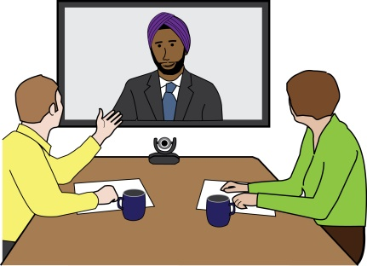  - From March 2020, all of the work had to happen online because of the pandemic.
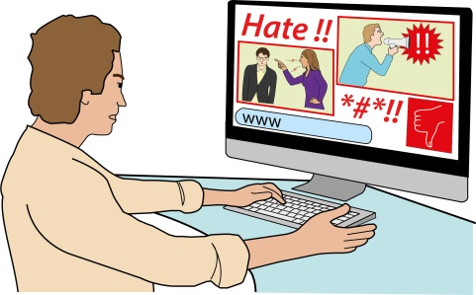  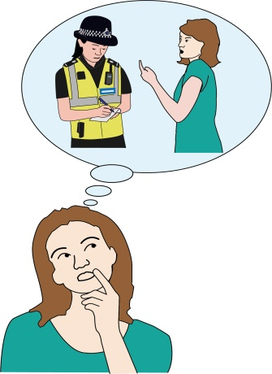 | What we achieved:  - The organisations we worked with said that their awareness and knowledge of hate crime was better  - The organisations we worked with said that they felt they were able to spot and deal with hate crime better  - Merton CIL produced a handbook for Deaf & Disabled People Organisations to evaluate and monitor their hate crime work
Evaluating Disability Hate Crime - Handbook for DDPOs - Inclusion London

Evaluate: this means to find out how well the work is going, is it doing what you set out to do.

Monitor: this means to regularly check the progress or quality of (something) over a period of time; to keep it under review.

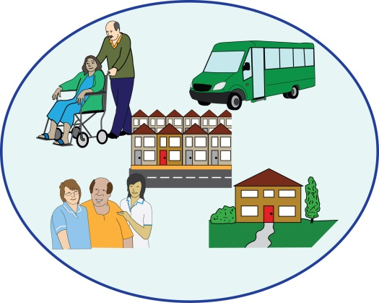 | Learning:  The secondments needed to be longer than 3 months, so we made them 6 months with an extra 2 months for follow-up support.  Many Disabled people go to organisations to deal with the consequences of hate crime, not the hate crime itself. Training needs to include working with other services.  Trustees need to have the training too, as there are a lot of staff changes in some organisations and lack of longer-term funding for posts.

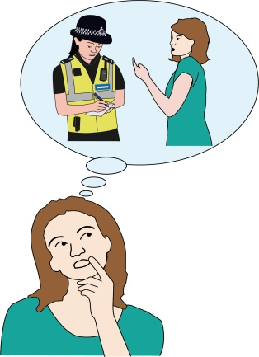 | 6.2. Training and Films Resource Project
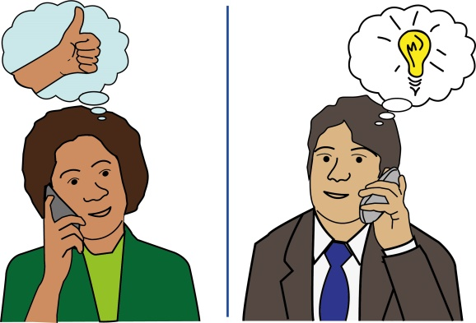 | This project aims to improve understanding of hate crime issues within non-Deaf & Disabled People Organisations.  Disabled trainers are using films as training materials to encourage non- Deaf & Disabled People Organisations to work in partnership with Disabled people.
 | These training materials were developed by 6 Deaf & Disabled People Organisations.
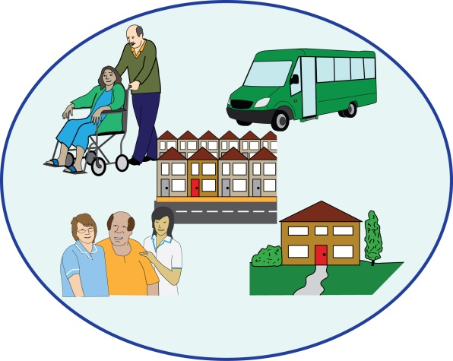 | The non-Deaf & Disabled People Organisation frontline services that we are focusing on are:  - Transport  - Housing  - Schools  - Deaf Organisations
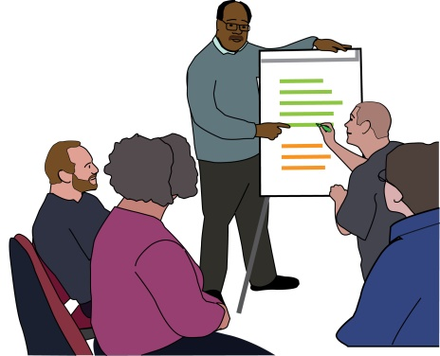 | There is also a one-hour presentation for other frontline services like estate agents, Direct Payment workers, social workers, and supermarkets.
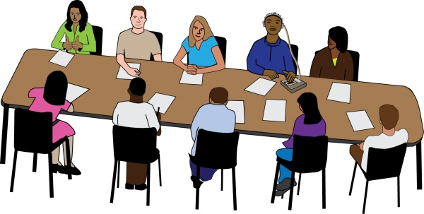 | What we did during 2019 to 2021  Inclusion London invited Deaf & Disabled People Organisations to join a  co-production working group that met 12 times.
Co-production: this means people working in equal partnership to influence, design, and deliver services.

 | We employed Kate Mercer, an independent training consultant and Fisayo Fadahunsi, founder and Director of Filmanthropy to bring everyone’s ideas together.
 | We developed and produced training materials and films for frontline staff.
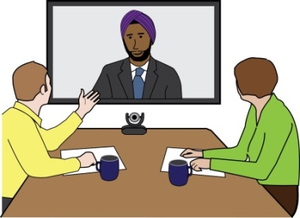  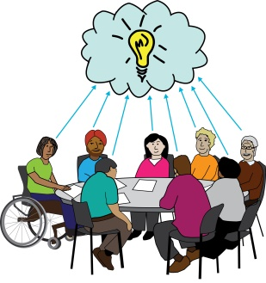  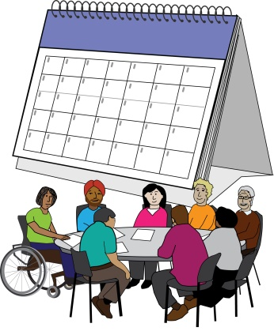 | Challenges:  - Coproduction is rewarding but can take a long time.  - Reaching agreement and understanding about social model language  - Not being able to meet up in person to film or have meetings.
Achievements:

- We worked well as a team and produced enough training materials and films to use for our pilot sessions in year 3

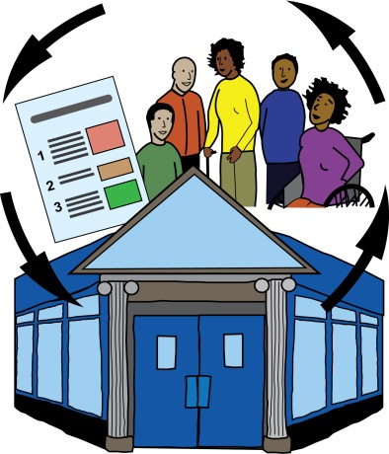  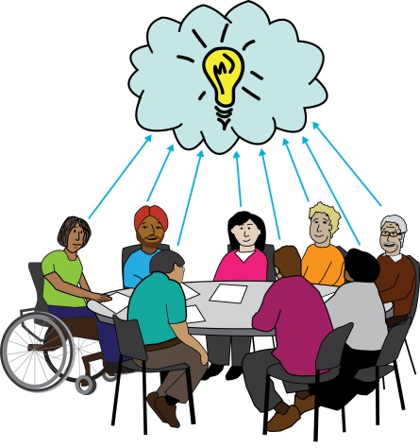  User Led | Learning:  - It is important to value everybody’s views and opinions and make sure everybody has the time and space to share them  - The development of the training materials and films were influenced and led by Deaf & Disabled People Organisations  - We were able to continue the work through the pandemic

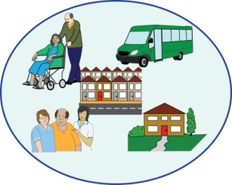
7. Services

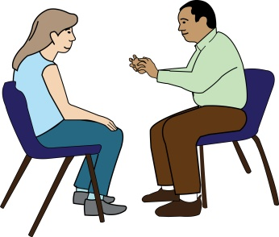  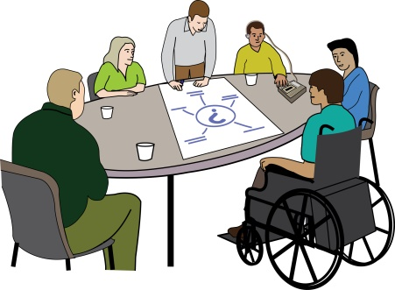  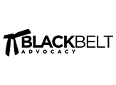 | Specialist Hate Crime Advocacy Services  Hate Crime Advocacy is difficult work but it is also very satisfying.  Because the work is often emotional and can take a long time, Hate Crime Advocates need more support than they sometimes get in Deaf and Disabled People Organisations.  Hate crime against Disabled people is rising in London so it was important to offer support to Hate Crime Advocate’s through this partnership. This included:  - One-to-one support  - Advocate Forums every 2 months  - Workshops  - Membership to Black Belt Advocacy
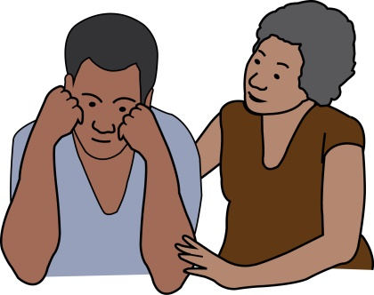 | Challenges:  - Staff changing or leaving  - Funding not available to keep staff  - Funding not available to fund Hate Crime Advocate’s for more than 14 hours a week
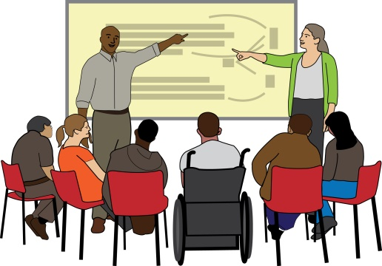 | Achievements:  - A lot of people attended the Emotional Resilience workshops for Deaf & Disabled People Organisations  - A lot of subjects were covered in the Emotional Resilience workshops  - The workshops helped people plan how to use what they learnt in their work

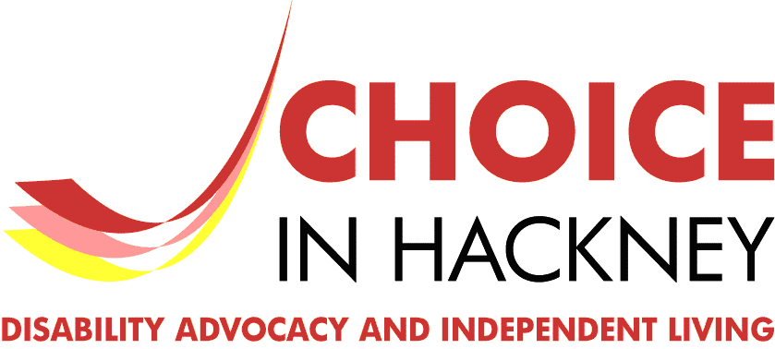 | Learning:  - A barrier to hate crime advocacy is that there is no recognised qualification  - Choice in Hackney is developing a hate crime module as part of their Advocacy Diploma course
Deaf & Disabled People Organisations Hate Crime Training

This training is available to all London Deaf & Disabled People Organisations; for their staff, volunteers and management commitment.

It is common for people to go to services to sort out the consequences of hate crime rather than a Disabled People Organisation.

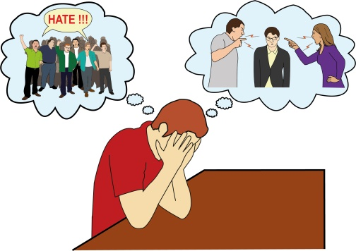 | What we did during 2019 to 2021  - In 2019 Ruth Bashall from Stay Safe delivered face-to-face training  - In 2020 Sarah Rennie ad Claire Barraclough from Roffey Park Institute trained two Disabled trainers to deliver online anti-hate crime training to Deaf & Disabled People Organisations  - We delivered sessions on these topics:  - Safeguarding  - Housing  - Cuckooing  - Intersectionality and hate crime  - Hidden Hate – how to recognise hate crime  - Transport and hate crime against Disabled people
Achievements

- Everybody who joined the training said they were very happy with it and they learnt more about hate crime.

- In 2020 all of the online courses were fully booked – each had 15 places

- Each course had a good mixture of people.

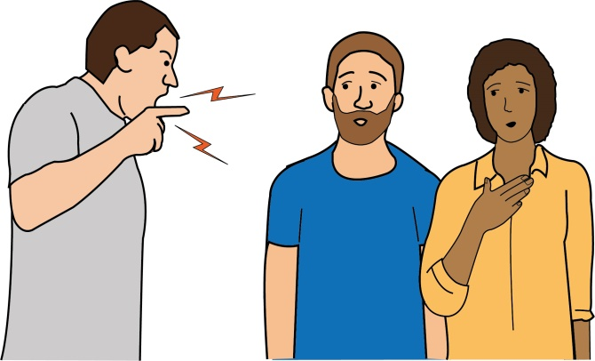  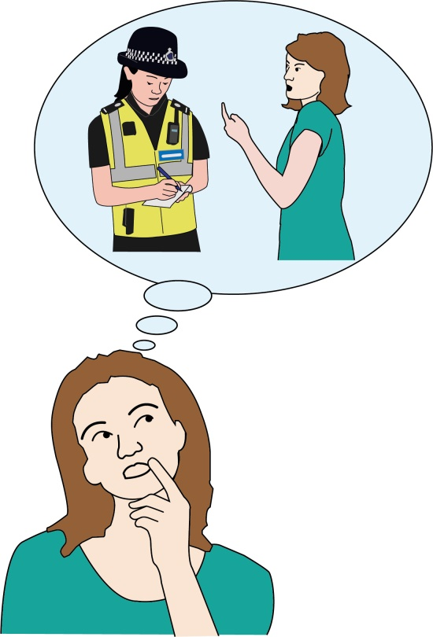 | Learning:  - A Disabled trainer who is a specialist in hate crime advocacy can provide real life examples during hate crime training  - Even staff members that do not work for a hate crime service can use what they have learnt in their organisation
Online anti hate crime resource

This resource is available to any London Deaf & Disabled People Organisation who is a member of the London Deaf & Disabled People Organisations Hate Crime Partnership.

Online Directory of Deaf & Disabled People Organisations doing Hate Crime work

Inclusion London are a membership organisation of Deaf & Disabled People Organisations across London. They are all listed on the online directory
DDPO directory - Inclusion London

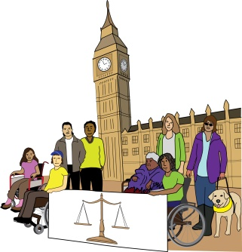
8. Strategic Campaigns, Comms & Policy

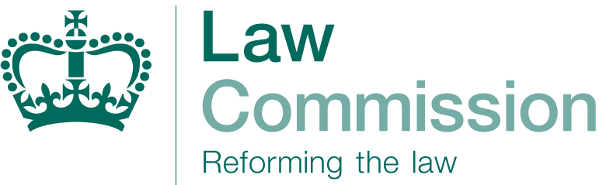 | Hate Crime Law Reform  The Law Commission have been asking the public about possible changes to Hate Crime Legislation.
The Law Commission: this is an independent body that aims to make sure the law is fair, simple and cost effective. They do this by conducting research and consultations in certain areas of law and to make recommendations to Parliament where improvements are needed.
We put on 2 consultation events with HEAR Network and the Law Commission on May 2019 and December 2020. Some of our messages were:

- We would welcome a new Hate Crime Act

- We want equality in hate crime legislation for all ‘protected characteristics’
 | - We gave suggestions for additional areas and use of certain language
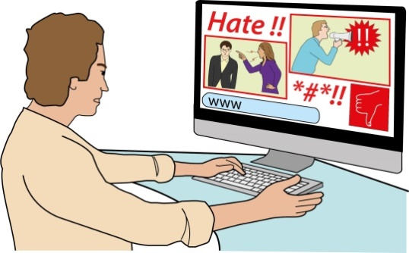 | - Online hate crime to be treated the same as offline hate crime and for social media companies to be held to account
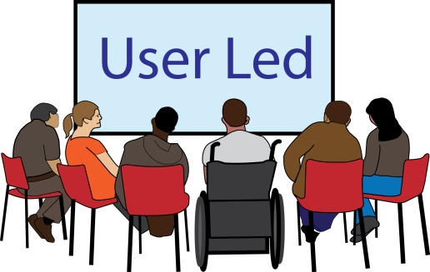 | - If a Hate Crime Commissioner’s office is formed then it should be led by and for people with lived experience
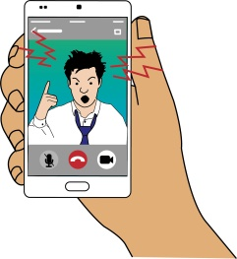 | Online Harms  We sent two responses to the consultation on the Government’s Online Harms White Paper.  The main headings for our recommendations were:  - Set up a regulator with responsibility for online safety and the power to enforce penalties  - Enforcement to include fines, stopping certain practices and bringing criminals to justice  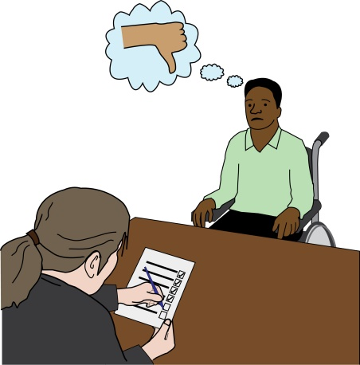  - Organisations funded to support people who make complaints  - Clear legal terms and definitions  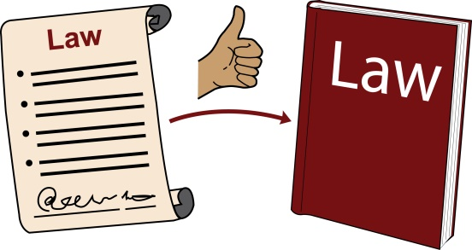  - Online harm to Deaf & Disabled people is fully includ ed in the legislation  - A Government social media campaign in partnership with Deaf & Disabled People Organisations  - Social media companies to fund hate crime service
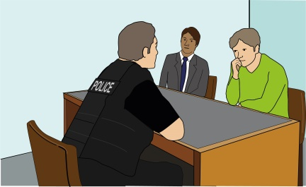  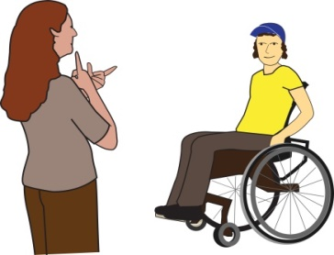 | Still Getting Away with Murder Report  Still-Getting-Away-with-Murder-Inclusion-London-Easy-Read.pdf (inclusionlondon.org.uk)  This report was published during National Hate Crime Awareness Week 10-17 October 2020.  It follows the 2008 report, ‘Getting Away with Murder’. Both reports are about hate crime and were produced by Disabled people.  It has 6 key findings.  - Disabled people are more likely to be victims of crime  - Disabled people are still seen as unreliable witnesses  - Use of a human rights approach increases understanding of Disabled people’s experience  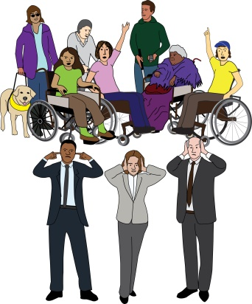  - Institutional Disablism creates more opportunity for hate crime to happen  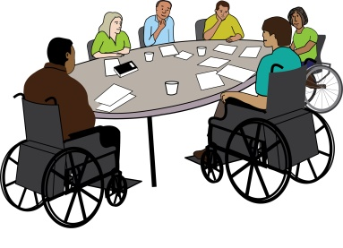  - More work is needed to increase understanding of disablism  - Co-production with Disabled people works
National Hate Crime Awareness Week

In 2019 and 2020, we produced a Campaign & Press Pack for Deaf & Disabled People Organisations across London to raise awareness of hate crime against Disabled People.

We used the hashtag #disabledpeopleloveworkplay

The message was
We all deserve to live in a fair society where we have opportunities to love work and play

In 2020 we worked with 10 other organisations on a Twitter campaign
#StandUpToHate

The 2020 National Hate Crime Awareness Week focused on Disability Hate Crime.

Although there were less events than planned because of the pandemic, we were able to have a smaller annual event at St Paul’s Cathedral.

We worked with the founder of National Hate Crime Awareness Week to produce a film of the event
Lighting the National Candle of Hope and Remembrance for Nation Hate Crime Awareness Week 2020 - YouTube

Candles were lit for all of the Disabled victims of hate crime who were murdered.

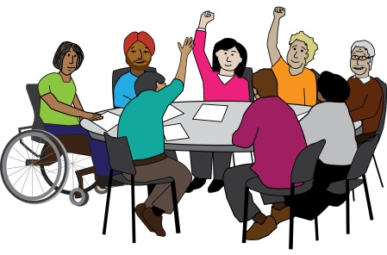
9. Representation

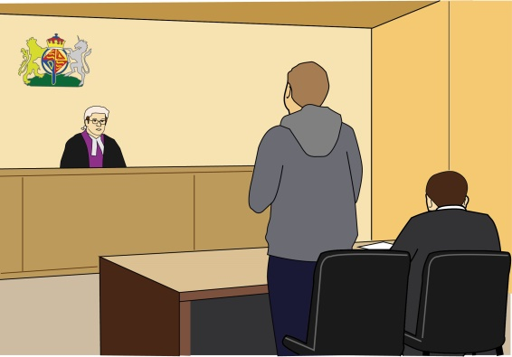  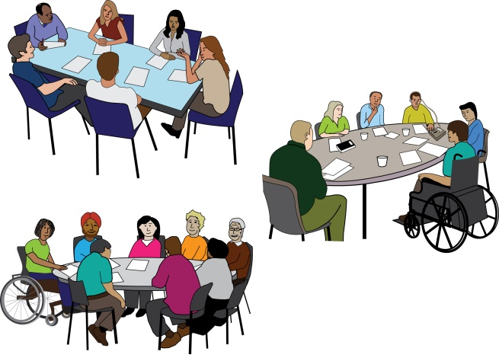  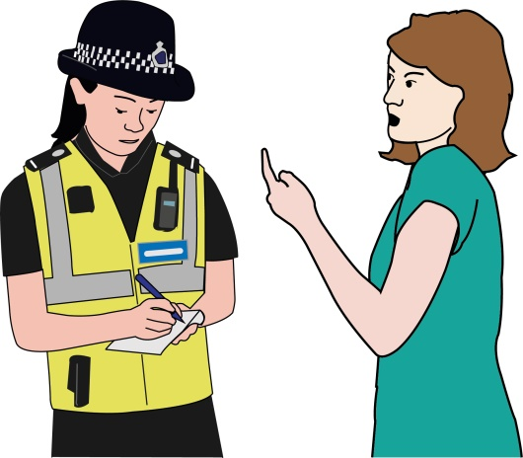 | Stakeholder meetings  Our aim is to make sure the views of Deaf and Disabled People Organisations and victims of hate crime are heard at the meetings.  The meetings are informed by our policy work, that includes:  - Crown Prosecution Service  - Home Office  - Equally Ours  - Metropolitan Police  - HEAR Network  We continually talk about how to improve training for police officers and what to include.  We work with the Crown Prosecution Service and the Police Force to improve the reporting of disability hate crime.
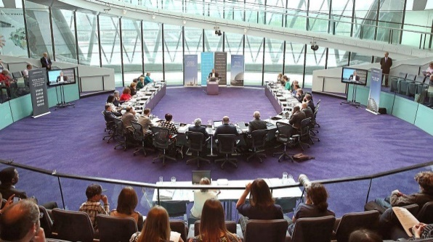 | London Assembly  Louise Holden and Henrietta Doyle from Inclusion London gave evidence to the London Assembly’s Police and Crime Committee.
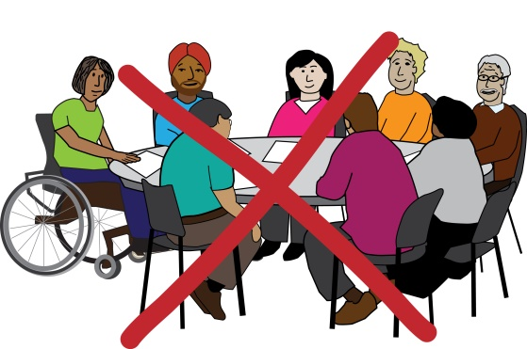  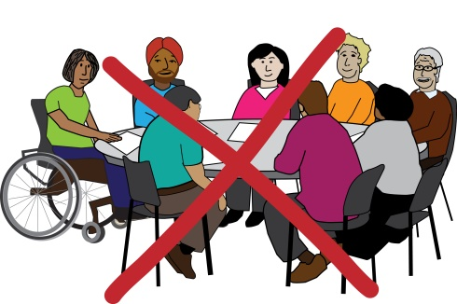 | Challenges:  In 2020 there were no meetings with the Mayor’s Office for Police and Crime and the Metropolitan Police stopped the Disability Hate Crime working group.  This was during the pandemic when hate crime against Disabled people was rising.  The HEAR Network’s funding for hate crime ended so the pan-equality network meetings stopped.  Equally Ours stopped their hate crime strategy group as part of a restructure.
10. Meetings and Events

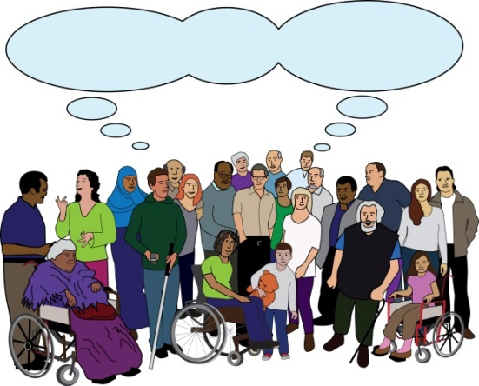 | Quarterly partnership meetings  During 2019 and 2020, we had 22 Deaf & Disabled People Organisations members.  Each meeting includes:  - Updates from members  - Sharing our learning  - Speakers  - Agreeing areas of work

11. What’s next?

Hate Crime Data & Insight Project

We received funding to set up the Hate Crime Data & Insight Project for two years.

We have a Hate Crime Data & Insight Officer at Inclusion London.

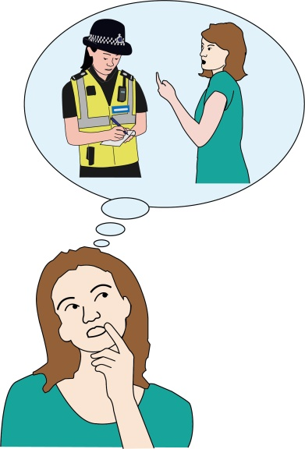
The Hate Crime Deaf & Disabled People Organisation Data Collection Project is looking at the reasons why the number of official reports to the Police do not match the amount of work Deaf & Disabled People Organisations do with victims.

We now have 24 members of the London Deaf & Disabled People Organisations Hate Crime Partnership.

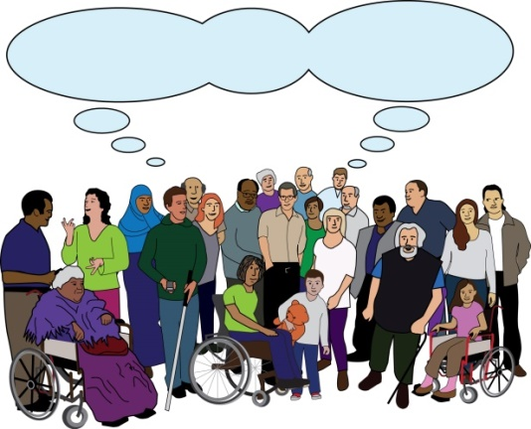
The partnership also represents disabled victims at:
- Victim’s Commissioner Community Reference Group

- Twitter Safety and Security Council

This is Part 1 of the report. For more information about an overview of the sector, the Social Model of Disability, what is hate crime?, why have this partnership of Deaf & Disabled People’s Organisation? and key highlights, please read Part 2 of this report.

If you are interested in getting involved please contact:

Louise Holden
Hate Crime Partnership Project Manager

louise.holden@inclusionlondon.org.uk

Find more information on the website
https://www.inclusionlondon.org.uk/training-and-support/partnership-working/disability-hate-crime-partnership/disability-hate-crime/

Produced by Inclusion London, October 2021
Easy Read provided by People First (Self Advocacy)

