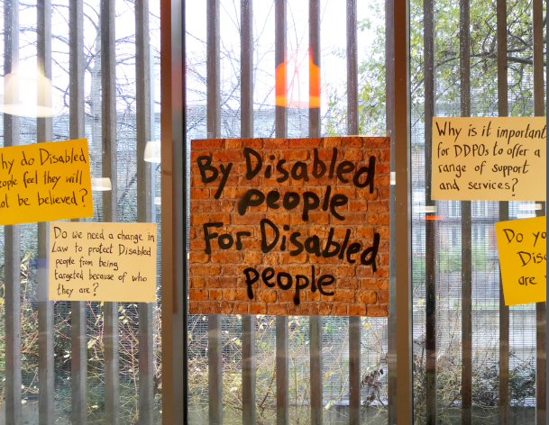

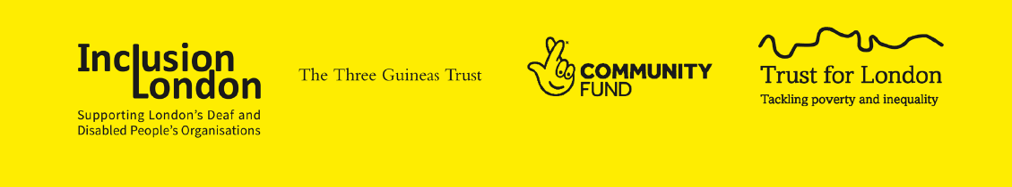

London Deaf & Disabled People’s
Hate Crime Partnership

Our work from April 2020 to March 2021
Part 1

Contents
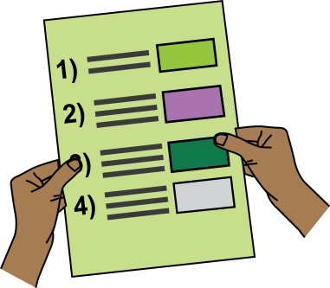
Contents list

Introduction | 3
- Overview of Sector and Social Model of Disability  - What is a Deaf & Disabled People’s Organisation?  - What makes a Deaf & Disabled People’s Organisation  - A note about language | 8
- Social Model of Disability | 10
- What is a hate crime? | 11
- Why have this partnership of Deaf & Disabled People’s Organisations | 13
- Key highlights | 17

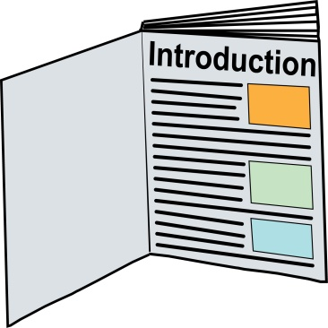
Introduction

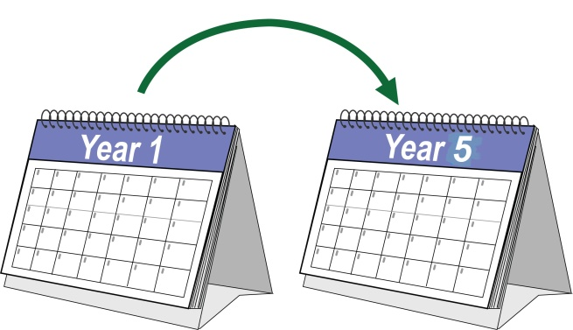  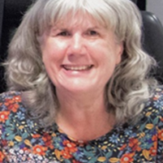  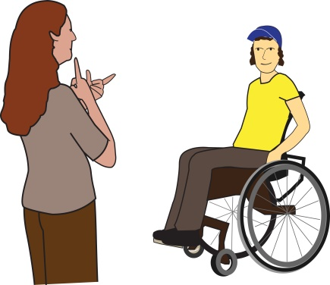  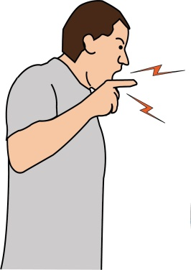  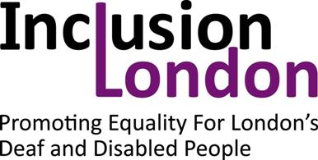 | This five-year Hate Crime Partnership was set up April 2018.  It was built on the campaign work of Anne Novis MBE at Inclusion London.  Inclusion London recognised that ‘the daily experience of many Disabled Londoners involved accepting abuse, harassment and feeling “less than” when going about their lives’.
 | Since it started we have worked on a lot of different hate crime projects to support Deaf and Disabled People’s Organisations (DDPOs) raise awareness of hate crime against Disabled people.
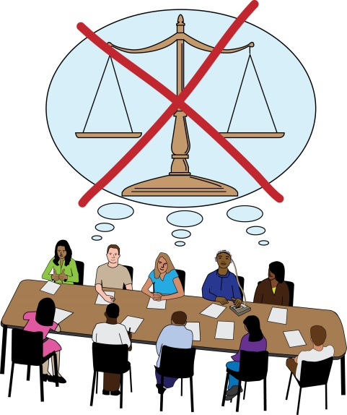 | Institutional Disablism is when there are discriminatory attitudes and behaviours throughout a whole organisation or system – this means they are treated differently, unequally and unfairly.
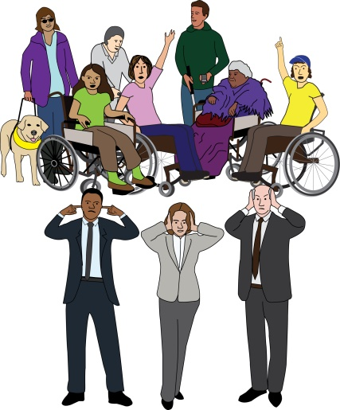  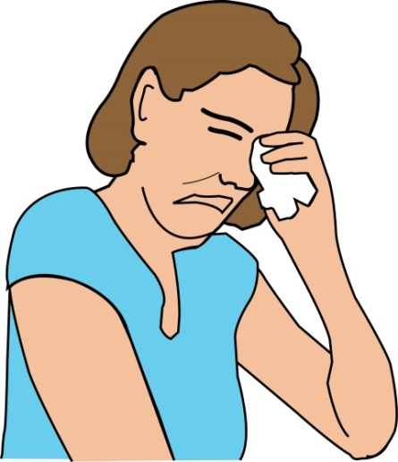 | If Disabled people are not treated equally in their everyday life (for example, relationships, employment, going out socially) then this will affect how they feel about themselves – they will not feel good about themselves.
 | It will also affect how non-Disabled people feel about and view Disabled people and how services and institutions are run. It can result in disablist attitudes.
Disablist attitudes: this is when non-Disabled people believe that disabled people are inferior - not as good as them.

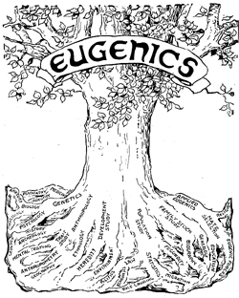 | There is strong evidence to show a link between the eugenics movement and the way the public thinks about Disabled people. It has led to negative views and acts of aggression, violence, and abuse.
Eugenics movement: this is also known as human genetic engineering. In the past it has been about trying to ‘breed out’ certain characteristics or conditions, including disabilities. Now it is understood to be more about changing or removing genes to prevent disease.
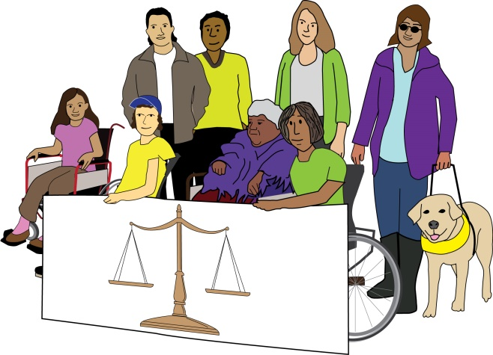 | We need to use a human-rights or justice-based approach to move towards real equality.  We know that people with lived experience are the best people to find solutions.
‘We are advocating that Deaf & Disabled People Organisations are best placed to provide the service, when supported themselves to do so, for Disabled victims of hate crime as they already have the holistic structures and services to enable someone to recognise, report and recover from hate crime.’
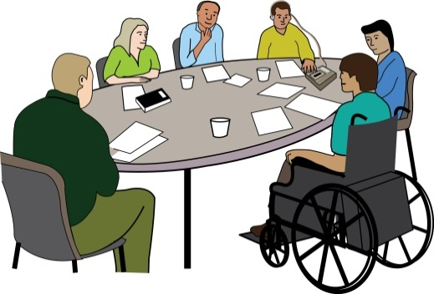 | This is the two-year report about the London Deaf & Disabled People’s Hate Crime Partnership. It is led by Inclusion London and is made up of 22 Deaf & Disabled People’s Organisations (DDPOs).
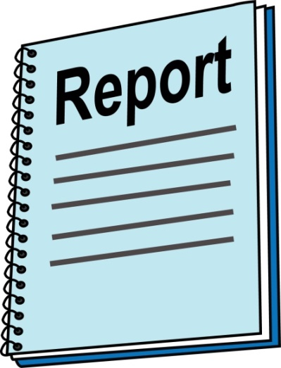 | The report will:  - Give you a description of each area of work  - Tell you what we did  - Tell you what we achieved  - Tell you what the challenges were  - Share what we learnt
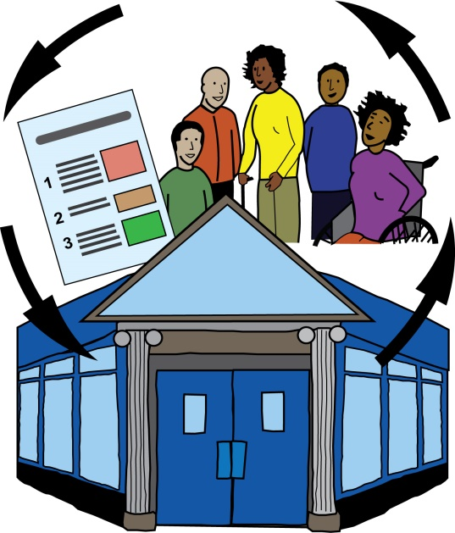  User-led | The most important area of learning is about the role of DDPOs within their communities. DDPOs:  - Challenge discrimination and prejudice  - Provide employment for Disabled People  - Provide leadership opportunities

‘The London Deaf & Disabled People’s Organisations Hate Crime Partnership is the only one of its kind in the UK. Inclusion London provides centralised management, strategic communications with campaigns and policy work and a range of capacity building projects and services, in partnership with Deaf and Disabled People’s Organisations who are experts in localised delivery.’
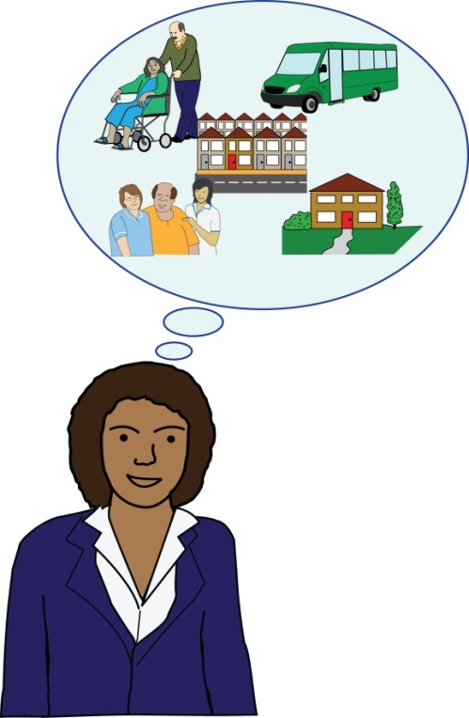  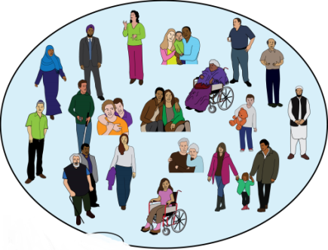 | Disabled people need local, accessible services run by Disabled people that they can trust. DDPOs not only provide services but they also create communities of Disabled people.  Many Disabled people are isolated and unaware of the Disability Rights Movement until they come across their local DDPO.
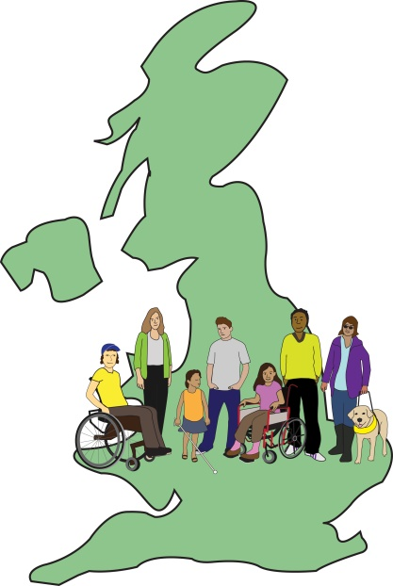 | We want the five-year project to show the benefits of supporting DDPOs to provide services.  We want the model to expand and cover other parts of the UK.
1. Overview of Sector and Social Model of Disability

What is a Deaf & Disabled People’s Organisation?

- It is led by and for Disabled people

- It developed out of the Disability Rights Movement

- Uses Disabled with a capital D – this is for political reasons, it relates to a group of people who face barriers in society due to an impairment or condition.

- We know that language changes over time and words take on different meanings.

- We use the word Disabled as a positive term linked to the Disability Rights Movement, ‘Nothing about us without us’.
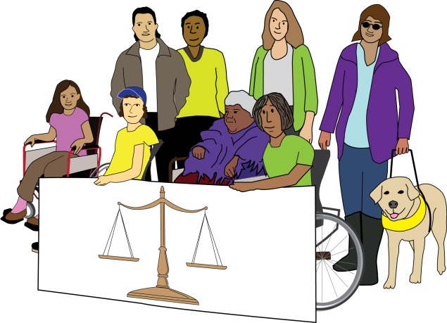
Nothing about us without us!

What makes a Deaf & Disabled People’s Organisation?

- 75% of the Trustees are Disabled people

- 50% of the Staff and Disabled people

- The term ‘Disabled’ covers:
  - Physical impairments
  - Sensory impairments
  - Learning Difficulties
  - Mental Health conditions / distress
  - Long term health conditions
  - Hidden impairments
  - Neuro diversity
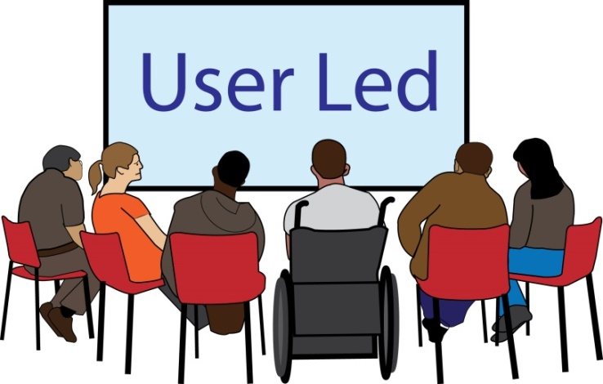

A note about language

Because everyone has different views and experiences language is constantly changing. Not everyone in the disabled population will relate to or agree with these definitions.

2. Social Model of Disability
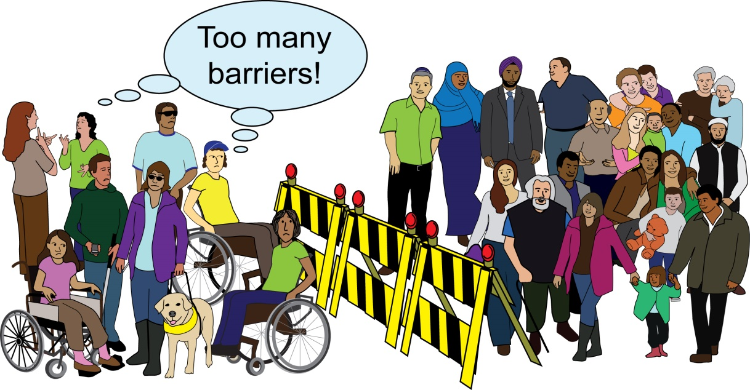

We work in line with the Social Model of Disability, which says that society is the problem not Disabled people. This is because society is not accessible and puts up barriers for Disabled people.

These barriers can be:

- The way things are organised or planned

- Where things take place

- How people think about disability - this could be thinking someone isn’t able to do something or can’t make a decision.

We can change and get rid of these barriers. The Social Model helps us look at things differently and stops us blaming the person for things they cannot do.

The Social Model recognises that impairment will always be part of society so everything we do should not be planned or organised in a way that leaves Disabled people out.
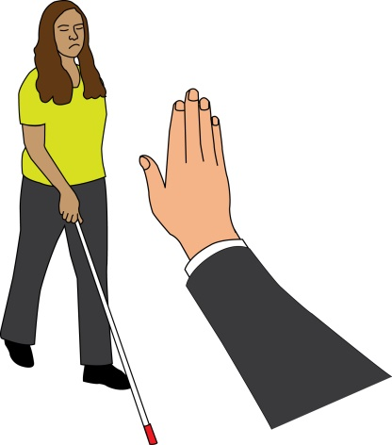
3. What is hate crime?
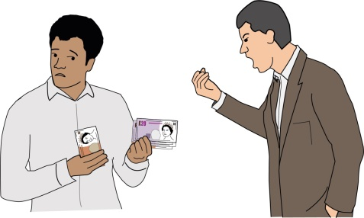

- Hate crime is an attack on who we are

- The abuser is telling us we are not wanted

- It affects the victim and the community around us because it is an attack on who we are

- Deaf & Disabled people can experience any form of hate crime

- Escalation from low level harassment into violence, resulting in physical injury and sometimes death

- Perpetrators are often close to the victim

- Disabled people with lived experience of hate crime report long term feelings of fear, distress and isolation

- Other types of hate crime are race, religion, sexual orientation, or transgender identity

- Crown Prosecution Service definition – any incident / crime which is perceived by the victim or any other person, to be motivated by hostility or prejudice based on a person’s disability or perceived disability.

Hate crime: is any incident or crime that the victim (or any other person) believes is happening because the victim has a disability.
- Police and other services do not fully understand the extent of the daily abuse experienced online and in person by Disabled people

- Hate crime against Disabled people is often misreported as Anti-Social Behaviour or Safeguarding issues, or not recorded as victim is not believed

There is a problem with language used by statutory services. The word “vulnerable” is often used when recording Disability Hate Crime. We do not want to be seen as “vulnerable”. A crime or incident may cause someone to be in a “vulnerable situation”.

Language used by statutory organisations and services needs to change to reflect this.
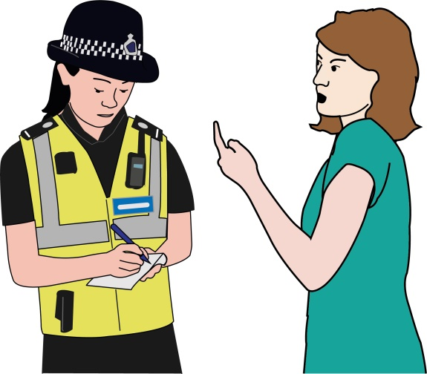  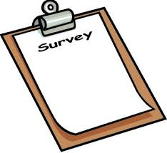 | Disabled people are not happy with how they are treated by the Metropolitan Police. According to the Victim Satisfaction Survey their level of satisfaction is a lot less than Black and minority ethnic communities. Even so, there is no work being done to make this better.
Am I being targeted due to my disability

Reporting Disability Hate Crime
4. Why have this partnership of Deaf & Disabled People Organisations?
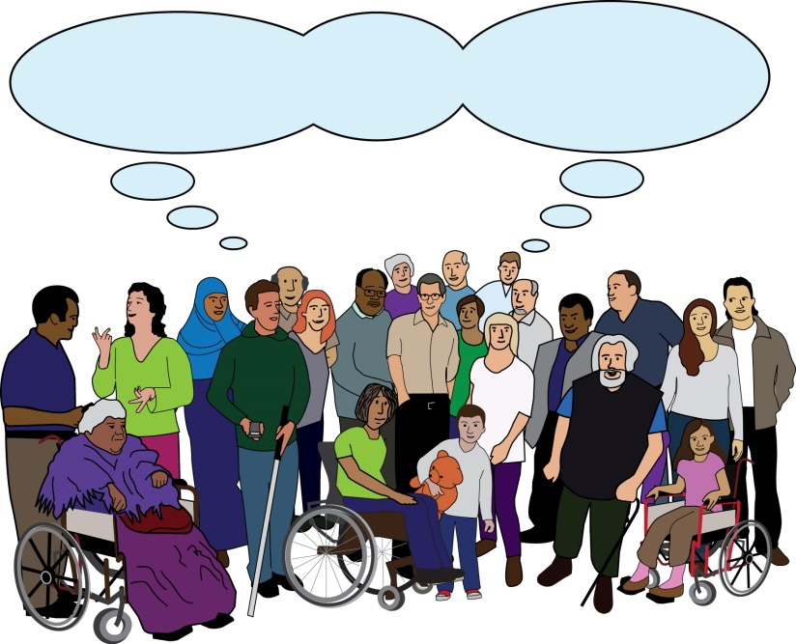
Hate Crime Partnership

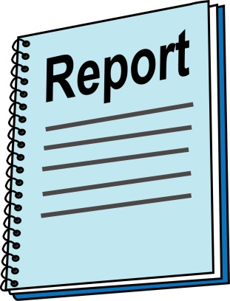  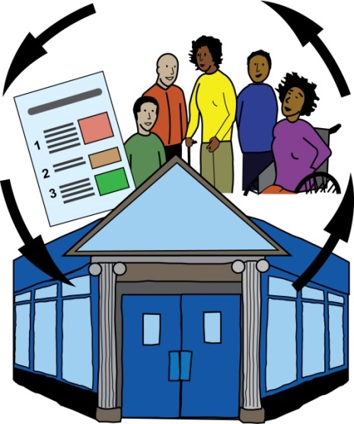  User-led | Inclusion London and Disability Wales recently published a report called ‘Understanding the needs of Deaf & Disabled People Organisations’.  It says how important DDPOs are because they support Disabled people access services and support, challenge discrimination and exclusion, and create a more inclusive and accessible world
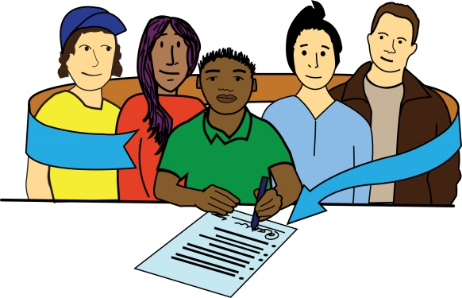  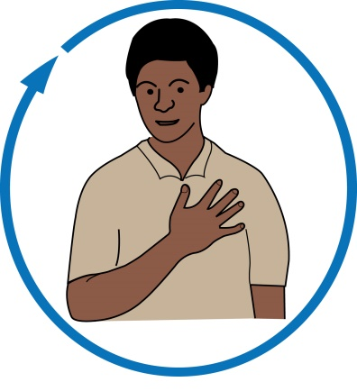  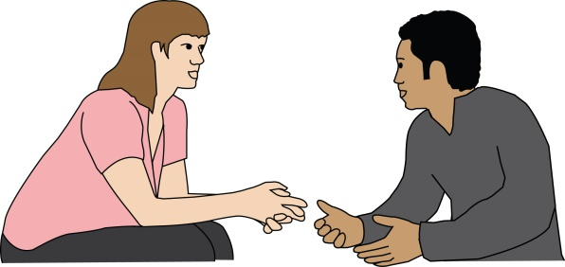  User-led | DPOs have extra value because of the following things:  - Expertise of lived experience: they understand the issues and what people need  - Peer support: Disabled people supporting each other  - Accessible: really good quality support for people who can’t access mainstream services  - Holistic: they meet the needs of the whole person  - Local knowledge, authentic voice & community asset: they are set up and run by Disabled people and have a better understanding of the local issues, barriers and opportunities.

 | Although hate crime against Disabled people is very common, it is not a priority for a lot of Deaf & Disabled People Organisations.
 | One reason for this is because of COVID19. When people replied to our survey they said that getting food, accessing health care, and funding for existing services took priority.
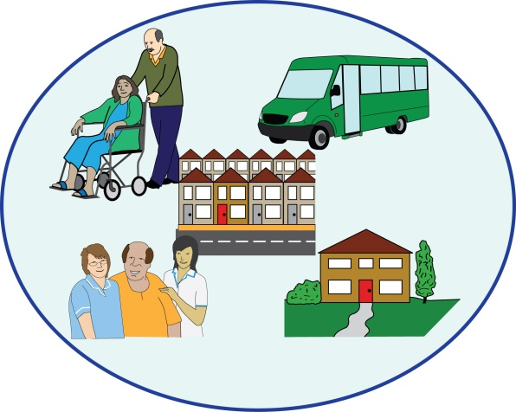 | Another reason may be because it is a hidden problem and Deaf & Disabled People Organisations feel they have more important issues to deal with.
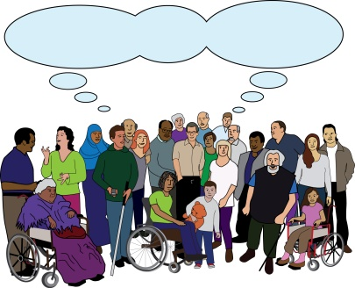  Stop Hate Crime | This partnership is raising awareness of the importance of hate crime with Deaf & Disabled People Organisations.
Hate crime and Disabled people
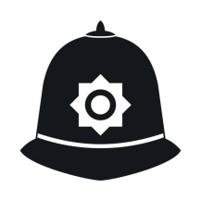  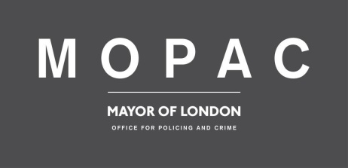  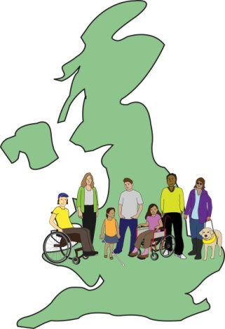  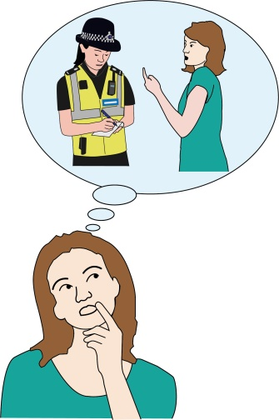 | - Disabled people are more likely to experience hate crime than non-disabled people  - A lot of hate crime against Disabled people goes unreported  - It is not easy to report hate crime and the processes are not made accessible  - Victims are not treated with respect or taken seriously, and reasonable adjustments are not made  - There has never been a London-wide or UK-wide specialist violence/hate crime support service for Disabled people, although there is for other communities
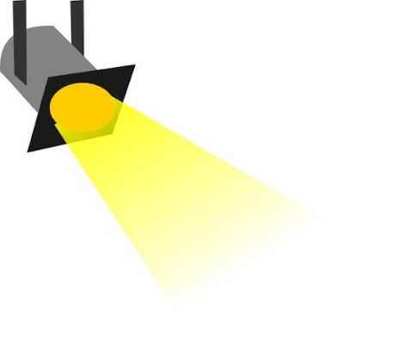
5. Key Highlights

 | Still getting away with murder: Inclusion London published a report in 2020 by Dr Laura Chapman. It tells us what has been happening over the last 10 years from a human rights, Social Model of Disability and Cultural Model of Deafness point of view.
Cultural model of Deafness and/or ‘Deaf Cultural Model’ is used to explain the position of the UK British Sign Language (BSL) community. It focuses on the shared experiences, histories and the role that sign language has within the Deaf community.
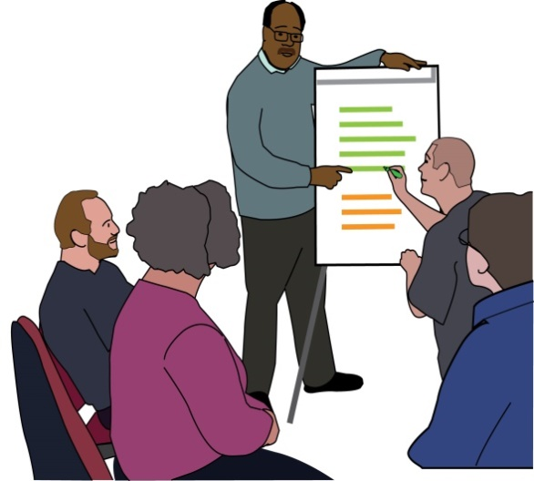 | Hate Crime Training for Deaf & Disabled People Organisations: We provided training for around 50 staff and volunteers at Deaf & Disabled People Organisations on the six topics chosen by the Hate Crime Partnership. Everyone said that they had a better understanding of hate crime.
 | Hate Crime Secondments: We provided 4 secondments to Deaf & Disabled People Organisations across London that did not have a hate crime service. Organisations told us that this improved their understanding of hate crime and how to spot it.
Secondment: This is when a member of staff from one organisation goes to work at another organisation for a short period of time to share skills and experience.
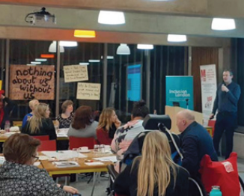  Excellent thought-provoking event…  An amazing event… | Big Learning Event: 78 people attended our Big Learning Event in 2019. There was a good mixture of Disabled people, Deaf & Disabled People Organisations, people who work in services and funders. We had speakers talking about recent research, a workshop on challenging the media, role play, poetry, performances, and updates on the work.  We had really good feedback about the event.
Hate Crime Evidence  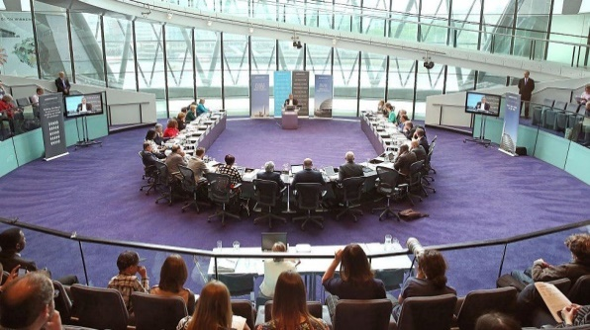 | Representation: We gave information and facts about hate crime to the London Assembly Police & Crime committee. We also spoke about how the public’s view of Disabled people can be negatively affected by what politician's say.  The London Assembly invited us to a meeting to find out more. This did not happen because of the London Mayoral Elections and the pandemic. We plan to meet in 2022.
The London Assembly: This acts as the eyes and ears of Londoners. The 25 members hold the Mayor to account by making sure all strategies, decisions, and actions are in the public interest.
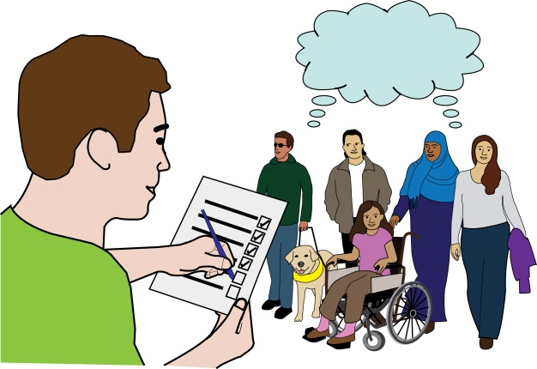 | Consultation responses: We asked people questions about cuckooing, online harms, hate crime law reform, 3rd Party Reporting and Disability Hate Crime Matters and Victim’s Code.
Cuckooing: is a term used by the police to describe when criminals befriend people and then take over their home and use it as a base to carry out crimes, like drug dealing or abusing person whose home it is.
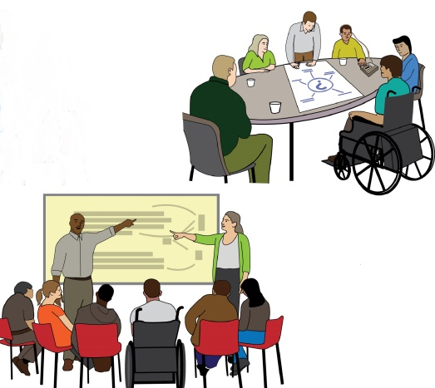 | We held 2 consultation events with the HEAR Network’s Pan-Equality London Forum and the Law Commission. We spoke about the Hate Crime Law Reform consultation.  After the consultations we came up with a list of ‘asks’. These are the things that we agreed were needed. They included:
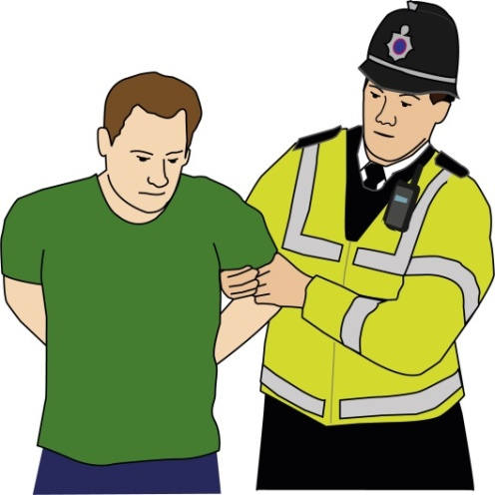 | - Statutory services and Deaf & Disabled People Organisations must work together around safeguarding adults, anti-social behaviour and housing to recognise cuckooing as a hate crime.
Statutory services: These are services that are paid for and provided by the government, such as the National Health Service (NHS), schools, nursing, social services, and education.
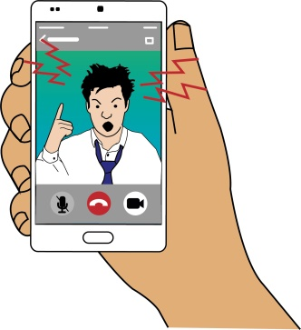  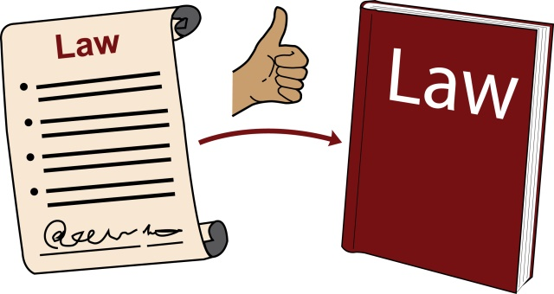 | - Online harm to be treated the same as harm caused in-person  - All hate crime should be treated equally in law  - A new Hate Crime Law that covers all types of hate crime, including intersectional hate crime
Intersectional: This is when people have more than one identity or protected characteristic so will experience more than type of oppression and discrimination.
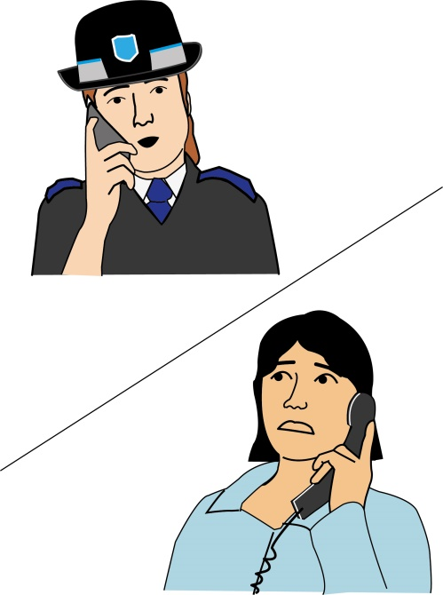  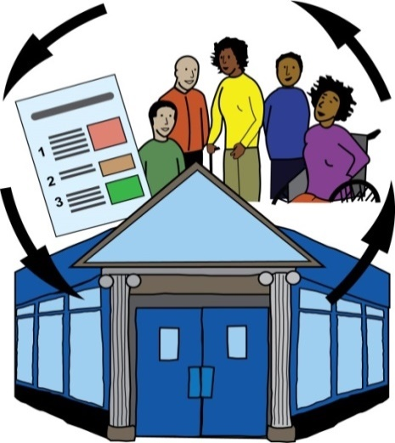  User-led | - 3rd party reporting centres to be funded and based in organisations led by people with lived experience  - Disability Hate Crime Matters awareness raising campaign to be brought back by the Metropolitan Police  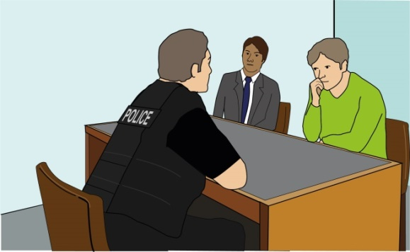  - All Disabled victims to have access to additional support under ‘special measures’ whatever the crime  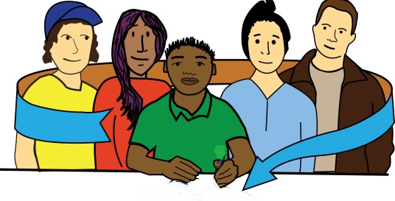  - Any services for Disabled victims should have people with lived experience at the heart of all decisions, policy making and delivery.

Inclusion London sent evidence on Disability Hate Crime to the London Assembly Police and Crime Committee

Inclusion London's evidence on Hate Crime to London Assembly - Inclusion London

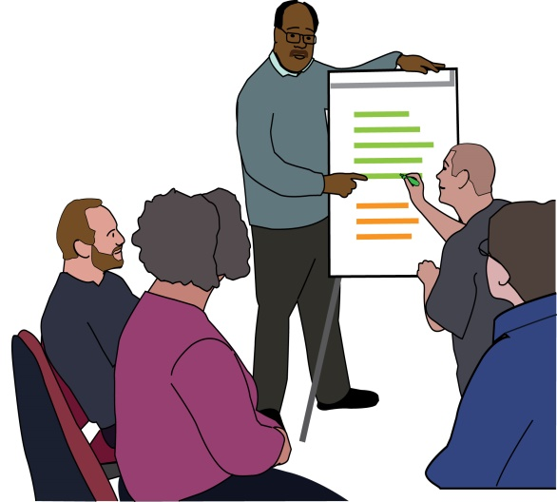 | Development of training materials for public service frontline staff: We started developing training for staff working in housing, transport, Deaf organisations, and schools. This training is being developed with a group of Deaf and Disabled using a co-production model.  The work was delayed because of the pandemic but it will be made available to any Deaf and Disabled People’s Organisation in London.
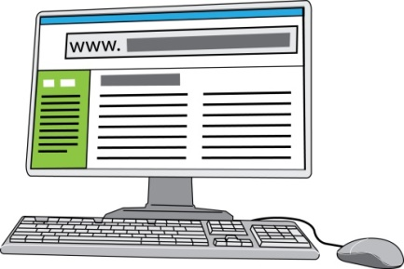  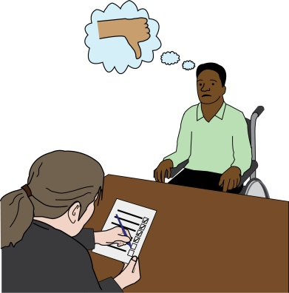 | Deaf & Disabled People Organisations Hate Crime online resources: We updated the Hate Crime Advocacy Toolkit, which is available to any staff working for Deaf and Disabled People Organisations who are working on hate crime and advocates who have hate crime casework.
Toolkit-for-DDPOs-supporting-victims-survivors-of-Hate-Crime-Dec-2019.pdf (inclusionlondon.org.uk)
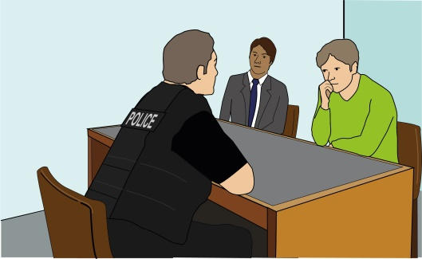 | Overall learning:  - Most Deaf & Disabled People Organisations do not treat hate crime as a main priority area of work  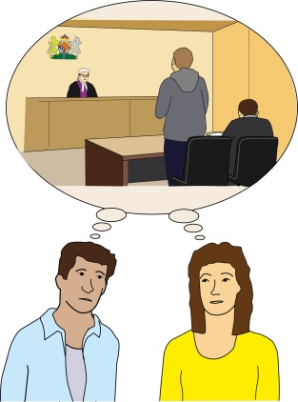  - Most Disabled victims of hate crime use lots of different services from Deaf & Disabled People Organisations to help them with the after effects of hate crime. They also need support from staff to recognise that what they are experiencing is a crime.  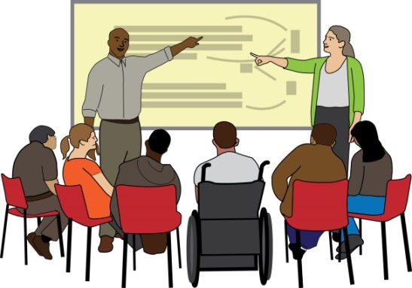  - If Deaf & Disabled People Organisations are trained and skilled in recognising and dealing with hate crime they can support more victims of hate crime.  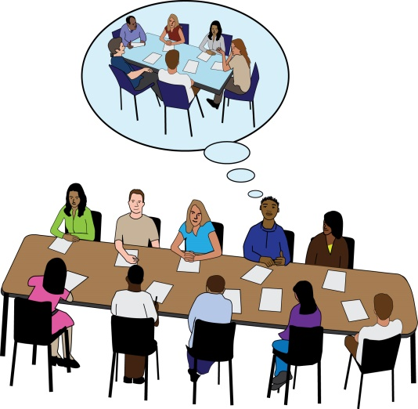  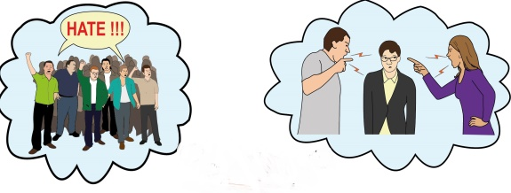  - We need to talk about Disability hate crime and the victims’ experiences at policy and planning meetings and talk to makes sure it stays on the agenda. This will increase support and improve things for victims of Disability hate crime.  - We do not have enough facts and figures or understanding about the experiences of Disabled victims of hate crime across London.
This is Part 1 of the report. For more information about our projects, services, strategic campaigns, comms and policy, representation, meetings and events, and what’s next? please read Part 2 of this report.

If you are interested in getting involved please contact:
Louise Holden Hate Crime Partnership Project Manager
louise.holden@inclusionlondon.org.uk

Find more information on the website
https://www.inclusionlondon.org.uk/training-and-support/partnership-working/disability-hate-crime-partnership/disability-hate-crime/

Produced by Inclusion London, October 2021
Easy Read provided by People First (Self Advocacy)

