Have your say in the latest England civil society Shadow Report

Shadow report: A shadow report is an opportunity for Deaf and Disabled People’s Organisations to write about the issues that have not been properly addressed in government reports, under the Convention of the Rights of Disabled People (CRPD). It brings together different information about what has happened in the UK since the last report. This is also sometimes called a parallel report.
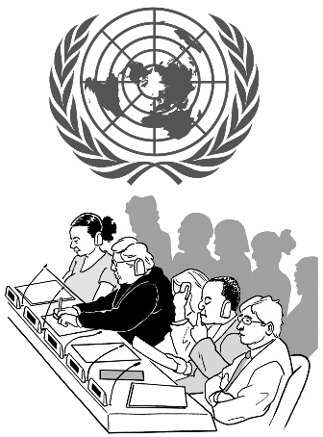 | Every four years, the United Kingdom (UK) has to report to the United Nations (UN) and be reviewed on what it has achieved. This is usually called an examination. A committee of independent experts, the UN Committee on the Rights of Persons with Disabilities (the Committee) does this examination.
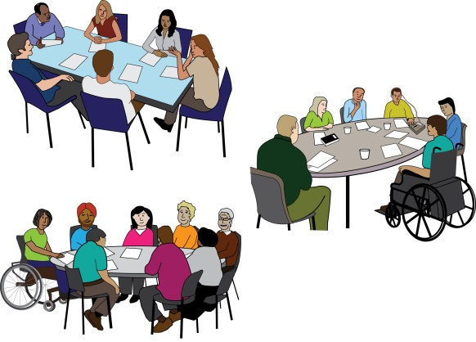 | A new project to produce a UK shadow report has just started.  A range of activities are taking place across the country so that Deaf and Disabled people can have their say in the report.
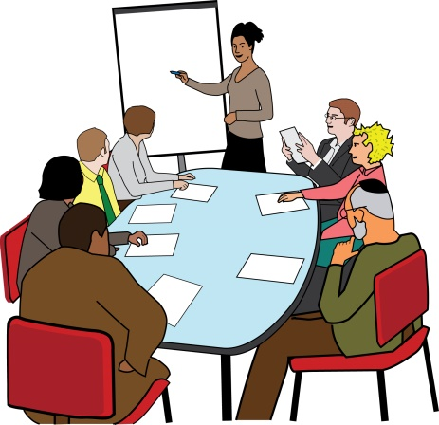  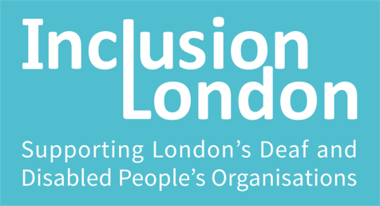  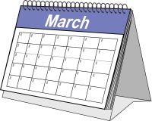  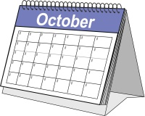 | These activities will take place from October 2021 until March 2022.  The work is being led by Inclusion London. They are working closely with other Deaf and Disabled people’s Organisations (DDPOs) in other regions. These are:  - Reclaiming Our Futures Alliance  - The Disabled People’s Organisation (DPO) Forum  - Disability Rights UK  - Our Voices  - Disabled People Against Cuts (DPAC)
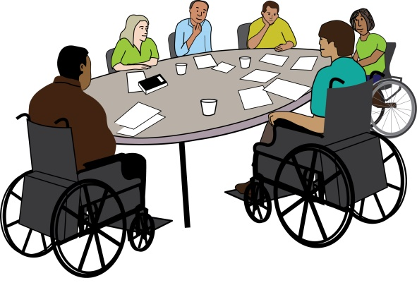 | York University’s Centre for Applied Human Rights and the London School of Economics will also be represented on the Steering Group overseeing the work.
Steering Group: The steering group is made up of people who are directing the work. They also make sure that all opinions are heard and decisions that are made are fair.
Calendar of events:
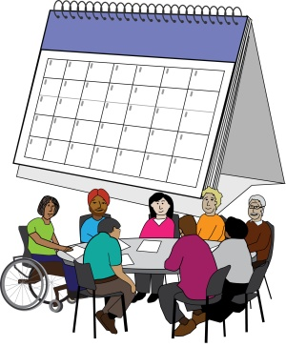
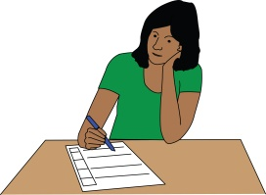
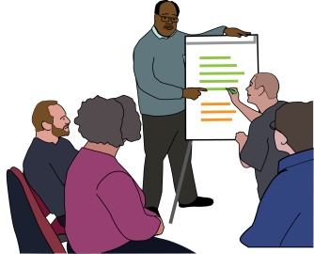
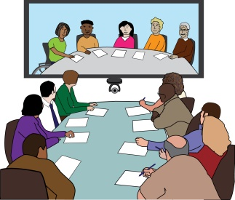

Wednesday 20th October 2021 |  | Launch event: a call for evidence to help shape the shadow report.
Wednesday 20th October - Monday 22nd November 2021 |  | Events to help people understand the shadow report process and to discuss the main issues that could be included in the report.
Monday 22nd November 2021 |  | Launch of the online survey to help find out more about the most important issues.
Friday 14th January 2022 |  | The first draft of the shadow report to be completed.
Friday 11th February 2022 |  | The final draft of the shadow report is shared publicly shared for sign up by DDPOs, allies and individuals.
March 2022 |  | Formal launch and promotion of the shadow report.
How You Can Get Involved

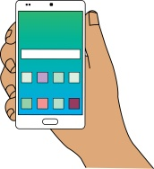
Stay in touch. Sign up on the Inclusion London website for shadow report alerts here.

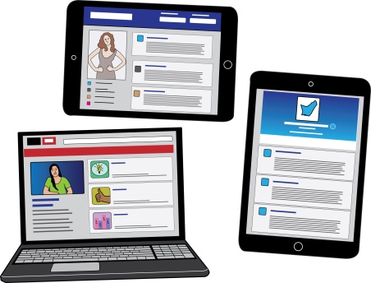
Watch and share our launch event. The event will be streamed live across social media platforms including YouTube, Facebook and Twitter.

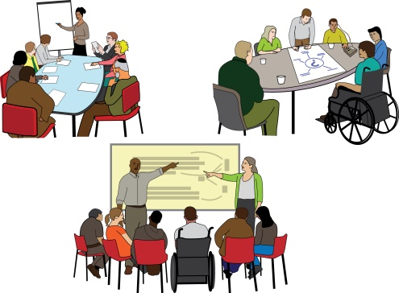
Sign up to join one of the DDPO events. You can take part in discussions to feed into the shadow report. Here is the link for a full list of planned events.

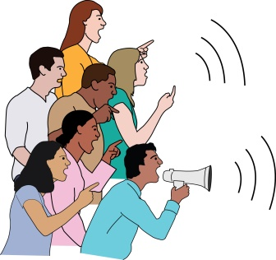
Tell us about the issues you think should be included in the report. There is more information about how to do this here.

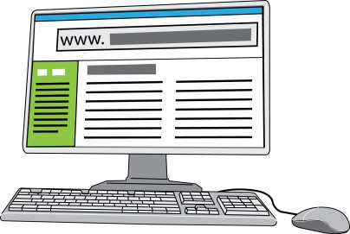
Later in the project we will have an accessible online survey for you to take part in.

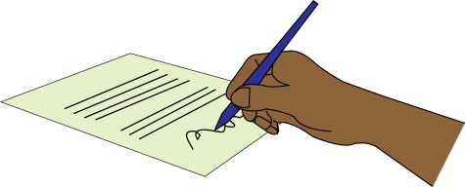
Add your name and the name of your organisation in support of the final shadow report.

Watch and share the final report launch.

This will be sometime in March.
