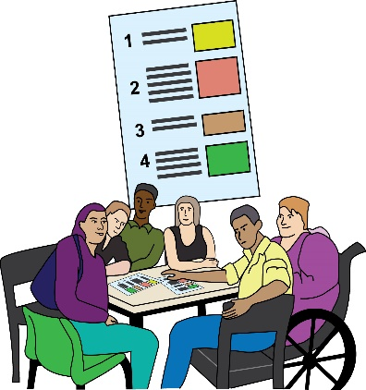
Hammersmith and Fulham
Disability Forum Planning Group (DFPG)

Invitation
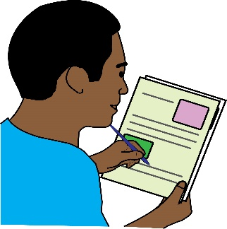
This is an invitation to Disabled people living, studying, working or volunteering in the borough to apply to join the Hammersmith & Fulham Disability Forum Planning Group (DFPG)

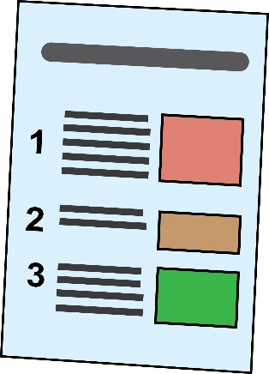
The group provides advice to Hammersmith & Fulham Council on making sure that planning applications create new buildings are accessible and inclusive that work for everyone. The group will use a Social Model of Disability and a human rights way of working in all its work.
Planning Applications: people must apply to the council for planning permission before they can build new buildings

Social Model of Disability: this is when Disabled people are seen as people with impairments who are ‘disabled’ by the barriers in society. These barriers discriminate against Disabled people and push us out of society. It is the way society is run and organised that is the problem, not the Disabled person.
Human Rights way - UN Convention on the Rights of Persons with Disabilities: this is an international agreement that the government signed up to, to bring about the full rights of Disabled people in the UK.

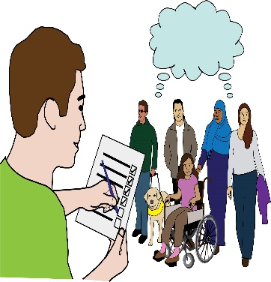
Background

Disability Forum Planning Group aim To help H&F achieve its ambition to be the most accessible borough in England, using inclusive design principles.

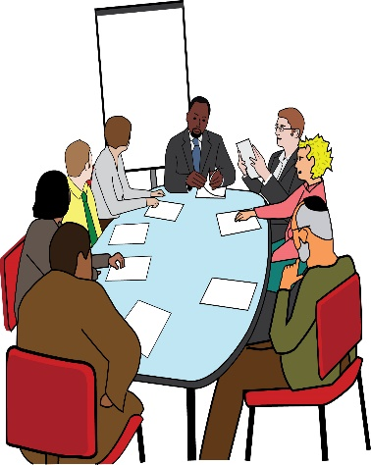
Structure of the group: this means who will be on the group

- Minimum of 5 Disabled people

There will be people from the planning department and other people as and when needed.

Frequency: this means how often the group will meet:

The group meets virtually at least 12 times each year for an up to 3 hour meeting usually during office hours. Otherwise we communicate with each other by email. There may be other meetings as and when needed.

Contract and payment
This is a paid role. Each member will be paid £20 an hour for each meeting that they go to and £20 for each hour of any extra work that is agreed. There will be a contract, which will be an agreement to work for at least 12 months.
Contract: this means a signed agreement to work together.
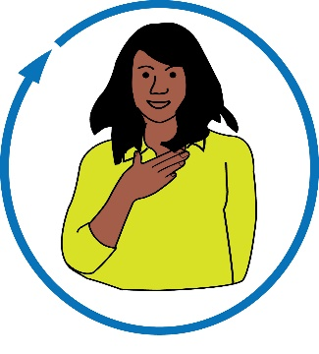
Who are we looking for?

Self-identified Disabled people who live, study, work or volunteer in Hammersmith & Fulham.
Self-identified: this is when someone sees themselves as a Disabled person

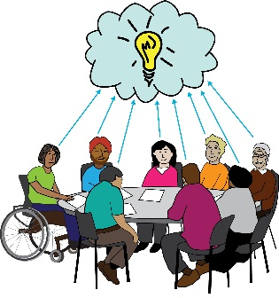
We are looking for Disabled people who:
- are familiar with the social model of disability and different impairments.
- can use knowledge and experience to promote inclusive design in the borough.
Impairment: there are different types of impairments, some affect the way that a person can move and get around. Others affect how a person can see or hear. Impairments can also affect the way that a person speaks, makes decisions, or remembers things.

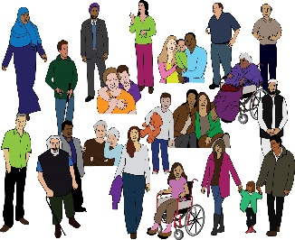
Skills and experience

You do not need to be qualified in the planning or inclusive design professions to join the DFPG. We can provide training in current building regulations and planning issues in the borough.

To apply we would like you to tell us about what you think you can bring to the group by giving information about your experience and/or skills of:
- Life as a Disabled person in using buildings and public open space.

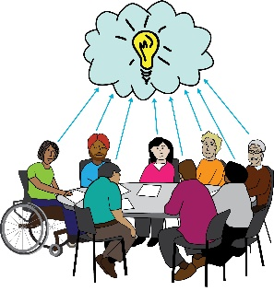
- Ability to assess architectural plans, and so be comfortable with drawings and illustrations. It would be a big plus if you have a background in this type of work.

- Understand how people move through a building or a public space. If you have a background in this work, we would be very interested in hearing from you.

- Apply legislation, such as the Equality Act 2010, to a variety of real-life circumstances.

- Have easy access to the internet. Lots of our communication and documents are online.

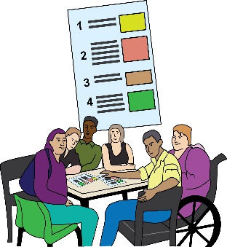
- Being able to use your skills to help the group give good advice on planning applications.

- Co-production (working together) to bring about change.

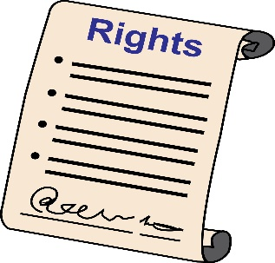
- Work on committees or steering groups that make sure change is put into place.

- Understanding of the Social Model of Disability, equality, diversity, and human rights.

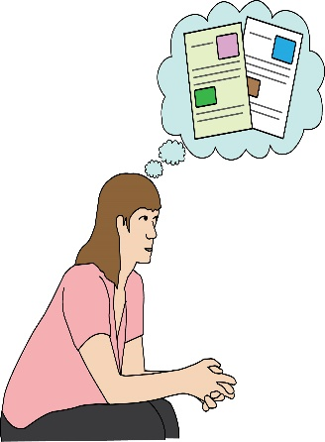
Selection process: this means how we decide who gets the role:

We will choose Hammersmith & Fulham
Disability Forum Planning Group members using the information they give about their experience and skills, and how strong that information is. We will make sure that the group can include the diversity of Disabled residents in the borough in its work.

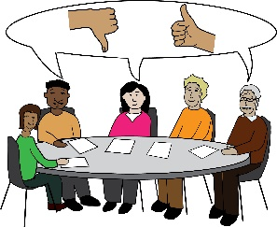
Applications will be looked at by a group including Disabled people and a councillor.

What to do if you are interested in this role:
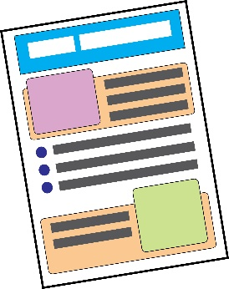
Please send us two sides of A4 paper setting out how you meet the skills and experience points in this document.

Let us know if you want to apply for the role in a different way or in a different format.

You can email your application to
coproduction@lbhf.gov.uk
The closing date is 12 noon on Thursday 30 September 2021.

If you have any questions, please contact Kevin Caulfield by calling or texting: 0777 667 2367 or email: coproduction@lbhf.gov.uk
Interviews: in early October 2021
Background and further information
What the DFPG do

The Hammersmith & Fulham Disability Forum Planning Group have provided advice to the council on individual planning applications for more than 10 years.

- The group is looking for Disabled people who live, study, work and volunteer in the borough to work with Jane Wilmot (Chair) of the Disability Forum Planning Group. DFPG has led on access and inclusion to remove barriers for disabled people in new developments.

We look at planning applications for:

- major developments with 10 or more housing units
- major office developments
- public buildings e.g. schools and colleges, hospitals, GP surgeries, theatres, community centres and sports facilities
- public open space e.g. around housing developments, public buildings, offices, hotels
- changes to shop fronts.

Things we think about when advising on planning applications:

- pedestrian routes across developments
- public open space inside developments
- kerbs and tactile paving at pedestrian crossings
- drop-off points for taxis or visitors
- parking for Blue Badge holders inside development
- shared surfaces (where vehicles and pedestrians share the same space)
- step free access to main entrances etc
- space inside buildings and common areas
- space for wheelchair users
- accessible toilets.

New housing developments with 10 or more housing units
We check statements and drawings for:
- 10 % new wheelchair accessible or wheelchair adaptable housing
- 90% accessible and inclusive housing
Hotels
We check statements and drawings for:
- wheelchair accessibility of the hotel and a sample of bedrooms
- step free access to hotel facilities.

Obstructions on the footway (pavement):
Our main concern is pedestrians being able to use pavements safely. We consider obstructions and street clutter such as tables and chairs and advertising boards outside shops, restaurants, pubs and cafes.

Parking for Blue Badge holders:
We check drawings and statements for:
  - the number and % of Blue Badge parking bays
  - layout and position of Blue Badge parking bays
  - parking management plan to reduce abuse by non-disabled people.

Sport facilities or stadiums
We check statements and drawings for:
- wheelchair accessible seating
- easy access and family friendly seating
- accessible toilets.

What the DF does not think about:
- the height or size of buildings
- housing mix
- coverings for outside walls.
- general highway (streets and pavement) issues

This is because many other people already do this.

