Disabled People’s Challenge to the next Mayor of London

The combined asks of Transport for All, Inclusion London and the Alliance for Inclusive Education

1

London Mayoral Elections 2021
What Disabled Londoners need from the next Mayor and the Greater London Authority

2

Inclusion London 336 Brixton Road London SW9 7AA
www.inclusionlondon.org.uk
020 7237 3181
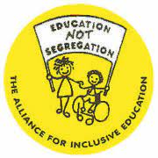
Alliance for Inclusive Education
336 Brixton Road
London SW97AA
https://www.allfie.org.uk

Contents

4 Introduction
The Manifesto:
7 Equality and Inclusion
14 Inclusive Learning for All
17 Accessible Transport

Introduction

There are 1.2 million Disabled people in London1, making up over 14% of the population, yet we remain one of the most marginalised and excluded groups in society2.
By the term Disabled people we mean people from all impairment groups, including Deaf people, people with learning difficulties, people who experience mental distress, people who are neurodiverse, people with a physical impairment, people with a visual impairment and people with long term health conditions and hidden impairments.
Too often politicians and policy-makers overlook our needs and the issues that matter most to us. The Covid 19 pandemic and the response to it is the most striking recent example of this.
In the current climate when we begin to emerge from the global pandemic, and when for the first time in the history of social policy, things are getting worse for Disabled people3, it is more important than ever that our voices are heard.
Disabled Londoners experience inequality in every area of our lives such as in housing, education and transport. 1 in 3 families in London with a Disabled adult live in poverty. The Covid 19 pandemic exacerbated inequality for Deaf and Disabled people and left many of us abandoned, forgotten and ignored.
While the overall employment in London is 85%, the employment rate for Disabled people in London is 46.5%4 and Disabled people who work are more likely to be low paid5. The number of pupils with Statements or Education, Health and Care Plans (EHCPs) has risen by 22% since 2010 across London, yet the national and London trend is that the majority of disabled pupils are being educated in segregated education provision6.
The Mayor of London and Greater London Assembly have significant powers to change this situation and enable Disabled Londoners to participate equally as active citizens in the life of the capital city.
This Manifesto brings together the key commitments London Deaf and Disabled People's Organisations (DDPOs) are asking all Mayoral candidates to sign up to and work with us on over the next four years.
DDPOs - organisations entirely run and controlled by Disabled people - are uniquely placed to understand the barriers that Disabled Londoners face and the solutions to overcome them.
We welcome the opportunity of the London Elections 2021 to put issues affecting Disabled Londoners firmly on the agenda and look forward to working with the next Mayor and newly elected GLA members to build a city that is equal and inclusive for all.

- https://assets.publishing.service.gov.uk/uploads/system/uploads/attachment_data/file/791271/family-resources-survey-2017-18.pdf
- Is Britain Fairer? The state of equality and human rights in Britain (2018) [online]. Available at: https://www.equalityhumanrights.com/sites/default/files/is-britain-fairer-accessible.pdf
- https://www.equalityhumanrights.com/en/publication-download/cumulative-impact-living-standards-public-spending-changes and https://data.london.gov.uk/dataset/welfare-reform-2019
- https://www.trustforlondon.org.uk/publications/supporting-disabled-people-into-work
- https://www.trustforlondon.org.uk/data/populations/disabled-people/
- Department for Education (2019) and Mayor of London (2019b). London Post-16 SEND Review. https://www.london.gov.uk/sites/default/files/london_send_post-16_review_0.pdf

Equality and Inclusion
- Commit to meaningful, resourced strategic engagement with DDPOs and ensure Disabled Londoners have access to advice and advocacy services

  - Establish a post of senior disability equality policy adviser employed within the Greater London Authority with sufficient authority to truly embed a strategic, social model approach to disability across the GLA.
  - Establish a regular and resourced strategic policy forum with London DDPOs based on the principle of ‘Nothing About Us Without Us’. Membership should include Assembly Members and the Mayor / Deputy Mayor.

  - Work with partners and DDPOs to ensure Deaf and Disabled Londoners, across all boroughs, can access independent and fully accessible information, advice and advocacy services.

  - Commit to strategic investment in community grassroots organisations, including DDPOs, to tackle inequality, poverty and discrimination.

  - Establish a London Access Fund which grassroots organisations can apply to so they can meet the access costs for work and engagement that they are currently not able to pay for.

  - Ensure all Covid 19 recovery plans fully consider and address the needs of Disabled Londoners.

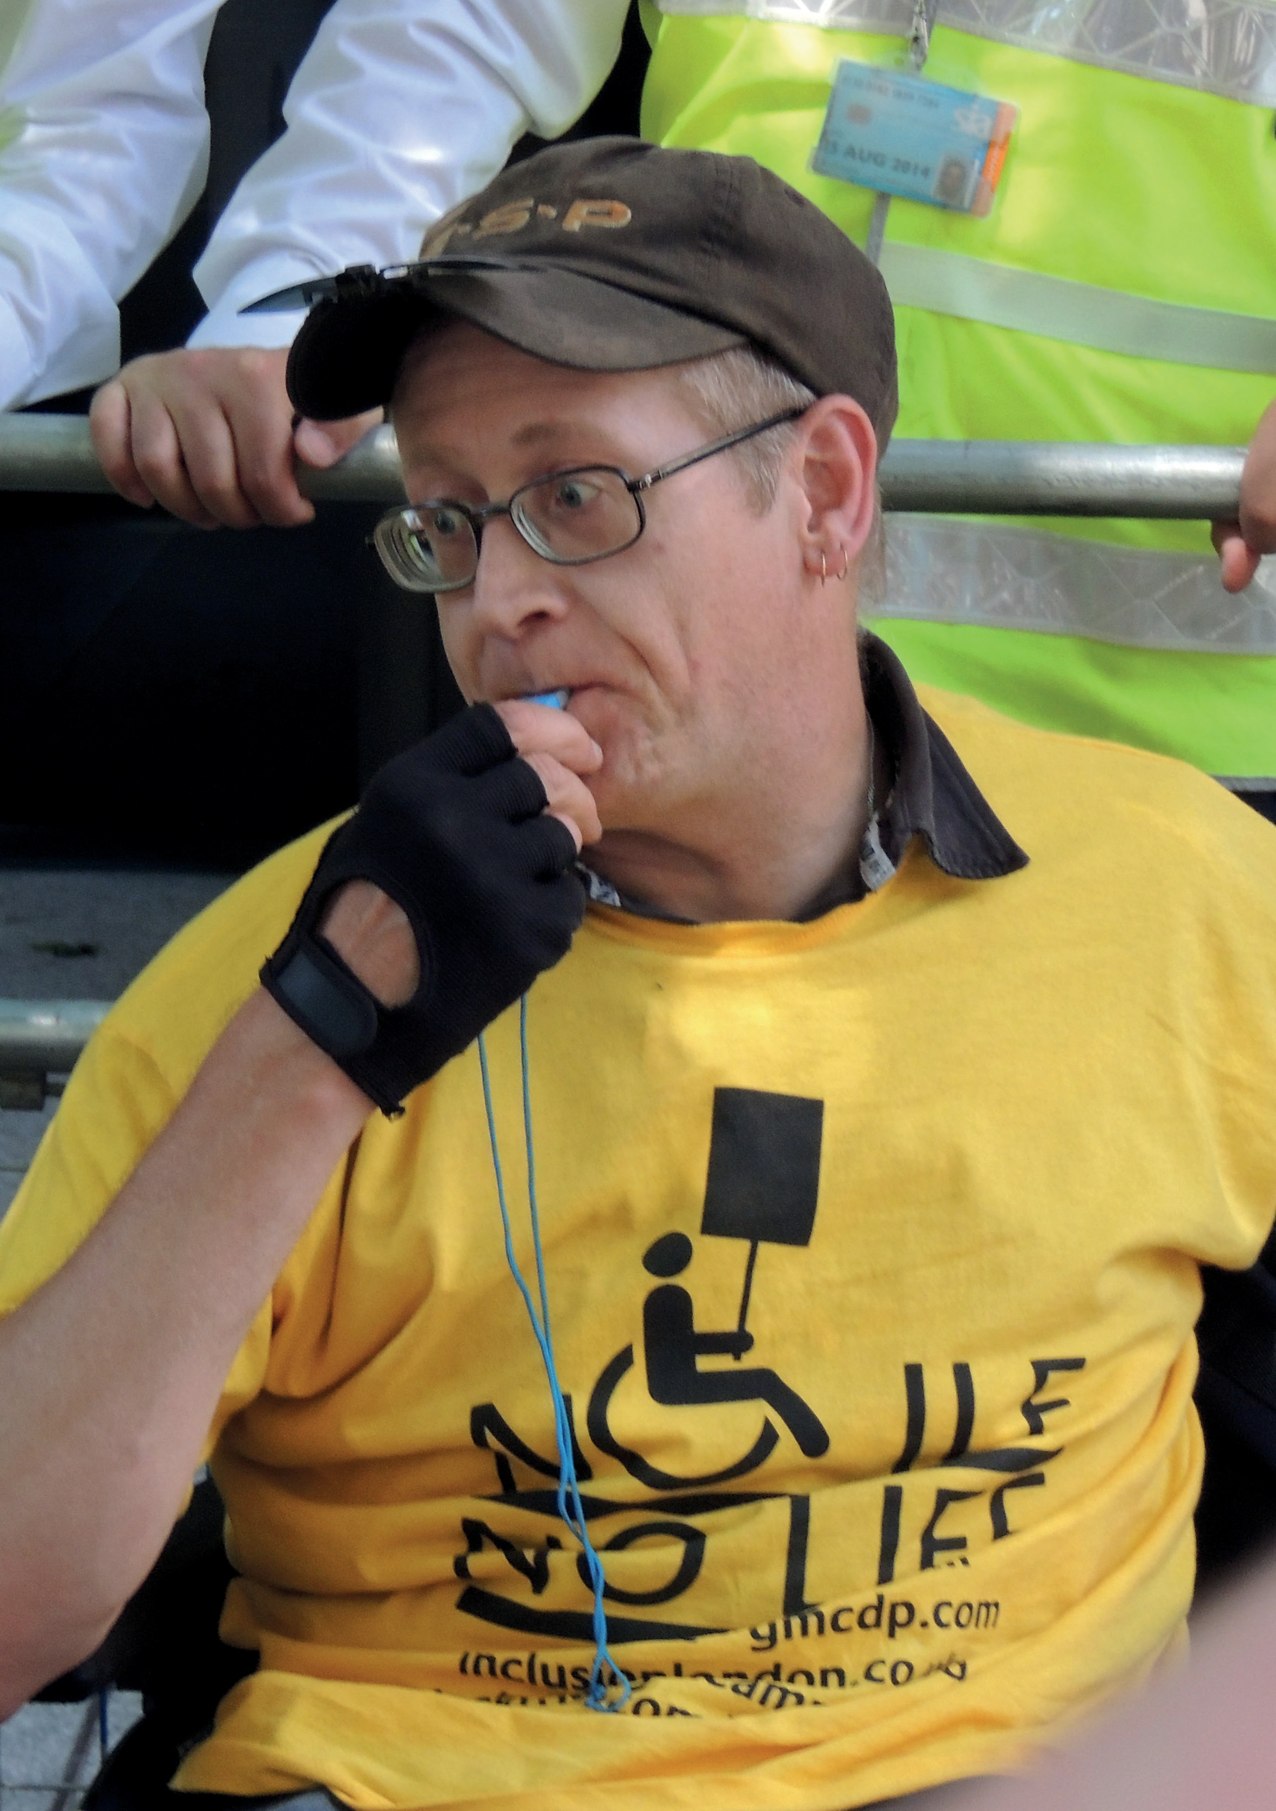

- Open up London employment opportunities to all Disabled people

  - Invest in employment support that is based on the Social Model of Disability and intersectional experiences of Disabled people.
  - City Hall and the GLA should lead by example and implement a comprehensive programme of action to ensure that the GLA becomes a leading, accessible and inclusive employer of Disabled people.
  - The Mayor’s Good Work Standard must include more robust requirements to address disability injustice, inequality and discrimination of Disabled people in the workplace, including the development of reasonable adjustment policies and support to apply to Access to Work.

- Address the housing crisis for Disabled Londoners

- Build more truly affordable accessible social housing to provide low cost secure tenancies for Disabled Londoners.
- Use powers within the planning process to enforce and monitor compliance with the current targets for all new build homes to meet Lifetime Homes standards and 10% of new build homes to be wheelchair accessible.
- Work with partners and coordinate to ensure Disabled homeless people receive fully accessible support services and are placed in accessible temporary and then permanent accommodation.

- Effectively tackle hate crime and violence against Disabled people

  - Re-establish Disability Hate Crime Matters - a proven initiative that improves the identification, investigation and response by police to Disability-related hate crime incidents and intersectional experiences.
  - Carry out research to develop a robust evidence base exploring the causes and scale of violence against Disabled people.
  - Promote and resource the development of DDPOs as third party reporting centres and specialist advocacy providers for Disabled victims of hate crime.
  - Ensure MOPAC works strategically with DDPOs to tackle Disability Hate Crime.
  - Lobby national government for equality of legislation so there is parity with the law covering other hate crime strands.

- Ensure London is an open and inclusive city

- The Mayor and GLA to be a champion and advocate of London’s full representation of Disabled communities, our needs and the contribution we make to the city.
- Enforce and ensure compliance with the Equality Act 2010, accessibility standards and inclusive design in London.
- Ensure all organisations contracted or commissioned by City Hall or the GLA can demonstrate a proven track record in providing accessible and inclusive services and employing Disabled people.
- Ensure cultural, sports and other programmes and events funded or organised by City Hall or the GLA comply with highest accessibility standards.
- Work with partners to champion the safety and inclusion of Disabled Londoners in decisions about the built environment and the use of streets and outside spaces.

inclusive learning for All
- Ensure inclusive adult and training education service for all

- Develop and commission London wide inclusive adult education and training opportunities that will be supported by Disabled and Deaf Peoples Organisations
- Develop a fully inclusive and representative apprenticeship offer for all including disabled staff in-house and in the awarding of contracts.
- Develop measures to address disability discrimination and the impact of intersectional injustice and inequality in education and training education services
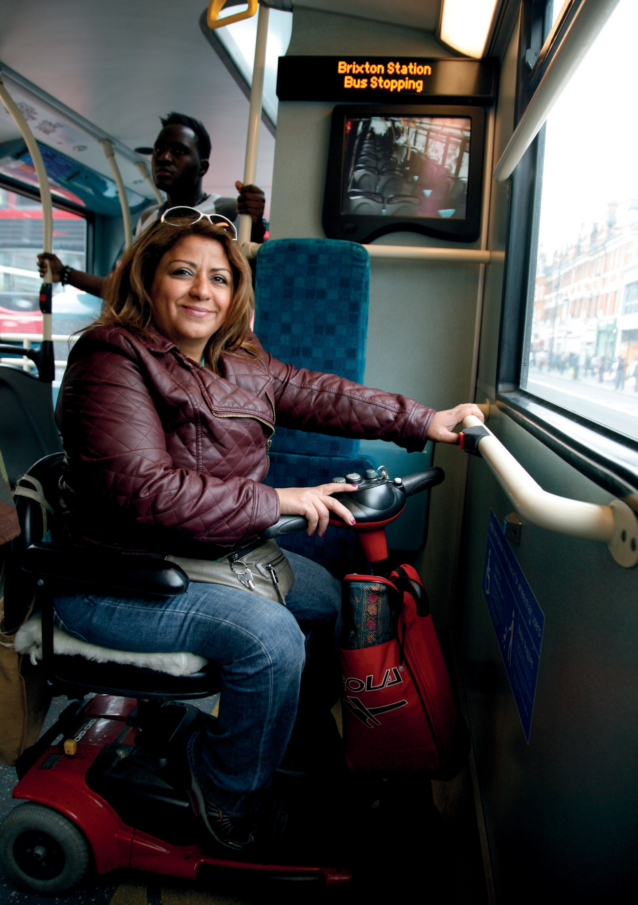

Accessible Transport

- Prioritise passenger safety

- Incentivise bus companies through stricter penalties to enforce wheelchair priority in the wheelchair bay, pull up to the stop, pull into the kerb and give people enough time to sit down.
- Research and invest in buses with bigger access spaces as wheelchair users and those using pushchairs and buggies are often forced into conflict with each other due to a lack of innovation and commitment to alternative bus design.

- Improve Disabled people’s experience of using tube and rail

- More transparency about the progress into making the Tube and Rail stations fully accessible.
- Continued investment and priority in ensuring stations are step-free from street to train and to challenge any delays in implementation
- To commit to Disabled and older people’s right to ‘Turn up and go’ by ensuring all underground stations are staffed so Disabled people can travel freely and safely.

3. Increase Disabled people’s opportunities to travel by taxi

  - Ensure Disability Equality Training along with other justice training is a condition of license for all hail and private ride vehicles which offer an ‘accessible’ service.
  - Introduce financial incentives for Taxi card providers to reduce incidents of refusal and bad customer service.
  - Commit to critical investment in the Dial-a-Ride service to combat persistent issues and to aim to reduce booking requirements.

- Prioritise pedestrians on our increasingly hostile streets

  - Support an urgent review of regulation and guidance on public walkways that puts pedestrians first and safeguards the needs of Disabled and older aged people.
  - Work with partners to lobby for new legislation and regulation to ensure new modes of transport do not hinder safety, participation and inclusion of Disabled people.

- Parking policies that facilitate participation and inclusion

Work with London Boroughs to facilitate a coordinated parking policy for blue badge holders that enables Disabled people to access essential services and participate in society.

- Nothing about us without us

  - To lead the way in a culture shift in how Disabled people are consulted by the transport sector by developing a professional, paid, co-production model with Disabled people’s needs and rights being a driver for change
  - For all bus, tube and train staff to have Disability Equality Training, delivered by Disabled people.

20

Inclusion London 336 Brixton Road London SW9 7AA

www.inclusionlondon.org.uk 020 7237 3181

