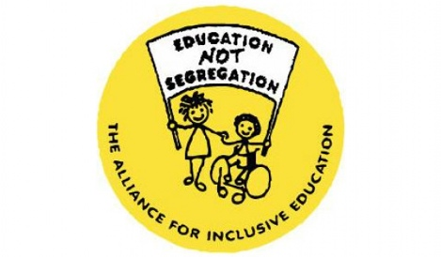
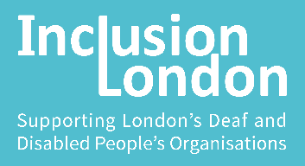
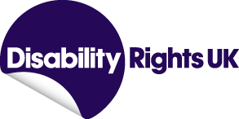

Restore the Rights of Disabled People

Scrap the Coronavirus Act easements

The Coronavirus Act contains provisions allowing local authorities to reduce vital social care duties, and weakens support and education for disabled children and young people. We believe these provisions should never have been included in the Act and now as we move to the recovery phase, it is vital that the disability-related provisions are removed from the Act, or at a minimum switched off.

The Impact of the COVID- 19 Pandemic on Disabled people

The evidence is clear as to the lethal and disproportionate impact that this pandemic has had on disabled people. Office for National Statistics figures show that 6 in 10 people who have died from COVID-19 were Disabled people. Deaths amongst people with learning disabilities were 3.7 times higher than people that do not have a learning disability. The ONS recognises that Disabled people are exposed to a range of generally disadvantageous circumstances and that these had an impact on the significantly higher rates of death.

Many Disabled people were left without essential social care support and struggled to access food and healthcare. Inclusion London’s reports into experiences of disabled people during the pandemic paints a stark picture of people being abandoned by support services, struggling to access basic necessities, denied access to essential healthcare, and disproportionately hit by job losses and increases in cost of living.

Social Care Easements

Many disabled people who need social care support to live a life of dignity experienced significant cuts to support packages or de facto were left without support. Day service provision was closed, physical support for some was replaced with online check ins, those who employ their personal assistants were largely left to resolve problems with PPE and testing, and Disabled People who use self-directed support experienced difficulties accessing vaccine for their staff. Too often local authorities did not offer alternatives to the support provision which was no longer available, leaving people to rely on family members or other informal support networks. We also have seen evidence of support hours being cut because individuals were shielding and not able to leave their house, when those support hours could have been used to buy food and get other necessities.
Although only 8 local authorities implemented the Care Act easements at stage 3, and none are implementing them at the moment, the de facto cuts to support, delays in needs assessments and failures to address specific needs which arose from the COVID-19 pandemic left thousands of people without essential social care support. At the same time, while having social care support dramatically reduced, Disabled people found themselves having to pay more in social care charges. These charges could be backdated under the Coronavirus Act provisions.
Diminishing Disabled peoples’ right to social care is not the way to address those problems. Instead, the government needed to allocate necessary resources to enable local authorities to comply with the Care Act in full.
We believe the introduction of the easements in the Coronavirus Act was a fatal mistake. Disabled people largely saw it as the government’s willingness to weaken their already limited rights to care and support. On the other hand, this power allowed local authorities not to focus on taking proactive action to put in place alternatives or contingencies to ensure Disabled and older people got the support they needed. These powers should have never been introduced. The easements caused confusion and distress. They must now be removed.

Educational Easements

Whilst the Children and Families Act easements, which set aside duties relating to SEND provision within the child’s or young person’s education, health and care plans, haven’t been used since the end of July 2020, nevertheless non-compliance continues.
Parents have contacted us to clarify their children’s rights to SEND as set out within their child’s EHCP. Over recent months, we have seen letters sent to parents explaining that local authorities are only required to use their reasonable endeavours to secure the SEND provision within the child or young person’s education, health and care plan. This is incorrect.
Whilst Disabled children and young people with EHCPs have been allowed to attend school during lockdown, we understand that they haven’t always been receiving all SEND provision in their plans. The “ALLFIE Survey Report: Coronavirus Impact on Disabled People’s Education” findings are supported by The Disabled Children’s Partnership (2020) “The return to school for disabled children after lockdown” research. Reported findings are:
32% of Disabled children received all the SEND provision within their EHCP.
39% of Disabled children received some SEND provision within their EHCP.
8% of Disabled children received no SEND provision within their EHCP.

In particular, therapies have continued to be unavailable for Disabled children either within the school setting or at home. There has been no consistent evidence of local authorities having discussions with families about the appropriateness of using alternative therapies that they could independently commission.

ALLFIE’s and DCP’s findings have highlighted that receiving full SEND provision in schools continues to be very problematic. We believe that the continued existence of the Children and Families Act easements send the wrong message to education providers. Some local authorities and schools are confused about their SEND duties. We therefore believe it is now time for the Government to remove the Children and Families Act easements from the Coronavirus Act, to ensure complete clarity.

You can help restore Disabled people’s rights

it is imperative that in this difficult time the rights of Disabled people are protected, not diminished. At a time when Disabled people need care, support, safeguards and education the most, powers for central and local government to reduce their legal responsibilities are wholly unacceptable.
Disabled people’s lives must be valued equally. Removing rights causes disadvantage and discrimination, and puts the mental and physical health of Disabled people at risk.
As the Coronavirus Act approaches its one year review, now is the time to recognise the devastating impact the exercise of these powers has had and to restore the legal rights of disabled people.
The government should confirm that:
- Social care easements will be switched off by the Department of Health and Social Care;
- The easements relating to the Children and Families Act will not be implemented by the Department of Education.

Alternatively, the Coronavirus Act could be voted down at the review, and the government would have to bring forward an alternative legislation within 21 days. This could allow the easements to be discontinued. Although the Coronavirus Act cannot be amended as part of the review, amendments could be made as part of the general Parliamentary process, and we would encourage Parliamentarians to do so.

https://www.ons.gov.uk/peoplepopulationandcommunity/birthsdeathsandmarriages/deaths/articles/coronaviruscovid19relateddeathsbydisabilitystatusenglandandwales/24januaryto20november2020#main-points
Abandoned, Forgotten and Ignored, June 2020: https://www.inclusionlondon.org.uk/disability-in-london/coronavirus-updates-and-information/campaigns-news-during-coronavirus-crisis/abandoned-forgotten-and-ignored-the-impact-of-covid-19-on-disabled-people/ , Locked down and abandoned, February 2021: https://www.inclusionlondon.org.uk/disability-in-london/coronavirus-updates-and-information/campaigns-news-during-coronavirus-crisis/locked-down-and-abandoned-disabled-peoples-experience-of-covid-19/
Research by Mencap revealed care packages have been halved for most people with learning difficulties https://www.communitycare.co.uk/2020/08/10/care-packages-halved-people-learning-disabilities-covid-report-carers/ Be Human register also evidences the cuts to social care experienced by Disabled people https://in-control.org.uk/wp-content/uploads/2021/02/iC-Building-Personal-Power-report-2021-SINGLE-FINAL.pdf
https://www.allfie.org.uk/inclusion-resources/allfie-survey-report-coronavirus-impact-on-disabled-peoples-education/
https://disabledchildrenspartnership.org.uk/wp-content/uploads/2020/11/Back-to-school-poll-report.pdf

