

**Hammersmith and Fulham Co-Production (working together) Implementation Group (HFCIG)**

**Implementation:** this means putting something into place, it could be a plan or a new way of working.

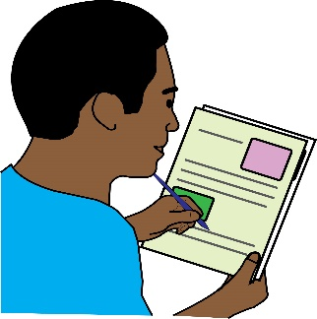**Invitation:**

This is an invitation to Disabled **residents** to apply to join the Hammersmith and Fulham

Co-production (working together) Implementation Group (HFCIG).

**Residents:** in this document, this means people living in Hammersmith and Fulham.

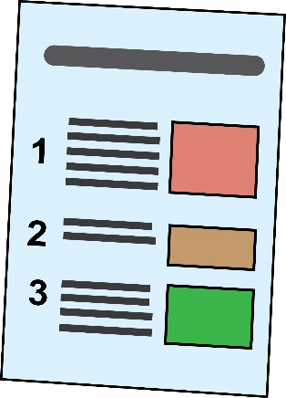

The group will make sure that the **recommendations** set out in the Hammersmith and Fulham Disabled People’s Commission report, are put into place. The Council Cabinet **approved** this report on December 4th, 2017. The Group will use a **Social Model of Disability** and a **human rights way** of working in all its work.

**Recommendations:** these are the things that the Disabled People’s Commission think should happen to make things better.

**Approved:** this means officially agreed.

**Social model of disability:** this is when Disabled people are seen as people with impairments who are ‘disabled’ by the barriers in society. These barriers discriminate against Disabled people and push us out of society. It is the way society is run and organised that is the problem, not the Disabled person.

**Human Rights way - UN Convention on the Rights of Persons with Disabilities:** this is an international agreement that the government signed up to, to bring about the full rights of Disabled people in the UK.

A link to the report. <https://www.lbhf.gov.uk/councillors-and-democracy/resident-led-commissions/disabled-people-s-commission>

Please get in touch with Jessica for a hard copy by calling/ texting: 07825833695 or emailing: [jessica.pezzolesi@lbhf.gov.uk](mailto:jessica.pezzolesi@lbhf.gov.uk)

**Background:**

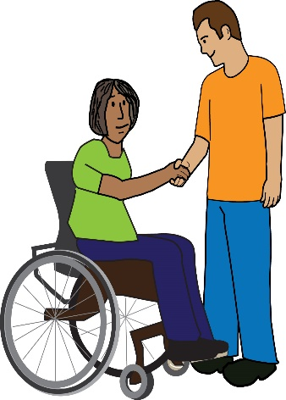On the International Day of Disabled People in December 2015, the Leader of Hammersmith and Fulham Council, Stephen Cowan, agreed to work closely with Disabled residents. He agreed to make decisions together about our support and services. As a result, we took the opportunity to have, what we believe is the first local Disabled People’s Commission in the country.

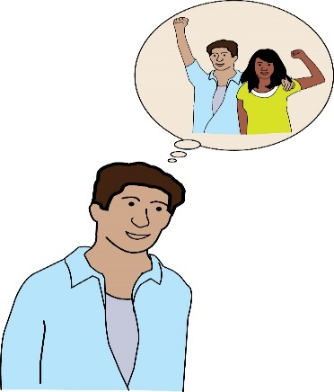The reason for setting up the Commission was to put in place a new way of doing things where Disabled residents, Councillors and officers and other organisations in the borough are working together.

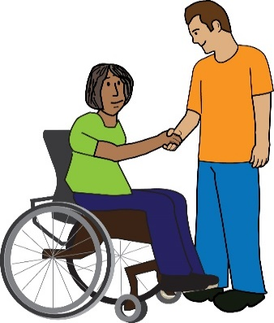These people would work together to build a culture that values, respects, and pushes for the rights of Disabled people living in Hammersmith and Fulham – making "Nothing About Disabled People Without Disabled People” at the heart of this **unique** and **diverse** borough.

**Unique:** this means one of a kind.

**Diverse:** this means many different people from different places and backgrounds living in the same place.

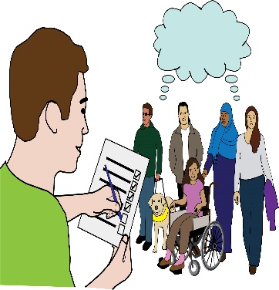The eight recommendations in the report come from the Commission’s research into the barriers still faced by Disabled residents. Each recommendation aims to break down those barriers and to **transform** **local public policy** and how services are designed and run.

**Transform:** this means to change and make better.

**Local public policy:** this means how decisions are made, the rules that are followed and how decisions about spending money are made in a local area.

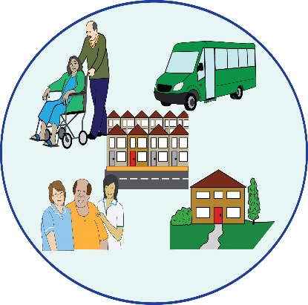The report is clear that change needs to happen across all Council departments and services. This way of working could become part of how the council does everything, not just with Disabled residents but with all residents.

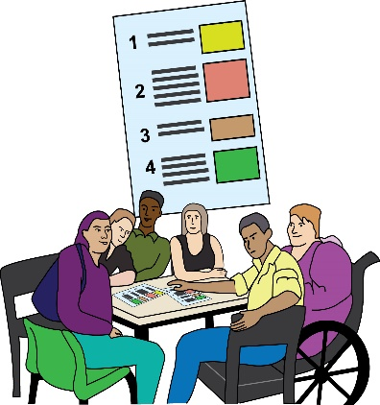**Aim:**

The new Hammersmith and Fulham

Co-production Implementation Group will lead on this and will make sure that the eight recommendations set out in the Disabled People’s Commission report, are put into place.

**Structure of the Group: this means who will be on the Grou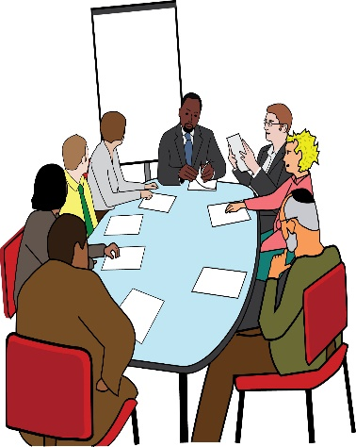p**

* Co-Chairs – 1 Hammersmith and Fulham Disabled resident and 1 Councillor.
* 8 – 10 members at most (5 of these will be Disabled residents)
* 2 Hammersmith and Fulham Strategic Directors

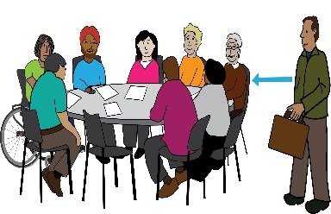There will be people from other council departments and people as and when needed.

**Frequency: this means how often the group will meet**:



The group will meet 10 times each year. This is a paid role. Each member will be paid £150 for each meeting that they go to and £30.00 for each hour of any extra work that is agreed. There will be a **contract**, which will be an agreement to work for at least 12 months.

**Contract:** this means a signed agreement to work together.

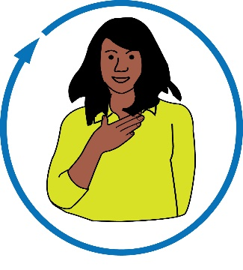**Who are we looking for:**

* **Self-identified** Disabled residents who live in Hammersmith and Fulham to become members of the Hammersmith and Fulham Co-Production Implementation Group.

**Self-identified**: this is when someone sees themselves as a Disabled person

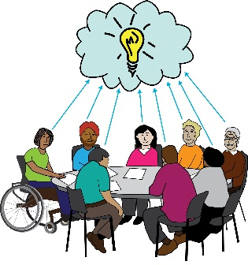

* Disabled residents who have experience in managing change and/or running projects.
* Disabled residents who will make sure that Disabled residents across all **impairment** groups and 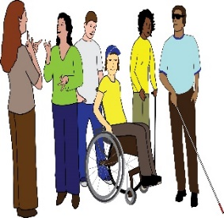residents who face other types of discrimination in their day-to-day lives are listened to and are a part of all

co-production work.

**Impairment:** there are different types of impairments, some affect the way that a person can move and get around. Others affect how a person can see or hear. Impairments can also affect the way that a person speaks, makes decisions, or remembers things.

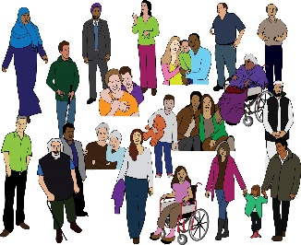

* Disabled residents who live in Hammersmith and Fulham.

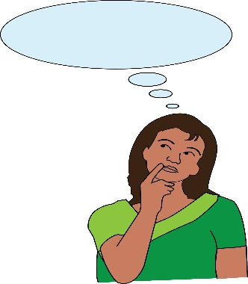

**Skills and Experience:**

To apply we would like you to tell us about what you think you can bring to the group by giving information about your experience and/or skills of:

* 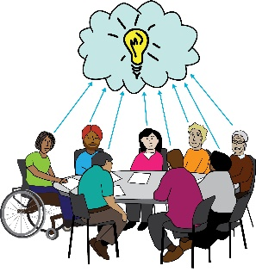Life as a Disabled person.
* Working on a project or policy change that set out to bring about change in people’s lives.
* 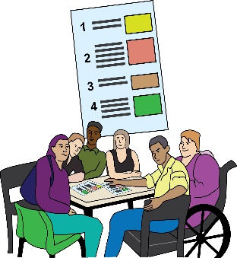Being able to use your skills to help turn the report’s recommendations into practice.
* Co-production (working together) to bring about change.

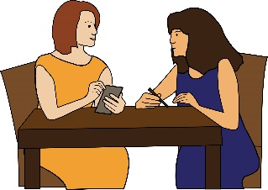

* Being a member or having another role with a local or national Disabled People’s Organisation (DPO).

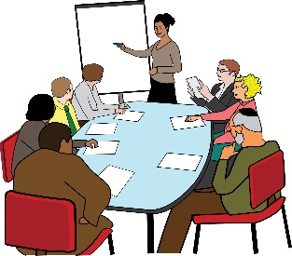

* Work on committees/ steering groups that make sure change is put into place.
* 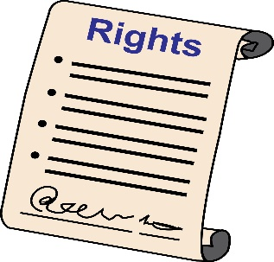Understanding of the Social Model of Disability, equality, diversity, and human rights.

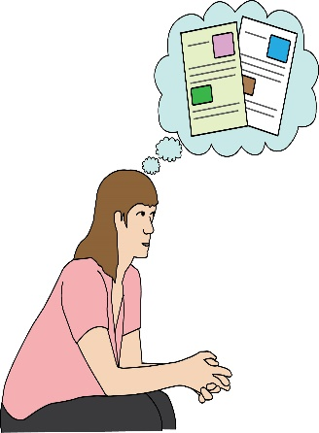**Selection Process: this means how we decide who gets the role:**

We will choose Hammersmith and Fulham

Co-Production Implementation Group members using the information they give about their experience and skills, and how strong that information is. We will make sure that the group can include the diversity of Disabled residents in the Borough in its work.

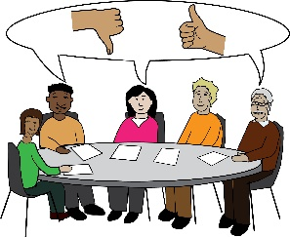Applications will be looked at by a group including Disabled people, a Councillor and a Council director.

**What to do if you are interested in this role:**

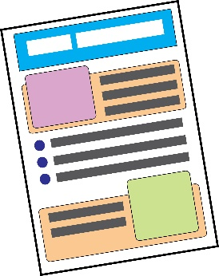

Please send us two sides of A4 paper setting out how you meet the skills and experience points in this document. Please let us know if you want to apply for the role in a different way or in a different format.

Please send your application to:

Jessica Pezzolesi, Executive Support Manager

Public Services Reform

Hammersmith and Fulham Council

1st Floor, Hammersmith Town Hall, King Street, W6 9JU



[jessica.pezzolesi@lbhf.gov.uk](mailto:jessica.pezzolesi@lbhf.gov.uk)

The closing date is Monday October 1st, 2018 by 5pm.

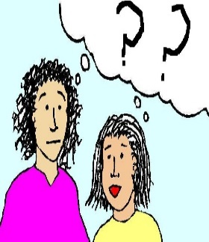

If you have any questions, please contact Jessica Pezzolesi by calling/ texting: 07825833695 / 0208 753 2106

or emailing: [jessica.pezzolesi@lbhf.gov.uk](mailto:jessica.pezzolesi@lbhf.gov.uk)