Supported by:

Disability Independent Advisory Group: Application Pack
Independent Advisory Group: this is a group that works with the police, giving them advice about how to make their service better.

Thank you for your interest in applying to be a member of the Disability Independent Advisory Group.
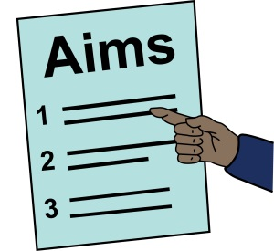
This application pack has the following information:

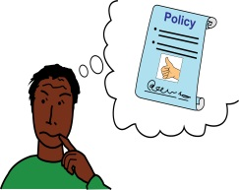
- Disability Independent Advisory Group: introduction and information on the group’s aims & work

- Disability Independent Advisory Group’s Working Policies and Procedures
Policies and procedures: these are documents in an organisation which tell everyone about the way things are done in the organisation.

- Disability Independent Advisory Group’s Role description and person specification
Role description: this mean information about a job and the different tasks and work a person will have to do in the job.
Person Specification: this is information about the skills, experience or knowledge that a person needs to do a job.

- How to apply to be a member of the Disability Independent Advisory Group

- Disability Independent Advisory Group: introduction and information on the group’s aims and work
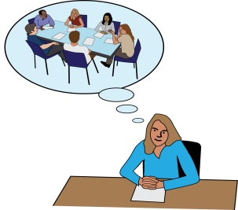

Information about Independent Advisory groups and how they have been used in the past
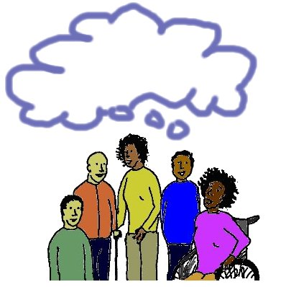
After the Stephen Lawrence Enquiry, the Metropolitan Police Service saw that they needed community advice. They also saw that in their work, they needed to know more about different communities in London.
Enquiry: this means an official investigation.

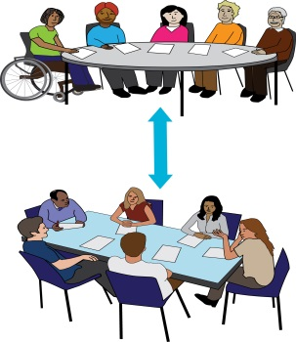
Independent Advisory groups were set up because the Metropolitan Police Service needed to work better with groups that are left out of society. They also need to get advice from these groups and know more about them.

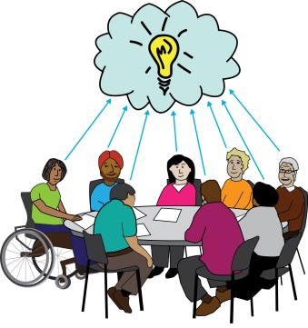
An Independent Advisory group is there to help the Metropolitan Police Service understand the groups of people who are usually not part of their decision making. They can understand the needs and wants of these groups.

Also, they can understand what these different groups give to society. The Metropolitan Police Service can use this information to make their service better. This is good for all our communities and will help to build trust and confidence.
Confidence: this is when a person feels that they can rely on or trust in another person or organisation.

More information on Independent Advisory groups can be found at the link below:

http://www.college.police.uk/What-we-do/Support/Equality/Documents/Independent_advisory_groups_advice_2015.pdf and http://library.college.police.uk/docs/appref/independent-advisory-groups-iag-guidance-revised-september-2011.pdf

The Disability Independent Advisory Group

In the past we have tried to set up a Disability Independent Advisory Group. The group did not meet but worked by email. This was not a way of working that could carry on.

For this reason, a new Disability Independent Advisory Group which meets face to face is being set up. Members and police officers will meet face to face so that they can give advice in a better way to the Metropolitan Police Service.

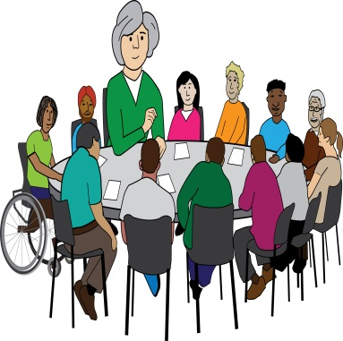
Anne Novis will be the Chair of the new Disability Independent Advisory Group until the group votes for a new Chair. She is a disabled campaigner on disability hate crime. She was part of the Disability Independent Advisory Group that worked just by email. She is also now giving advice to the Metropolitan Police Service.
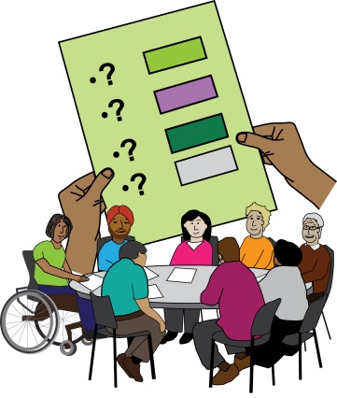
Although we will be supported by the Metropolitan Police Service with admin and finances, the group will be independent of the police. Our Disability Independent Advisors will be volunteers. They will give the police advice that is strong and challenging.
Independent: here, this means that even though the group works with the police, it is free to make its own decisions and is in control of its own work as an advisory group.

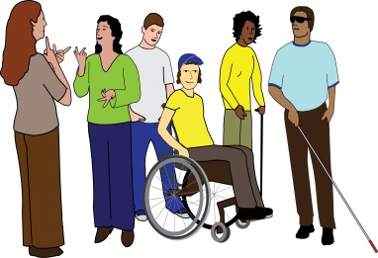
The Disability Independent Advisory Group will aim to have members that show the diversity of Deaf and Disabled people in London. The group will have ten Advisor members.
Diversity: this means there are lots of different people.

Our Aims
The Disability Independent Advisory Group will aim to work with the Metropolitan Police Services to bring about a better police service for Deaf and Disabled people’s communities in London. This means a police service that meets the needs and deals with the issues of Deaf and Disabled people.
We aim to make sure that Deaf and Disabled people’s issues stay on the agenda of all areas of work of the Metropolitan Police Service. This could be from every day police work to big picture decisions and plans.

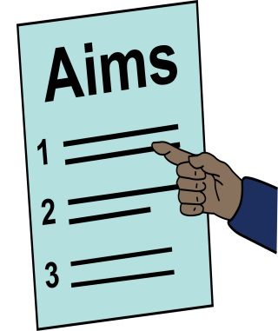
We aim to help the Metropolitan Police Service to:
- Bring down the number of hate crimes
- Make relationships between communities better
- Protect people at risk in our community full of diversity
- Become more accessible and aware of issues affecting Deaf and Disabled Londoners
Through our work, we aim to help the Metropolitan Police Service build trust and confidence from all areas of the Deaf and Disabled people’s community.

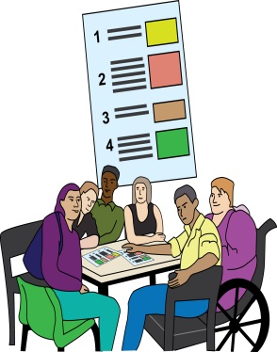
Our Work
We will give advice and information from a community point of view on issues that affect Deaf and Disabled people’s communities in London. Our work will look at different things, from the challenges of hate crime reporting to urgent advice on important incidents such as murders.
Incident: this is where a violent event or crime has happened.

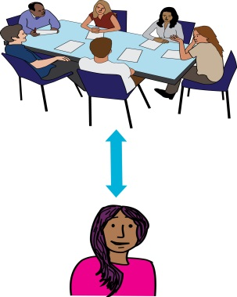
People from the Metropolitan Police Service will ask us for advice on issues. We will ask the best advisors for the job to support them on that issue. A report on the work done with the Advisor, will come back to the Disability Independent Advisory Group.
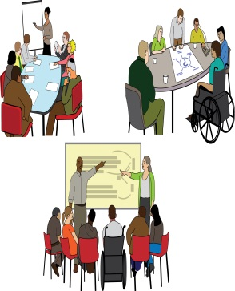
Our meetings will happen every two months. The timing of these meetings will be arranged by the group. Sub groups may be set up when needed, such as a sub group on Disability Hate Crime. At the moment Hate Crime is already a group, but it will become a sub group once the Disability Independent Advisory Group is set up.
Sub group: this is a smaller group that is put together to look at a specific area or issue.

As well as meetings, a lot of our work will be done by email.
We give advice to all levels of the Metropolitan Police Service.

- Critical Incidents Advice:
Critical Incident: It is an event or crime that has happened, where how the police deal with the event will have a big impact on the victim, their family or a community.

We will send Disability Independent Advisory Group Advisors to give advice on critical incidents linked to Deaf and Disabled people. This will generally be murders or attempted murders. Our advisors can go to Gold Groups.
Attempted murder: this is when someone tries to kill someone else.
Gold Groups: These are groups that make big picture decisions about how money and police officers are used in an investigation. They also decide on plans for working with communities and the media.

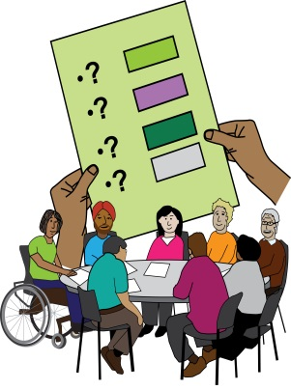
Disability Independent Advisory Group advisors will help us to get information about different communities. We will also be able to help the Metropolitan Police Service to see what effect a critical incident will have on a community. At the end of the process, we will pull out the lessons to be learnt.

- Metropoliotan Police Service Hate Crime Strategy
Strategy: this means big picture plan.

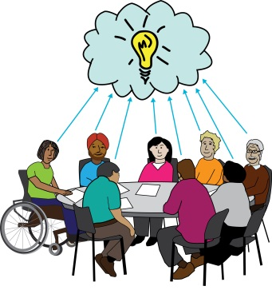
The Hate Crime Diamond Group was set up in 2015 by the Metropolitan Police Service. It was set up to write strategies to deal with hate crime in London. The group is chaired by Commander Dave Stringer. Many different anti-hate-crime experts also take part.
Anti-hate-crime expert: this means an expert in dealing with and stopping hate crime.

Anne Novis goes to the Diamond Group meetings and has a leading role in the Disability Hate Crime Working Group. This group looks at all the work of the Metropolitan Police Service and makes decisions about the most important things to work on to deal with hate crime.

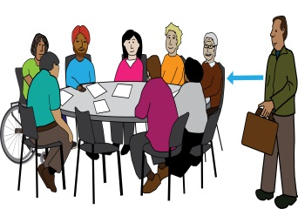
One of the first objectives of the new Disability Independent Advisory Group will be to make sure that the group’s members as well as the Chair Anne Novis, can go to Diamond Group meetings.
Objectives: this means the aim or the results you want to get out of the work you do.

2. Disability Independent Advisory Group’s Working Policies and Procedures

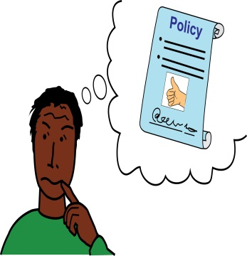
The Disability Independent Advisory group will follow some basic policies. We have put some of these here so that you can understand what the group is about and where we stand on important issues. We hope this will give you enough information to make the decision about joining the Group.

On Equality and Diversity
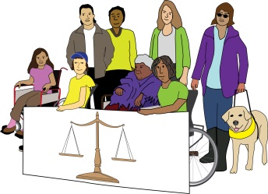
The Disability Independent Advisory Group works in a way that makes sure there is equality for all in a diverse society made up different cultures.
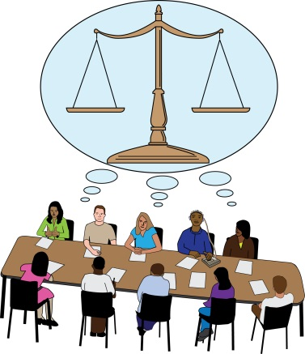
We respect and value the diversity of our society. We aim to have more of an understanding of Deaf and Disabled people’s needs. We aim to make sure Deaf and Disabled people face less marginalisation and discrimination. We also aim to make relationships between communities better.
Marginalisation: this is when a person or a group of people are treated as not important or are left out completely.
Discrimination: this means being treated unfairly.

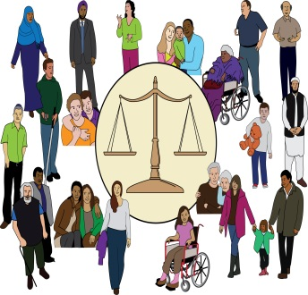
We work to make the understanding of diversity issues better in the Metropolitan Police Service and within the Disability Independent Advisory Group. This also means intersectional issues that affect Deaf and Disabled people’s communities, such as race, faith, age, class, gender and sexuality.
Intersectional issues: this means looking at how different types of discrimination affect each other.

We see that there is inequality in all parts of our society. This could also be inequality which comes out of power relationships. We see that this can lead to discrimination, hate, abuse and violence. For this reason we aim to get rid of inequalities, through the work of our group.
Inequality: this means that people are not treated fairly or in the same way and so there is no equality.

We also see that there are complicated barriers in society that can mean that Deaf and Disabled people are left out, treated unfairly and discriminated against. We aim to work to get rid of these barriers within the Metropolitan Police Service and the Disability Independent Advisory Group by:
- Raising awareness and understanding of Deaf and Disability equality and access issues,

- Working to make sure all access needs of Disability Independent Advisory Group members are met

- Making sure the work of the Disability Independent Advisory Group is carried out in an accessible and inclusive way.
Inclusive: this means not leaving out anyone.

Each member of the Disability Independent Advisory Group should respect and work on all aspects of community diversity. This is whether or not it is part of their own experience.
For example, a Deaf BSL user member must think about, raise issues and advocate on behalf of Disabled people. In the same way, a Disabled member must be prepared to think about, raise issues and advocate on behalf of Deaf people.
Advocate: this means to speak up for a person or group of people.

Commitment to The Disability Independent Advisory Group: this means how much time we will need from members

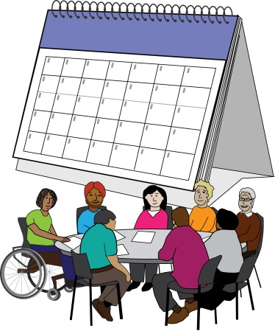
Members of the Disability Independent Advisory Group must go to our full Disability Independent Advisory Group meetings. These take place once every two months. When more than three meetings are missed in a row without apologies, would lead to a review of the membership of that person in our group by the Chairs and Vice-Chairs of the Group.

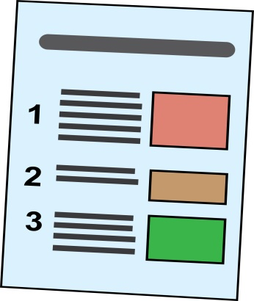
Code of behaviour: this means rules about how to behave

1. Members of the Disability Independent Advisory Group in their work for the group must work to the important values in the section called Equality and Diversity (see above).

They must also work to the 7 Nolan principles of public life. Not doing this may lead to disciplinary action. Breaking these rules in a small way would not lead to disciplinary action. Such as choosing not to be a part of a difficult equality issue. However, any complaints of upsetting behaviour will be investigated in line with the disciplinary code.
7 Nolan principles: these are 7 values about how a person should act.
Disciplinary action: this is when an organisation takes action against someone that works for them because of something they have done which has broken the rules or the organisation.
Disciplinary code: these are the rules for dealing with people that break the rules of an organisation.

2. Members must not do anything on purpose that would get in the way of justice. Members must not give out confidential information given by the Metropolitan Police. For example, information about a case that is open or that was investigated in the past.
Justice: this means the fair use of the law.
Confidential: this means private.

3. Members of the group must not say anything harmful about issues within the group to anyone outside the group. This can only happen where it is in the interest of the public or our community. It can also happen if the group agrees to it.
Behaviour that is not ok, includes telling people outside the group of arguments within the group. It could also be giving out private contact details of people without their permission. People outside the group means, people, the press or social media.
Permission: this means agreeing or allowing someone to do or say something.

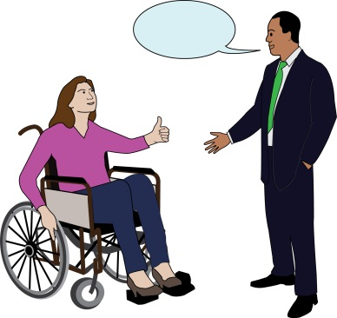
4. The full Disability Independent Advisory Group meeting or the Chair / Co-Chairs must agree communications to the media or organisations and people. This is the case unless there is a special situation.

A Chair/ Co-Chair may not write a letter from the whole group, unless the letter has been agreed on with one of the other Co-Chair or Vice Chairs. Other members of the group shall keep copies of all communications for checking when needed. The Disability Independent Advisory Group must be told about all communications.

Conflicts of Interest
Conflict of interest: this is where a person has two or more roles or jobs. Some decisions or parts of the jobs may go against each other. It can mean that if a decision needs to be made a person might have to take sides with one of their roles.

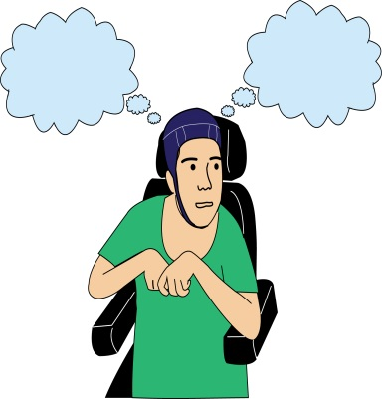
We see that the work of the Disability Independent Advisory Group may cross over with a member's work outside the Advisory Group. This may lead to a conflict of interest. This does not mean that a person can’t be a part of this work for the Disability Independent Advisory Group.

However, the Advisory Group should be told about it. The Disability Independent Advisory Group can then talk about ways of making sure there isn’t a conflict of interest. If this is not possible, then the member must take themselves out of any talks on this area of work.
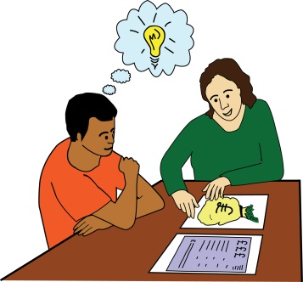
1. The Advisory Group should be told about a possible conflict of interest, if a member’s finances of the finances of an organisation that the member works for are affected by the work of the Advisory Group.

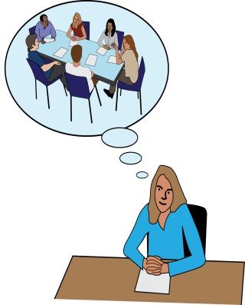
An example of conflict of interest may be that the group is talking about running training in the Metropolitan Police Service. A member may be part of a training company that aims to try to get this work. This would mean that the person has a conflict of interest when talking about the training in the Advisory Group.

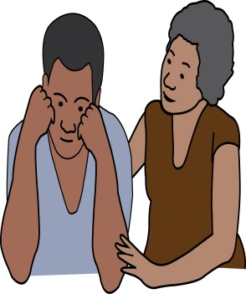
2. A member should tell the Advisory Group if the work of the Group crosses over with other work that the member does. For example, a member of the Advisory Group may meet with victims or witnesses of crimes at social events or may have links to victims or witnesses through family or social links.
There is a possible conflict of interest if the member is giving advice to the Metropolitan Police Service about the incident that a person they know was a part of.
The Disability Independent Advisory Group may decide to add other important policies and procedures to guide members.

3. Disability Independent Advisory Group Role description and person specification
The role of a member of the Disability Independent Advisory Group to the Metropolitan Police is a voluntary role, this means that the role is not paid.

The aim for the role
To work well together within the Disability Independent Advisory Group as follows:

1. Give advice to the Metropolitan Police Service on policing matters that affect Deaf and Disabled people’s communities.
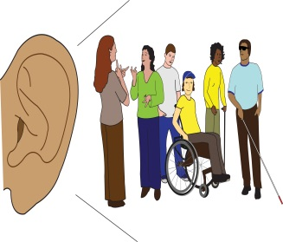
2. Listen to, think about and advocate on different experiences of Deaf and Disabled people’s communities.

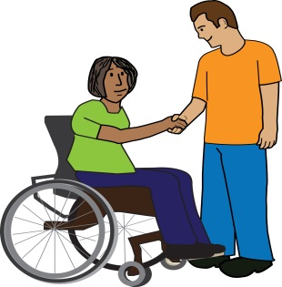
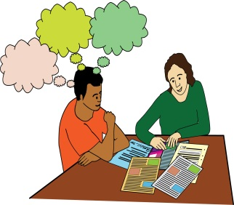
3. Take responsibility for learning from the information and experience of others. Also use your own information and experience to give big picture ideas and information about the policing of Deaf and Disabled people’s communities in London.

4. Work well as part of a team to give advice to the police and other organisations.

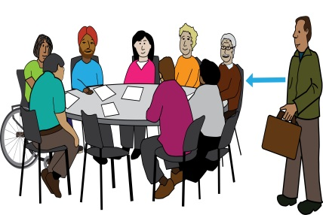
Main Duties: this means main things to do in this role

- Go to regular meetings of the Disability Independent Advisory Group and any sub-groups that you may be a part of.

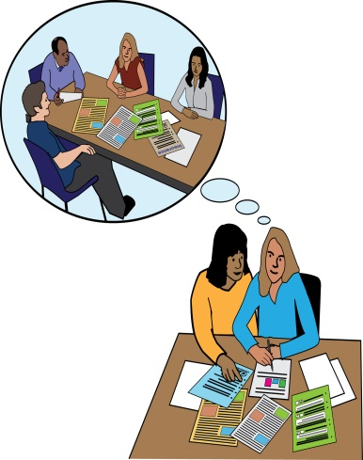
- Take part in the work of the group, this also means:
  - Reading the meeting papers
  - Bringing issues that you are worried about to meetings
  - Questioning and challenging when needed, this means going against a decision or a plan if you think that it is not the best thing to do

- Take part in looking at and deciding which work the group should do and when.

- Be prepared to work on the issues below as well as other issues:
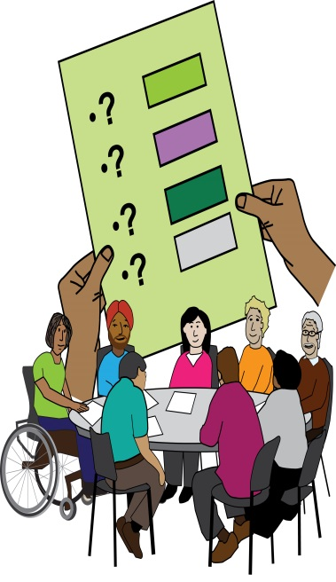
  - Reviewing how we investigate and stop hate crime, and how we make it better
  - Working towards a police service that is inclusive
  - Supporting the Metropolitan Police Service with their work on critical incidents
  - Making the trust and confidence in the Metropolitan Police Service better for Deaf and Disabled people’s communities
  - Hate Crime Liaison Officers
Hate Crime Liaison Officer: This is a contact person in the police for all people that have been victims of hate crime.

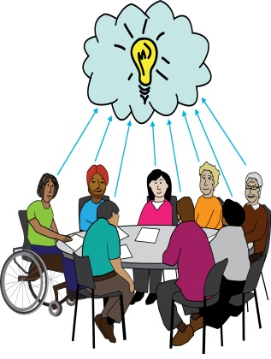
  - Giving advice on liaison and support with victims, family and witnesses
  - How police do their job at Deaf and Disabled people’s protests & events
  - Domestic violence
  - Police training
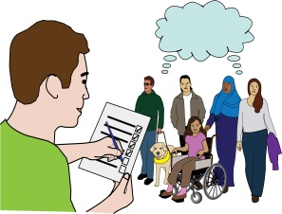
  - Firearms, this means different types of guns

- To do and take part in research and writing reports.

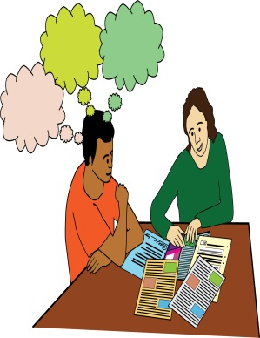
- To keep up to date with the worries that the Deaf and Disabled people’s community have about the police.

- To keep up to date with what is happening that may affect the work of the Disability Independent Advisory Group.

Person Specification: this means information about the skills, experience or knowledge that a person needs to do a job.
We are looking for Deaf or Disabled people to work as part of the Disability Independent Advisory Group who can show the following skills, knowledge and experience:

The skills, knowledge and experience that you must have for this role

- Be a self-identified Deaf or Disabled person.
Self-identified: this means that a person sees themselves as a Deaf or Disabled person.

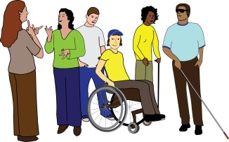
- Know about and work to the Social Model of Disability and the Cultural Model of Deafness.
Social Model of Disability: this is when Disabled people are seen as people with impairments who are ‘disabled’ by the barriers in society. These barriers discriminate against Disabled people and push them out of society. It is the way society is run and organised that is the problem, not the Disabled person.
Cultural Model of Deafness: the Deaf community see two different cultures, the hearing world and the Deaf community. This model does not see deafness as a loss or impairment, but as a different culture.

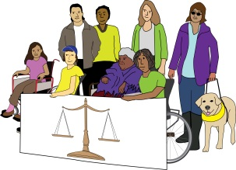
- Work in a way that values equality and diversity.

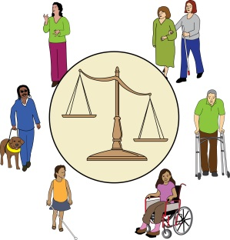
- Know about Deaf and Disabled people’s communities.

- Know about equality and diversity and how they affect people in different ways such as multiple discrimination or intersectionality.
Multiple discrimination: this means when a person or group of people are treated in an unfair way because they are part of a number of groups that face discrimination.
Intersectionality: this means looking at how different types of discrimination affect each other.

- Up to date experience, interest and knowledge of police issues.

- Want to work in a helpful way with both the police and the Disability Independent Advisory Group.

- Go to meetings regularly, both the whole group and any sub-groups that you are part of . This means going to 75% of all meetings, or 3 out of every 4 meetings.

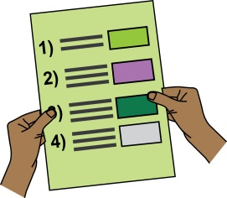
- Working to the aims and values of the Disability Independent Advisory Group and the following Seven Nolan Principles of Public Life:
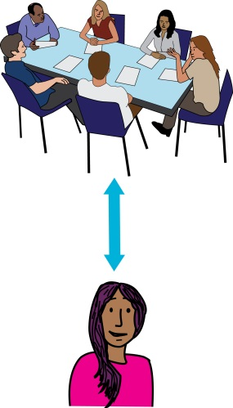
- Selflessness, this means working in a way that looks at the needs and wishes of others more than your own
- Integrity, this means working in a way that is in line with your values
- Objectivity, this means working in a way that uses information without letting personal opinions and feelings get in the way
- Accountability, this means being responsible for your actions and the way that you work
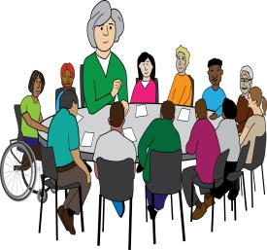
- Openness, this means being open
- Honesty, this means telling the truth
- Leadership, this means being able to lead a group of people or an organisation
- Openness to research, learn and build your knowledge about important issues.
- Be able to work and communicate in an accessible and inclusive way with different groups of people.

- Be able to communicate what you think in a confident way with many different groups of people, from police constables to management in the Metropolitan Police.
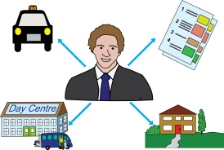
- Live, work, study, socialise or access services in Greater London.

- A wish to work to advocate for Deaf and Disabled peoples issues as decided by the Disability Independent Advisory Group. As well as on issues that may not be part of your own experience.
- Have access to emails and be able to check your emails regularly.
The skills, knowledge and experience that we would like you to have, but that you do not need to have for this role

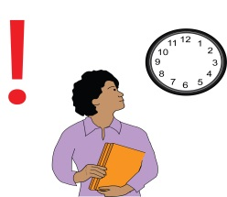
- Be willing to go to critical incidents with not much warning and out of office hours

4. How to apply to become a member of the Disability Independent Advisory Group
There is no application form for this role. To apply you will need to send us:

- An Disability Independent Advisory Group application information and supporting statement, and;
Supporting statement: this is a chance to tell an organisation why you are the right person for the job, using the information in the person specification.

- If you want to you can fill in and send us a “Recruitment Equal opportunities monitoring form” which is part of this application pack on the Inclusion London website: DIAG Recruitment Equal Opportunities Monitoring form.doc
We will then look at all of the applications. We will invite to an interview, the people that can meet all of the points in the person specification.

Before you fill in and send your application and supporting statement” please read all the information in this application pack and the following notes. We hope you find them helpful.

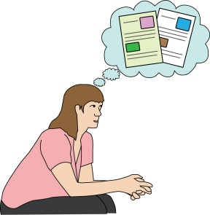
Disability Independent Advisory Group Application information and supporting statement

You need to put the following information in your supporting statement. Your statement should be no longer than 1,200 words:
- Personal information
This means your name, address and the best way for us to get in touch with you e.g. giving us your telephone number or email address.
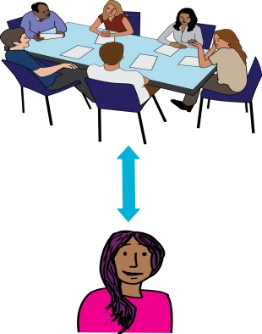
- Why you are interested in becoming a member of the Disability Independent Advisory Group

- How you meet the points in the person specification in the role description.

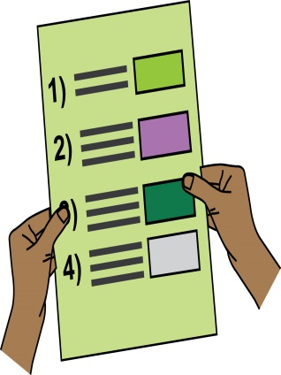
This is the most important part of your application and your chance to show why you are the right person for this role. It is also your chance to show us how you meet each of the points in the person specification. Please tell us about your skills, knowledge and experience for each of the points in the person specification. Give as much information as possible.

It is a good idea to tell us about how you meet each point in the person specification, point by point. It is also a good idea to give us examples of your work, skills, experience and knowledge where possible. Think about any paid or unpaid work you have done in the past and any work you are doing now.
Do not forget to tell us about any voluntary or community work, leisure interests, and other experience not linked to work, that would help you in this role. This could be skills that you got from running a home and/or organising a family, if this has been a big part of your experience.
- Access needs
Please give information about any access needs you have and how we can meet those needs if you are invited to an interview.

- Equal Opportunities Monitoring Form: this is a form we use to find out information about the people that are applying for this role

Keeping a check on the diversity of the people applying for this role is an important part of how we work towards our values of Equality and Diversity.

You do not have to fill in the form, but it will help us. It is completely confidential and will not be kept together with your supporting statement. It will not be given to the people who will decide who to invite for an interview or those who decide who will be chosen for the role. It will not be used for any other reason, other than for checking and reporting on equality and diversity.
Confidential: this means private.

- Personal Information
We will only use the information that you have given us for recruitment to the Disability Independent Advisory Group. We will not share it with anyone else. We will keep and use your information in line with the General Data Protection Regulations.
Recruitment: this is the process of hiring the best person for a job.
Data Protection Regulations: these are rules about how people’s information is used and kept safe.

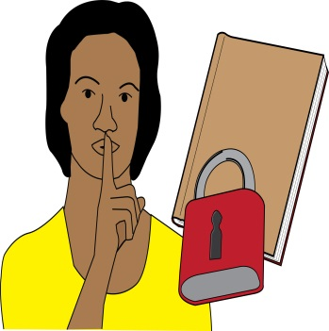
You can ask us for the information that we have collected about you. You can also ask us to delete your information or change any information that is wrong. You can tell us how to use your information or make a complaint about the way we have used your information.

We will keep personal and sensitive information about people who apply for this role but do not get the job, for 3 months. When that time is over we will delete your information. We will keep information about the people that get the role on the Disability Independent Advisory Group during their time on the Group and for 7 years after.
Sensitive information: this is information that is private and personal.

Send your Disability Independent Advisory Group Application information and supporting statement and the monitoring form by email to: tracey.lazard@inclusionlondon.org.uk

Closing date for applications: 5pm Tuesday 30 October 2018

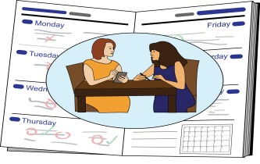
Interviews will take place in central London on:
14, 15 and 16 November 2018

People invited to interview will be told about this by: 2 November 2018

