Yes we can!
Summary Report

Getting Deaf and Disabled People to take part in Sport and Physical Activity
Physical activity: this is anything that you do that means that you move your body in a way that uses energy. For example, this could be going for walks often, gardening or dancing.

A report to be used by Deaf and Disabled People’s Organisations
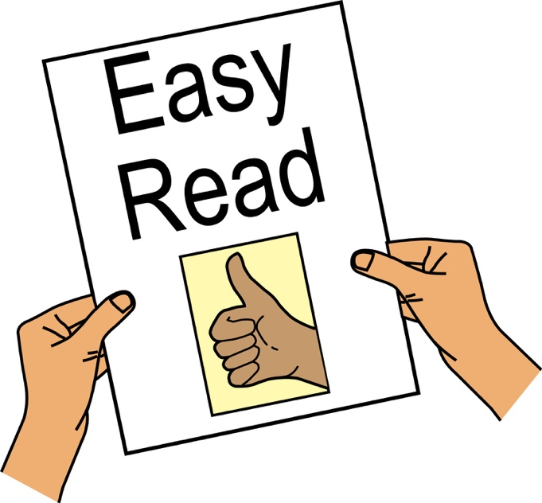
Written by Inclusion London, October 2017
What is a Deaf and Disabled People’s Organisation?
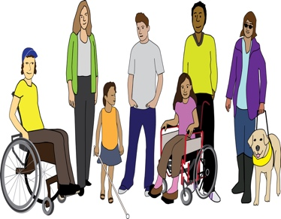
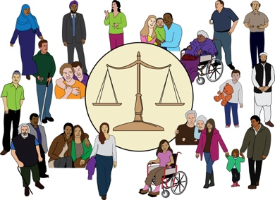
A Deaf and Disabled People’s Organisation is an organisation run by and for Deaf and Disabled People. They give important support to the 1.2 million Deaf and Disabled people living in London. They do this by:
- Working to make sure Deaf and Disabled people can use their rights
- Campaigning for equality and inclusion
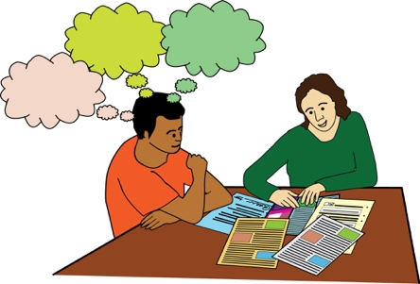
- Running many different services that support Deaf and Disabled people to stand up to discrimination and exclusion. Also, services that support them to have choice, control and independence.
Discrimination: this is when people are not treated in a fair way. This could be because of their sex, their age, or because they are Disabled people.
Exclusion: this means being left out or not being allowed to take part.

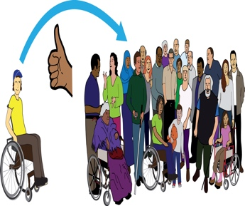
What is Inclusion London?
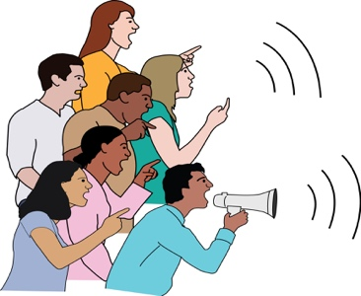
Inclusion London is the only organisation run by and for Deaf and Disabled people working across every borough in London. It pushes for Deaf and Disabled people’s equality and inclusion. It does this by supporting Deaf and Disabled People’s Organisations to have a strong and powerful voice together. It supports organisations to run empowering and well-run services for Deaf and Disabled people living in London.
Empowering: here this means services that make the people that use the service feel strong, good about themselves and in control.

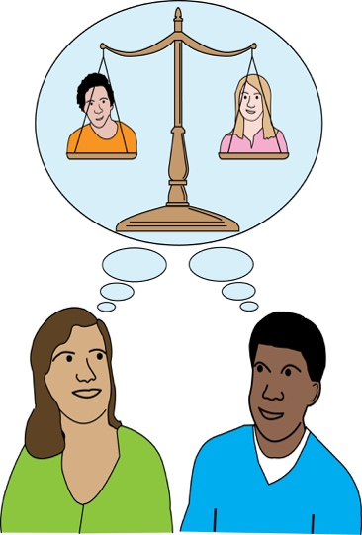
Background of the Into Sport project
Disabled people should have the same right as anyone else to be active and enjoy the good things that come from doing sport and physical activity. However, four out of five Disabled people are not active.
We therefore believe that taking part in sport and physical activity and the barriers faced when trying to do this, must be seen as a rights, equality and discrimination issues.

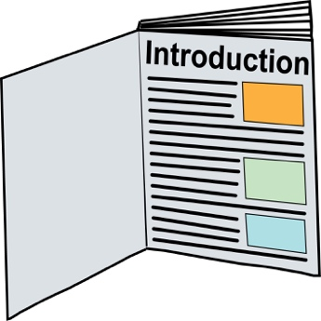
Introduction
This report is a summary of the information resource ‘Yes we can! Engaging Deaf and Disabled People in Sport and Physical Activity’, which gives more information about the learning from the Into Sport project.

What is Into Sport?
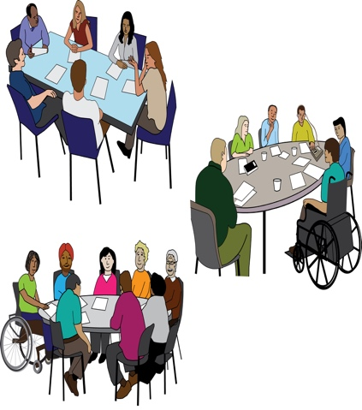
Into Sport is a three-year project (2014-17), funded by Sport England. It is a one of a kind partnership of Deaf and Disabled People’s Organisations across five London boroughs - Inclusion Barnet, Disability Advice Service Lambeth, Richmond Advice and Information on Disability, Southwark Disablement Association, Greenwich Association of Disabled People.
Partnership: here this is where two or more organisations work together.

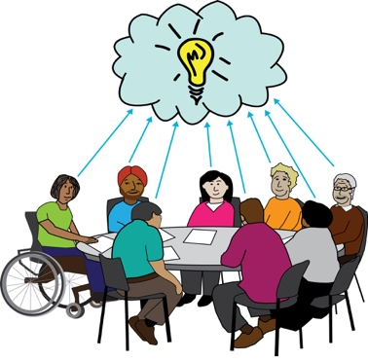
It is led and run by Inclusion London, with sports advice given by Interactive (which has now joined together with London Sport).

The aim of the project
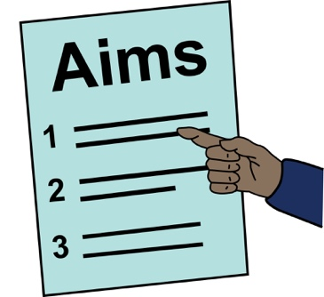
The aim of the project was to get more Deaf and Disabled people living in London taking part in sport and physical activity. This was to be done by building the skills of Deaf and Disabled people’s organisations. At the end of the three years:
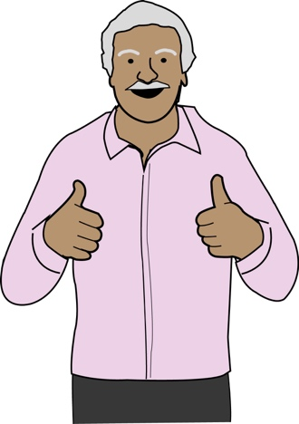
- 901 Deaf and Disabled people have gone from being inactive to active
Inactive: this means not being active.

- 42,343 sport activities have been done, this number is also made up of one-to-one advice and information sessions

The barriers Deaf and Disabled people face when taking part in sport and physical activity
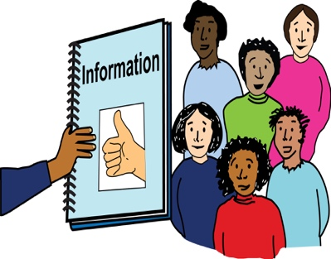
The information that we got from the Into Sport project shows that Deaf and Disabled people face many barriers. These can be
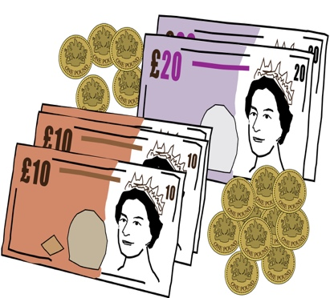
- Physical, these are barriers that stop people from getting around or accessing places
- Economic, these are barriers around money and either a person not having enough money or things being too expensive
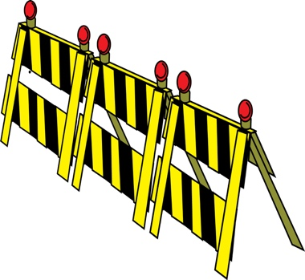
- Attitudinal, these are barriers that come from the way people think about and treat Deaf and Disabled people
These barriers make it harder and can stop people from taking part in sport and physical activity. We have put the barriers into the different groups below:

Attitudes
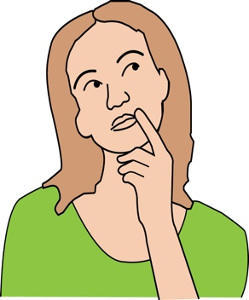
‘I’m not sure sport and physical activity is for me’
‘I never see other Disabled people at the leisure centre’
‘I’m bothered by other people’s opinions when I talk about sport and physical activity’

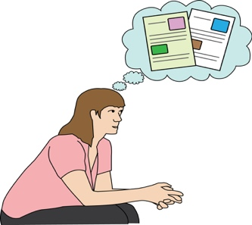
Not enough accessible information and advice
‘I don’t know where to look for information’
‘The information isn’t in an accessible format for me’

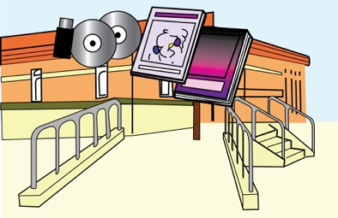
Places being inaccessible
‘Where do I go when I arrive?’
‘Will the equipment work when I get there?’

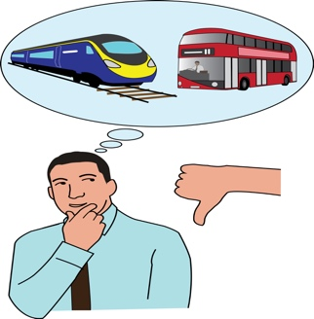
Transport barriers
‘Is there anyone I could travel with?’
‘What about accessible parking?’
‘How do I get there?’

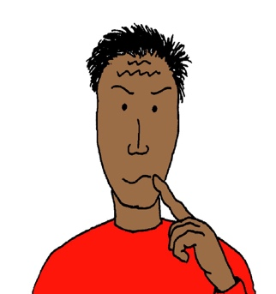
Not enough accessible and inclusive sport and physical activity
‘Can someone meet me and show me around?’
‘Can I start off by trying something with other Disabled people?’
‘Will it meet my access needs?’

Not enough of the equipment needed
Equipment: these are things that help a person to do things and get around

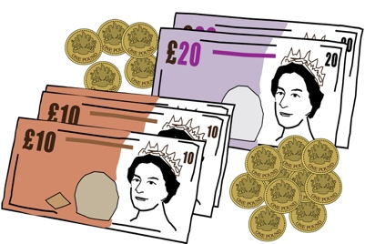
‘Do I need to bring my own equipment?’
‘How much does it cost to buy or hire equipment?

Taking part in sport and physical activity costs too much
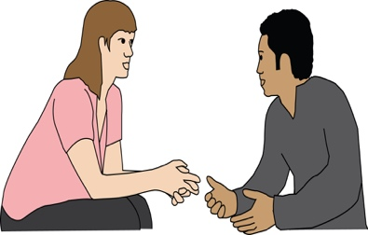
‘Are there any discounts?’
‘Does my support worker have to pay too?’

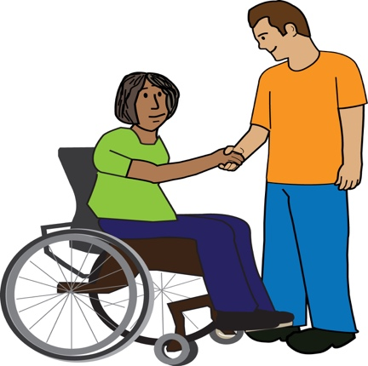
There are not many role models who work in sport and physical activity

‘Lots of my Disabled friends are volunteers but not in the area of sport and physical activity’
‘Why aren’t there any Disabled people working at my leisure centre?’

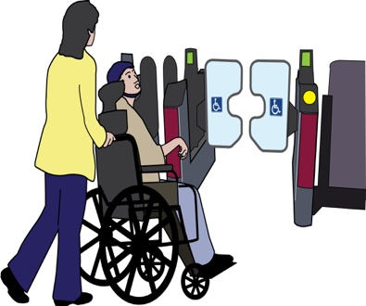
Not enough support to take part in a session
‘How can I get motivation and support to keep doing sport and physical activity?’
‘Can someone come with me?’

Not enough support for Disabled people with high support needs
‘Can I use my personal budget to take part in sport and physical activity?’
‘How can I find a personal assistant to support me to take part?’

Did you know:
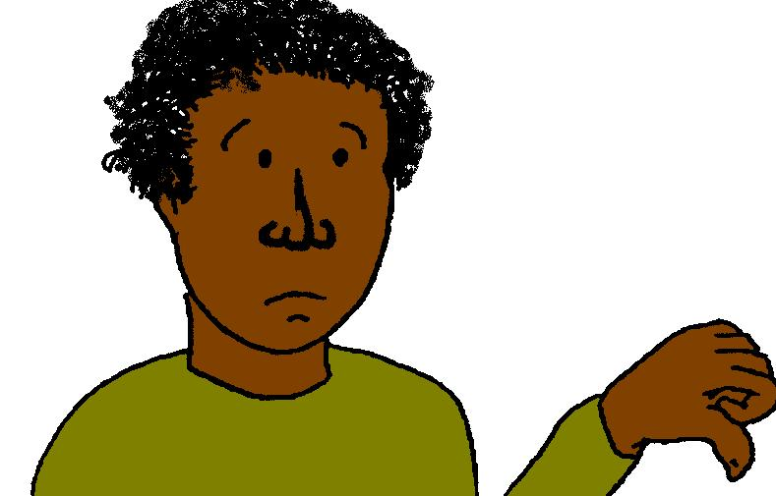
- Since 2012 the number of Disabled people doing physical activity has been going down
- 43% of Disabled people are inactive and only 21% of non-disabled people are inactive
- Only 9% of volunteer coaches and referees are disabled people

How Deaf and Disabled People’s Organisations are breaking down barriers to sport and physical activity: New solutions from the Into Sport project
Solutions: these are ways of dealing with problems or making something work in a better way.

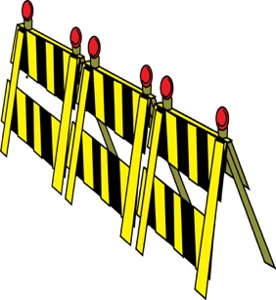
The Into Sport project tried and tested many ways of getting rid of barriers to sport and physical activity. Many of these solutions can be put into place by spending little or no money.
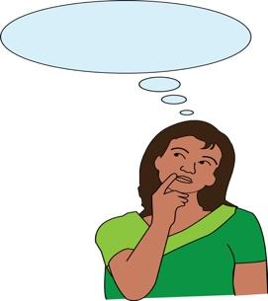
They can mostly be done by changing the way a Deaf and Disabled People’s Organisation works and changing the way it thinks about sport and physical activity. However, some of the changes would need more funding and more staff.

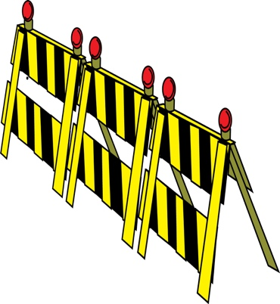
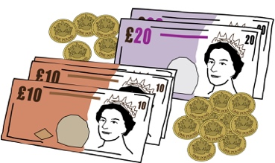
As well as this there are barriers that Deaf and Disabled People’s Organisations cannot get rid of on their own. Especially barriers such as there not being many role models working in the area of sport and physical activity and there not being enough support for Disabled people with high support needs. These will need a big change.
They will need time and money being spent across the area of sport and physical activity and in adult social care.
The following solutions show real experiences of the five Into Sport partner Deaf and Disabled People’s Organisations and what they found worked well.

Deaf and Disabled People’s Organisations show that sport and physical activity is possible for Disabled people
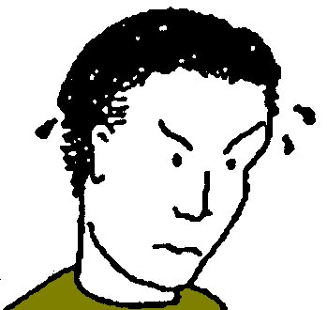
Many Disabled people think that sport and physical activity is not important in their lives. Many do not feel confident and are worried about:
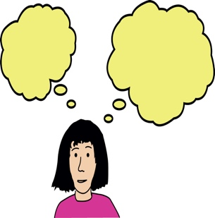
- How they will be able to take part
- How sports and physical activity organisations will meet their needs
- The attitudes of staff and the public at places where sports and physical activities are run

Solutions put together by the Into Sport Deaf and Disabled People’s Organisations:
- Use photos of ordinary Disabled people when advertising sport and physical activities. Try not to use images of professional athletes and Paralympians
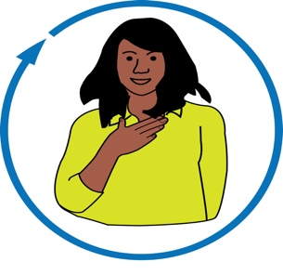
- Use real life examples of people that use local Deaf and Disabled People’s services

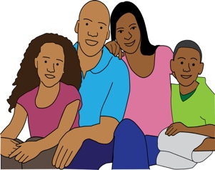
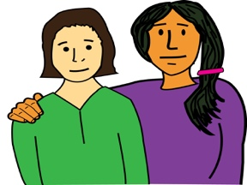
- Give one-to-one support for going to sessions and set up buddy and volunteer projects

- Help to change the attitudes of family, friends and support workers

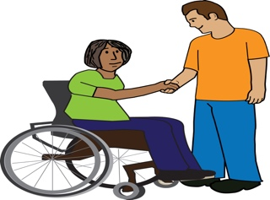
- Set up accessible sport and physical activities for people to get started, such as relaxed walking sessions or boccia groups
Boccia: this is a sport that is played in the Paralympics which is like bowls.

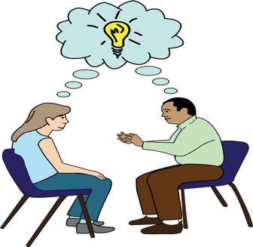
- Introduce people to different activities which are not seen everywhere and are not competitive, this means there is not a winner and a loser. For example, things like wheelchair-dancing.
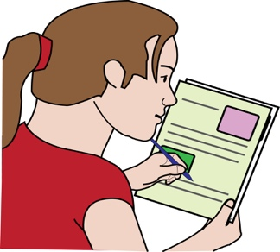
- Get together Easy Read information and tools about accessing sport and physical activity for people with learning difficulties

Deaf and Disabled People’s Organisations are building relationships with local organisations that run sport and physical activities
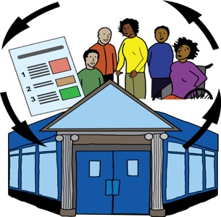
Through Into Sport, Deaf and Disabled People's Organisations have found that building relationships with local sport and physical activity organisations is very important. It is very important in making sure that there is accessible information and there are accessible activities.
Deaf and Disabled People's Organisations are in the best place to educate sport and physical activity organisations about the best ways of working and about how to get in touch with and work with Disabled people.
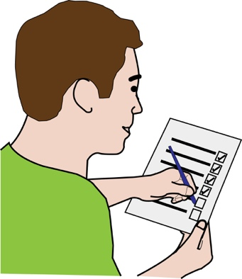
Solutions put together by the Into Sport Deaf and Disabled People’s Organisations:
- Support service users to be ‘mystery shoppers’ and check how well local sport and physical activity services are run

- Set up ways of communicating with local sport and physical activity organisations
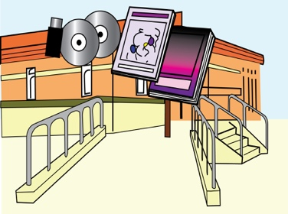
- Help by giving information to sport and physical activity organisations about what it means to be fully accessible and build more inclusive ways of working
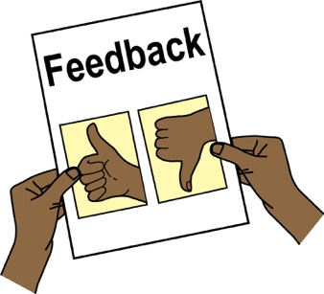
- Always ask for feedback from service users and share feedback with sport and physical activity organisations
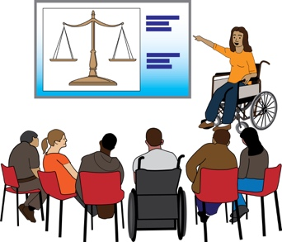
- Make sure organisations know about how important Disability Equality Training is for sports and physical activity staff

Deaf and Disabled People’s Organisations are helping to make sport and physical activity more accessible

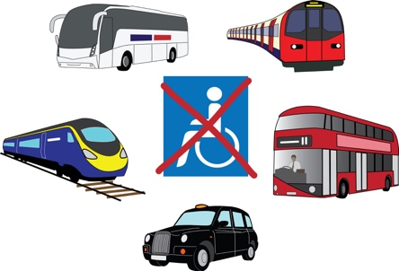
Sport and physical activities are sometimes said to be accessible when they are not. Getting to and from the activity can also be a barrier for some Disabled people.

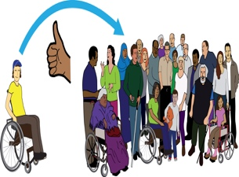
Solutions put together by the Into Sport Deaf and Disabled People's Organisations:
- Work with local organisations that run sport and physical activities to set up activities that are fully inclusive
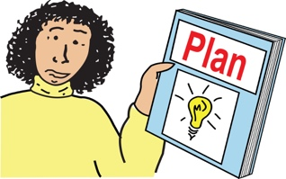
- Help to plan sessions that are for local Disabled people as a first step for some service users
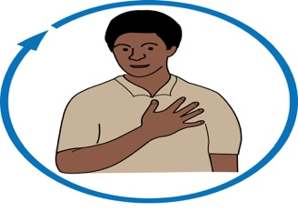
- Support people to find activities that meet their needs
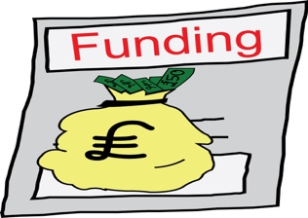
- Support local clubs or organisations to get funding for equipment and sessions for Disabled people
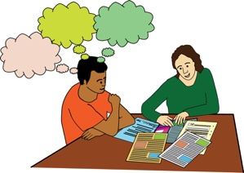
- Use local knowledge to help support service users to access and plan transport and travel
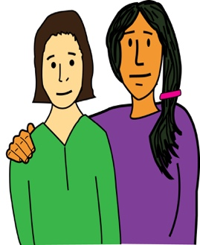
- Organise volunteers to go with service users

- Try to get Disabled people to go with each other to activities so they can support each other

Deaf and Disabled People’s Organisations are skilled at supporting and trying to get Disabled people to take part in sport and physical activity
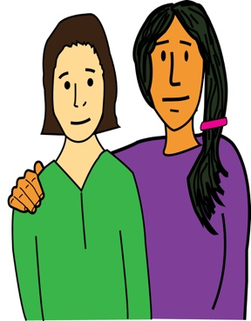
Some Disabled people will need support while taking part in sport and physical activity. This can mean:
- Supporting and motivating people
- Communication support
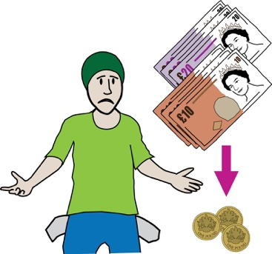
- Supporting a person during the activity

Into Sport has found that many Disabled people with high support needs want to take part in sport and physical activity but are not able to pay for the right support.
Into Sport had a Personal Assistance Access Fund, this was a pot of money that people could use to pay for support to take part in sport and physical activity. This supported a small number of people with high support needs to get personal assistants so that they could take part in sport and physical activity.

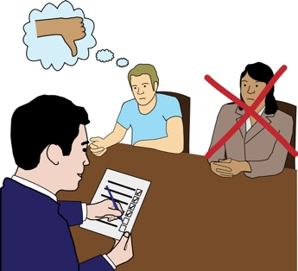
However, since this funding finished, people that have tried to get more support in their care packages so that they can take part in sport and physical activity support, have not been able to get the extra support.

Solutions put together by the Into Sport Deaf and Disabled People's Organisations:
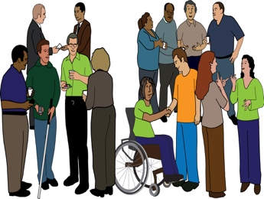
- Set up local networks of Deaf and Disabled people and volunteers that give support to each other

- Set up Facebook pages and groups where service users can get in touch with and support each other in a safe way. They can also share their sport and physical activity experiences
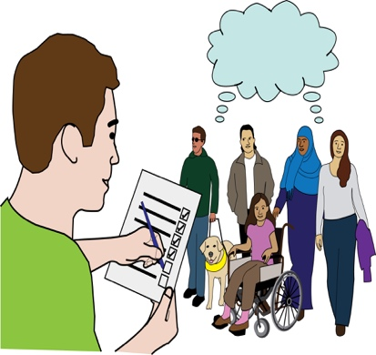
- Find out about local organisations that run sport and physical activity taster sessions. Also find out which sport and physical activity organisations give discounts and let personal assistants and carers go free
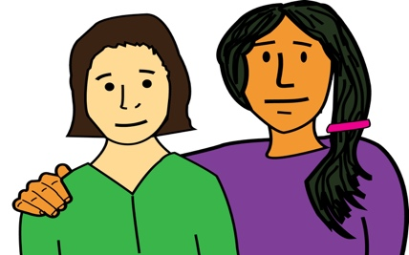
- Set up peer support and buddying projects

Deaf and Disabled People’s Organisations are helping to make sure that there is diversity in the sport and physical activity workforce
Diversity: this means having lots of different people from different backgrounds.
Workforce: here this means the people working in a certain area such as sport and physical activity.

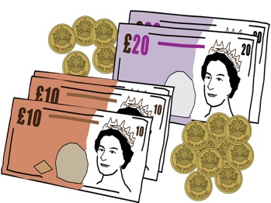
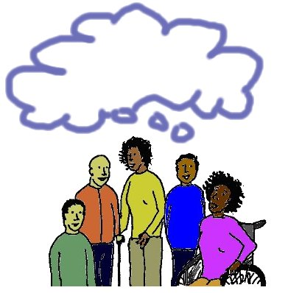
The sport and physical activity workforce should be made up of the same communities that it works with. However, the sport and physical activity workforce does not have enough Disabled people working in it. Dealing with this is not something that Deaf and Disabled People's Organisations can do on their own.
It needs big change in the whole area of sport and physical activity. There needs to be money and time spent on doing this.

However, there are some things that Into Sport Deaf and Disabled People's Organisations have started to do:
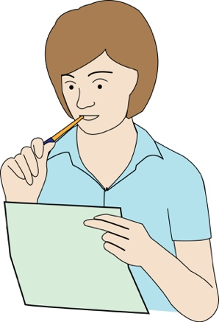
- Try to get service users to volunteer with local sports clubs and activity groups

- Look into which coaching and leadership programmes welcome Disabled people to apply

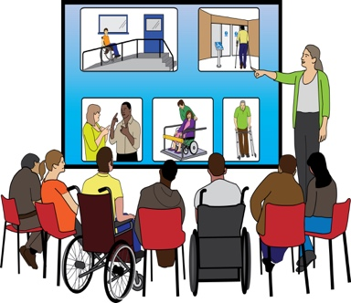
- Support service users who would like to train or work as coaches. This might mean talking to organisations that do training about the access needs of service users. They may also need to talk about a clear recruitment process or helping the person to apply for Access to Work funding
Recruitment: this is the process of hiring the best person for a job.

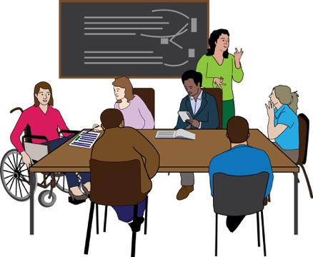
- Find out if there are courses which are made to meet the needs of different groups of people

Why the area of sport and physical activity needs to work with Deaf and Disabled People’s Organisations to support inactive Disabled people to become active
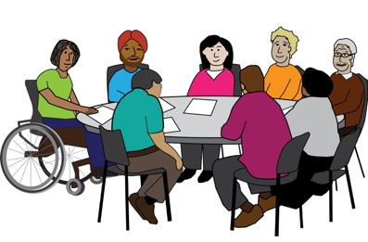
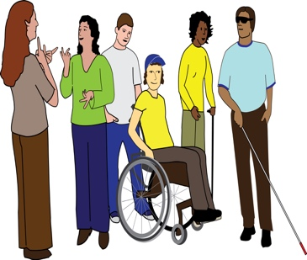
Deaf and Disabled People’s Organisations can reach Disabled people in their local communities like no one else. Disabled people tell them what is happening and therefore they can give a voice to the needs of local Disabled people.

These organisations are therefore very important to making sure that local sport and physical activity becomes fully inclusive. They are in a good place to:
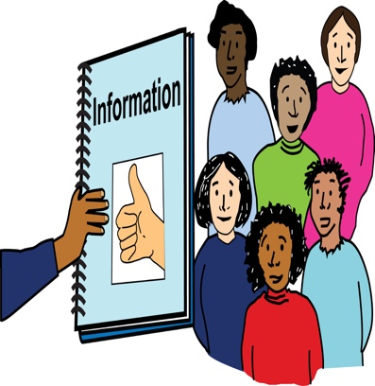
- Give information, help make changes and plan local sport and physical activity services

- Be a part of putting together local sport and physical activity plans

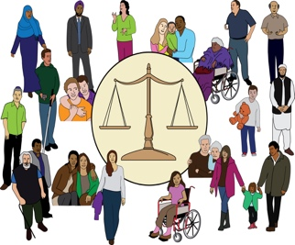
- Campaign to push for equal opportunities for Disabled people

- Make the community more accessible
This expert information will help to make the organisations that run sport and physical activity are more accessible and inclusive.

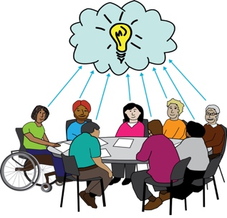
A summary of Deaf and Disabled People’s Organisations skills and ways of working that will support this change:
1. Expert information of real life experience of the barriers Disabled people face
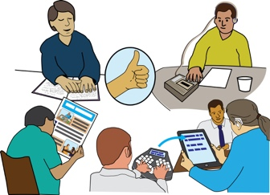
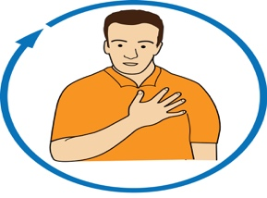
2. Understanding of how to make places accessible and accessible ways of running services

3. They offer personalised support
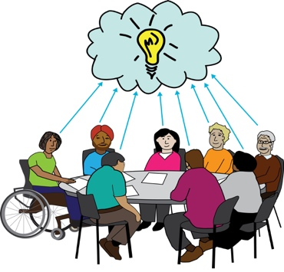
4. Skills in finding gaps in services and finding ways of dealing with barriers to sport and physical activity. They do this by finding new ways of running services
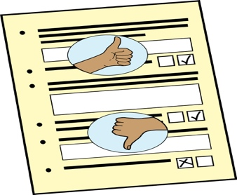
5. Service user feedback, which helps build stronger relationships between Deaf and Disabled People's Organisations and organisations that run sport and physical activities
6. A way of working which looks at the service user and their needs as a whole, such as understanding how sport and physical activity will help with a person’s wellbeing in the rest of their life
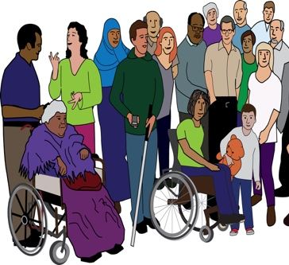
7. Links with the local community which lead to more Disabled people using services. Organisations not run by Deaf and Disabled people would find it harder to reach Disabled people who are often left out of sport and physical activity

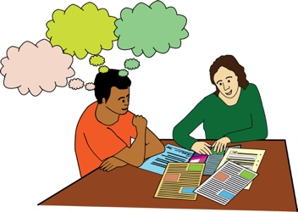
8. Use of peer support, buddying and volunteers as a way of running services. These have shown to be a very good way of making sure more Disabled people take part in sport and physical activity

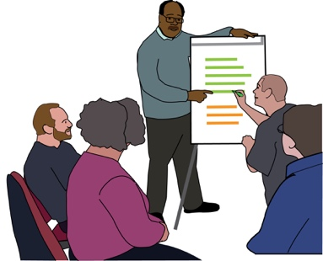
9. They make sure there are more employment, training and volunteering opportunities for Disabled people. This helps to make sure there is more diversity in sport and physical activity

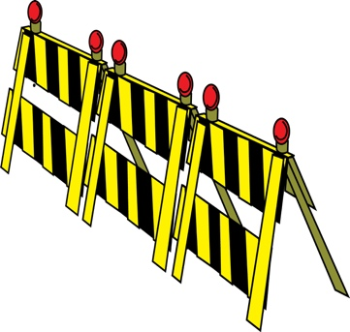
Conclusion

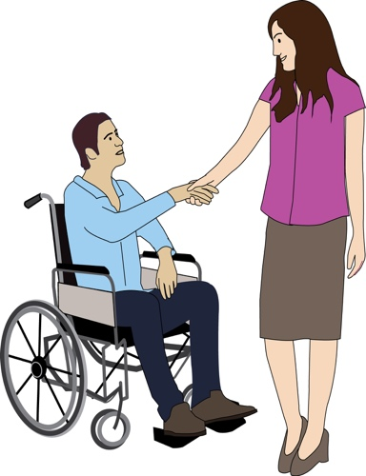
There is clearly still a lot to be done in dealing with the barriers that Deaf and Disabled people face when taking part in sport and physical activity. However, the Into Sport project has shown that even small steps towards inclusion can make positive change happen.

A very important part of this change is Deaf and Disabled People’s Organisations and sport and physical activity organisations working in partnership, this means working together. It is also important that changes are made in Deaf and Disabled People’s Organisations so that sport and physical activity becomes a part of their other services such as information, advocacy and advice.

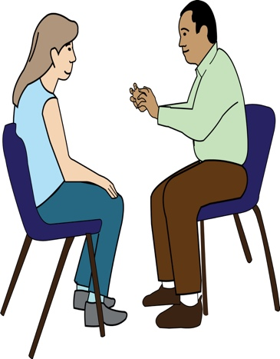
Peer support is also a very important part of this. It has been shown to help Disabled people feel more confident in sport and physical activity. It also supports people to get started and to keep on taking part. As well as this, peer support helps to build strong communities and stops people from being left out and on their own by linking people into groups, local services and support.

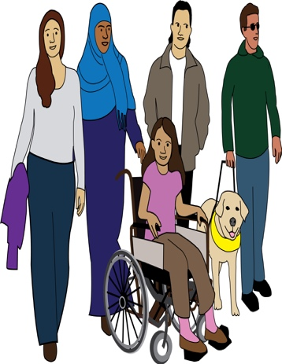
Much more needs be done to have a workforce with more diversity. Work needs to be done to get more Disabled people into volunteering, coaching, paid jobs, leadership roles and into jobs where decisions are made within sport and physical activity organisations. This will lead to people knowing more about the needs and barriers that Deaf and Disabled people face.
It will also lead to more role models and more people starting sport and physical activity. Over time it will lead to a change in culture where Disabled people take part in every area of sport and physical activity.
Because of the Into Sport project going so well, more funding has been given to the project which will take it up to March 2018

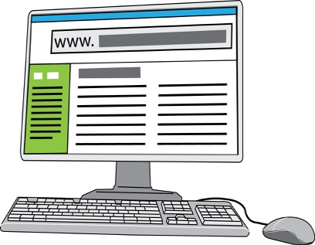
Useful Links
English Federation of Disability Sport
www.efds.co.uk
London Sport
www.londonsport.org
Full version of the ‘Yes we can! Engaging Deaf and Disabled People in Sport and Physical Activity’ resource (written March 2017)
www.inclusionlondon.org.uk/yeswecan

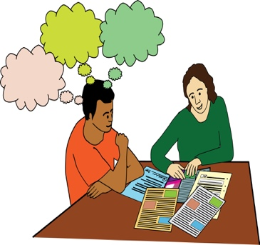
Places where Deaf and Disabled People’s Organisations can get support to get sport and physical activity on their agenda
There are different places where Deaf and Disabled People's Organisations that are interested in sport and physical activity can get support. Such as:
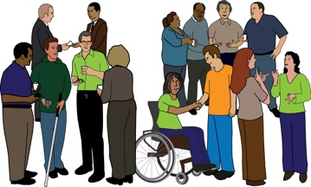
- The local authority
- The disability team at London Sport
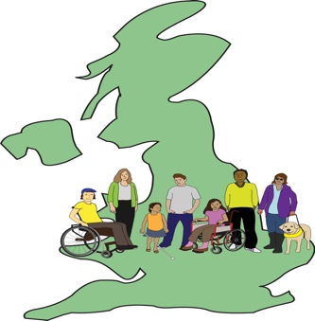
- Local sport and physical activity networks
- Different pots of money for this type of work
- A number of local, regional and national organisations.
For full information please go to Section 5 of the full version of ‘Yes we can’, pages 39-44.

Written by Inclusion London, October 2017

Copyright: this means legal information about how this document and the information in it, can be used
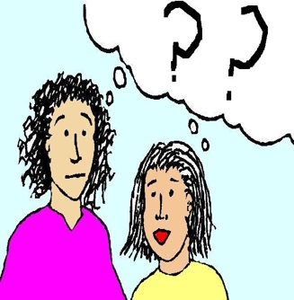
We are happy for any part of this document to be copied and used, but we ask that you say that it has come from Inclusion London.
Inclusion London has tried to make sure that information in this document is up to date and correct. However, we cannot always be sure, so it is up to the person reading this document to get their own legal advice when needed.

Get in touch:
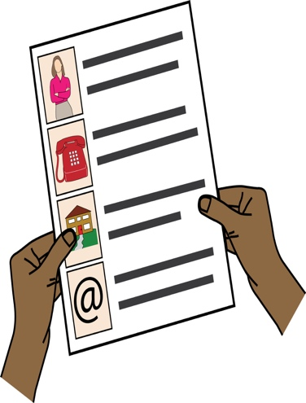
By post:
Sian Williams, Into Sport Project Manager
Inclusion London
336 Brixton Road, London SW9 7AA

By email: intosport@inclusionlondon.org.uk
By telephone: 020 7237 3181

Website: www.inclusionlondon.org.uk/intosport

‘Sporting Future: A New Strategy for an Active Nation’, HM Government, December 2015, p.22
‘Sporting Future: A New Strategy for an Active Nation’, HM Government, December 2015, p.66

