Making Access to Work Better

Our recommendations
Recommendations: these are the things that we think should happen to make Access to Work better.

These recommendations have been put together by Deaf and Disabled people. They have been put together using our experiences of problems that we have had recently with Access to Work. The recommendations deal with the issues that came out of our research report called Barriers to Work.

Recommendations
October 2017

- Agree to an Access to Work programme that has the values below:
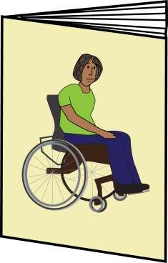
The aim of Access to Work must be to make sure that Disabled people have equal access to:
- Get into work
- Stay in work
- Get on in work
Support through Access to Work should look at what we can do and should support us to do as much as we can.
It should not:
- Put Deaf and Disabled people at risk with money
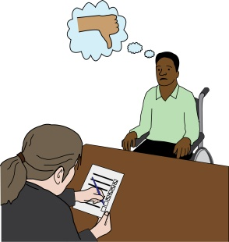
- Give Deaf and Disabled people less of an opportunity at work
- Make people use the wrong type of support
- Make inequality seem normal

- Make Deaf and Disabled people deal with hostility and discrimination.
Hostility: this means not being nice to a person.

- Put Access to Work at the centre of the government’s strategy to get more Disabled people in work.
Strategy: this is a big picture plan.

“Improving Lives: the work, health and disability green paper” talks about Access to Work only a few times.
However, there is a lot of information that shows how well Access to Work supports Deaf and Disabled people with work. Access to Work also brings in more money that it spends.
Green paper: this is a document written by parliament. This is the start to bringing in a new law. This document is written so that people inside and outside of parliament can talk about the ideas in the document and say what they think.

To get more Disabled people into work we must have a better Access to Work that can support more people.

- Give Access to Work what it needs so that it can support Deaf and Disabled people who are looking for work, to move into work.

  - Give new Access to Work customers an idea of the support package that they would get so that they can show this when applying for jobs. They could use this to show how they will use support to do the job.

  - Look at the rules for Higher Level Permitted Work customers. These rules say that these customers can only get support at work for 52 weeks. The rules for the Employment and Support Allowance and Universal Credit have changed so that people can work for more than 52 weeks.
Higher Level Permitted Work: this is for people who get some disability benefits which mean they can only work for 16 hours each week.

However, with Access to Work the amount of time a person can get support has not changed and still stops at 52 weeks.

  - Make Access to Work open to Deaf and Disabled people getting experience through volunteering and other types of work experience.
At the moment the rules mean that only people on some types of internships, trainee jobs and work placements can get support.
Internship: this is when a student or someone in training works in an organisation to get experience or to get a qualification. Sometimes this work is not paid.

- Have better job security and job stability for Deaf and Disabled people in work.
Job security: this means knowing that your job is safe and that you probably won’t get fired.
Job stability: this means having and keeping the same job, mostly working the same hours and getting paid around the same amount.

  - Bring down the waiting times for getting Access to Work support to 4 weeks. If it is any longer it can mean that it is too long for employers to wait and it could put a Disabled person’s job at risk.
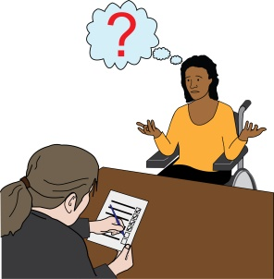
  - Don’t have assessments so often for people who have a lifelong condition or a condition that keeps on coming and going; this can be called a chronic condition.
Another assessment should only be done if there is a change in support needs or for conditions that are thought to change over time.

  - Give Access to Work support for longer amounts of time. This is very important for
self-employed workers. It gives them more job stability. It also means that they don’t waste time and have less risk of losing their job because of reassessments and bad assessment decisions.

  - Advisers should not bring down Access to Work support when people do not use all of their budget from the year before. This should not happen when the reason for not using all of the budget is sickness or being in hospital.
  - Access to Work should be responsible for getting new equipment or fixing broken equipment for as long as the person is getting Access to Work support.
  - Make Access to Work support easier to move from one job to another. This is very important for self-employed people as it means they can take up new work without waiting for assessments.

It means there are not so many barriers to taking up short pieces of work where waiting for an Access to Work assessment would mean a person could not apply.
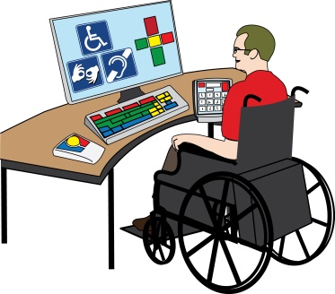
  - Review how wheelchair equipment is given, because it can be long and difficult. This is so that wheelchair users have the same chance as everyone else.

- Bring in new systems to bring down waiting times, bring down bad ways of working and deal with fraud.
Fraud: this is when a person gets money, support or a benefit that they are not meant to get. This is usually done because a person lies about something or they do not tell the organisation when something changes in their life.

  - Set up an online way of getting the money for Access to Work support. These would stop both customers and support staff from being victims of any fraud. It would also bring down waiting times when forms go missing.

  - Paying online would bring down waiting times or problems with payments missing in the post.

- Have better communication with customers, new customers and employers
  - Tell customers three months before their support ends, and again one month before. This is so that there is enough time for them to apply for more support without getting in the way of their work in any way.
  - Get back to any questions from the call centre in no more than 48 hours.

  - Let customers know in writing about any changes to Access to Work support and how it is given. For example changes to rates of pay for British Sign Language. Access to Work should give clear reasons for any changes.
  - Give clear information on what to do if you do not agree with a decision and how to make complaints.

  - Bring back having a named person for each person’s Access to Work support. Access to Work customers should be able to get in touch with their named person at any time when using Access to Work support.

  - Things should be put in place so that customers can get in touch with Access to Work in a way that meets their access needs. This could mean in British Sign Language, using a computer, in Easy Read, face to face visits or using another person if that best meets the customer’s needs.
Access needs should be written down and respected by all Access to Work staff at all times when getting in touch.
  - Have better signposting, information and advice for new customers and employers.
Signposting: this is when a person or organisation tells someone where they can get the service or information that they need.

  - Good communication should be part of the rules for customer service used by Access to Work staff. The rules should help to get rid of ideas and ways of treating customers as if they are problems for society.

- Make decision making in Access to Work better
  - Access to Work staff need Deaf and disability training given by Disabled people’s organisations. The training should be done using the social model of disability.

  - Have better information for staff on Minimum Needs, this means the amount of support a person would need to be able to work. This is to make sure that Access to Work support packages meet all Deaf and Disabled people’s support needs at work.

Deaf and Disabled people should have choice and control over the support they need and should not have the wrong type of support pushed onto them.

  - Support needs of customers should be the most important thing rather than trying to give support for shorter amounts of time.
It needs to be seen how important it is having long-term support which means that Deaf and Disabled people can stay in and get on in work. This is the same for all Disabled people.
  - Advisors should be open to customers having the choice about how they would like their support needs to be met. This should be done instead of using the same kind of support for everyone.
  - Look into how the 80% and 20% rule is used for meeting the support needs of people with learning difficulties or disabilities in different jobs.

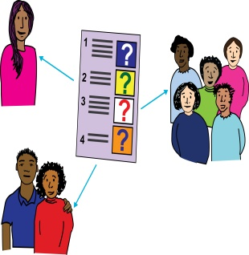
  - Make decision making more open by talking to Deaf and Disabled People’s Organisations about all changes to staff guides and how to tell customers about this.

  - Have better staff training in making decisions and how they understand the staff guides. This is to make sure that staff make decisions in the same way. It also means that there would be less complaints.

  - Have a clear set way of deciding how much support someone should get which is done in the same way and is fair for everyone. This will mean that decisions will be made in a more open way and it will stop differences between customers with the same needs.

- Get rid of the limit which in unfair for Deaf and Disabled people with high support needs in important job roles.

For as long as this limit is still in place two things need to happen:

  - Access to Work must get in touch with customers before they reach their limit for support. This is to make sure that they don’t use support that they cannot then pay for.

  - One-time costs should not be a part of the limit. For example buying a wheelchair would bring down how much money a person could spend on support in a year. This could bring down the amount of support so much that the person does not have enough support to work.

- Look at the information on self-employment ‘business viability’
Business viability: this means whether a business makes enough money to be worth running.

  - Speak with Deaf and Disabled people about the barriers in the Access to Work guides to self-employment, this means working for yourself. Being self-employed can be good for Deaf and Disabled people. It can mean more flexibility, this means the hours or the way a person works can be changed when needed.

However, the Access to Work guide on self-employment is not flexible and stop self-employment from being a good thing for Deaf and Disabled people.
  - Look at the limit for business viability of £5876 coming in each year. This is a barrier for Disabled people who are
self-employed and do not have very much money coming in or who work part-time.

  - Have a longer start up time where the limit of £5876 is not used. At the moment it is set at 12 months, but in many cases it takes much longer for a business to be set up. This is more important for Deaf and Disabled people who may need longer because of the extra barriers we face.

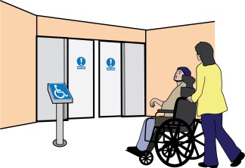
  - Make sure the Access to Work guides have enough information about time that Disabled people need to take off because they are ill or time they need to do other things to do with their disability. This is something that may happen over and over again for Deaf and Disabled when self-employed, especially if they work on their own.

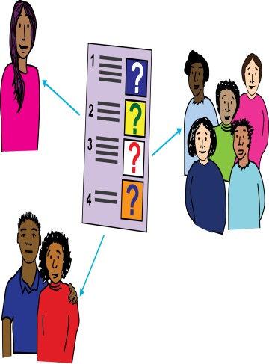
- Put Deaf and Disabled people back at the centre of Access to Work. Speak to StopChanges2AtW and other user-led organisations of Deaf and Disabled people. Ask them about any future changes to the way that Access to Work works or any changes to the way that the service is run.

- Deal with the unfair way that Deaf/deaf, deafened and hard of hearing customers are affected by changes to Access to Work

  - Make sure that were interpreting support is needed, Deaf Access to Work customers are always given a qualified Registered Sign Language Interpreter. This needs to happen unless the customer agrees that a trainee Sign Language Interpreter can meet their support needs.

  - Ask and get feedback from Deaf/deaf, deafened and hard of hearing customers on any change with specialist teams and the planned video relay service for British Sign Language. This is to make sure that it is fully meeting their access needs.
Video Relay Service: this is a way for deaf people to be able to talk to other people on the phone or using a computer.

  - New technology should only be offered as a choice or as part of a mixed support package. It should not be given in the place of other types of support to save money. They must fully meet access needs.
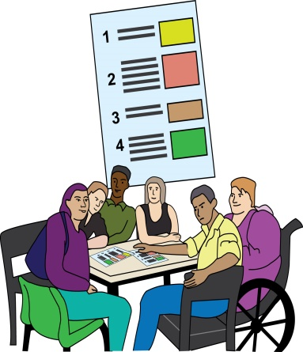
  - Do not bring in the Framework Agreement for interpreting services in Access to Work. This will mean that customers have less choice and control. It will also put at risk the jobs of interpreters.
Framework Agreement: here this is an agreement so that all interpreting services for Deaf Access to Work customers can only be given to some agencies and organisations which are decided by Access to Work. It means that people cannot choose any interpreter that they want.

To make sure that changes in the future will work, speak to the National Union of British Sign Language Interpreters, this organisations works to give interpreters better rights.
Contact
Ellen.Clifford@inclusionlondon.org.uk
Telephone: 020 7237 3181 www.stopchanges2atw.com
@stopchanges2atw

Supported by
StopChanges2ATW
Inclusion London
Disabled People Against Cuts
People First (Self Advocacy)

