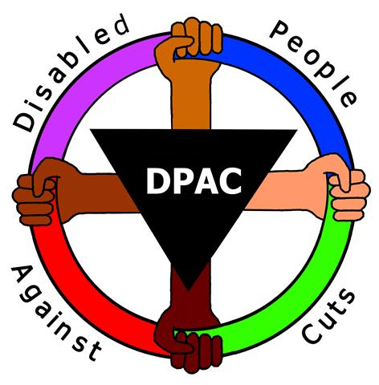

Independent Living Campaign Conference
Date: Saturday 25 November
Venue: 336 Brixton Road, London, SW9 7AA
Time: 11.30am – 4.30pm (Registration 11 – 11.30am)

The aim of this year's Independent Living Campaign Conference is to take stock of the key barriers to independent living that Disabled people who use adult social care services face. The day will aim to assess how far the situation has deteriorated in the last year and also to explore a shared vision for an independent living support system that can truly uphold our rights.
There will be speakers and workshops on campaigning for Article 19 rights, charging and Disability Related Expenditure, Direct Payment rates and recruitment, using the media to make the invisible visible and international models of independent living as well as discussions on setting out vision and next steps.
If you would like to book a place, please contact ellen.morrison@inclusionlondon.org.uk with your access needs and dietary requirements.
The venue is accessible, please see the website for more info: http://www.weare336.org.uk/

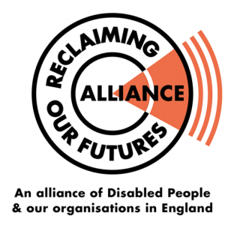
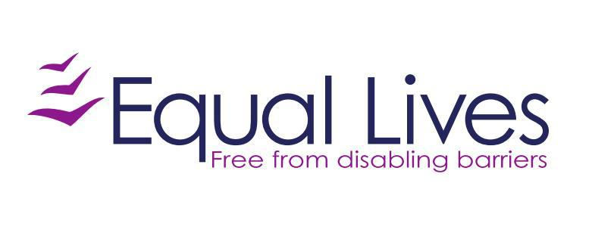
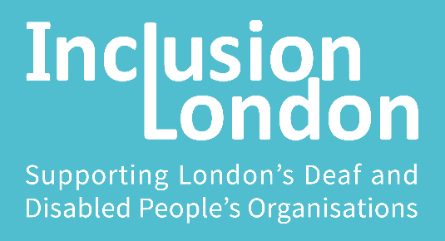

Background:
The Independent Living Campaign is the successor to the #SaveILF campaign, set up in 2011 to oppose the closure of the independent living fund. We accurately predicted the closure would have a devastating impact not only on the lives of former ILF recipients but also on those who would miss out on it. The campaign – supported by Disabled People Against Cuts, Inclusion London and Equal Lives – challenged the closure in a number of ways including a petition backed by the cast of Coronation Street, two high court legal challenges and an appeal, a complaint to the United Nations and a number of direct actions and protests. DPAC also triggered an investigation by the UN into grave and systematic abuse of Disabled people's rights. Campaign members are in daily contact through a peer support email group, sharing experiences and tips for managing social care assessments and cuts. The supporting organisations continue to work with solicitors to develop resources to help individuals understand their rights under the Care Act and to make referrals for legal advice where needed. In 2016 Inclusion London published its evaluation report into the impact of the ILF closure one year on. The major focus of the campaign, besides supporting individuals who are suffering injustice through denial of their rights to independent living, is now to campaign for an independent living support system free at the point of need paid for by general taxation and independent of local authorities.

