Your right to information in easy read
The law gives a right to people with learning difficulties to ask for information in easy read.
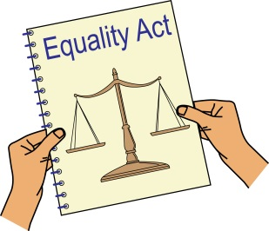
The Equality Act – is the law that says people should not be treated badly because they are disabled.
It also says that when someone provides a service, they should take steps so that disabled people can access it.
This is called making reasonable adjustments.

The services are things like:
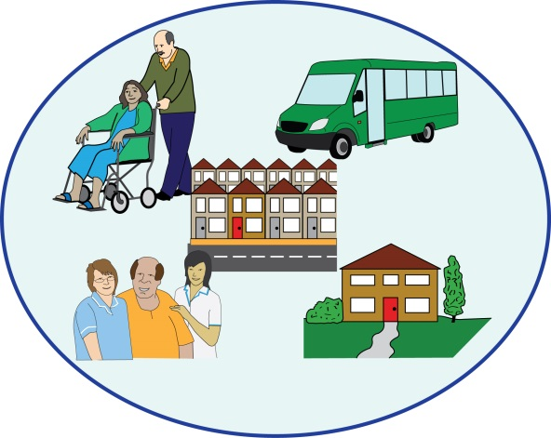
Transport,
Shops and businesses,
Banks,
Cinema, theatre,
Café
Housing, social care
Emergency services: police, fire and ambulance,
Voluntary organisations and clubs.
The Equality Act also says that public bodies such as government departments, like DWP, the NHS or local authorities should take steps to facilitate disabled people’s access. This includes access to information.

The law says that providing information in accessible format is a step which is reasonable for a service provider to take. Unless they have a good reason, a service that does not provide information in easy read could be acting against the law and discriminating against people with learning difficulties.

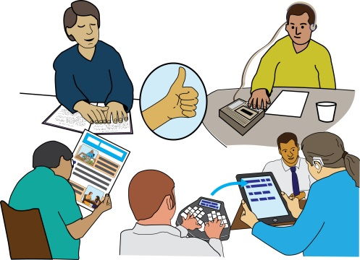
The Equality Act also says that a service provider should not sit and wait until a person with learning difficulties comes to them and asks for information in easy read. They should think ahead and remember the needs of people with learning difficulties.

In Social care
The Equality Act applies to social care, but in addition to it, The Care and Support Guidance requires local authorities to provide information in accessible formats.
This includes:
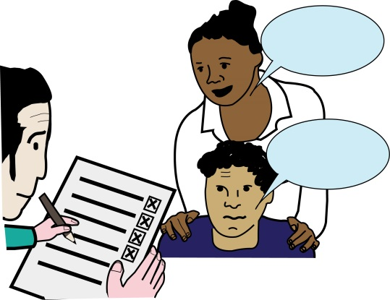
When local authority wants to find out what kind of support you may need
When they give you Information and advice. Important materials explaining how to get support from social services should be in easy read.
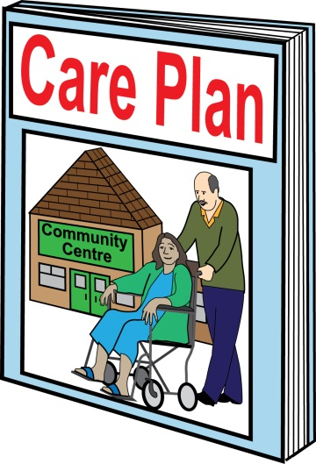
To make sure you are involved in the process of deciding what support you need.

When local authority tells you what they decided about your case.

When giving a copy of a care plan
When explaining about personal budget

When going to a doctor
The document called the NHS Accessible Information Standard says that health and social care services should
find out if you need information in alternative format,
Record this,
Provide information in the format you need.

See Services, Public Functions and Associations Statutory Code of Practice, 7.48

