

Easy Read.
Inclusion London
Annual Report
2014-2015

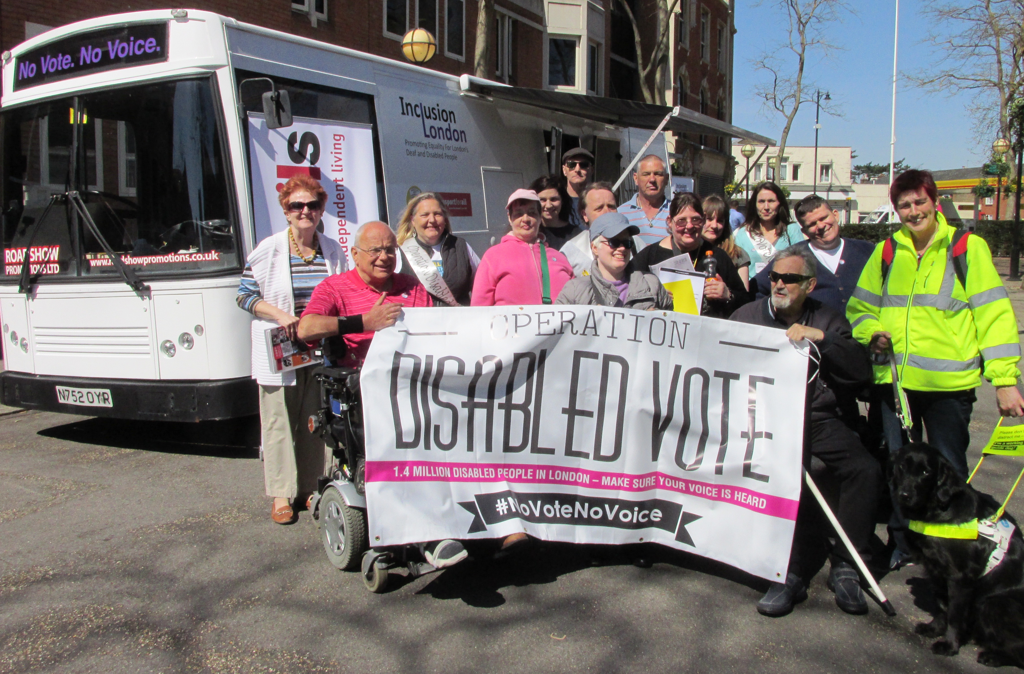

About Inclusion London

Inclusion London is the only London wide organisation run by and for Deaf and Disabled people.  Set up in 2008 our job is to work for Deaf and Disabled people’s equality and inclusion by supporting Deaf and Disabled people’s organisations (DDPOs) in London to have a strong voice and run good services for Deaf and Disabled Londoners. | 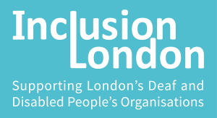
We believe in human rights, the Social Model of Disability, the Cultural Model of Deafness and independent living.  We want a society with no discrimination where everyone is able to take part and everyone is valued.  We work to make this happen. We try and get rid of the things that discriminate against us and work in an accessible way with Deaf and Disabled people leading. | 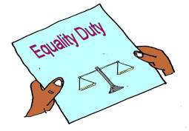
We have 3 big aims that direct our work:  - To support London DDPOs to have a strong voice so that the needs, interests and views of Deaf and Disabled people are met and disabling barriers removed.  - To provide accessible services that build skills, knowledge and help London DDPOs grow.  - Tell people about the good things DDPOs do and how DDPOs make London a better place |   

Chair’s report
Inclusion London got stronger and bigger in 2014-2015  We supported 90 London DDPOs and a 192 disability sector organisations in London over the year. | 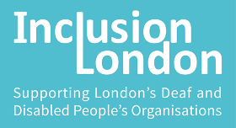
- 90% + of people on our training said it was excellent  - We set up two new DDPO partnerships the Into Sport project and the “Making It Work” consortium – where DDPOs work together  - We helped the Save the Independent Living Fund (ILF) campaign  - We helped get Article 19 of the United Nations Conventions on Rights of People with Disabilities (UNCRPD) and Disabled people's right to independent living in the Care Act 2014 legal guidance | 
- We had £98,553 more money coming in than last year  - We had a total of £592,839 money coming in  - £82,041 of this money was from training and consultancy income  - We had spent a total of £570,071 which left £22,768 to put in our reserve  - We now have £97,563 in our reserve | 
- We became a registered charity  - We got a new Board of Directors  - We made a new 3 year Strategic Business plan which shows what we want to do over the next 3 years | 
Our staff and Directors want to stop the discrimination and inequality faced by the 1.4 million Deaf and Disabled Londoners in this city  We want to carry on supporting DDPO’s so they can keep helping Deaf and Disabled Londoners | 
Zara Todd, Chair

Our work in 2014-2015
We worked with 90 DDPOs and a 192 disability organisations in London over the year.
We ran 27 training sessions for 280 people on fundraising, business planning, bid writing, being a good manager and disability equality. | 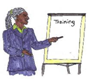
We ran 10 networks meetings for 100 people. | 
We gave “1-2-1” business and money advice to 56 DDPOs. | 
We made 17 policy and consultation papers. | 
We set up and supported two DDPO partnerships made up of 14 DDPOs. | 
- We had 11 meetings with MPs and Lords and ran 3 big meetings with MPs  - We ran 5 campaigns on Deaf/disability equality issues  - We trained over 170 people in lobbying and campaigning | 
- We trained over 600 London Underground staff in Disability Equality | 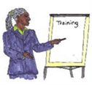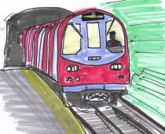

Good things we did over the year
We got Deaf and Disabled people on 6 TV programmes and in 9 newspapers | 
We helped the Save the Independent Living Fund (ILF) campaign which kept the ILF open for a bit and got the media talking about independent living | 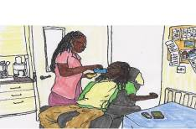
We helped get Article 19 of the United Nations Conventions on Rights of People with Disabilities (UNCRPD) and Disabled people's right to independent living in the Care Act 2014 legal guidance | 
We set up Operation Disabled Vote to get more Deaf and Disabled people in London to register to vote. | 
We helped get the Mayor’s Office for Policing and Crime (MOPAC) to write a Hate Crime Reduction Strategy to cut down Hate crime | 
We supported 26 DDPOs to do campaigns and policy work | 
Our Into Sport project got 172 non-active Disabled people to take up Sport and Physical Activity | 
90% of people say our training and support is excellent | 
Nearly 70% of people said our information and website helped them keep up to date with news and information | 

What DDPOs say about our work
“The support from Inclusion London staff and peer networks has helped us grow as an organisation. Knowing that there is always someone to bounce ideas off and that Inclusion London are always addressing the hot issues has been invaluable. We would not be where we are today without IL support.”

“[The bid writing training and follow up surgery] improved my understanding of what was required to write detailed and informative bids”

“We are focusing on fundraising and trying to establish it as a project in its own right. Training has helped our organisation to take this forward as an area of development. Has helped us develop our strategy and plan and the tools we use. Has helped me as an individual develop my professional skills and my confidence in dealing with situations”

“It’s helpful to gain clarification of policy and then be able to pass on information. I've gained info from the Legal network which has enabled me to appeal situations and others in similar situation to consider appealing policy in relation to our care packages”

“We are hosting our first Hustings this year. This would not have been possible without the advice and guidance from Inclusion London” (OurElection2)

“[The policy resources] increased my knowledge of the wider policy landscape”

“You address a lot of issues, always have time for sharing experiences and are very inclusive”

“I work for a very small user led organisation, I only work one day per week as a campaigns officer. I am able to access more information, tools and support through all the resources provided this means I am able to be more effective in my role and I am far more in touch and up to date with key issues arising and equipped to deal with them. Our organisation is going from strength to strength because of the support we receive from Inclusion London”

“The disability equality course was a real eye opener that alerted me to the changes that we need to make to allow our resources to be more accessible”

Our capacity building services and projects
We run 3 projects to help support and build London DDPOs and the wider disability sector. | 
The Power Up Project  Funded by London Councils and run with Transport for All. The project provides information, advice, training and networking to meet the needs of London DDPOs and the wider disability sector. The Power Up project provided support to over 280 DDPOs and disability sector organisations in 2014-2015.  To see what the project is running go to www.inclusionlondon.org.uk/powerup | 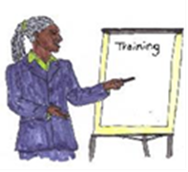
Business Development Project.  Funded by the City Bridge Trust this project provides:  - Help to understand what you need to do to make your organisation stronger and more effective  - Training and advice in money and business skills  - Hands on “1-2-1” money and business support to organisations  The project also works with the Power Up project to support setting up and DDPO partnership working.  The project worked with 56 DDPOs in 2014-2015. | 
The Into Sport project. Funded by Sport England, the project works with 5 London DDPOs to get more Deaf and Disabled people into sport and physical activity.  The project got 172 Deaf and Disabled people to take up sport and physical activity in year one of the project. | 

Our campaigns and policy work
Our campaigns and policy work supports DDPOs to get their voice heard . We voice Disabled people’s views through consultation responses and information papers, and by taking action such as lobbying, demonstrations and using the law.  We run 2 campaign projects: | 
Campaigns & communications project. Funded by Trust for London . This project provides campaigns support to London DDPOs so they can get their voice heard at a local, regional and national level. The project:  - helps DDPOs meet with Ministers and Parliamentarians, lobbying their Local Authorities and use the media to get their messages across.  - runs campaigns training and resources for DDPOs  - provides “1-2-1” advice and support for DDPOs local campaign work  - supports the Policy and Campaigns forum | 
Our Election2 project  Funded by Trust for London this 2 year project helps us provide specific training and support to DDPOs in the lead up to local, mayoral and General Election. | 

DDPOs in London
Inclusion London supports over 90 Deaf and Disabled People’s Organisations (DDPOs) and groups in London. We have detailed information on 78 of these DDPOs. Together, these DDPOs work with and support over 70,000 Deaf/Disabled Londoners.

Income (money coming in)
- These 78 DDPOs had a total turnover of about £25,872,270 for the year ended 2014.
- 15 have no income at all, but for the other 63 organisations the average income is £417,000.
- 14% of organisations have an income between £500,000 and £1 million, and 6% have an income over £1 million.

Employees
London’s DDPOs employed at least 430 full time equivalent (FTE) staff this year. 46% of these employees are Deaf/Disabled.

Board Members
From our 78 DDPOs:
- 35 DDPOs (45%) have Boards where Deaf and Disabled People make up at least 75% of Board membership.
- 16 DDPOs (21%) have Boards where Deaf and Disabled People make up between 30% and 75% of Board membership.

Services
Our 78 DDPOs provide services to an estimated
- 79,000 people a year
- 73,000 of these are Disabled/Deaf people. The rest are carers

Services and support DDPOs provide:
- 50 (64%) provide advice and advocacy services
- 51 (65%) carry out campaigning, research and representation work
- 13 (17%) provide personal assistance services
- 8 (10%) provide health and care services
- 25 (32%) provide self directed support, admin and brokerage services
- 42 (53%) run sport, social and cultural activities
- 52 (66%) provide training, volunteering and employment support services

Money from April 2014 to March 2015
 | In 2014-2015 | In 2013-2014
Total money in (income) | 592,839 | 494,286
Total money spent | 570,071 | 455,414
Total money left over | 22,768 | 38,872
Total money saved in reserve | 95,563 | 74,795

Who we are and our funders
The Directors during the year were as follows:
Rebecca Bunce – appointed 19 Nov 2014
Valerie Charbit – co-opted 20 March 2014
Tara Flood - appointed 19 Nov 2014
Kamran Mallick - appointed 19 Nov 2014
Anne Novis - appointed 19 Nov 2014
Paul Ntulila - appointed 19 Nov 2014
Alan Murray (Treasurer) - appointed 19 Nov 2014
Zara Todd (Chair) - appointed 19 Nov 2014
Faisal Yusaf - co-opted 20 March 2014

Simone Aspis - resigned 19 Nov 2014
Rahel Geffen - resigned 19 Nov 2014
Kirsten Hearn (Chair) - resigned 19 Nov 2014
Tony Heaton - resigned 19 Nov 2014
Roger Hewitt (Treasurer) - resigned 19 Nov 2014
Sharon Matthew - resigned 19 Nov 2014
Caroline Nelson - resigned 19 Nov 2014

Our funders are:
Thank you to our funders for their support:
London Councils, City Bridge Trust, Trust for London, Sport England

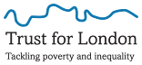

Inclusion London
336 Brixton Road
London SW9 7AA

Email: info@inclusionlondon.org.uk
Phone: 020 7237 3181
SMS: 0771 839 4687
Website: www.inclusionlondon.org.uk

Registered Charity number: 1157376
Company registration number: 6729420

