

All in this together?
The impact of spending cuts on Deaf and disabled people in London
An evidence base on Deaf and disabled Londoners and the impact of past and future policies

April 2011



About Inclusion London

Inclusion London provides policy, campaigning and strategic capacity building support to Deaf and disabled people’s organisations (DDPOs). We aim to ensure a strong collective voice that reflects diversity of Deaf and disabled Londoners organisations and addresses the strategic issues that impact on DDPO’s ability to survive and thrive.

www.inclusionlondon.co.uk

About OPM

OPM is a public interest company that is dedicated to improving social results. We help organisations that want to make a greater social impact and respond to change. We work with clients across public services and the voluntary and community sector. www.opm.co.uk

Our members have wide experience in leadership and management development, policy development, organisational and system change, evaluation, research and public and stakeholder engagement. Strong project management, user engagement and use of evidence underpin all our work. As leading thinkers about the future of public services, we publish our ideas and invest in public interest activities. Founded in 1989 as an independent, not-for-profit centre, OPM is now fully owned by its members through an employee share ownership trust.

About this research project

This research project has been managed by Sanah Sheikh ssheikh@opm.co.uk and directed by Dr. Chih Hoong Sin csin@opm.co.uk. Additional researchers were Robert Pralat and Shama Sarwar.

London Councils

This project has been funded by London Councils:
‘London Councils is committed to fighting for more resources for London and getting the best possible deal for London’s 33 councils. London Councils has a website about its grants service. To read about our grants funding and the work of some of the 300 groups we support please visit www.londoncouncils.gov.uk/grants’

Contents
Executive Summary 4
Socioeconomic characteristics of Deaf and disabled people in London 5
Impact of past employment and benefits policies on disabled people 11
Impact of future spending cuts on disabled people in London 15
Conclusions 24
1. Introduction 27
2. Method and overview of evidence included 30
2.1. Input from experts 30
2.2. Literature search and review process 30
2.3. Overview of material included 32
2.4. Dataset identification and analysis 32
3. Socioeconomic characteristics of Deaf and disabled people in London 34
3.1. Demographics 35
3.2. Household and accommodation characteristics 45
3.3. Education and economic characteristics 54
3.4. Benefit receipt 68
4. Impact of past employment and benefits policies on disabled people 83
4.1. Impact of benefit systems 84
4.2. Impact of employment programmes 96
5. Impact of future spending cuts on disabled people in London 104
5.1 Overall impact of tax, benefit and spending measures 106
5.2 Impact of change in up-rating of benefits 114
5.3 Impact of changes to disability related benefits 116
5.4 Impact of changes to housing benefit and Local Housing Allowance 122
5.5 Impact of cap on benefits 127
5.6 Impact of other spending cuts 127
6. Conclusions 133
7. Appendices 143
Appendix 1: Methodology and overview of evidence included 143
Appendix 2: Interviewee list 151
Appendix 3: Database search logs 152
Appendix 4: Websites searched 156
Appendix 5: Data Extraction Sheet 157
Appendix 6: Literature reviewed 161
Appendix 7: Additional references 167
Appendix 8: Potentially relevant datasets 171

Foreword
The coalition government’s programme of £81 billion spending cuts is unprecedented. It involves the biggest planned cuts ever to the welfare state, including £18 billion of welfare benefit cuts, cuts to service provision and major job losses. Deaf and disabled people’s organisations are already feeling the brunt of cuts to local government funding, as their own funding base is cut and service provision imperilled.
Individual policy announcements alone do not give the full flavour of the meaning this programme holds for disabled people. Spending cuts that result in the removal of welfare benefits, job losses or the ending of a service will be compounded by the realities of poverty and other barriers facing different communities. As this report shows, for example, young Pakistani Londoners are twice as likely to be disabled than their peers, reflecting the complex results of disability discrimination, racism and poverty. Other legislative proposals will compound the effect of cuts too. As we go to print, the government is consulting on proposals that would see far fewer disabled children receiving special educational needs support and, once again, on proposals to water down the public sector equality duty. Such an approach takes legislation, as this report argues, in the direction of being a ‘bare minimum’ rather than an encouragement towards a genuinely more equal society.
The socio-economic evidence gathered and analysed here amounts to a compelling case against such cuts. Disabled Londoners face entrenched barriers to equality. They are more likely to be unemployed, but the barriers that contribute to this need to be understood if they are to be tackled: compared to non-disabled people, disabled Londoners are more likely to have been receiving redundancy payments, are three times as likely to report that transport issues have prevented them taking up a new job and are more likely to be working in a temporary job because they could not find a permanent one.
These kinds of barriers will be made worse because of the spending cuts. Disability Living Allowance makes a vital contribution to independence for many disabled people. Yet the government’s planned 20 per cent cut will see 32,000 Londoners lose this support. Similarly Access to Work funds adjustments that support many disabled people to be in employment and pays for itself in increased tax revenue. Yet the government has recently cut the adjustments that will be funded.
This approach will inevitably deepen the inequality and poverty that mark the lives of disabled people. These are stark. For example, this report shows that disabled people in London experience significant pay inequality, with average net weekly pay in London almost £50 less than that of non-disabled people, and average gross hourly pay of £14.50 compared to £16.17 for non-disabled people. These are the result of compound discrimination in education, training and employment which will be worsened by the government’s proposals for education, equality legislation and public sector restructuring and spending cuts.
This report also found that disabled Londoners are more likely to live in rented accommodation, and to rent from the local authority than non-disabled Londoners. They are a shocking four times more likely than non-disabled people to be receiving housing benefit. These facts of poverty and discrimination will be made much worse by the government’s proposed cuts to housing benefit and possible changes to social housing.
The evidence gathered here reflects the reality of structural discrimination and inequality on the lives of disabled people in London. It lays a basis for understanding the prejudices, stereotypes and social barriers that may grow as a result of cuts and competition for scarce resources – and which Inclusion London will be challenging. And, rather than harsh cuts that will hit the poorest most, it points towards the need for stronger interventionist measures: to address the disability pay gap, encourage take up of benefits that can support independence and lower poverty, facilitate access to employment and firmly tackle discrimination and exclusion.
We are grateful to OPM for their work on this important report.
We hope Deaf and disabled people’s organisations and communities will be able to use this evidence-base as a resource in their work and in presenting the case for the funding they and service users need.
We want government to look at the facts presented here, and think again.
Anne Kane
Policy Manager
Inclusion London
policy@inclusionlondon.co.uk

Executive Summary
The Office for Public Management (OPM), an independent public interest organisation, was commissioned by Inclusion London to establish a robust and comprehensive evidence base which identifies the central social and economic characteristics of Deaf and disabled people in London and explores the impact of past and impending economic and social policies on this population.
The specific research questions that this project sought to address are:
- What are the current social and economic characteristics of Deaf and disabled people in London?
- What has been the impact of past economic and social policies on Deaf and disabled people?
- What is the likely future impact of the coalition government’s economic and social policies, particularly spending cuts and welfare reforms, on Deaf and disabled people in London?
A full description of the methodology used can be found in Appendix 1.
In order to strike a balance between in-depth analysis and sufficient coverage, a pragmatic decision was made that the project would focus primarily on employment, benefits and income. This should not be taken to imply that other aspects of Deaf and disabled people’s lives are unimportant. Instead, it acknowledges that poverty has a cross-cutting influence on multiple exclusions experienced by Deaf and disabled people across all areas of life.
We also recognise that the policy agenda is rapidly changing, with new reforms or policy intentions being introduced every few months.

Socioeconomic characteristics of Deaf and disabled people in London
This section draws on our analysis of the Annual Population Survey (APS) and Family Resources Survey (FRS) to provide an in-depth description of demographics, household and accommodation characteristics, education, economic and employment characteristics and benefit receipt of disabled people in London. We have supplemented the statistical data with secondary evidence in order to draw out some of the key implications of the findings.
Demographics
Analysis revealed that 17.6% of the surveyed APS sample in London is disabled. Based on a mid-2009 London population estimate of 7.75 million, this means that there are approximately 1.4 million disabled people living in London. Additionally, women are slightly more likely (55.1%) to be disabled than men (44.9%). Given that there is strong evidence that disabled women face greater barriers in the labour market, this means that they are likely to need targeted support and advice to help them gain access to and progress within sustainable forms of employment. Disabled people in London are also younger than disabled people across the UK – 45.3% of disabled people in London are under 55 years of age compared with 40.7% of disabled people across the UK. This could suggest that older disabled people tend to move away from London once they reach pensionable age because they can no longer afford to live in London when they are not working.
Among the different ethnic groups, Asian/Asian British groups (19.2%), Black/Black British groups (17.8%) and those that classify themselves as ‘other’ (19%) are most likely to be disabled. Within these groups, Black Caribbean, Bangladeshi and Pakistani people in London are most likely to be disabled. Moreover, approximately 1 in 10 young people between the ages 20-24 from a Pakistani background (10.3%) are disabled. This is approximately double the proportion of all young people in London between the ages of 20-24 (5.2%) that are disabled. Our analysis suggests that these disabled minority groups are likely to be amongst the poorest in London, given the strong evidence base relating to the significant differences in deprivation, income and qualifications between Black and minority ethnic people those from a White background (Platt, 2007).
Where there are children in a household, households with disabled adults are themselves more likely to have disabled children living in them compared to households with no disabled adults: 18.5% of households with disabled adults have one disabled child living in them compared to 10% of households without disabled adults. This is worrying because evidence indicates that parents of disabled children are less likely than other parents to work; and even when they do, their earnings are lower than for parents as a whole (ippr, 2005). This may point to the additional barriers that parents of disabled children face in fitting employment with child care needs, such as finding suitable hours and affordable and good quality childcare appropriate for the needs of disabled children. Additionally, whereas families with disabled children face greater service needs, they are not in fact receiving these services or even where they are, services often fail to meet their needs. This evidence indicates that households with both disabled adults and disabled children face a wide range of interconnecting barriers that contribute to a high level of poverty and unmet need (OPM, 2010a).
Household and accommodation characteristics
Disabled people living in London are more likely to live in rented accommodation: 48.7% of disabled people compared to 41% non-disabled people live in rented accommodation. Moreover, more than half of disabled people rent their accommodation from the local authority or council (53.1%) whereas non-disabled people are most likely to rent from other individual private landlords (46.3%). The tendency for disabled people to be in social rented housing reflects the fact that they are less likely to be able to afford appropriate housing in the housing market. Despite this disproportionate concentration of disabled people in social housing, this type of housing is also unlikely to have been designed or adapted appropriately for the needs of disabled people. Additionally, the English House Condition Survey 2001 found that 36.5% of disabled people lived in ‘non-decent housing’ compared to 31.4% of non-disabled people which is of great concern given that disabled people are already disadvantaged because their housing do not meet their needs (ippr, 2005). According to the GLA’s London Housing Strategy (2010), disabled people are more than twice as likely as non-disabled people to be living in unsuitable housing. Additionally, a survey by Habinteg Housing Association and London South Bank University (2010) that considered the ‘unmet housing need’ of wheelchair user households (i.e. only a section of disabled people) found that 78,300 such households had unmet housing needs in England, with an estimated 12,517 of these being in London.
Households with disabled adults are smaller than those without disabled adults and this difference is driven by the number of dependent children living in both households: 21% of households with disabled adults have one or more dependent children living in them compared to 41.1% of households without disabled adults. Furthermore, within households without children, disabled adults are more likely to live alone than non-disabled adults: households with disabled adults are most likely to consist of one adult (49.1%) whereas households without disabled adults are most likely to either consist of one (37%) or two adults (32%).
Additionally, households with disabled children are more likely to have a greater number of dependent children in them compared with households without disabled children which is likely to contribute to the existing high level of poverty that is experienced by families with disabled children. The Office for Disability Issues (ODI), using data from the 2008/2009 Family Resources Survey (FRS), has reported that 37% of households with disabled children across the UK live in poverty (calculated after housing costs) compared to 28% households with no disabled children.

Educational and economic characteristics
Disabled people in London are less likely to hold degree level qualifications (34%) compared with non-disabled people (46.6%) and are also more likely to hold no formal qualifications at all (4.3%) compared with their non-disabled counterparts (1.6%). These findings are not surprising given the wealth of evidence indicating that disabled people often face barriers to achieving educational outcomes and qualifications at school, as the result of a range of factors including negative experiences of schooling, being excluded from mainstream education and discrimination and low expectations from teachers (OPM, 2010a).
Disabled people also have an unemployment rate of 13% which is markedly higher than the 8% unemployment rate amongst non-disabled people. They are also more likely to be unemployed for a longer period of time. Additionally, disabled people are twice as likely (12.2%) to have received redundancy payments compared to non-disabled people (6.9%) which could imply that they are more likely to have been made redundant. Disabled people in London are also more than three times as likely (9.3%) as non-disabled people (2.6%) to report that issues relating to transport have prevented them from taking up a new job. These findings indicate the significant barriers that disabled people face in accessing and remaining in the labour market.
Similar proportions of employed disabled and non-disabled people in London have permanent jobs: 94.2% and 93.4%, respectively. However, amongst those with a temporary job, disabled people are more likely than non-disabled people to work on a temporary basis because they could not find a permanent job: 36.7% and 28.7% respectively. Disabled people are also more likely than non-disabled people to be in part-time jobs (31.1% and 24.9% respectively) and this also tends to be because of not being able to find a full-time job. This implies that disabled people would much rather be in permanent or full time jobs but find it hard to secure such work.
Disabled people in London are more likely than non-disabled people to work in the public sector than the private sector (29.4% compared to 22.8%). They are most likely to work in local government, council and including police (39.3%).
Average net weekly pay for disabled people in London is £344.90, which is almost £50 less than that of non-disabled people (£389.40). More than one in three households with disabled adults (35.5%) earn less than £300 a week which compares to only 19.8% of households with no disabled adults. Furthermore, average gross hourly pay received by disabled people is less than that of non-disabled people – £14.50 compared with £16.17. Additionally, households without disabled adults are twice as likely (40.6%) as those with disabled adults (21.5%) to earn more than £800 a week. This is particularly worrying because households with disabled adults are also more likely to have disabled children living in them.
Benefit receipt
Disabled people in London are more than twice as likely (66.7%) as non-disabled people (33.1%) to be claiming state benefits or tax credits. The benefits most commonly claimed by disabled people in London are sickness or disability related benefits (29.6%) and housing and/or council tax benefit (29.3%). It is noteworthy that the claimant rate for sickness or disability related benefits is low, and points to the fact that disabled people are under-claiming key benefits they are entitled to. This compounds poverty and disadvantage.
Disabled people who are claiming benefits are more likely than non-disabled claimants to be claiming multiple benefits. Moreover, households with disabled adults in London are also more likely to have been in receipt of benefits for a longer period of time. These findings confirm the relative level of support that households with disabled adults need in order to make ends meet, compared with households without disabled adults. This makes the under-claiming of certain benefits even more problematic.
Disabled people are more likely than non-disabled people to be claiming unemployment related benefits for 18 months or more. Disabled people in London are also more than four times (27.2%) as likely as non-disabled people in London (6.1%) to be claiming housing benefits.

Impact of past employment and benefits policies on disabled people
In this section we draw on evidence in the literature to explore the impact of existing and past employment programmes and benefit policies on disabled people. In the current environment of rapid welfare reform and concerns about unemployment in the public sector the lessons learned from previous changes to benefits and the introduction of employment support programmes provide valuable insight into how impending changes may be experienced by disabled people.

Impact of benefits systems
There is evidence to suggest that the Employment and Support Allowance (ESA), which has replaced Incapacity Benefit (IB) for new claimants (with a migration of all existing claimants planned to start in April 2011), and means that claimants could be expected to undertake work-related activity, can have a negative impact on the wellbeing and mental health of disabled people. For instance, the barriers disabled people face in getting and keeping a job can result in increased pessimism, under-confidence and demoralising rejection (Kemp and Davidson, 2010). The inclusion of sanctions that effectively cut benefits if claimants are found not to be following their work-related activities plan can also force claimants to take work that is not suitable for them which could cause great stress (GLA, 2007). Furthermore the Work Capability Assessment (WCA) which forms part of the system has been reported by disabled people and their representatives as often failing to take into account many factors that can significantly affect the extent to which they are able to work (CAB, 2010b), resulting in a rise in people being denied benefit and in high numbers of appeals, many successful.
Changes to the ESA and IB (in the past) put increased pressure on disabled people to find work and yet there is evidence to demonstrate that the barriers faced by disabled people in the labour market often result in failure to find employment. Kemp and Davidson (2010) in their study with recent IB claimants found that only 11% of respondents who self-categorised as ‘potential workers’ had done any work in the six months between surveys.
Negative attitudes and lack of awareness among employers means that they often make assumptions about disabled people’s productivity which continue to act as a significant barrier to disabled people getting and keeping a job, with research in London showing that one in six workers who develop an impairment lose their job, doubling with mental health conditions (GLA 2007) and higher for people in manual jobs than professional ones. Employers also tend to have low awareness about the cost and types of reasonable adjustments that disabled people need which can make them less likely to implement such adjustments (OPM, 2010b).
There is also evidence in the literature that although disability benefits, particularly the Disability Living Allowance (DLA), have a positive impact on disabled people’s lives, they are not adequate to cover the additional costs of disability faced by disabled people (OPM, 2010a; Smith et al, 2004). This makes it particularly worrying when, as is the current case, policy changes have been announced that would both reduce disabled people’s ability to meet the additional costs incurred by disability, and also reduce their service entitlements and other income sources.
For a disabled person, gaining employment instead of receiving benefits does not always result in a better standard of living. Many benefits are cut and some can be taken away altogether once employment is gained. Employment is more likely to be low paid and can also result in other costs such as child care and transport. People may be put off working by the fear that they will be financially worse off if they do and will fall into the ‘poverty trap’ – a situation where neither employment nor benefits can meet their living standards. (GLA, 2007; Grewal et al, 2002).
Impact of employment programmes
A number of employment programmes have been introduced over the years with the aim to provide disabled people with the support they may need to take up employment. For example, Pathways to Work programme is a gateway to advice and support for people receiving IB or ESA but there is mixed evidence about the extent to which it has been successful in helping disabled people gain employment. Disabled people often report the work focused interviews to be unhelpful and lacking in privacy (Lancashire, 2010). There are also concerns that performance targets could lead contractors to concentrate their efforts on those disabled people who are, or are perceived to be, the easiest to get into work (GLA, 2007; Riddell et al, 2010). The New Deal for Disabled People (NDDP) is another such programme that has been found to be only moderately successful, and even so mostly with younger claimants (Stafford et al, 2007). Additionally, the evaluation of the programme also found that although there were cost savings in the amount of benefits paid out to participants, there was a lack of information on the number of disabled people successfully finding employment which could mean that there is an increase in the number of disabled people not receiving either income from benefits or employment.
Access to Work (AtW) is a programme that provides financial support to disabled people and their employers for both one-off and ongoing costs associated with employing a disabled person. An evaluation of the programme found that there were very low levels of awareness about the programme amongst disabled people and employers. However, it also found that on the whole employers and customers could point to many benefits such as reduced sickness and absenteeism, savings on work-related expense and staff retention (Riddell et al, 2010). The Disability Employment Coalition (2004) estimated that AtW recoups £1.48 in increased tax and National Insurance contributions for every £1 spent, and therefore generates tangible economic benefits. Similarly, the National Audit Office (2005) has also highlighted the cost effectiveness of the AtW programme in its assessment of the Department of Work and Pension’s (DWP) support for disabled people. The recent announcement by the coalition government of the list of ‘standard equipment’ not eligible for Access to Work funding is therefore particularly worrying.

Impact of future spending cuts on disabled people in London
In the last six months there has been a significant amount of analyses of the impact of the welfare reforms and spending cuts to public services, tax credits and benefits and wider public spending cuts announced by the coalition government. A review of these allows us to generate valuable insight into the likely impact of impending changes. This is because such analyses tend to present the impact of the planned spending cuts in relation to the poorest and richest households. Our analyses of the APS and FRS have already highlighted the fact that the level of poverty experienced by disabled people in London is significantly greater than that experienced by non-disabled people. We can therefore assume that the impact of the policy changes and cuts on disabled people are likely to mirror those experienced by the lowest income groups reported by others.
It is important to note that much of the available literature only estimates the financial impact of the spending cuts and policy changes introduced by the coalition government. However, there is a wealth of evidence indicating that financial or economic exclusion is correlated with many other forms of exclusion and disadvantage. This means that impacts described in this section are only a starting point for understanding how spending cuts and policy changes are going to impact on disabled people in London. It should not be interpreted as the totality of potential impact on disabled people.
We are also aware that many of the spending cuts and policy changes will also have a negative impact on those disabled people who may not be in the lowest income groups, for example, cuts to DLA or cuts in public services (such as NHS or education) such that this may then push this group into much lower income groups.
Overall impact of tax, benefit and spending measures
An unprecedented scale of public spending cuts announced by the coalition government have included a wide range of tax and benefit measures as well as spending cuts to services, set out in the emergency budget in June and the Comprehensive Spending Review (CSR) in October 2010. Statistical modelling exploring the impact of all these measures has demonstrated that they are deeply regressive because they result in a greater loss, in terms percentage of income, for lower income groups (20-35%), compared with higher income groups (5-10%) (Reed, 2010). Since our analyses of the APS and FRS demonstrated that disabled people in London are likely to be in the lowest income groups, it is likely that the package of measures will have a relatively greater adverse impact on disabled people compared with non-disabled people.
Reed (2010) has also modelled the impact of the coalition government’s announced tax and benefit measures and spending cuts to services separately. With regards to the tax and benefit measures, the impact again is clearly regressive with lower income groups losing between 4-6.5% of their net income and higher income groups losing less than 2%. With regards to the spending cuts to services, the lowest and second lowest income groups suffer a loss of approximately ten times (~30%) and six times (~20%) as much as the richest group. These poorest income groups are also most affected by cuts to social care and education. Again, since disabled people in London are amongst the lower income groups, they are likely to be disproportionately affected by the cuts to services.
The government, in the CSR, indicated there are likely to be approximately 490,000 public sector job losses but others have suggested the numbers are likely to be much higher. Immediately after the budget was announced, the Chartered Institute of Personnel and Development, have argued that this number could be closer to 725,000 by 2015 and in February 2011 added that ‘around 12.5 per cent of public sector workers are likely to lose their jobs in the coming year’ alone . Across the economy as a whole, after the June 2010 budget, an unpublished Treasury assessment suggested 1.3 million jobs would be lost.
We know from our analysis that the majority of disabled people in London are economically inactive (68.1%) with only 27.7% in employment. This means that there are 387,800 disabled people in employment in London (based on a population estimate of 1.4million disabled people in London). We also know that 29.4% of this 387,800 disabled people in employment in London work in the public sector. This means that there are approximately 114,000 disabled people working in the public sector in London who face the risk of losing their jobs. Additionally, evidence from the recent recession has found that the ILO unemployment rate for disabled people had increased, albeit at a slower rate than for non-disabled people, even before the announcement of public sector job losses (EHRC and DWP, 2009). The Trades Union Congress (TUC) (2009) has warned against complacency, noting that while large-scale redundancies have yet to materialise in the public sector, where disabled people are disproportionately employed, these may yet take place against the context of inevitable cuts to public spending.
Impact of change in up-rating of benefits,
The change in the linking of benefits from the Retail Price Index (RPI) and Rossi to the Consumer Price Index (CPI) means that benefits will increase less than they would have otherwise and this has led to concerns about the extent to which this will reduce the amount of benefits received by people. It is argued that people on lower incomes face inflation rates higher than the CPI and that it does not reflect the spending of those receiving benefits (e.g., excludes council tax). Since our analysis demonstrated that disabled people tend to have low incomes and are also most likely to be claiming benefits, they are likely to suffer significantly from this change in indexation (Browne and Levell, 2010; CAB, 2010a).
Impact of changes to disability related benefits
There is evidence in the literature reviewed that there are concerns about the proposed changes to the DLA that have been announced by the coalition government with an aim to cut recipients by 20%. As our data analysis revealed, 11.4% and 11.7% of disabled people in London receive DLA care component and mobility component respectively. This means that there are currently approximately 160,000 DLA recipients in London. A 20% cut would mean that approximately 32,000 would lose DLA.
These proposed changes include changing the name of the benefit to Personal Independence Payment (PIP). Unlike DLA, eligibility for PIP would be based on having an impairment or condition for a period of at least 12 months. Additionally, those in hospital or residential care will be automatically ineligible. There are very real concerns that the new medical test planned for DLA will miss out the impact and costs of the real barriers associated with disability (ECDP, 2010). Wood and Grant (2010b) in their survey of disabled people found that the costs faced and support needed by this group often did not correlate with the severity of the ‘functional impact’ of their disability which is what the new medical test would assess. A further impact of the tightening of eligibility for DLA is that it will also have a direct effect on Carers Allowance (CA) which can only be claimed by those receiving the higher or middle rate of DLA. This means that those disabled people that fail the medical test would no longer get DLA and CA (Wood and Grant, 2010). Additionally, the fact that the mobility component of the DLA would no longer be available to those living in residential care has resulted in concerns by CAB (2010a), Inclusion London (2010) and others that this will greatly limit the level of choice and independence experienced by those in residential care. A report by 27 national organisations in the disability charity sector argued that the cut will mean ‘people will be forced to remain indoors and have a diminished quality of life; or social services will be forced to make up the difference in funding. Given the current climate, we do not expect local authorities to be able to do this.’ (Don’t Cut Mobility, 2010: 1).
The CSR announced a planned one year time limit for entitlement to contributions based ESA for those in the work related activity group (WRAG). CAB (2010a) have argued that this new limit will affect disabled people who are single with some savings or other income and couples where one partner works but who still struggle to make ends meet. Additionally, since more disabled people are likely to start claiming Job Seekers Allowance (JSA) once their one year time limit on ESA is over, they are also likely to suffer from the ‘harsh’ sanctions that have been imposed on failing to comply with the proposed mandatory work activity (CAB, 2010c).

Impact of changes to housing benefit and Local Housing Allowance
A wide range of changes to housing benefit and Local Housing Allowance (LHA) have been announced over the previous year, many of which would be likely to impact on London disproportionately. Since disabled people are more than four times as likely (27.2%) as non-disabled people (6.1%) to be receiving housing benefits there is likely to be a disproportionate adverse impact on them. In fact, CAB (2010a), National Housing Federation (2010) and Chartered Institute of Housing (2010) have all argued that the combination of changes in the LHA allowance rate from the 50th to the 30th percentile from October 2011 and the caps imposed on the maximum LHA payable by property size from April 2011 means that in many London boroughs this will restrict the availability of affordable housing to less than 30% of the market which means that people will have to move out to more affordable boroughs (CIH, 2010; NHF, 2010). Additionally, an extension of the Shared Room Rate (SRR) from single claimants under 25 to those under 35 from April 2012 means that all single people under 35 will have their LHA restricted to a bedroom in shared accommodation rather than a self contained bed sit or 1 bedroom flat. This will have an impact on the 10.5% percent of disabled people in London who are under 35 (approximately 145,000 people), and many of whom are likely to be single.
The June 2010 budget also announced that housing benefit would be cut by 10% for those people who had been claiming JSA for over a year. This proposal was not included in the Welfare Reform Bill and appears to have been withdrawn. However, it raised important issues and we consider some of these in the report. Wood and Grant (2010a) have argued that the disabled people are likely to be on JSA longer because of the increased difficulties they face in the labour market (confirmed by our analysis).
The National Housing Foundation (2010) have argued that low income groups are likely to be priced out of London because reduced housing benefits would make accommodation affordable.
Other changes that are likely to impact on disabled people include the downward adjustment of the Supported Mortgage Interest (SMI) rate from October 2010 and the increase in the deduction from housing benefits that applies to claimants who live with non-dependents from April 2011. With regards to the former, Wood and Grant (2010a) have argued that disabled people whose employment tends to be more erratic are likely to suffer the most in trying to make their mortgage payments. With regards to the latter, the change is likely to have more of an impact on disabled people in London compared to non-disabled people because the former are more likely to live in adult-only households (79% compared to 58.9% of non-disabled people).
Impact of cap on benefits
The CSR introduced a proposed cap on household benefits from 2013 at approximately £500 for couples and lone parents, and £350 for single adult households. Although those receiving DLA are exempt, those receiving ESA or IB are not. Additionally, the fact that the cap will apply regardless of household size and geographical location means that it will have a disproportionate impact on large families and areas of high rent, such as London. Disabled people are thus more likely to suffer from this cap if they live in London than if they live elsewhere.
Impact of other cuts
Many disability organisations have expressed serious concerns about other changes announced by the coalition government. These include the proposed sharp cuts in the availability of Legal Aid (including making it not available for employment, education, and a range of other areas), the closure of the Independent Living Fund and cutbacks to Access to Work. All of these are likely to impact negatively on disabled people. Additionally, a range of other tax credit and benefit cuts have been announced which will have varying impacts on disabled people, although they are not disability related benefits as such. For example, the decision to freeze Child Benefit for three years, cut childcare support provided under tax credits by 10% and restrict the Sure Start maternity grant to the first child only may have particularly harsh impacts on households with disabled adults and/or disabled children. As we have shown, households with disabled children across the UK are more likely to live in poverty than households with children who are not disabled and households with disabled children are also more likely to have a greater number of children in them. However, detailed consideration of the impact of this very large number of cuts in benefits and tax credits that are not disability focussed, but will impact differently on disabled people, is beyond the scope of this report.

Conclusions
In this report we have drawn on a selection of published and unpublished literature and fresh analyses of two key existing datasets to identify the socioeconomic characteristics of disabled people in London as well as to describe and estimate, as far as possible, the likely impacts of the coalition government’s announced spending cuts and changes to benefits and tax credits. We have also explored the impact of existing and past employment programmes and benefit policies on disabled people as the lessons learned from these provide valuable insight into how impending changes may be experienced by disabled people. The key recurrent theme is that of the marked difference in the level of poverty and barriers to employment experienced by disabled people in London compared with non-disabled people.
A key observation emerging from our review is that despite the existence of legislation to promote the rights of disabled people in Britain, genuine equality for disabled people is a long way from being a reality. Legislation needs to square up to the fact that many of the findings here point to growing disability inequality. There is also a risk legislation provisions may only be regarded as a prompt to achieve the ‘bare minimum’ rather than to see them as encouraging society to aspire to a genuine cultural shift towards promoting genuine equality of outcome. A rights-based approach to disability equality further draws attention to the fact that a number of fundamental rights are guaranteed by the UN Convention on the Rights of Persons with Disabilities and by the Human Rights Act.
While effective implementation and enforcement are important, we also need a greater emphasis on outcomes. It is clear from the evidence that the coalition government’s policy agenda will lead to worsening outcomes for disabled people. Some groups of disabled people may suffer disproportionately, for example, in London, those from a Pakistani and Bangladeshi background. Added to this, the shift towards focussing only on the most basic needs of disabled people in relation to health, housing etc., without accompanying steps to promote the inclusion and participation of disabled people in society though changing attitudes and offering real choice and control is likely to lead to greater hardship. Decision making therefore needs to move away from selective short term financial considerations to ones that take into account the longer term social vision, and specifically the outcomes for disabled people and their families. Our findings do not provide support for the government’s view that its cuts are necessary for economic stability: more than this, however, we show how the definition of ‘cost’ and ‘benefit’ needs to embrace much more than pure monetary value.
Therefore, while our review has pointed out numerous overlapping adverse financial impacts of recently announced policies, the true impact of government policy on disabled people’s lives is likely to be significantly more far-reaching and fundamental. Our findings indicate that statistics of inequality are likely to worsen over time for disabled people across the different domains of life. It is imperative that careful tracking of quantitative and qualitative data is used as the basis of evidence-based approaches to enforcement and intervention in order that equality and human rights are taken seriously. This report is intended to assist Inclusion London, and other disabled people’s organisations in London, to have a baseline of evidence that can be used to undertake this kind of tracking.

Introduction
The Office for Public Management (OPM), an independent public interest organisation, was commissioned by Inclusion London to establish a robust and comprehensive evidence base which identifies the central social and economic characteristics of Deaf and disabled people in London and explores the impact of past and impending economic and social policies on this population. This research is particularly timely and important because of:
- rising concerns about the spending cuts and changes to tax and benefits announced by the Coalition Government and how these will impact on Deaf and disabled people; and
- the lack of centrally-held evidence on the characteristics of Deaf and disabled people in London which has meant that the evidence that exists is becoming increasingly out of date.
The specific research questions that this project sought to address are:
- What are the current social and economic characteristics of Deaf and disabled people in London?
- What has been the impact of past economic and social policies on Deaf and disabled people?
- What is the likely future impact of the coalition government’s economic and social policies, particularly spending cuts and welfare reforms, on Deaf and disabled people in London?
To meet the above aims, three principal strands of research activity were undertaken:
- Telephone interviews with a small sample of seven experts in disability related issues
- A review of relevant literature
- Scoping and analysis of a selection of key British datasets
OPM and Inclusion London acknowledged from the outset that there was likely to be a plethora of available evidence on the multiple dimensions of Deaf and disabled people’s lived experiences. An exhaustive review of all available evidence was thus unrealistic within the time and budget constraints of the project. In order to strike a balance between in-depth analysis and sufficient coverage, a pragmatic decision was made that the project would focus primarily on economic characteristics (including employment and education), benefits and income. This should not be taken to imply that other aspects of Deaf and disabled people’s lives are unimportant: indeed the report has also attempted to present recent top line data on a wider range of characteristics. However, our focus acknowledges that poverty has a cross-cutting influence on multiple exclusions experienced by Deaf and disabled people across all areas of life.
This review and analysis of evidence has been designed to meet very specific objectives. Our analysis and interpretation of data and evidence has been conducted in the context of the current policy environment. We recognise that the policy agenda is rapidly changing, with new reforms or policy intentions being introduced every few months.
The rest of the report reads as follows:
- Chapter 2 provides an overview of the methodologies used and a description of the data and literature that have been included in this review.
- Chapter 3 presents an analysis of key British datasets and describes the socioeconomic characteristics of Deaf and disabled people in London. The analysis includes: basic demographics, household and accommodation characteristics, economic and employment characteristics, and benefit receipt.
- Chapter 4 discusses the impact of previous benefit systems and employment programmes on disabled people
- Chapter 5 discusses the impact of a range of welfare reforms and the spending cuts on Deaf and disabled people in London. It explores the impact of the overall package of reforms introduced in the March and June budgets as well as the Comprehensive Spending Review. It also explores the impact of specific types of reforms, such as changes to disability related benefits and housing benefits.
- Chapter 6 concludes the report by drawing together some of the key findings discussed in the report and their implications.

Method and overview of evidence included
In the following sections we provide a brief overview of the methodology used in this review and analysis of evidence. For further detail please see Appendix 1.

Input from experts
OPM completed seven interviews with key experts involved in research and evidence gathering in relation to Deaf and disabled people’s experiences and outcomes, and the disability rights movement. These include practitioners, academics, policy makers and disability groups. The interviews were also used as an opportunity to identify relevant literature and data sources. The full list of interviewees can be found in Appendix 2.

Literature search and review process
Our approach to the literature search, review and synthesis has been informed by good practice guidelines issued by government agencies and universities relating to rapid evidence review.
In recognition of the importance of qualified search specialists in enhancing the quality of reviews, we worked with search specialist Alan Gomersall, Deputy Director of the Centre for Evidence-Based Policy and Practice (CEBPP).
Representatives from Inclusion London and OPM worked in partnership to develop the approach towards database searches. We agreed that it needed to be underpinned by an iterative process of progressive and informed filtering. Initial searches were broad and allowed us to ascertain the broad contours of the terrain and identify the extent and type of relevant literature available on the different databases. Each subsequent search was based on decisions informed by the findings of preceding searches and guided by the overall objectives of the review. We shared all material identified with Inclusion London. Appendix 3 shows the databases that were searched, the specific search terms and strategies that were used and the results obtained.
In order to ensure that no critical items were missed OPM also conducted internet searches of a selective number of websites of a number of government departments, public bodies, think tanks, research centres, organisations and charities representing Deaf and disabled people to search for potentially relevant material. OPM also monitored news alerts relating to any new literature that was published over the course of the project. A full list of the websites searched can be found in Appendix 4.
The material identified from these searches was sifted to assess relevance against inclusion/exclusion criteria agreed by Inclusion London and OPM. For the first research question we recognised that our scoping and analysis of British datasets (discussed below) was likely to provide the most up-to-date and in-depth analysis of the socioeconomic characteristics of Deaf and disabled people in London, but we did choose a small number of reviews of evidence and other studies to draw on in order to highlight the key implications of the findings. For the second and third research questions the only inclusion criterion used was:
- Focus on the impact of previous/future policies relating to employment, benefits and income
Material that met the inclusion/exclusion criteria was read in full and data were extracted using a Data Extraction Sheet (DES) (included in Appendix 5) designed in collaboration with Inclusion London. The reviewed literature was analysed using broad content analysis which was guided by the research specification.

Overview of material included
A total of 37 documents were included on the final shortlist for review. These included:
- Quantitative and qualitative primary research (13 documents)
- Secondary review of quantitative and qualitative research (10 documents)
- Modelling the impact of government policies (12 documents)
- Think pieces (5 documents)
Additionally, there were 6 documents that addressed the first research question (socioeconomic characteristics), 17 that addressed the second (impact of past policies) and 18 that addressed the third research question (impact of future/impending policies).
An overview of the literature included can be found in Appendix 6.
A further 42 documents have been drawn on to explore the implications of our findings in more depth and a list of these can be found in Appendix 7.

Dataset identification and analysis
OPM were mindful of the fact that the reported data in published literature was unlikely to reflect the full range of existing relevant data sources. We thus conducted scoping and analysis of key British datasets that have relevance for this research. A search by key terminology was conducted of the UK Data Archive based at the University of Essex which yielded a ‘long list’ of potentially useful datasets, the details of which are included in Appendix 8. The following inclusion criteria were agreed with Inclusion London:
- Variables relating to employment, benefits and income policy area
- A London sample size that facilitates meaningful analysis
- Based on fieldwork conducted in 2008-2010
Based on these criteria the following datasets were identified as suitable for analysis:
- Annual Population Survey, January - December 2009 (APS)
- Family Resources Survey, 2008-2009 (FRS)
The Annual Population Survey (APS) measures and records evidence about nationality and ethnicity, economic activity and inactivity, employment and training, pay and hours, educational background, benefits, housing tenure, and benefits. The sample for analysis was those respondents that met the DDA definition of disability. For London, this consisted of 3,719 Deaf and disabled adults.
Analyses included comparisons across Deaf and disabled people with non-Deaf and disabled people in London and the UK. In addition, where appropriate cross-linking analyses were also undertaken.
The Family Resources Survey (FRS) collects information on income and benefit receipt, household composition and characteristics, children in education and tenure and housing costs. The sample for analysis, based on the DDA definition of disability, consisted of 986 adults. Similarly, the full sample of Deaf and disabled children in London consisted of 116 respondents. Additionally, the full sample of households with Deaf and disabled adults was 824 and the full sample of households with Deaf and disabled children was 98.
For both datasets, analyses included comparisons across Deaf and disabled people and non-Deaf and disabled people, across households with and without disabled adults or children and across disabled people in London and the UK. In addition, where appropriate cross-linking analyses were also undertaken.
For ease of reference we will refer to Deaf and disabled people as ‘disabled people’ in the following sections.

Socioeconomic characteristics of Deaf and disabled people in London
This chapter draws on our analysis of the APS and FRS to provide an in-depth and broadly up-to-date description of the key socioeconomic characteristics of disabled people in London. We have supplemented the statistical data with secondary evidence in order to draw out some of the key implications of the findings. In this chapter we explore:
- Basic demographics,
- Household and accommodation characteristics,
- Education, economic and employment characteristics, and
- Benefit receipt.
The key theme is that of the marked difference in the level of poverty and barriers to employment experienced by disabled people in London compared with non-disabled people. For example:
- There is a marked difference in the weekly pay and income that disabled people have to live on compared with non-disabled people. Average net weekly pay for disabled people is £50 less than for non-disabled people: £344.90 compared to £389.40. Average gross hourly pay is also much lower for disabled people: £14.50 an hour compared to £16.17 for non-disabled people. Furthermore more than one in three disabled adults earns less than £300 a week compared to less than one in five non-disabled adults. While these figures mean it is not surprising that disabled people are also more likely to be claiming multiple types of benefits and to have been doing so for a long period of time, our analysis of disability benefit receipt shows that disabled people are significantly under claiming benefits to which they are entitled.
- Households with disabled people face multiple challenges in making ends meet. For example, households with disabled adults are also more likely to have disabled children living in them compared with households with no disabled adults. Additionally, households with disabled children are also more likely to have other dependent children living in them, compared with households with no disabled children. These characteristics create multiple barriers that compound one another and are reflected in the high levels of poverty and unmet need in disabled peoples’ households.
- Disabled people in London are less likely to hold degree level qualifications compared with non-disabled people) and are also more likely to hold no formal qualifications compared with their non-disabled counterparts. Furthermore, not only are disabled people more likely to be unemployed than non-disabled people, they are also much more likely to stay unemployed for a longer period of time. They are also more likely to have received redundancy payments implying that they are more likely to have been made redundant. They are also likely to find it difficult to get permanent or full-time jobs compared to non-disabled people thus rendering their employment patterns more erratic.

Demographics

Basic demographics
Our analysis of the APS revealed that 17.6% of the surveyed sample in London is disabled which compares to 20.4% of the national sample. Based on a mid-2009 London population estimate of 7.75 million, this means that there are approximately 1.4 million disabled people living in London. Additionally, analysis of the FRS revealed that approximately four out of ten households in London have disabled adults living in them (39.9%) compared with 46.6% of households across the UK. The chart bellow illustrates the number of disabled adults living in households in London and the UK.
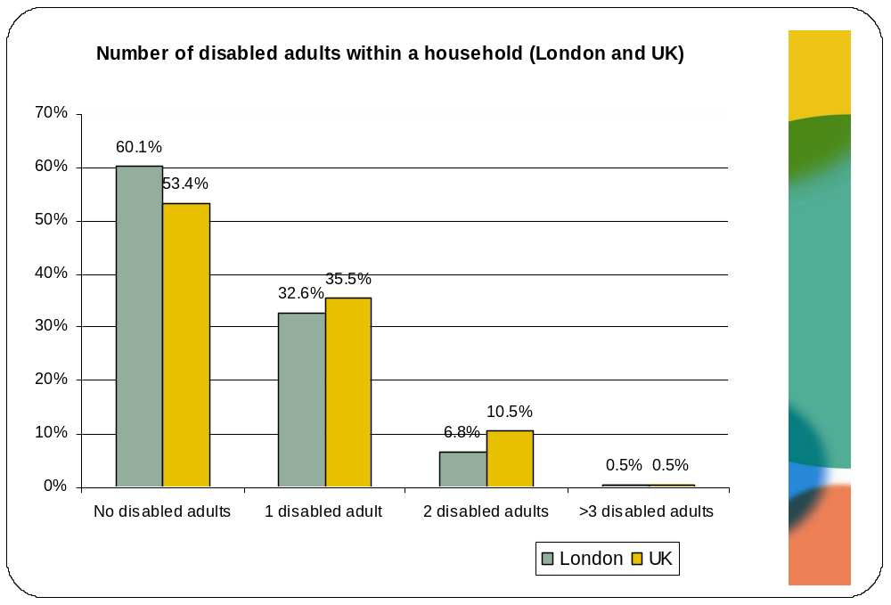
Compared to the large number of households that have disabled adults living in them, there are many fewer households (with children) that have disabled children living in them – 14.4% of households with children in London and 14.4% of those across the UK have disabled children living in them.
However, households with disabled adults are themselves more likely to have disabled children in them, compared to households with no disabled adults. As illustrated in the table below, 18.5% of households with disabled adults have one disabled child living in the same household compared with only 10% of households with no disabled adults. The former are thus likely to incur greater costs that relate not only to meeting the needs of the disabled adults living in the household but also those relating to the needs of disabled children living in the household.
There is evidence pointing to families with disabled children facing two specific extra challenges which increases their risk of living in poverty – additional expenses incurred through caring for their disabled child, and difficulties in getting and sustaining employment (OPM, 2010a). A report by ippr (2005) on the circumstances of disabled people in the UK reported that parents of disabled children are less likely than other parents to work; and even when they do, their earnings are lower than for parents as a whole. This may point to the additional barriers that parents of disabled children face in fitting employment with child care needs, such as finding suitable hours and affordable and good quality childcare appropriate for the needs of disabled children, attending additional educational, medical or disability related appointments, etc. It may also indicate that where disabled people are able to find employment compatible with caring demands, it may come at the price of low remuneration or unsatisfactory employment: parents may be obliged to trade down, working below their skills level, to find a fit with the needs of their disabled children.
Whereas families with disabled children face greater service needs, they are not in fact receiving these services or even where they are, services often fail to meet their needs. Unmet needs range from equipment needs and poor access to speech and language therapy to physiotherapy and occupational therapy and key workers and regular support services (including short breaks and direct payments). This evidence indicates that households with both disabled adults and disabled children face a wide range of interconnecting barriers that contribute to a high level of poverty and unmet need (OPM, 2010a).
 | Households with disabled adult(s) | Households without disabled adults
No disabled children in household | 76.3% | 88.8%
1 disabled child in household | 18.5% | 10.0%
2 disabled children in household | 5.2% | 0.6%
3 disabled children in household | 0.0% | 0.6%
Base | N=173 | N=509

Gender
Analysis of the APS revealed that women are slightly more likely to be disabled than men – 55.1% of disabled people in London are women and 44.9% are men. This is particularly worrying because there is evidence to suggest that disabled women, particularly older disabled women, are more likely to suffer from social exclusion and poverty (OPM, 2010a). There is also strong evidence that disabled women face greater barriers in the labour market which means that they are likely to need targeted support and advice to help them gain employment (Parker et al, 2007).
Age
The chart below illustrates the age spread of disabled people in London and the UK. Unsurprisingly, the prevalence of disability varies greatly by age with the rate of disability increasing steeply among those over the age of 65. More than 1 in 3 disabled people in London are over the age of 65 (34.1%) compared with approximately 1 in 10 disabled people between 60-64 (10%), 55-59 (10.5%), 50-54 (10.4%) and 45-49 (9.3%) years. However, these numbers may in fact be higher than reported. In their review of evidence relating to the circumstances of disabled people in the UK, ippr (2005) argued that the number of older disabled people is likely to be an under-estimation because there is evidence to indicate that that older people are likely to under-report chronic conditions because they regard limitations in their daily activities as a normal part of growing old rather than evidence of disability.
Furthermore, approximately 1 in 25 disabled people in London are between 16-24 years (3.8%), whereas approximately 1 in 15 disabled people are between 25-34 years (6.7%) and 1 in 6 are between 35-44 years (15.1%). Disabled people in London are likely to be younger than disabled people across the UK. For example, 45.3% of disabled people in London are under 55 compared with 40.7% of disabled people across the UK. This could suggest that older disabled people tend to move away from London once they reach pensionable age. This could be because they can no longer afford to live in London when they are not working.
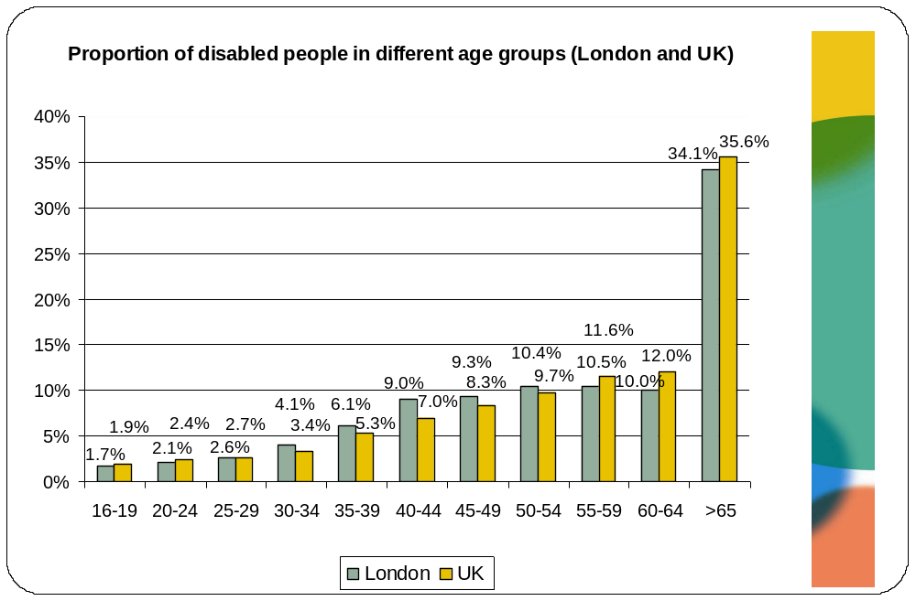
Another representation of the prevalence of disability by age group is to consider the proportion of each age group in London that is disabled and non-disabled. This is illustrated in the chart below.
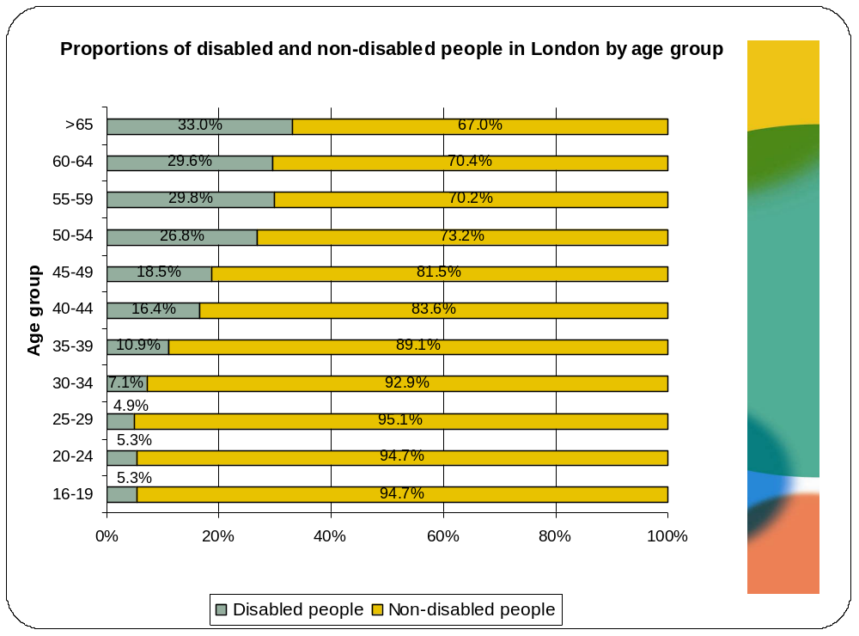

Ethnicity
An analysis of the ethnic make-up of London’s disabled population reveals that 66.5% are White whereas 33.7% are from a black or minority ethnic background (BME). More specifically, 15.3% are Asian/Asian British and 10.6% are Black/Black British. The remaining 7.7% include individuals of a mixed ethnic origin (1.3%), Chinese people (0.6%) and people from other ethnic backgrounds (5.7%). However, a more interesting analysis relates to the percentage of each ethnic group in London that is disabled. As the table below illustrates, Asian/Asian British groups (19.2%), those that classify themselves as ‘other’ (19%) and Black/Black British groups (17.8%) are most likely to be disabled.
 | % of ethnic group that is disabled
White | 17.3%
Asian/Asian British | 19.2%
Black/Black British | 17.8%
Mixed | 12.9%
Chinese | 9.7%
Other | 19%
Base | N=3,713
Further disaggregated analysis of the Asian/Asian British and Black/Black British also yields interesting findings. Within the Asian/Asian British group, Bangladeshis and Pakistanis are most likely to be disabled – approximately 1 in 5 Bangladeshis (20.8%) and Pakistanis (19.8%) are disabled compared to approximately 1 in 6 disabled people from a White background (17.3%). Additionally, within the Black/Black British group, Black Caribbeans are most likely to be disabled – almost 1 in 4 are disabled (22.9%).
This analysis implies that these disabled minority groups are likely to be amongst the poorest people in London, given the strong evidence base relating to the significant differences in deprivation, income and qualifications between Black and minority ethnic people and those from a White background (Platt, 2007). As we will explore in further detail later in the report, the relative position of BME disabled people means that they are likely to be amongst the worst off as a result of the spending cuts announced by the coalition government. Additionally, evidence elsewhere points to the fact that although disability rates tend to be higher among many BME groups, take-up of disability benefits such as Disability Living Allowance and Attendance Allowance tend to be lower (OPM, 2010a). This can be disproportionately damaging due to the relationship between poverty and ethnicity. In other words, Black and minority ethnic disabled people appear to be significantly under-claiming disability related benefits to which they are entitled, and this is reflected in the higher rates of poverty among these sections of London’s population. Rather than tightening eligibility and lowering the real value of benefits, a focus on tackling disability related poverty should instead develop an awareness raising campaign aimed at increasing take up rates.
The chart below presents a detailed overview of the percentage of different ethnic groups that are disabled in London.

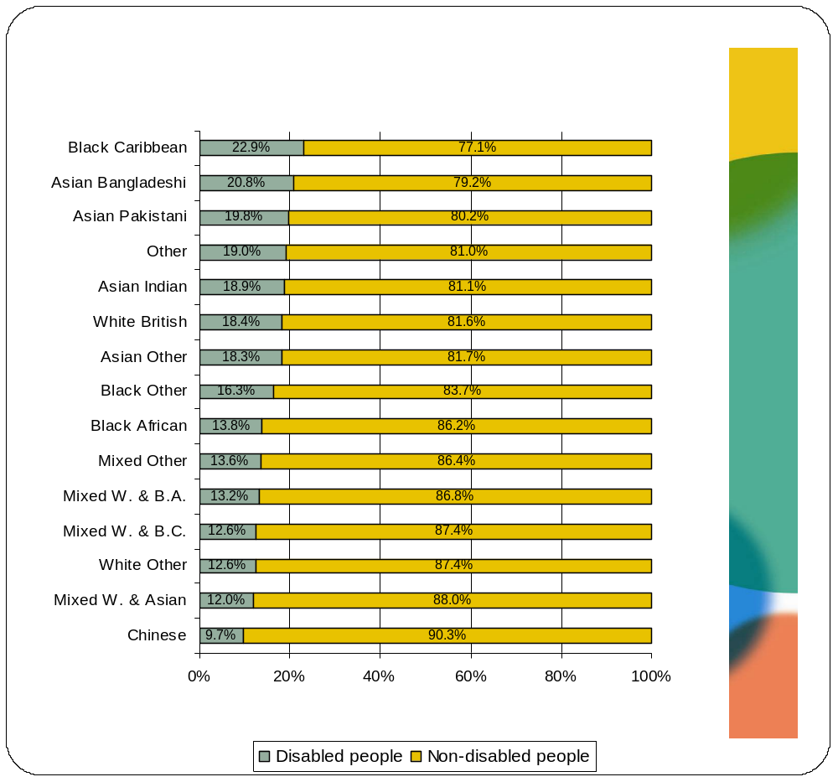
Given that Black Caribbean, Bangladeshi and Pakistani people in London are most likely to be disabled, a closer analysis of the age structure of this group was conducted. As the chart below demonstrates approximately 1 in 10 young people between the ages 20-24 from a Pakistani background (10.3%) in London are disabled. This is approximately double the proportion of all young people in London between the ages of 20-24 that are disabled (5.2%). Amongst the Bangladeshi population, the proportions of disabled people are particularly high amongst individuals in their 40s and 50s. In fact, approximately half (or more) of Bangladeshis between the ages of 40-59 are disabled. Finally, more than a staggering 60% of Pakistanis between 60-64 years are disabled. Pakistani and Bangladeshi people are very likely to live in relatively large and multi-generation households and this inevitably means that there are greater demands on the available household income (Platt, 2007). The very high proportion of older disabled adults, who probably are not contributing to the household income, means that these groups are likely to struggle to make ends meet. This is compounded by the fact that the perception of disability (e.g. stigma and shame) among many South Asian families can present further barriers to the seeking help and support. This has been documented for both the younger and older age groups within such communities (Bowes and Dar, 2000; Hatton et al, 2002; Katbamna et al, 2000)
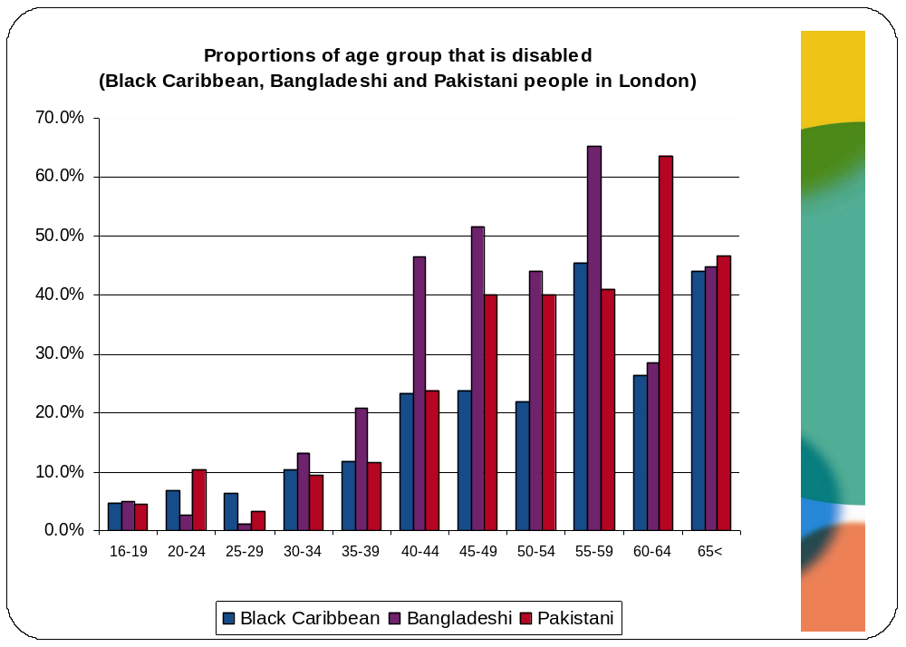

Religion
More than six in ten of all disabled people in London identify themselves as Christian (61.5%). The second and third largest groups are Muslims and people who identified themselves as having no religion, constituting 13.4% and 13.1% of disabled people, respectively. The remaining 12.0% identify themselves as Hindu (4.9%), Jewish (2.8%), Sikh (1.9%), Buddhist (0.9%) and other religions (1.5%).
Within religious groups, approximately one quarter of Sikhs (24.6%) and Muslims (22.4%) are disabled compared with approximately one in five Jewish people (21.5%), Hindus (18.8%) and Christians (17.7%). This is illustrated in the chart below.
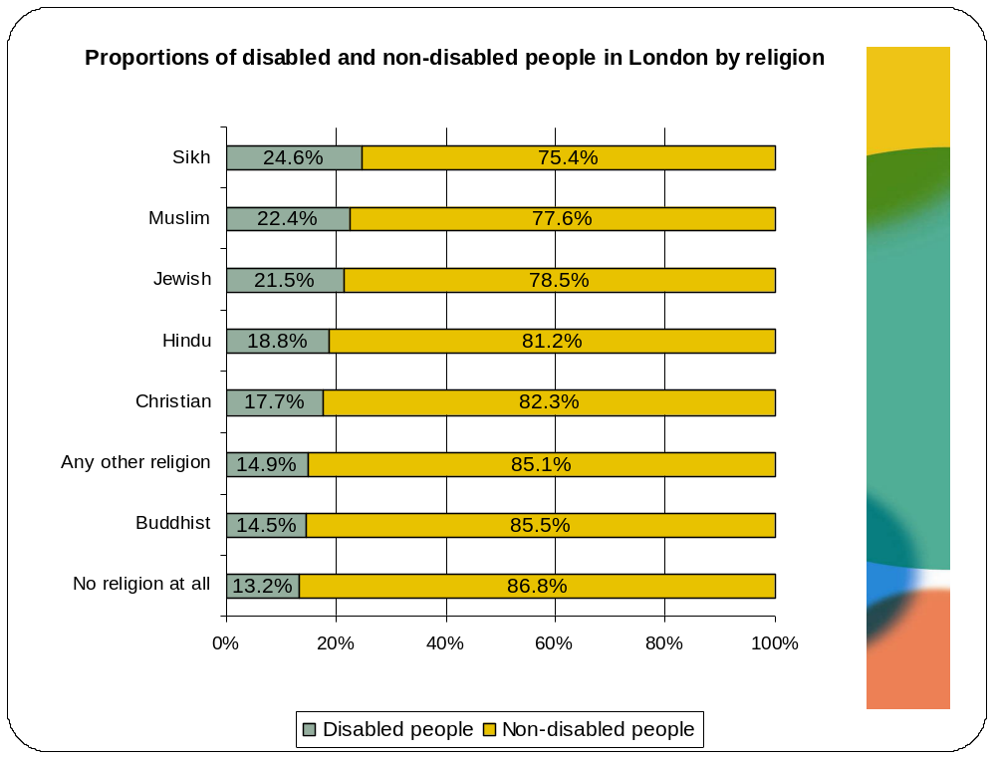

An analysis of the ethnicity of disabled people in different religious groups reveals that the majority of disabled Muslims are predominantly Bangladeshi (23.2%), Pakistani (16%) or identify themselves as ‘other’ (22.8%).

Marital status
In London, disabled people are twice as likely (12%) to be divorced compared to non-disabled people (6%). They are also almost three times more likely to be widowed than their non-disabled counterparts (13.5% and 4.8%, respectively). This is not surprising given that disabled people are likely to be older than non-disabled people.
The proportions of individuals who are married or in civil partnerships are similar amongst disabled and non-disabled people (approximately 55%), although disabled people are slightly more likely to be separated from their partner. These findings are illustrated in the table below.

 | Disabled people | Non-disabled people
Single, never married | 26.0% | 40.4%
Married, living with spouse | 43.5% | 45.2%
Married, separated from spouse | 4.9% | 3.1%
Divorced | 12.0% | 6%
Widowed | 13.5% | 4.8%
Currently or previously in civil partnership | 0.2% | 0.5%
Base | N=3,719 | N=17,463

Household and accommodation characteristics

Housing tenure and accommodation type
Almost half of the disabled people in London (48.7%) live in rented accommodation compared with approximately four out of ten non-disabled people (41%). Therefore, while disabled and non-disabled people living in London are both more likely to live in rented accommodation than in other accommodation, disabled people are more likely to do so than non-disabled people.
Disabled people are also slightly more likely to own their homes outright (30.4%), perhaps because of the older age profile of this group, compared with non-disabled people (22.5%), but less likely to be buying their homes with a mortgage or loan (18.9% compared with 34.7%). This is illustrated in the chart below.
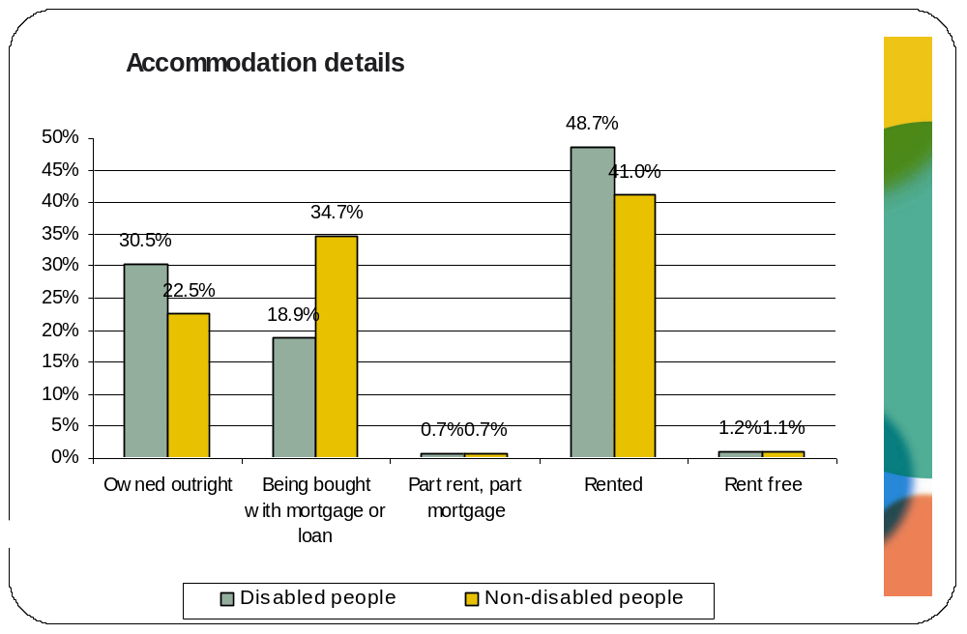
Moreover, as the chart below illustrates, more than half of the disabled people living in London rent their accommodation from the local authority or council (53.1%) whereas non-disabled people are most likely to rent from other individual private landlords (46.3%). The tendency for disabled people to be in social rented housing reflects the fact that they are less likely to be able to afford appropriate housing in the market sector. Despite this disproportionate concentration of disabled people in social housing, this type of housing is also unlikely to have been designed or adapted appropriately for the needs of disabled people.
The unsuitability of social housing creates a disabling domestic environment for disabled people in the one place where people normally expect to spend the majority of their time and enjoy the most control over their surroundings (ippr, 2005). The shortage of appropriate accessible housing is exacerbated by the old age of Britain’s housing stock: 60% of the housing stock in England was built before 1964 and 38% was built before the Second World War. The Survey of English Housing indicated that although approximately 1.4 million people require specially adapted accommodation: only 77 per cent live in accommodation that is suitable. This problem is particularly acute for disabled children, of whom only approximately half live in suitable housing (ippr, 2005). According to the GLA’s London Housing Strategy (2010), disabled people are more than twice as likely as non-disabled people to be living in unsuitable housing. Additionally, a survey by Habinteg Housing Association and London South Bank University (2010) that considered the ‘unmet housing need’ of wheelchair user households (i.e. only a section of disabled people) found that 78,300 such households had unmet housing needs in England, with an estimated 12,517 of these being in London.
Additionally, although a priority for housing policy has been to make all social housing meet a decent standard there is also evidence to suggest that disabled people are more likely that non-disabled people to live in housing that does not meet a decent standard. Using data from the English House Conditions Survey 2001, ippr (2005) found that 36.5% of disabled people lived in non-decent housing compared to 31.4% of non-disabled people. Given that disabled people are already disadvantaged because their housing does not meet their needs, the fact that they are also more likely to live in a home that does not meet standards of decency is of great concern.
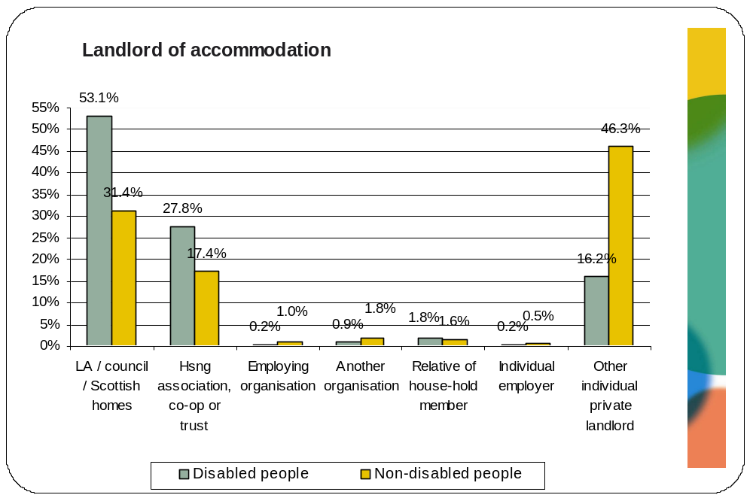
Almost four out of ten disabled (37.4%) and non-disabled (39%) people live in three bedroom accommodation and approximately one in three live in two bedroom accommodation (28.6% and 28.9% respectively). Very few disabled and non disabled people live in accommodation with five or more bedrooms, as illustrated in the table below.
 | Disabled people | Non-disabled people
1 bedroom | 19.6% | 12.3%
2 bedrooms | 28.6% | 28.9%
3 bedrooms | 37.4% | 39%
4 bedrooms | 11% | 14%
5 bedrooms | 2.7% | 4.1%
6 bedrooms | 0.7% | 1.7%
Base | N=986 | N=2,555

Size of households
Households with disabled adults tend to be smaller than those without disabled adults. As the chart below illustrates almost three out of four households (73.4%) with disabled adults have 2 or fewer people living in them compared to 58.3% of households without disabled adults.
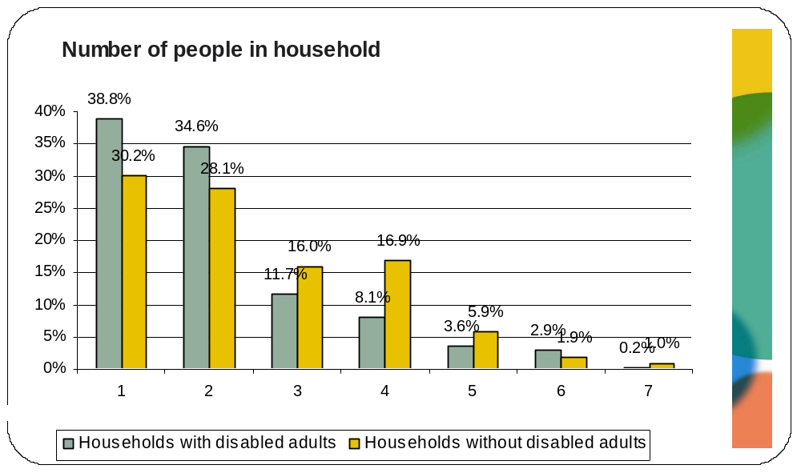
However, this difference in household size is not driven by differences in the number of adults in the household. As illustrated in the chart below, approximately nine out of ten households with (87.8%) and without (91.9%) disabled adults include two or fewer adults. Additionally, households with disabled adults are slightly more likely (12.1%) than those without (8.1%) to have more than 3 adults living in them.
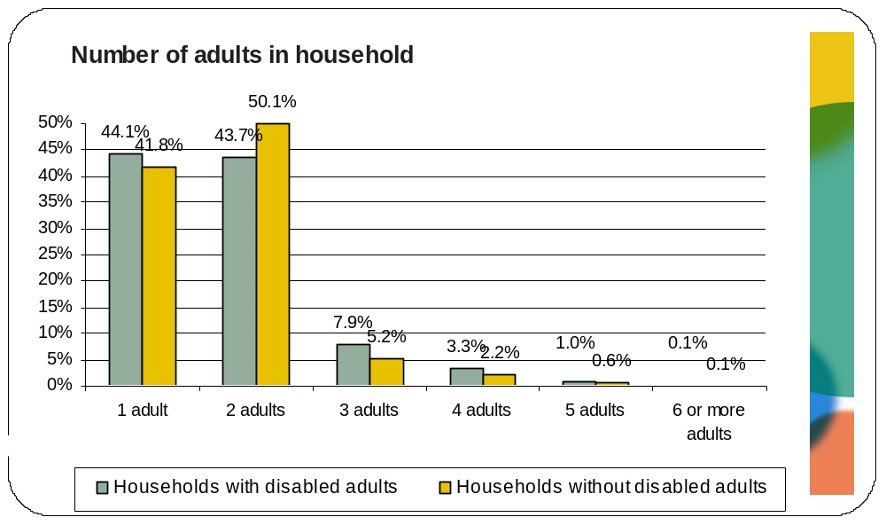
Instead this difference in size is driven by the number of dependent children living in households with and without disabled adults. As the chart below illustrates, households without disabled adults are approximately twice as likely as households with disabled adults to have one or more dependent children living in them (41.1% and 21% respectively).
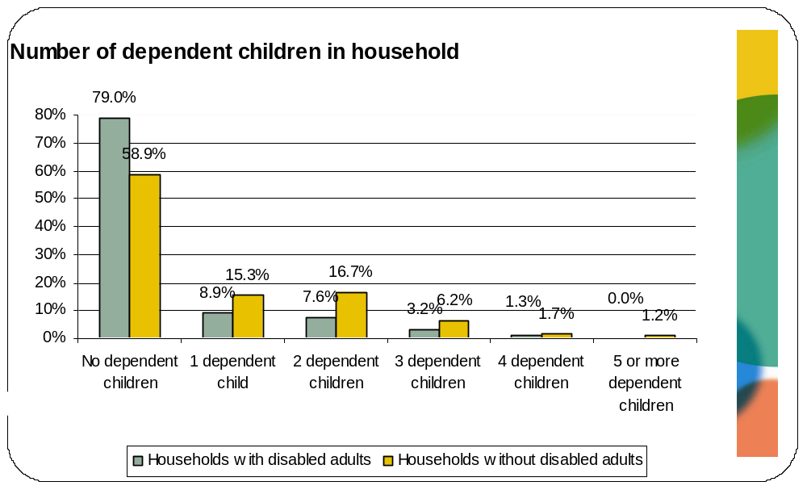
On the other hand households with disabled children are more likely to have a greater number of dependent children in them compared with households without disabled children. This inevitably means that the demands and costs facing households with disabled children are exacerbated by needs of other dependent children living in the household. This is likely to contribute to the already existing high level of poverty that is experienced by families with disabled children (OPM, 2010a). Based on 2008/2009 data from the FRS, 37% of households with disabled children across the UK live in poverty (calculated after housing costs) compared to 28% households with no disabled children
As the chart below illustrates more than 1 in 3 (31.5%) households with disabled children have three or more dependent children living in them compared to approximately 1 in 5 (20.3%) households without disabled children.
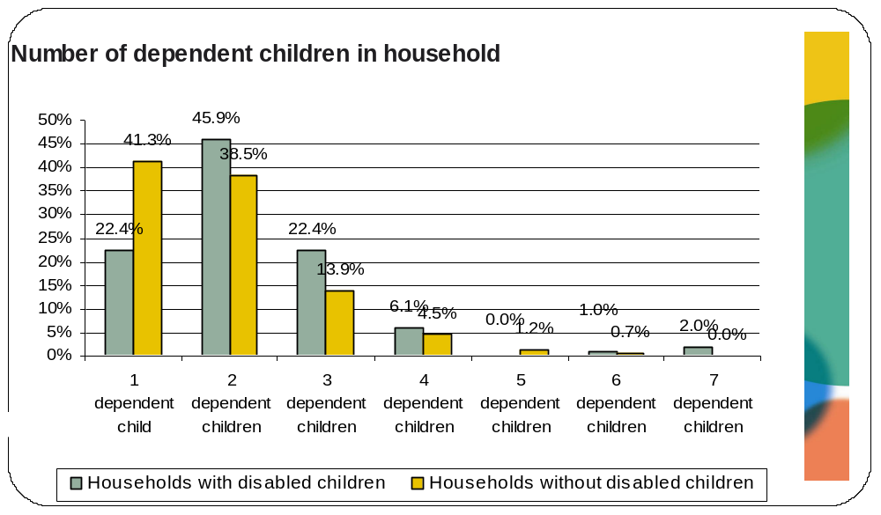

Household composition
As the graph below indicates, households with disabled adults are most likely to consist of one (38.8%) or two (31.7%) adults with no children. In fact, 79% of all households with disabled adults are adult-only households compared to 58.9% of households without disabled adults.
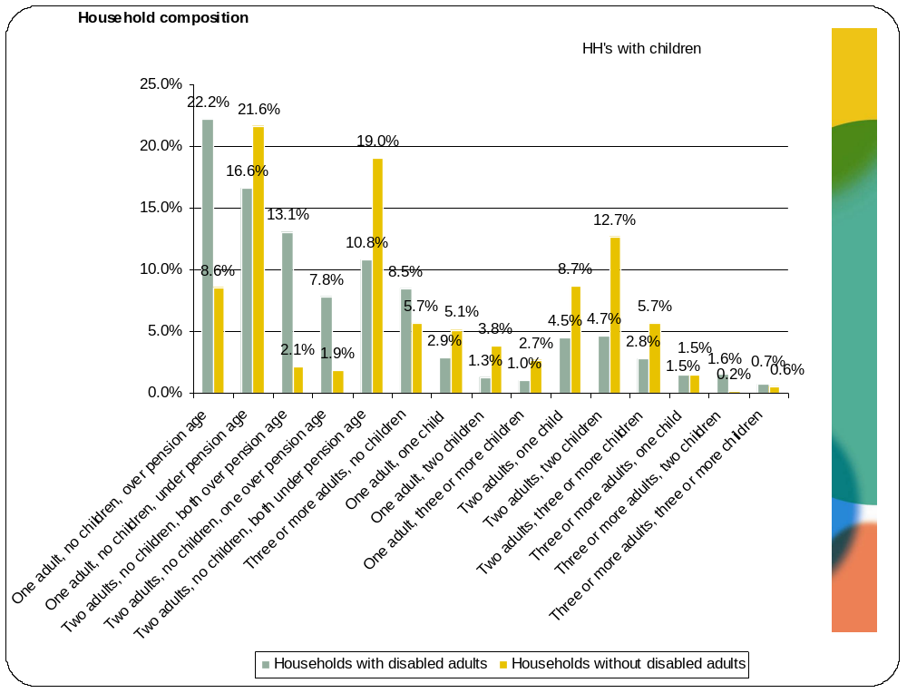
Furthermore, within households without children, disabled adults are more likely to live alone than non-disabled adults: households with disabled adults are most likely to consist of one adult (49.1%) whereas households without disabled adults are most likely to either consist of one (37%) or two adults (32%). This is illustrated in the chart below.
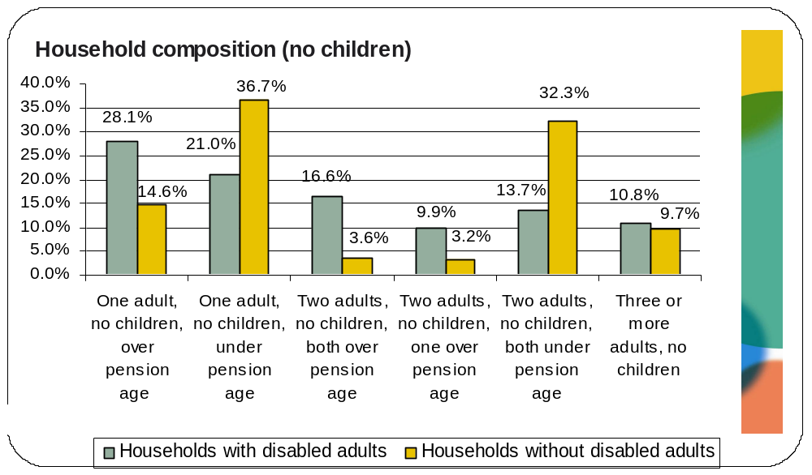
On the other hand, within households with children, households with and without disabled adults are both most likely to consist of two adults with one child (21.2% and 21.4% respectively) or two adults with two children (22.4% and 31% respectively). This is illustrated in the chart below.
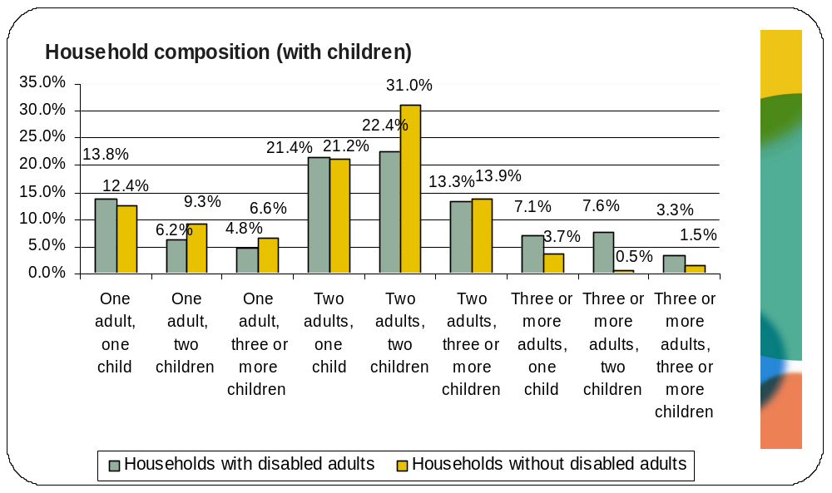
Households with and without disabled children
The household composition of households with and without disabled children is illustrated below. Both types of households are most likely to consist of two adults and two children (27.6% for households with disabled children and 28.9% for those without).
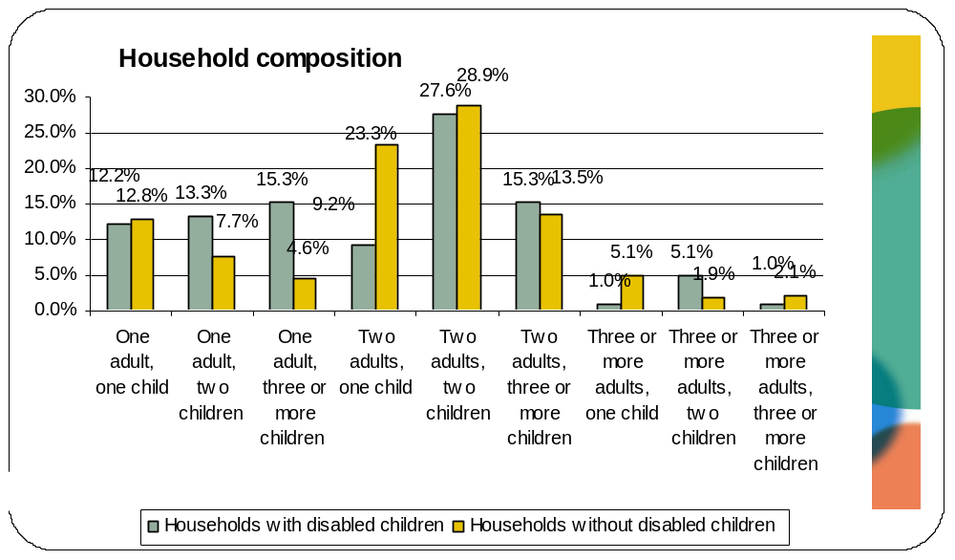

Education and economic characteristics

Educational qualifications
Analysis of the FRS indicates that roughly one third of disabled people (34%) in London hold degree level qualifications compared with almost half (46.6%) of non-disabled people. Additionally, disabled people are also more likely to hold no formal qualifications compared with non-disabled people (4.3% compared with 1.6%).

 | Disabled people | Non-disabled people
Degree level qual. | 34% | 46.6%
Higher education qual. below degree level | 9.7% | 8.1%
A levels or higher | 9.1% | 11.3%
ONC / National level BTEC | 3.1% | 4.2%
O/GCSE equiv (A-C) | 17.9% | 15.1%
O/GCSE equiv (D-G) | 8.2% | 4.9%
Other quals. | 13.6% | 8.1%
No formal quals. | 4.3% | 1.6%
Whereas there has been no change in the percentage of disabled working age people with degree-level qualifications (10%) between 2005 and 2008, this percentage has increased from 19.4% to 21.8% amongst non disabled people (OPM, 2010b). Data from the 2004 Youth Cohort Survey (DfES, 2004) further indicated that:
- 39% of disabled sixteen-year-olds had five or more GCSEs grades A-C, compared to 55 per cent of non-disabled sixteen year-olds.
- 68% of disabled sixteen-year-olds were in full-time education compared with 72 per cent of non-disabled sixteen-year-olds.
- 68% of disabled sixteen-year-olds had a qualification, compared to 75 per cent of non-disabled sixteen-year-olds.
These findings are not surprising given the wealth of evidence indicating that disabled people often face barriers to achieving educational outcomes and qualifications at school, as the result of a range of factors including negative experiences of schooling, being excluded from mainstream education, discrimination and low expectations from teachers, special schools lacking an academic orientation, and a lack of education provision during hospital and other absences. A survey by the Disability Rights Commission (DRC) (2003) found evidence of exclusion and subsequent low expectations. Almost a quarter of the disabled children and young people interviewed said they had experienced problems at school for reasons related to their impairment, and 38% of respondents said that they had been bullied. Furthermore, many young people said they had been discouraged from taking GCSEs, A-levels or going on to higher or further education. Elsewhere, the Office of the Children’s Commissioner reported that disabled children are twice as likely as ‘typically developing’ peers of being targets of bullying (Mencap, 2007). Although there have been efforts to improving disabled children’s inclusion in education since the Warnock Report in 1978, which laid the ground for transformation in the education of children with Special Educational Needs (SEN), significant challenges remain. A 2004 Ofsted report found that while most mainstream schools were now committed to meeting SEN as a result of the former Labour government’s revised inclusion framework, this framework continues to have little impact on the proportion of pupils with SEN in mainstream schools or on the range of needs for which mainstream schools cater.

Employment and unemployment
The majority of disabled people living in London are categorised as economically inactive (68.1% compared to 32.2% of non-disabled people). Asian/Asian British disabled people are most likely to be economically inactive (70.6%) which may, in part, be the result of the older nature of these groups.
The employment rate of disabled people in London is 87% which is less than that of non-disabled people (92%). Disabled people in London also have a slightly lower employment rate than disabled people in the UK (90%).This raises interesting questions about whether there may be additional barriers to disabled people’s participation in the labour market as a result of the characteristics of London’s economy, infrastructure and job market. The unemployment rate, conversely, is 13% for disabled people living in London which is markedly higher than the 8% unemployment rate amongst non-disabled people in London. Black/Black British disabled groups have the highest unemployment rate (16.8%).
This employment gap reflects a combination of the qualifications gap between disabled and non-disabled people highlighted above – itself a product of discriminatory factors which we have highlighted – and other barriers including employer attitudes, failure to make reasonable adjustments and a lack of legislative enforcement. The link between skills and employability has become stronger over time such that fewer than one in two people with no qualifications are currently in work. This has profound implications for the longer-term employability of disabled people if the skills and employment gaps are not addressed. The current and ongoing shift away from demand for unskilled labour is likely to have a disproportionately negative impact on disabled people, who are more likely than non-disabled people to have no, fewer or lower qualifications, and fewer ICT skills (Evans, 2007).
However, there is also evidence to suggest that disabled people who do hold qualifications are still more likely to be unemployed than their non-disabled counterparts. Palmer et al (2005) showed that at every level of qualification, disabled people are up to three times more likely than non-disabled people to be without a job but want to work. Palmer et al (2005) also showed that disabled graduates have a higher chance of being out of, but wanting, work than a non-disabled adult who has no qualifications at all.
The chart below illustrates the duration of unemployment experienced by disabled and non-disabled people in London. Non-disabled people are more likely than disabled people to experience short-term unemployment. Almost four out of ten (39.4%) non-disabled Londoners have only been unemployed for up to three months. This compares with just under one in four disabled people (23.5%). As far as long-term unemployment is concerned, the figures are reversed: 23.2% of non-disabled people and 39.8% of disabled people remain unemployed for more than a year. The difference is particularly marked, however, when those unemployed for five years or more are considered: Disabled people are more than four times as likely (7.8%) as non-disabled people (1.8%) to be unemployed for more than five years.
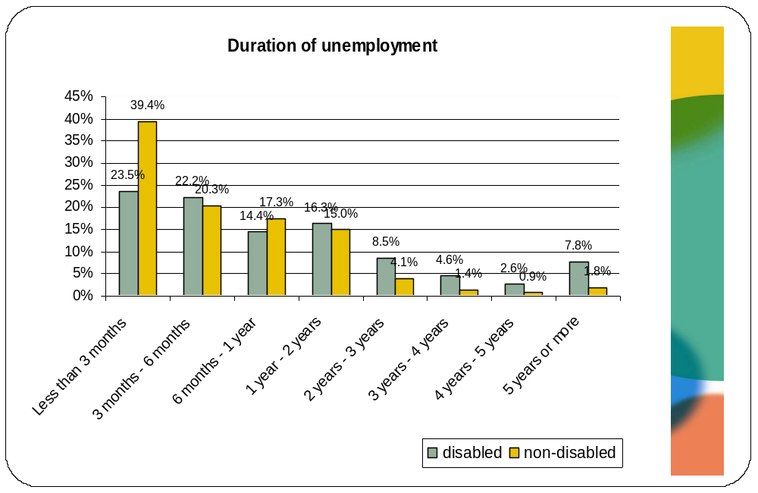
Similar differences exist in terms of how long disabled people and non disabled people report that they having been looking for work. Non-disabled people are most likely to have been looking for work for under three months (41.4%) whereas a similar proportion of disabled people (38%) have been looking for work for over a year.
It is important to dispel the myth that disabled people ‘can work but won’t work’, choosing instead to rely on benefits. Sensationalist accounts in the media about ‘benefits scroungers’ can propagate the belief that disabled people are trying to take advantage of the benefits system. While figures vary, partly depending on the definitions of disability used for data collection, evidence consistently shows that economically inactive disabled people want to work, even when they have not worked for a long time and do not expect to work in the near future (Howard, 2002, Grewal et al, 2002). Disabled people make up half of those who are not employed but would like to work, and one-third of those who are available to start work in a fortnight (Burchardt, 2000).
Additionally, analysis of the FRS revealed that 12.2% of disabled people that were either not working or had only been in employment for one year have received redundancy payments. This is almost twice as much as the equivalent figure of 6.9% for non-disabled people. This could be interpreted as implying that disabled people in London are more likely to have been made redundant than non-disabled people.
There is also clear evidence that transport can act as a barrier to employment for disabled people. Analysis of the APS revealed that disabled people are more than three times as likely (9.3%) as non-disabled people (2.6%) to report that issues relating to transport have prevented them from taking up a new job. A wide body of evidence supports these findings. Bowyer (2005) reported that the lack of access to appropriate transport created real knock-on effects for disabled people in terms of their ability to participate in the labour market – 23% of those respondents actively seeking employment had turned down a job offer, while 23% had turned down a job interview because of a lack of access to transport services. The impact of the lack of accessible transport for disabled people who live in rural areas across the UK is even worse as it severely limits their capacity to visit employment sites or services (OPM, 2010b).

Employment characteristics
Disabled people and non-disabled people who are in employment are both most likely to be employees (81.8% and 83.1%, respectively). Additionally, a similar percentage of disabled (17.2%) and non-disabled people (16.5%) in employment report being self-employed. Relatively small numbers of both disabled and non-disabled people are unpaid family workers (0.8% and 0.3%, respectively) or take part in a government scheme (0.2% and 0.1%, respectively).
An analysis by ethnic groups yields interesting findings. After Chinese people for whom the sample is very small (N=7) and people who classified themselves as ‘Other’, White and Asian/Asian British disabled people are most likely to be self-employed (17.9% and 15.8%) respectively.
Disabled people in London
 | Employee | Self-employed | Gov scheme | Unpaid family work
White | 81.3% | 17.9% | 0.3% | 0.6%
Asian/Asian British | 83.6% | 15.8% | 0% | 0.7%
Black/Black British | 89.3% | 9.7% | 0% | 1%
Mixed | 82.4% | 17.6% | 0% | 0%
Chinese | 71.4% | 28.6% | 0% | 0%
Other | 65.8% | 28.9% | 0% | 5.3%
Base | N=1029
Similar proportions of employed disabled and non-disabled people in London have permanent jobs: 94.2% and 93.4%, respectively. Amongst those working in temporary jobs, the types of temporary jobs held by disabled and non-disabled people vary with disabled people more likely to work on a contract for a fixed period or task (51% compared with 44.6%) or do casual work (26.5% compared with 19.4%), but less likely to do temporary work through an agency (8.2% compared with 17.5%). Disabled people have reported that recruitment agencies can be reactive rather than proactive in seeking out disabled applicants, and only do so when specifically asked by employers (OPM, 2010b). This is further exacerbated by the recent recession when there are fewer positions available and thus even less incentive for agencies to seek out disabled applicants.
Reasons for having a temporary job
Among those Londoners having a temporary job, the reasons for the job being temporary vary between disabled and non-disabled people. Not being able to find a permanent job is given as the main reason for working on a temporary basis by 36.7% of disabled people compared to 28.7% of non-disabled people. In contrast, only 16.3% of disabled people working in a temporary capacity say they do so because they do not want a permanent job, which compares to 27.5% of non-disabled people with temporary jobs. This implies that disabled people would much rather be in permanent jobs than temporary jobs but find it hard to find such work. These findings are illustrated in the charts below.
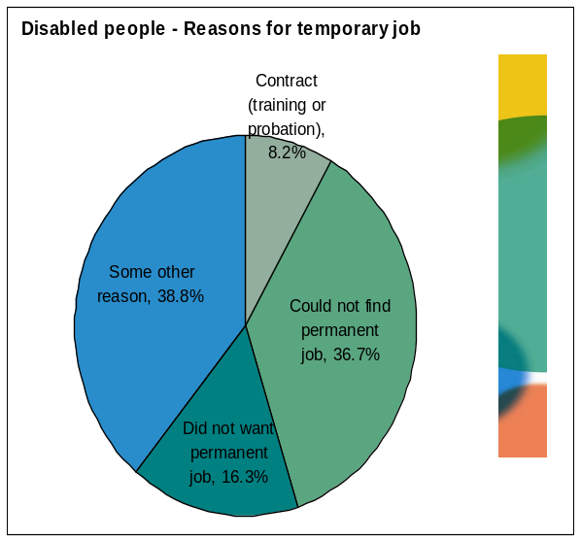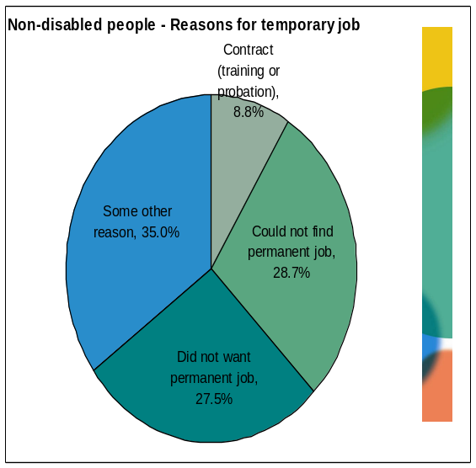
Full time and part time working
Although the majority of disabled and non-disabled people in London are likely to be in full time jobs, disabled people are more likely than non-disabled people to be in part-time jobs (31.1% and 24.9% respectively). A further analysis by ethnic group reveals that Asian/Asian British (31.7%) and Black/Black British (36.7%) disabled people as well as disabled people from a mixed backgrounds (33.3%) are more likely than White disabled people (29.5%) to be in part time jobs. This is illustrated in the table below.
Disabled people in London
 | Full-time | Part-time
White | 70.5% | 29.5%
Asian/Asian British | 68.3% | 31.7%
Black/Black British | 63.3% | 36.7%
Mixed | 66.7% | 33.3%
Chinese | 81.8% | 18.2%
Other | 59.5% | 40.5%
Base | N=1729
There are considerable differences between disabled and non-disabled people in their reasons for having part-time jobs. Disabled people are less likely than non-disabled people to work part-time because they do not want a full-time job (56.2% compared to 66.3%). Working part-time because of not being able to find a full-time job is also more common amongst disabled than non-disabled people (17.9% and 15.8%, respectively). A further inference that could be made from this data may be that flexibility in work schedules may be one way that disabled people can participate more easily in the labour market and thereby develop job skills and accumulate job experience (OPM, 2010b). It may also be the case that disabled people feel unable to work full time due to the lack of appropriate adjustments and support provided by employers. For example, there is evidence that discussion of reasonable adjustments between employee and employer can be a flash point that produces negative behaviour, especially for those requiring time off work or for flexible working (Douglas, 2009; Rutherford and Ollereamshaw, 2002).
That said, it is important to bear in mind wider evidence on flexible working. There are significant gender differences in availability and take up: part time working, for example, is available to 52 per cent of women compared to 25 per cent of men. Linked to this, two out of five men are afraid to ask for flexible working for fear of harming their career prospects, and only seven per cent of managers and senior officials work flexible hours compared to 33 per cent of those in administrative and secretarial occupations (The Women and Work Commission, 2006).
These findings are illustrated in the pie charts below.
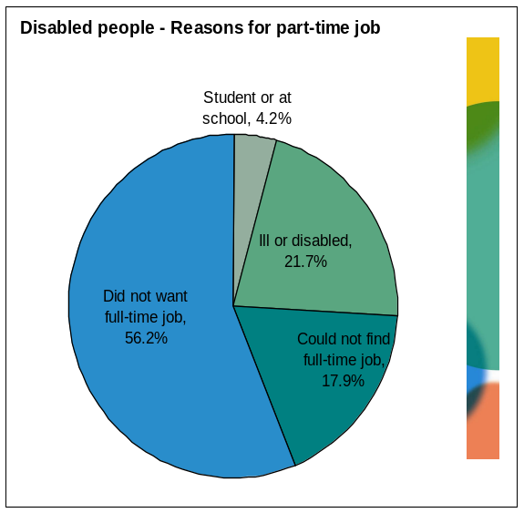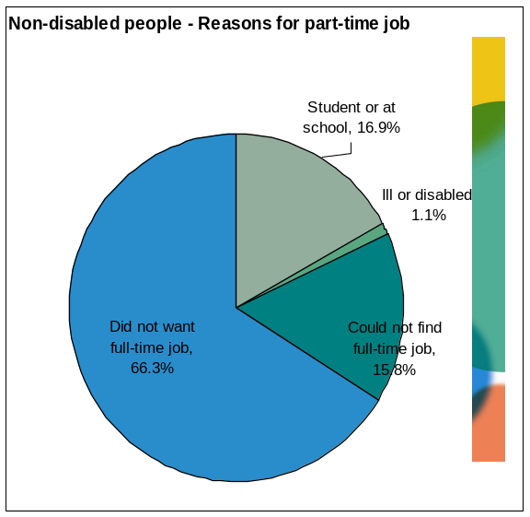

Employment sector and industry
Disabled people are more likely than non-disabled people to work in the public sector than the private sector (29.4% of disabled employees work in the public sector compared to 22.8% of non-disabled employees). Moreover, disabled people constitute only 8.2% of the private sector workforce, compared to 11.2% of the public sector. This means that the anticipated job losses in the public sector as a result of spending cuts by the coalition government are likely to have a disproportionate adverse impact on disabled people in London. A further analysis by ethnicity reveals that, excluding disabled Chinese people (due to the small sample size), Black/Black British disabled people (35.6%) are most likely to work in the public sector. Therefore disabled Black/Black British people may be particularly hard hit by the impact of impending public sector job cuts.
Disabled people in London
 | Private sector | Public sector
White | 70.2% | 29.8%
Asian/Asian British | 73.3% | 26.7%
Black/Black British | 64.4% | 35.6%
Mixed | 70.6% | 29.4%
Chinese | 57.1% | 42.9%
Other | 89.5% | 10.5%
Base | N=1021
An analysis of the types of public sector organisations that Londoners tend to work in found that disabled people are most likely to work in local government (39.3%) followed by health authorities (17.9%) and central government (11.6%). However, the picture is similar for non-disabled people, as illustrated in the chart below.
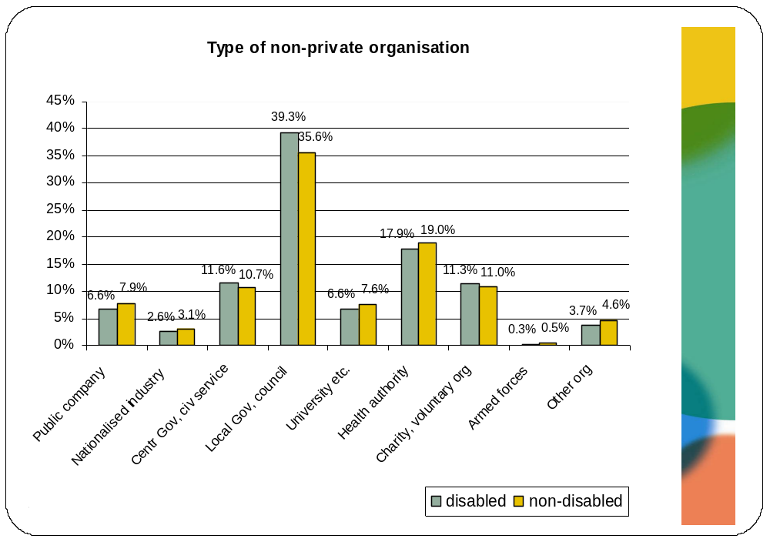
Furthermore, an analysis of the different industries in which disabled and non-disabled people in London tend to work in reveals that non-disabled people are much more likely to work in banking and finance (25.1%) compared with disabled people (19%). On the other hand, the proportion of disabled and non-disabled people working in distribution (15.8% and 15.7% respectively) or transport and communication (11.5% and 11.9% respectively) is approximately the same. These findings are illustrated in the chart below. 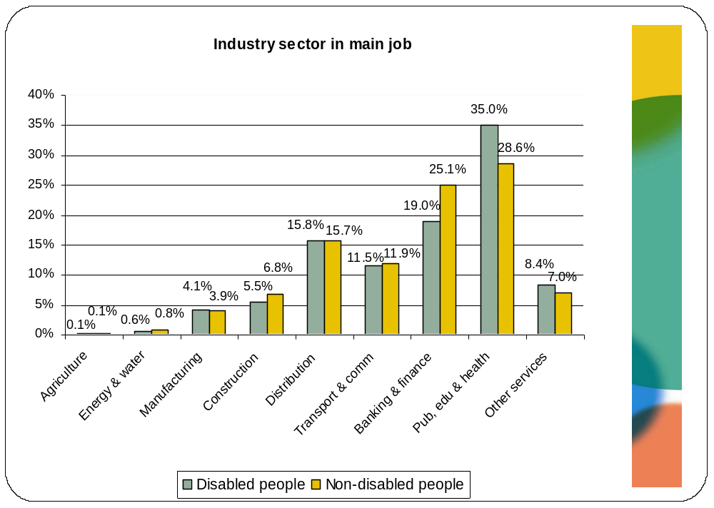
An analysis by ethnic group demonstrates that the Black/Black British disabled people and those from a mixed background are most likely to work in public administration, education and health (49.5% and 47.1% respectively) whereas Asian/Asian British disabled people are most likely to work in distribution and hotels. These findings are illustrated in the table below.

Disabled people in London
 | Manufa-cturing | Constr-uction | Distrib-ution, hotels | Transp-ort & comm | Banking / finance | Pub admin, edu, health | Other services
White | 3.9% | 6.5% | 13.5% | 11.0% | 20.8% | 35.3% | 9.1%
Asian /Asian British | 4.8% | 2.7% | 29.5% | 15.8% | 15.1% | 26.7% | 5.5%
Black /Black British | 2.9% | 5.9% | 8.8% | 10.8% | 13.7% | 49% | 8.8%
Mixed | 11.8% | 0% | 5.9% | 0.0% | 29.4% | 47.1% | 5.9%
Chinese | 14.3% | 0% | 14.3% | 0.0% | 14.3% | 14.3% | 42.9%
Other | 2.6% | 0% | 31.6% | 15.8% | 13.2% | 18.4% | 18.4%
Base | N=1022

Pay, income and hours worked
Disabled people earn less than non-disabled people. Analysis of the APS revealed that the average net weekly pay for disabled people in London is £344.90, which is almost £50 less than that of non-disabled people (£389.40). Furthermore, average gross hourly pay received by disabled people is also less than that of non-disabled people – £14.50 compared with £16.17.
Rigg (2005) has used evidence from the LFS to examine the earnings trajectories of disabled people through time. Based on his analysis, Rigg (2005) reported that changes in earnings of disabled people lags behind that of non-disabled people, especially for men.
Analysis of the FRS provided some insight into the weekly income of households with and without disabled people in London. As highlighted in the chart below, more than one in three households with disabled adults (35.5%) earn less than £300 a week which compares to only 19.8% of households with no disabled adults. Additionally, households without disabled adults are twice as likely (40.6%) as those with disabled adults (21.5%) to earn more than £800 a week. This is particularly worrying because households with disabled adults are also more likely than households without disabled adults to have disabled children living in them, thereby incurring greater expenses.
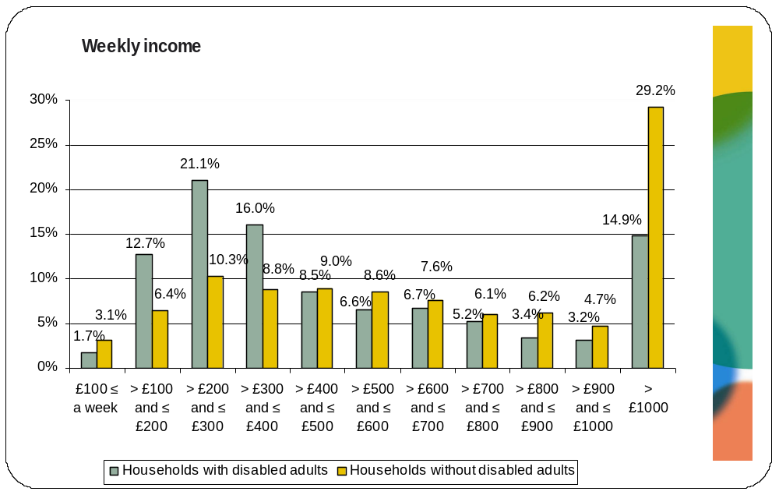
These findings are not surprising given the wealth of evidence indicating that disabled people are much more likely than non-disabled people to be in the lowest income groups and to be living below the poverty level. The Office for Disability Issues (ODI) have reported that in 2008/09, 26% of individuals in families where at least one member is disabled were living in income poverty (as defined by those below 60 per cent of median national income) after housing costs were taken into consideration, compared to 21% of individuals in families where no-one is disabled.
Although the sample size is small a similar, but less pronounced, trend exists for households with and without disabled children. As highlighted in the chart below, households with disabled children are more likely to earn less than £400 a week (19.4%) compared to those without (13.9%). As discussed earlier, households with disabled children are also more likely to have other dependent children living in them which means that the weekly income will need to be stretched even further. Additionally, as above, households without disabled children are twice as likely (41.9%) as those with (19.4%) to earn more than £800 a week. These findings are not surprising given the fact that, as discussed earlier, families with disabled children tend to suffer from high levels of unmet need and poverty. Additionally, the ODI reported a significant increase in the percentage of disabled children living in income poverty, with 32 % doing so in 2004/05 compared with 37% in 2008/09, after housing costs were taken into consideration.
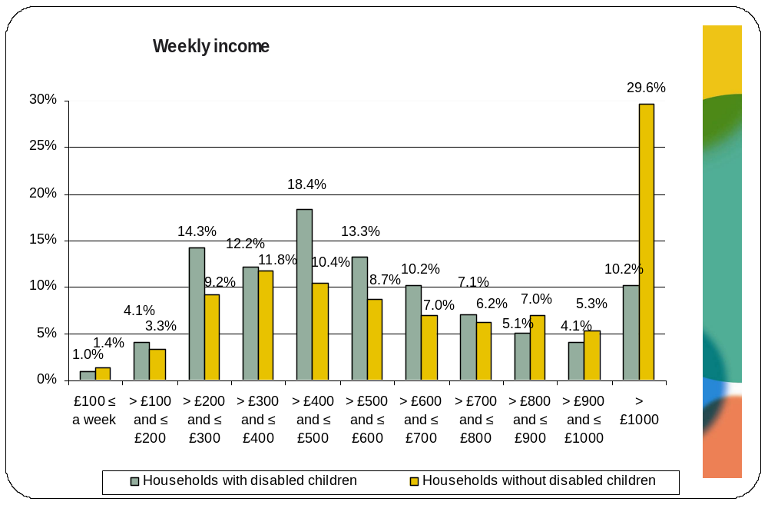

Benefit receipt
The benefits system has for many years recognised that disabled people and their families face additional costs of living resulting from their impairment that leave them worse of than non-disabled people with similar incomes. Certain benefits, like Disability Living Allowance (DLA), were designed specifically to help disabled people meet these additional costs. These additional costs of disability will be discussed in more detail in the next chapter.

Overview of benefit receipt
Analysis of benefit receipt figures from the APS reveal that disabled people are more than twice as likely (66.7%) as non-disabled people (33.1%) to be claiming state benefits or tax credits. This is not surprising given the fact that disabled people have a markedly lower weekly income than non-disabled people, are more likely to be unemployed or economically inactive and also, as mentioned above, incur additional living costs resulting from their impairment.
The chart below illustrates number of disabled and non-disabled people claiming different types of benefits.
More than one out of four disabled people in London are likely to be claiming sickness or disability related benefits (29.6%). This figure is surprising as one would have expected the claimant rate for sickness or disability-related benefits to be much higher for this group. This could indicate that many disabled people are under-claiming benefits to which they are entitled. There is certainly evidence of this, with people from BME backgrounds found to be experiencing particular challenges in claiming disability-related benefits and also suffering from lower levels of awareness of entitlement and due procedures (Jones and Tracy, 2010). This counters the unhelpful media representation of disabled people as ‘benefits scroungers’, a false stereotype that has re-emerged with vigour in recent months in the context of the government spending cuts programme. The same applies to housing or council tax benefit: 29.3% of disabled people in London claim housing benefit and/or council tax benefit.
Additionally one in five disabled people in London are likely to be claiming income support (21%) and child benefit (18.7%). Non-disabled people in London on the other hand are most likely to be claiming child benefit (claimed by 20.1% of non-disabled people overall), with the proportion claiming other types of benefits less than 10%. Disabled people are approximately twice as likely (15.4%) as non-disabled people (7.5%) in London to be claiming state pensions. This is not surprising given the older age profile of disabled people in London compared to non-disabled people which indicates that they are more likely to be of pensionable age.
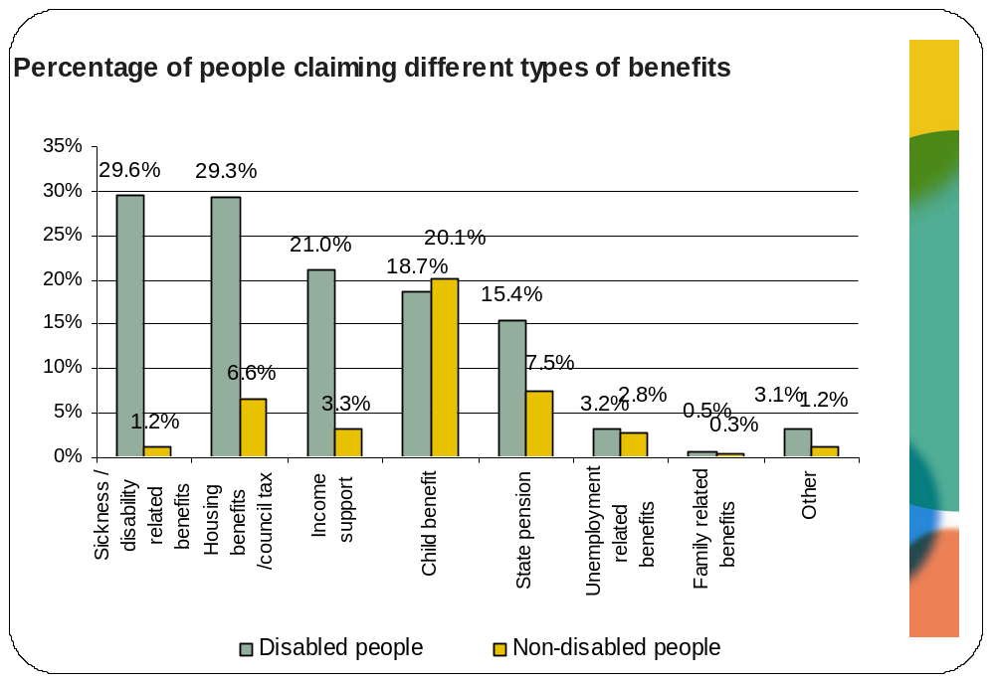
There are also differences in the number and combination of benefits received by disabled and non-disabled people who are claiming benefits. As the chart below illustrates disabled people who are claiming benefits are likely to be claiming multiple benefits.
More than one in five disabled people in London who are claiming benefits receive state pension (23.4%) child benefit (28.4%), income support (31.9%), housing or council tax benefit (44.4%) and sickness or disability (44.8%) related benefits. In contrast, non-disabled people who are claiming benefits primarily receive child benefit (62.6%) and state pension (23.2%) with the percentage receiving other types of benefits being relatively low. These findings imply that disabled people are likely to feel the impact of a greater number of the government’s proposed cuts to benefits compared to non-disabled people, an issue that will be discussed further in chapter 5.
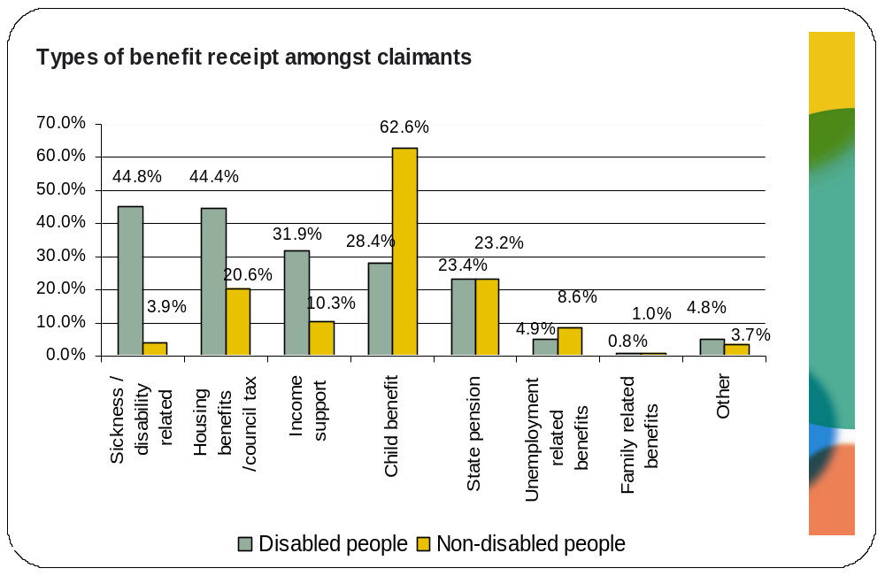
Analysis of the FRS also provided some insight into the combination of benefits that households with and without disabled adults receive. The findings confirm those discussed above. As illustrated in the chart below, approximately one in four households (22.5%) with disabled adults in London is likely to be receiving a full package of benefits comprised of council tax benefit, housing benefit, income support, employment and support allowance and pension credit, compared to only 8.7% of households without disabled adults. Additionally, more than twice as many households with disabled adults (9.3%) in London are likely to be receiving both council tax and housing benefit compared with households without disabled adults in London (3.8%).
These findings confirm the relative level of support that households with disabled adults need in order to make ends meet, compared with households without disabled adults. They also indicate the potentially significant negative impact that the government’s changes to and restructuring of the welfare system will have on disabled people.

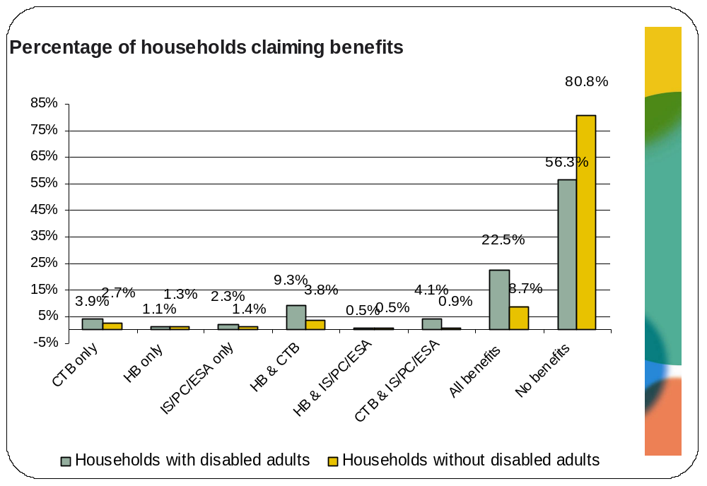
NB: CTB= council tax benefit, HB=housing benefit, IS=income support, PC=pension credit, ESA=employment and support allowance
Households with disabled adults who are claiming benefits are also more likely to have been in receipt of many benefits for a longer period of time. This is not surprising given that more than one in three of all disabled adult households in London earn a weekly income of less than £300. As the chart below illustrates, almost half (46.1%) of the households with disabled adults that have been claiming income support, jobseekers allowance and pension credit have been doing so for 5 years or more. On the other hand, a similar proportion of (42.2%) households with no disabled adults that have been claiming the same benefits have only been doing so for up to 2 years.

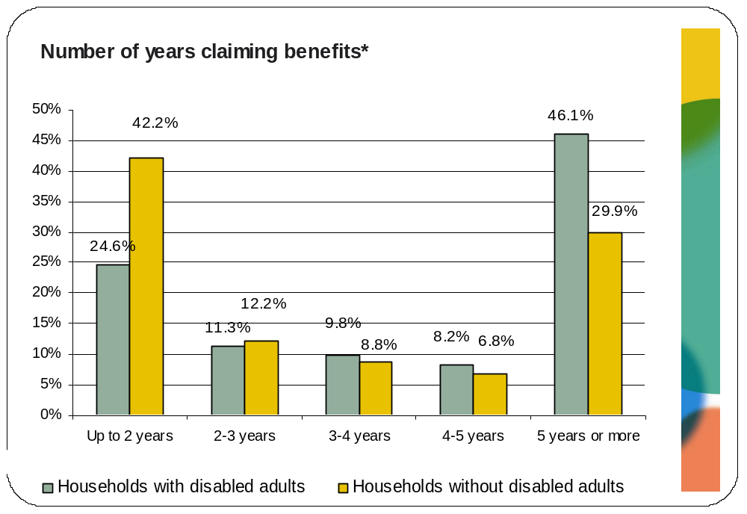
*Includes income support, jobseekers allowance and pension credit
This trend also holds for households with and without disabled children who are claiming benefits, albeit not as starkly. As the chart below demonstrates, more than half (53.3%) the households with disabled children have been in receipt of income support, jobseekers allowance and pension credit for five years or more. However, the majority of households (43%) without disabled children have also been in receipt of the same benefits for 5 years or more. On the other hand, only 17.8% of households with disabled children who are claiming benefits have been in receipt of these benefits for up to two years compared to 30.6% (almost double) of households without disabled children.
The interaction between the benefits and employment systems present unique challenges for disabled people. The average rate of disabled people making a transition into employment from economic inactivity is four per cent, while the equivalent figure for non-disabled people is six times higher (Burchardt, 2003). People who have been claiming Incapacity Benefits (IB) for 12 months, for example, are likely to claim it for full eight years. Once people have been on the benefit for 24 months, they are more likely to die or retire than to leave the benefit for a job (Burchardt, 2003). One of the reasons why, despite many disabled people’s desire to move into work, very few benefit claimants did actually move into work was the inadequacy and complexity of relevant benefits policies. Unsurprisingly, this has led to uncertainty and misunderstandings amongst claimants and employers alike. For example, many claimants feared that taking steps towards employment may place their benefits at risk, and that returning to work will place any future claim at risk (Grewal et al, 2002, Piggot et al, 2005). This is discussed in greater details in section 4.1.4.
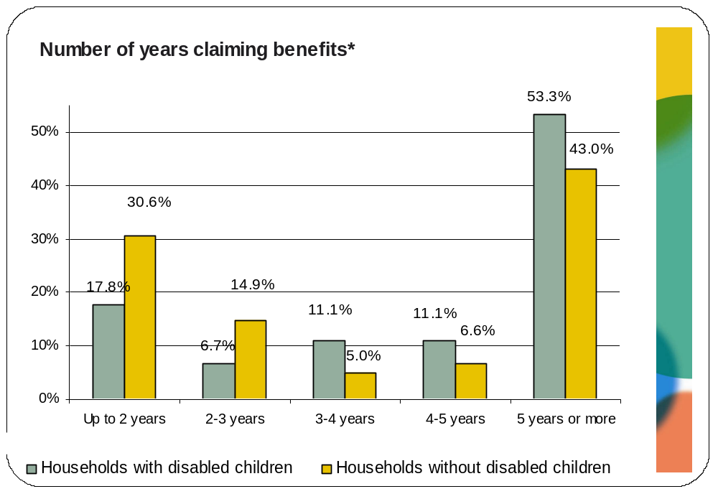
*Includes income support, jobseekers allowance and pension credit

Disability related benefit receipt
As mentioned earlier, more than one out of four disabled people in London are likely to be claiming disability related benefits (29.6%). Analysis of the FRS provided valuable insight into the take-up of the different types of disability related benefits. As the chart below illustrates both components of the Disability Living Allowance (DLA) appear to be claimed the most by disabled people in London followed by Incapacity Benefit (IB) and Attendance Allowance (AA).
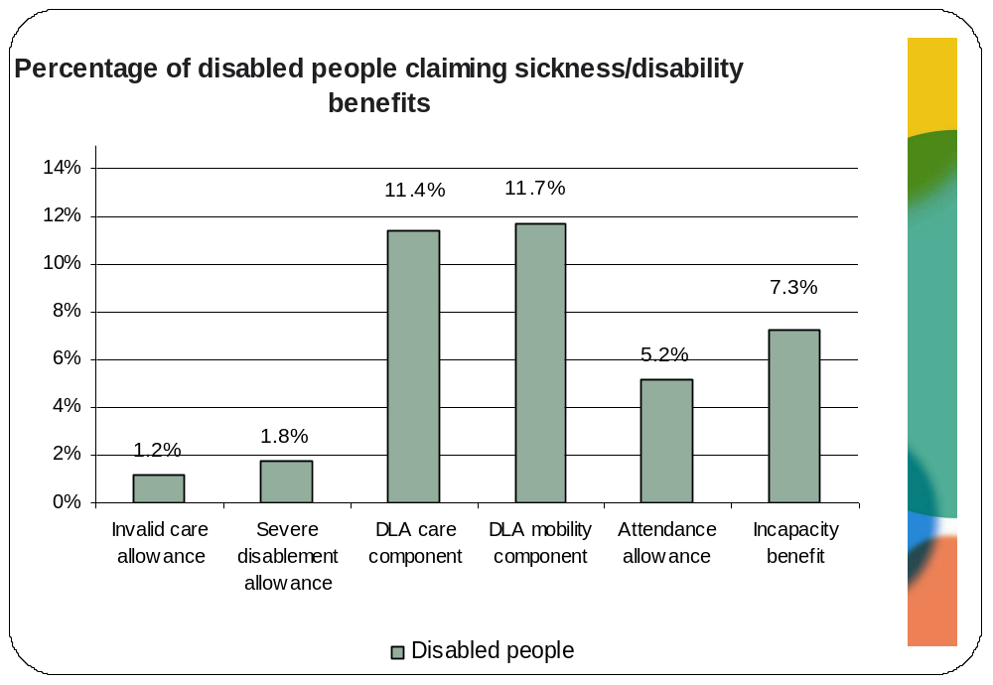
Additionally, 68.8% of disabled people in London in receipt of the DLA care component in London are also receiving the DLA mobility component, compared to only 31.3% of those not receiving DLA care.

Unemployment and income related benefit receipt
A very small number of disabled adults (3.2%) and non disabled adults (2.8%) in London appear to claim unemployment related benefits. This is not surprising given that the majority of disabled people in London are economically inactive (68.1%) and do not appear in the unemployment statistics nor as recipients of unemployment benefits. Within this group, it appears that both disabled and non-disabled people are more likely to be claiming JSA compared to NI credits (although sample sizes are small).

Type of unemployment benefit claimed
 | Disabled people | Non-disabled people
Jobseekers allowance | 89.7% | 94.7%
National insurance credits | 13.8% | 9%
Base | N=87 | N=433
As the chart below illustrates disabled people in London claiming JSA are more likely to be claiming contributory based JSA whereas non-disabled people are more likely to be claiming income-based JSA. However, as discussed in chapter 5, the number of disabled people on JSA is likely to grow considerably in the future as a result of the coalition government’s significant tightening of the eligibility for ESA as well as the imposed time limit of one year for contributory ESA work-related activity group claimants.
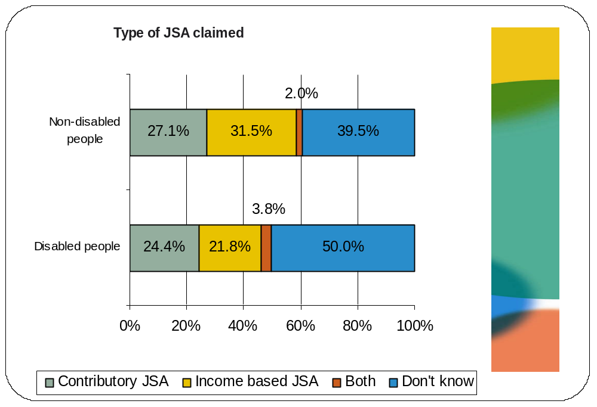
Additionally, disabled people are more likely than non-disabled people to be claiming unemployment related benefits for 18 months or more, as illustrated in the chart below. This is not surprising given that disabled people report having been looking for work for a lot longer than non-disabled people.
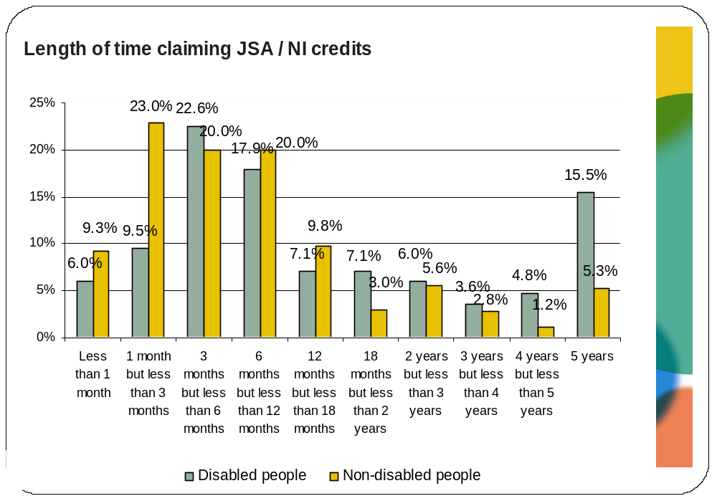
Additionally, approximately one in five disabled people in London are likely to be claiming income support (21%) compared to only 3.1% of non-disabled people in London. This supports the finding that households with disabled adults or disabled children have lower weekly income. Unsurprisingly most disabled adults claiming income support are doing so as a ‘sick person’ (66.4%) whereas most non-disabled adults are doing so as a lone parent (74.8%) as illustrated in the table below.

Type of income support claimed
 | Disabled | Non-disabled
Sick person | 66.4% | 5.9%
Pensioner | 3.6% | 2.0%
Lone parent | 22.0% | 74.8%
Other inc. Support | 7.9% | 17.4%
Base | N=581 | N=512

Council tax and housing benefits
On the other hand, disabled people in London are more than four times (27.2%) as likely as non-disabled people in London (6.1%) to be claiming housing benefits and council tax benefits (27.6% and 5.9% respectively). As with unemployment related benefits and income support, disabled people are more likely to have been claiming housing benefit for longer periods of time. As the chart below highlights 65.3% of disabled people in London who are claiming housing benefit have been claiming for 5 years or more compared with 45.8% of non-disabled people.
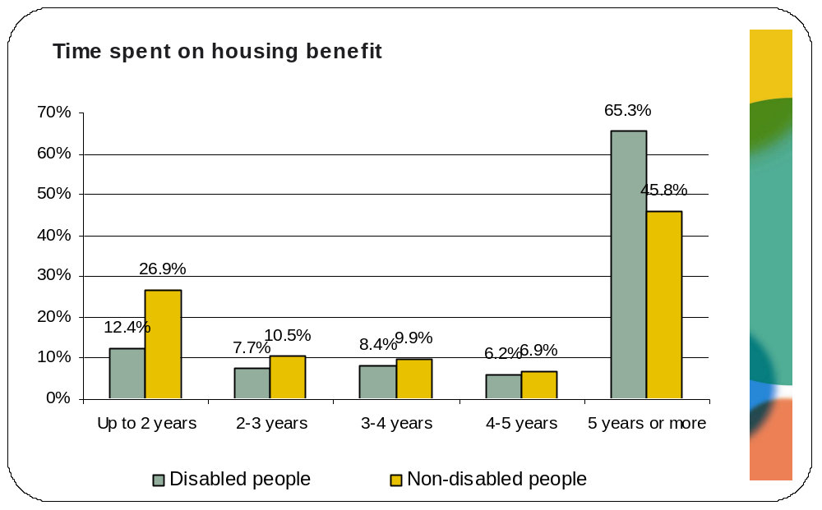

Summary
Demographics
- Analysis revealed that 17.6% of the surveyed APS sample in London is disabled which based on a mid-2009 London population estimate amounts to 1.4 million disabled people in London. Women are slightly more likely (55.1%) to be disabled than men (44.9%). Given that there is strong evidence that disabled women face greater barriers in the labour market, this means that they are likely to need targeted support and advice to help them gain employment. Disabled people in London are also younger than disabled people across the UK – 45.3% of disabled people in London are under 55 compared with 40.7% of disabled people across the UK.
- Within different ethnic groups, Asian/Asian British groups (19.2%), Black/Black British groups (17.8%) and those that classify themselves as ‘other’ (19%) are most likely to be disabled. Within these groups, Black Caribbean, Bangladeshi and Pakistani people in London are most likely to be disabled. Moreover, approximately 1 in 10 young people between the ages 20-24 from a Pakistani background (10.3%) are disabled. This is approximately double the proportion of all young people in London between the ages of 20-24 (5.2%) that are disabled. This analysis implies that these disabled minority groups are likely to be amongst the poorest in London, given the strong evidence base relating to the significant differences in deprivation, income and qualifications between Black and minority ethnic people those from a White background (Platt, 2007).
Household and accommodation characteristics
- Disabled and non-disabled people living in London are both most likely to live in rented accommodation although disabled people are more likely to do so (48.7% and 41% respectively).Moreover, more than half disabled people rent their accommodation from the local authority or council (53.1%) whereas non-disabled people are most likely to rent from other individual private landlords (46.3%). The tendency for disabled people to be in social rented housing reflects the fact that they are less likely to be able to afford appropriate housing in the market sector.
- Despite this disproportionate concentration of disabled people in social housing, this type of housing is also unlikely to have been adapted appropriately for the needs of disabled people. According to the GLA’s London Housing Strategy (2010), disabled people are more than twice as likely as non-disabled people to be living in unsuitable housing.
- Within households without children, disabled adults are more likely to live alone than non-disabled adults: households with disabled adults are most likely to consist of one adult (49.1%) whereas households without disabled adults are most likely to either consist of one (37%) or two adults (32%). Households with disabled adults are smaller than those without disabled adults and this difference is driven by the number of dependent children living in both households: 21% of households with disabled adults have one or more dependent children living in them compared to 41.1% of households without disabled adults. Additionally, households with disabled children are more likely to have a greater number of dependent children in them compared with households without disabled children which is likely to contribute to the existing high level of poverty that is experienced by families with disabled children.
Educational and economic characteristics
- The educational and economic characteristics of disabled people in London reflect the challenges and barriers they face at every stage of life. Disabled people in London are less likely to hold degree level qualifications (34%) compared with non-disabled people (46.6%) and are also more likely to hold no formal qualifications (4.3%) compared with their non-disabled counterparts (1.6%). This is not surprising given the wealth of evidence indicating that disabled people often face barriers to achieving educational outcomes and qualifications at school, such as negative experiences of schooling, being excluded from mainstream education and discrimination and low expectations from teachers.
- Disabled people also have an unemployment rate of 13% which is markedly higher than the 8% unemployment rate amongst non-disabled people. They are also more likely to be unemployed for a longer period of time. Additionally, they are almost twice as likely to have received redundancy payments 12.2%) which could imply that they are more likely to have been made redundant than non-disabled people (6.9%). This could indicate unfair discrimination and prejudice in the labour market. Disabled people are also more than three times as likely (9.3%) as non-disabled people (2.6%) to report that issues relating to transport have prevented them from taking up a new job.
- Similar proportions of employed disabled and non-disabled people in London have permanent jobs: 94.2% and 93.4%, respectively. However, amongst those with a temporary job, disabled people are more likely than non-disabled people to work on temporary basis because they could not find a permanent job: 36.7% and 28.7% respectively. Disabled people are also more likely than non-disabled people to be in part-time jobs (31.1% and 24.9% respectively) and this also tends to be because of not being able to find a full-time job.
- Disabled people are more likely than non-disabled people to work in the public sector than the private sector (29.4% compared to 22.8%). They are most likely to work in local government, council and the police (39.3%).
- Disabled people are much more likely to be living on very low incomes. More than one in three households with disabled adults (35.5%) earns less than £300 a week which compares to only 19.8% of households with no disabled adults. Furthermore, average gross hourly pay received by disabled people is less than that of non-disabled people – £14.50 compared with £16.17. Additionally, households without disabled adults are twice as likely (40.6%) as those with disabled adults (21.5%) to earn more than £800 a week. This is particularly worrying because households with disabled adults are also more likely to have disabled children living in them.
Benefit receipt
- Disabled people in London are more than twice as likely (66.7%) as non-disabled people in London (33.1%) to need to be claiming state benefits or tax credits. They are also most likely to be claiming sickness or disability related benefits (29.6%) and housing and/or council tax benefit (29.3%). These figures are surprising as one would have expected the claimant rate for benefits to be much higher for this group. This could indicate that many disabled people are under-claiming benefits to which they are entitled.
- Disabled benefit claimants are more likely than non-disabled claimants to need to be claiming multiple benefits. Moreover, households with disabled adults are also more likely to have been in receipt of benefits for a longer period of time. These findings confirm the relative level of support that households with disabled adults need in order to make ends meet, compared with households without disabled adults.
- Disabled people are more likely than non-disabled people to be claiming unemployment related benefits for 18 months or more. Disabled people in London are also more than four times (27.2%) as likely as non-disabled people (6.1%) to be claiming housing benefits.

Impact of past employment and benefits policies on disabled people
In this section we draw on evidence in the literature to explore the impact of existing and past employment programmes and benefit policies on disabled people. In the current environment of rapid welfare reform and concerns about unemployment in the public sector the lessons learned from previous changes to benefits and the introduction of employment support programmes provide valuable insight into how impending changes may be experienced by disabled people. The economic and political terrain is in a state of flux, making it somewhat risky to interpret future development on the basis of past experience in any deterministic manner. However, it is possible to understand how economic and social policies can fail to address and, in some instances, create further barriers (such as physical impediments or other people’s attitudes) which exclude and disadvantage disabled people. From this it is possible to have an informed judgement about the likely impact of the current government’s approach and planned policies. Interpreting the impact of such policies requires the ‘lens’ of the social model of disability – a model that represents a shift away from an emphasis on individual impairments towards the ways in which physical, cultural and social environments exclude or disadvantage people labeled ‘disabled’.
With this in mind, we will explore the:
- Impact of the benefits system on:
- The mental health and well-being of disabled people
- The pressure on disabled people to find employment in the face of a range of barriers
- Meeting the additional costs associated with disability
- Creating a ‘poverty trap’ that disabled people may fall into
- Impact of employment programmes such as Pathways to Work and the New Deal for Disabled People on the employment prospects of disabled people.

Impact of benefit systems

Mental health and well-being
There are a number of benefit policies and measures that research shows have an impact on the mental health and well being of recipients. The reported effects in the literature are both positive and negative.
For example, a considerable amount of the recent literature reviewed focused on the impact of Employment and Support Allowance (ESA). This is not surprising since the ESA represents the biggest change to benefit policy over the last five years. ESA was introduced in October 2008 in order to replace Incapacity Benefit (IB). It is received whilst applicants are being assessed on their ability to work. Following an initial medical assessment called a Work Capability Assessment (WCA), new ESA claimants are allocated to one of two groups, a Work-related Activity Group (WRAG) where they are expected to take steps towards gaining employment or a support group if they are judged to be severely disabled and are not expected to undertake any work -related activity.
Kemp and Davidson (2010) conducted a baseline and follow-up survey on the employment trajectories of recent IB claimants in order to explore the extent to which they returned to work and the factors associated with this outcome. The purpose of this study was to shed some light on the potential impact of the new ESA system on those claimants who were likely to be allocated to the WRAG group. The IB claimants were allocated based on their own perception, to ‘potential worker’ and ‘permanently off sick groups’, intended to mirror the WRAG and support group. The study found that the barriers faced by the potential worker group in trying to gain and retain a job as a claimant had a negative impact on their well-being. Increased pessimism and under-confidence was reported. A majority of these people had not been able to keep a job, either because of their health condition or because the job was temporary, resulting in a struggle to stay in the labour market.
Another aspect of the ESA that has reportedly had a negative impact on claimants is the elements of conditionality and sanctions that it includes. Where members of the WRAG group are thought not to be following their work-related activities plan or where they fail to attend their work focussed interviews, a reduced rate of benefit can be imposed. A qualitative research study conducted by the Greater London Authority (2007) which included discussions with a range of people including IB claimants, Job Centre Plus leads and disability advice providers found that there were very real concerns that such sanctions would force claimants to take work that was not suitable for them which could cause great stress, worsen their condition or suffer ‘demoralising repeated rejection in the labour market’ (GLA, 2007: 9).
ESA claimants are also expected to undergo periodic reviews which the GLA study (2007) found ‘wears claimants down and many become depressed even though mental illness was not behind their initial claim’ (GLA: 2007: 9). This also conflicted with the previous sense of entitlement claimants had to benefits based on the severity of their condition.
There is also evidence in the literature that the WCA conducted as part of the ESA can be a source of further anxiety and stress. This is often the case when the severity of the claimant’s condition is felt to be undermined. A report by the Citizens Advice Bureau (CAB) (2010b) which drew on workshops with representatives from advice centres and welfare rights workers found that ESA claimants felt there was little recognition of generalised pain and exhaustion or the seriousness of their condition in the WCA. Additionally, a lot of factors such as the context of the work environment, including a person’s education, skills and circumstances, or the discrimination they may face in looking for work, all of which can significantly affect the scale of the person’s barriers to work are not taken into account when they are assessed as to whether they are able to work. The lack of recognition combined with personal barriers that disabled people face is felt to result in heightened anxiety and mental stress.
Early assessment of the impact of ESA has highlighted a number of negative developments. Between January and October 2009, Citizens Advice Bureaux received 61,254 enquiries about ESA while Macmillan Cancer Support’s Benefit Helpline received 661 calls between May and October 2009. Cumulatively, a number of key failings of the ESA in terms of people with cancer have been identified (Macmillan Cancer Support and Citizens Advice Bureau 2009). Despite the safeguards to ensure that people are not forced unreasonably to attend WCA, Macmillan Cancer Support and Citizens Advice Bureau (2009) reported that terminally ill patients are not being fast tracked onto into the ESA support group but have been required to attend WCA. Similarly those receiving chemotherapy and radiotherapy have also been required to attend WCA. The WCA itself is not sensitive to the needs of people with cancer. These early indications suggest that the ESA may not be taking person-centred and sensitive approaches to supporting disabled people into work. At the same time, the level of benefits received may be reduced.
Before ESA was introduced eligibility for IB included a personal capability assessment (PCA) which assigned the claimant to a severity points system in accordance with their physical and mental functional impairments and those with a disability severe enough on the points system were eligible for IB and were not expected to seek work. This then changed when ESA was introduced and the PCA was replaced by the WCA. A qualitative research study conducted by the Greater London Authority (2007) which included discussions with a range of people including IB claimants, Job Centre Plus leads and disability advice providers, found that there were real concerns about the extent to which the WCA would accurately assess claimants’ capacity to work. A lot of cases have gone to appeal and the authors report that according to the Citizen’s Advice Bureau, the success rate is very high at almost 60 per cent. However, since the process of appeals can take months (during which claimants are denied benefits) this has can cause financial hardship and worsening of conditions, both of which have an impact on the individual’s mental health and well-being.
These findings are supported by Compass who, using statistics published by the DWP, showed that up to 500,000 disabled people have been wrongly assessed as fit for work and thus denied IB over the past fifteen years. The DWP themselves, in a study on customer and staff experiences of the WCA by Barnes et al (2010b), have reported that many health care professionals felt that the eligibility criteria for the WCA was much tighter than that of the PCA which it replaced, and that consequently potential claimants had to demonstrate significantly less function in order to qualify for the benefit. Whereas many health care professionals felt that the WCA was an improvement over the PCA, there were also some that felt that the perhaps the threshold had moved too far in the opposite direction and had become too high which meant there was now a group of disabled people who would have qualified for IB but not for ESA, even though they were ‘not particularly Fit for Work’ (DWP, 2010: 27).
There is also some evidence in the literature relating to the positive impact that the Disability Living Allowance (DLA) and Attendance Allowance (AA) have had on the mental health of disabled people. A report by Corden et al (2010) based on qualitative research with professionals and advisers in touch with people who claim or might be entitled to DLA or AA, and DLA and AA recipients found that they had both had a positive impact on claimants’ well-being and quality of life. The report finds that claimants felt DLA contributed to improving their well being by having a positive impact on various aspects of their lives, for example ‘improving meals and nutrition, warding off depression caused by financial struggle and anxiety, helping to maintain physical health and enabling warmer, cleaner, more comfortable homes, with less anxiety about meeting fuel bills’ (Corden et al, 2010: 89). These findings suggest that the coalition government’s aim to cut the number of DLA recipients by 20%, discussed fully in the next section, is likely to have a significant negative impact on the well being of those disabled people who lose the benefit.

Failure to find employment because of barriers faced
Policy changes in recent years have put increased pressure on disabled people to find work. A report by Barnes et al (2010a) on ESA which collated survey data through face to face interviews with claimants highlights that far fewer customers are exempt from assessment under the work capability assessment than were under the personal capability assessment, and the threshold for eligibility is also higher (Barnes et al: 2010, 1). Although this increased pressure exists, there is a great deal of evidence demonstrating the poor employment prospects of IB and ESA claimants due to the barriers they face in the labour market.
For example, Kemp and Davidson (2010) in their study with recent IB claimants found that only 11% of those respondents that self-categorised themselves as ‘potential workers’ (as opposed to those that categorised themselves as ‘permanently off sick’) had done any work in the six months between surveys. These ‘potential worker’ respondents were also asked about the barriers to work they experienced. As the table below illustrates, there was an upwards shift in the number of people agreeing with the statements over the six month period thus implying that the ‘potential workers’ had become more pessimistic about finding work and that their perceptions of the barriers they faced had increased. The perception that increased the most was that there were not enough jobs available for people with their skills (from 19% to 42%). Additionally, the percentage of respondents that felt unable to find a job because of their health condition also jumped considerably, from 28% to 42%.
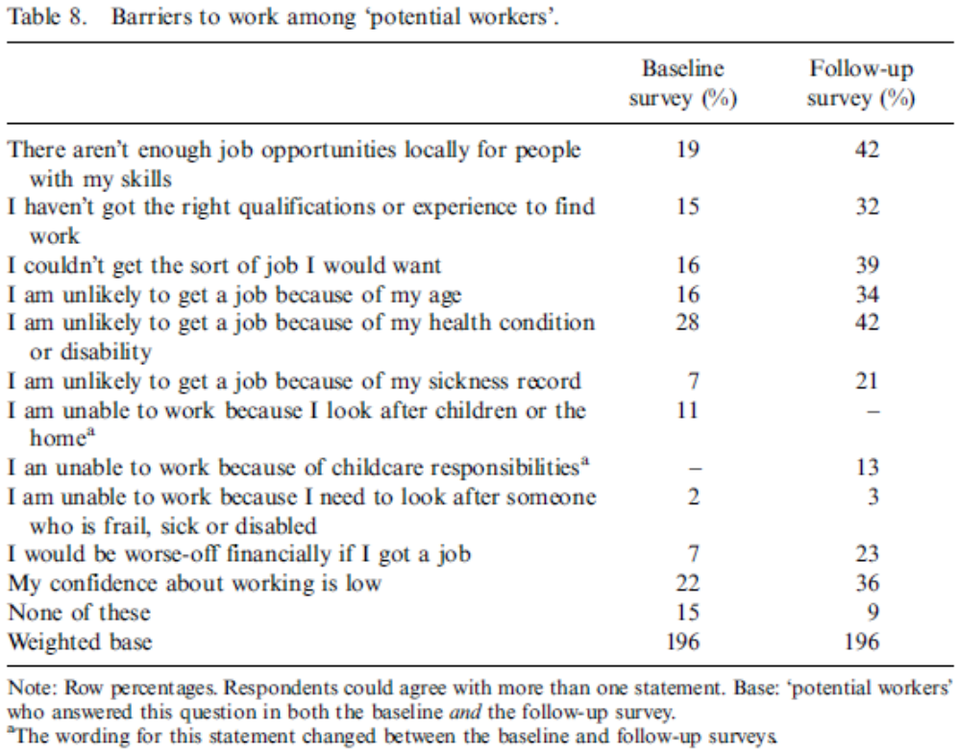
Source: Kemp and Davidson, 2010, Table 8, p 78.
This increased pessimism and failure to find employment has also been reported in other literature reviewed. Barnes et al (2010), in their survey of ESA claimants, found that women allocated to the WRAG groups were more likely than men to think that they would not work again in the future (38% compared with 27%, respectively). Additionally, those over 55 years of age who were allocated to the WRAG group were also much more likely (55%) than other age groups to think they would not work again. The barriers to finding work were similar to those reported above with 64% reporting poor health conditions, 12% reporting low confidence and 10% reporting the lack of availability of jobs.
The failure of benefit claimants to find employment has also been linked in the literature to discrimination and prejudice by employers.
A qualitative research report by the Greater London Authority (2007) on incapacity benefits in London which included discussions with a range of people including IB claimants, Job Centre Plus leads and disability advice providers, highlights clear evidence of widespread discrimination and prejudice. The report evidences quotes from other disability organisations as below:
‘Employers’ attitudes can be a real barrier to incapacity benefit claimants getting jobs, particularly people with mental health problems.” London Borough of Camden, Welfare Rights Service
Employers are not willing to continue my employment after diagnosis. No employer in my field of work is willing to take a chance in employing someone with mental health needs.” Client of drop-in centre in Harrow.’ (GLA, 2007: 8)
The GLA also quote research relating to the discrimination and prejudice faced by the wider group of disabled people. They report that ‘one in six workers who develops an impairment loses his or her job. The risk is twice as high for people with mental health problems, and three times as high for people in manual jobs as for people in professional occupations. If you are looking for a job, your chance of success is 40 percentage points lower if you are disabled’ (GLA, 2007: 8).
There is a wealth of evidence on the barriers faced by disabled people in applying for, securing and keeping a job:
- Inaccessible procedures and information - A third of disabled people (active job seekers and potential workers) in a study by Mehta and Keil (2007) stated that difficulty in finding out about jobs is a key challenge to finding employment. Disabled people can encounter particular challenges in seeking employment-related advice or information. For example, a Formal Investigation by the DRC (2004) reported that 81 per cent of the 1,000 websites tested failed to satisfy the most basic Web Accessibility Initiative category. Evaluations of a sample of these websites undertaken by disabled users show that they have characteristics that make it very difficult, if not impossible, for people with certain impairments, especially those who are blind, to make use of the services provided. Research by Adam and Kreps (2009) on the provision of information via private bodies or through the Internet commented on the lack of progress since the DRC Formal Investigation.
- Discrimination and negative attitudes - A lack of disability awareness and negative attitudes among employers is a significant barrier faced by disabled people. For example, employers often make assumptions about the productivity of disabled people in that they expect them to be less able to do the work effectively, have to take more time off, be less productive or effective and need more supervision. They thus feel that employing a disabled person is risky. Simm et al (2007) found that although 95% of employers claim they always hire the best person for the job, over a fifth still think that employing a disabled person is a major risk for their organisation. The most negative assumptions are made for people with mental health conditions. Perkins et al (2009), for example, found that only 37% of employers would even consider employing someone with a mental health condition even if they faced labour shortages.
- Lack of awareness of ‘reasonable adjustments’ - The concept of ‘reasonable adjustment’ is poorly understood by employers and the perceived ambiguity about what employers are required to do and the vagueness of the term ‘reasonable’ act as particular barriers for disabled people. Additionally, awareness among employers of what adjustments may be needed for which impairments is higher for physical and sensory impairments and lower for learning disabilities and mental health conditions. Employers tend to wrongly assume that adjustments for disabled members of staff would require large-scale infrastructural changes to their workspaces that can be very costly, whereas in fact adjustments are often simple and low-cost (Simm et al, 2007). In addition to advice and support around how to make reasonable adjustments, there is a need to clarify the financial implications of making such adjustments in order for employers to be persuaded by its benefits. A survey by Russell (2006) of 53 employers found that 79% were concerned about the costs of reasonable adjustments and that this influenced their willingness to make them. Employers were less likely to make reasonable adjustments during the recruitment stage compared with retaining disabled people, which again indicates the barriers faced by disabled people in securing a job. Howard (2004) found that 59% of larger firms claim to have made adjustments for disabled people in recruitment. This compared with 88% claiming to have made adjustments for retention.
The above evidence makes a strong case against benefit policies that put undue pressure on disabled people to find employment. Before such policies can be successful a great deal of work is needed in order to remove the barriers faced by disabled people in the labour market.

Failure to meet additional costs faced by disabled people
The benefits system has for many years recognised that disabled people and their families face additional costs of living resulting from their impairment that leave them worse of than non-disabled people with similar incomes. These include, but are not limited to, costs relating to wheelchairs, heating, transport and bathroom adaptations (Smith et al, 2004).
The DLA is the primary benefit that was designed to meet the additional costs associated with disability. However, there is clear indication in the evidence reviewed that the amount of benefits received by disabled people is often not enough to meet the additional costs of disability.
Despite the positive impact of disability benefits on disabled peoples lives, many disabled people receive benefits that are not sufficient to lift them out of poverty. A study by Leonard Cheshire Disability (2008) argued that:
“Many disabled people are trapped in inescapable poverty – those furthest from the labour market with little immediate chance of getting in to work frequently rely on benefits that are simply not sufficient…This leaves people with little or no chance of escaping poverty other than through charity, or support from family and friends” (Leonard Cheshire Disability, 2008: 6).
Smith et al (2004) modelled these additional costs of disability and found that even if disabled people are receiving the maximum level of benefits (DLA, Income Support, Incapacity Benefit and housing and council tax benefit) they still experience a shortfall in income. Additionally, even those disabled people that are in paid work do not receive enough wages to cover the cost of their needs.
“For disabled people solely dependent on benefits, irrespective of the type or level of their need, levels of benefits fall approximately £200 or more short of the weekly amount required for them to ensure a minimum standard of living. These figures suggest that benefits meet only 28 per cent of the costs of those with low-medium needs; 30 per cent of the costs of those with intermittent/ fluctuating needs; 35 per cent of the costs of those with hearing and visual impairments, respectively; and 50 per cent of the costs of those with high support needs”. (Smith et al, 2004: 78).
The authors also note that these calculations exclude personal assistance costs which represent the highest costs for disabled people. Whilst these calculations are likely to have changed and most likely risen since this report was published, it does highlight the fact that disabled people’s needs are not being met by the current benefits systems.
There are also some groups of disabled people that are likely to face higher costs of disability that others. Wood and Grant (2010b) in their survey of 845 disabled people have sought to identify the type of factors or drivers that increase or decrease the costs of disability faced by this group. They report that no single factor or variable, such as hours of care needed, employment status or housing status, was strongly linked to the costs of disability. However, they also state that disabled people with the following characteristics would be most likely to have the highest additional costs: unsuitable accommodation, private rented accommodation, reliance on public transport, no informal support from family and friends, requiring higher levels of care and support, unemployed, living in London, receiving Jobseeker’s Allowance, no savings, in debt and no bank account.
Additionally, Wood and Grant (2010b) report that 83% of their surveyed sample reported spending up to £50 per month in each of the categories of spending they selected (19 categories were asked about). The average amount spent across the sample was around £800-1,550 per month.
Such evidence highlights the fact that the additional costs of disability faced by disabled people are very real. Not only do they have a significant impact on the standard of living experienced by disabled people, but they also impede the extent to which disabled people are able to function as equal citizens with equal rights. This makes it particularly worrying when, as is the current case, policy changes have been announced that would both reduce disabled people’s ability to meet the additional costs incurred by disability, and also reduce their service entitlements and other income sources. For example, these include the planned restrictions in DLA to cut the number of recipients, the planned removal in the mobility component to people living in care homes and the closing of the Independent Living Fund, all of which are discussed in more detail in the next chapter.

The ‘poverty trap’
There is evidence in the literature reviewed that entering the labour market is regarded as financially risky by many disabled people who are worried about the impact that having a job can have on their benefits and the support that they are offered. For a disabled person, gaining employment instead of receiving benefits does not always result in a better standard of living. The GLA report (2007) based on discussions with a range of people including IB claimants, Job Centre Plus leads and disability advice providers reported that several benefits such as Housing Benefit, Income Support and Council Tax Benefit are reduced by 85p for every pound of earnings. Other benefits are entirely withdrawn if a certain number of hours of work in a week are undertaken.
Entering employment also results in other costs being accrued such as the cost (and availability) of child care and of (accessible) transport. Additionally, there is also evidence to indicate that disabled people are more likely to earn less than their non-disabled counterparts. The GLA research argued that because of this, people may be put off working by the fear that they will be financially worse off if they do and will fall into the ‘poverty trap’ – a situation where neither employment or benefits can meet their living standards. The authors also argue that the financial pressure on the individual and perhaps even a family caused by the withdrawal of benefits, and the stress and worry that results because of this, makes it more likely that a benefit leaver might quit a new job, or end up performing badly and therefore lose the job (GLA, 2007).
This is a very real risk for many disabled people as securing employment does not always equate to staying and progressing within employment. At least 150,000 workers each year leave employment as a result of ill-health (Baker, 2006). In particular, many people with mental health conditions find it difficult to remain in employment and can face isolation and discrimination in their workplaces. They are at double the risk of losing their jobs compared with those who do not have a mental health problem (Social Exclusion Unit, 2004). The majority of disabled people experience the onset of disability during adulthood and each year around three per cent of those in work become ‘limited in daily activities’ (Bardasi et al, 2000). One in six of those who become disabled while in work lose their employment during the first year after becoming disabled. Using data from the British Household Panel Survey, Bardasi et al (2000) suggest that 80 per cent of all those who become disabled are in employment at the time of onset, falling to 60 per cent the following year and 36 per cent the year after that.
Many disabled people who do move back into work find that employment is difficult to sustain: one in three is out of a job again by the following year, compared with one in 20 of non-disabled people (Burchardt, 2003). The Social Exclusion Unit (2004) has also found that little – if any – support is provided to people once they enter employment.
The fear of having one’s benefits withdrawn is also often the result of the confusing nature of benefit policies. For example, there is evidence in the literature to suggest that despite many people’s desire to move into work, very few IB claimants did actually move into work because of a lack of understanding of the policy. Eligibility for IB was based on a person being demonstrably incapable of work every day that they were in receipt of the benefit. At the same time, it was recognised that many people in receipt of IB did want to and could work. The introduction of compulsory work focused interviews was posited as a way of requiring claimants to consider work. However, the nature of these work focused interviews has been subject to significant criticism as we analyse above.
Grewal et al (2002) in their report on the experiences of disabled people and Piggot et al (2005) in their article on disabled people’s employment needs argue that the IB policy as it is framed means that claimants must simultaneously demonstrate their incapacity to work and discuss their capacity to work with a view to taking steps towards moving into work. Unsurprisingly, this had led to uncertainty and misunderstandings amongst claimants and employers alike with many claimants fearing that taking steps towards employment may place their benefits at risk, and that returning to work will place any future claim at risk (Grewal et al, 2002; Piggot et al, 2005).
Grewal et al (2002) have also argued that the fear of losing benefits is most acutely felt by those who have been forced to stop work through disability, as having experienced one traumatic event in the world of work meant there was heightened concern about making the transition back into the workforce.
GLA (2007) in their report based on qualitative research with a range of people including IB claimants, Job Centre Plus leads and disability advice providers found that the benefit system can also impact on the claimants desire to take up other forms of employment, such as voluntary work. The GLA research revealed even if volunteer organisations give a disabled person a free drink, this can be translated into a ‘benefit in kind’ which can also lead to deductions from benefits.

Impact of employment programmes

Non-definitive impact on employment prospects
A number of employment programmes have been introduced over the years with the aim to provide disabled people with the support and advice they may need to take up employment.
For example, the Pathways to Work programme is a gateway to advice and support for people receiving IB or ESA which aims to provide people with personalised support that will help them get into appropriate employment. It was rolled out, after pilots across the country, in 2008 and consists of compulsory work focused interviews with a personal adviser and access to NHS rehabilitation to help claimants manage their condition. There is mixed evidence in the literature about the extent to which the programme and its associated processes has been successful in helping disabled people gain employment.
DWP (2008) research into the role of conditionality in employment programmes reported that the initial evaluation of the programme found that it increased an individual’s likelihood of being in employment eighteen months after the start of the claim from 28% to 35%. It also reduced the likelihood that they reported having a health problem that affected their day-to-day activities a great deal. However, a review of literature and policy initiatives by Riddell et al (2010) reported that subsequent evaluations did not find a statistically significant impact from the programme on any of the work, earnings and self-reported health outcomes identified in the earlier evaluation.
Another concern raised by the GLA (2007) is that the measure of results, which was based on the proportion of disabled people that enter employment and stay there for at least six months, could lead contractors to concentrate their efforts on those disabled people that are perceived to be the easiest to get into work and on employers that offer the most accessible jobs, which can often be low-skilled and low paid jobs. The authors also note that the economic calculation of how to improve the ‘performance indicator’ at minimal cost will discourage advisers doing other valuable work such as helping long term disengaged clients into voluntary work or training and confidence building. This could therefore result in the exclusion of those disabled people that need more support or disabled people taking jobs that were not suitable for them. A similar point is made by Riddell et al (2010) who quote research by Nice et al. (2009) which reported that
‘Performance targets may have dysfunctional impacts on the delivery of Pathways and on client progress, if those targets put DEAs [Disability employment advisers] under pressure to increase the numbers of interviews completed per day, or to refer clients to the cheaper forms of provision.’ (Riddell et al, 2010: 62)
A similar criticism has been levied at WORKSTEP, another employment programme that provides support to disabled people facing complex barriers to getting and keeping a job. Kane and Gooding (2010) in their research on supported employment for disabled people report that many stakeholders interviewed felt that because contractors were funded by results, people with more complex needs were likely to be excluded.
There is also some evidence to suggest that the work focused interviews that form part of the Pathways to Work programme are not considered very useful in helping claimants find work. A survey by Lancashire (2010) of benefit claimants found that IB and ESA claimants were most likely to disagree with the following statement: The interview was useful. It gave me some ideas about returning to work or training when I’ m able to.
These claimants felt that the interview was conducted as a ‘tick box’ exercise without any real consideration of how the claimants could go about getting back into work or education.
‘I asked about going to college after 15 years since leaving school. No one in the office could help me. They shipped me from one person to the next asking me where I had looked for work and not listening to my responses. I am still none the wiser as to how to get started. All they were interested in was ticking boxes. Male aged 25-49, had been claiming ESA for less than three months. (Lancashire, 2010: 6)
On the other hand, Barnes et al (2010a), in their survey of ESA claimants, found that 70% of those in the WRAG found their work focused interviews helpful. However, this tended to decline with age with 76% of those between 25-34 years finding it helpful compared with 61% of those over 55 years.
There is also evidence in the literature relating to the lack of privacy which also contributes to the extent to which these interviews are thought to be helpful or productive (Lancashire, 2010; Riddell et al, 2010). Lancashire (2010) in his research with benefit claimants reported that many claimants found it difficult to talk about their health condition or disability and the way it could impact on their ability to work because they were worries that others would hear them. Furthermore, the expertise of personal advisers conducting the interviews was also questioned by claimants. Riddell et al (2010) have argued that the role of personal advisers is ‘pivotal’ and quote research by Nice et al. (2009) which reported ‘serious concerns about whether personal advisers have the time to develop sufficient awareness and in-depth understanding of all available provision, in order to be able to give customers appropriate advice’ (Riddell et a, 2010: 62).
The New Deal for Disabled People is another such programme of advice and support for people with disabilities and health problems which aims to move them off benefits and into employment. It includes support such as advice in CV writing, preparing for interviews and identifying job opportunities. An evaluation by Stafford et al (2007) found that the programme was moderately successful. It found that although the programme was successful in helping people get into employment, there were differences in the participants of the programme and those receiving incapacity benefits. Participants of the programme tended to be younger, had been claiming benefits for short period of time and had better qualifications and employment experience.
The evaluation by Stafford et al also found that the programme had led to cost-savings in the amount of incapacity-related benefits paid out to participants. Whilst the evaluation does not explicitly consider the impact of the programme on disabled people’s income levels, the cost savings can be interpreted as lower weekly incomes for disabled people. At the same time the evaluation also notes that whereas there has been a decline in benefit receipt there is a lack of information about the number of disabled people that are successfully finding employment. The authors report that:
‘One major source of uncertainty [of the impact of the NDDP] is that there is a greater impact on incapacity benefit receipt than on employment – in other words there is an increase in the proportion leaving benefit but not recorded as in employment.’ (Stafford et al, 2007:146)
It thus appears that without any evidence relating to the numbers of disabled people successful in finding employment as a result of such employment programmes, there is a risk that there is an increase in the number of disabled people not receiving either income from benefits or employment. This has serious implications for the level of poverty and exclusion suffered by this group.

Lack of awareness of Access to Work
Access to Work provides financial support to disabled people and their employers for both one-off and ongoing costs associated with providing adjustments and support that may be needed in employing a disabled person. Riddell et al (2010) in their review of literature and policy initiatives reported that an in-depth evaluation of the programme found that there were very low levels of awareness about the programme amongst employers with many reporting that they had not heard about the programme until one of their employees made an application for support. JobCentre Plus staff also had low levels of awareness. Furthermore, most disabled people who made an application said they had found out about the programme by accident. However, employers who had taken part also said that, as a result of the assessment process, they felt much more knowledgeable about the ways in which they could support their employees. Additionally, Lancashire (2010) in his survey of benefit claimants found it very surprising that only one respondent mentioned the programme. The evaluation of the programme reported in Riddell et al’s (2010) review also found that on the whole employers and customers could point to many benefits such as reduced sickness and absenteeism, savings on work-related expense and staff retention. Additionally, disabled people have also reported that the programme is particularly effective in helping with travel costs which in turn improves the capacity of disabled people to participate in the labour market (OPM, 2010b). Thornton et al’s (2001) study of Access to Work schemes reported that nine out of ten users said that it met most or nearly all of their requirements, and nearly half of users said that they would not be able to work without them. Nonetheless, the impact of Access to Work is uneven. Thornton et al reported that:
- it was used much more in the public than in the private and voluntary sectors, and particularly in central government
- public sector users are somewhat more likely than others to have a bigger package of Access to Work supports but less satisfied with the extent to which it met their needs
- public sector users hold less favourable opinions on employers’ involvement in the process of getting Access to Work and are less satisfied with the time for the support to be provided, compared with users in other sectors
- a lower overall opinion of Access to Work among public sector users than those in the private and voluntary sectors.
The Disability Employment Coalition (2004) estimated that AtW recoups £1.48 in increased tax and National Insurance contributions for every £1 spent, and therefore generates tangible economic benefits. Similarly, the National Audit Office (2005) has also highlighted the cost effectiveness of the AtW programme in its assessment of the Department of Work and Pension’s (DWP) support for disabled people. The recent announcement by the coalition government of the list of ‘standard equipment’ not eligible for Access to Work funding is therefore particularly worrying (discussed in more depth in the next section).

Summary
Impact of benefits systems
There is evidence to suggest that the ESA, which has replaced IB for new claimants (with a migration of all existing claimants planned to start in April 2011), and means that claimants could be expected to undertake work-related activity, can have a negative impact on the wellbeing and mental health of disabled people. For instance, the barriers disabled people face in getting and keeping a job can result in increased pessimism, under confidence and demoralising rejection (Kemp and Davidson, 2010). The inclusion of sanctions that effectively cut benefits if claimants are found not to be following their work-related activities plan can also force claimants to take work that is not suitable for them which could cause great stress (GLA, 2007) . Furthermore the WCA which forms part of the system has been reported by disabled people and their representatives as often failing to take into account a lot of factors that can significantly affect the extent to which they are able to work (CAB, 2010b), resulting in a rise in people being denied benefit and in high numbers of appeals, many successful.
Changes to the ESA and IB (in the past) put increased pressure on disabled people to find work and yet there is evidence to demonstrate that it is the barriers faced by disabled people in the labour market that often result in failure to find employment. Kemp and Davidson (2010) in their study with recent IB claimants found that only 11% of respondents who self-categorised themselves as ‘potential workers’ had done any work in the six months between surveys.
Disabled people can encounter particular challenges in seeking employment-related advice or information. Additionally, negative attitudes and lack of awareness among employers means that they often make assumptions about disabled people’s productivity which continue to act as a significant barrier to disabled people getting and keeping a job, with research in London showing those one in six workers who develops an impairment loses their job, doubling with mental health conditions (GLA 2007) and higher for people in manual jobs than professional ones. Employers also tend to have low awareness about the cost and types of ‘reasonable adjustments’ that disabled people need which can make them less likely to implement such adjustments (OPM, 2010).
There is also clear evidence in the literature that although disability benefits, particularly the DLA, have a positive impact on disabled people’s lives, they are not adequate to cover the additional costs of disability faced by disabled people (OPM, 2010; Smith et al, 2004)
For a disabled person, gaining employment instead of receiving benefits does not always result in a better standard of living. Many benefits are cut and some can be taken away altogether once employment is gained. Employment is more likely to be low paid and can also result in other costs such as child care and transport. This is also a very real risk for many disabled people as securing employment does not always equate to staying and progressing within employment. At least 150,000 workers each year leave employment as a result of ill-health (Baker, 2006) People may be put off working by the fear that they will be financially worse off if they do and will fall into the ‘poverty trap’ – a situation where neither employment nor benefits can meet their living standards. (GLA, 2007; Grewal et al., 2002)
Impact of employment programmes
A number of employment programmes have been introduced over the years with the aim to provide disabled people with the support they may need to take up employment. For example, Pathways to Work programme is a gateway to advice and support for people receiving IB or ESA but there is mixed evidence about the extent to which it has been successful in helping disabled people gain employment. Disabled people often report the work focused interviews to be unhelpful and lacking of privacy (Lancashire, 2010). There are also concerns that performance targets could lead contractors to concentrate their efforts on those disabled people that are the easiest to get into work (GLA, 2007; Riddell et al, 2010). The New Deal for Disabled People (NDDP) is another such programme that has been found to be only moderately successful, and even so mostly with younger claimants (Stafford et al, 2007). Additionally, the evaluation of the programme also found that although there were cost savings in the amount of benefits paid out to participants, there was a lack of information on the number of disabled people successfully finding employment which could mean that there is an increase in the number of disabled people not receiving either income from benefits or employment,
Access to Work is a programme that provides financial support to disabled people and their employers for both one-off and ongoing costs associated with employing a disabled person. An evaluation of the programme found that there were very low levels of awareness about the programme amongst disabled people and employers. However, it also found that on the whole employers and customers could point to many benefits such as reduced sickness and absenteeism, savings on work-related expense and staff retention (Riddell et al, 2010). The Disability Employment Coalition (2004) estimated that AtW recoups £1.48 in increased tax and National Insurance contributions for every £1 spent, and therefore generates tangible economic benefits. The programmes potential for success makes it worrying that the coalition government has recently announced a list of standard equipment not eligible for funding, discussed more fully in the next chapter.

Impact of future spending cuts on disabled people in London
In the last six months there has been a significant amount of analysis of the impact of welfare policy changes and spending cuts to public services announced by the coalition government. The organisations that have been at the forefront of generating statistical analyses are the Institute for Fiscal Studies (IFS), the Trades Union Congress (TUC) and Citizen’s Advice Bureau (CAB). However, none of these studies disaggregate the impact of these reforms and spending cuts by disability which thus limits our ability to draw firm conclusions or calculate precise estimates relating to the financial impact on disabled people.
However, drawing on the analyses conducted by these institutions does allow us to generate valuable insight into the likely impact of impending changes. This is because such analyses tend to present the impact of policy changes and spending cuts in relation to the poorest and richest households. Our analyses of the APS and FRS have already highlighted the fact that the level of poverty experienced by disabled people in London is significantly greater than that experienced by non-disabled people. This is demonstrated by the fact that disabled people and households with disabled adults or children tend to have lower incomes compared to households without disabled adults or children. Disabled people are also more likely to be unemployed than non-disabled people. Furthermore, disabled people are more likely to be receiving multiple benefits and to have been on different types of benefits for a longer period of time compared with non-disabled people. We can therefore assume that the impacts of the cuts on disabled people are likely to mirror those experienced by the lowest income decile groups.
In the following sections we will explore the:
- Overall impact of tax, benefit and spending measures,
- Impact of change in up-rating of benefits,
- Impact of changes to disability related benefits,
- Impact of changes to housing benefit and Local Housing Allowance,
- Impact of cap on benefits, and
- Impact of other fiscal consolidation measures such as cuts to Access to Work and Legal Aid.
The overwhelming message that emerges is that disabled people in London are likely to be amongst those that suffer the most from the tax, benefit and spending measures announced last year. In fact considered together, all fiscal consolidation measures announced to date are likely to result in a 20-35% loss in net income per year for disabled people in London.
The package of tax and benefit measures is likely to lead to a reduction of approximately 4-6.5% in the net income of disabled people in London with the rest of the loss a result of the spending cuts to services, particularly cuts to social care, housing and education (schools). The large proportions of disabled people claiming disability related and housing benefits also means that changes to these are likely to have a considerable adverse impact on them. Finally, cuts in Legal Aid, the abolition of the Independent Living Fund as well as cutbacks to Access to Work are also likely to add significantly to the levels of poverty and barriers to equality faced by disabled people.
It is important to note that much of the available literature only estimates the financial impact of the spending cuts and policy changes introduced by the coalition government. However, there is a wealth of evidence indicating that financial or economic exclusion is correlated with many other forms of exclusion and disadvantage. This means that impacts described in this section are only a starting point for understanding how spending cuts and policy changes are going to impact on disabled people in London. It should not be interpreted as the totality of potential impact on disabled people.
We are also aware that many of the spending cuts and policy changes will also have a negative impact on those disabled people who may not be in the lowest income groups, for example, cuts to DLA or cuts in public services (such as NHS or education) such that this may then push this group into much lower income groups.

Overall impact of tax, benefit and spending measures

Impact of all fiscal consolidation measures announced in 2010
Reed (2010) in a post-CSR briefing at the TUC modelled the distributional impact of the 2010 spending review. The chart below, from Reed, shows, the impact of tax, benefits and tax credit measures announced by the previous and coalition government in March, June and the CSR. This will be discussed in more detail in the next section.
Distributional impact of benefit and tax credit measures – as % of net income
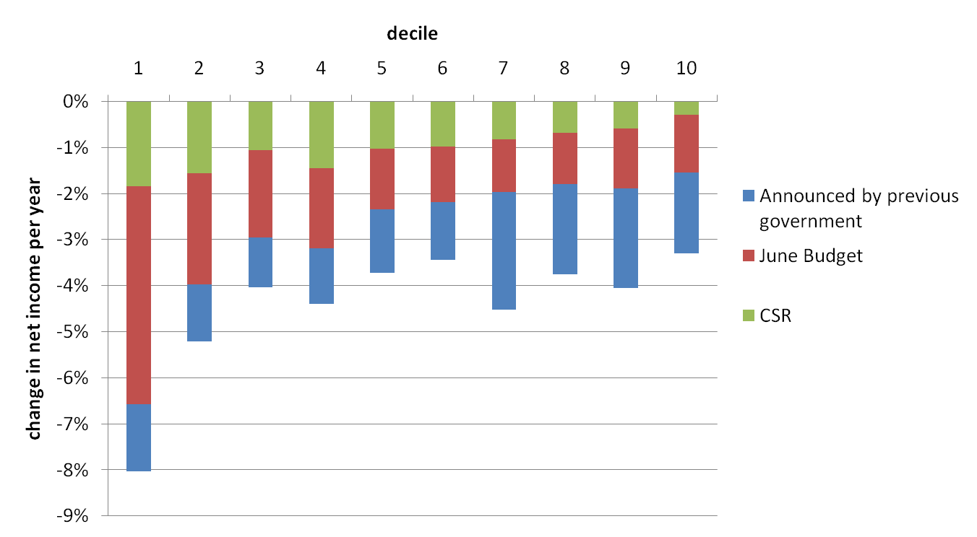
Source: Reed (2010), Slide 21
Additionally, the chart below shows the combined impact of tax, benefit and spending cuts to services announced in the CSR in October. This second chart in particular shows the deeply regressive nature of the measures introduced this year. Whereas the poorest groups lose between 20-35% of their net income per year, the two richest groups only lose between 5-10%.

Distributional impact of tax/benefit and spending measures: as % of net income

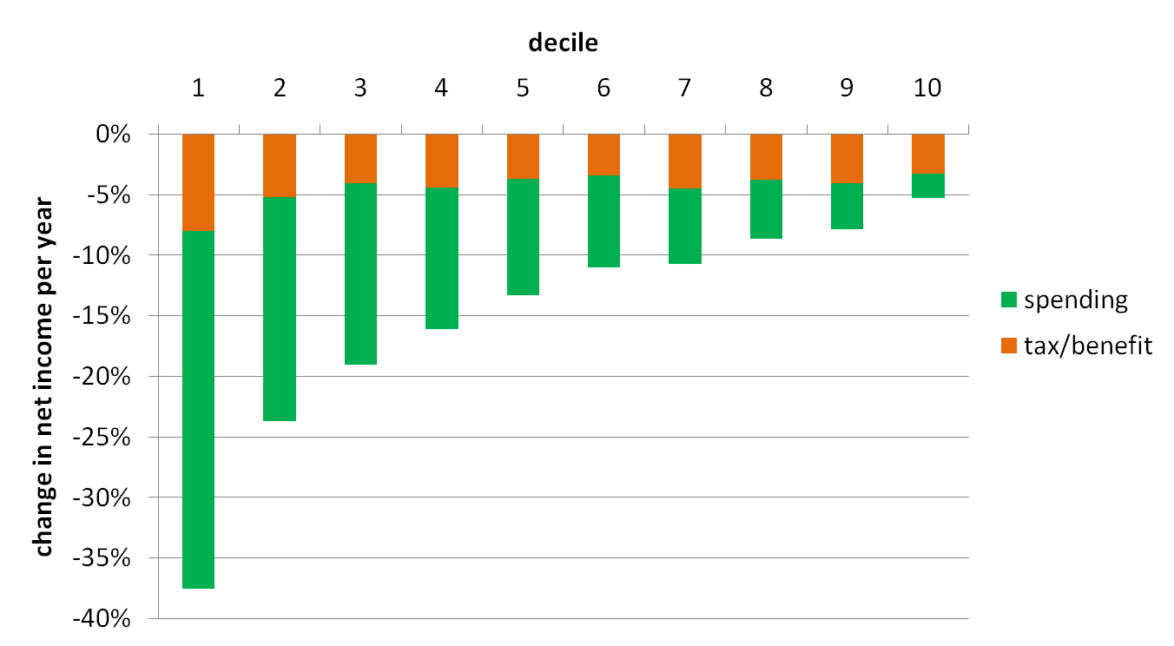
Source: Reed (2010). Slide 22.
Since our analysis of the APS and FRS demonstrated that disabled people in London as well as households with disabled people are likely to be in the lowest income groups, it is likely that the fiscal consolidation measures will result in them losing approximately 20-35% of their net income per year. Our analysis also indicated that Asian/Asian British and Black/Black British groups are most likely to be disabled and that Black/Black British groups are most likely to be unemployed. These groups also have relatively higher levels of poverty compared with their White counterparts. They are thus likely to suffer disproportionately from these measures.
It is also important to remember that the whole magnitude of the impact of the spending cuts is much greater than that of tax and benefit changes alone.

Impact of all tax and benefit measures introduced by the coalition government
A wide range of tax and benefit measures were proposed by the coalition government in the emergency budget in June and in October’s CSR. These introduced very significant changes to Local Housing Allowance rates, Council Tax Benefit and Housing Benefit. They also announced the use of the Consumer Price Index rather than the Retail Price Index to up-rate benefits, a new medical test for DLA with an aim of cutting recipients by a fifth and changes to the time limit for receipt for some ESA recipients. Some of these changes are likely to be in place by as early as next year whereas others will come into effect by 2014/2015. A full description of the measures introduced in the June budget can be found here and those introduced in the CSR can be found here.
Considering only the impact of reforms announced by the coalition government (the June Budget (in red) and the CSR (in green)), Reed (2010) presented data illustrated in the chart below demonstrating that the lowest and second lowest income groups are likely to experience approximately 6.5% and 4% fall in net income per year, respectively. On the other hand the richest and second richest income groups are likely to experience a less than 2% fall in net income. Because disabled people in London tend to fall into the lowest income groups, the fall in net income experienced by them is likely to be closer to 4 - 6.5% than 2%. Again, Asian/Asian British and Black/Black British groups are likely to suffer disproportionately.
Distributional impact of benefit and tax credit measures – as % of net income
Source: Reed (2010), Slide 21
Phillips and Kenway (2010) have also conducted an analysis of the impact of the tax and benefit measures introduced by the coalition government on different income quintile groups in London. They consider the impact up until 2012/2013 and up until 2014/2015. The authors note that up to 2012/2013 ‘considering the reforms announced by the coalition Government only, the tax rises and welfare cuts look to hit lower income households harder, proportionally, than richer ones.’ (Kenway and Phillips, 2010: 6).
The authors go on to argue that by 2014/2015 the cuts to benefits, particularly housing benefit, disability benefits and the change in up-rating to CPI, mean that the overall impact becomes even more regressive with lower income households suffering considerably. The following table illustrates these findings:
Income quintile | % Impact on net income (2012/2013) | % Impact on net income (2014/2015)
1 | -3.4% | -5.7%
2 | -2.9% | -4.6%
3 | -2.9% | -3.9%
4 | -0.9% | -1.6%
5 | -1.3% | -1.7%
Source: Adapted from Phillips and Kenway (2010), Table 3, pg 11.
Since we know that disabled people in London are likely to be in the lowest income group, the change in net income experienced by them is likely to be closer to 5.7% by 2014/2015 (as experienced by the lowest income quintile group) than 1.7% (as experienced by the highest income quintile group). The true extent and nature of impact on disabled people depends on the exact details of the relevant policy changes and spending cuts which, at the time of writing, are still emerging.

Impact of public sector spending cuts (excluding tax and benefit measures)
In addition to the impact of tax and benefit measures announced in the June Budget and CSR , there has also been some coverage in the literature of the anticipated impact of the public sector spending cuts to different government departments and service areas. Reed (2010) highlighted that once the cuts to benefits and tax credit (£18bn) and the reduced debt interest (£10bn) had been subtracted from the total £81bn in spending cuts, the impact on services at 2010/2011 prices is likely to be £48bn. Reed then goes on to model the impact of these £48bn cuts across all public service area.
In order to model the impact of the cuts to public service areas on different income groups, Reed first presents an analysis of spending on public services by different income groups. As the chart below illustrates, the lower income groups spend a much greater percentage of their net income on public services compared with the richest income groups.
Average public spending by household income: percentage of net income
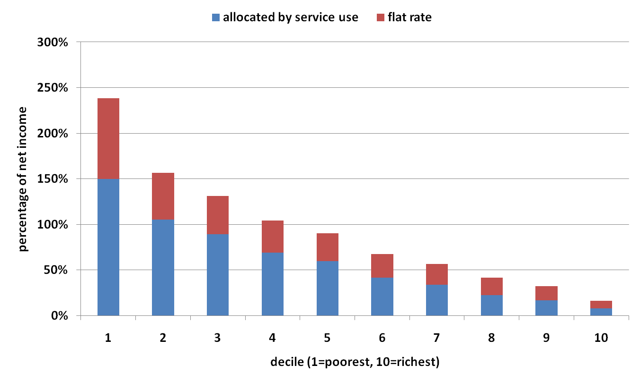
Source: Reed (2010), Slide 6.
The chart below illustrates the impact of spending cuts to services on different income groups in cash terms. Even in cash terms the impact is deeply regressive with the two poorest income groups losing out considerably more than the two richest groups. It also appears that whilst the biggest impact on the two lowest income groups is from cuts to social care and education (schools), the two richest groups primarily feel the impact of cuts to transport and higher/further education.
Effects of spending cuts by income group: cash terms
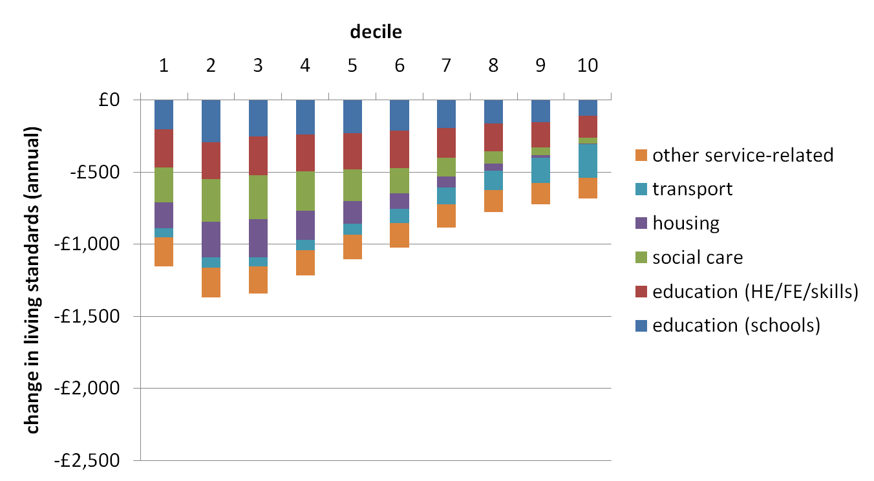
Source: Reed (2010). Slide 12.
The following chart highlights the same impact as a percentage of net income, and also includes the impact of other services (e.g., defence and environmental protection) at a ‘flat rate’ based on household size rather than household spending. Again, the impact is highly regressive with the lowest and second lowest income groups suffering a loss of approximately ten times (~30%) and six times (~20%) as much as the richest group (~3%), respectively. In this case, the two lowest income groups appear to lose out most from ‘flat rate’ services as well as from social care and education (schools and FE/HE).

Effects of spending cuts by income group: as % of net income
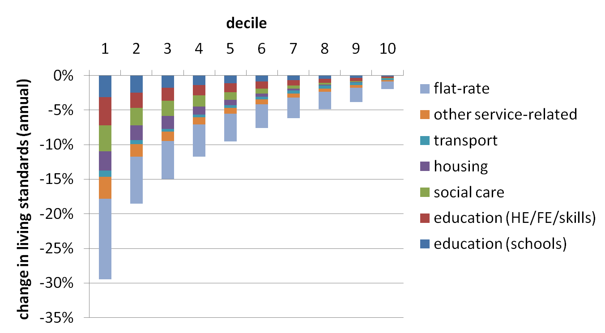
Source: Reed (2010). Slide 14.
This disproportionate impact on lower income groups is not surprising given that their reliance on public services is greater. Horton and Reed (2010) similarly noted that:
‘…the impact of these cuts will be deeply regressive…One important reason for this is that a lot of public spending is ‘pro-poor’, with poorer households receiving a greater value of services to meet their extra welfare needs. Because of this, cuts in public spending on major areas of welfare (such as education or social housing) will tend to hit the poorest hardest.’ (Horton and Reed, 2010: 6-7)
Given the socio-economic positions of disabled people in London, they are likely to be disproportionately adversely affected by the cuts to services, particularly by cuts to social care and education.
Reed also presents the impact of the cuts to services for different family types. As our analysis earlier demonstrated, households with disabled people tend to consist of one pensioner (22.2%), one adult below pension age (16.6%) or couple pensioners (13.1%). As the chart below demonstrates these groups suffer most from cuts to social care and housing, as opposed to cuts in other service areas. Additionally, after the lone parent group, the group that suffers the worst impact is the single pensioner group which will affect disabled people in London to a great extent.

Effects of spending cuts by family type: as % of net income
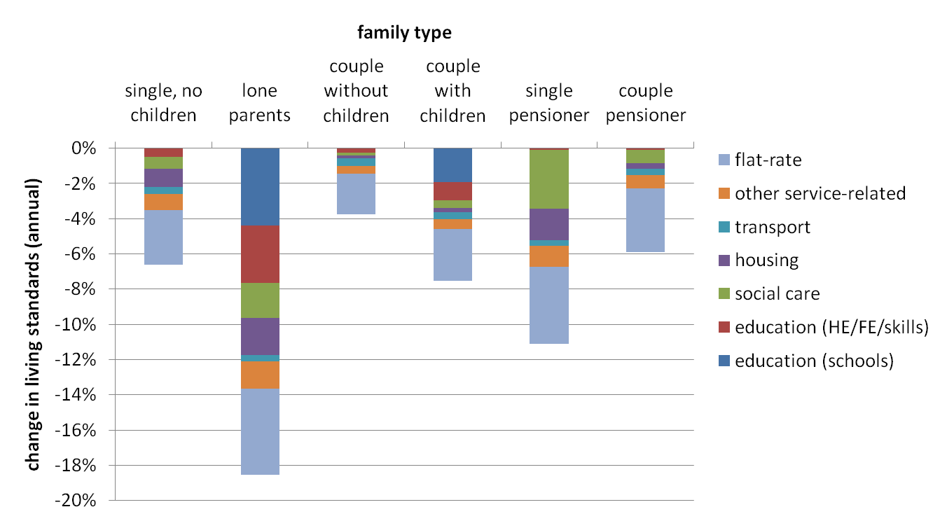
Source: Reed (2010). Slide 17.
Public sector spending cuts are also reportedly going to result in significant job losses in the public sector, with the exact number being hotly disputed. The CSR indicated that this would approximate 490,000 job losses but the coalition government was quick to revise this figure down to 330,000 a few days after the review was published. However, others have estimated that much larger job losses than this are likely as the impact of the scale of spending cuts unfolds. For example, the Chartered Institute of Personnel and Development, have argued that this number could be closer to 725,000 by 2014/2014 and in February 2011 added that ‘around 12.5 per cent of public sector workers are likely to lose their jobs in the coming year’ alone . Across the economy as a whole, after the June 2010 budget, an unpublished Treasury assessment suggested 1.3 million jobs would be lost. We know from our analysis that the majority of disabled people in London are economically inactive (68.1%) with only 27.7% in employment. This means that there are 387,800 disabled people in employment in London (based on a population estimate of 1.4million disabled people in London). We also know that 29.4% of this 387,800 disabled people in employment in London work in the public sector. This means that there are approximately 114,000 disabled people working in the public sector in London who face the risk of losing their jobs. Additionally given what we know about the barriers faced by disabled people in finding employment, as discussed in the previous chapter, this group is likely to find it much more difficult than their non-disabled counterparts to find alternate employment. We also know that once unemployed, disabled people are likely to stay unemployed for much longer than non-disabled people which means that the impact of the job losses will be felt by this group for a number of years.
Additionally, evidence from the recent recession found that the ILO unemployment rate for disabled people had increased, albeit at a slower rate than for non-disabled people, even before the announcement of public sector job losses (EHRC and DWP, 2009). The TUC (2009) has warned against complacency, noting that while large-scale redundancies have yet to materialise in the public sector, where disabled people are disproportionately employed, these may yet take place against the context of inevitable cuts to public spending.
Evidence from previous recessions has also shown that disabled people have tended to experience an increase in, and longer duration of, unemployment during an economic downturn. In fact, there is evidence indicating that during the period from the mid 1970s to the mid 1990s, the relative position of disabled people worsened (Berthoud and Blekesaune, 2006).

Impact of change in up-rating of benefits
The June 2010 budget introduced a change in the linking of benefits from the Retail Price Index (RPI) and Rossi to the Consumer Price Index (CPI). The literature reviewed highlighted some very real concerns about the extent to which this would reduce the amount of benefits received by people and the resulting impact a fall in benefits could have on their standard of living. Since disabled people in London are much more likely than non-disabled people to be claiming multiple types of benefits, this change in up-rating is likely to have a disproportionate adverse impact on them. The Disability Benefits Consortium, a coalition of disability and welfare advice organisations, has expressed its concern at the switch which they feel will significantly decrease the support that is available to and needed by disabled people.
CAB (2010a), in their response to the CSR, have noted that the CPI tends to rise at a lower rate than the RPI which would mean that the value of benefits is likely to fall compared with average earnings. CAB also quote research conducted by the Joseph Rowntree Foundation which shows that people on lower incomes face much higher inflation rates than the CPI because of their household spending patterns and could thus suffer a disproportionate loss from this change. This is also likely to be true of disabled people living in London as we know that they tend to live in households with low levels of weekly income.
Browne and Levell (2010) have also argued against the coalition government’s claim that the ‘basket of goods’ that the CPI includes better reflects the spending of those receiving benefits. Amongst other things it excludes mortgage interest payments and council tax. This means that the amount of benefit received would not change if there was a rise in either of these payments. The authors conducted an analysis to test the extent to which those who are eligible for council tax and those who rent or own their homes would be ‘insulated’ from changes in the cost of council tax and mortgage interest payments. Although they found that poorer households are better insulated than richer households they also argue that:
‘The proportion of poorer households who are not insulated is still high: around one in three benefit recipients in the bottom income decile are not fully insulated from mortgage interest and council tax costs. In the second poorest decile, more than half (54%) are not insulated.’ (Browne and Levell, 2010: 20-21)
This also implies that a considerable proportion of disabled people in London, who tend to live in poorer households, are likely to suffer from this change in indexation.

Impact of changes to disability related benefits

Disability Living Allowance
The coalition government’s reforms include significant proposed changes to Disability Living Allowance (DLA) with an aim to cut the number of recipients by 20%, as stated in the emergency budget in June. The Disability Alliance has estimated that based on current figures, 360,000 people would stop receiving DLA. As our analysis revealed, 11.4% and 11.7% of disabled people in London receive DLA care component and mobility component respectively. This means that there are currently approximately 160,000 DLA recipients in London. A 20% cut would mean that approximately 32,000 would lose DLA.
This reduction in numbers is to be achieved, amongst other things, by the introduction of a new medical assessment. The government’s approach to reforming the benefit was set out in a consultation document published in December 2010. It would include changing the name of the benefit to Personal Independence Payment (PIP). Unlike DLA, eligibility for PIP would be based on having an impairment or condition for a period of at least 12 months. Additionally, those in hospital or residential care will be automatically ineligible. The proposals have provoked concern and anger from many disabled people’s organisations. At the time of writing this report a number of disability organisations are conducting research on the views of DLA recipients.
Impact of introduction of medical assessments
The June 2010 budget included the introduction of medical assessments for all new and existing claimants of DLA from 2013 onwards. There have been a number of studies published since then exploring the likely impact of this change on disabled people.
Wood and Grant (2010a), in their review of literature, argue that the fundamental problem with introducing the medical assessment, which will be much like the WCA that forms part of the ESA application process, is that it will miss the costs of the social and practical obstacles associated with disability. A strictly medical test would only capture part of the picture and may in fact be irrelevant to the calculation of additional costs. The authors quote Ann Begg, newly appointed chair of the Parliamentary Committee on Work and Pensions who said that ‘to turn it [DLA] into something which you only get if you actually have a medical diagnosis detracts from the whole purpose of DLA’ (Wood and Grant, 2010: 45).
A survey of 141 disabled people conducted by Essex Coalition of Disabled People (ECDP) found that the respondents had similar concerns. Ninety three per cent of respondents reported that they were very or quite concerned about this change to the DLA and more than half (57%) thought that their DLA may be taken away. Respondents felt that any resulting loss of the DLA as a result of the medical assessment would have a very big negative impact on them. This is because respondents reported using DLA to support their every day lives:
‘Without my DLA I would lose my adapted car, my independence and my job. DLA supports me to contribute because it enables me to work full time.
If our DLA was stopped we would lose our home, car and everything. We rely on our DLA to pay the bills.’ (ECDP, 2010: 3).
Respondents were also worried about the manner in which medical assessments would be carried out. In particular respondents were concerned about the extent to which the assessors would be able to understand their disability and their circumstances. There was the general view that the addition of the assessment would only serve to make the process of application harder than it already is. Respondents felt that they already tended to struggle with the paperwork and documentation they had to work with during the process. There was also a general view that those with ‘hidden impairments’ or those with fluctuating conditions would probably be amongst the worst affected.
Wood and Grant (2010b) have also addressed this issue of the appropriateness of the new medical assessment that will form part of the new PIP. In their survey of disabled people they found that the costs faced and support needed by this group did not correlate with the severity of the ‘functional impact’ of their disabilities which is what the new medical test would assess. In fact, disabled people with lower functional impact may face higher costs than those with higher functional impact because of other factors such as housing status and age. The authors thus argue that:
‘Our findings suggest that the proposed reform for DLA assessment will be too narrow to take full account of people’s disability costs and award the new PIP accordingly… this means those experiencing a low functional impact of disability, but high costs, will lose out. Conversely, those experiencing high functional impact but relative low costs will do well.’ (Wood and Grant, 2010b: 23)
Wood and Grant (2010a) have also noted that an ‘unforeseen’ consequence of tightening up the eligibility for DLA will also have a direct effect on Carers Allowance (CA) which can only be claimed by those receiving the higher or middle rate of DLA. This means that those disabled people that fail the medical test would no longer get DLA and CA. Additionally, those that have their DLA amount reduced to the lower rate would also lose CA. Wood and Grant quote Carer’s Watch who have argued that:
‘Because Middle and Higher rate DLA are both also passport benefits to enable family members to claim Carer’s Allowance, removing or reducing DLA will not only have an enormous financial impact on disabled people it will also impact on their carers – a double blow which will especially hit hard those families on the poverty line.’ (Wood and Grant, 2010: 51).
Impact of revisions to criteria for those living in residential care
The CSR also announced that the mobility component of the DLA would no longer be available to those living in residential care. It has been estimated that 80,000 people who live in care homes will be affected by this measure. CAB (2010a) and Inclusion London (2010), amongst others, have expressed real concerns about how this will have a negative impact on the level of choice and independence experienced by those in residential care. For example, the DLA enables this group to access a car through the Motability scheme which helps them maintain a level of control over their lives. Additionally, this component of the DLA has also helped disabled people in residential care to maintain links with their friends and families. A report by 27 national organisations in the disability charity sector argued that the cut will mean ‘people will be forced to remain indoors and have a diminished quality of life; or social services will be forced to make up the difference in funding. Given the current climate, we do not expect local authorities to be able to do this.’ (Don’t Cut Mobility, 2010: 1).
Impact of change in indexation from RPI to CPI
Wood and Grant (2010a) have also modelled the change in the DLA care component amount received by claimants as a result of the shift in the indexing of benefits from the RPI and Rossi to the CPI (discussed in the previous section). The authors note that if the DLA had remained indexed to the RPI it would have increased from £74.40 in 2011/12 to £84.55 per week by 2015/16. Whereas the government used a 1.5 percentage difference between the CPI and RPI to calculate what these new values would be, the authors argue that at the a time of writing, the difference was 1.7 percent and that just this small difference would result in £40 less over the year in 2015. The following chart highlights these findings.
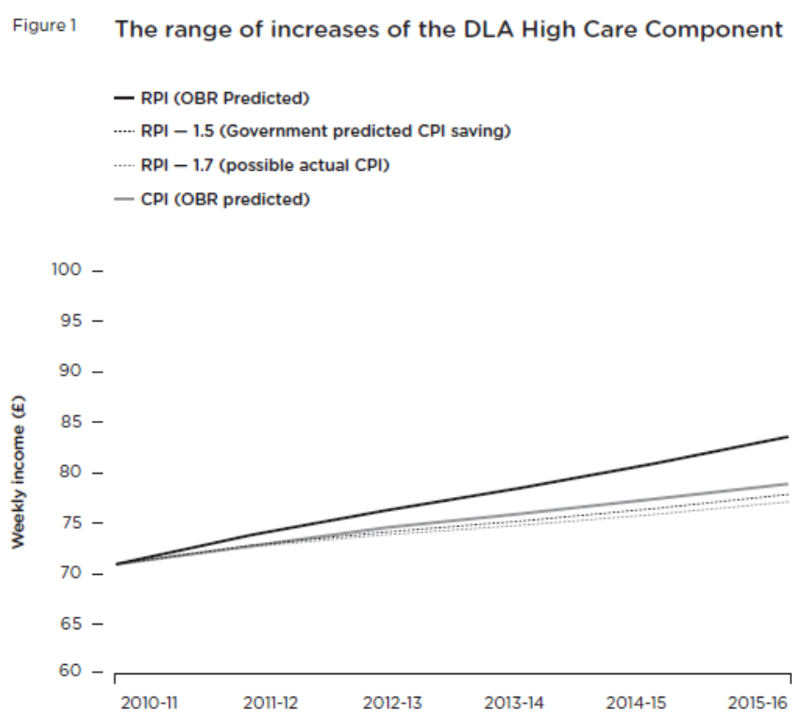
Source: Wood and Grant (2010): Figure 1, p 43.

Employment and Support Allowance
The emergency budget announced in June and the CSR announced in October 2010 set out some significant proposed changes to Employment and Support Allowance (ESA). All claimants will be reassessed with a view to reducing the number who receive the benefit.
The CSR specifically proposed a time limit of one year for entitlement to contributions based ESA for those in the WRAG group from April 2012. Those that have no income or limited savings will still be able to apply for income-based ESA. CAB (2010a) have argued that this new limit will affect disabled people who are single with some savings or other income and couples where one partner works but who still struggle to make ends meet. The authors provide the following example to make their case:
‘A northern bureau recently saw a couple where the wife earned less than £200 per week and the husband had already been on ESA(CB) in the WRAG, for more than a year, following a serious accident. He had worked as a manual worker all his life, and was desperate to get work, but had great difficulty walking, used crutches in the house and a wheelchair when outside, so was at a serious disadvantage in the job market. They also had debts and were struggling to live on their current income – before the loss of a further £91.40 when he loses his ESA. Both were already on antidepressants, and he had made a suicide attempt the previous week. ‘(CAB, 2010a: 20)
The authors also argue that these changes would mean that it is even more important that the WCA is successful in allocating people to the right group – WRAG or the support group.
The Disability Benefits Consortium, a coalition of disability organisations, has also expressed real concern about the time limit for contributions based ESA. In their published response to the CSR, they have stated that the policy would mean that ‘disabled people who have worked and paid National Insurance throughout their lives who lose their job while still of working age will only be able to claim ESA for a year before being directed to other benefits’ and that this really ‘seems to contradict the government’s stated aims of supporting hard-working families and of providing real support to those who need it most’.
One circumstance of this change to ESA policy is that more disabled people would be likely to start claiming Job Seekers Allowance (JSA) once their one year time limit on ESA is over. This means that they are also likely to suffer from the new sanctions for on failing to comply with the proposed mandatory work activity (MWA) to form part of JSA. CAB, in their response to the proposals have argued that:
'A thirteen week sanction for the first instance of non-compliance and 26 weeks for the second ‘transgression’ is very punitive, particularly when the decision to require MWA is at the discretion of the adviser, and it is not clear how much additional training advisers will be given.’ (CAB, 2010c; 4)
They also go to argue that ‘the length and severity of sanctions that will continue to apply even when a claimant re-engages, mean that it is difficult to see how homelessness and destitution will be avoided for some families.’ (CAB, 2010c; 4-5)

Impact of changes to housing benefit and Local Housing Allowance
A wide range of changes to housing benefit and Local Housing Allowance (LHA) have been announced over the previous year. There has been a considerable amount of literature published on the impact of these changes and the consensus is that London is likely to suffer the most. Additionally, since disabled people are more than four times as likely (27.2%) as non-disabled people (6.1%) to be in receipt of housing benefits there is likely to be a disproportionate impact on them. Wood and Grant (2010a), in their review of literature, have argued that
‘This is not only because...disabled people as a cohort are more dependent than others on benefits, including HB, as a source of income and a means of meeting their housing needs. It is also because disabled people have specific housing needs – accessible accommodation requirements, adaptations, etc., which come at a significant expense (the conversion disadvantage) and reduce the range of accommodation they can choose from.’ (Wood and Grant, 2010a:53)
In the following sections we will discuss those reforms that are likely to impact on disabled people in London most significantly.

Impact of changes to the LHA
The coalition government has announced a number of changes to LHA. Firstly, to lower the LHA allowance rate from the 50th to the 30th percentile from October 2011. This means that people will only be able to claim rent that is in line with the bottom third of properties in the local area as opposed to the bottom half of the market. Tenants in private rented housing who can claim LHA will thus have access to fewer properties in their area where their full rent could be covered by their benefit. Those who cannot find a property priced in line with the bottom third of properties will need to make up the difference in rent.
The National Housing Federation (2010) noted that this will lead to an increased demand for affordable housing and that households may face debt and homelessness if they cannot make up the difference in rent through their own income. It may also lead to people having to move away from cities to cheaper areas thus taking them away from areas of employment. CAB (2010a) have also noted that the lack of any transitional arrangements or protection means that these changes are likely to apply to existing claims who on their next review will suddenly find their homes unaffordable. Since rents in London are amongst the highest in the UK it is likely that London residents will be disproportionately affected. Our analysis indicated that almost half the disabled people in London rent their accommodation (48.7%) and although the vast majority of them rent from the local authority or housing associations (80.9%) this still leaves approximately one in ten disabled people in London (9.5%) or approximately 130,000 people (based on estimated population 1.4million disabled people) people with private landlords who will be affected by this change.
Additionally, the Chartered Institute of Housing (2010) has estimated the average additional costs for families living in different sizes of accommodation. This is illustrated in the table below. Since our earlier analysis revealed that 66% of disabled people in London live in two or three bedroom accommodation, the data suggest that they are likely to lose £11 or £12 a week for which they will need to find from elsewhere.
Additional costs to families living in different sized households
 | Estimate of number of losers | Estimate of percent of losers | Average loss per loser, £/week
Shared Room | 22,110 | 30% | -9
1-bedroom | 188,520 | 49% | -12
2-bedroom | 139,860 | 43% | -11
3-bedroom | 59,090 | 53% | -12
4-bedroom | 21,860 | 78% | -14
5-bedroom | 6,680 | 82% | -15
Adapted from CIH (2010): p 8.
Another change which will compound the availability of affordable housing for those in the private rented sector (approximately 130,000 disabled people in London) are the caps imposed on the maximum LHA payable by property size from April 2011. This change means that tenants will be able to claim a maximum amount for each property size with an overall limit set at the cap for four-bedroom accommodation. The caps will affect London and some of the more expensive areas in the South East and will be in addition to the reduction in LHA to the 30th percentile. CAB (2010a), National Housing Federation (2010) and Chartered Institute of Housing (2010) have all argued that in many London boroughs this will restrict the availability of affordable housing to less than 30% of the market which means that people will have to move out to more affordable boroughs.
Finally, the June 2010 budget also included an extension of the Shared Room Rate (SRR) from single claimants under 25 to those under 35 from April 2012. This restriction means that all single people under 35 will have their LHA restricted to a bedroom in shared accommodation rather than a self contained bed sit or 1 bedroom flat. This will have an impact on the 10.5% percent of disabled people in London who are under 35 (approximately 145,000 people), many of whom are likely to be single.
Moreover, both CAB (2010a) and Inclusion London (2010) have argued that this restriction is likely to be hardest for disabled claimants who will find it very difficult to find suitable accommodation. Inclusion London (2010) have further noted that the likelihood of this has also been included in the Treasuries Equality Impact Assessment of the reforms.

Impact of linking housing benefits to JSA
The June 2010 budget also announced that housing benefit would be cut by 10% for those people who had been claiming JSA for over a year. Although the recently published Welfare Reform Bill (17 February 2011) has indicated that this is no longer likely to be the case, it is still worth exploring the potential impact of this change. A number of organisations have argued that it would disproportionately impact on disabled people (Wood and Grant, 2010a; CAB, 2010a). They recognise that in light of other policy changes there are a considerable number of disabled people who are being moved onto JSA; for example those that fail the medical assessment and work capability assessment associated with IB and ESA (discussed in depth in the previous section).
Wood and Grant (2010a: 56) have argued that ‘as JSA does not recognise the specific difficulties disabled people may have in finding work within the 12 month cut off period, disabled people will be disproportionately likely to see their HB cut.’
This is confirmed by our analysis which revealed that disabled people are much more likely than non-disabled people to have been on JSA for over a year. At the same time the authors have also argued that disabled people are often very reliant on housing benefits to help meet their additional housing costs (e.g. adaptations necessary to make accommodation suitable for their needs). Faced with the prospect of a cut in housing benefits, those affected may have to move in order to find affordable and suitable housing, make up the difference from their own income or savings (if they have any) or fall into rent arrears.
The National Housing Foundation (2010 6) have also estimated that this link between housing benefits and JSA will mean that ‘an unemployed, single and childless person in London, with a weekly rent bill of £350, would see their housing benefit cut by £35. This would mean that if they topped up their Housing Benefit with part of their JSA they would be left with £30.45 for food, clothing and energy.’
Our analysis demonstrated that disabled people are most likely to live in single adult households (38.8%) many of whom to which this estimate is likely to apply to. The National Housing Foundation (2010) goes on to argue that low income groups are likely to be priced out of London because reduced housing benefits would make accommodation unaffordable. Again, this analysis will apply to a significant proportion of disabled people in London.

Impact of readjusting Support for Mortgage Interest (SMI) payments
SMI is a benefit that provides claimants of means tested benefits (JSA, Income Support, ESA) with help to meet mortgage interest payments. The June 2010 budget announced that the rate at which SMI is paid will be adjusted downwards so that it is in line with the Bank of England’s published Average Mortgage Rate from October 2010. Wood and Grant (2010a) have argued that the cut in SMI is likely to impact disproportionately on disabled people whose employment tends to be more erratic, often consisting of temporary jobs. This has been confirmed by our analysis. The National Housing Federation has also highlighted that the change could cause approximately 64,000 disabled people across the UK to go into arrears.
Wood and Grant go on to argue that a fall in SMI payments could lead to disabled people not being able to access affordable credit from banks. This is because potential SMI income is considered by lenders in their decision on whether or not to grant a loan. The resulting impact would be that many disabled people would not be able to own their own homes.

Impact of increase in non-dependent reductions
This change introduced by the government involves an increase in the deduction from housing benefits that applies to claimants who live with non-dependents (e.g., adult children, extended family members) from April 2011. As the Chartered Institute of Housing (2010) and the National Federation of Housing (2010) have noted, this will inevitably result in lower net income for these claimants who will also need to ask the non-dependents living with them to contribute a greater amount to rent. This change is likely to have a disproportionate adverse impact on disabled people in London as this group is much more likely to live in adult households (79% or approximately 1.1 million disabled people live in adult-only households compared to 58.9% of non-disabled people).

Impact of cap on benefits
The CSR introduced a proposed cap on household benefits from 2013 at approximately £500 a week for couples and lone parent households and approximately £350 a week for single adult households. People receiving DLA are exempt from this but Inclusion London (2010), in their response to the CSR have noted that income from ESA and IB will be included in this calculation (as will Industrial Injuries Disablement Benefit) and thus have an impact on large numbers of disabled people. CAB (2010a), in their response to the CSR, have also noted that the fact that the cap will apply regardless of household size and geographical location means that it will have a disproportionate impact on large families and areas of high rent, such as London. Disabled people are thus more likely to suffer from this cap if they live in London than if they live elsewhere.

Impact of other spending cuts
A number of other cuts announced by the coalition government have sparked a significant amount of controversy amongst disability organisations. For example, Access to Work, a scheme that provides assistance to disabled workers, has considerably cut the list of items that can be paid for using funding from the scheme. This includes basic items such as hearing aids and voice activated software. There is a concern amongst those who work with disabled people that these changes may damage their employment prospects.
Similarly there is also some very real concern about the cuts to Legal Aid which mean that there will no longer be the possibility of free legal advice and support in relation to education, employment, welfare benefits, housing and family cases, amongst other areas. The Equality Impact Assessment published by the Ministry of Justice has also acknowledged that disabled people will be disproportionately affected by many of the proposed changes. Many disability organisations have expressed concerns that disabled people will be amongst those that will be most hard hit by these changes. For example, Scope, have commented that:
‘In an era of budget cuts, job losses and welfare reform that contains some pretty sharp sticks, what now happens to disabled people who fall foul of public and private bureaucracies? The courts have traditionally been the last line of defence against poor, unfair and unlawful decisions.’
Similarly, Inclusion London, in their submission to the consultation on the proposals for reform to legal aid, has argued that ‘the assumption of the availability of alternative sources of help is flawed. Withdrawal of legal aid will simply mean no advice for many [disabled people] as alternative sources are not available and/or not accessible.’
Inclusion London also argue against the suggestion that in many cases legal aid clients should be able to represent themselves: ‘In the case of many disabled people, both in respect of employment and in other areas proposed to be removed, this may not be the case: clients will often particularly require legal assistance because of the impact of their impairments and barriers’.
Finally, the Independent Living Fund, which supports approximately 21,000 disabled people by providing them with the support they need to exercise choice and be able to stay in the community as opposed to being forced to live in residential institutions, has been abolished by the coalition government. Disability organisations such as Scope have expressed great concern about the abolition of the fund which has played a vital part in helping disabled people live independently.
Additionally, a range of other tax credit and benefit cuts have been announced which will have varying impacts on disabled people, although they are not disability related benefits as such. For example, the decision to freeze Child Benefit for three years, cut childcare support provided under tax credits by 10% and restrict the Sure Start maternity grant to the first child only may have particularly harsh impacts on households with disabled adults and/or disabled children. As we have shown, households with disabled children across the UK are more likely to live in poverty than households with children who are not disabled and households with disabled children are also more likely to have a greater number of children in them. However, detailed consideration of the impact of this very large number of cuts in benefits and tax credits that are not disability focussed, but will impact differently on disabled people, is beyond the scope of this report.
Summary
Overall impact of tax, benefit and spending measures
An unprecedented scale of public spending cuts announced in by the coalition government have included a wide range of tax and benefit measures as well as spending cuts to services, set out in the emergency budget in June and the CSR in October. Statistical modelling exploring the impact of all these measures has demonstrated that they are deeply regressive because they result in a greater loss, in terms percentage of income, for lower income groups (20-35%), compared with higher income groups (5-10%) (Reed, 2010). Since our analysis of the APS and FRS demonstrated that disabled people in London are likely to be in the lowest income groups, it is likely that the package of measures will have a relatively greater adverse impact on disabled people compared with non-disabled people.
Reed (2010) has also modelled the impact of the coalition government’s announced tax and benefit measures and spending cuts to services separately. With regards to the tax and benefit measures, the impact again is clearly regressive with lower income groups losing between 4-6.5% of their net income and higher income groups losing less than 2%. With regards to the spending cuts to services, the lowest and second lowest income groups suffer a loss of approximately ten times (~30%) and six times (~20%) as much as the richest group These poorest income groups are also most affected by cuts to social care and education. Again, since disabled people in London are amongst the lower income groups, they are likely to be disproportionately affected by the cuts to services.
Very large numbers of public sector job losses that are projected to follow when spending cuts take effect are also likely to have a disproportionate impact on disabled people since our analysis demonstrated that they are more likely than non-disabled people to work in the public sector – an estimated 114,000 disabled people work in the public sector.
Impact of change in up-rating of benefits,
The change in the linking of benefits from the RPI and Rossi to the CPI means that benefits will increase less than they would have otherwise and this has led to concerns about the extent to which this would reduce the amount of benefits received by people. It is argued that people on lower incomes face inflation rates higher than the CPI and that it does not reflect the spending of those receiving benefits (e.g., excludes council tax). Since our analysis demonstrated that disabled people tend to have low incomes and are also most likely to be claiming benefits, they are likely to suffer significantly from this change in indexation (Browne and Levell, 2010; CAB, 2010a).
Impact of changes to disability related benefits
There is evidence in the literature reviewed that there are concerns about the proposed changes to the DLA that have been announced by the coalition government. These will include changing the name of the benefit to Personal Independence Payment (PIP) and in so doing tightening eligibility. Unlike DLA, eligibility for PIP will be based on having an impairment or condition for a period of at least 12 months. Additionally, those in hospital or residential care will be automatically ineligible. There are very real concerns that the new medical test planned for DLA will miss out the impacts and the costs of the real barriers associated with disability (ECDP, 2010). A further impact of the tightening of eligibility for DLA is that it will also have a direct effect on Carers Allowance (CA) which can only be claimed by those receiving the higher or middle rate of DLA. This means that those disabled people that fail the medical test would no longer get DLA and CA (Wood and Grant, 2010). Additionally, the fact that the mobility component of the DLA would no longer be available to those living in residential care has resulted in concerns by CAB (2010a) and Inclusion London (2010) about how this may have a negative impact on the level of choice and independence experienced by those in residential care.
The CSR introduced a proposed time limit one year for entitlement to contributions based ESA for those in the WRAG group. CAB (2010a) have argued that this new limit will affect disabled people who are single with some savings or other income and couples where one partner works but who still struggle to make ends meet. Additionally, since more disabled people are likely to start claiming Job Seekers Allowance (JSA) once their one year time limit on ESA is over, they are also likely to suffer from the ‘harsh’ sanctions that have been imposed on failing to comply with the proposed mandatory work activity (CAB, 2010c).
Impact of changes to housing benefit and Local Housing Allowance
A wide range of changes to housing benefit and LHA have been announced over the previous year, many of which are likely to impact on London disproportionately. Since disabled people are more than four times as likely (27.2%) as non-disabled people (6.1%) to be claiming housing benefits there is likely to be a disproportionate impact on them. The change in the LHA allowance rate from the 50th to the 30th percentile (from October 2011) and the caps imposed on the maximum LHA payable by property size (from April 2011) are likely to result in people having access to fewer properties in their area where their full rent could be covered by their benefit. They would either have to make up the difference or move to a more affordable area (CIH, 2010; NHF, 2010).
The June 2010 budget also announced that housing benefit would be cut by 10% for those people who had been claiming JSA for over a year. Wood and Grant (2010a) have also argued that disabled people are likely to be on JSA longer because of the increased difficulties they face in the labour market (confirmed in our analysis).
Other changes that are likely to impact on disabled people include the downward adjustment of the SMI rate from October 2010 and the increase in the deduction from housing benefits that applies to claimants who live with non-dependents from April 2011. With regards to the former Wood and Grant have argued that disabled people whose employment tends to be more erratic are likely to suffer the most in trying to make their mortgage payments. With regards to the latter, the change is likely to have more of an impact on disabled people in London compared to non-disabled people because they are more likely to live in adult households (79% compared to 58.9% of non-disabled people).
Impact of cap on benefits
The CSR have introduced a proposed cap on household benefits from 2013 at approximately £500 for couples and lone parents and £350 single adult households. Although those receiving DLA are exempt, those receiving ESA or IB are not. Additionally, the fact that the cap will apply regardless of household size and geographical location means that it will have a disproportionate impact on large families and areas of high rent, such as London. Disabled people are thus more likely to suffer from this cap if they live in London than if they live elsewhere
Impact of other spending cuts
Many disability organisations have expressed serious concerns about other changes announced by the coalition government. These include significant proposed cuts in Legal Aid, which will have specific and disproportionate impacts on disabled people, and the abolition of support programmes such as the Independent Living Fund as well as cutbacks to Access to Work. All of these are likely to impact heavily on disabled people. Other proposed changes to benefits and tax credits which are not disability focussed, such as the decision to freeze Child Benefit for three years, cut childcare support provided under tax credits by 10% and restrict the Sure Start maternity grant to the first child only, will also still have a negative impact on disabled people.

Conclusions

6.1 Summary of findings
In this report we have drawn on a selection of published and unpublished literature, and have conducted fresh analyses of two key existing datasets to identify the socioeconomic characteristics of disabled people in London as well as to describe and estimate, as far as possible, the likely impacts of the coalition government’s announced spending cuts and changes to benefits and tax credits. We have also explored the impact of existing and past employment programmes and benefit policies on disabled people as the lessons learned from these provide valuable insight into how impending changes may be experienced by disabled people. The key recurrent theme is that of the marked difference in the level of poverty and barriers to employment experienced by disabled people in London compared with non-disabled people. Furthermore, this gap between disabled and non-disabled people in London is only liken to worsen once the full impact of the spending cuts and policy changes are realised.
Nearly 18% of the London population is disabled, which equates to approximately 1.4 million people based on mid-2009 population estimates. Disabled people in London have a younger age profile compared to disabled people across the UK. For example, 45.3% of disabled people in London are under 55 compared with 40.7% of disabled people across the UK. It is likely that older disabled people tend to move away from London once they reach pensionable age, perhaps because they can no longer afford to live in London when they are not working. This trend is likely to persist and worsen given the spending cuts and benefit changes, all of which will make London increasingly unaffordable for many disabled people.
Additionally, Asian/Asian British groups (19.2%), Black/Black British groups (17.8%) and those that categorise themselves as ‘other’ (19%) are most likely to be disabled. Within these groups, Black Caribbean, Bangladeshi and Pakistani people in London are most likely to be disabled. Moreover, approximately 1 in 10 young people between the ages 20-24 from a Pakistani background (10.3%) are disabled. This is approximately double the proportion of all young people in London between the ages of 20-24 that are disabled (5.2%). Given the strong evidence base relating to the significant differences in deprivation, income and qualifications between Black and minority ethnic people and those from a White background (Platt, 2007) this suggests strongly that these minority ethnic disabled people are likely to be amongst the poorest people in London. The relative position of Black and minority ethnic disabled people means that they are likely to be amongst the worst off as a result of the spending cuts announced by the coalition government. Additionally, evidence elsewhere points to the fact that although disability rates tend to be higher among many BME groups, take-up of disability benefits such as Disability Living Allowance and Attendance Allowance tend to be lower (OPM, 2010a). Race and disability can therefore interact to compound disadvantage for some groups.
Within households without children, disabled adults are more likely to live alone than non-disabled adults: households with disabled adults are most likely to consist of one adult (49.1%) whereas households without disabled adults are most likely to either consist of one (37%) or two adults (32%). Households with disabled adults are themselves more likely to have disabled children in them: 18.5% of households with disabled adults have one disabled child living in the same household compared with only 10% of households with no disabled adults. This is worrying because evidence indicates that parents of disabled children are less likely than other parents to work; and even when they do, their earnings are lower than for parents as a whole (ippr, 2005). This may point to the additional barriers that parents of disabled children face in fitting employment with child care needs, such as finding suitable hours and affordable and good quality childcare appropriate for the needs of disabled children. Additionally, whereas families with disabled children face greater service needs, they are not in fact receiving these services or even where they are, services often fail to meet their needs. This evidence indicates that households with both disabled adults and disabled children face a wide range of barriers that contribute to a high level of poverty and unmet need (OPM, 2010a)
Disabled people living in London are more likely to live in rented accommodation (48.7%) compared with non-disabled people, and more than half of these people rent from the local authority or council (53.1%) whereas non-disabled people are most likely to rent from other individual private landlords (46.3%). Despite this disproportionate concentration of disabled people in social housing, this type of housing is also unlikely to have been designed or adapted appropriately for the needs of disabled people. The Survey of English Housing indicated that although approximately 1.4 million people require specially adapted accommodation: only 77 per cent live in accommodation that is suitable. This problem is particularly acute for disabled children, of whom only approximately half live in suitable housing (ippr, 2005). According to the GLA’s London Housing Strategy (2010), disabled people are more than twice as likely as non-disabled people to be living in unsuitable housing. Additionally, a survey by Habinteg Housing Association and London South Bank University (2010) that considered the ‘unmet housing need’ of wheelchair user households (i.e. only a section of disabled people) found that an estimated 12,517 such households had unmet needs in London.
Disabled people have an unemployment rate of 13% which is markedly higher than the 8% unemployment rate amongst non-disabled people. They are also more likely to be unemployed for a longer period of time. Additionally, they are more likely (12.2%) than non-disabled people (6.9%) to have been receiving redundancy payments which could imply that they are more likely to have been made redundant. Wider evidence suggests that this could be the result of discrimination and prejudice in the labour market. Disabled people are also more than three times as likely (9.3%) as non-disabled people (2.6%) to report that issues relating to transport have prevented them from taking up a new job. Additionally, among those disabled people that work in temporary jobs, not being able to find a permanent job is given as the main reason for working on a temporary basis by 36.7% of disabled people compared to 28.7% of non-disabled people. Working part-time because of not being able to find a full-time job is also more common amongst disabled than non-disabled people (17.9% and 15.8%, respectively). Thus disabled people would much rather be in permanent or full time jobs but find it hard to find such work.
Taken together, these findings point to the significant barriers that disabled people face in accessing and remaining in the labour market. These findings are of great concern given the scale of projected public sector job losses that have already begun to occur. We know that the majority of disabled people in London are economically inactive (68.1%) with only 27.7% in employment. This means that there are 387,800 disabled people in employment in London (based on a population estimate of 1.4million disabled people in London). We also know that 29.4% of this 387,800 disabled people in employment in London work in the public sector. This means that there are approximately 114,000 disabled people working in the public sector in London who face the risk of losing their jobs. Additionally, evidence from the recent recession found that the ILO unemployment rate for disabled people had increased, albeit at a slower rate than for non-disabled people, even before the announcement of public sector job losses (EHRC and DWP, 2009). With the impending scale of public sector job losses, the TUC (2009) has warned against any complacency as disabled people are likely to be disproportionately hit.
Even for those who are employed, disabled people in London earn less than non-disabled people. Analysis of the APS reveals that the average net weekly pay for disabled people in London is £344.90, which is almost £50 less than that of non-disabled people (£389.40). Average gross hourly pay received by disabled people is also less than that of non-disabled people – £14.50 compared with £16.17. Finally, households without disabled adults are twice as likely (40.1%) as those with (21.5%) to earn more than £800 a week. The ODI have reported that in 2008/09, 26% of individuals in families where at least one member is disabled were living in income poverty (as defined by those below 60 per cent of median national income) after housing costs were taken into consideration, compared to 21% of individuals in families where no-one is disabled.
Given these challenges, it is not surprising that disabled people in London are more than twice as likely (66.7%) as non-disabled people (33.1%) to be claiming state benefits or tax credits. The benefits most commonly claimed by disabled people in London are sickness or disability related benefits (29.6%) and housing and/or council tax benefit (29.3%). It is noteworthy that the claimant rate for sickness or disability related benefits is low, and points to the fact that disabled people are under-claiming key benefits they are entitled to. This compounds poverty and disadvantage.
Additionally, disabled people are more likely than non-disabled people to be claiming unemployment related benefits, income support and housing benefits for longer periods of time compared with non-disabled people. For example, 65.3% of disabled people in London have been claiming housing benefits for five years or more compared with 45.8% of non-disabled people. However, it is important to note that although the benefit system has been designed to some degree to assist disabled people face the additional costs of living resulting from their impairment, very often these benefits fail to cover these costs. Smith et al (2004) modelled these additional costs of disability and found that even if disabled people are receiving the maximum level of benefits (DLA, Income Support, Incapacity Benefit and housing and council tax benefit) they still experience a shortfall in income. This makes it particularly worrying when, as is the current case, policy changes have been announced that would both reduce disabled people’s ability to meet the additional costs incurred by disability, and also reduce their service entitlements and other income sources. For example, the proposed changes to DLA are aimed at reducing claimants by 20%. 11.4% and 11.7% of disabled people in London receive DLA care component and mobility component respectively. This means that there are currently approximately 160,000 DLA recipients in London. A 20% cut would mean that approximately 32,000 would lose DLA. This is particularly worrying given the existing evidence demonstrating the manner in which DLA has had a positive impact on claimants’ well-being and quality of life (Corden et al, 2010).
Additionally, since disabled people are more than four times as likely (27.2%) as non-disabled people (6.1%) in London to be receiving housing benefits, the wide range of proposed changes to housing benefit and LHA that have also been announced are likely to have a disproportionate impact on them. More specifically, the change in the LHA allowance rate from the 50th to the 30th percentile from October 2011 will have an impact on the estimated 130,000 disabled people in London who rent their accommodation from private landlords. Additionally, since we know that 66% of disabled people in London live in two or three bedroom accommodation, data from the Chartered Institute of Housing (2010) estimating the average additional costs for families living in different sizes of accommodation tells us that this group is likely to lose £11 or £12 a week which they will need to find elsewhere. Similarly, the extension of the Shared Room Rate from single claimants under 25 to those under 35 from April 2012 will have an impact on the estimated 145,000 disabled people in London who are under 35, and many of whom are likely to be single.
The coalition government also introduced a proposed cap on household benefits from 2013 at approximately £500 a week for couples and lone parent households and approximately £350 a week for single adult households. CAB (2010a), in their response to the CSR, have also noted that the fact that the cap will apply regardless of household size and geographical location means that it will have a disproportionate impact on large families and areas of high rent, such as London. This, along with the fact that benefits received are already often not enough to cover the additional costs faced by disabled people means that disabled people in London are likely to suffer significantly from this cap.
With regards to the full range of spending cuts and changes to benefits and tax credits announced by the coalition government, the overwhelming message that emerges is that disabled people in London are likely to be amongst those that suffer the most. Statistical modelling exploring the impact of all these changes has demonstrated that they are deeply regressive because they result in a greater loss, in terms percentage of income, for lower income groups, compared with higher income groups (Reed, 2010). Given that we know that disabled people in London are in the lower income groups, the impact of all changes and cuts is likely to be a 20-35% loss in net income per year. The package of tax and benefit measures is likely to lead to a reduction of approximately 4-6.5% in the net income of disabled people in London with the rest of the loss a result of the spending cuts to services, particularly cuts to social care, housing and education (schools).

6.2 Implications and conclusions
As we explained in the introduction, we are not claiming that this review is exhaustive. There are, expectedly, limitations to this review and we have no doubt there are omissions. Nonetheless, we believe that this review makes a useful contribution to generating greater clarity around the direct and indirect impacts of the coalition government’s policy agenda, starting to disentangle some of the claims and counter-claims.
The coalition government has suggested that its spending cuts are necessary and that everyone will be affected: that we are ‘all in this together’. However, this report by drawing together evidence on the impact of the government’s policy agenda on disabled people as well as evidence relating to the economic and social realities of disabled people’s lives has highlighted the disproportionate impact that the spending cuts and changes to benefits will have on this group.
It is important to reiterate that we have only focussed on a number of issues that have cross-cutting implications for other dimensions of disabled people’s lives. The types of impact we discussed in this report are therefore only the starting point for considering wider disadvantage and exclusions that are likely to be compounded by increasing poverty.
A key observation emerging from our review is that despite the existence of legislation to promote the rights of disabled people in Britain, genuine disability equality has yet to become a reality. With the policy agenda being implemented by the coalition government, there are real risks that the spirit of disability equality has been overlooked in the rush to achieve ‘savings’: our review of evidence has demonstrated that such ‘savings’ are often likely to be mythical and cuts that are detrimental to equality can result in costs rather than savings. For example, the cost-benefit calculation for Access to Work by the Disability Employment Coalition found that the programme recoups £1.48 in increased tax and National Insurance contributions for every £1 spent,

We are not ‘all in this together’
Equality will never be attained, or even progress towards it, if it is regarded as a luxury, as something that a society can only afford ‘in good times’. Equality is either fundamental to a society’s values or it is not: cuts that undermine pillars of the welfare state and public services suggest that it is not. This is a great threat to the position of disabled people.
The findings reported here point to the fact that while legislation is important, it needs to be enforced for it to have any real meaning or significance. Legislation needs to square up to the fact that many of the findings here point to growing disability inequality. There is also a risk legislation provisions may only be regarded as a prompt to achieve the ‘bare minimum’ rather than to see them as encouraging society to aspire to a genuine cultural shift towards embracing and promoting genuine equality of outcome.
A rights-based approach to disability equality further draws attention to the fact that a number of fundamental rights are guaranteed by the UN Convention on the Rights of Persons with Disabilities and by the Human Rights Act. We cannot simply look dispassionately upon these adverse impacts on disabled people as a ‘disability’ issue only. The likely impact on the right to live independently; the right to have an adequate standard of living; the right to participate in public life; the right to have equal access to justice, etc. are all erosions of basic and fundamental human rights. The issues highlighted in this report therefore have resounding implications for society as a whole.
Despite the various international and domestic legislation, there continues to be a glaring ‘implementation gap’ whereby high level commitment to disability equality has not translated to actual progress on the ground. For example, despite the legislative provisions to promote disability equality in employment, disabled people still confront entrenched attitudinal and procedural barriers to accessing and securing sustainable employment. Good practice tends to exist in isolated pockets. Without wide-spread culture change, we may only be addressing the symptoms of discrimination.
While effective implementation and enforcement are important, we also need a greater emphasis on outcomes. It is clear from the evidence that the coalition government’s policy agenda will lead to worsening outcomes for disabled people. Some groups of disabled people may suffer disproportionately, for example, in London, those from a Pakistani and Bangladeshi background. The adverse impact of individual policies cannot be considered separately. Instead, they overlap and compound disadvantage and multiple exclusions and have a pernicious effect on all areas of disabled people’s lives. For example, the current focus on welfare changes influences direct and specific negative treatment of disabled people (e.g. by encouraging false and negative stereotypes which fuel hostility towards and contempt of disabled people).
Added to this, the shift towards focussing only on the most basic needs of disabled people in relation to health, housing etc., without accompanying steps to promote the inclusion and participation of disabled people in society though changing attitudes and offering real choice and control is likely to lead to greater hardship. This is not helped by the increasing medicalised approach to disability, for example in assessments around entitlements, that unhelpfully shifts the focus away from the barriers to inclusion which are the focus of the social model of disability and removal of which are one of the fundamental levers of progress.
Narrowly defined approaches towards ‘efficiency’ and ‘cost saving’ can lead to false economy. Decision making should move away from selective short term financial considerations to ones that take into account the longer term social vision, and specifically the outcomes for disabled people and their families. This report does not provide support for the government’s view that its cuts are necessary for economic stability: more than this, however, we show how the definition of ‘cost’ and ‘benefit’ needs to embrace much more than pure monetary value. For example, independent living is a human right (acknowledged in the UN Convention) and is known to bring about improvement in terms of emotional, physical and social health. While such factors are difficult to ascribe a quantifiable or monetisable value, it is important that government acknowledges and upholds them: the current cuts in Disability Living Allowance and certain other benefits indicates this is not the case.
Therefore, while our review has pointed out numerous overlapping adverse financial impacts of recently announced policies, the true impact of government policy on disabled people’s lives is likely to be significantly more far-reaching and fundamental. It is critical that we monitor developments.
Our findings here indicate that statistics of inequality are likely to worsen over time for disabled people across the different domains of life. It is imperative that careful tracking of quantitative and qualitative data is used as the basis of evidence-based approaches to enforcement and intervention in order that equality and human rights are taken seriously. It is hoped that this report will assist Inclusion London, and other disabled people’s organisations in London, by providing a baseline of evidence that can be used to undertake this kind of tracking and therefore support Deaf and disabled people in defending rights, tackling discrimination and improving equality.

Appendices

Appendix 1: Methodology and overview of evidence included

Input from experts
OPM completed seven interviews with key experts involved in research and evidence gathering in relation to Deaf and disabled people’s experiences and outcomes, and the disability rights movement. These include practitioners, academics, policy makers and disability groups with the following backgrounds:
- Particular impairment-specific expertise, such as learning disability or visual impairment
- Specific areas that affect disabled and Deaf people such as housing, transport and employment
- Experts with a London-specific focus or experience.
The interviews explored the following topic areas:
- Perceptions of the social and economic characteristics of Deaf and disabled people in London
- Perceptions of how previous governments’ social and economic policies over the last three decades have impacted upon Deaf and disabled people
- The likely future impacts of the Coalition Government’s social and economic policies, welfare reforms and spending plans on Deaf and disabled people in London.
The interviews were also used as an opportunity to identify relevant literature and data sources. The full list of interviewees can be found in Appendix 2.

Literature search and review process
Our approach to the literature search, review and synthesis has been informed by good practice guidelines issued by government agencies and universities. These have been developed with the specific aim of synthesising diverse material to inform the evidence-based policy and practice movement within the UK.
In recognition of the importance of qualified search specialists in enhancing the quality of reviews, we worked with search specialist Alan Gomersall, Deputy Director of the Centre for Evidence-Based Policy and Practice (CEBPP). Alan provided expert advice and support as we developed our search strategies. The stages of the review process were as follows:

Database searches
Representatives from Inclusion London and OPM worked in partnership to develop the approach towards database searches. We agreed that it needed to be underpinned by an iterative process of progressive and informed filtering. Initial searches were broad and allowed us to ascertain the broad contours of the terrain and identify the extent and type of relevant literature available on the different databases. Each subsequent search was based on decisions informed by the findings of preceding searches and guided by the overall objectives of the review.
The initial broad search terms were developed in accordance with the three research questions and included terms relating to disability, economic (income, employment) and social (housing, welfare) policy and specific benefits and policies (Disability Living Allowance, Employment and Support Allowance). They were compiled by OPM and our literature search expert at CEBPP with contributions from Inclusion London. Our search expert conducted a total of twenty three search iterations across four databases. The outputs from the initial searches fed into the refinement of search terms.
We shared all material identified with Inclusion London. There was significantly more potentially relevant material identified for the first (socioeconomic characteristics) and second (impact of past policies) research questions than for the third (likely impact of future policies). However, this had been anticipated because the searches were conducted in July 2010, which was not long after the coalition government’s budget, and tax and benefit reform announcement. Additionally, there is also a time lag between when literature is published and when it is uploaded onto databases. In order to ensure that no critical items were missed OPM also conducted intensive internet searches, discussed in more detail below.
The database search and reviewing process was designed to be robust and transparent, and every effort has been made to ensure that no relevant item has been omitted. Additionally, we also drew on our knowledge of the evidence base and our own past work on the subjects to identify relevant literature. Appendix 3 shows the databases that were searched, the specific search terms and strategies that were used and the results obtained.

Internet searches
OPM and Inclusion London agreed on a selective number of websites of a number of government departments, public bodies, think tanks, research centres, organisations and charities representing Deaf and disabled people to search for potentially relevant material. 18 websites were searched in total a full list of which can be found in Appendix 4.
OPM also monitored news alerts relating to any new literature that was published over the course of the project (e.g. monthly bulletins published by the Equality and Diversity Forum). This proved an effective way of ensuring that the latest analysis of the impact of the spending review and the changes to the tax and benefits systems would be included.

Defining inclusion and exclusion criteria
Following the search, we developed a set of inclusion and exclusion criteria against which to generate a shortlist of relevant material to be included in the detailed document review.
We did not feel it was appropriate to set inclusion and exclusion standards prior to carrying out the initial searches. We wished to ensure that the standards we developed were informed by our initial searches, which yielded helpful clues about the relative distribution of various sources of material and their likely content and quality. In searching and reviewing less well-researched areas, imposing objective inclusion or exclusion standards prior to any search being carried out can mean that potentially useful material is excluded. It can also mean that too little or too much literature is included in the review.
The eventual set of inclusion criteria was agreed in consultation with Inclusion London. For the first research question we recognised that our scoping and analysis of British datasets (discussed below) was likely to provide the most up-to-date and in-depth analysis of the socioeconomic characteristics of Deaf and disabled people in London, and that other literature would be unlikely to add value. However, we did think it would be helpful to supplement the statistical findings with secondary evidence in order to draw out some of the key implications of the findings. We thus chose a small number of key reviews of evidence to draw on for this purpose.
For the second and third research questions the only inclusion criterion used was:
- Focus on the impact of previous/future policies relating to employment, benefits and income
Additionally, the number of items that were selected for inclusion was, to an extent, constrained by the time, scope and budget of this project.

Review and synthesis of evidence
Material that met the inclusion standards was read and reviewed in full. To facilitate a systematic extraction of relevant information, a data extraction sheet (DES) was designed so that identification of relevant evidence was consistent and directed towards answering the review questions. The DES was designed in collaboration with Inclusion London. A copy of the blank DES is provided in Appendix 5.
The reviewed material was subjected to broad content analysis, with key themes and associations drawn out.

Overview of material included
A total of 37 documents were included on the final shortlist for review. These included:
- Quantitative and qualitative primary research (13 documents)
- Secondary review of quantitative and qualitative research (10 documents)
- Modelling the impact of government policies (12 documents)
- Think pieces (5 documents)
Additionally, there were 6 documents that addressed the first research question (socioeconomic characteristics), 17 that addressed the second (impact of past policies) and 18 that addressed the third research question (impact of future/impending policies).
An overview of the literature included can be found in Appendix 6.
A further 42 documents have been drawn on to explore the implications of our findings in more depth and a list of these can be found in Appendix 7.

Dataset identification and analysis
OPM were mindful of the fact that the reported data in published literature was unlikely to reflect the full range of existing relevant data sources. We thus conducted scoping and analysis of key British datasets that have relevance for this research.
This involved gaining access to the UK Data Archive based at the University of Essex. A search by key terminology was conducted to identify the range of datasets that contain variables for both ‘disability’ (and related) and other areas (e.g. employment, education, transport etc). This initial search identified a ‘long list’ of potentially useful datasets. These were then scrutinised further to ascertain true utility for the purpose of this research, for example, whether they had sufficient London-specific data to be helpful. At this stage an annotated bibliography of potentially relevant datasets was produced, the purpose of which was to create a useful resource for Inclusion London that points to the location of evidence on particular issues. Six datasets felt to be of greatest potential relevance to Inclusion London’s needs were identified, the details of which are included in Appendix 8.
The next step involved selecting specific datasets that would be suitable for fresh secondary analysis. The following inclusion criteria were agreed with Inclusion London:
- Variables relating to employment, benefits and income policy area
- A London sample size that facilitates meaningful analysis
- Based on fieldwork conducted in 2008-2010
Based on these criteria the following datasets were identified as suitable for analysis:
- Annual Population Survey, January - December 2009 (APS)
- Family Resources Survey, 2008-2009 (FRS)
- Quarterly Labour Force Survey, April - June, 2010 (QLFS)
Since the APS includes data from the LFS (albeit six months older) we decided to exclude the QLFS.

Annual Population Survey, January – December 2009
The Annual Population Survey (APS) combines results from the Labour Force Survey (LFS) and the English, Welsh and Scottish Labour Force Survey boosts which are funded by the Department for Work and Pensions, the former Department for Education and Skills, the National Assembly for Wales and the Scottish Executive. The 2009 survey includes a total sample of 333,430 respondents (across the UK). Amongst other things, the survey measures and records evidence about nationality and ethnicity, economic activity and inactivity, employment and training, educational background, residential history and income from work and benefits. Many of the variables included in the survey are the same as those in the LFS.
Some of the key strengths of the APS include:
- Large sample size enabling the generation of statistics for small geographical areas
- Smaller sampling errors compared to other social survey designs
- Coverage of a large range of employment-related variables and non-employment-related variables, allowing cross-linking analyses to be undertaken (e.g., employment sector against ethnicity).
The APS, like the LFS, allows people to identify themselves as falling into one of following categories of disability:
- DDA disabled only: Includes people who have a long term health problem or disability which has a substantial and long-term adverse effect on their ability to carry out normal day to day activities.
- Work limiting disabled only: Includes people who have a long-term health problem or disability which affects the kind or amount of paid work which a person might do.
- DDA disabled and work limiting disabled: Includes people who meet the criteria for both current DDA and work-limiting definitions of disability.
For the purpose of this project, it was decided that the sample for analysis would be those respondents that are most likely to meet the DDA definition of disability. Thus, respondents who classified themselves as either option 1 or option 3 constituted the sample base for analysis. For London, this consisted of 3,719 Deaf and disabled people. However, since the variable that records disability is drawn from the LFS which only surveys the adult population, the London sample of Deaf and disabled people did not include respondents under the age of 16.
The groups of variables that were selected for analysis included:
- Demographics (e.g., age, ethnicity, marital status)
- Economic activity and inactivity (e.g., employment/unemployment rate, reasons for unemployment)
- Employment characteristics (e.g., private/public sector, permanent/temporary, managerial status)
- Pay and hours (e.g., average hours, weekly/yearly pay)
- Benefits (e.g., unemployment, disability and family related benefits)
- Housing tenure (e.g., accommodation type and details).
Analyses included comparisons across Deaf and disabled people and non-Deaf, and disabled people in London and the UK. In addition, where appropriate cross-linking analyses were also undertaken.

Family Resources Survey, 2008-2009
The Family Resources Survey (FRS) is a continuous survey of private households across the UK and is commissioned by the Department for Work and Pensions (DWP). Amongst other things it collects information on income and benefit receipt, household composition, children in education and tenure and housing costs.
The FRS was launched in 1992. Traditionally, DWP had relied on other social surveys which had relatively small sample sizes and therefore did not provide sufficiently reliable information on many groups in society which were of particular interest to the DWP.
The FRS provides new or much more detailed information in a number of areas and brings some topics together on one survey. The 2008-2009 survey includes a total sample 25,092 households and 75,866 respondents (across the UK).
In order to calculate how many adults in the sample have a DDA disability, the FRS first asks all respondents whether they have a long standing illness, disability or infirmity. The sample who respond yes to this are then asked whether this illness/disability/infirmity means that they have substantial difficulties in:
1: Mobility (moving about)
2: Lifting, carrying or moving objects
3: Manual dexterity (using your hands to carry out everyday tasks)
4: Continence (bladder and bowel control)
5: Communication (speech, hearing or eyesight)
6: Memory or ability to concentrate, learn or understand
7: Recognising when you are in physical danger
8: Your physical co-ordination (eg: balance)
Respondents who answer yes to any of these are classified as DDA disabled.
Additionally, respondents who receive medication without which their health problems would significantly affect their life, or respondents with a progressive health condition are also classified as DDA disabled. Finally, an affirmative response to having a long standing illness, disability or infirmity that limits activities is also classified as DDA disabled.
Based on this, the full sample of Deaf and disabled adults in London consisted of 986 respondents. Similarly, the full sample of Deaf and disabled children in London consisted of 116 respondents. Additionally, the full sample of households with Deaf and disabled adults was 824 and the full sample of households with Deaf and disabled children was 98. It is worth noting however that the FRS annual technical report noted that there was an unusually low response rate from London (47%) compared to other regions (62% in North East/West, 56% in South East/West).
The groups of variables that were selected for analysis included:
- Demographics (adult, child)
- Benefits received (e.g., Disability Living Allowance, Attendance Allowance)
- Household composition (e.g., number of adults/dependent children/disabled adults/disabled children)
- Household characteristics (e.g., size, income, unemployment)
Analyses included comparisons across Deaf and disabled people and non-Deaf and disabled people, as well as across households with and without disabled adults or children. In addition, where appropriate cross-linking analyses were also undertaken.
Finally, the FRS was selected for inclusion as we felt that it would complement the analysis of the APS. The APS provides meaningful data about Deaf and disabled people at the individual level, and as mentioned earlier excludes those under the age of sixteen. The FRS, on the other hand does include data on disabled children and also allows us to compare households with disabled adults/children with households without disabled adults/children.

Appendix 2: Interviewee list

 | Name | Organisation | Role
1 | Tracy Lazard | Disability Action in Islington | Chief executive
2 | Claire Wise | Royal Borough of Kensington and Chelsea | Housing register Coordinator
3 | Marie Pye | Transport for London’s disability advisory group | Councillor / Freelance disability consultant
4 | Henrietta Doyle | London Visual Impairment Forum | Development worker
5 | David Ruebain | Equality Challenge Unit | Chief executive
6 | Bruce Stafford | University of Nottingham | Professor of Public Policy
7 | Peter Purton | Trade Union Congress | Policy officer

Appendix 3: Database search logs
 | Date of search | Name of Database | Search focus | Search terms and strategy used | No. results yielded | No. relevant results
1 | 19 July | Social Policy and Practice | London only  2005 | (deaf or disab* or handicap*) and (london or borough) | 66 | 16
2 | 19 July | Social Policy and Practice | Economic policies  2005 - current | (deaf or disab* or handicap*) and (london or borough)  + economic* or spend* or budget* or income or earning* or poverty or benefit* or employ* or unemploy* or recession | 126 | 45
3 | 19 July | Social Policy and Practice | Social policies  2005 - current | (deaf or disab* or handicap*) and (london or borough)  + equalit* or discrimin* welfare or educat* or housing or household* or transport* or crim* or justice | 176 | 52
4 | 19 July | Social Policy and Practice | Policies generic  2005 - current | (deaf or disab* or handicap*) and (london or borough)  + legislation or policy or policies or strateg* or labour or conservative* or liberal or manifesto* or reform or impact assessment | 97 | 24
5 | 20 July | Social Policy and Practice | Policies specific  2005 - current | (London or borough*)  + Disability Discrimination Act or Disability Equality Duty or Disability Living Allowance or Special Educational Needs or SENs or seN | 33 | 6
6 | 21 July | Social Policy and Practice | Policy specific - DDA  2005 – current | (Disability Discrimination Act and (London or borough*)) | 42 | 11
7 | 21 July | Social Policy and Practice | Policy specific - DED  No time limit | (Disability Equality Duty and (London or borough*)) | 7 | 3
8 | 21 July | Social Policy and Practice | Policy specific – SEN Act  2005 – current | (Special Educational Needs and Disability Act and (London or borough*)) | 14 | 4
9 | 21 July | Social Policy and Practice | Policy specific - DLA  No time limit | (Disability Living Allowance and (London or borough*)) | 2 | 1
10 | 21 July | Social Policy and Practice | Policy specific - AA  No time limit | (Attendance Allowance and (London or borough*)) | 5 | 2
11 | 21 July | Social Policy and Practice | Policy specific – Welfare to Work  No time limit | (Welfare-to-Work and (London or borough*)) | 38 | 11
12 | 21 July | Social Policy and Practice | Policy specific – Incapacity benefit  No time limit | (Incapacity Benefit* and (London or borough*)) | 10 | 3
13 | 21 July | Social Policy and Practice | Policy specific – Independent Living Fund  No time limit | (Independent Living Fund* and (London or borough*)) | 1 | 0
14 | 21 July | Social Policy and Practice | Policy specific – Employment Support Allowance  No time limit | (Employment Support Allowance* and (London or borough*)) | 0 | 0
15 | 21 July | Social Policy and Practice | Policy specific – Jobseeker Allowance  No time limit | (Jobseeker Allowance* and (London or borough*)) | 0 | 0
16 | 21 July | Social Policy and Practice | Policy specific – Carers Allowance  No time limit | (Carers Allowance* and (London or borough*)) | 0 | 0
17 | 23 July | Community Abstracts | London only  No time limit | disab* or deaf* or (hard and hear)) and (london or  borough*) | 45 | 9
18 | 23 July | Community Abstracts | Policy specific – incapacity, jobseeker  No time limit | disab* or deaf* or (hard and hear)) and (london or  borough*) incapacity/job seekers etc allowances and policies | 6 | 0
19 | 23 July | Community Abstracts | Policy specific – SEN  No time limit | disab* or deaf* or (hard and hear)) and (london or  borough*) SEN special educational needs | 1 | 0
20 | 23 July | Community Abstracts | Disability policies generic  No time limit | disab* or deaf* or (hard and hear)) and (london or  borough*)disability legislation and policies | 10 | 3
21 | 23 July | Community Abstracts | Disability policies generic  No time limit | disab* or deaf* or (hard and hear)) and (london or  borough*) disability policies | 10 | 4
22 | 23 July | ASSIA | London only  2005-2010 | (disab* or handicap* or deaf) or hard hearing) and (London or borough*) | 39 | 2
23 | 23 July | British Library Direct | London only  2005-2010 | (disab* or handicap* or deaf) or hard hearing) and (London or borough*) | 9 | 5

Appendix 4: Websites searched
 | Organisation/website
1 | Communities and Local Government
2 | Department for Work and Pensions
3 | Equality and Diversity Forum newsletter
4 | Government Equalities Office
5 | Greater London Authority
6 | Institute of Public Policy Research
7 | Institute of Fiscal Studies
8 | Joseph Rowntree Foundation
9 | Local Government Association
10 | London Councils
11 | London Development Agency
12 | London Health Observatory
13 | ODI
14 | Office for National Statistics
15 | Social Policy Research Unit at the University of York
16 | Trade Union Congress
17 | Trust for London
18 | UK Commission for Employment and Skills

Appendix 5: Data Extraction Sheet

Deaf and disabled people in London - Establishing a robust evidence base – Data Extraction Sheet (DES)
Note page numbers in brackets when referencing
Add brief headings to paragraphs extracted
Please italicise researcher reflections/analysis

Title
Author(s)
Date published
ID Number (from spreadsheet)
Date document analysed by OPM / Analysed by
Content Overview (from abstract) or Background and context
Type of evidence
Think piece, primary research (quant or qual), literature reviews, secondary analysis of data, statistical modelling)
Sector background of document
Employment, benefits, income, poverty, disability
Methodology – record
- the research questions/hypotheses posed;
- the research design;
- the sampling strategy;
- the nature and quality of the fieldwork;
- the process of analysis; and
- the nature and robustness of findings.
Quality Assessment (TBD)
Sample group(s) discussed, e.g.
Disabled people, all Londoners, ethnic group, male/female, religion
Geographical focus
UK, England, London
Research question 1: Current economic and social characteristics of deaf and disabled people in London
This research question is largely covered by the secondary data analysis. However, look for:
(NB: ONLY INTERESTED IN DATA ON DISABLED PEEOPLE IN LONDON)
- Longitudinal data on demographics, employment, income, poverty and benefits.

- Future projections of above listed data

- Comparisons across London boroughs

- Comparison across groups (ethnic groups, age groups etc)
Research question 2: Impact of past government economic and social policy on deaf and disabled people
Record information on:  Which policy? (e.g., Disability living allowance, Incapacity benefit reform, conditionality, DWP programmes to help disabled people find work)  Type(s) of impact (e.g., financial, well-being, incentives to work, employment prospects, levels of unmet need)  Groups impacted on (e.g., women, men, ethnic groups. Low income groups, groups with dependent children)  Comparison of impacts on different groups  (NB: ONLY INTERESTED IN EMPLOYMENT, INCOME AND BENEFITS RELATED POLICIES)  (NB: DOESN’T HAVE TO BE LONDON SPECIFIC) | .
Research question 3: Likely impact of coalition government’s future economic and social policy reforms and spending cuts on deaf and disabled people
Record information on:
Which policy? (e.g., Housing benefits, welfare cut ,income tax changes)
Type(s) of impact (e.g., financial, well-being, incentives to work, employment prospects, levels of unmet need)
Groups impacted on (e.g., women, men, ethnic groups. Low income groups, groups with dependent children)
Comparison of impacts on different groups
(NB: ONLY INTERESTED IN EMPLOYMENT, INCOME AND BENEFITS RELATED POLICIES)
(NB: DOESN’T HAVE TO BE LONDON SPECIFIC)
Research gaps identified
Implications for stakeholders identified (service providers, local authorities, policy makers)
Key conclusions of study
Additional references to obtain (add to spreadsheet)

Appendix 6: Literature reviewed
N. | Author(s) | Year published | Title | Published by | Type of literature
1 | Barnes, H., Sissons, P. and Stevens, H. | 2010a | Employment and Support Allowance: Findings from a Face-to-Face Survey of Customers | Department for Work and Pensions: London | Primary research
2 | Barnes, H., Aston, J. and Williams, C. | 2010b | Employment and Support Allowance: Customer and Staff Experiences of the face-to-face Work Capability Assessment and Work-Focused Health-Related Assessment | Department for Work and Pensions: London | Primary research
3 | Berthoud, R. | 2009 | The Impact of Disability Benefits: A Feasibility Study | Department for Work and Pensions: London | Modelling
4 | Berthoud, R. and Blekesaune, M. | 2006 | Persistent Employment Disadvantage 1974 to 2003 | ISER Working Paper, ISER: Colchester | Secondary research
5 | Browne, J. | 2010 | Distributional Analysis of Tax and Benefit Changes | Institute for Fiscal Studies | Modelling
6 | Browne, J. and Levell, P. | 2010 | The Distributonal Effect of Tax and Benefit Reforms to be Introduced between June 2010 and April 2014: A Revised Assessment | Institute for Fiscal Studies | Modelling
7 | Chartered Institute of Housing | 2010 | Briefing Paper on the Impact of Changes to Housing Benefit and Local Housing Allowance in the Budget | Chartered Institute of Housing | Modelling
8 | Citizens Advice Bureau | 2010a | The Coalition Budget and CSR 2010: An Analysis of Key Welfare Changes and their Impact on Low Income Households | Citizens Advice Bureau: London | Modelling
9 | Citizens Advice Bureau | 2010b | Not working: CAB evidence on the ESA work capability assessment | Citizens Advice Bureau: London | Primary research
10 | Citizens Advice Bureau | 2010c | Response to the SSAC Consultation on Jobseeker’s Allowance Mandatory Work Activity Regulations 2011 | Citizens Advice Bureau: London | Think piece
11 | Corden, A., Sainsbury, R., Irvine, A. and Clarke, S. | 2010 | The Impact of Disability Living Allowance and Attendance Allowance: Findings from Exploratory Qualitative Research | Department for Work and Pensions: London | Primary research
12 | Department for Work and Pensions | 2008 | More Support, Higher Expectations: The Role of Conditionality in Improving Employment Outcomes - A Background Research and Discussion | Department for Work and Pensions: London | Secondary research
13 | Department for Work and Pensions | 2010 | Impacts of the Housing Benefit proposals: Changes to the Local Housing Allowance to be Introduced in 2011-12 | Department for Work and Pensions: London | Modelling
14 | Equality and Human Rights Commission and Department for Work and Pensions | 2009 | Monitoring the Impact of the Recession on Various Demographic Groups | Government Equalities Office: London | Secondary research
15 | Essex Coalition of Disabled People | 2010 | Changes to DLA and ILF: An ECDP Survey on Disabled People’s Views | Essex Coalition of Disabled People | Primary research
16 | Fenton, A. | 2010 | Which neighbourhoods in London will be affordable for housing benefit claimants 2010-16, as the Government's reforms take effect? | Shelter | Modelling
17 | GLA | 2007 | Fit to Work?: Incapacity Benefits in London | Greater London Authority: London | Primary research
18 | Grover, C. and Piggott, L | 2010 | From Incapacity Benefit to Employment and Support Allowance: Social Sorting, Sickness and Impairment, and Social Security | Policy Studies –London, 2010 Vol 31: (2), p. 265-282 | Think piece
19 | Henwood, M. and Hudson, B. | 2007 | The Independent Living Funds: What does the Future Hold? | Department for Work and Pensions: London | Primary research
20 | Horton, T. and Reed, H. | 2010 | Don't Forget The Spending Cuts! The Real Impact of the Budget 2010 | TUC and Unison | Modelling
21 | Inclusion London | 2010 | Comprehensive Spending Review and Disabled people: A Brutal Attack on Equality | Inclusion London | Think piece
22 | Institute of Public Policy Research (IPPR) | 2005 | The Citizenship Oo Disabled People in Britain In 2005 | Unpublished | Secondary research
23 | Kane, A, and Gooding, C. | 2010 | Disabled People and Supported Employment: A Research and Discussion Paper | Unpublished | Think piece
24 | Kemp, P. and Davidson, J. | 2010 | Employability Trajectories among New Claimants of Incapacity Benefit | Policy Studies –London, 2010 Vol 31: (2), p. 203-221 | Primary research
25 | Lancashire, M. | 2010 | Fair Welfare: Supporting claimants into work | Citizens Advice Scotland | Primary research
26 | MacInnes, T. and Kenway, P. | 2009 | London's Poverty Profile | New Policy Institute: London | Secondary research
27 | National Housing Federation | 2010 | Housing Benefit and Local Housing Allowance Reforms | National Housing Federation: London | Think piece
28 | OPM | 2010a | Monitoring the UN Convention on the Rights of Persons with Disabilities: Literature and Data Review | Unpublished | Secondary research
29 | OPM | 2010b | Working Better for Disabled People: A Review of the Aspirations, Experiences, Barriers And Solutions for Improving Labour Market Opportunities for Disabled People | Unpublished | Secondary research
30 | Phillips, D. Kenway, P. | 2010 | Poverty and the Impact of Tax and Benefit Changes in London | Institute for Fiscal Studies | Modelling
31 | Reed, H. | 2010 | Comprehensive Spending Review Briefing | Trade Union Congress | Modelling
32 | Riddell, S., Edward, S., Weedon, E. and Ahlgren, L. | 2010 | Disability, Skills and Employment: A Review of Recent Statistics and Literature on Policy and Initiatives | Equality and Human Rights Commission: Manchester | Secondary research
33 | Smith, N., Middleton, S., Ashton-Brooks, K., Cox, L. and Dobson, B. with Reith, L. | 2004 | Disabled People's Costs of Living: More than You Would Think. | Joseph Rowntree Foundation: York | Primary research
34 | Stafford, B, Corden, A., Meah, A, Sainsbury, R. and Thornton, P | 2007 | New Deal for Disabled People: Third Synthesis Report - Key Findings from the Evaluation | Department for Work and Pensions: London | Primary research
35 | Thornton, P, Hirst, M, Arksey, H and Tremlett, N | 2001 | Users’ Views of Access to Work. | The Employment Service: London. | Secondary research
36 | Wood, C, and Grant, E. | 2010a | Destination Unknown : For disabled people cuts to welfare will have a deep and lasting impact | DEMOS: London | Modelling / Primary/ secondary research
37 | Wood, C, and Grant, E. | 2010b | Counting the Cost | Demos | Modelling / Primary research

Appendix 7: Additional references
- Adam, A and Kreps, D. (2009) Disability and Discourses of Web Accessibility. Information Communication and Society. Volume 12. Issue 7: 1041-1058
- Alkire, S., Bastagli, S., Burchardt, T., Clark, D., Holder, H., Ibrahim, S., Munoz, M., Tsang, P.T.T. and Vizard, P. (2009) Developing the Equality Measurement Framework: Selecting the indicators. EHRC: London
- Baker, M. (2006) Opportunity Blocked: The Employment Experiences of Deaf and Hard of Hearing People. Royal National Institute for the Deaf: London.
- Bardasi, E, Jenkins, S, and Rigg, J. (2000) Disability, Work and Income: A British Perspective. Institute for Social and Economic Research (ISER) Working Paper. ISER: Colchester.
- Bowes, A. and Dar, N. (2000) Family Support and Community Care: A Study of South Asian Older People. Scottish Executive Central Research Unit: Edinburgh.
- Bowyer, E. (2005) Disabled People’s Transport Needs. Transport for London: London
- Burchardt, T. (2000) Enduring economic exclusion: Disabled People, Income and Work. Joseph Rowntree Foundation: York.
- Burchardt, T. (2003) Being and Becoming: Social Exclusion and the Onset Of Disability. ESRC Centre for the Analysis of Social Exclusion. Report 21. London School of Economics: London.
- Cabinet Office (2007) Fairness and Freedom: the final report of the Equalities Review, Cabinet Office: London
- DfES (2004) The Youth Cohort Study Cohort 10 Sweep 4: Technical Report .DFES: London
- Disability Employment Coalition (2004) Access to Work for Disabled People. DEC. London
- Disability Rights Commission (2003) The Experience of Disabled People: The Nature and Extent of Discrimination. DRC Strategic Review, London: DRC
- Disability Rights Commission (2004) The Web: Access and Inclusion for Disabled People. A Formal Investigation Conducted by the Disability Rights Commission. DRC: London.
- Douglas, N. (2009) Working with HIV. National Aids Trust: London
- Evans, S. (2007) Disability, Skills and Work: Raising our Ambitions. Social Market Foundation: London.
- GLA (2010) London Housing Strategy. GLA: London
- Grewal, I, Joy, S, Lewis, J, Swales, K and Woodfield, K. (2002) 'Disabled for Life?' Attitudes towards, and Experiences of, Disability in Britain. DWP Research Report 173. DWP: Norwich.
- Habinteg Housing Association and London South Bank University (2010) Mind the Step: An Estimation of Housing Need among Wheelchair Users in England, Habinteg Housing Association: London
- Hatton, C., Akram, Y., Shah, R., Robertson, J. and Emerson, E. (2002) Supporting South Asian Families with a Child with Severe Disabilities: A Report to the Department of Health. University of Lancaster Institute of Health Research: Lancaster.
- Howard, M. (2002) Not Just the Job: Report of a Working Group on Disabled People Using Personal Assistance and Work Incentives. Joseph Rowntree Foundation: York.
- Howard, M. (2004) Small Employer Literature Review. Disability Rights Commission: London
- Jones, M. and Tracy, I. (2010) Ethnic Minority Customers’ Experiences of Claiming Disability Benefits. Research Report 609. Department for Work and Pension: London.
- Katbamna, S., Bhakta, P. and Parker, G. (2000) Perceptions of Disability and Care-Giving Relationships in South Asian Communities, in W. Ahmad (ed) Ethnicity, Disability and Chronic Illness. Open University Press: Buckingham, pp. 12-17.
- Leonard Cheshire Disability (2008) Disability Poverty in the UK. Leonard Cheshire Disability: London.
- Macmillan Cancer Support and Citizens Advice Bureau (2009) Failed by the System. Why the Employment and Support Allowance isn’t working for People Living with Cancer. Macmillan Cancer Support and Citizens Advice Bureau: London.
- Mehta, P and Keil, S. (2007) Survey of Visually Impaired People: Key Findings of the ‘Network 1000’ Study. University of Birmingham: Birmingham.
- Mencap (2007) Bullying Wrecks Lives: The Experiences of Children and Young People with a Learning Disability, Mencap: London
- National Audit Office (2005) Gaining and Retaining a Job: The Department for Work and Pensions' Support for Disabled People, National Audit Office: London
- Nice, K., Irvine, A. & Sainsbury, R. (2009) Pathways to Work from Incapacity Benefits: A Study of Referral Practices and Liaison between Jobcentre Plus Advisers And Service Providers. (DWP research report 555) London: DWP
- Ofsted (2004) Special educational needs and disability. Ofsted: London
- Palmer, G, Carr, J and Kenway, P. (2005) Monitoring Poverty and Social Exclusion. Joseph Rowntree Foundation and New Policy Institute: York and London
- Parker, G., Grebe, C., Hirst, M., Hendey, M., and Pascall, G. (2007) Double Discrimination?: Gender and Disability in Access to the Labour Market. Social Policy Research Unit, University of York: York
- Perkins, R and Farmer, P and Litchfield, P. (20090 Realising Ambitions: Better Employment Support for People With a Mental Health Condition. DWP: Norwich
- Piggott L and Spacey B and Wilenius F. (2005) Out of Touch: Local Government and Disabled People's Employment Needs. Disability and Society. Oct 2005
- Platt, L (2007) Poverty and Ethnicity in the UK. Joseph Rowntree Foundation: Bristol.
- Rigg, J. (2005) Labour Market Disadvantage amongst Disabled People: A Longitudinal Perspective. Centre for Analysis of Social Exclusion (CASE) Paper 103. CASE: London.
- Russell, D. (2006) Employer Willingness to Consider Workplace Adjustments for People with Mental Health Problems. Journal of Occupational Psychology, Employment and Disability. Volume 8. NO. 2: 211-228
- Rutherford, S. and Ollerearnshaw, S. (2002) The Business of Diversity: How Organisations in the Public and Private Sectors are Intergrating Equality and Diversity to Enhance Business Performance. Scheider-Ross : Andover
- Simm, C , Aston, J, Williams, C, Hill, D, Bellis, A, and Meager, N. (2007) Organisations' Responses to the Disability Discrimination Act (Department for Work and Pensions research report no 410). DWP.=: Norwich
- Social Exclusion Unit (2004) Mental Health and Social Exclusion. ODPM: London.
- Trades Union Congress (2009) Recession Report, Number 9. TUC: London.
- Women and Work Commission (2006) Shaping a Fairer Future. Government Equalities Office: London.

Appendix 8: Potentially relevant datasets
N. | Data archive ID number | Title | Disability & London variables
1 | SN 6514 | Annual Population Survey, January - December, 2009 | Disability  ’Current disability’  London  ‘Government Office regions’
2 | SN 6523 | Family Resources Survey, 2008-2009 | Disability  ‘Whether adult/child has a DDA defined disability’  ‘Any long standing illness/disability’ (chealth)  ‘Whether registered disabled / partially sighted / blind with LA/SS’  ‘Number of adults/children in households with DDA disability’  London  ‘Government Office regions’
3 | SN 6457 | Quarterly Labour Force Survey, January - March, 2010 | Disability  ‘Current disability’  London  ‘Government Office regions’
4 | SN 6021 | Experiences and Expectations of Disabled People, 2007 | ‘Government Office regions’
5 | SN 6388 | Citizenship Survey 2008-2009 | Disability  ‘If has long-term illness’  London  ‘Government office regions’
6 | SN 6399 | Survey of English Housing, 2007-2008 | Disability  ‘Household member limited by illness or disability’  London  ‘Government Office region’

Inclusion London
www.inclusionlondon.co.uk
Tel: 020 7237 3181
Fax: 020 7394 7096
Can Mezzanine
49-51 East Road
London
N1 6AH
London Deaf and Disability Organisations CIC is registered in England and Wales, Company Limited by Guarantee. Company number 6729420.

http://www.statistics.gov.uk/statbase/Product.asp?vlnk=15106
The categories of ethnic groups described are those that are recorded by the Annual Population Survey.
From ODI, Disability Equality Indicators, online: http://odi.dwp.gov.uk/roadmap-to-disability-equality/indicators.php
For example, the change in linking of benefits from the Retail Price Index (RPI) and Rossi to the Consumer Price Index, the 20% reduction in recipients of DLA and changes to the Local Housing Allowance Rate.
http://www.personneltoday.com/articles/2010/06/10/55887/public-sector-job-losses-could-hit-725000-warns-cipd.html
http://www.hrreview.co.uk/articles/hrreview-articles/hr-strategy-practice/more-job-losses-expected-in-the-public-sector/17434
http://www.guardian.co.uk/uk/2010/jun/29/budget-job-losses-unemployment-austerity
Several of the announced changes to disability related benefits (DLA, ESA) require legislation and are being taken forward in the Welfare Reform Bill, published on 16 February 2011
This was due to be removed in October 2012 but has now been delayed to March 2013
http://www.disabilityalliance.org/dbcdontlimit.pdf
Some of the announced changes to housing benefits require legislation and are being taken forward in the Welfare Reform Bill, published on 16 February 2011
The publication of the Welfare Reform Bill (17 February 2011) suggests this proposal may now be dropped but this will only become fully clear as the Bill proceeds.
http://www.guardian.co.uk/uk/2010/jun/22/2010-budget-child-tax-credits-cut
.Government Social Research, Rapid Evidence Assessment Toolkit (http://www.gsr.gov.uk/professional_guidance/rea_toolkit/index.asp); EPPI-Centre, Systematic Research Synthesis (http://eppi.ioe.ac.uk/cms/Default.aspx?tabid=67); Hartley, J. (2004). Long-term Evaluation of the Beacon Council Scheme. Outline for the Systematic Review of Innovation and Improvement. Draft report to the ODPM and IDeA. Coventry: University of Warwick
Wade, C.A., Turner, H.M., Rothstein, H.R. and Lavenberg, J.G. (2006) Information retrieval and the role of information specialist in producing high quality systematic reviews in the social, behavioural and education sciences, Evidence and Policy, volume 2, issue 1.
The number of documents add up to more than 37 as some documents included more than one type of methodology.
According to the DDA, and now the Equality Act, a person has a disability if he or she has a physical or mental impairment which has a substantial and long-term adverse effect on his or her ability to carry out normal day-to-day activities.
http://www.statistics.gov.uk/statbase/Product.asp?vlnk=15106
The categories of ethnic groups described are those that are recorded by the Annual Population Survey.
From ODI, Disability Equality Indicators, online: http://odi.dwp.gov.uk/roadmap-to-disability-equality/indicators.php
It is important to note that because the base sample of households with disabled children is low (N=98), the percentages above represent small numbers and should thus be interpreted with caution.
It is important to note that because the base sample of households with disabled adults that have children is low (N=173), the percentages above represent small numbers and should thus be interpreted with caution.
It is important to note that because the base sample of households with disabled children is low (N=98), the percentages above represent small numbers and should thus be interpreted with caution.
It is worth noting that the Conservative party, in their election manifesto, declared that they would ‘call a moratorium on the ideologically-driven closure of special schools. We will end the bias towards the inclusion of children with special needs in mainstream schools.’ The Conservative Party Manifesto, 2010: 53) It is difficult to see how such a policy (if implemented) can be successful in fostering inclusion when the previous government’s inclusion-driven policy has so far had disappointing outcomes.
Calculated as % of people who are economically active (looking for or in work) who are in employment.
The sample sizes on which the above figures are based are small (49 disabled and 378 non-disabled people) and therefore these statistics should be interpreted with caution.
Since the number of disabled people in temporary jobs is relatively small (n=49) the findings discussed above should be interpreted cautiously.
The ‘local government’ category includes the police as well.
Due to small numbers of people working in agriculture and energy and water, these were clustered with other services.
From ODI, Disability Equality Indicators, online: http://odi.dwp.gov.uk/roadmap-to-disability-equality/indicators.php
ibid
This includes unemployment related benefits, income support, disability related benefits state pension, family related benefits, child benefit, housing benefit, council tax benefit and tax credits.
It is important to note that because the base sample of households with disabled children claiming these benefits is very low (N=45), the percentages above represent small numbers and should thus be interpreted with caution.
Only includes jobseekers allowance and national insurance credits
The sample size is small and findings should thus be interpreted cautiously
http://www.guardian.co.uk/politics/2011/jan/03/incapacity-benefit-compass-survey-dwp
This is based on the calculation most relevant in 2007 and applies to policies in 2007.
http://www.direct.gov.uk/en/Nl1/Newsroom/Budget/Budget2010/DG_188501
http://www.direct.gov.uk/en/Nl1/Newsroom/SpendingReview/DG_191799
Reed’s calculations include cuts of 10% in education, 15% in transport, 20% in social care and policing, 24% in social housing, 27% in HE/FE and adult education and 18% in other income related categories.
http://www.personneltoday.com/articles/2010/06/10/55887/public-sector-job-losses-could-hit-725000-warns-cipd.html
http://www.hrreview.co.uk/articles/hrreview-articles/hr-strategy-practice/more-job-losses-expected-in-the-public-sector/17434
http://www.guardian.co.uk/uk/2010/jun/29/budget-job-losses-unemployment-austerity
http://www.disabilityalliance.org/dbcpress2.htm
Several of the announced changes to disability related benefits (DLA, ESA) require legislation and are being taken forward in the Welfare Reform Bill, published on 16 February 2011
http://www.disabilityalliance.org/dlatest3.htm
http://www.dwp.gov.uk/consultations/2010/dla-reform.shtml
This was due to be removed in October 2012 but has now been delayed to March 2013
http://www.mencap.org.uk/news.asp?id=20623
http://www.disabilityalliance.org/dbcdontlimit.pdf
http://www.disabilityalliance.org/spendingrev.htm
Some of the announced changes to housing benefits require legislation and are being taken forward in the Welfare Reform Bill, published on 16 February 2011
http://www.abilitymagazine.org.uk/Articles/Article-108-3.aspx
http://www.scope.org.uk/news/comment-on-governments-legal-aid-paper
http://www.inclusionlondon.co.uk/domains/inclusionlondon.co.uk/local/media/downloads/Legal_Aid_consultation_submission_February_2011_1.doc
http://www.scope.org.uk/news/independent-living-fund-comment
http://www.guardian.co.uk/uk/2010/jun/22/2010-budget-child-tax-credits-cut
The recently published Welfare Reform Bill (17 February 2011) has indicated that this is no longer likely to be the case, it is still worth exploring the potential impact of this change.
From ODI, Disability Equality Indicators, online: http://odi.dwp.gov.uk/roadmap-to-disability-equality/indicators.php
This includes unemployment related benefits, income support, disability related benefits state pension, family related benefits, child benefit, housing benefit, council tax benefit and tax credits.
Article 19 United Nations Convention on the Rights of Persons with Disabilities
For example, via developing an equality measurement framework as suggested by the Equalities review (Cabinet Office, 2007)
.Government Social Research, Rapid Evidence Assessment Toolkit (http://www.gsr.gov.uk/professional_guidance/rea_toolkit/index.asp); EPPI-Centre, Systematic Research Synthesis (http://eppi.ioe.ac.uk/cms/Default.aspx?tabid=67); Hartley, J. (2004). Long-term Evaluation of the Beacon Council Scheme. Outline for the Systematic Review of Innovation and Improvement. Draft report to the ODPM and IDeA. Coventry: University of Warwick
Wade, C.A., Turner, H.M., Rothstein, H.R. and Lavenberg, J.G. (2006) Information retrieval and the role of information specialist in producing high quality systematic reviews in the social, behavioural and education sciences, Evidence and Policy, volume 2, issue 1.
Government Social Research, Rapid Evidence Assessment Toolkit (http://www.gsr.gov.uk/professional_guidance/rea_toolkit/index.asp)
OPM, 2010a; OPM, 2010b; IPPR, 2005.
The number of documents add up to more than 37 as some documents included more than one type of methodology.
According to the DDA, and now the Equality Act, a person has a disability if he or she has a physical or mental impairment which has a substantial and long-term adverse effect on his or her ability to carry out normal day-to-day activities.
The term ‘handicap’ was used because our search strategies our designed to find literature based on the terms used by the original authors. It is not an indication of our own use of terminology.

