Polling Station Access Guide

Operation Disabled Vote

Polling Station

Polling Station Access Guide
Operation Disabled Vote
Polling Station: this is a building like a school or a community centre where people go to vote in elections.
Operation: in this document this means a plan about how to make sure disabled people can vote.

Operation Disabled Vote was set up to make sure that disabled people have equal access to vote in the May 2015 General Election.
General Election: this is when the people in each area of the UK vote for a member of parliament to sit in the House of Commons. Usually the party with the most members of parliament becomes the government.

Or contact: ellen.clifford@inclusionlondon.co.uk
And remember to register to vote! You can do this online at:
www.operationdisabledvote.co.uk
#NoVoteNoVoice
Register to vote: this is where you give information to the government about yourself and where you live so that you can vote in elections.

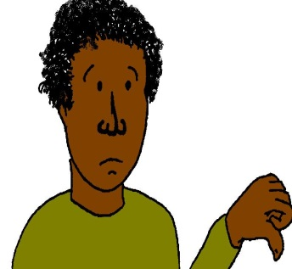
Complaints
If you need to make a complaint about access to voting at a polling station you need to contact the electoral office at your local authority.
Electoral Office: this is the office where the Electoral Commission works. This organisation works to make sure that people can vote and that elections are done in a fair way.

The contact details for your electoral office will be on your local authority website or you can get this information at:
www.aboutmyvote.co.uk

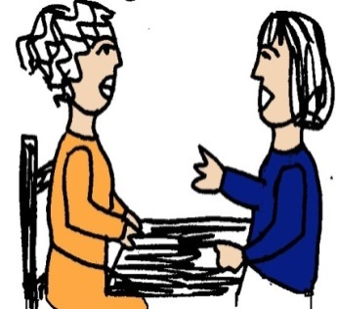
You can also let the Electoral Commission know about your complaint and they will check the reply that you get.

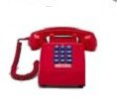
You can contact the Electoral Commission on:
Telephone: 03331031928
Textphone: 1800102072710500
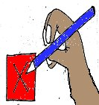
Polling Station Access Guide
Disabled people have the right to turn up and vote at their local polling station like anyone else.
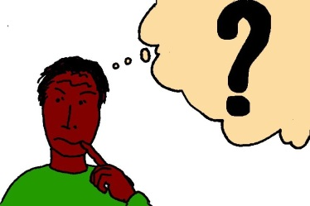
Many disabled people do not know how accessible their polling station is.
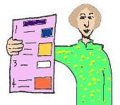
The Electoral Commission has put together the following information for disabled people about our voting rights.

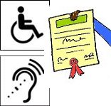
Disabled people’s voting rights
Local authorities now have to take action to make sure that disabled people have equal access to polling stations.
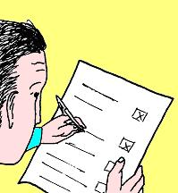
All voters have a right to vote independently and in secret.

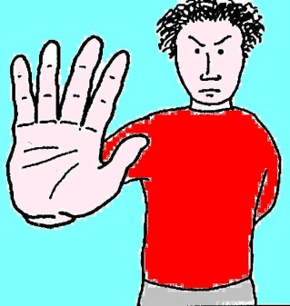
A person who is registered to vote or who is on record as being a proxy voter has to be given a ballot paper. They are not allowed to stop someone voting because of mental or physical incapacity.
Proxy voter: this is when someone chooses someone to vote for them.
Ballot Paper: this is the piece of paper used to vote.
Mental or physical incapacity: in this document this is when a disabled person is seen as not being able to do something or make decisions.

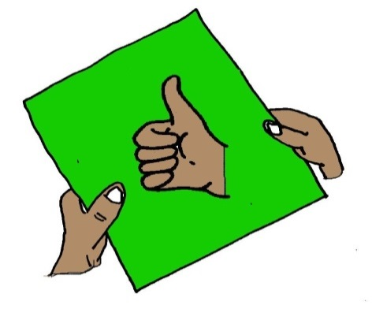
Polling station staff must make sure that disabled voters are given the same level of service as other voters.

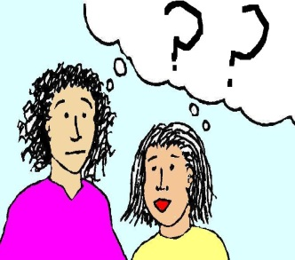
Staff should also be able to explain what support there is for disabled voters who want to vote in person at a polling station.

Disabled voters have the right to:
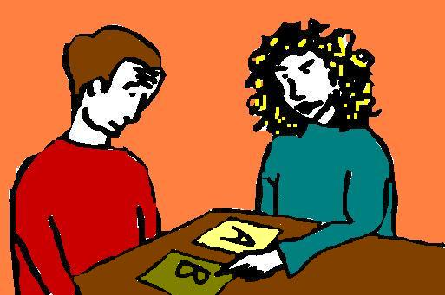
Get help to mark the ballot paper
Disabled voters can ask for help from the Presiding Officer to mark the ballot paper for them. They can also bring in someone else to support them to vote. This person must be from the persons close family, over 18 years old or a person that is allowed to vote.
Presiding Officer: this is the person in charge of a polling station.

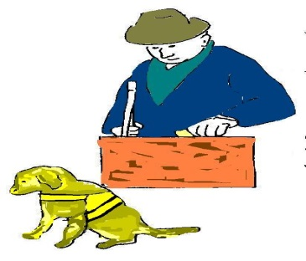
Tactile voting device
This is a piece of plastic that is fixed onto the ballot paper. It is so that a person with a visual impairment or a person that cannot mark the ballot paper can do so in secret.
Visual impairment: this affects the way that a person can see.

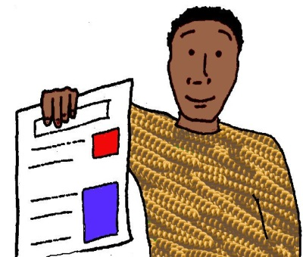
Large-print version of the ballot paper
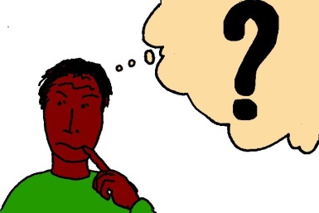
A large-print version of the ballot paper should be easy to find inside the polling station. A copy can be given to voters to take with them into the polling booth, the area where they go to vote in private. A voter cannot vote on the large-print version, but it can be used by the person to understand what is written on the smaller text version.

Help to people coming to vote that are not able to access the polling station
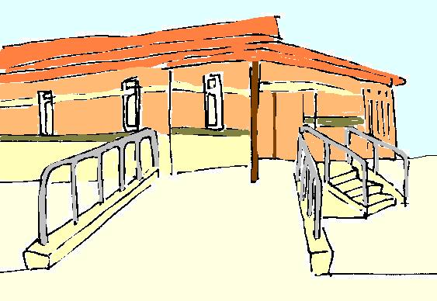
It is the responsibility of the council to decide where polling stations will be and check that these are the right places. The council must think about access for disabled voters.
If a person coming to vote cannot get into the polling station because of a physical disability, the Presiding Officer can take the ballot paper to the disabled person.
Physical disability: this affects the way that you can move and get around.

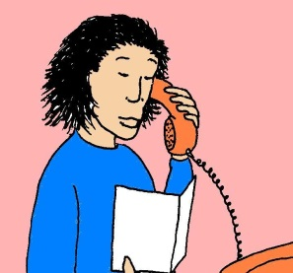
If you have any problems on Election Day, you should call your local authority to try to deal with this.
You can also contact the Electoral Commission
by telephone: 03331031928
or textphone: 1800102072710500

