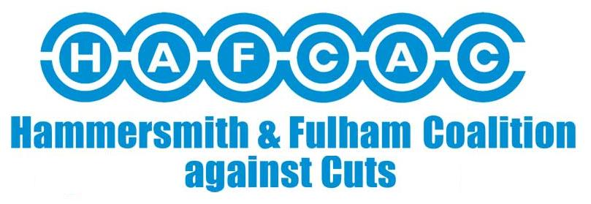
Why Deaf and Disabled People’s Organisations (DDPOs) and Lawyers should work together?
Kevin Caulfield

Good reasons to work together
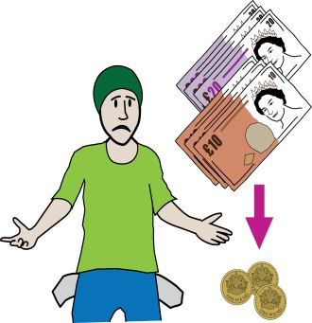

- We now live in a country where dying people are declared fit for work, disabled people are forced from their homes by the bedroom tax, families have to choose between eating and heating, and tens of thousands are waiting for benefits they are entitled to that never come
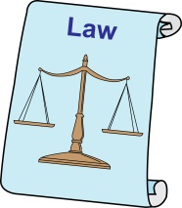
- Cuts targeted at disabled people 9 times more than the general population and people with high or complex support needs have been targeted 19 times more than the non-disabled population.

- Often with unlawful policy/ process which can be challenged.
- The effect of these cuts taken together is that the situation of disabled people has got worse in many areas of our lives. And made them less equal.
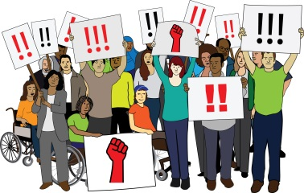
- The network and now the Disability Justice Project and other campaigning disabled people and lawyers have all been part of campaigning against it.

The inspiration for the DDPO legal network
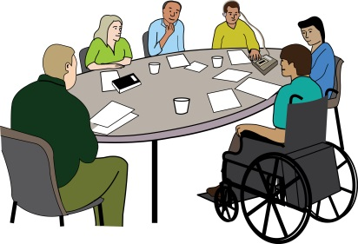
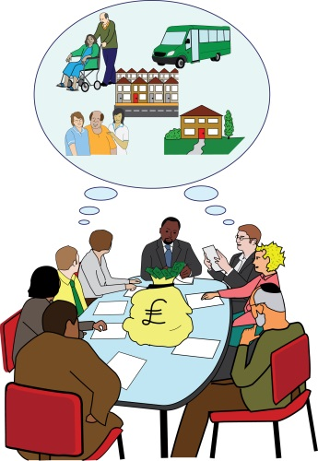
- The Network was mostly inspired from our experience of legal challenge in Hammersmith and Fulham. Coalition Against Cuts (HAFCAC) is a DDPO campaign group, our initial main aim was to stop HF reintroducing charging disabled people for support and services. ‘home care’.
- The inspiration for much of Conservative government policy in 2010 came from Hammersmith and Fulham which was Conservative run from 2006 -2014 - the Council tax cutting Council.

- For us the writing was on the wall as services were cut/ HAFCAC 2007 began the long process of supporting local disabled residents with the help of super lawyers at Public Law Project / judicial review Council’s proposal to start charging older and disabled people again for essential support.


The inspiration for the DDPO legal network
- END RESULT was that we lost the Judicial Review and the Appeal but for us the loss in court was still a victory for disabled people.


- The Council had taken over 18 months to finally get it’s charging policy adopted in January 2009. This kept hundreds of thousands of pounds where it belonged in the pockets of local disabled and older people and we felt much stronger to fight cuts.
- We knew that ALL disabled people need to use whatever avenues at our disposal to campaign and that access to legal advice/ legal action to defend our rights was crucial.
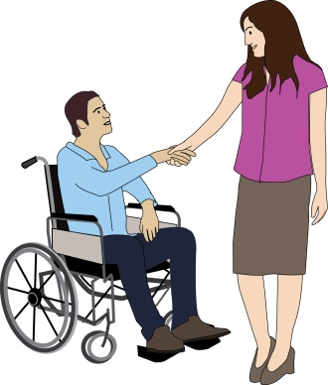
- With that aim the network was launched with Inclusion London and Public Law project in 2012. We knew we needed competent lawyers, experts in discrimination/ public law and we wanted disabled people to meet lawyers on a more equal basis not as clients and so we could get support for DDPOs and be strategic.
Without the legal action what happened next was less likely to have happened

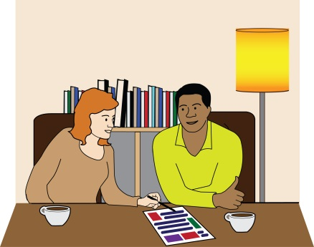
- The Court case and our campaigning inspired opposition HF Labour group who now in office since 2014 / and supported legal challenge.


- Incredibly Council now abolished charging for ‘home care’ services for disabled people.
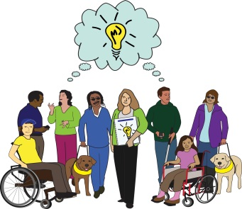
- Ring fenced the money for former Independent Living fund recipients
- And set up Disabled Peoples Commission to understand better the lives of local disabled people and implement policy to improve life.

though we have warned HF that we are not averse to use the law again to enforce our rights if we need to

Why Deaf and Disabled People’s Organisations (DDPOs) and Lawyers should work together?
- the work of Disability Justice project will enable DDPOs and disabled people to be better informed on our rights and how to enforce them
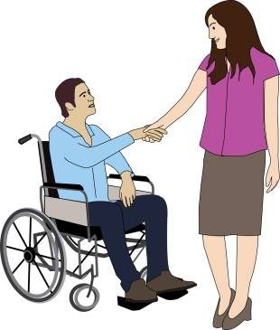
- Greatly strengthen good connections with DDPOs and lawyers that the network has already achieved
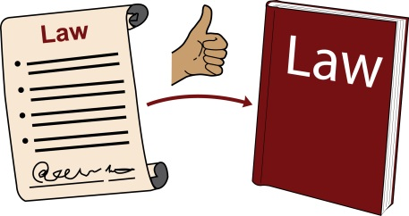
- All the work will help make DDPOs stronger and lawyers better informed and more experienced working on disabled people’s legal issues.
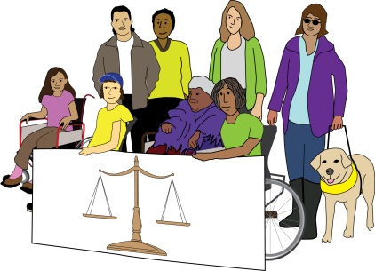
- And I hope from tonight you will all want to lend your support to the network/ project that works for the end of disabled peoples poverty, inequality and exclusion. And as you all know there are many many struggles ahead.

