Answers to the most asked questions by Independent Living Fund users and other people with High Support Needs

This guide has been written to help Independent Living Fund users understand the law and other issues around community care assessments and support.
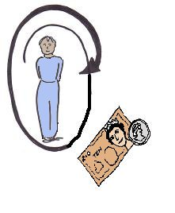
It will help users to understand how the changes will affect them after the Independent Living Fund has closed in June 2015. It is also for other adults with high support needs who may not have had support from the Independent Living Fund.

It has been written for people who do not work in or know much about law. However, if you are thinking about using the law to take action about support, you should get advice from an expert and a lawyer, as well as reading this guide.

This document has been put together by Kate Whittaker with Independent Living Fund users, Inclusion London and Disability Sheffield Centre for Independent Living.

People and local groups can use parts of this document, they can copy it and send it round by email. If parts of this document are used in other documents, then please say that the information was taken from this guide. A copy of this guide can also be found at the following link:

www.disabilitysheffield.org.uk/fact-information-sheets www.inclusionlondon.co.uk/ILF
http://ilfaction.net/info-guidance/

You can also check the link above for updates to this information about changes in the future.

- When will changes happen to my support and how long before the changes happen will I know about it? Will I get enough time so that I can meet my duties as an employer?
A duty or duties: these are things that a person or organisation must do by law.
Employer: this is the person who pays a person or people to work for them. In this case it could be a person employing someone to support them.

No one should have their support cut without having an assessment done by their local authority. For some users who have not had local authority support before it will be the first time they have had an assessment. If you have not had local authority support before, you should ask for an assessment as soon as possible.

This is so that the local authority knows that you have needs that the Independent Living Fund used to cover. For most Independent Living Fund users this will be a re-assessment, this means that it is not the first time that they have been assessed.

The assessment needs to meet all of the rules around community care assessments by local authorities. However, the local authority should also use government guides around people moving from the Independent Living Fund to local authority support, this is called a transfer.
Some of this information about transfers is a part of the Care Act Statutory Guidance; Statutory Guidance is a document that has rules about the Care Act that must be followed by local authorities:
www.gov.uk/government/uploads/system/ uploads/attachment_data/file/366104/43380_23902777_Care_Act_Book.pdf - From paragraph 23.26 onwards

There is also the Code of Practice, which gives information about the way that transfers should be done. This was agreed by the Independent Living Fund, the Association of Directors of Adult Social Services and the Local Government Association. To read the Code of Practice, go to the link below:

www.adass.org.uk/ilf-code-of-practice-nov-2014/

Statutory guidance does not have to be kept to by law, but local authorities must follow it unless there is a good reason not to. Even when there is a good reason not to follow these rules, they must make sure they keep to the rules as much as possible.

Some people will not have had a
re-assessment by the end of June 2015 and many local authorities know this. They have said that people’s funding will stay the same after the Independent Living Fund is closed and until their re-assessment has been done. The local authority will pay the Independent Living Fund part of a person’s support until they have been re-assessed.
There may be some problems about keeping this amount of support for everyone. An example reason for this is because the way that a person pays money towards their support from the Independent Living Fund is different from the way it is done in the local authority.

A note that adds extra information to the Care Act 2014, called the guidance / clarification note says:

It will usually be best for the change from the Independent Living Fund to local authority support under the Care Act 2014 to happen at the planned review of a person.
The Statutory Guidance says that:

The review must not be used as a way for a local authority to give a person less money in their personal budget. This can be found in paragraph 13.4 of the Statutory Guidance.
Once a re-assessment has been done, if there are plans to lower or change support, then the Statutory Guidance and Code of Practice make it clear that:

- This should be talked about with you: the local authority should take on your opinions about your wellbeing (this is talked about more below). They should also take on your opinions about how the changes will affect both you and your family.
- People will need to be given enough time and support before the change happens. This is so that a person can meet duties by law for the people who work for them.
This is also so that they can meet their duties in the contracts of the people that work for them. This could be duties around redundancy payments and notice periods for the people working for them.
Contract: this is a signed agreement for one person to work for another person or organisation.
Redundancy payments: this is the money you get by the person or organisation that you are working for when you are left without a job.
Notice periods: this is the amount of time that you have to give a person between the day when you let them know that their job will be ending and their last working day.

The Code of Practice makes it clear that the funding moved to local authorities when the Independent Living Fund closed should be enough to cover the costs of the change.
See below for information about whether changes or getting less support can be put back if a complaint or an appeal has been made.

- How will the local authority go about assessing me and giving me support once the Independent Living Fund has closed?
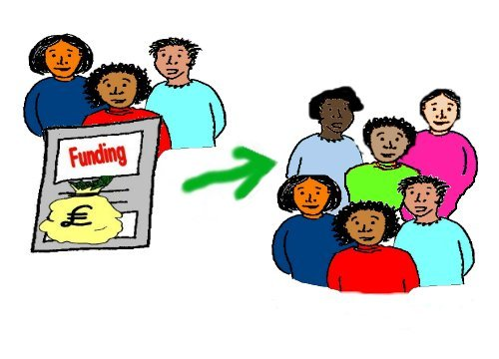
After the Independent Living fund has closed, local authorities will have the same duties to Fund users as they do to all other users of Adult Social Care. These duties are now mostly watched over by the Care Act 2014 and other rules and guides linked to the Act.
There is some information that pushes local authorities to think about certain things for Independent Living Fund users. However there is no duty by law to treat Independent Living Fund users any differently from other users of adult social care.

So the best way forward is to:
- Get as much information as you can about general tips for dealing with:

  - Community care assessments
  - Decisions about whether you can get support
  - Support planning
  - Getting local support to go through this process
Here are some ideas about information that you can use for this:

- Top ten tips from Luke Clements with the Challenging Behaviour Foundation. The document written before the Care Act came into law can be seen below, and the document with the Care Act 2014 information is coming soon:

www.challengingbehaviour.org.uk/learning-disability-files/16---Ten-top-tips-2014.pdf
It was written for family carers of people with a learning disability and challenging behaviour. However it gives very good general advice on getting and keeping a good adult social care package, not just for people with learning disabilities.

- The Scope guide to Social care and dealing with cuts or changes to your care package:
www.scope.org.uk/support/disabled-people/social-care-overview
- Professor Luke Clements Care Act information:
www.lukeclements.co.uk/whats-new/
- PowerPoint presentation on the Care Act 2014 by the lawyer Steve Broach; you can get this from Inclusion London:
By phone at: 020 7237 3181
By email at: ellenclifford@inclusionlondon.co.uk
This information is useful for looking at how key points in the Care Act are written about in the Statutory Guidance and other law and rules. Key points could be about whether you can get support, support planning, direct payments and other things.
- Carers UK guide to the Care Act:
www.carersuk.org/images/publications/ Factsheet_E1029__Assessments_ and_the_Care_Act_updated_27_March _2015.pdf

- Luke Clements, Carers and their Rights (2015 6th edition) at:
www.lukeclements.co.uk/publications/

- Factsheet about whether you can get continuing care through the NHS:
http://www.ageuk.org.uk/Documents /EN- GB/Factsheets/FS20_NHS_ continuing_healthcare_and_NHS-funded_nursing_care%20_fcs.pdf?dtrk=true

In this document we are not trying to copy the information given in these links. We would like you to use them together with the information in this guide that points out tips for Independent Living Fund users.

- Think about extra things you can say about how your needs as an Independent Living Fund user should be thought about.

This is about trying to get your local authority to understand your situation and the risks that there are. It is very important in all local authority social care assessments for them to look at your needs as a person. This means looking at the fact that you used to get Independent Living Fund support.
This means that you have set up a good independent way of living that you need to keep. Some points and ideas to think about are:

- The local authority needs to use the transfer review; this is a review that was done before the Independent Living Fund closed and funding for support was moved to local authorities.
The reviews are done by the Independent Living Fund and sometimes the local authority has been a part of this.

Local authorities do not have to give the same amount of funding or support that the Independent Living Fund gave. However, they have to be able to show that they have used the transfer review information to make their decision.

- The independent Living Fund, Association of Directors of Adult Social Services and the Local Government Association Code of Practice on the Independent Living Fund says:
  - Local authorities will need to listen to people who want to keep on living in the community

  - They must think about how people can be supported to keep on living in the community

  - This must be done in a way that means that people can keep as much independence as possible

- Keeping your support and staying in the community are not only in line with the values of the Care Act, but also the UN Convention on the Rights of Persons with Disabilities. Especially around Article 19 of the Convention about the right to independent living.

The Convention has been signed up to by the UK Government, which means that the UK must work towards making the rights in the Convention a part of real life for Disabled people.
The UK has not yet brought the Convention into our national law, unlike the European Convention on Human Rights, which was brought into law through the Human Rights Act.

So the Convention cannot be used like other pieces of UK law, but in law it is still important for local authorities. This is because they must think about the Convention when dealing with issues that affect people’s human rights.

Under the Human Rights Act all public organisations have to act in a way that is in line with human rights. Part of their understanding of what human rights mean comes from other international duties and the UN Convention is one of these duties.

- It might be worth pointing out that in order to get Independent Living Fund support people have been assessed and have been found to:
  - Have high support needs
  - Be at risk of not being able to live independently unless they get support for this
An important point to make is that the Independent Living Fund has been a system which helpfully points out people with these needs and risks. It then makes sure that their needs are met in a way that means they live independently. It was not just a pot of money.

Local authorities need to know that without having a system they might not see how big these needs and risks are. If these needs and risks are not seen it could mean that local authorities will think they are saving money when actually these decisions will lead to crisis in care for people living in the community.
This will mean that in the future it will actually cost more money.

The Independent Living Fund, social care and health worked together to give good care packages that met a person’s needs. This can sometimes hide how big a person’s needs are and how a small cut or change in a person’s support can have a very bad result.

Rather than testing with cuts that could end very badly, local authorities need to think seriously about keeping support that has been tried and tested and works really well. This support has meant that people can stay independent.

- This is not about treating Independent Living Fund users differently than other disabled people. It is about making it clear that Independent Living Fund users have some needs and risks around staying independent.
The Equality Act makes it clear that getting rid of discrimination against disabled people and pushing forward equality of opportunity, means meeting needs that they have and others do not.
For those with the highest support needs the same values must be used. This is so that they are not discriminated against just because they have higher support needs than others.

- What is the well-being duty in the Care Act and how can it help me make sure my independent living needs are met?
The well-being duty is set out at the very beginning of the Care Act, as Section 1. It is very important for all adult social care users and is especially important for people who have been users of the Independent Living Fund and other people with high support needs. It is important for people who have needs around being able to stay independent.
The well-being duty must be met by all local authorities. In everything that the local authority does when working with a person under the Care Act, they must push for the well-being of that person.
According to the Care Act Well-being means that a person must:
- Have dignity: this means that a person and their opinions or wishes are important and listened to. This also means being treated with respect.
- Be healthy and happy

- Be safe from abuse
- Have control over their day to day life. This also means having control over care and support and the way that it is given.

- Be able to take part in work, education, training or other activities

- Have a life and enough money

- Be able to have a family and personal life

- Have the right place to live

- Be able to be a part of society
As this is a duty by law and not just part of a guide, local authorities must meet their duty to push for well-being.
The question of course, is what that means. This depends very much on each case and the role that the local authority is playing in a person’s life.
Section 1 of the Care Act also sets out a big list of different things that local authorities must think about when meeting the well-being duty. We have written these points below because there are so many important points that may be important and powerful for Independent Living Fund users to talk about:
Section 1(3): When working with a person, in this part of the Care Act, local authorities must think about the following things:
- How important it is from the start to think that the person being assessed knows best about their own well-being

- The persons views, what they want, how they feel and what they believe
- It is important to try to stop or slow down a person’s needs for care or support getting higher. It is important that the needs that a person already has go down

- The need to make sure that decisions about the person are made thinking about all parts of that person’s life. Decisions should not be made only by looking at the age of a person, how the person looks or how they behave. This might lead to getting the wrong idea about a person’s well-being
- How important it is for the person to take part as much as possible in decisions about what is happening. They should be given information and support they need to be able to take part
- How important it is to make sure they think about both a person’s well-being and the well-being of any friends or family who are a part of their care

- The need to make sure a person is safe from abuse
- The need to make sure that a person has their rights met as much as possible. If at any point, this cannot happen, then this must be as little as possible

So the well-being duty is a duty about how the local authority does its job and the things that it should think about and use as a guide when working.

It is a duty to push for well-being; this does not mean that they have to be successful. However it gives some really powerful tools to make clear what is important for people in terms of social care and support.
Well-being under the Care Act is therefore an idea that can mean a lot of things. When using this for a person around losing Independent Living Fund support, it can be said that there are two very important values.
The first is how important it is from the start to think that the person being assessed knows best about their own well-being. This means that if a local authority does not think a person knows best, they would have to show why they think that.
The second is about the right to ‘independent living’. Even though this is missing from the Care Act, it is talked about in a strong way in the Statutory Guidance. It says in paragraph 1.19:
The wellbeing value is there to cover key areas of independent living, as in the UN Convention on the Rights of Persons with Disabilities, the most important section being Article 19 of the Convention. Supporting people to live as independently as possible, for as long as possible, is a key value of the Care Act.
Some of the questions and case studies below will show how the idea of well-being comes up when local authorities are:
- Assessing social care needs
- Deciding if a person should get local authority support, also called eligibility
- Deciding the support that will be given
The case studies show how well-being can be used to point out the types of needs that Independent Living Fund users have.

- Do I have a right to an independent advocate through the assessment process? Or other support to be able to go through the process and take part?
Independent Advocate: they make sure that people can get and use their rights, have a stronger voice and have as much control as possible. Being independent means that they are not linked to any person or organisation that is part of the local authority care and support decision.

Everyone has the right to have someone that they choose with them in assessments or to support them with issues around getting social care.
That could be an advocate, friend or family member. Or it could be another disabled person who has been through this before and can give peer support. Disabled people’s organisations and other local advice and support groups can give options about the peer support and advocacy that you can get.
Peer support: this is where a person going through something can get support from someone who has experience of the same thing.

Sometimes people can get free independent advocacy support for dealing with assessments and other care issues. However there is not a right for everyone to get this support. It depends on each person.
However, there are a number of ways that the Care Act puts stronger duties on local authorities to make sure that people have advocacy or support where needed. These are:
- A bigger duty under Section 4 to give adults and carers information about their care and support. This could be information about how adult care works, the care and support choices they have, and the choices about organisations that offer care and support, and how to access this support.

It can also be information about how to deal with safeguarding worries, this means information about what to do if you think a person may be at harm. For some people, making sure they get this information will mean that they need advocacy support.

- A duty to make sure a person can take part. This can also be carers or other people that the person wants to be a part of their care and support. Again, for some people this will mean advocacy support. This duty is part of their well-being.
- A duty under Section 67 to give independent advocacy support to some people in some cases. This duty comes into action when the local authority thinks that:
- You would have a lot of difficulty in taking part in your assessment, the preparation of your care and support plan or other parts of care. This could be reviews, safeguarding questions and safeguarding reviews.
And

- There is no one that is right or on hand to support you with this.

Substantial difficulty, which means having a lot of difficulty in taking part in any one of the points below:
- Understanding information
- Remembering information
- Using or thinking about the information,
- Communicating you views, what you want and how you feel
The duty to make sure a person can be a part of their care and support becomes a duty from the first point of contact and at any point after that.
When someone supports another person they are called an ‘appropriate adult’. For this to be the right person to give support:
- They must be able to support a person to take part in an active way

- They must not already be paid or a part of giving you or your carer, care or treatment. It must be someone independent, this means not being linked to giving your care and support or to an organisation that does so.

- The person being supported must agree with this person supporting them, if they have the capacity to decide. If they do not have the capacity to decide then the local authority must agree.
To have capacity: in the Mental Capacity Act, this means that a person is able to make decisions about their care and support.

- The person being supported will always be able to say no to advocacy, whether they have capacity or not. This can be called a veto.

There will usually be a family member or friend who can and wants to give advocacy support. Sometimes people will not want this and may be able to get independent advocacy from the local authority, if they meet the points above.

- What are the most important things I need to think about to get ready for my re-assessment?
As talked about above the local authority will treat the re-assessment like all other assessments and re-assessments for adult social care. Here are some key points about assessments. You can also find out more about this in the list of links in Section 2:
- The Care Act Guidance, paragraph 6.38: says that before an assessment, local authorities must give a list of questions that will be asked in the assessment in an accessible format. This is a new rule that is very helpful and has not been used a lot, so it is good to push for this.
- Assessments should normally be face to face. They should not be just by telephone or a self-assessment questionnaire posted to you, that you cannot talk about with the person assessing you.
Self-assessment questionnaire: this is a list of questions about a person’s support or care needs. The person looks at their own needs and fills in the questionnaire.

The Care Act guidance says that in very simple cases it may be OK to have an assessment by telephone, but this is not likely to be right for Independent Living Fund users.
- The people doing the assessments do not need to be social workers. However the statutory guidance says that they must have the right training (paragraph 6.88).

The guidance also says that if the person assessing someone does not know about any part of a person’s disability, then they must talk to someone who has this expert information. If you think that the person assessing you does not have the right training or skills, it is important to bring up any worries at the beginning or as soon as possible.

- If you have other types of needs, apart from social care then the person assessing you should know this. They should put you in touch and work together with other professionals and organisations. This is to make sure that assessments are done as soon as possible and that the different professionals and organisations work together to plan and meet your needs.

Other needs could be around health or housing. This is important for Independent Living Fund users because many have a number of different health needs and may need an assessment for NHS funded healthcare. They may also need a joint package of health and social care funded by both the NHS and the local authority.

- The assessment should also get information from carers, family or other people who can give information about your needs, if you want this to happen. You should also be given a chance to speak to the person assessing you away from your carers or family if you want to. This is the same for your carers if they want to, so they can talk about their own needs as a carer.

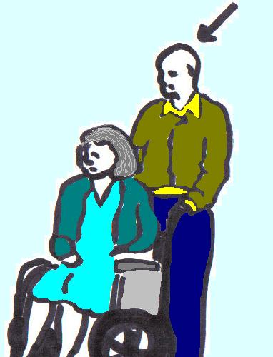
- If family or others are giving care without getting paid, then it is important to make sure this is looked at in the assessment process. It should be written down how much care the carer wants to and can keep on giving, if they can at all. It should also be written down whether the person being cared for wants to carry on being supported by that person.

Disabled adults should not have to get free care from family or others if they do not feel that it meets their needs. This is about making sure the Disabled person has
well-being and independence.
As well as this, family members, such as older parents, should not feel that they have to keep giving care in a way that means that they or the Disabled person no longer have
well-being. This could happen if a local authority does not see or meet people’s needs.

It is very important that these things are clearly written down in the assessment so that the people doing the assessments do not make their own decisions. This is to make sure that people, who have the right to get support from the local authority and want it, can get the support that they need.

- Under the Care Act there are stronger rights and more information about assessments and support for carers. These are talked about later in this document.

- If the assessment shows that there are needs that must be met straight away then the Care Act lets the local authority do this right away without waiting for the full assessment process to happen (Section 19(3) of the Care Act).

- It is very important to get a copy of the assessment and documents showing what decisions have been made and why. The Care Act and the statutory guidance make local authorities give a person a copy of their assessment (Section 12(3) of the Care Act and paragraph 6.98 of the statutory guidance).

They must also give a person a copy of their care plan (Section 25(9) of the Care Act and paragraph 10.87 of the statutory guidance). You need to get copies of these so that you can be sure that all of the information needed has been written down in the assessment.

You also need to get copies of your assessment to make sure that what you have said in the assessment has been thought about in the decisions about your needs. You will be able to see which needs the local authority will give you support for and what support they will give you. If information is missing from the assessment documents, then tell them that it needs to be added.

- What are eligible needs?
Eligible needs are the needs that the local authority must meet by law.
The local authority assessment should find out about all of your needs, even the needs that are not so high. There is then a process of deciding which needs are ‘eligible’, which means which ones the local authority must make sure are met.
They then decide what support is actually going to be given. This is different from deciding which needs are ‘eligible’. Not all eligible needs will lead to the local authority giving support for them. They may be met in another way. As well as this some needs will get support, even though they may not be eligible needs. This may be to stop the person’s needs getting worse or to stop these needs from having a bad effect on other needs.
In the Care Act, there is a very strong point about local authorities taking preventative steps; this means taking steps to stop a person’s needs getting higher in the future. There is also a strong point about looking at the whole person and how their needs add up and affect their lives. This point is not new: local authorities have been pushed to do more than the least possible for a long time.

With the cuts to local authority money getting worse all the time, it is hard to see how local authorities are going to be able to do this in a better way. This is because even before the cuts they were not doing it very well.
However it is still important to make this point. Local authorities need to see that cutting support that is working is bad. This support has been keeping people independent and a part of the community. It might look like they are saving money, but in the future the costs are going to go up.
These issues about local authorities deciding what support you can get and planning with you how it will work are talked about further down in this document. This section is about deciding which needs are eligible, which is an important step to getting the support you need from the local authority.
The Care Act 2014 brings in a national way of deciding who should get support in all local authorities in England. Before the Care Act local authorities used Fair Access to Care Services, this meant that there were a lot of differences between local authorities.

The information about the new way of deciding who should get support is set out in the Care and Support Regulations 2014. These are the rules about how a local authority decides who should get support. To get support, you must meet three needs:
- Your needs must be because of a physical or mental impairment or illness. This is the case for Independent Living Fund users.

- Because of this you must not be able to do two or more things, set out in the list below, and

- Because of this, there is, or is likely to be a big effect on your wellbeing.
Physical impairment: this affects the way that you can move and get around or your senses, like touch, smell, being able to see and hear.
Mental impairment: this affects the way that the brain works. It might affect that way people remember things, how they speak and how they make decisions.

The outcomes or things that you are not able to do because of your impairment or illness:
- Getting and eating the right food to stay healthy
- Keeping your body clean

- Being able to use the toilet
- Having and wearing the right clothes

- Making use of your home in a safe way

- Keeping your home in a way that is good enough to live in
- Starting and keeping family or other relationships
- Accessing and getting into work, training, education or volunteering

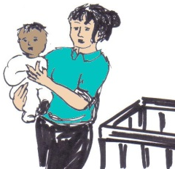
- Making use of places or services in the local community. This could be using public transport, doing activities, or using services

- Carrying out duties that you have around caring for a child

The rules say that you are seen as not able to meet one of the things in the list above, if you:
- Can’t do it at all
- Are not able to do it with support
- Are able to do it without support, but this leads to you being in pain, upset, stressed or worried
- Are able to do it

The level for showing that you cannot do something is low. However, before you can then get support for this, they look at how it affects your well-being. If you are not able to do one of the things on the list, it needs to affect your
well-being in a big way before you can get support.
The Care Act Guidance says that when looking at this the word ‘significant’, means that it has a big effect on your daily life, independence and well-being.
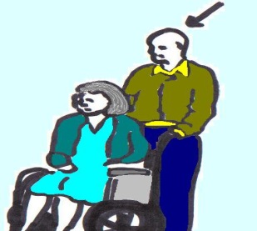
When looking at which needs you should get support for, it is important that they do not look at the support you are already getting from people in your life.
They should look at the need itself without thinking about any carers that you might have. This is very important, so that what is measured, is the need itself and not the question of how you are already dealing with that need.

- My needs have been reassessed and the local authority isn't offering enough support or the right support for me to live independently. How can I get the support plan and amount of personal budget that I need?
Once the eligible needs have been decided the local authority will go on to think about what support it will offer to meet these needs and any other needs that it decides to meet. This could be to stop a person’s needs from getting higher.
Needs can be met by the local authority organising for support services to be given, for example a care organisation. Needs can also be met by the disabled person getting direct payments which they use to organise support themselves to meet their needs.
A care and support plan will be put together with you. This should set out all the key information about how the support is going to be given to meet your needs.
The Care Act guidance sets out what must be in the care and support plan:
- A note of all your needs put together during the assessment

- Information about which needs are eligible for support
- The needs that the local authority is going to meet, and how they will do this. This may be in part or all by direct payments

- Agreed results that you want to get out of the support and how support will be organised to do this, these can be called outcomes

- Support which carers and others can and want to give. Or they must make it clear if the carers or you do not want to give or use this support
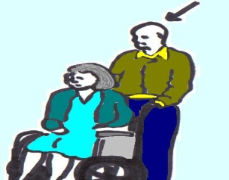
- For a carer, the outcomes that they want to reach, which could be about giving care, working, getting education or other activities.

Also information about how support will be organised so that they can reach these results. This may be by direct payments or other support to the carer or support to you
- The personal budget, as well as information about any money that you will need to pay

- Information about what can be done to lower your needs or stop your needs from getting worse

- How much and how often you will get any direct payments

A very important value of the Care Act is that support planning should be person-centred. You should be as much a part of this as possible, in thinking about what is the best way to meet your needs. This is so that you can get the results that you want in a way that pushes forward your well-being.
Resource Allocation Systems, are ways that local authorities decide how much money people will get to spend on their care and support. Some local authorities use this system at the beginning. They put in information from the assessment to be able to give people an idea about how much money they will be getting for care and support.
This is used to help support planning. This is not the exact amount, as it might end up being higher or lower, but it is there to help disabled people to think about different options for meeting their needs. This can also help to give information to the local authority so that they can make their final decision about what support will be given.

Having an idea early on, about the amount of money that you may get, is important in support being person-centred. It helps people to take part and to think about how the money will be spent in the best way to meet their needs. Disabled people have fought for personalisation and it can give people a lot of power.
So it is very important to understand how much the local authority can think about its own money situation when deciding what support to give. It is also important to look at this together with the real push for well-being, choice and control over how needs are met.
In real life:
- The local authority can decide to only give support for eligible needs, and

- When choosing different options for meeting your needs, the local authority may be able to decide to offer a cheaper option, even though it is not your first choice
So for example, if you get your support as a direct payment:
The local authority may be able to give you an amount of money that covers your eligible need in a cheap way. But this money may not be enough for meeting the need in the way that you would choose.
For example if you would rather use personal assistants than go to a day service. Even though direct payments let you decide how to put your support in place, you still may not be able to meet your need in the way that you would choose because you may not have enough money.
However if you are able to show that the planned local authority funding would not be enough for you to meet your eligible needs, then the amount given would have to go up.
Paragraph 10.27 of the Care Act guidance gives more information about how this should work. It says:
In deciding how to meet needs, the local authority can also think about the amount of money that it has to spend and how much it will have in the future. It must also meet its duties by law. This means making sure that the money that the local authority can use is enough to meet the needs of everyone who lives in their area.
The local authority may think about these things when deciding how to meet the eligible needs of a person, but they must make sure these needs are met.

However, the local authority should not set limits on how much it will spend on different types of support to meet needs. If they do this then they would not be working in a person-centred way, which is part of the law. The local authority can make decisions in a case by case way.
They can think about the total costs of different ways of meeting needs. The cost can be a part of the decision about which type of support is offered by the local authority to meet a person’s needs. This does not mean choosing the cheapest option, but the one that gets the results needed at the best price.
The last sentence is very important to look at in your assessment and support planning. It can be used to explain why the support that you have had, using Independent Living Fund is good and should carry on. You can use it to make a case for each part of the support you need and your support in general.
Also remember that when you are talking about whether you will get results using different support options:
- The idea of well-being is one of the most important things – link everything back to that. This could be the parts of well-being listed in Section 1 of the Care Act.

For example point out if changes or cuts will affect:
  - Your dignity: this means that a person and their opinions or wishes are important and listened to. This also means being treated with respect.
  - Having control over day to day life. This also means having control over care and support and the way that it is given.
  - Whether you can be healthy and happy

  - The place that you live
  - How you are able to be a part of society

And any other points listed in Section 1 of the Care Act.

And
- Think about the things listed in Section 1 of the Care Act about how the local authority should do its job and push for your well-being. For example:
  - How important it is to from the start to think that the person being assessed knows best about their own well-being

  - It is important to try to stop or slow down a person’s needs for care or support getting higher. It is important that the needs that a person already has go down

  - How important it is for the person to take part as much as possible in decisions about what is happening. They should be given information and support they need to be able to take part
  - The need to make sure that the ways of supporting you, mean that you have as much choice and control as possible

In the Care Act guidance it talks about getting the results needed at the best price and thinking about total costs of different options. It is a good idea when thinking about this to use the word ‘costs’ in the biggest way possible. For example, a cut to your social care might:
- Cost the NHS more money, because you will have poorer mental health or be in hospital more
- Affect your housing costs

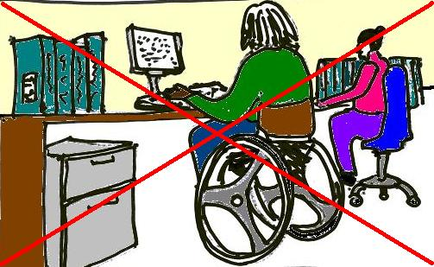
- Have costs such as you not being able to keep a job, or not being able to keep on paying your carers.

If this is so, then make it clear.

Even though local authorities do not have to think about these other costs, local authorities have stronger duties to move towards health and social care working together. So it is important to tell local authorities about these costs and make sure they are written about in your assessment.

Thinking about what carers do:

It is at the stage of support planning that the local authority can sometimes think about whether friends, family or others can give unpaid support towards some of your needs. As talked about above, the local authority must not think about this support when deciding which of your needs are eligible needs.

However, once they have decided what your eligible needs are, they may decide that they do not need to give support for some of these needs, if you already have unpaid support. However this can only happen if both the carer and the adult are happy with this. That is why it is important to:

- Make sure it is written in the assessment what you and your carers want around the level of support to be given by carers, and

- Make sure that your care and support plan says in the right way what has been decided about this unpaid support and that it is also clear about needs that the local authority will give support for.

Case Study
One of the latest most important cases about community care needs is that of Elaine McDonald. It is important because it looks at how local authorities make decisions about the different options for meeting a person’s needs. She used to be a ballerina and she got support from her local authority (Kensington and Chelsea) to meet her needs after she had a stroke.
She brought a judicial review against the local authority’s decision to get rid of the night time support she had for using a commode. They had decided instead to give her pads. Each year this would save the local authority around £22,000.
Judicial review: this is where a judge in court looks at the way that a public organisation has made a decision. When looking at this they decide if the organisation followed the rules when making the decision.

She said that making her incontinent in this way meant that she no longer had dignity. She took the case all the way through the UK courts, to the Supreme Court, where she lost the case. She then took this on to the European Court of Human Rights.
Incontinent: this is when a person does not have control over when they go to the toilet.
Supreme Court: When you are making an appeal, this is the last court that you go to.

The European Court found that the planned cuts to Ms McDonalds care meant that she could not have the right to respect for her private life. This is under Article 8 of the European Convention on Human Rights.
However, the Court found that this was OK because the UK courts had listened to what Ms McDonald wanted but they had to balance this against the needs of the rest of the people living in the local authority.
In this case the local authority’s decision was seen as an OK choice between the different options for meeting Ms McDonald’s needs when also looking at its own money situation.

If this case was looked at under the Care Act there may have been a different result. In the decision about whether the person should get support and how to give this support, the local authority would need to use information that was given in the assessment.
They would need to use the information about what outcomes Ms McDonald needed support to reach and how this affected her wellbeing. For the outcome of ‘managing toilet needs’, the Care Act Guidance says (paragraph 6.107):

When deciding if a person can get support to meet this need, the local authority must look at whether a person can access and use a toilet and manage their toilet needs. This is helpful for someone with needs like Ms McDonald.

There are also some general points to make about how a local authority must push for a person’s wellbeing. For example, from the start, local authorities must think that the person being assessed knows best about their own well-being (Section 1(3) of the Care Act).
That should mean knowing that Ms McDonald is the best person to tell the local authority what it means to her to manage her toilet needs. The local authority must then push for her wellbeing in line with what is most important to her.
In this case the points given by Ms McDonald were about her dignity and her relationship with her partner. These are both important parts of wellbeing and are important to her.
However the local authority said that using pads affected her dignity less than the support of a carer. They also said that there would be less of a risk of having a fall.
Under the Care Act the points made by the local authority would have been less powerful than the points made by Ms McDonald. For Ms McDonald using incontinence pads meant that the local authority would not be supporting her to manage her toilet needs.
Other points like this could make a real difference in getting support for needs around independent living. For example, can a need for support with shopping be met by internet or telephone shopping, instead of having support to go out into the community?
Areas of well-being should all be part of local authority decision making. For example, a person being in control of their day to day life, having enough money, as well as having good mental health and a healthy body.

Local authorities should make sure that these things are a part of the decisions about how support is given. This is so that people get the right outcomes in a way that pushes for their well-being and the things that are important to that person. This could be in areas such as getting the right food, accessing places in the local community and other needs.
We can use the same points as above when looking at whether a person’s needs can be met through a residential home rather than staying in their own home with support.
Before making a decision it is very important to look into the different options put forward by the local authority. This is so that you can decide whether they really are right for you and meet your needs.
Also in paragraph 10.27 of the Care Act guidance, it talks about what local authorities should do when there is more than one type of support that meets a person’s needs.
It says that even though cost is something local authorities can think about, it is not about choosing the cheapest option. It is about choosing the one that gets the results needed for the best price.

- My Direct Payment is not enough to pay for the support I need.

The Care Act guidance says in paragraph 11.23 that the amount that the local authority decides to give as a personal budget:
- Must be enough to meet the persons needs which the local authority must do (these are called eligible needs)

- Must be enough to meet the needs that the local authority has decided to meet (called non-eligible needs)
- Must take on information about how the person wants to use support to meet their needs as written about in the care and support plan.

- The budget for your care may be less because of bad decisions about your eligible needs and/or because of wrong decisions about support options offered to meet your needs. These issues are talked about in the questions above.

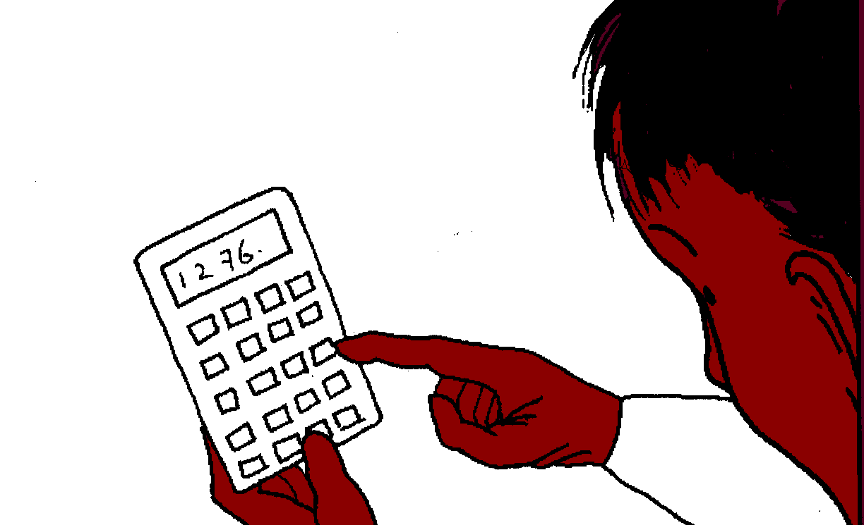
- There may be problems with how the money that you need, to organise your support, has been worked out. This could be problems with how much money you need to put in yourself towards your care.

The amount of your direct payment needs to be enough not only to cover the actual help you need, but also all of the other costs of arranging and managing this yourself. For example:
- Costs of finding and employing someone, services to make sure they get paid and CRB checks; these are checks done by the government about any crimes a person might have taken part in, in the past
- Paying National Insurance, tax, pensions of the person or people that work for you

- Paying VAT in some cases, this is a type of tax that you pay on some of the things that you buy

- Holiday pay, sick pay, maternity and paternity leave and other benefits for the people that work for you

- Redundancy pay: this is an amount of money you give to a person if their job is no longer there and they have to leave.

- Insurance
- Costs for starting up and training staff, when you first take on people to support you
- Costs for when you have to use other organisations to find your support

If you have direct payments then the local authority has the same duties to give you copies of your assessment and support plan. It is even more important to get these so that you have all of the information about your needs and care plan. This is to be clear about what support you can get and how it will actually work.
The local authority must make sure you have clear information about:
- What you need to think about when using a personal budget, such as your duties when you have people working for you
- How your direct payment is made up, to make sure there is enough money to cover all of the costs
- What support you can get to deal with your direct payments package, both at the start and if there are any problems
The local authority must be able to show that the money and support given is enough to cover your eligible needs and that it is enough to help you meet the outcomes that you need.
So for example you may need to pay staff more money than what is normal in your area. This would be to make sure you get people interested in working for you, that they have the right skills and that you can keep them from leaving. Many local authorities have a normal amount per hour that they do not like to change.
To try to change this, it is important to be able to show why more skill is needed in your case. Also you will need information about why the normal rate per hour is not enough to keep good staff. This could be information about the number of staff that have left, or about local jobs that do not need any skills that pay more than you can.
Sometimes it can work out best to use a mix of direct payments and support organised by the local authority. For example you could use agency support through your local authority for short visits and use direct payments for longer amounts of time such as for community activities.
You cannot be forced to choose all of one or the other, you can mix and match if that will meet your needs with the amount of money that you have.

- What does the Care Act say about carers? Does the Care Act give us any rules or advice that we can use to show how important it is to keep the support that we have?
Or to show that this is the only way things can work for the family and not just the disabled person?
When a disabled person is being assessed and their carer has a carer’s assessment, it should go as follows:
- Information about the adults needs is collected in the assessment

- The carer’s needs are pulled out in the carers assessment process. This looks at not just if the carer can carry on giving support, it also looks at whether they want and are able to carry on with this role in the same way.

The risks of carrying on as a carer could be health risks or if a carer wants to keep on working or go back to work, do training, education or other activities.
- The person assessing the carer then looks at the carers needs against the national rules for supporting carers. They then decide which of these needs must be met. A support plan must then be written that looks at how these needs will be met.

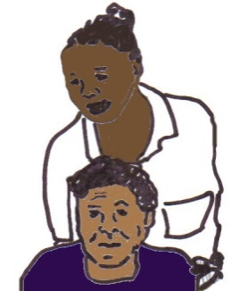
- In many cases the support that the carer needs will be someone else giving care and support to the disabled person that they care for. This is so that they can do other things such as work or training and at the same time know that the person they care for has the support they need.
The Care Act makes it clear that this kind of service must be on offer. The needs of the carer must be met by the local authority, even if the disabled person was not seen as needing this support.
This is talked about more in the Carers and their Rights document. This can be found at:
www.lukeclements.co.uk/publications/

And in the Carers UK factsheets at: www.carersuk.org/files/section/4630/factsheet -e1029--assessments-and-the-care-act-after-april-2015.pdf

New rules about how much support carers can get is a big change in the Care Act. Before this, local authorities had powers to give support to carers, but there was no way of making local authorities do this.

Carer’s needs and Disabled people’s needs are looked at in the same way. They look at the results that the carer wants to get, and what will happen to their well-being if they do not get the right support. Some of the areas where support may be needed to get results are:
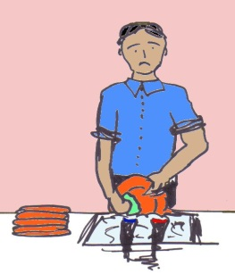
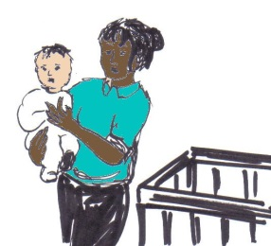
- Doing some or all of the basic activities in the carer’s home such as making meals, cleaning and fixing things in the house. This can be in the carer’s home even if they do not live with the person that they care for

- Carrying out caring duties for a child or giving care to other people

- Working, getting training or education, volunteering or other activities

- Having a family life or other relationships
- Accessing places and services in the community

In Question 3 of this document, the points about well-being, can be used in the same way for carers. Part of this is the need to look at the whole family in assessment processes.

As well as this, is the point about how important it is from the start for local authorities to think that the person being assessed knows best about their own well-being. They also know what to do to make sure that they get this. Part of well-being is independent living (Article 19 of the UN Convention on the Rights of Persons with Disabilities).

The Care Act guidance makes it clear that carers cannot be made to offer care. It also sees that the care given by unpaid carers in an important part of the way that people’s needs are met. This is at a time when the need for care is going up. Many Independent Living Fund users with a learning disability already get a high level of support from family and others.
There are real risks that cuts to their support will put a lot of stress on family members. This could mean that the support then breaks down and everything that they have worked for is lost.

It is important to point out the risks of cutting support, showing that in the long run this might have more costs. Also making the important point that adults with learning disabilities should not have to rely on their family too much for basic care, if this does not push for their well-being and independence.
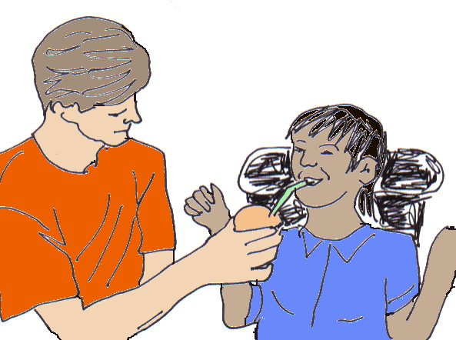
Another big change for carers under the Care Act is that before the Care Act came in, a carer had to be giving a person a lot of care before they were able to get an assessment for support. This has now been taken out of the Care Act and assessments now look more at the type of relationship between the carer and the adult with care needs.

A carer could be someone giving a person support to do things as well as giving support to a person around how they are feeling.
As before, the Care Act duties to assess and support carers falls on the local authorities where the person who gets care and support lives, not where the carer lives.

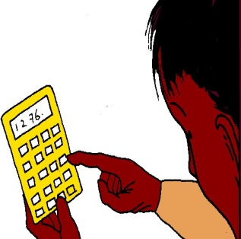
- What do I need to know about money assessments and how much I need to pay? What is disability related expenditure?
Disability related expenditure: these are extra costs that a disabled person has because of their disability or impairments.

A good and up to date guide about money assessments and how much adult social care costs can be found from Age UK at:
www.ageuk.org.uk/Documents/EN-GB/Factsheets/FS46_Paying_for_care_and_support_at_home_fcs.pdf?dtrk=true
On page 22, there is information about how you decide which of your costs count as
‘disability-related expenditure’. For example extra living costs that you have to pay because of your impairment or disability. The local authority must think about this when deciding what money you can afford to pay for support and care, this money can be called charges.
It is important to know what type of costs count as disability-related expenditure. This is because when the local authority looks at how much money you have, and how much you should pay for your care and support, the disability-related expenditure is left out of this decision.
There is not a set list of what counts as disability-related expenditure or what information you need to give the local authority about this. There is also no set way of how the local authority decides how much you will have to pay for your care and support. Different local authorities have different guides and ways of deciding this.
So it is important to get to know the general rules about how local authorities make decisions about disability-related expenditure, for example by reading the Age UK factsheet in the link above.
It is also important to get information and support about how things are done in your area. This could be by getting in touch with your local disabled people’s organisation.
Some disabled people’s organisations and other groups work to get the local authority to give better information on disability-related expenditure. They also work to find better ways for local authorities to make decisions about disability-related payments and charges.

- What can I do if I am not happy with the local authority’s decision about what support I will get?
The Care Act gives new powers to set up a way of making appeals about community care issues. This has not yet been put in place. It will be set up using direct payment rules and eligibility rules; these are the rules that help to decide whether you can get support.
Some plans about what it will look like have been put forward and the Government are now looking at consultation responses.
Appeal: this is the way that you tell an organisation, local authority or government department that you are not happy with a decision that they have made.
Consultation responses: when an organisation, local authority or government department want to know what you think about something they do a consultation. When a person or organisation replies to the consultation, it is called a consultation response.

Some of the consultation responses showed that there were worries about putting in place this way of making appeals. Some people said that this might just make it slower for people to get a final decision from their local authority.
It might also mean that they waste time, when they actually need to make an appeal in a different way, for example taking their appeal to the Ombudsman.
Ombudsman: this is a government organisation that a person can make a complaint to. This organisation is used when a person thinks that a public organisation has done something in an unfair way or given a bad service.

At the moment, the plan is for this way of making appeals to start in April 2016. This will start at the same time as the plans to put a limit on the amount people pay for their care. Nothing has been completely decided about either of these things yet.
A final version of the rules for this way of making appeals will be written before it is put into place, but we do not know when that will be.

Until then the three main ways that you can appeal if you think that the wrong decision has been made about you care, are:
- The local authority complaints procedure: this is the way that you make a complaint in your local authority
- The Local Government Ombudsman: this is the government organisation that you can go to if you think that local government has done something in an unfair way or given a bad service.
- Taking it to court as a judicial review: you can do this if you think that a public organisation has broken the law in the way that it has made a decision.
In many cases you need to appeal the way that a decision around support was made and not just the final decision. For example if you think that an assessment was not fair and that meant that the local authority did not have all of the information about your needs, you could make an appeal about the way that the decision was made.
How you appeal depends on each case. You have to think about things such as how quickly you need a final decision and how seriously you have been affected. In most cases it is thought that people should use the local authority complaints procedure first.
Then you should try all of the other options before taking your case to court. This is how most people do it, unless the issue is very serious and you need it to be sorted out quickly.
Each local authority will have its own complaints procedure which they must give you information about, but they do have to follow national rules. There is more information about this below.
The Ombudsman can be a good way of making a complaint, but it is quite slow and you have to go through the local authority’s whole complaints procedure first.
There are good things and bad things about each way of making a complaint. Each way of making a complaint has different costs that you may have to pay. For example if you lose a judicial review then you have to pay the local authorities costs.
Legal aid is support with taking a case to court and the costs that you have when you do this. You might be able to get this support for a judicial review and in some cases for Ombudsman complaints. There are a lot of rules about whether you can get legal aid. These rules look at how much money you have and how strong your case is.

Some people have to pay a part of their legal aid costs. If you get legal aid, it will pay for the costs of a lawyer to give you advice and go to court with you. It can also help you if you lose the case and have to pay the costs of the local authority.
There is good information about the different ways of making complaints and appeals, and example complaints letters for you to use. Some of this information can be found at the links below:
- www.mind.org.uk/information-support/legal-rights/complaining-about-health-and-social-care/complaints-procedure-in-england/

- www.scope.org.uk/support/disabled-people/social-care-overview

See sections on ‘How to complain’ and ‘What next?’

- www.lukeclements.co.uk/wp-content/uploads/2015/04/5-Reduction-in-care-services.pdf:

This is Luke Clements’ summary on complaining about cuts to an adult social care package. It also has links to the Cerebra webpage which has a number of excellent letters that you can use as examples.
- w3.cerebra.org.uk/research/legal-entitlements-research-project/precedent-letters/

These example letters have mainly been written for parents of disabled children but they are very useful for telling local authorities when you are worried about something in adult social care.

- www.lgo.org.uk/adult-social-care/

There is also a guide with lots of information called Using the Law to Fight Cuts to Disabled People’s Services, written by Steve Broach and Kate Whittaker. This gives a summary of the most important rights of disabled people by law.
It gives advice and information to help people use their rights, such as how to use complaints procedures and other ways of making complaints such as judicial reviews.
It has information about support that you can use locally and nationally to help with community care and other issues.
It also has information about when legal aid can be used. This is to help with costs of a lawyer giving you advice and going to court with you.

At the end of the guide is a list of lawyers who work with disabled people, with their contact information. You can find the guide at:
www.scomo.com/KWhittaker.php.

- Can I stop the changes happening until after my complaint or appeal has been dealt with? Can my local authority cut my funding if I don't sign an agreement?
There is no right to stop changes from happening whilst you wait for a decision about a complaint or an appeal. Not signing an agreement for cuts in your care and support package from the local authority will not stop them from making the cut.
However, in some cases you may be able to get the changes put on hold whilst your worries are looked into.
For example you should point out the risks that are there if the change happens before you have had a chance to get a review done. If the change means that you will need to get rid of staff or cut their hours to the point where they will need to find other work, you should point this out.
You should ask the local authority not to take these steps until you have had a fair chance to make your case, as these changes cannot then be undone. You can also ask for your complaint to be looked at quickly before the change happens.
In really urgent cases where there is a big risk of getting hurt, that cannot be dealt with in any other way; you can make an urgent application through a judicial review. You can ask the court to tell the local authority what to do to keep you safe. This can stay in place while the issues are looked into, but this does not happen very often at all.

Kate is a consultant solicitor at Scott-Moncrieff & Associates, a national firm of solicitors specialising in community care, public law, mental capacity and other civil liberties work. Scott-Moncrieff & Associates have a franchise with the Legal Aid Agency to provide legal aid work in these areas. Kate also provides independent legal consultancy and training. She specialises in cases involving disabled adults and children and others who need care and support from public bodies. As well as working as a solicitor Kate works closely with a number of disabled people’s organisations providing advocacy and other services, including Disability Sheffield where she is a trustee.
An updated version will be issued shortly but much of the information remains current

